**Exp No. 5**

**Create an app for children to study numbers and alphabets.**

1. HTML and Stylesheet files

**//home.page.html**

<ion-header [translucent]="true">

<ion-toolbar>

<ion-title>

Home

</ion-title>

</ion-toolbar>

</ion-header>

<ion-content [fullscreen]="true">

<ion-card [routerLink]="['/alphabet']">

<ion-card-title class="card-title">Alphabets</ion-card-title>

<ion-card-subtitle class="card-subtitle">Let's learn some letters</ion-card-subtitle>

<img src="./assets/alphabets.gif" alt="" style="float: left; border-radius:50%; padding: 10px; width: 150px; height: 100px;">

</ion-card>

<ion-card [routerLink]="['/number']">

<ion-card-title class="card-title">Numbers</ion-card-title>

<ion-card-subtitle class="card-subtitle">Let's learn some numbers</ion-card-subtitle>

<img src="./assets/numbers.gif" alt="" style="float: left; border-radius:50%; padding: 10px; width: 150px; height: 100px;">

</ion-card>

<ion-card [routerLink]="['/color']">

<ion-card-title class="card-title">Colors</ion-card-title>

<ion-card-subtitle class="card-subtitle">Let's learn some color</ion-card-subtitle>

<img src="./assets/colors.gif" alt="" style="float: right; border-radius:50%; padding: 10px; width: 150px; height: 100px;">

</ion-card>

<ion-card [routerLink]="['/shape']">

<ion-card-title class="card-title">Shapes</ion-card-title>

<ion-card-subtitle class="card-subtitle">Know some figures</ion-card-subtitle>

<img src="./assets/shape.gif" alt="" style="float: right; border-radius:50%; padding: 10px; width: 150px; height: 100px;">

</ion-card>

<ion-card [routerLink]="['/quiz']">

<ion-card-title class="card-title">Quizes</ion-card-title>

<ion-card-subtitle class="card-subtitle">Test what we know</ion-card-subtitle>

<img src="./assets/quiz.gif" alt="" style="float: left; border-radius:50%; padding: 10px; width: 150px; height: 100px;"><br><br>

</ion-card>

</ion-content>

**//home-routing.module.ts**

import { NgModule } from '@angular/core';

import { RouterModule, Routes } from '@angular/router';

import { HomePage } from './home.page';

const routes: Routes = [

  {

    path: '',

    component: HomePage,

  },

  {

    path: 'alphabet',

    loadChildren: () => import('../pages/alphabet/alphabet.module').then( m => m.AlphabetPageModule)

  },

  {

    path: 'number',

    loadChildren: () => import('../pages/number/number.module').then( m => m.NumberPageModule)

  },

  {

    path: 'color',

    loadChildren: () => import('../pages/color/color.module').then( m => m.ColorPageModule)

  },

  {

    path: 'quiz',

    loadChildren: () => import('../pages/quiz/quiz.module').then( m => m.QuizPageModule)

  },

  {

    path: 'rank',

    loadChildren: () => import('../pages/rank/rank.module').then( m => m.RankPageModule)

  },

];

@NgModule({

  imports: [RouterModule.forChild(routes)],

  exports: [RouterModule]

})

export class HomePageRoutingModule {}

**//home.page.scss**

#container {

  text-align: center;

  position: absolute;

  left: 0;

  right: 0;

  top: 50%;

  transform: translateY(-50%);

}

#container strong {

  font-size: 20px;

  line-height: 26px;

}

#container p {

  font-size: 16px;

  line-height: 22px;

  color: #8c8c8c;

  margin: 0;

}

#container a {

  text-decoration: none;

}

.card-title{

  margin-top: 8%;

  text-align: center;

  font-size: 32px;

  letter-spacing: 3px;

  cursor:grab;

}

.card-subtitle{

  text-align: center;

  font-size: 16px;

  margin-bottom: 5%;

  cursor:grab;

}

ion-card {

  --background:pink;

  --color: green;

}

* **Pages->alphabet**

**//alphabet.page.html**

<ion-header>

  <ion-toolbar>

    <ion-item>

      <ion-back-button></ion-back-button>

      <ion-title>alphabet</ion-title>

  </ion-item>

  </ion-toolbar>

</ion-header>

<ion-content>

  <ion-card style="width: 100%; height: 45%;">

    <iframe width="100%" height="100%" src="https://www.youtube.com/embed/KBPAI6qLW5o" title="YouTube video player" frameborder="0" allow="accelerometer; autoplay; clipboard-write; encrypted-media; gyroscope; picture-in-picture" allowfullscreen></iframe>

  </ion-card>

  <ion-card style="width: 100%; height: 45%;">

    <iframe width="100%" height="100%" src="https://www.youtube.com/embed/tFQKwKWroMA" title="YouTube video player" frameborder="0" allow="accelerometer; autoplay; clipboard-write; encrypted-media; gyroscope; picture-in-picture" allowfullscreen></iframe>

  </ion-card>

  <ion-card style="width: 100%; height: 45%;">

    <iframe width="100%" height="100%" src="https://www.youtube.com/embed/KBPAI6qLW5o" title="YouTube video player" frameborder="0" allow="accelerometer; autoplay; clipboard-write; encrypted-media; gyroscope; picture-in-picture" allowfullscreen></iframe>

  </ion-card>

</ion-content>

* **Pages->color**

**//color.page.html**

<ion-header>

  <ion-toolbar>

    <ion-item>

      <ion-back-button></ion-back-button>

      <ion-title>Color</ion-title>

  </ion-item>

  </ion-toolbar>

</ion-header>

<ion-content>

  <ion-card style="width: 100%; height: 35%;">

    <iframe width="100%" height="100%" src="https://www.youtube.com/embed/6eYb-d9e8Aw" title="YouTube video player" frameborder="0" allow="accelerometer; autoplay; clipboard-write; encrypted-media; gyroscope; picture-in-picture" allowfullscreen></iframe>

  </ion-card>

  <ion-card style="width: 100%; height: 45%;">

    <iframe width="100%" height="100%" src="https://www.youtube.com/embed/1941bBZjTjE" title="YouTube video player" frameborder="0" allow="accelerometer; autoplay; clipboard-write; encrypted-media; gyroscope; picture-in-picture" allowfullscreen></iframe>

  </ion-card>

</ion-content>

* **Pages->number**

**//number.page.html**

<ion-header>

  <ion-toolbar>

    <ion-item>

      <ion-back-button></ion-back-button>

      <ion-title>number</ion-title>

    </ion-item>

  </ion-toolbar>

</ion-header>

<ion-content>

  <ion-card style="width: 100%; height: 45%;">

    <iframe width="100%" height="100%" src="https://www.youtube.com/embed/ea5-SIe5l7M" title="YouTube video player" frameborder="0" allow="accelerometer; autoplay; clipboard-write; encrypted-media; gyroscope; picture-in-picture" allowfullscreen></iframe>

  </ion-card>

  <ion-card style="width: 100%; height: 45%;">

    <iframe width="100%" height="100%" src="https://www.youtube.com/embed/4YpHh3e0h7U" title="YouTube video player" frameborder="0" allow="accelerometer; autoplay; clipboard-write; encrypted-media; gyroscope; picture-in-picture" allowfullscreen></iframe>

  </ion-card>

  <ion-card style="width: 100%; height: 45%;">

    <iframe width="100%" height="100%" src="https://www.youtube.com/embed/ea5-SIe5l7M" title="YouTube video player" frameborder="0" allow="accelerometer; autoplay; clipboard-write; encrypted-media; gyroscope; picture-in-picture" allowfullscreen></iframe>

  </ion-card>

</ion-content>

* **Pages->quiz**

**//quiz.page.html**

<ion-header>

  <ion-toolbar>

    <ion-item>

      <ion-back-button></ion-back-button>

      <ion-title>Quiz</ion-title>

  </ion-item>

  </ion-toolbar>

</ion-header>

  <ion-button>Score : {{score}}/4</ion-button>

<ion-content>

  <ion-card>

    <ion-card-content>

      <ion-card-header>

        <ion-card-title>Q1.</ion-card-title>

        <img src="assets/star.jpg" alt="">

        <ion-card-subtitle>What is the Colour of above shape</ion-card-subtitle>

      </ion-card-header>

      <ion-grid fixed>

        <ion-row>

          <ion-col size="6">

            <ion-button expand="block" color="{{btn1}}" (click)="opt1()">

              Green

            </ion-button>

          </ion-col>

          <ion-col size="6">

            <ion-button expand="block" color="{{btn2}}" (click)="opt2()">

              Blue

            </ion-button>

          </ion-col>

        </ion-row>

      </ion-grid>

    </ion-card-content>

  </ion-card>

  <ion-card>

    <ion-card-content>

      <ion-card-header>

        <ion-card-title>Q2.</ion-card-title>

        <img src="assets/hand.jpg" alt="">

        <ion-card-subtitle>how many fingres in the hand</ion-card-subtitle>

      </ion-card-header>

      <ion-grid fixed>

        <ion-row>

          <ion-col size="6">

            <ion-button expand="block" color="{{Q2o1}}" (click)="opt21()">

              5

            </ion-button>

          </ion-col>

          <ion-col size="6">

            <ion-button expand="block" color="{{Q2o2}}" (click)="opt22()">

              4

            </ion-button>

          </ion-col>

        </ion-row>

      </ion-grid>

    </ion-card-content>

  </ion-card>

  <ion-card>

    <ion-card-content>

      <ion-card-header>

        <ion-card-title>Q3.</ion-card-title>

        <img src="assets/car.png" alt="">

        <ion-card-subtitle>What is the Colour of above shape</ion-card-subtitle>

      </ion-card-header>

      <ion-grid fixed>

        <ion-row>

          <ion-col size="6">

            <ion-button expand="block" color="{{Q3o1}}" (click)="opt31()">

              Red

            </ion-button>

          </ion-col>

          <ion-col size="6">

            <ion-button expand="block" color="{{Q3o2}}" (click)="opt32()">

              Blue

            </ion-button>

          </ion-col>

        </ion-row>

      </ion-grid>

    </ion-card-content>

  </ion-card>

  <ion-card>

    <ion-card-content>

      <ion-card-header>

        <ion-card-title>Q4.</ion-card-title>

        <img src="assets/circle.jpg" alt="">

        <ion-card-subtitle>What is the name of above shape</ion-card-subtitle>

      </ion-card-header>

      <ion-grid fixed>

        <ion-row>

          <ion-col size="6">

            <ion-button expand="block" color="{{Q4o1}}" (click)="opt41()">

              cube

            </ion-button>

          </ion-col>

          <ion-col size="6">

            <ion-button expand="block" color="{{Q4o2}}" (click)="opt42()">

              circle

            </ion-button>

          </ion-col>

        </ion-row>

      </ion-grid>

    </ion-card-content>

  </ion-card>

</ion-content>

* **Pages->shape**

**//shape.page.html**

<ion-header>

  <ion-toolbar>

    <ion-item>

      <ion-back-button></ion-back-button>

      <ion-title>Shape</ion-title>

  </ion-item>

  </ion-toolbar>

</ion-header>

<ion-content>

  <ion-card style="width: 100%; height: 35%;">

    <iframe width="100%" height="100%" src="https://www.youtube.com/embed/fQqru--4aJU" title="YouTube video player" frameborder="0" allow="accelerometer; autoplay; clipboard-write; encrypted-media; gyroscope; picture-in-picture" allowfullscreen></iframe>

  </ion-card>

  <ion-card style="width: 100%; height: 35%;">

    <iframe width="100%" height="100%" src="https://www.youtube.com/embed/6eYb-d9e8Aw" title="YouTube video player" frameborder="0" allow="accelerometer; autoplay; clipboard-write; encrypted-media; gyroscope; picture-in-picture" allowfullscreen></iframe>

  </ion-card>

  <ion-card style="width: 100%; height: 45%;">

    <iframe width="100%" height="100%" src="https://www.youtube.com/embed/1941bBZjTjE" title="YouTube video player" frameborder="0" allow="accelerometer; autoplay; clipboard-write; encrypted-media; gyroscope; picture-in-picture" allowfullscreen></iframe>

  </ion-card>

</ion-content>

* **Pages->splash**

**//splash.page.html**

<ion-header>

  <ion-toolbar>

    <ion-title>splash</ion-title>

  </ion-toolbar>

</ion-header>

<ion-content>

  <div class="container ion-text-center">

    <img src="assets/splash.gif" alt="">

  </div>

</ion-content>

1. 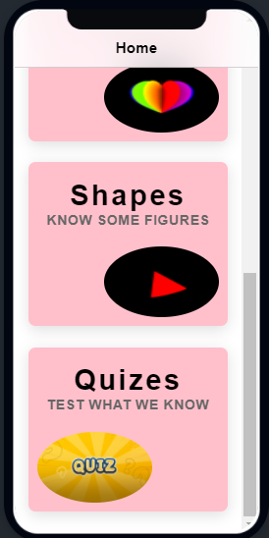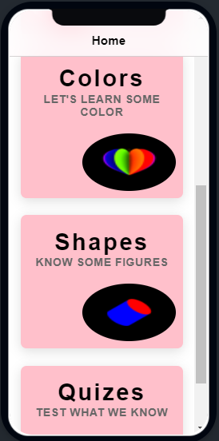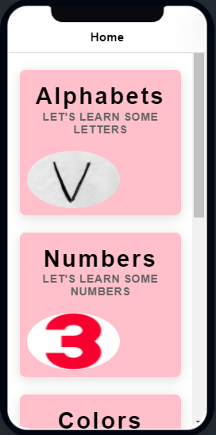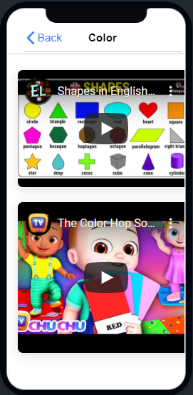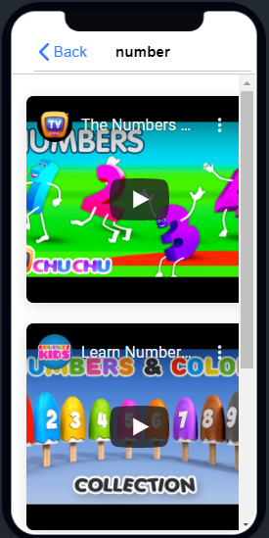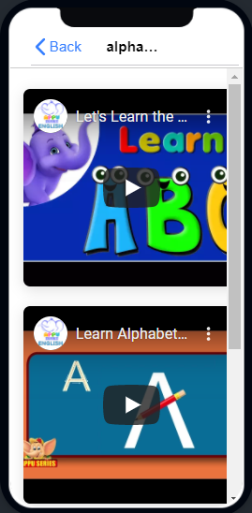UI Screenshots

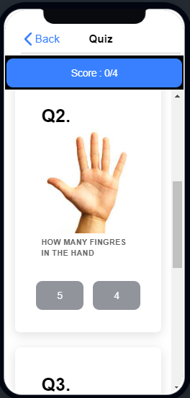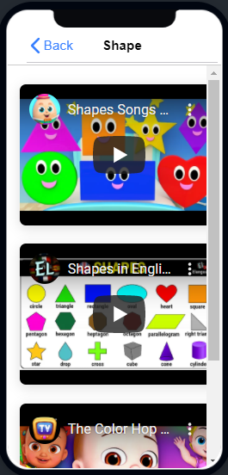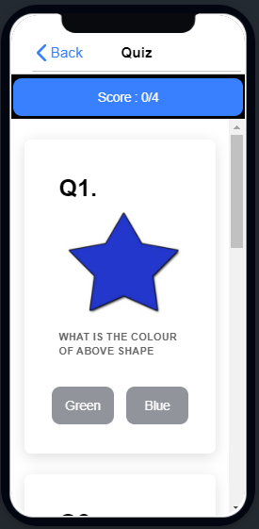

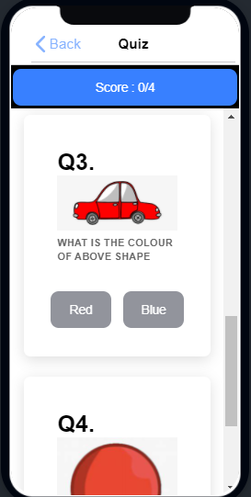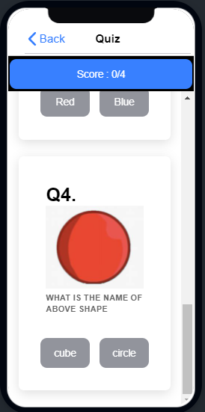

**Questions to be answered:**

1) How to embedd Video into Ionic file?

* <ion-card style="width: 100%; height: 45%;">

<iframe width="100%" height="100%" src="https://www.youtube.com/embed/ea5-SIe5l7M" title="YouTube video player" frameborder="0" allow="accelerometer; autoplay; clipboard-write; encrypted-media; gyroscope; picture-in-picture" allowfullscreen></iframe>

</ion-card>

1. Do you think that having a website and having an app will make an impact on the children while using it?

* Yes, Apps will impact more. Because, its just download one times in our smart phone and use it and don’t go to search engine and type the website name and the use it.

3) What things have you kept in mind while designing the App.

* Deep Market Research. ...
* Consider Where Your App Will Be Used. ...
* Choosing the right platform. ...
* Design & Usability. ...
* Focus on your marketing strategy. ...
* Test your app before it hits the market. ...
* Know your Budget in advance.

4) Code for adding Splash Screen.

export class SplashPage implements OnInit {

constructor(public router:Router) {

setTimeout(()=>{

this.router.navigateByUrl('/home');

}, 4000)

}