**EXP No. 6**

**To create an APP for TPO of our college.**

The document should consist of the following:

1.     Code which are used in the program

**//tab1.page.html**

<ion-header>

<ion-toolbar color="tertiary">

<ion-title>Register</ion-title>

<ion-buttons slot="start">

<ion-menu-button menu="main-menu">

</ion-menu-button>

</ion-buttons>

</ion-toolbar>

</ion-header>

<ion-content>

<ion-item>

<ion-label position="floating"><ion-icon name="person-outline"></ion-icon>&nbsp;&nbsp;Full Name</ion-label>

<ion-input  [(ngModel)]="name"></ion-input>

</ion-item>

<ion-item>

<ion-label position="floating"><ion-icon name="mail-outline"></ion-icon>&nbsp;&nbsp;Email</ion-label>

<ion-input type="email"  [(ngModel)]="email"></ion-input>

</ion-item>

<ion-item>

<ion-label position="floating"><ion-icon name="call-outline"></ion-icon>&nbsp;&nbsp;Contact</ion-label>

<ion-input  type="tel"  [(ngModel)]="phone"></ion-input>

</ion-item>

<ion-item>

<ion-label position="floating"><ion-icon name="stats-chart-outline"></ion-icon>&nbsp;&nbsp;UCID</ion-label>

<ion-input  type="number"  [(ngModel)]="uid"></ion-input>

</ion-item>

<br><br>

<ion-item>

<ion-label><h1><ion-icon name="school-outline"></ion-icon>&nbsp;&nbsp;<b>Graduation</b></h1></ion-label>

</ion-item>

<ion-item>

<ion-label position="floating"> Year of Passing</ion-label>

<ion-datetime displayFormat="YYYY" [(ngModel)]="clgPassing"></ion-datetime>

</ion-item>

<ion-item>

<ion-label position="floating">Name of College</ion-label>

<ion-input [(ngModel)]="clgCollege"></ion-input>

</ion-item>

<ion-item>

<ion-label position="floating">Total Marks</ion-label>

<ion-input type="number" [(ngModel)]="clgMarks"></ion-input>

</ion-item>

<ion-item>

<ion-label position="floating">Marks out-off</ion-label>

<ion-input type="number"  [(ngModel)]="clgTotal" ></ion-input>

</ion-item>

<ion-item>

<ion-input readonly>Percentage : {{(clgMarks/clgTotal)*100}}%</ion-input>

</ion-item><br><br>

<ion-item>

<ion-label><h1><ion-icon name="school-outline"></ion-icon>&nbsp;&nbsp;<b>HSC</b></h1></ion-label>

</ion-item>

<ion-item>

<ion-label position="floating">Year of Passing</ion-label>

<ion-datetime displayFormat="YYYY"  [(ngModel)]="hscPassing"></ion-datetime>

</ion-item>

<ion-item>

<ion-label position="floating">Name of School</ion-label>

<ion-input [(ngModel)]="hscCollege"></ion-input>

</ion-item>

<ion-item>

<ion-label position="floating">Total Marks</ion-label>

<ion-input type="number" [(ngModel)]="hscMarks"></ion-input>

</ion-item>

<ion-item>

<ion-label position="floating">Marks out-off</ion-label>

<ion-input type="number" [(ngModel)]="hscTotal"></ion-input>

</ion-item>

<ion-item>

<ion-input readonly>Percentage : {{(hscMarks/hscTotal)*100}}%</ion-input>

</ion-item><br><br>

<ion-item>

<ion-label><h1><ion-icon name="school-outline"></ion-icon>&nbsp;&nbsp;<b>SSC</b></h1></ion-label>

</ion-item>

<ion-item>

<ion-label position="floating">Year of Passing</ion-label>

<ion-datetime displayFormat="YYYY" [(ngModel)]="sscPassing"></ion-datetime>

</ion-item>

<ion-item>

<ion-label position="floating">Name of School</ion-label>

<ion-input [(ngModel)]="sscCollege"></ion-input>

</ion-item>

<ion-item>

<ion-label position="floating">Total Marks</ion-label>

<ion-input type="number" [(ngModel)]="sscMarks"></ion-input>

</ion-item>

<ion-item>

<ion-label position="floating">Marks out-off</ion-label>

<ion-input type="number"  [(ngModel)]="sscTotal" ></ion-input>

</ion-item>

<ion-item>

<ion-input readonly>Percentage : {{(sscMarks/sscTotal)*100}}%</ion-input>

</ion-item>

<ion-item>

<ion-card class="ion-text-center" *ngIf="!isFileUploading && !isFileUploaded">

<ion-card-header>

<ion-card-title>Upload Resume</ion-card-title>

</ion-card-header>

<ion-card-content>

<ion-button color="primary" size="medium">

<input type="file" (change)="uploadImage($event.target.files)" />

</ion-button>

</ion-card-content>

</ion-card>

<!-- File upload progress bar -->

<div *ngIf="percentageVal | async as percentage">

Progress: {{ percentage | number }}%

<ion-progress-bar value="{{ percentage / 100 }}"></ion-progress-bar>

</div>

<div *ngIf="trackSnapshot | async as snap">

File size: {{ snap.totalBytes | formatFileSize }}

Data transfered: {{ snap.bytesTransferred | formatFileSize }}

<a [href]="downloadURL | async">{{ downloadURL | async }}</a>

</div>

</ion-item>

<ion-button color="dark" expand="block" fill="outline"(click)="submitForm()" >Submit</ion-button>

<!-- <ion-button (click)="open_chooser()">File Chooser</ion-button> -->

<!-- <ion-button (click)="view_pdf()">View PDF</ion-button> -->

</ion-content>

**//tab2.module.ts**

import { IonicModule } from '@ionic/angular';

import { NgModule } from '@angular/core';

import { CommonModule } from '@angular/common';

import { FormsModule } from '@angular/forms';

import { Tab1Page } from './tab1.page';

import { ExploreContainerComponentModule } from '../explore-container/explore-container.module';

import { FormatFileSizePipe } from './format-file-size.pipe';

import { Tab1PageRoutingModule } from './tab1-routing.module';

@NgModule({

  imports: [

    IonicModule,

    CommonModule,

    FormsModule,

    ExploreContainerComponentModule,

    Tab1PageRoutingModule

  ],

  declarations: [Tab1Page,FormatFileSizePipe]

})

export class Tab1PageModule {}

**//tab2.page.html**

<ion-header>

  <ion-toolbar>

    <ion-title>Your Form</ion-title>

  </ion-toolbar>

</ion-header>

<ion-content>

<ion-card>

        <ion-item>

    <!-- <ion-label position="stacked">Full Name</ion-label> -->

    <b>Name :</b>  <ion-input readonly [(ngModel)]="name"></ion-input>

  </ion-item>

  <ion-item>

    <!-- <ion-label position="stacked">Email</ion-label> -->

    <b>Email :</b> <ion-input type="email"  readonly [(ngModel)]="email"></ion-input>

  </ion-item>

  <ion-item>

    <!-- <ion-label position="stacked">Contact</ion-label> -->

    <b>Contact :</b> <ion-input  type="tel" readonly [(ngModel)]="phone"></ion-input>

  </ion-item>

  <ion-item>

    <!-- <ion-label position="stacked">UCID</ion-label> -->

    <b>UCID :</b> <ion-input  type="number" readonly [(ngModel)]="uid"></ion-input>

  </ion-item>

  <br>

  <ion-item>

    <ion-label><h1>Graduation</h1></ion-label>

    </ion-item>

      <ion-item>

        <!-- <ion-label position="stacked">Year of Passing</ion-label> -->

        <b>Year of Passing :</b> <ion-datetime displayFormat="YYYY" readonly [(ngModel)]="clgPassing"></ion-datetime>

      </ion-item>

      <ion-item>

        <!-- <ion-label position="stacked">Name of College</ion-label> -->

        <b>Name of College :</b> <ion-input [(ngModel)]="clgCollege" readonly></ion-input>

      </ion-item>

      <ion-item>

        <ion-input readonly><b>Percentage : </b>{{clgPercentage}}%</ion-input>

      </ion-item>

  <ion-item>

  <ion-label><h1>HSC</h1></ion-label>

  </ion-item>

    <ion-item>

      <!-- <ion-label position="stacked">Year of Passing</ion-label> -->

      <b>Year of Passing :</b>  <ion-datetime displayFormat="YYYY" readonly [(ngModel)]="hscPassing"></ion-datetime>

    </ion-item>

    <ion-item>

      <!-- <ion-label position="stacked">Name of College</ion-label> -->

      <b>Name of School :</b>  <ion-input [(ngModel)]="hscCollege" readonly></ion-input>

    </ion-item>

    <ion-item>

      <ion-input readonly><b>Percentage : </b> {{hscPercentage}}%</ion-input>

    </ion-item>

    <ion-item>

      <ion-label><h1>SSC</h1></ion-label>

      </ion-item>

        <ion-item>

          <!-- <ion-label position="stacked">Year of Passing</ion-label> -->

          <b>Year of Passing :</b><ion-datetime displayFormat="YYYY" readonly [(ngModel)]="sscPassing"></ion-datetime>

        </ion-item>

        <ion-item>

          <!-- <ion-label position="stacked">Name of School</ion-label> -->

          <b>Name of School :</b>  <ion-input readonly [(ngModel)]="sscCollege"></ion-input>

        </ion-item>

        <ion-item>

          <ion-input readonly><b>Percentage : </b>{{sscPercentage}}%</ion-input>

        </ion-item>

  <ion-list>

    <ion-item *ngFor="let f of cloudFiles">

    <ion-button href="{{f.url}}">Check Resume</ion-button>

      <ion-label class="ion-text-wrap">

        {{ f.name }}

        <p>{{ f.full }}</p>

      </ion-label>

    </ion-item>

  </ion-list>

</ion-card>

</ion-content>

**//tab2.module.ts**

import { IonicModule } from '@ionic/angular';

import { RouterModule } from '@angular/router';

import { NgModule } from '@angular/core';

import { CommonModule } from '@angular/common';

import { FormsModule } from '@angular/forms';

import { Tab2Page } from './tab2.page';

import { ExploreContainerComponentModule } from '../explore-container/explore-container.module';

import { Tab2PageRoutingModule } from './tab2-routing.module';

@NgModule({

  imports: [

    IonicModule,

    CommonModule,

    FormsModule,

    ExploreContainerComponentModule,

    Tab2PageRoutingModule

  ],

  declarations: [Tab2Page]

})

export class Tab2PageModule {}

**//tab3.page.html**

<ion-header [translucent]="true">

  <ion-toolbar>

    <ion-title>

      Upcoming Companies on Campus

    </ion-title>

  </ion-toolbar>

</ion-header>

<ion-content [fullscreen]="true">

  <div id="faq">

    <ul>

      <li>

        <input type="checkbox" checked>

        <i></i>

        <h2>Nomura</h2>

        <p><b>Date</b> - 25/9/2021<br>

          <b>Internship and Placement</b><br>

          <b>Job Role</b> - Analyst<br>

           <b>Time</b> -<br> 08 - 09 am -> Aptitude round<br>

           10 am -> Technical Interview<br>

           1 pm -> HR round<br>

           </p>

      </li>

      <li>

       <input type="checkbox" checked>

        <i></i>

        <h2>Deloitte</h2>

        <p><b>Date</b> - 25/9/2021<br>

          <b>Internship and Placement</b><br>

          <b>Job Role</b> - Analyst<br>

           <b>Time</b> -<br> 08 - 09 am -> Aptitude round<br>

           10 am -> Technical Interview<br>

           1 pm -> HR round<br>

           </p>

     </li>

     <li>

      <input type="checkbox" checked>

      <i></i>

      <h2>Ugam</h2>

      <p><b>Date</b> - 25/9/2021<br>

        <b>Internship and Placement</b><br>

        <b>Job Role</b> - Analyst<br>

         <b>Time</b> -<br> 08 - 09 am -> Aptitude round<br>

         10 am -> Technical Interview<br>

         1 pm -> HR round<br>

         </p>

     </li>

    </ul>

  </div>

  <ion-button color="success" expand="block" fill="outline"(click)="apply()" >Apply Now</ion-button>

</ion-content>

**//tab3.module.ts**

import { IonicModule } from '@ionic/angular';

import { RouterModule } from '@angular/router';

import { NgModule } from '@angular/core';

import { CommonModule } from '@angular/common';

import { FormsModule } from '@angular/forms';

import { Tab3Page } from './tab3.page';

import { ExploreContainerComponentModule } from '../explore-container/explore-container.module';

import { Tab3PageRoutingModule } from './tab3-routing.module';

@NgModule({

  imports: [

    IonicModule,

    CommonModule,

    FormsModule,

    ExploreContainerComponentModule,

    RouterModule.forChild([{ path: '', component: Tab3Page }]),

    Tab3PageRoutingModule,

  ],

  declarations: [Tab3Page]

})

export class Tab3PageModule {}

2.     Output of the experiment

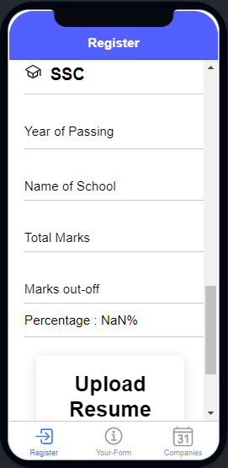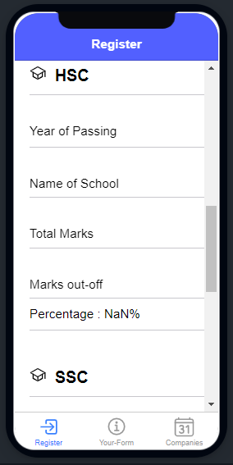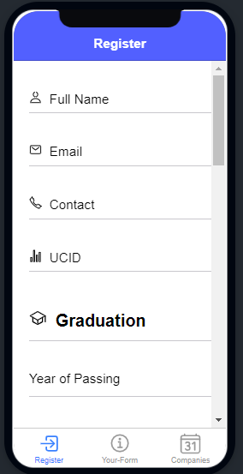

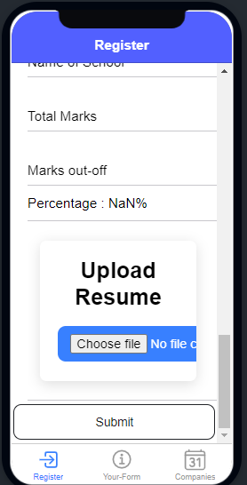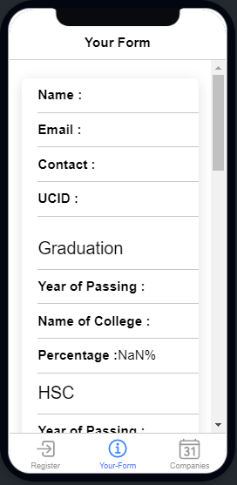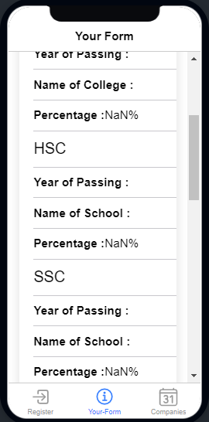

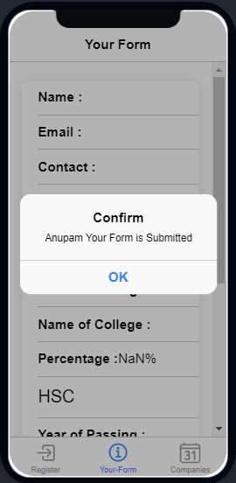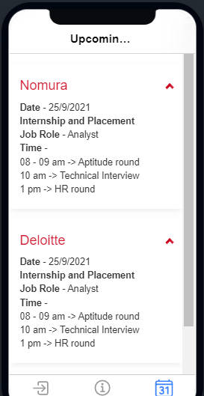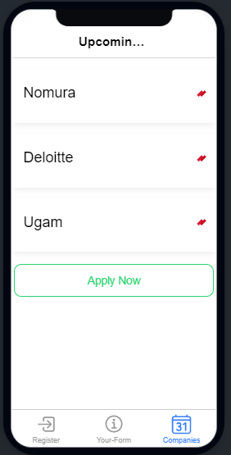

**Answer to the following questions:**

**a)   What is the use of File transfer plugin, File chooser, Document Viewer, File Opener and Document Viewer?**

* This plugin offers a slim API to view PDF files which are either stored in the apps assets folder (/www/*) or in any other file system directory available via the cordova file plugin.
* File Transfer plugin: This plugin allows you to upload and download files.
* File Choser: File choosers provide a GUI for navigating the file system, and then either choosing a file or directory from a list, or entering the name of a file or directory. To display a file chooser
* Document Viewer: A file viewer is an application software that presents the data stored in a computer file

**b)     What parameters do we need to pass to upload a file?**

-> To upload a file we have to give the upload file storage path.

**c)     What parameters do we need to pass to download a file?**

* The Cordova File Transfer plug in allows you to upload and download docs files. This plugin is supported on iOS, Android, Windows, and more platforms

**d)     What is API endpoint in file upload?**

* For APIs, an endpoint can include a URL of a server or service. Each endpoint is the location from which APIs can access the resources they need to carry out their function

**e)     What is the difference in URL and URI?**

* URL stands for Uniform Resource Locator. URI stands for Uniform Resource Identifier. URL is a subset of URI that specifies where a resource is exists and the mechanism for retrieving it. A URI is a superset of URL that identifies a resource either by URL or URN