**Exp No.-8**

**Develop Camera and Calendar API integrated in one app**

1) Document file consisting of the following:

    a) HTML file and another file if used

* **Camera**

**//tab2.page.html**

<ion-header>

<ion-toolbar>

<ion-title>

Photo Gallery

</ion-title>

</ion-toolbar>

</ion-header>

<ion-content>

<ion-header collapse="condense">

<ion-toolbar>

<ion-title size="large">Photo Gallery</ion-title>

</ion-toolbar>

</ion-header>

<ion-grid>

<ion-row>

<ion-col size="6" *ngFor="let photo of photoService.photos; index as position">

<ion-img [src]="photo.webviewPath" (click)="showActionSheet(photo, position)"></ion-img>

</ion-col>

</ion-row>

</ion-grid>

<ion-fab vertical="bottom" horizontal="center" slot="fixed">

<ion-fab-button (click)="photoService.addNewToGallery()">

<ion-icon name="camera"></ion-icon>

</ion-fab-button>

</ion-fab>

</ion-content>

**//tab2.page.scss**

ion-content ion-toolbar {

--background: translucent;

}

**//tab2.module.ts**

import { IonicModule } from '@ionic/angular';

import { RouterModule } from '@angular/router';

import { NgModule } from '@angular/core';

import { CommonModule } from '@angular/common';

import { FormsModule } from '@angular/forms';

import { Tab2Page } from './tab2.page';

import { ExploreContainerComponentModule } from '../explore-container/explore-container.module';

@NgModule({

imports: [

IonicModule,

CommonModule,

FormsModule,

ExploreContainerComponentModule,

RouterModule.forChild([{ path: '', component: Tab2Page }])

],

declarations: [Tab2Page]

})

export class Tab2PageModule {}

* **Calendar**
* **Install calendar Plugin**

npm install --save ion2-calendar@next moment

**//tab3.page.html**

<ion-header>

<ion-toolbar>

<ion-title>

Calendar

</ion-title>

</ion-toolbar>

</ion-header>

<ion-content>

<div class="ion-padding">

<ion-calendar [(ngModel)]="dateRange"

[options]="optionsRange"

[type]="type"

[format]="'YYYY-MM-DD'">

</ion-calendar>

</div>

</ion-content>

**//tab3.module.ts**

import { IonicModule } from '@ionic/angular';

import { RouterModule } from '@angular/router';

import { NgModule } from '@angular/core';

import { CommonModule } from '@angular/common';

import { FormsModule } from '@angular/forms';

import { Tab3Page } from './tab3.page';

import { ExploreContainerComponentModule } from '../explore-container/explore-container.module';

// Calendar UI Module

import { CalendarModule } from 'ion2-calendar';

@NgModule({

imports: [

IonicModule,

CommonModule,

FormsModule,

ExploreContainerComponentModule,

RouterModule.forChild([{ path: '', component: Tab3Page }

]),

CalendarModule

],

declarations: [Tab3Page]

})

export class Tab3PageModule {}

**//tab3.page.ts**

import { Component } from '@angular/core';

import { CalendarComponentOptions } from 'ion2-calendar'

@Component({

selector: 'app-tab3',

templateUrl: 'tab3.page.html',

styleUrls: ['tab3.page.scss']

})

export class Tab3Page {

dateRange: { from: string; to: string; };

type: 'string';

optionsRange: CalendarComponentOptions = {

pickMode: 'range'

};

constructor() { }

}

     b) Screenshot of the UI made.

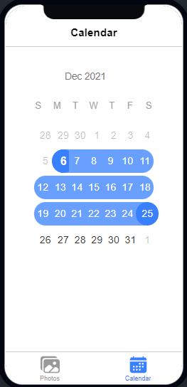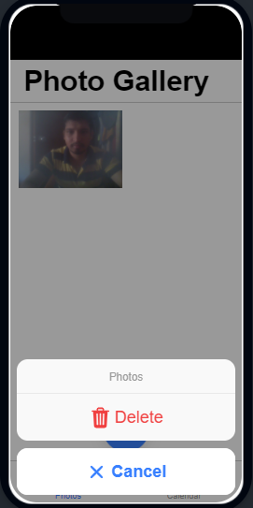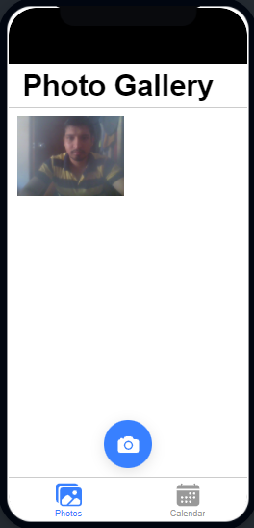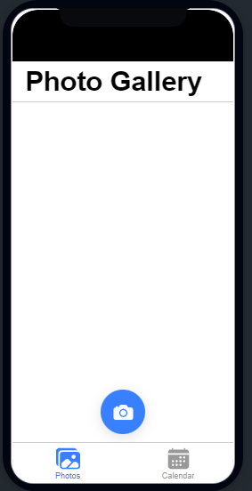

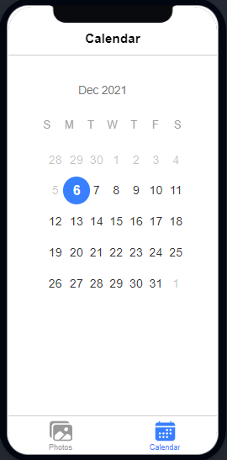

2) Document consisting of the following questions and answers:  
  
Q.1 **Which camera Library do we import for camera API?**

* import { ExploreContainerComponentModule } from '../explore-container/explore-container.module';

Q.**2 What is the use of camera.getPicture()?**

* getPicture opens the device's default camera application so that the user can take a picture (if [Camera](camera. **html**).

Q.3 What parameter do we set when we use CameraOptions?

* Text, role, icon

Q.4 What is base64 Image? What is the use of it?

* Base64 is most commonly used as a MIME (Multipurpose Internet Mail Extensions) transfer encoding for email. Base64 images are primarily used to embed image data within other formats like HTML, CSS, or JSON.

Q.5 In app.module.ts where do we initialize the camera (in which ngmodel) ?

* import { NgModule } from '@angular/core';

Q.6 Which service do we require for saving images in the gallery?

* Photoservice

Q.7 What is the use of importing an ionic storage module?

* **import** { IonicStorageModule } from '@ionic/storage';

Storage is an easy way to store key/value pairs and JSON objects. Storage uses a variety of storage engines underneath, picking the best one available depending on the platform.

Q.8 Which Calendar Library do we import for working with Calendar in an APP?

import { CalendarModule } from 'ion2-calendar';