**SHRI GOVINDRAM SEKSARIYA INSTITUTE OF TECHNOLOGY AND SCIENCE**



**Computer Science and Engineering**

**2019-20**

**Project Report On**

**Patients survey HCAHPS states**

**(Survey Visualization on Western US)**

**Submitted By: Submitted To:**

Swapnil Chouhan Mr. Swarnim Soni 0801CS161093

Anupama Narware

0801EI161011

**Patients survey HCAHPS states**

**(Survey Visualization on Western US)**

**Introduction:**

* **HCAHPS :** For the past decade, hospitals and other providers have surveyed patients to capture their health care experiences in a national and standardized fashion. The Hospital Consumer Assessment of Healthcare Providers and Systems (HCAHPS) is a patient experience survey developed from the partnering of the Centers for Medicare and Medicaid Services (CMS), the Agency for Healthcare Research and Quality (AHRQ), and the CAHPS Consortium. It is managed by CMS with three goals:

1. To provide patients with useful information to make better informed decisions on hospital choice.
2. To give hospitals incentives to improve the quality of their care through public reporting; and
3. To enhance public accountability by increasing transparency of the quality of hospital care.

Prior to the existence of the HCAHPS survey, patient satisfaction surveys were developed and deployed by various survey vendors for hospitals. There was no standardized and scientifically rigorous evaluation of a national, representative survey that could be used for reporting and comparisons. In 2008, the HCAHPS survey filled a much-needed gap that allows CMS to provide a mechanism to fairly compare hospitals. However, more than 10 years have passed since the HCAHPS survey was initially developed and deployed, and much has changed in technological advancements and the way care is delivered. The HCAHPS survey contains 32 questions: 25 questions focus on patient experience with the care received during their hospitalization, and seven questions in the “About You” section, which elicit patient-level information for use in patient-mix adjustment of HCAHPS survey scores.

* **An Introduction to patients survey :** Patient care experience surveys evaluate the degree to which care is patient-centered. This article reviews the literature on the association between patient experiences and other measures of health care quality. Research indicates that better patient care experiences are associated with higher levels of adherence to recommended prevention and treatment processes, better clinical outcomes, better patient safety within hospitals, and less health care utilization.

**Problem Statement**

A list of the state averages for the HCAHPS survey responses. HCAHPS is a national, standardized survey of hospital patients about their experiences during a recent inpatient hospital stay. The model provides the information from the patients survey held by HCAHPS in **Western United States** , through visualizing the rating of the hospitals of the particular state , recommendation of the hospitals and patients review towards the doctors of the state.

**Previous work done**

Previously the survey was done on the whole of the United States covering all the states and on a particular hospital of a particular state or on a particular states. Visualizations were also given on particular type of the hospitals for example cancer hospitals, dentals etc, review on the quantity and quality of doctors and nurses of the country, which ultimately gives the overall rating to the nurses and doctors of the country or the particulars.

**Proposed Solution**

The model visualizes the HCAHPS survey of  **Western United States** with  dataset of size(12*17)=204. The visualizations will be based upon the questionnaire under the categories of always, sometimes or never, usually. Basically visualizing the way of communication, treatment of the doctors towards their patient, how well they listen to the patient, explain things in a way patient could understand.

Communicate the purpose of the medication, its after-effects, proper dosage of medication and how many patients understood the purpose of medication.

**Data Analysis**

**Data Preprocessing**

**Removing columns HCAHPS Measure ID, Footnote, Measure Start Date, Measure End Date**

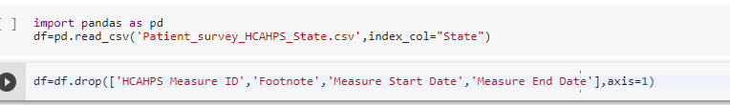

**Dropping Rows of States other than States of Western US**

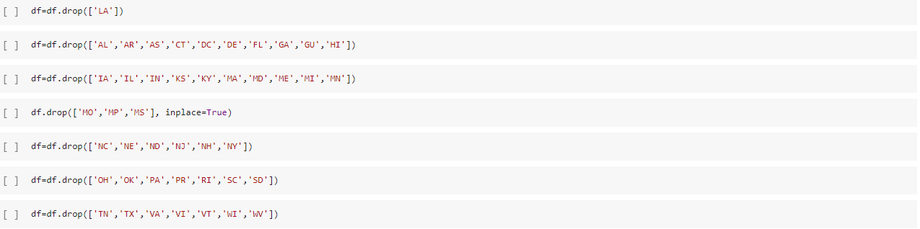

**Renaming all Columns And keeping Useful Rows**





**Preprocessed Data**

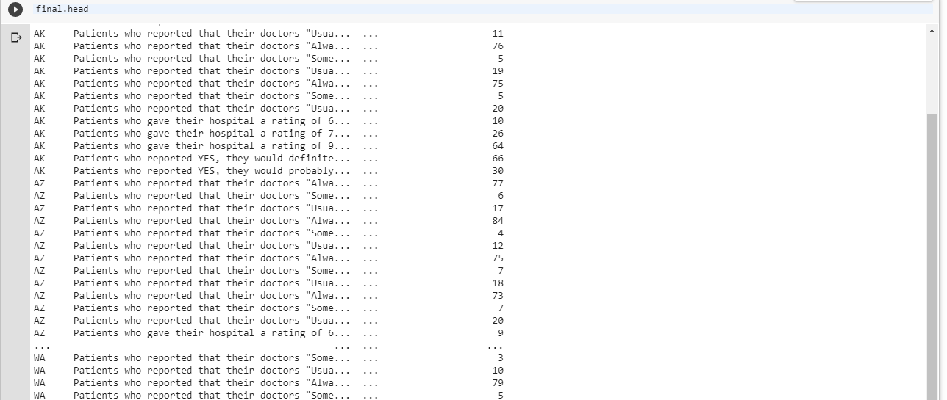

**Sample Input/Output**

1. **Ratings of hospitals of states**

Sample Input:

|  |  |  |
| --- | --- | --- |
| AK | Patients who gave a rating of "6" or lower (low) | 10 |
| AK | Patients who gave a rating of "7" or "8" (medium) | 26 |
| AK | Patients who gave a rating of "9" or "10" (high) | 64 |
| AZ | Patients who gave a rating of "6" or lower (low) | 9 |
| AZ | Patients who gave a rating of "7" or "8" (medium) | 21 |
| AZ | Patients who gave a rating of "9" or "10" (high) | 70 |
| CA | Patients who gave a rating of "6" or lower (low) | 9 |
| CA | Patients who gave a rating of "7" or "8" (medium) | 22 |
| CA | Patients who gave a rating of "9" or "10" (high) | 69 |
| CO | Patients who gave a rating of "6" or lower (low) | 7 |
| CO | Patients who gave a rating of "7" or "8" (medium) | 17 |
| CO | Patients who gave a rating of "9" or "10" (high) | 76 |

Sample Output:

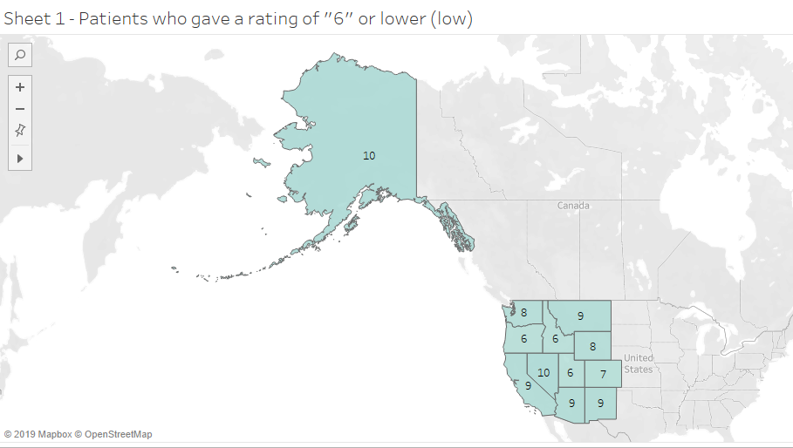

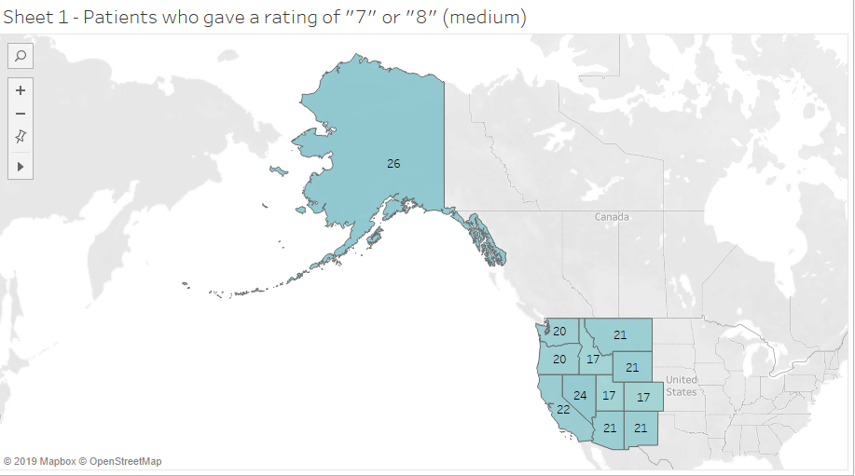

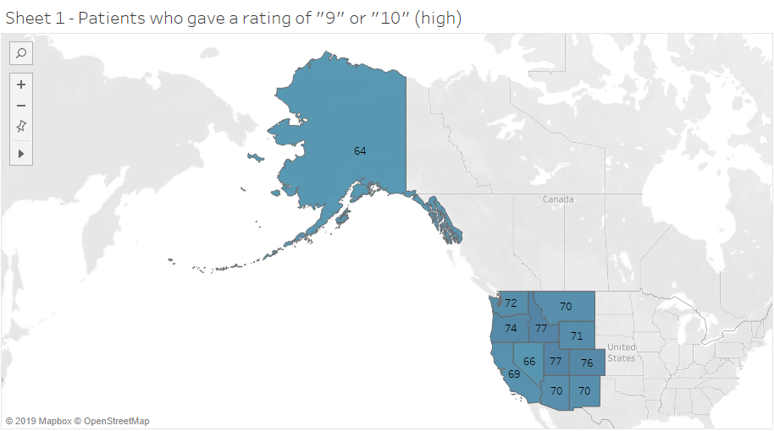

1. **Recommendation of hospitals of the state by patients**

Sample Input:

|  |  |  |
| --- | --- | --- |
| AK | patients would definitely recommend the hospital | 66 |
| AK | patients would probably recommend the hospital | 30 |
| AZ | patients would definitely recommend the hospital | 70 |
| AZ | patients would probably recommend the hospital | 24 |
| CA | patients would definitely recommend the hospital | 70 |
| CA | patients would probably recommend the hospital | 23 |
| CO | patients would definitely recommend the hospital | 75 |
| CO | patients would probably recommend the hospital | 20 |
|  |  |  |

Sample Output:

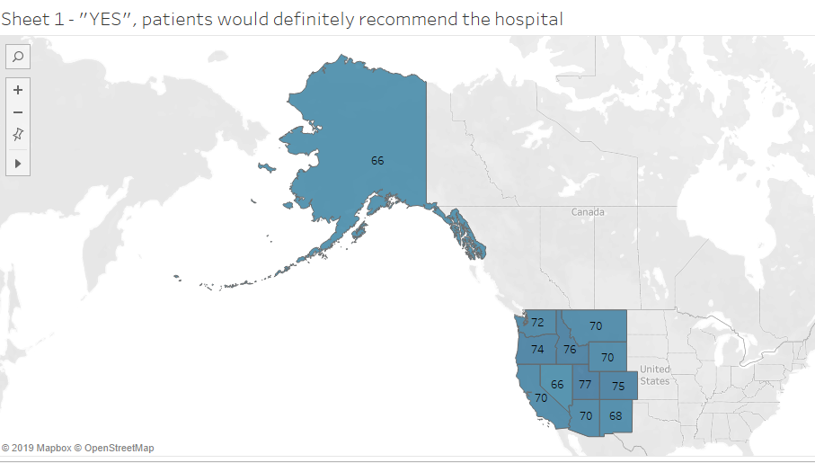

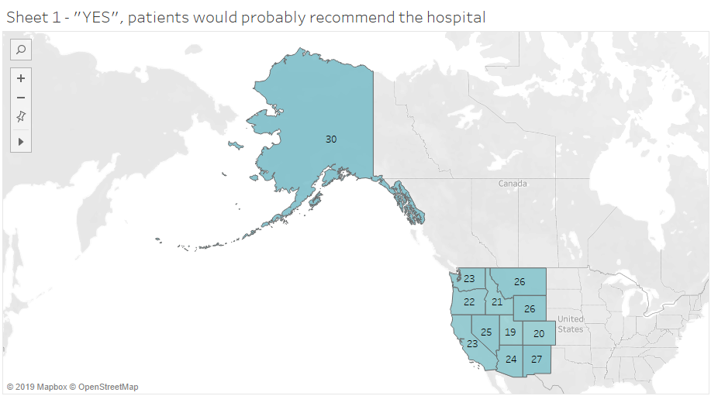

**References**

**URL:** <https://www.cms.gov/Medicare/Quality-Initiatives-Patient-Assessment-Instruments/HospitalQualityInits/HospitalHCAHPS.html>

**URL:** <https://catalog.data.gov/dataset/patient-survey-hcahps-state-0a47a>

**URL:** <https://www.geeksforgeeks.org/python-data-analysis-using-pandas/>