

**Anupama Avusula**

**000786453**

**GENERATIVE IMAGES**

Generating images from text using face hugging libraries, like DALL-E, is a fantastic tool. These libraries come with pre-trained models that can transform textual descriptions into vibrant visuals. Selecting the appropriate model, such as DALL-E, is crucial as it determines the accuracy and attractiveness of the generated images. Once a model is chosen, you articulate the desired image in words, which the model breaks down into smaller sections called tokens for better comprehension. Then, it proceeds to generate the image based on your description. Occasionally, slight adjustments may be necessary to enhance the image's quality. Finally, tools like 'matplotlib' or 'PIL' can be employed to view and share the image. The process of creating images using Hugging Face libraries involves a cyclical flow of describing, generating, refining, and examining the image, seamlessly integrating computer vision and language technologies.

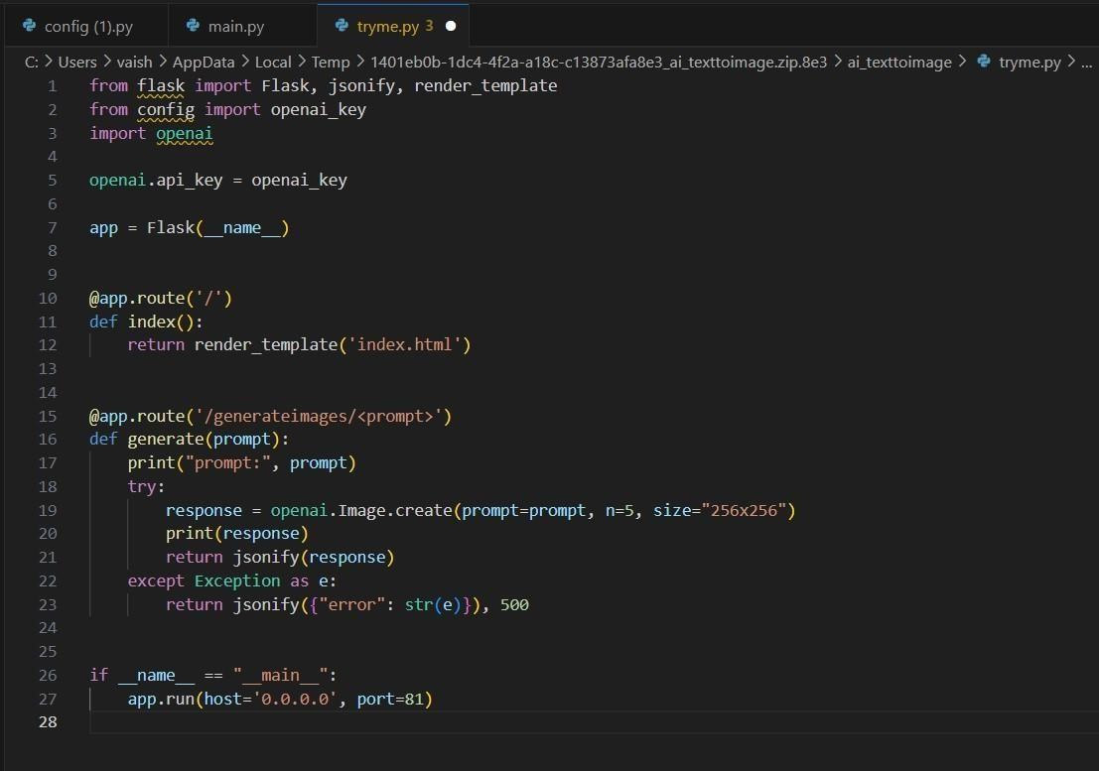

A groundbreaking application ingeniously combines OpenAI's state-of-the-art artificial intelligence with imagination to effortlessly convert written descriptions into vivid visuals within a Node.js framework. This application utilizes Express for efficient server-side operations and Axios for interfacing with OpenAI's API. It transforms user-supplied text into imaginative images, facilitated by Postman for user interaction with the API, enhancing accessibility and intuitiveness. This innovative integration not only showcases AI's proficiency in interpreting and rendering human language but also furnishes a user-friendly platform for individuals to explore their creative boundaries by bridging verbal concepts with visual expressions.

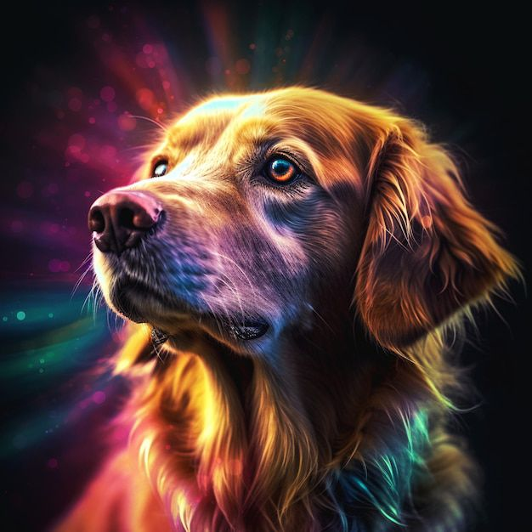

Hugging Face primarily focuses on developing libraries and models for natural language processing (NLP), but they might have expanded into other areas or partnered with external entities to develop text-to-image capabilities. Although Hugging Face's techniques don't directly integrate OpenAI's DALL-E image generation model, they can complement its usage. Tasks involving text-toimage conversion can be accomplished using pre-trained models like DALL-E, which can generate images based on textual descriptions.

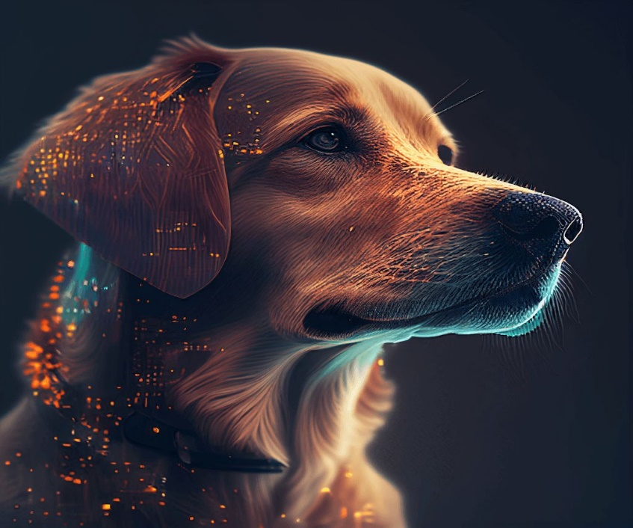

Hugging Face offers an array of NLP libraries, with Transformers being one of the prominent ones. Transformers serves as a comprehensive toolkit for various NLP tasks, providing access to pre-trained models like BERT, GPT-2, GPT-3, and T5, all of which have undergone training on extensive textual datasets. While models like GPT-2 and GPT-3 weren't specifically designed for text-to-image generation, they can still be effectively utilized for this purpose. By integrating Transformers with image generation libraries or models like DALL-E, comprehensive text-to-image systems can be constructed, leveraging the strengths of both image synthesis and natural language comprehension for innovative applications.

Hugging Face's Tokenizers module serves as a valuable asset in preparing textual data for NLP tasks. It simplifies the tokenization process by dividing text into smaller units and converting them into numerical representations. With support for various tokenization methods like Byte-Pair Encoding (BPE), WordPiece, and SentencePiece, Tokenizers offer flexibility in text preprocessing. Accurate tokenization is crucial in text-to-image tasks as it ensures that textual descriptions or prompts are appropriately encoded before being inputted into image generation models, enabling downstream components to utilize the content more effectively.

Additionally, Hugging Face's dataset collection provides access to a diverse range of datasets commonly used in NLP research and applications. These datasets cover a wide array of tasks, languages, and topics, facilitating the development and evaluation of NLP models. Managing datasets is simplified through tools for loading, preprocessing, and partitioning them into training, validation, and testing sets. Compatible with various data formats such as JSON, CSV, and Parquet, datasets play a vital role in text-to-image tasks by providing written descriptions paired with corresponding images for training and testing generation models. This ensures the creation of reliable systems capable of generating images from textual input.

const express = require('express'); const dotenv = require('dotenv'); const path = require('path'); // You need to require the 'path' module dotenv.config();

// Load environment variables from .env file const port = process.env.PORT || 5000; // Corrected typo in 'process.env.PORT'

const app = express();

app.use(express.json()); app.use(express.urlencoded({ extended: false }));

app.use(express.static(path.join(__dirname, 'public')));

app.use('/openai', require('./routes/openaiRoutes'));

app.listen(port, () => console.log(`Server started on port ${port}`));

There are a few corrections and improvements needed in your code snippet. Here's the corrected version:

```javascript const express = require('express'); const dotenv = require('dotenv'); const path = require('path'); // You need to require the 'path' module dotenv.config(); // Load environment variables from

.env file

const port = process.env.PORT || 5000; // Corrected typo in 'process.env.PORT'

const app = express();

app.use(express.json()); app.use(express.urlencoded({ extended: false })); app.use(express.static(path.join(__dirname, 'public')));

app.use('/openai', require('./routes/openaiRoutes'));

app.listen(port, () => console.log(`Server started on port ${port}`));

isd`

.spinner { position: fixed; zindex: 999; height: 2em; width: 2em; margin: auto; top:

0; left: 0; bottom: 0; right: 0; display: none;

}

.show { display: block;

}

/* Transparent Overlay */ .spinner:before { content:

''; display: block; position: fixed; top:

0; left: 0;

width: 100%; height: 100%;

background: radial-gradient(rgba(20, 20, 20, 0.8), rgba(0, 0, 0, 0.8)); background: -webkit-radial-gradient(rgba(20, 20, 20, 0.8), rgba(0, 0, 0, 0.8)); }

/* Hides these rules from IE9 and below */ .spinner:not(:required) { font: 0/0 a; color: transparent; textshadow: none; background-color: transparent; border: 0;

}

.spinner:not(:required):after { content: ''; display: block; font-size: 10px; width: 1em; height: 1em; margin-top: -0.5em; animation: spinner 150ms infinite linear; borderradius: 0.5em; box-shadow: rgba(255, 255, 255, 0.75)

1.5em 0 0 0, rgba(168, 69, 69, 0.75)

1.1em 1.1em 0 0, rgba(49, 4, 4, 0.75) 0

1.5em 0 0, rgba(255, 255, 255, 0.75) -1.1em

1.1em 0 0, rgba(255, 255, 255, 0.75) -1.5em

0 0 0, rgba(255, 255, 255, 0.75) -1.1em - 1.1em 0 0, rgba(255, 255, 255, 0.75) 0 1.5em

0 0, rgba(255, 255, 255, 0.75) 1.1em -

1.1em 0 0;

}

/* Animation */

@keyframes spinner {

0% { transform: rotate(0deg); }

100% { transform: rotate(360deg); }

}

.spinner { position: fixed; top: 50%; left: 50%; transform: translate(-50%, -50%); border: 4px solid rgba(0, 0, 0, 0.1); border-left-color: #333; /* Change color as needed */ border-radius: 50%; width: 50px; height: 50px; animation: spin 1s linear infinite; zindex: 9999;

}

@keyframes spin {

0% { transform: rotate(0deg); }

100% { transform: rotate(360deg); }

}

.overlay { position: fixed; top: 0; left: 0;

width: 100%; height: 100%;

background: rgba(0, 0, 0, 0.5); /* Semi-transparent black overlay */ z- index: 999;

}

@import

url('https://fonts.googleapis.com/css2?family=Roboto:wght@300;400;700&display=s

wap');

* { box-sizing: borderbox;

}

body {

font-family: 'Roboto', sans-serif; fontsize: 16px; line-height: 1.6; color: #444; background-color:

#f9f9f9; margin: 0;

padding: 0;

}

.navbar {

background-color: #333;

color: #fff;

padding: 1rem;

}

.navbar ul { liststyle: none; display: flex;

}

.navbar ul li { marginleft:

1rem;

}

.navbar a { color: #fff; text-decoration: none;

}

.navbar a:hover { color: #f9b64d;

}

.showcase { backgroundcolor: #f9b64d; padding: 4rem 2rem; text-

align: center; }

.showcase h1 { fontsize:

2.5rem; marginbottom:

1.5rem;

}

.showcase form input, .showcase form select { font-size: 1rem; padding: 1rem; border: 1px solid

#ccc; borderradius: 5px; marginbottom: 1rem;

}

.showcase form button { font-size: 1rem; padding: 1rem 2rem; border: none; borderradius: 5px; background-color: #333; color: #fff; cursor:

pointer; }

.showcase form button:hover { backgroundcolor:

#444;

}

.image { margintop:

2rem;

}

img { display: block; max-width: 100%; height: auto;

}

.msg { font-size: 1rem; text-align: center;

margintop: 1rem;

}

In the initial phase of this module, the focus was on setting up a local environment to establish connectivity with OpenAI's image generation server. This setup enabled users to request and obtain images. Given my limited familiarity with JavaScript, I heavily relied on tutorials to effectively replicate the provided code. However, when attempting to generate extremely small images, such as those with dimensions of 32x32 pixels, it became evident that OpenAI did not support images of this size. I have included my code and some of the images I managed to create.

Moving on to the second segment of the curriculum, I designed a text-to-image generation tool using Hugging Face, specifically leveraging Stable-Diffusion. While the coding aspect was relatively straightforward, establishing an environment capable of executing the code demanded significant time and effort. Nonetheless, I found this program particularly captivating as it allowed us to apply and expand upon our existing knowledge in a practical context.

Honor code: "I affirm that I have not provided or received unauthorized assistance in completing this assignment, nor have I claimed someone else's work as my own."