1.TOTAL REVENUE
SELECT SUM(total_price) AS Total_revenue FROM pizza_sales
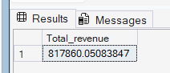
2.AVERAGE ORDER VALUE
SELECT SUM(total_price)/COUNT(DISTINCT order_id) AS Avg_order_value FROM pizza_sales
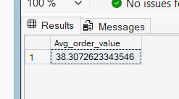
3.TOTAL PIZZAS SOLD
SELECT SUM(quantity) AS Total_pizza_sold FROM pizza_sales
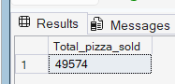
4. TOTAL ORDERS
SELECT COUNT(DISTINCT order_id) AS Total_orders FROM pizza_sales
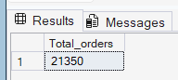
4. AVERAGE PIZZAS PER ORDER
SELECT CAST(CAST(SUM(quantity) AS DECIMAL(10,2))/CAST(COUNT(DISTINCT order_id) AS DECIMAL(10,2)) AS DECIMAL(10,2)) AS Avg_pizza_per_order FROM pizza_sales
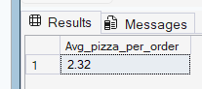

FOR CHARTS
1.DAILY TREND FOR TOTAL ORDERS
SELECT DATENAME(DW,order_date) as order_day,count(distinct order_id) AS Total_orders
from pizza_sales
group by DATENAME(DW,order_date)
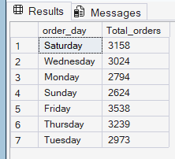
2.MONTHLY TREND FOR TOTAL ORERS
SELECT DATENAME(MONTH,order_date) as order_month,count(distinct order_id) AS Total_orders
from pizza_sales
group by DATENAME(MONTH,order_date)
ORDER BY Total_orders desc
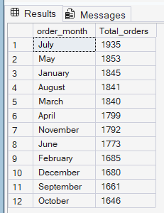
3.PERCENTAGE OF SALES BY PIZZA CATEGORY
SELECT pizza_category,SUM(total_price) AS Total_sales, SUM(total_price)*100/(SELECT SUM(total_price) FROM pizza_sales) AS PCT
FROM pizza_sales
GROUP BY pizza_category
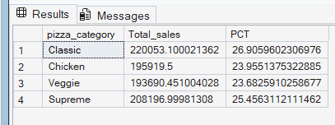

4.PERCENTAGE OF SALES BY PIZZA SIZE
SELECT pizza_size,CAST(SUM(total_price) AS DECIMAL(10,2)) AS Total_sales, CAST(SUM(total_price)*100/(SELECT SUM(total_price) FROM pizza_sales) AS DECIMAL(10,2)) AS PCT
FROM pizza_sales
GROUP BY pizza_size
ORDER BY PCT DESC
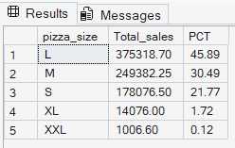
5.TOTAL PIZZA SOLD BY PIZZA CATEGORY
SELECT pizza_category,SUM(quantity) AS Quantity_sold
FROM pizza_sales
GROUP BY pizza_category
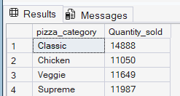
6.TOP 5 BEST SELLERS WITH RESPECT TO SALES
SELECT TOP 5 pizza_name,SUM(total_price) AS Total_revenue
FROM pizza_sales
GROUP BY pizza_name
ORDER BY Total_revenue DESC
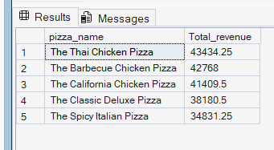
7.BOTTOM 5 BEST SELLERS WITH RESPECT TO SALES
SELECT TOP 5 pizza_name,SUM(total_price) AS Total_revenue
FROM pizza_sales
GROUP BY pizza_name
ORDER BY Total_revenue ASC
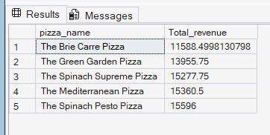
8.TOP 5 BEST SELLERS WITH RESPECT TO QUANTITY
SELECT TOP 5 pizza_name,SUM(quantity) AS Total_quantity
FROM pizza_sales
GROUP BY pizza_name
ORDER BY Total_quantity DESC
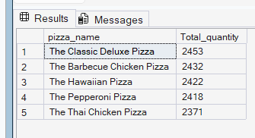
9.BOTTOM 5 BEST SELLERS WITH RESPECT TO QUANTITY
SELECT TOP 5 pizza_name,SUM(quantity) AS Total_quantity
FROM pizza_sales
GROUP BY pizza_name
ORDER BY Total_quantity
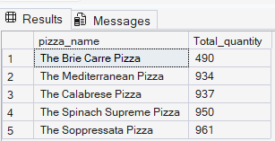
10. TOP 5 BEST SELLERS WITH RESPECT TO ORDERS
SELECT TOP 5 pizza_name,COUNT(DISTINCT order_id) AS Total_orders
FROM pizza_sales
GROUP BY pizza_name
ORDER BY Total_orders DESC
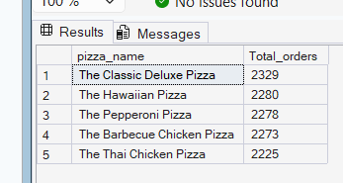
11. BOTTOM 5 BEST SELLERS WITH RESPECT TO TOTAL ORDERS
SELECT TOP 5 pizza_name,COUNT(DISTINCT order_id) AS Total_orders
FROM pizza_sales
GROUP BY pizza_name
ORDER BY Total_orders
