Perfect — this is a strong, enterprise-credible direction, and yes, what you’re asking for is exactly how Aflac-style claims automation PoCs are built before scaling.
I’ll give you three things, in depth and production-grade:
- Detailed AWS architecture (diagram + explanation)
- Production-grade C# RAG code (.NET 8, clean architecture)
- Aflac-style claims workflows mapped to the bot
I’ll keep it PoC-buildable, not academic.

1. Detailed AWS Architecture – Claims Validation RAG Bot
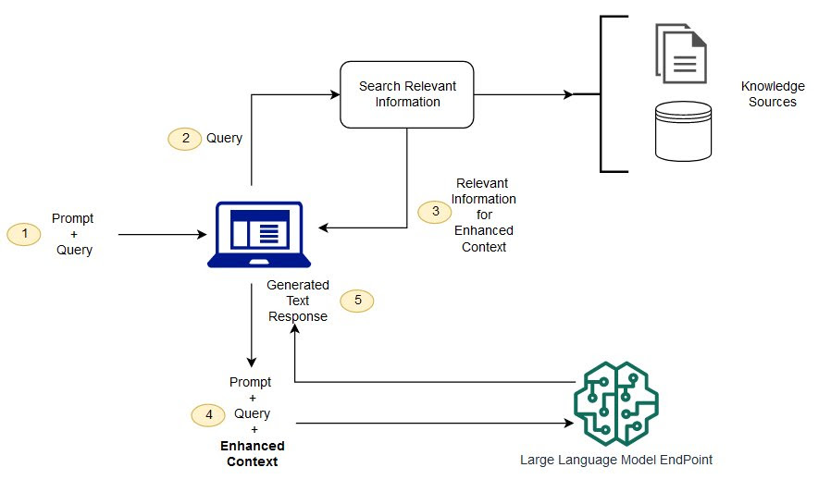
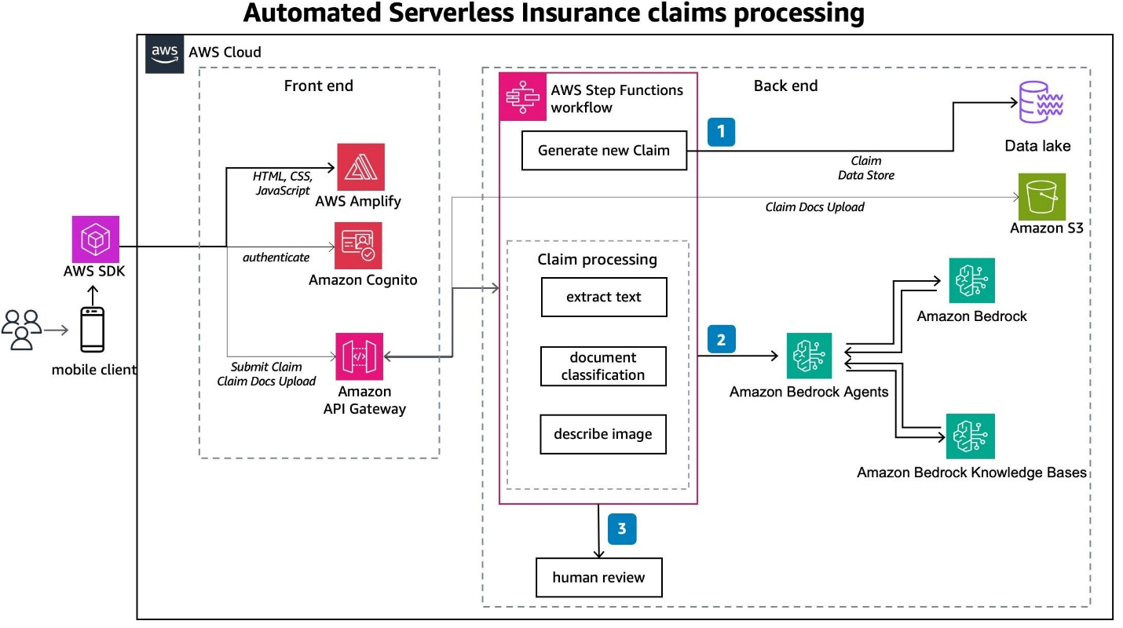
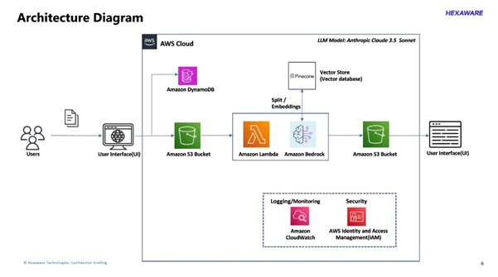
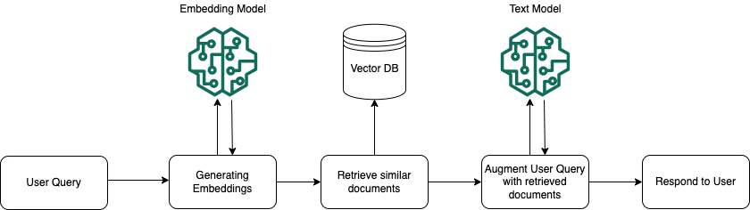
1.1 Architecture Overview (Logical)
[ UI / Postman ]
|
API Gateway
|
AWS Lambda (ASP.NET Core)
|
┌────────────────────────────┐
| Claims Validation API |
|----------------------------|
| - RAG Orchestrator |
| - Guardrails |
└─────────────┬──────────────┘
|
┌───────────┼───────────────┐
| | |
Bedrock OpenSearch DynamoDB
(LLM + (Vector DB) (Audit /
Embeds) Metadata)
|
S3 (Policies, SOPs)

1.2 AWS Services Breakdown (Why Each Exists)
Layer | Service | Why
API | API Gateway | Secure entry point
Compute | AWS Lambda (.NET 8) | Low cost, scalable
LLM | Amazon Bedrock (Claude / Llama) | No key mgmt
Embeddings | Titan Embeddings | Optimized for Bedrock
Vector DB | OpenSearch Serverless | Native AWS vectors
Storage | S3 | Policy PDFs
Metadata | DynamoDB | Claim & audit trail
Security | IAM + KMS | Enterprise-grade
Logs | CloudWatch | Compliance
 This mirrors how large insurers (including Aflac-like environments) design AI workloads.

1.3 Production-Grade Guardrails (Mandatory)
-  IAM role-based access
-  Clause-level citations enforced
-  “Needs Manual Review” fallback
-  Full decision audit trail
-  Confidence thresholding

2. Production-Grade C# RAG Implementation (.NET 8)
Below is clean-architecture style, not demo spaghetti code.

2.1 Solution Structure
ClaimsRagBot/
│
├── Api/
│ └── Controllers/ClaimsController.cs
│
├── Core/
│ ├── Models/
│ ├── Interfaces/
│ └── Prompts/
│
├── Infrastructure/
│ ├── Bedrock/
│ ├── OpenSearch/
│ ├── Storage/
│
└── Application/
├── RAG/
└── Workflows/

2.2 Core Models
public record ClaimRequest(
string PolicyNumber,
string ClaimDescription,
decimal ClaimAmount
);

public record PolicyClause(
string ClauseId,
string Text,
string CoverageType,
float Score
);

public record ClaimDecision(
string Status, // Covered | Not Covered | Manual Review
string Explanation,
List<string> ClauseReferences,
List<string> RequiredDocuments,
float ConfidenceScore
);

2.3 Embedding Service (Bedrock – Titan)
public class EmbeddingService : IEmbeddingService
{
private readonly AmazonBedrockRuntimeClient _client;

public async Task<float[]> GenerateEmbeddingAsync(string text)
{
var request = new InvokeModelRequest
{
ModelId = "amazon.titan-embed-text-v1",
Body = Encoding.UTF8.GetBytes(
JsonSerializer.Serialize(new { inputText = text })
)
};

var response = await _client.InvokeModelAsync(request);
var result = JsonSerializer.Deserialize<EmbeddingResponse>(
Encoding.UTF8.GetString(response.Body.ToArray())
);

return result!.Embedding;
}
}

2.4 Vector Retrieval (OpenSearch)
public async Task<List<PolicyClause>> RetrieveClausesAsync(
float[] embedding,
string policyType)
{
var query = new
{
size = 5,
query = new
{
bool = new
{
filter = new[]
{
new { term = new { policyType } }
},
must = new[]
{
new
{
knn = new
{
embedding = new
{
vector = embedding,
k = 5
}
}
}
}
}
}
};

// Execute against OpenSearch
}

2.5 RAG Orchestrator (Heart of the System)
public async Task<ClaimDecision> ValidateClaimAsync(ClaimRequest request)
{
var embedding = await _embeddingService
.GenerateEmbeddingAsync(request.ClaimDescription);

var clauses = await _retrievalService
.RetrieveClausesAsync(embedding, "Motor");

if (!clauses.Any())
return ManualReview("No relevant clauses found");

var decision = await _llmService.GenerateDecisionAsync(
request,
clauses
);

await _auditService.SaveAsync(request, decision, clauses);

return decision;
}

2.6 LLM Prompt (STRICT – Production Safe)
SYSTEM:
You are an insurance claims validation assistant.
You MUST:
- Use ONLY the provided policy clauses
- Cite clause IDs
- If unsure, say "Needs Manual Review"

USER:
Claim:
{ClaimDescription}

Policy Clauses:
{Clauses}

Respond in JSON:
{
"status": "",
"explanation": "",
"clauseReferences": [],
"requiredDocuments": [],
"confidenceScore": 0.0
}

3. Aflac-Style Claims Workflow Mapping

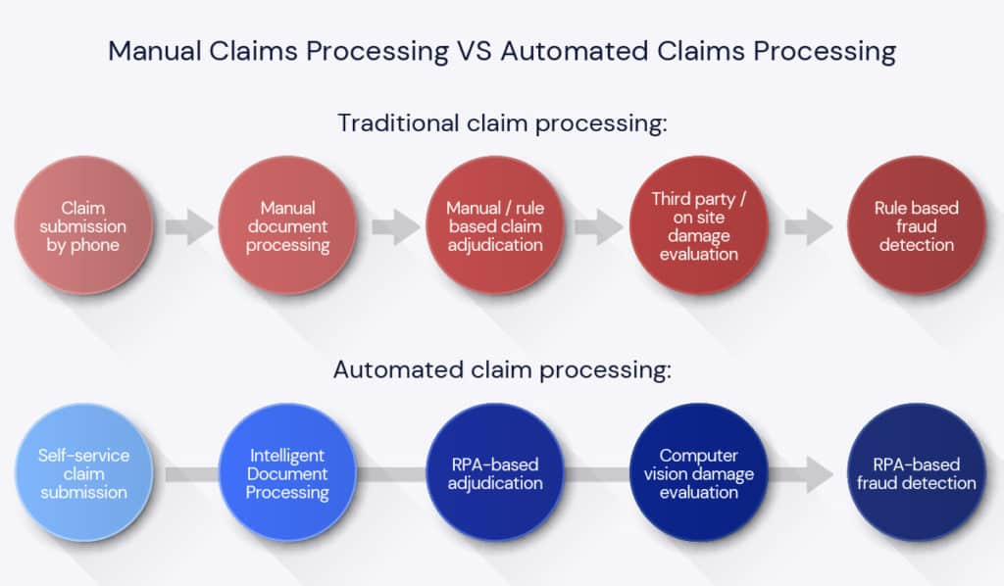
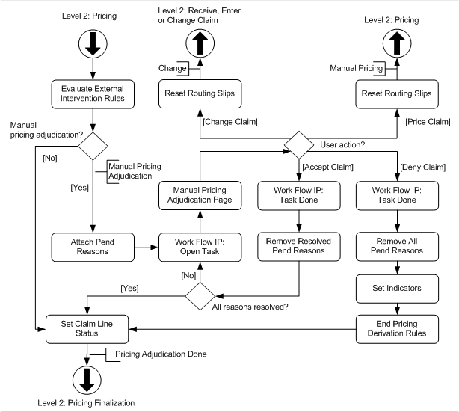
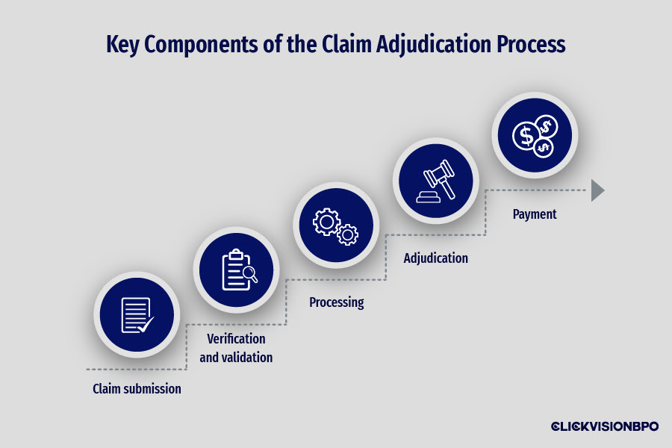
3.1 Where the Bot Fits in Aflac-Style Claims
FNOL
↓
Pre-Validation ←  RAG BOT
↓
Adjudication
↓
Payment

3.2 What the Bot Does (Exactly Like Aflac’s Early Automation)
Step 1: Intake Validation
- Policy active?
- Coverage exists?
- Documents required?
Step 2: Coverage Determination
- Clause-based validation
- Exclusion detection
- Rider check
Step 3: Routing
Scenario | Action
Clear coverage | Auto-approve
Partial coverage | Ask docs
Ambiguous | Manual review

3.3 Aflac-Style Decision Rules (Simplified)
IF confidence > 0.85 AND amount < threshold
→ Auto-approve

IF exclusion clause found
→ Partial / Reject + clause reference

IF multiple clauses conflict
→ Manual review

