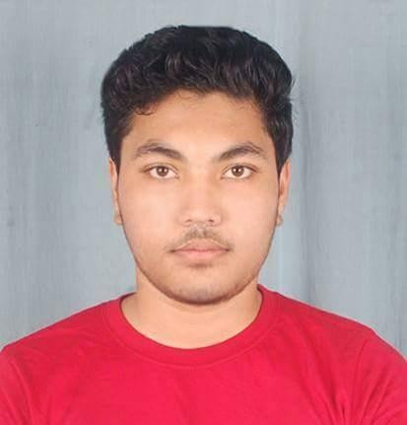

# PROFILE

ANUPAM DAS

**EDUCATION**

|  |
| --- |
| **Aiming to be successful in life, to gain hands on experience about today’s fast paced .corporate sector Looking to gain experience about the modern day scenario, and looking forward to give my hundred percent effort towards the growth of the organization** |
| **Techno India college of technology 2014-2018** |
| **B.Tech, Information Technology** |
| It is an eight-semester course. DGPA is **6.40/10.0** |
| **Acharya Prafulla Chandra high School 2011-2014** |

# CONTACT

PHONE:

+91 7003624784

ADDRESS:

Krishnapur Tarulia 2nd lane Kolkata, 700102

Email :

[anupamd30@gmail.com](mailto:anupamd30@gmail.com)

# HOBBIES

Playing Football

Watching

Movies

**HIGHER SECONDARY, SCIENCE**

## I secured 57.4% marks in my Higher Secondary Examination under West Bengal Council of Higher Secondary Education.

**Acharya Prafulla Chandra high School 2010-2011**

## I secured 63.2% marks in Secondary Examination under West Bengal Board of Secondary Education..

propfmdkdsjfdskf

# SKILLS

* Programming Languages: C , C#
* Web: HTML
* Database: Microsoft SQL
* Software Tools: Visual Studio, MS SQL Server Management Studio,
* Operating System: Windows 8.1, Windows 10

|  |  |
| --- | --- |
| **Place** – Kolkata  **Signature** –  **Date-** | **PROJECTS:**   * **.Net Project : Music Library(Under Training Institution)**   In this project. My role was create Database System Including admin Part and user part. All project base on Microsoft Sql Server.   * **Library Management System using ADK(Final Year Project)**   We developed an mobile version app to access the book library. During this project we used Java as programming language and SQL as database  **COURSES:**   * **Completed certification course of Dot NET(.NET) from Ejob India**. |