Advanced Unix Programming
Assignment-10

Nikhil Gawande 111408013
Anupam Godse 111408016

Q1. A pipe setup is given below that involves three processes. P is the parent process,
and C1 and C2 are child processes, spawned from P. The pipes are named p1, p2,
p3, and p4. Write a program that establishes the necessary pipe connections,
setups, and carries out the reading/writing of the text in the indicated directions.

CODE:
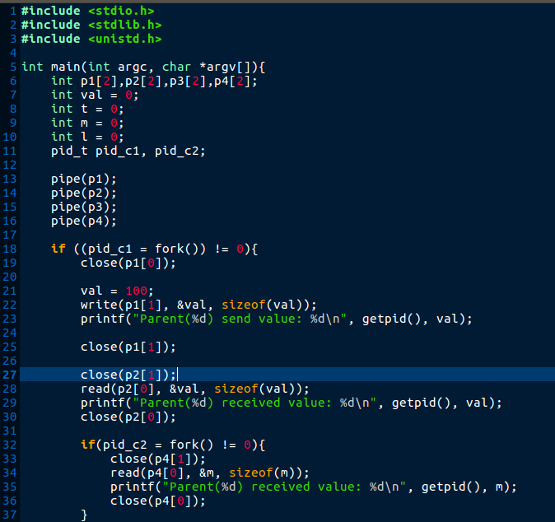

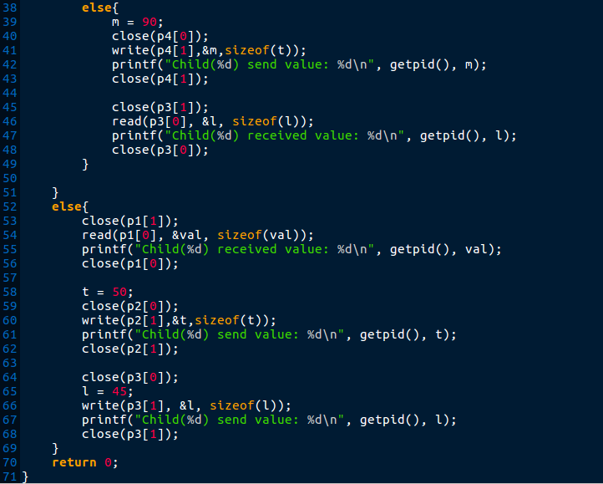

OUTPUT:

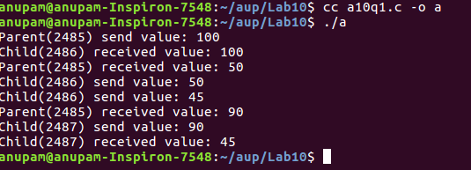

Q2. Let P1 and P2 be two processes alternatively writing numbers from 1 to 100 to a
file. Let P1 write odd numbers and p2, even. Implement the synchronization
between the processes using FIFO.

CODE: Process 1:
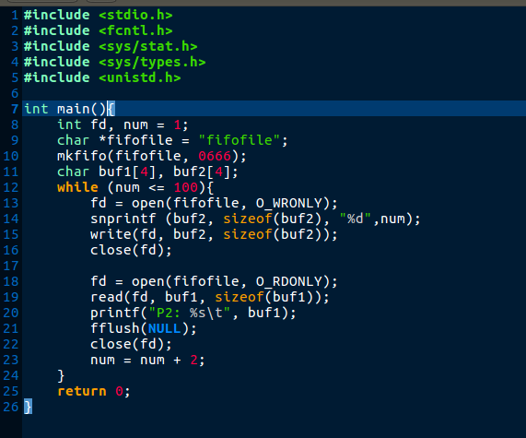

Process P2:
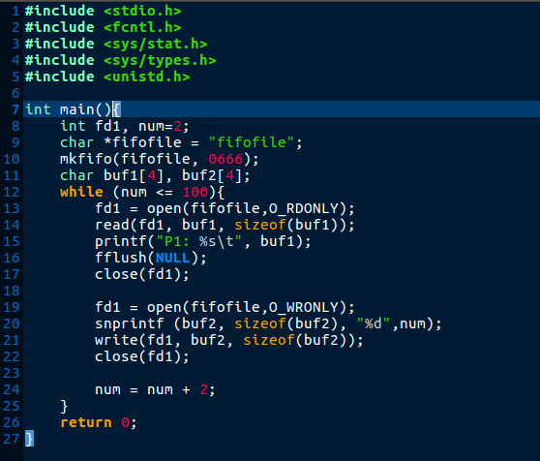
OUTPUT:

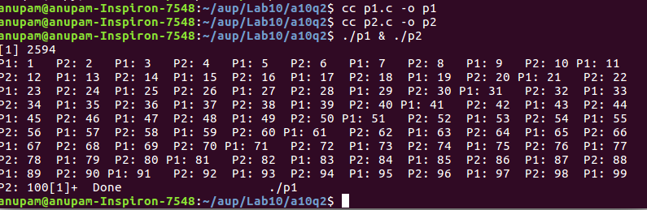

Q3.Implement a producer-consumer setup using shared memory and semaphore.
Ensure that data doesn’t get over-written by the producer before the consumer
reads and displays on the screen. Also ensure that the consumer doesn’t read the
same data twice.

CODE:
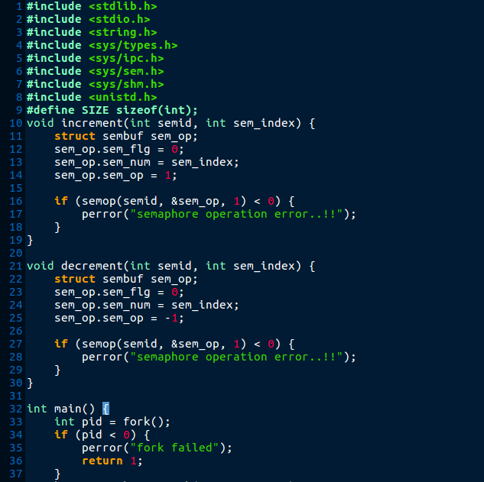

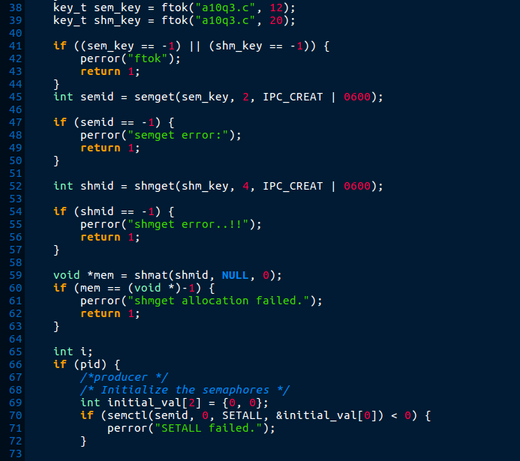

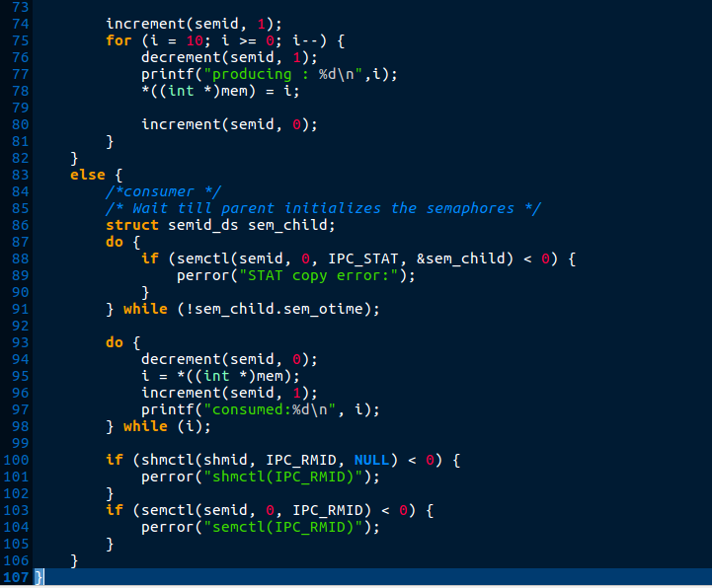
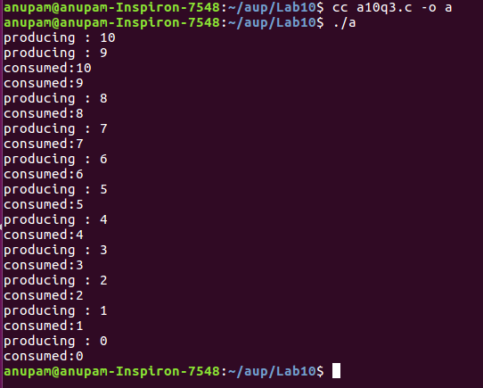
Output:

