3. What will be the output for the program with following operation?
- Create a new file “f1” and write “abcde” in it and close
- Open the file “f1” for writing with O_APPEND flag
- lseek to the beginning of the file
- Replace the existing data in the file with “12345”
Justify your answer.
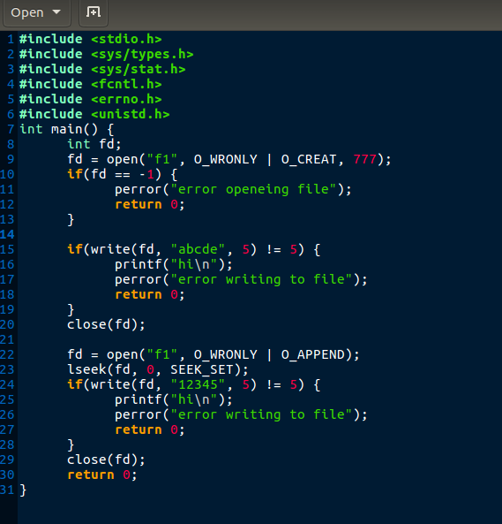
Program:-

File “f1” :-

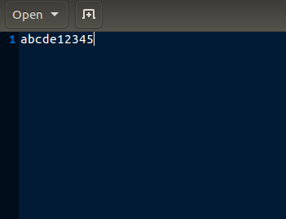

Justification:

As given in open(2) documentation,
“The file is opened in append mode. Before each write(2), the file offset is positioned at the end of the file, as if with lseek(2). “

So even though if we lseek to start of file and try to overwrite existing content it will still write new content to end of file.

