Assignment Lab 7
Anupam Godse 111408016
Nikhil Gawande 111408013

1. “The child “exec” call inherits the file descriptors of parent if Close_on_exec is not set“. Demonstrate with an example.

Program:-

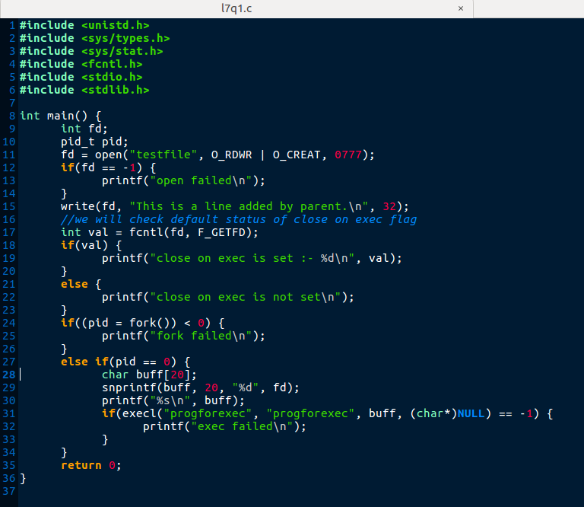

Program used for execution in child :-
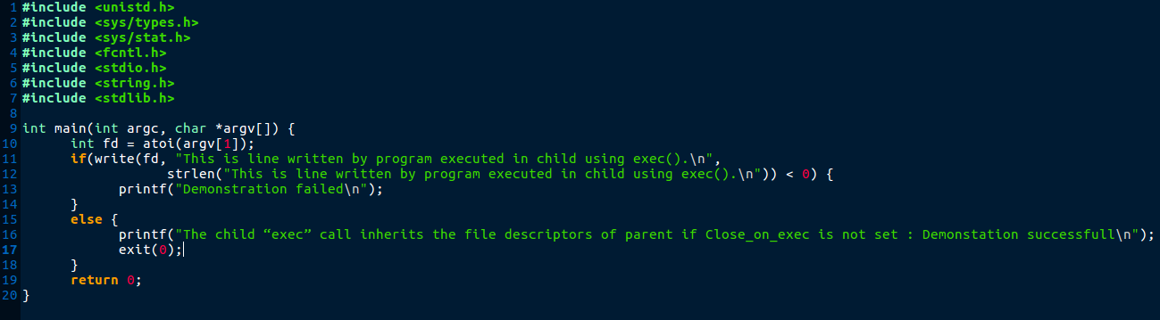

Directory contents:-

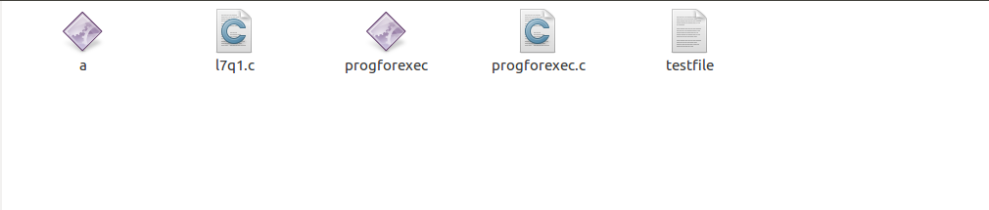

Execution:-

Before exec call:-

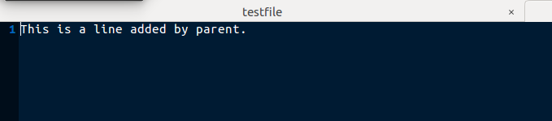

After exec call:-
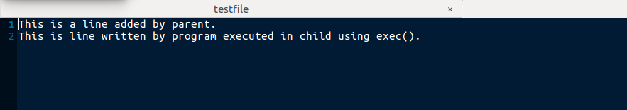

Explanation:-

As close on exec flag is not set all the file descriptors open in parent are inherited by child
exec() call. This can be demonstrated by,
1) Creating a new file in parent and writing some content to the file.
2) Passing the file descriptor as an argument to the program to be executed.
3) Using the same descriptor in the program that is executed using exec to see if it can be used to write/read from the same file.

As demonstrated in above program output, we can see that the file was created by parent program and the file descripted was passed to the program to be executed. The program to be executed used the file descriptor to write some content in file which was successfull. Hence we can conclude that, “The child “exec” call inherits the file descriptors of parent if Close_on_exec is not set”.

2.Write a program that takes a file name as an argument, opens the file, reads it and closes the file. The file should contain a string with the name of another application (e.g., 'ls' or 'ps' or any of your own applications) and the program forks a new process that executes the application named in the file.

Program:-

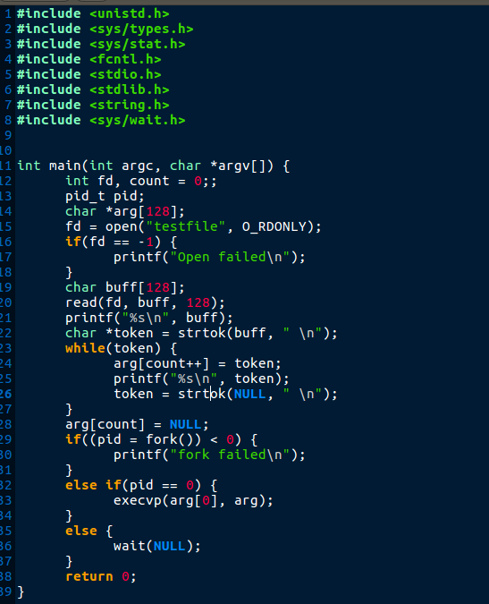

Testfile :-
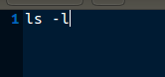

Output :-

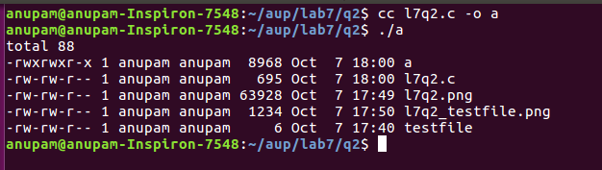

3. Implement cat < hw.txt > hw-copy.txt

Program:-

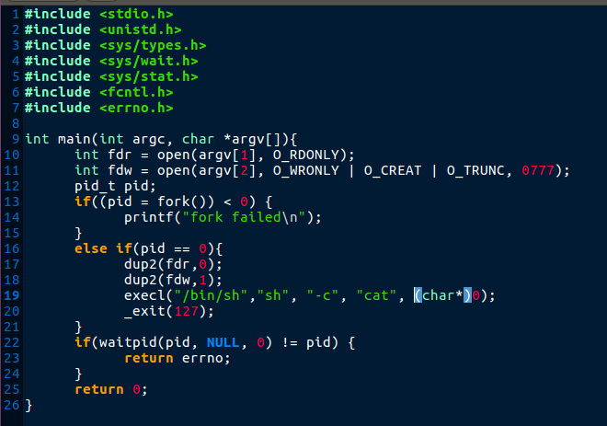

Execution :-

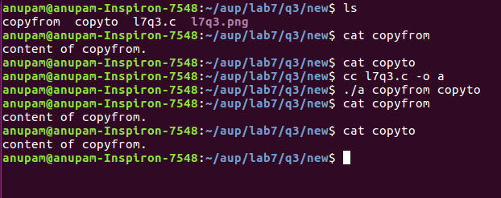

4. Bob works for an auditing agency needs to be able to read all the files in the system. The system admin has to protect the integrity of the system and should not allow Bob to modify or delete any file. Write a special SETUID program for the admin so that he can gave the executable permission of it to Bob. This program requires Bob to type a file name at the command line and then it will run /bin/cat to display the specified file. Can Bob compromise the integrity (by adding/modifying/deleting files) of this system? How?

Program:

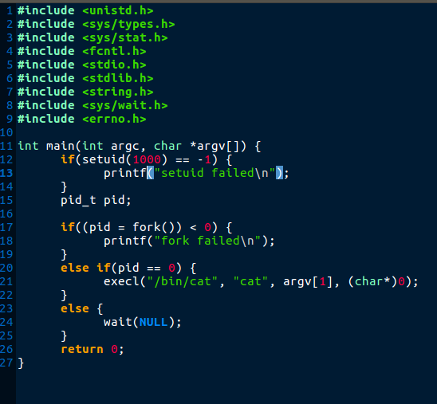

testfile content:

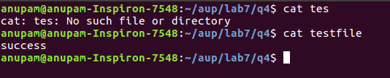

Execution:

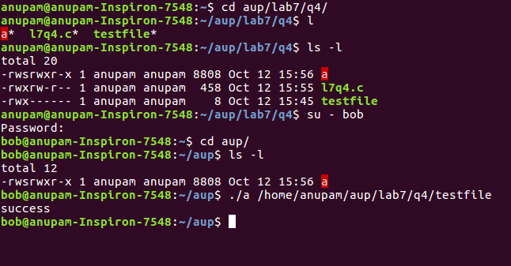

Explanation:

No. Bob cannot compromise the integrity of the system because he has no permissions for other files other than execute permisson of executable given by admin. As he has no permissions of files given by admin (as we can see here, testfile has only rwx permissions for owner).

