SYSTEM ADMINISTRATION
LAB ASSIGNMENT : LVM
Nikhil Gawande 111408013
Anupam Godse 111408016
Siddhesh Rane 111408057

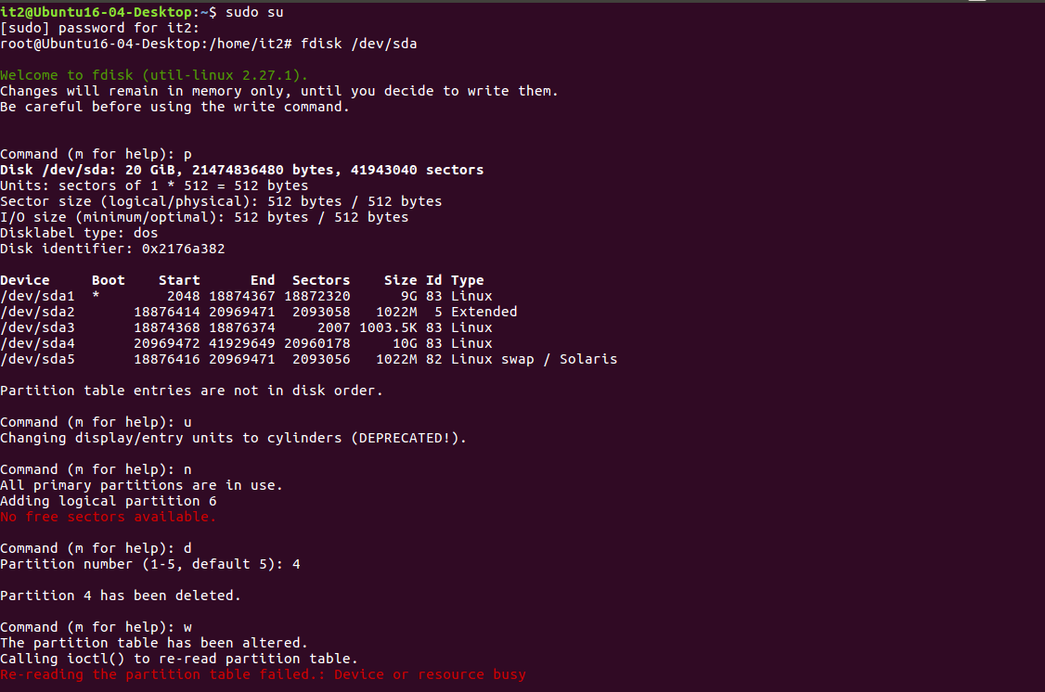
There was no space to create a new partition so the existing partition was deleted.

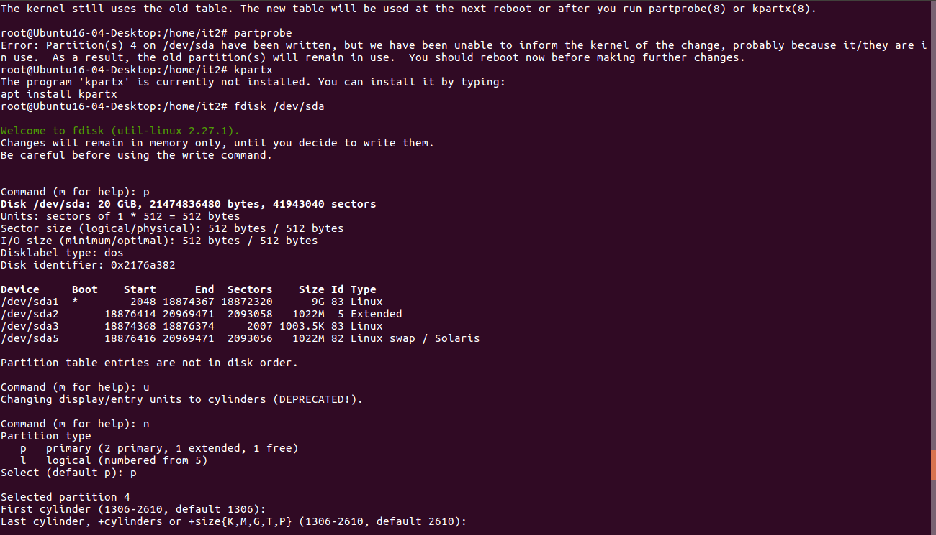
Now the new partion was made of 10Gb

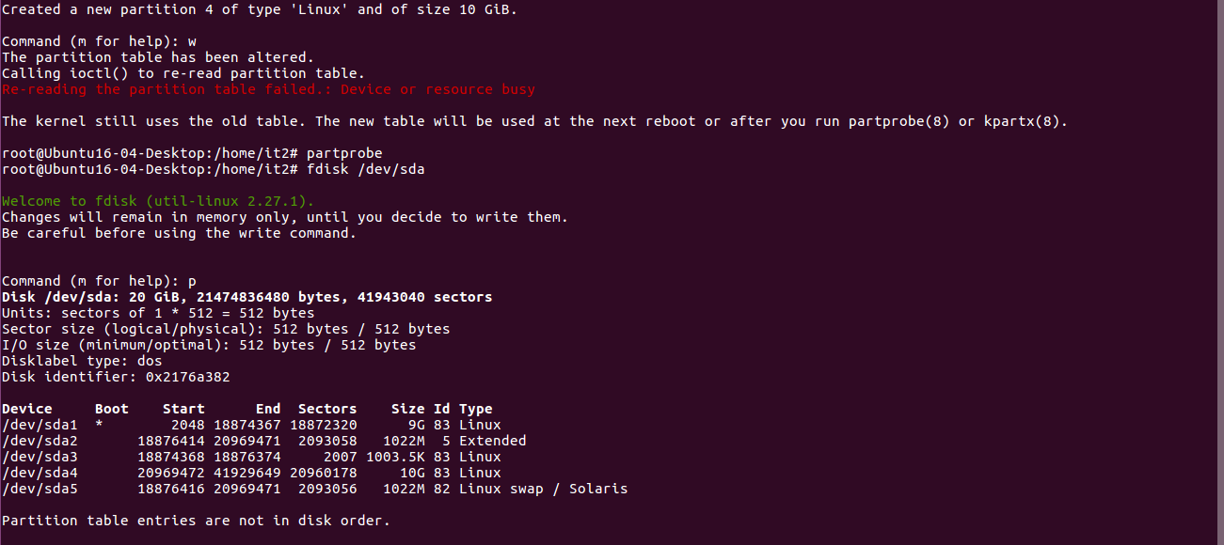

Here are the entries of partition table where you can verify the newly created partion (/dev/sda4)
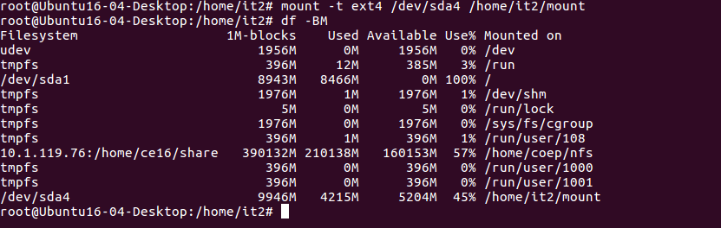
Success

