SYSTEM ADMINISTRATION
LAB ASSIGNMENT : NFS
Nikhil Gawande 111408013
Anupam Godse 111408016
Siddhesh Rane 111408057

NFS Server
Install NFS Package on your Ubuntu Server
sudo apt-get install nfs-kernel-server
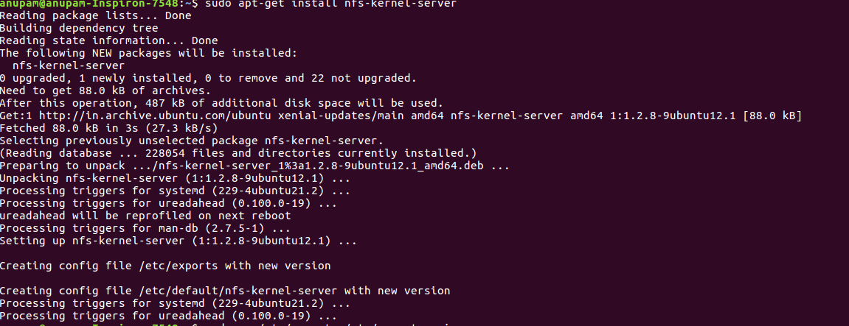
Create Folder List to Share
This example I will be sharing my whole RAID folder with any user (except root) in my LAN.
sudo nano /etc/exports
Add the following line to the end of the exports file.
The spacing is very important, e.g. there is no space between the IP address and Options list.
/mnt/raiddisk 192.168.1.0/255.255.255.0(rw,sync,root_squash,subtree_check)
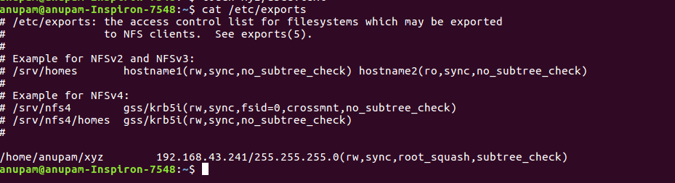

Start NFS Service
sudo service nfs-kernel-server start
If all is well you will see the message:
* Exporting directories for NFS kernel daemon... [ OK ]
* Starting NFS kernel daemon [ OK ]
Otherwise if there is an error you can stop the NFS service, and then go back and edit the Export list.
sudo service nfs-kernel-server stop

NFS Clients
Install NFS Client Package
sudo apt-get install nfs-common
Create Mount Point
You could either create a mount point under the /mnt folder, or use your home folder.
Here is how to create a folder under /mnt:
sudo mkdir /mnt/nfsmount
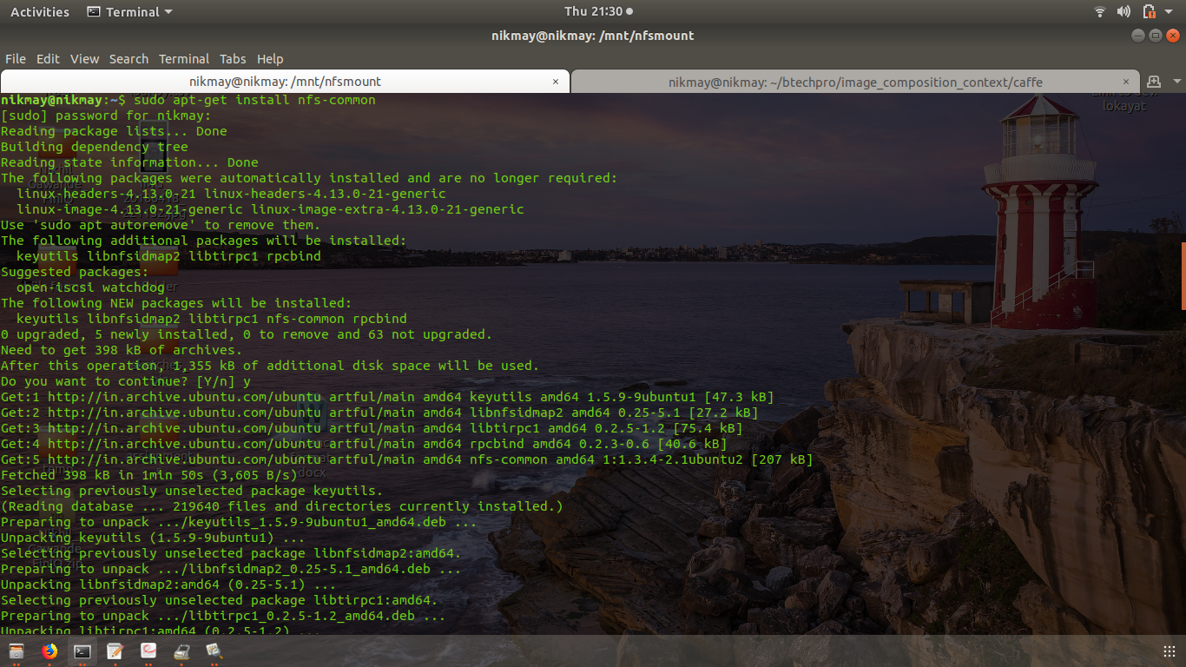

Edit fstab
(Substitute nano for your favorite text editor)
sudo nano /etc/fstab
Add the following line to the end of the fstab file:
ServerIP:/ServerFolder ClientFolder nfs Options dump pass
For Example:
192.168.1.100:/mnt/raiddisk /mnt/nfsmount nfs rw,soft,intr,noatime,timeo=100,rsize=32768,wsize=32768 0 2
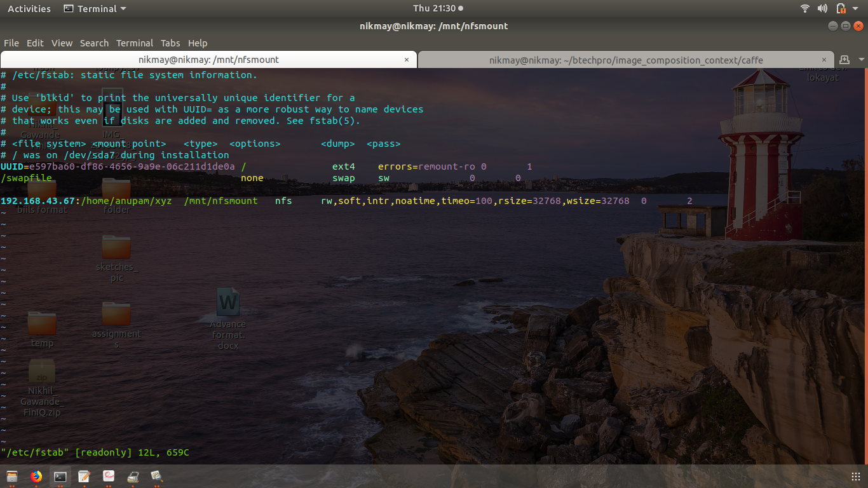

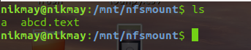

Accessing the file:

