**Theory:**

* Direct implementation of DFT is not efficient.
* In direct computation, total number of complex additions are N(N − 1) and complex multiplications are N2.
* FFT is an algorithm to compute DFT in an efficient manner.
* Two common algorithms are

1. Decimation-in-time FFT
2. Decimation-in-frequency FFT
3. **Radix-2 DIT-FFT:**

* Radix 2 algorithm means N can be expressed as a power of 2, i.e., N = 2M
* Input sequence is broken in to two sequence of length N/2.
  + xe(n)=x(2n); n=0,1,….,(N/2)-1 🡪 even samples
  + xo(n)=x(2n+1); n=0,1,….,(N/2)-1 🡪 odd samples

$$X\left(k\right)=\sum_{\begin{aligned}n=0 \\ (even)\end{aligned}}^{N-1}{x\left(n\right)W_{N}^{kn}}+\sum_{\begin{aligned}n=0 \\ (odd)\end{aligned}}^{N-1}{x\left(n\right)W_{N}^{kn}}$$

Or,

$$X\left(k\right)=\sum_{n=0}^{\frac{N}{2}-1}{x\left(2n\right)W_{N}^{2nk}}+\sum_{n=0}^{\frac{N}{2}-1}{x\left(2n+1\right)W_{N}^{\left(2n+1\right)k}}$$

So,

$$X\left(k\right)=\sum_{n=0}^{\frac{N}{2}-1}{x\left(2n\right)W_{N}^{2nk}}+W_{N}^{k}\sum_{n=0}^{\frac{N}{2}-1}{x\left(2n+1\right)W_{N}^{2nk}}$$

Or,

$$X\left(k\right)=\sum_{n=0}^{\frac{N}{2}-1}{x_{e}\left(n\right)W_{N}^{2nk}}+W_{N}^{k}\sum_{n=0}^{\frac{N}{2}-1}{x_{0}\left(n\right)W_{N}^{2nk}}$$

Where

$$W_{N}^{2}={\left(e^{-j2π/N}\right)}^{2}=e^{-j2π/\left(N/2\right)}=W_{N/2}$$

Hence,

$$X\left(k\right)=\sum_{n=0}^{\frac{N}{2}-1}{x_{e}\left(n\right)W_{N/2}^{nk}}+W_{N}^{k}\sum_{n=0}^{\frac{N}{2}-1}{x_{0}\left(n\right)W_{N/2}^{nk}}$$

Or,

$$X\left(k\right)=X_{e}\left(k\right)+W_{N}^{k}X_{o}\left(k\right)\text{ For }k≥N/2$$

As we know that

$$W_{N}^{k+N/2}=-W_{N}^{k}$$

Therefore,

$$∴X\left(k\right)=X_{e}\left(k\right)-W_{N}^{k}X_{o}\left(k\right), \text{ for k }≥N/2$$

So, three steps are used.

* Compute N/2-point DFT Xe[k] of xe[n] = even samples of x[n].
* Compute N/2-point DFT Xo[k] of xo[n] = odd samples of x[n].
* Compute G[k] = $W_{N}^{k}X_{o}\left(k\right)$, k = 0, . . . , N/2 – 1
* Combine: X[k] = Xe[k] + G [k]

X[k + N/2] = Xe[k] − G [k] , k = 0, . . . , N/2 – 1

Butterfly:

G[k]

xo[n]

xe[n]

X[k+N/2]

X[k]

**-1**

$$W_{N}^{k}$$

So basically key idea is: splitting into two sequences (even/odd) each of half the length, take DFT of each, then combine, saves a factor of 2 in complex multiplies.

**Result:**

**We get following graph using while computing FFT using DIT:**

`

**2. Radix-2 DIF-FFT:**

* + Output sequence X(k) is divided into smaller and smaller subsequences.
  + Input sequence x(n) partitioned into two sequences each of length N/2
* x1(n) – first N/2 samples of x(n)
* x2(n) – last N/2 samples of x(n)
$x_{1}(n)=x(n),n=0,1,2,……,\frac{N}{2}-1$

$x_{2}(n)=x(n+\frac{N}{2}),n=0,1,2,……,\frac{N}{2}-1$

* The N - point DFT of x(n) can be written as:
$$\begin{matrix}X(k)=\sum_{n=0}^{\frac{N}{2}-1}{ }x(n)W_{N}^{nk}+\sum_{n=\frac{N}{2}}^{N-1}{ }x(n)W_{N}^{nk} \\ =\sum_{n=0}^{\frac{N}{2}-1}{ }x_{1}(n)W_{N}^{nk}+\sum_{n=0}^{\frac{N}{2}-1}{ }x_{2}(n)W_{N}^{\left(n+\frac{N}{2}\right)k} \\ X(k)=\sum_{n=0}^{\frac{N}{2}-1}{ }x_{1}(n)W_{N}^{nk}+W_{N}^{Nk/2}\sum_{n=0}^{\frac{N}{2}-1}{ }x_{2}(n)W_{N}^{nk} \\ =\sum_{n=0}^{\frac{N}{2}-1}{ }x_{1}(n)W_{N}^{nk}+e^{-jπk}\sum_{n=0}^{\frac{N}{2}-1}{ }x_{2}(n)W_{N}^{nk}\end{matrix}$$

* When k is even, $e^{-jπk}=1.$
$$\begin{matrix} X(2k)=\sum_{n=0}^{\frac{N}{2}-1}{ }\left[x_{1}(n)+x_{2}(n)\right]W_{N}^{2nk} \\ =\sum_{n=0}^{\frac{N}{2}-1}{ }\left[x_{1}(n)+x_{2}(n)\right]W_{N/2}^{nk} \left(∵W_{N}^{2}=W_{N/2}\right)\end{matrix}$$

* This is N/2-point DFT of the N/2-point sequence obtained by adding the first half and the last half of the input sequence.
$$\begin{matrix}X(2k)=\sum_{n=0}^{\frac{N}{2}-1}{ }f(n)W_{N}^{2nk} \\ where f\left(n\right)=x_{1}\left(n\right)+x_{2}\left(n\right), n=0,1,2,…,\frac{N}{2}-1\end{matrix}$$

* When k is odd, $e^{-jπk}=-1.$
$$X\left(2k+1\right)=\sum_{n=0}^{\frac{N}{2}-1}{ }\left[x_{1}\left(n\right)-x_{2}\left(n\right)\right]W_{N}^{\left(2k+1\right)n}$$

$$X\left(2k+1\right)=\sum_{n=0}^{\frac{N}{2}-1}{ }\left[x_{1}(n)-x_{2}(n)\right]W_{N}^{2kn}W_{N}^{n}$$

$$X\left(2k+1\right)=\sum_{n=0}^{\frac{N}{2}-1}{ }\left[x_{1}(n)-x_{2}(n)\right]W_{N}^{n}W_{N/2}^{nk}=\sum_{n=0}^{\frac{N}{2}-1}{ }g(n)W_{N/2}^{nk} \begin{matrix} \\ \\ \end{matrix}$$

* This is the N/2- point DFT of the sequence obtained by subtracting the second half of the input sequence from the first half and multiplying the resulting sequence by $W_{N}^{n}.$
* Where $g\left(n\right)= \left[x_{1}\left(n\right)-x_{2}\left(n\right)\right]W_{N}^{n}.$
* So the even and odd samples of the DFT can be obtained from the N/2-point DFTs of f(n) and g(n) respectively:
* $f\left(n\right)=x_{1}\left(n\right)+x_{2}\left(n\right), n=0,1,2,…,\frac{N}{2}-1$.
* $g\left(n\right)= \left[x_{1}\left(n\right)-x_{2}\left(n\right)\right]W_{N}^{n} n=0,1,2,…,\frac{N}{2}-1$.

$\left[x_{1}\left(n\right)-x_{2}\left(n\right)\right]W_{N}^{n}$ = $g\left(n\right)$

$$x_{1}\left(n\right)+x_{2}\left(n\right)=f\left(n\right)$$

$$x_{2}\left(n\right)$$

$$x_{1}\left(n\right)$$

$$W_{N}^{n}$$

**Result:**

**We get following graph using while computing FFT using DIF:**



**Conclusion:**

* For DIT, the input is bit reversed while the output is natural order. For DIF, the input is in natural order while the output is bit reversed. 2.
* The DIF butterfly is slightly different from the DIT.
* In DIF, the complex complex multiplication takes place after the add-subtract operation.
* Both algorithms require N log2N operations to compute the DFT. Both algorithms can be done in-place and both need to perform bit reversal at some place during the computation.

**APPENDIX**

# FFT Using DIT

clear all  
close all  
clc  
warning off  
fs=1000;  
[readmusic,fs]=audioread('1610958375116.wav');  
N=1024;  
  
%Taking first 1024 samples  
for z = 0:1:(N-1)  
 a(z+1)=readmusic(z+1);  
end  
  
%finding even and odd parts  
for zz = 0:1:(N/2)-1  
 a_even(zz+1) = a(2*zz+1);  
 a_odd(zz+1) = a((2*zz)+2);  
end  
  
%For twiddle factor type 1 length=(N/2)  
for k= 0:1:(N/2)-1  
 for n= 0:1:(N/2)-1  
 p=exp(-sqrt(-1)*pi*2*2*k*n/N);  
 twiddle_fact_matrix(k+1, n+1)=p;  
 end  
end  
%N/2-point DFT of even samples  
fft_ev = twiddle_fact_matrix*a_even';  
%N/2-point DFT of even samples  
fft_odd = twiddle_fact_matrix*a_odd';  
  
%Combine  
for k=0:1:(N/2)-1;  
 fft_simm(k+1) = fft_ev(k+1) + (exp(-sqrt(-1)*2*pi*k/N)*fft_odd(k+1));  
 fft_simm((N/2)+k+1) = fft_ev(k+1) - (exp(-sqrt(-1)*2*pi*k/N)*fft_odd(k+1));  
end  
  
subplot(211);  
stem(abs(fft_simm));  
title('FFT using DIT')  
fft_inbuilt=fft(a);  
subplot(212);  
stem(abs(fft_inbuilt));  
title('FFT using inbuilt command')

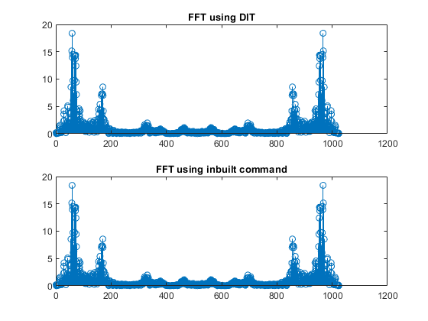

[*Published with MATLAB® R2020b*](https://www.mathworks.com/products/matlab)

# FFT Using DIF

clear all  
close all  
clc  
warning off  
fs=1000;  
[readmusic,fs]=audioread('1610958375116.wav');  
N=1024;  
  
%Taking first 1024 samples  
for z = 0:1:(N-1)  
 a(z+1)=readmusic(z+1);  
end  
  
%Input sequence x(n) partitioned into two sequences each of length N/2  
% 0 to 511 as x1[n] and 512 to 1023 as x2[n]  
for zz = 0:1:(N/2)-1  
 x1(zz+1) = a(zz+1);  
 x2(zz+1) = a((N/2)+zz+1);  
end  
  
  
%For twiddle factor type 1 length=(N/2)  
for k= 0:1:(N/2)-1  
 for n= 0:1:(N/2)-1  
 p=exp(-sqrt(-1)*pi*2*2*k*n/N);  
 twiddle_fact_matrix(k+1, n+1)=p;  
 end  
end  
  
f=x1+x2;  
g=x1-x2;   
  
%N/2-point even samples DFT  
fft_even_2k = twiddle_fact_matrix*f';  
%N/2-point odd samples DFT  
fft_odd_2kplus1 = twiddle_fact_matrix*g';  
  
%Combine  
for k=1:1:(N/2)  
 fft_simm(2*k) = fft_even_2k(k);  
 fft_simm((2*k)+1) = fft_odd_2kplus1(k)*exp(-sqrt(-1)*2*pi*k/N);  
end  
  
subplot(211);  
stem(abs(fft_simm));  
title('FFT using DIF')  
fft_inbuilt=fft(a);  
subplot(212);  
stem(abs(fft_inbuilt));  
title('FFT using inbuilt command')

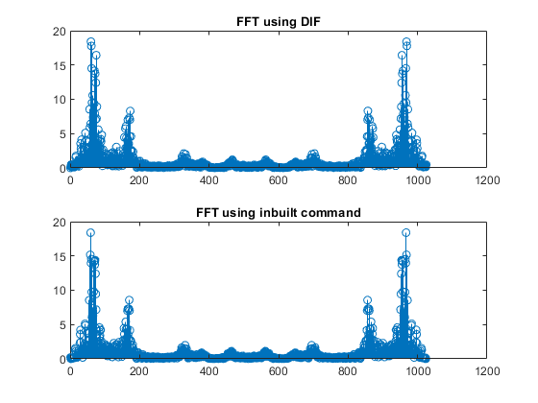

[*Published with MATLAB® R2020b*](https://www.mathworks.com/products/matlab)