**DESIGN OF LPG, SMOKE, AND ALCOHOL DETECTION SYSTEM WITH AUTOMATIC MAINS CUT-OFF**

***A Report submitted***

***in partial fulfillment for the Degree of***

**B. Tech**

**in**

**Electronics & Communication Engineering**

***by***

**ANUPAM ROY, ACHINTYA ROY, ADITI RAY, ADITI DAS, PRATIMA MAITI, DEBAYAN MUKHERJEE**

pursued in

**Department of Electronics & Communication Engineering**

**Techno International Newtown**

To



**TECHNO INTERNATIONAL NEWTOWN**

**KOLKATA**

**OCTOBER, 2020**

**TECHNO INTERNATIONAL NEWTOWN**

**NEWTOWN, KOLKATA**

**DEPARTMENT OF ELECTRONICS & COMMUNICATION ENGINEERING**



CERTIFICATE

This is to certify that the project report entitled **Design of LPG, Smoke, and Alcohol Detection System with Automatic Mains cut-off** submitted by **Anupam Roy, Achintya Roy, Aditi Ray, Aditi Das, Pratima Maiti, and Debayan Mukherjee** to the Techno International Newtown, Kolkata, in partial fulfillment for the award of the degree of **B. Tech in (Electronics & Communication Engineering)** is a *bona fide* record of project work carried out by them under our supervision. The contents of this report, in full or in parts, have not been submitted to any other Institution or University for the award of any degree or diploma.

Prof. (Dr.) Pradip Kumar Ghosh Prof. (Dr.) Subhankar Bhattcharjee

Supervisor Co-Supervisor

Department of Electronics & Department of Electronics &

Communication Engineering Communication Engineering

Kolkata

October, 2020

DECLARATION

We declare that this project report titled **Design of LPG, Smoke, and Alcohol Detection System with Automatic Mains cut-off** submitted in partial fulfillment of the degree of **B. Tech in (Electronics & Communication Engineering)** is a record of original work carried out by us under the supervision of **Prof. (Dr.) Pradip Kumar Ghosh and Prof. (Dr) Subhankar Bhattcharjee**, and has not formed the basis for the award of any other degree or diploma, in this or any other Institution or University. In keeping with the ethical practice in reporting scientific information, due acknowledgements have been made wherever the findings of others have been cited.

1. Anupam Roy
2. Achintya Roy
3. Aditi Ray
4. Aditi Das
5. Pratima Das
6. Debayan Mukherjee

Signature(s):

Kolkata

Date: -

ACKNOWLEDGMENTS

We would like to make our deepest appreciation and gratitude to Prof. (Dr.) Pradip Kumar Ghosh and Prof. (Dr.) Subhankar Bhattacharjee for his invaluable guidance, constructive criticism and encouragement during the course of this project.

We are also grateful to Prof. (Dr.) Manabendra Maiti, Head of the Department, Electronics & Communication Engineering for providing the necessary opportunities for the completion of this project.

In the last we would like to thank the management of Techno International Newtown, for providing us such an opportunity to learn from these experiences.

Anupam Roy

Achintya Roy

Aditi Ray

Aditi Das

Pratima Maiti

Debayan Mukherjee

ABSTRACT

Household and Hotel fires have been taking place frequently and the threat to human lives and properties is growing in recent years. Liquid petroleum gas (LPG) is highly inflammable and can burn even at some distance from the source of leakage. Most fire accidents are caused because of a poor-quality rubber tube or the Gas Regulator not turned off when not in use. Therefore, developing the gas leakage alert and control system is very essential. Hence, in this project we have proposed a LPG, Smoke, and Alcohol detection system with automatic mains gas supply cut-off.

The system will work such that if there’s a LPG leakage from gas cylinders, it’ll ring an alarm, turn off the gas regulator key to stop further gas leakage, switch on a propeller to fan out the already leaked gas. It’ll also detect smoke due to fire and inflammable liquids like Ethanol (Alcohol) near the gas cylinders which poses a threat to normal working of the gas cylinders.

So, our build up will be a hit for household and hotel kitchen uses as it is smart and cheap which not only acts as a detecting system but also can take care of the leakage. Our work was also focused on how to make it affordable to general public.

CHAPTER 1

# INTRODUCTION

## Problem Definition

Gas leakage poses great danger in this modern era where the use of gas has become an important source of energy for industries, homes and vehicles alike. The leakage of Liquefied Petroleum Gas (LPG) is known to cause serious accidents which have resulted in loss of lives and properties worth billions of dollars across the globe. The 2019 statistics of National Crime Records Bureau (NCRB) show that 346 people died in Tamil Nadu because accidental fire due to cooking gas cylinders. Maharashtra registered 285 such deaths. Tamil Nadu tops the southern states in the category, far above Andhra Pradesh (93), Karnataka (286) and Kerala (53). This means more than 6 people in Tamil Nadu die every week because of accidental fire due to cooking gas cylinders. On the whole, there have been 2143 such deaths in 2019 and in 2681 deaths in 2018.

LPG is one of the most commonly used fuels in India. In a survey conducted by National Statistical Office between July and December 2018, it revealed that 48.3% household in rural areas and 86.6% household in urban areas making the average 61.4% Indians who use LPG as cooking fuel. With Pradhan Mantri Ujjwala Yojana started by PM Narendra Modi in 2016, the numbers are rapidly rising especially in the rural areas.

LPG is made up of mixtures of propane and butane which are inflammable chemicals. Due to the odourless nature of these chemicals, Ethyl Mercaptan is added as odorant in order to make the gas detectable by smell. However, some people have poor sense of smell especially at low concentrations and so a more effective and reliable means of detecting the gas has to be adopted in homes, industries and vehicles that rely on the use of LPG. One of the preventive methods of stopping accident associated with LPG leakage is to install gas leakage detection devices.

Even though there have been great strides in developing effective LPG leakages detection and response systems over the past years, there are still improvements that can be made to previous designs. Most systems developed focus on the detection of the leakage and sounding of an alarm in response to the detection. Other systems detect the gas and use a microcontroller to activate an alarm and also send SMS to the appropriate personnel. A much more improved version has a power fan installed for circulating the gas. These designs even though prudent do not solve the leakage problem.

The purpose of this project is to design a system capable of detecting the leakage of LPG and automatically shutting down the supply of the gas and the mains power supply to the room. The system consists of a sensor (MQ-6) that is highly sensitivity to propane (C3H8) and butane (C4H10), an alarm, a microcontroller, a relay module and a servo motor. This system does not only detect LPG leakage but shuts down supply to minimise wastage, accidents and cut down cost associated with the leakage. The mains power supply is cut off as switching on/off a high voltage electric appliance can cause an electric spark catching fire inside the room.

Furthermore, the device would be able to detect other gases which have traces of butane and propane.

Table 1.1 Injuries and Deaths due to Accidental Fire due to Cooking Gas Cylinder in 2019

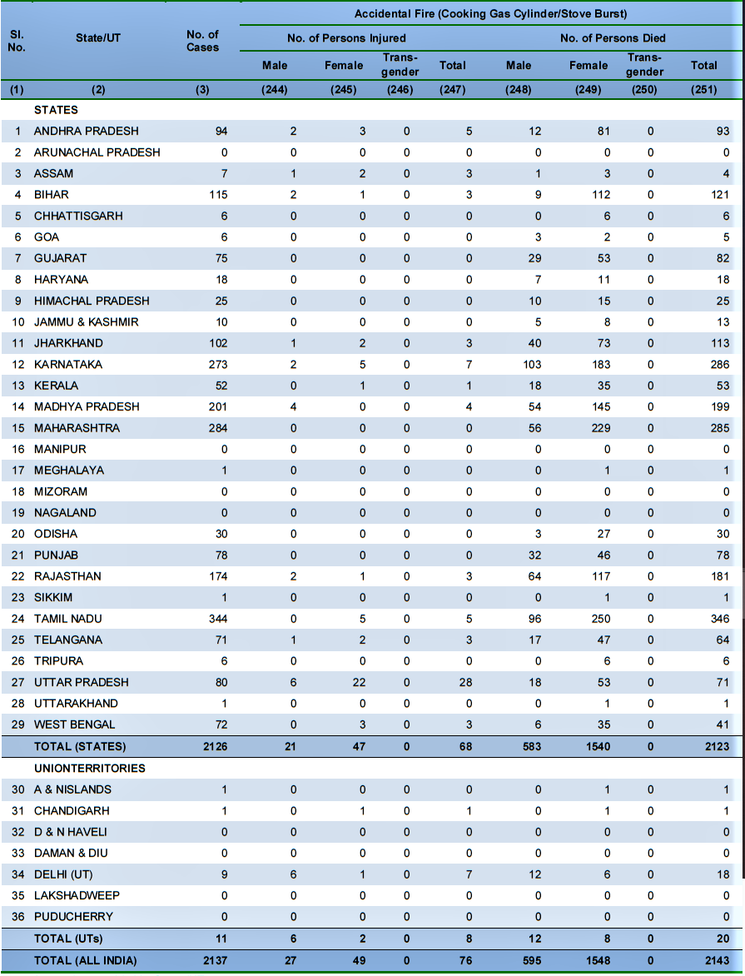(Source: NCRB, 2019)

Table 1.2 Injuries and Deaths due to Accidental Fire due to Cooking Gas Cylinder in 2018

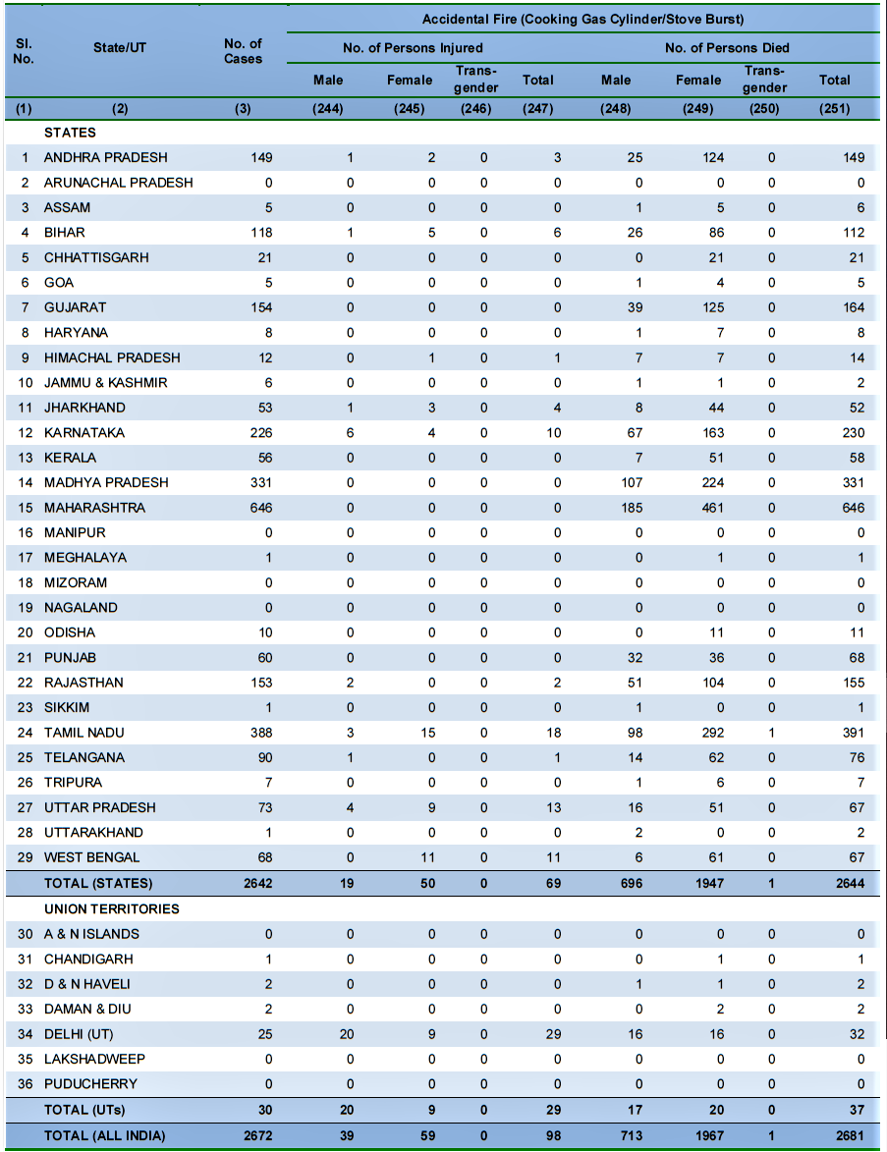(Source: NCRB, 2018)

The image as given in Figure 1.1 shows the percentage of households with different types of fuel usage.

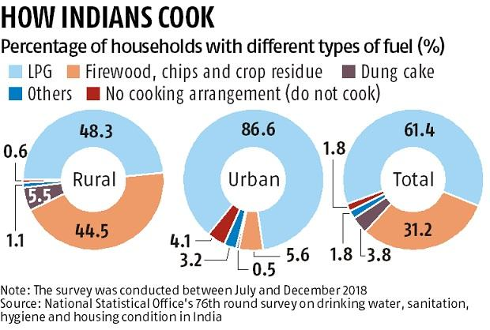

Figure 1.1 Percentage of households with different types of fuel usage

## 1.2 Objective

The objectives of this project are:

* To design a system that monitors LPG leakage in an enclosed area;
* To design a system that alarms the user of the leakage;
* To design a system that switch off the gas regulator key during leakage;
* To design a system that propels out the already leaked gas; and
* To design a system that detects fire and alcohol near a gas cylinder.

## 1.3 Methods Used

The research methods adopted include:

* Review of related literature;
* Use of datasheet in selecting suitable components for the circuit design;
* Circuit design and simulation; and
* Analysis of results from simulation.

## 1.4 Facilities Used

The facilities used during this project include:

* Internet access;
* Personal computer.

## 1.5 Scope of Work

This work is limited to the design of an efficient system for monitoring LPG leakage in a susceptible area, alerting the user and shutting down the gas supply using a microcontroller based detection system.

## 1.6 Work Organization

This work is organised into five chapters. The first chapter deals with the problem definition, project objectives, methods used, facilities used for the project and the scope of work. Chapter two gives the review of the related literature. Chapter three focuses on the proposed design and component selection for the Microcontroller based LPG leakage detection and response system. The fourth chapter provides a detailed analysis of results from simulation and the last chapter talks about conclusion and recommendations.

CHAPTER 2

# LITERATURE REVIEW

## 2.1 Introduction

LPG consists of a mixture of Commercial Propane and Commercial Butane having saturated as well as unsaturated hydrocarbons. It is an odourless gas due to which Ethyl Mercaptan is added as powerful odorant so that leakage can easily be detected. LPG is commonly used in homes for heating and cooking. This energy source is primarily composed of propane and butane which are highly flammable chemical compounds.

LPG was first produced in 1910 by Walter Snelling (Didpaye1, 2015) and is classified as a hazardous material because of its flammable properties and explosive potential when stored under pressure. Before the development of electronic household gas detectors in the 1980s and 90s, gas presence was detected with a chemically infused paper that changed its colour when exposed to the gas (Didpaye1, 2015). Since then, many technologies and devices have been developed to detect, monitor, and alert the leakage of a wide array of gases. Hence the requirement of an efficient system to detect leakage of LPG is inevitable, which may be used for domestic and commercial purposes.

## 2.2 Classification of Leakage Detection Technologies

There are various classifications available for leakage detection. Several criteria are considered for classification, some of which are, the amount of human intervention needed, the physical quantity measured and the technical nature of the methods (Murvaya, 2011). If the degree of intervention needed from a human, by each detection method is used for classification, three categories are used to distinguish between them (Murvaya, 2011):

* Automated detection – complete monitoring systems that, can report the detection of a gas leak without the need of a human operator, once they are installed (e.g. fibre optic or cable sensors);
* Semi-automated detection – solutions that need a certain amount of input or help in performing some tasks (e.g. statistical or digital signal processing methods); and
* Manual detection – systems and devices that can only be directly operated by a person (e.g. thermal imagers or Light Detection and Ranging (LIDAR) devices).

Most detection techniques rely on the measurement of a certain physical quantity or the manifestation of certain physical phenomenon. This can be used as a rule for classification as there are several commonly used physical parameters and phenomena namely; acoustics, flow rate, pressure, gas sampling, optics and sometimes a mix of these. Because of the great variety of these detection solutions, leak finding technologies are sometimes classified into optical and non-optical methods (Batzias *et al*., 2011).

Leakage Detection Mthod

Non-technical

Hardware Based

Acoustic

Cable Sensor

Vapor Sampling

Optical

Soil Monitoring

Ultrasonic Flow Meter

Software Based

Pressure Point Analysis

Statistical

Method

Real Time Transient Modelling

Mass/Volume Balance

Negative Pressure Wave

Digital Signal Processing

Some authors see the technology as fitting into two great categories direct methods and indirect or inferential methods (Folga, 2007 and Liu *et al*., 2008). The direct detection is made by patrolling along the pipelines using either visual inspection or handheld devices for measuring gas emanations. Thanks to technological advancements it is now common to use helicopter or airplane-mounted optical imaging devices especially for very long pipelines (Liu *et al*., 2008). Indirect or inferential methods detect leaks by measuring the change of certain pipe parameters such as flow rate and pressure.

Fig. 2.1 Classification of Gas Leak Detection Techniques Based on Technical Nature (Source: Murvaya, 2011).

The most common way of classifying leak detection methods is based on their technical nature (Scottand, 2003). Thus, two main categories can be distinguished; hardware based methods and software based methods. These two categories are sometimes mentioned as externally or internally based leak detection systems. Fig. 2.1 illustrates these main categories and the different methods associated with each of them. This classification is similar to the one presented in the previous paragraph with the remark that indirect or inferential methods overlap with the software based methods while the direct methods cover both hardware methods and non-technical methods.

Non-technical leak detection methods are the ones that do not make use of any device and rely only on the natural senses (i.e. hearing, smelling and seeing) of humans and/or animals.

Hardware based methods rely mainly on the usage of special sensing devices in the detection of gas leaks. Depending on the type of sensors and equipment used for detection, these hardware methods can be further classified as: acoustic, optical, cable sensor, soil monitoring, ultrasonic flow meters and vapour sampling.

Software based methods, as the name states, have software programs at their core. The implemented algorithms continuously monitor the state of pressure, temperature, flow rate or other pipeline parameters and can infer, based on the evolution of these quantities, if a leak has occurred. The software methods can use different approaches to detect leaks: mass/volume balance, real time transient modelling, and acoustic/negative pressure wave, pressure point analysis, statistics or digital signal processing.

## 2.3 Microcontroller Based Detection System

This method of LPG leakage detection is an automatic method of detecting leakages and involves the use of a microcontroller which serves as the brain of the system. The microcontroller responds to the leakage of LPG detected by LPG sensors by initiating a set of commands to mitigate or alert the authorities for prompt action to be taken.

### 2.3.1 Microcontroller

A microcontroller often serves as the “brain” of a mechatronic system. Like a mini, self-contained computer, it can be programmed to interact with both the hardware of the system and the user. Even the most basic microcontroller can perform simple math operations, control digital outputs, and monitor digital inputs.

Recent microcontrollers are much faster, have more memory, and have a host of input and output features that dwarf the ability of earlier models. Most modern controllers have analogue-to-digital converters, high-speed timers and counters, interrupt capabilities, outputs that can be pulse-width modulated, serial communication ports, etc. Fig. 2.2 shows a block diagram of a microcontroller.

**INTERRUPTS**

**I/O PORT**

**REGISTER**

**ALU**

**TIMER/ COUNTER**

**Memory**

**ROM**

**RAM**

Fig. 2.2 Block Diagram of Microcontroller (Source: Parai *et a*l., 2013)

### 2.3.2 Classification of Microcontrollers

In 1993, the introduction of EEPROM allowed microcontrollers (beginning with the Microchip PIC16x840) to be electrically erased quickly (Parai *et al*., 2013). It allows both rapid prototyping and In-System-Programming (ISP). The same year, the first microcontroller using Flash memory was introduced by Atmel. There are 4-bit to 32-bit microcontrollers available in the market. Based on the number of bits, it is broadly classified into four different categories i.e., 4-bit, 8-bit, 16-bit and 32-bit microcontrollers. The 4-bit microcontrollers are extensively used in electronic toys. The 8-bit microcontrollers are generally used in various control applications such as position control, speed control and any process control system. The 16-bit microcontroller are designed and developed for the purpose of high speed control application such as servo control system, robotics etc. (Parai *et al*., 2013).

Programming of such microcontroller can be achieved either by high level programming language or by assembly language programming. For very high speed operations in robotics, image processing, automobiles, intelligent control system and telecommunications 32- bit microcontrollers are used. Typical examples of microcontroller are the Intel MCS48, 51 and 96 families, the Motorola MC68HC11 family and the Zilog Z8. Most of these MCUs have an 8-bit word size (except the MCS-96 with a 16-bit word size), at least 64 bytes of R/W memory and 1 KB of ROM. The range of I/O line varies from 16 to 40 lines. Fig. 2.3 shows the classifications of microcontrollers.

Instruction act

RISC

CISC

Instrument implemented on

RISC core

CISC

Family

Memory

Embedded Memory

External Memory

8

16

32

Bits

Memory Architecture

Harvard

Princeton

A VSLI core

(VDHL/Verilog Format)

IC Chip

8051

PIC

ARM

Texas

Hitachi

Motorola

Others

Intel

Philips (Nexperia)

Atmel

Siemens

Dallas

Types of Microcontrollers

Fig. 2.3 Classification of Microcontrollers (Source: Parai *et al*., 2013)

## 2.4 MQ Series Semiconductor Gas Sensors

These are highly sensitive devices that are used for detecting the presence of a variety of gases in an area. They range from MQ-2 through to MQ-9, MQ303, MQ306, MQ307, MQ131 and MQ135 to MQ138 with sensitivity to different kind of gases. Table 2.1 shows the various types of MQ sensors and their specifications.

Table 2.1 MQ Series Specifications

|  |  |
| --- | --- |
| **Semiconductor Sensor for Flammable Gas, Plastic or Metal Cover** | |
| **Model** | **Target Gas** |
| MQ-2 | General combustible gas |
| MQ-3 | Alcohol |
| MQ-4 | Natural gas, Methane |
| MQ-5 | LPG, Natural gas, Coal gas |
| MQ-6 | LPG, Propane |
| MQ-7 | Carbon Monoxide |
| MQ-8 | Hydrogen |
| MQ-9 | CO and Combustible gas |
| MQ306 | LPG, Propane |
| MQ307 | Carbon Monoxide |
| MQ303 | Alcohol |
| MQ131 | Ozone |
| MQ135 | Air Quality Control |
| **Semiconductor Sensor for Toxic Gas** | |
| MQ136 | Sulphureted Hydrogen (H2S) |
| MQ137 | Ammonia (NH3) |
| MQ138 | Volatile Organic Compound (Mellow, Benzene, Aldehyde, Ketone, Ester ) |

(Source: Anon., 2015)

## 2.5 Related Works

Various research groups are working all over the world for the development of LPG leakage detectors and response systems. Before the development of electronic household gas detectors in the 1980s and 90s, gas presence was detected with a chemically infused paper that changed its colour when exposed to the gas. Since then, many technologies and devices have been developed to detect, monitor, and alert the leakage of a wide array of gases.

Bhattacharjee et al , 2011, designed a system entitled “Design and Development of a Flexible Reliable Smart Gas Detection System”. The system composed of three modules; the base station, wireless sensor array and an intelligent wireless alarm unit, which offers high reliability, flexibility and uninterrupted sensing. These are achieved by incorporating various intelligent protocols like auto sensor calibration, sensor handover, wireless threshold fixation and intelligent alarm mechanism. The sensor node consists of three gas sensors, one temperature sensor and one pyro-electric infrared sensor (PIR) which enhances the sensing intelligence.

Somov et al ,2012, designed a Energy-Aware Gas Sensing Using Wireless Sensor Networks focusing on a sensor node, a relay node, a wireless actuator and a network coordinator. The network coordinator is the main unit of the WSN. It supports the network operation by wireless communication based on the IEEE 802.15.4 standard and the ZigBee specifications. The network coordinator is also responsible for alerting a network operator or an emergency service using the Ethernet network or sending a SMS using a GSM/GPRS modem. In fact, upon receiving the alert message from the sensor node, the network coordinator can perform the first counter action by deactivating the source of gas emission via the wireless actuator.

A similar project by Sunithaa and Sushmitha, 2012, has a system that detects the leakage of the LPG and alerts the consumer about the leak and as an emergency measure, the system switches on an exhaust fan to circulate the gas. An added feature of the system is that the approximate consumption is indicated in terms of the total weight. The proposed system makes use of GSM module in order to alert user about the gas leakage via an SMS. Whenever the system detects the increase in the concentration of the LPG it immediately alerts by activating an alarm and simultaneously sending message to the specified mobile phones. The exhaust fan is switched on. The device ensures safety and prevents suffocation and explosion due to gas leakage

Ashish et al., 2013, designed a GSM based LPG detection system which consisted of a Philip microcontroller, MQ-6 sensor and a GSM module. The MQ-6 sensor is very sensitive to LPG and Propane and hence is capable of detecting the smallest leakage of the gas. The microcontroller response to the leakage detected by the sensor by sending an SMS through the GSM module to the authority for appropriate response.

In the year 2014, Hitendra Rawat, Ashish Kushwah, Khyati Asthana, Akanksha Shivhare, designed a system, They provided security issues against thieves, leakage and fire accidents. In those cases their system sends SMS to the emergency number provided to it. In the proposed system we have designed “LPG gas monitoring and automatic cylinder booking with alert system”. These report focus on detection of economic fuels like petroleum, liquid petroleum gas, alcohol etc., and alert the surrounding people about the leakage through SMS. It also sense surrounding temperature, so that no fire accidents occurs.

# CHAPTER 3

# PROPOSED DESIGN HARDWARE & SOFTWARE SELECTION

## 3.1 Introduction

This project as stated earlier on is aimed at designing an efficient system that would be capable of detecting LPG leakage and turning off the gas regulator key in order to prevent wastage and accidents in Indian homes where the use of LPG is very common. The system consists of a microcontroller with an MQ-6 gas sensor used to detect gas leakages If leakage is detected, it’ll ring an alarm, turn off the gas regulator key to stop further gas leakage, switch on a propeller to fan out the already leaked gas. It’ll also detect smoke due to fire and inflammable liquids like Ethanol (Alcohol) near the gas cylinders which poses a threat to normal working of the gas cylinders. To implement this idea we’ve used Arduino platform to code into the hardware assembled on a PCB.

## 3.2 MQ-6 Gas Sensor Module

The MQ-6 sensor module comes with a Digital Pin which makes this sensor to operate even without a microcontroller and that comes in handy when you are only trying to detect one particular gas. When it comes to measuring the gas in ppm the analog pin has to be used, the analog pin also TTL driven and works on 5V and hence can be used with most common microcontrollers.

MQ-6 is a semiconductor type gas sensor which detects the gas leakage. The sensitive material of MQ-6 is tin dioxide (SnO2). It has very low conductivity in clean air (Ashish, *et al*., 2013). This Gas sensor not only has sensitivity to propane and butane but also to other natural gases, low sensitivity to cigarette smoke and alcohol.

The concentration range of MQ-6 gas sensor is 200-1000 ppm. This sensor is available in 6 pins package, out of which 4 pins are used for fetching the signals and other 2 pins are used for providing heating current. This sensor has fast response time. The sensor has different resistance value in different concentration.

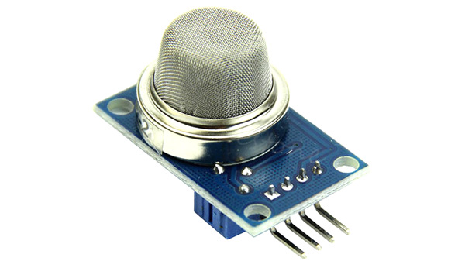

Fig. 3.1 MQ-6 Gas Sensor Module (Source: Components101, n.d.)

### 3.2.1 Features

The features of an MQ-6 gas sensor module are:

* Operating Voltage is +5V
* Can be used to detect LPG or Butane gas
* Analog output voltage: 0V to 5V
* Digital Output Voltage: 0V or 5V (TTL Logic)
* Preheat duration 20 seconds
* Can be used as a Digital or analog sensor
* The Sensitivity of Digital pin can be varied using the potentiometer

### 3.2.2 Construction

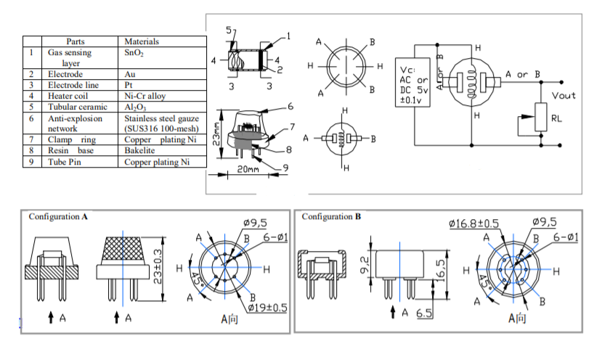

Fig. 3.2 Internal structure and construction materials used in MQ-6 Gas Sensor (Source: Components101, n.d.)

Structure and configuration of MQ-6 gas sensor is shown as Fig. 1 (Configuration A or B), sensor composed by micro AL2O3 ceramic tube, Tin Dioxide (SnO2) sensitive layer, measuring electrode and heater are fixed into a crust made by plastic and stainless steel net. The heater provides necessary work conditions for work of sensitive components. The enveloped MQ-6 have 6 pin , 4 of them are used to fetch signals, and other 2 are used for providing heating current.

### 3.2.3 Pin Configuration

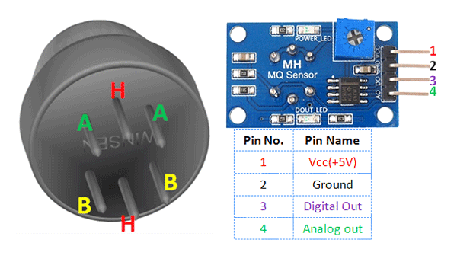

Fig. 3.1 Pin Configuration of MQ-6 Gas Sensor Module (Source: Components101, n.d.)

|  |  |  |
| --- | --- | --- |
| 1 | Vcc | This pin powers the module, typically the operating voltage is +5V |
| 2 | Ground | Used to connect the module to system ground |
| 3 | Digital Out | You can also use this sensor to get digital output from this pin, by setting a threshold value using the potentiometer |
| 4 | Analog Out | This pin outputs 0-5V analog voltage based on the intensity of the gas |

### 3.2.4 Applications

The applications of an MQ-6 gas sensor are:

* Detect or measure Gases like LPG, and butane
* Air quality monitor
* Gas leak alarm
* Safety standard maintenance
* Maintaining environment standards  in hospitals

## 3.3 MQ-3 Alcohol Sensor Module

MQ-3 gas sensor module is suitable for detecting Alcohol, Benzene, CH4, Hexane, LPG, CO. Sensitive material of MQ-3 gas sensor is SnO2, which with lower conductivity in clean air. When the target alcohol gas exist, the sensor’s conductivity is higher along with the gas concentration rising. MQ-3 gas sensor has high sensitivity to Alcohol, and has good resistance to disturb of gasoline, smoke and vapor.

This sensor provides an analog resistive output based on alcohol concentration. When the alcohol gas exist, the sensor’s conductivity gets higher along with the gas concentration rising. In the picture the blue colored square shaped component on the module is a potentiometer which is used to set the sensitivity of the sensor. By rotating it we can set the sensitivity of the sensor (rotating anti-clockwise will result decrease in sensitivity and rotating clockwise will result the increase in sensitivity). There are two LEDs on the module. One is power LED and other one is D0-LED. D0-LED will show the output of the sensor i.e whether alcohol is present in the environment or not. The IC present on the module is a comparator IC; it will compare the signal coming from the potentiometer and the signal coming from the sensor. The output will be shown through D0 pin (Either 0 or 1). A0 is the direct analog output; the quantity of alcohol sensed by the sensor will be shown by A0. A0 and D0 will be fed to the arduino board for further programming. Whenever the amount of alcohol sensed by the sensor will increase the voltage at A0 pin will also increase and vice-versa.

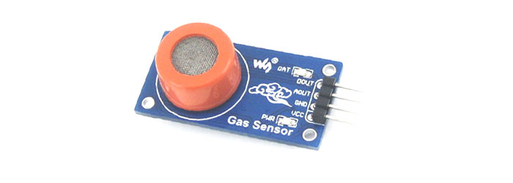

Fig. 3.1 MQ-3 Alcohol Sensor Module (Source: Components101, n.d.)

### 3.2.1 Features

The features of an MQ-3 gas sensor module are:

* Sensor Type - Semiconductor
* Easy SIP header interface
* Compatible with most of the microcontrollers
* Low-power standby mode
* Requires heater voltage
* Good sensitivity to alcohol gas
* Fast response and High sensitivity
* Long life and low cost
* Requires simple Drive circuit

### 3.3.2 Construction

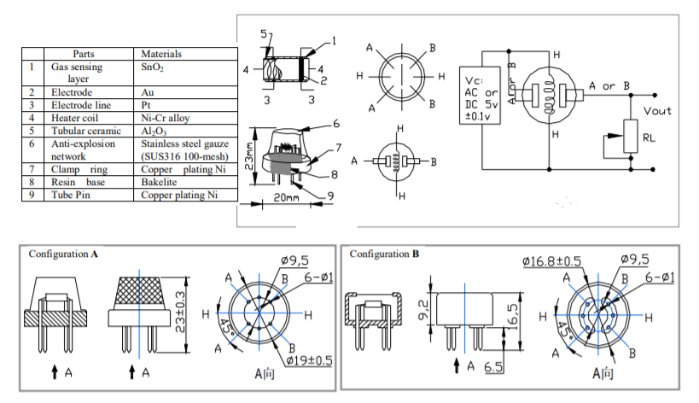

Fig. 3.2 Internal structure and construction materials used in MQ-3 Alcohol Sensor (Source: Components101, n.d.)

Structure and configuration of MQ-3 gas sensor is shown in the Fig. 3.2 (Configuration A or B), sensor composed by micro AL2O3 ceramic tube, Tin Dioxide (SnO2) sensitive layer, measuring electrode and heater are fixed into a crust made by plastic and stainless steel net. The heater provides necessary work conditions for work of sensitive components. The enveloped MQ-3 has 6 pin, 4 of them are used to fetch signals, and other 2 are used for providing heating current.

There is a resistance across A and B inside the sensor which varies on detection of alcohol. The higher the alcohol detected, the lower is the resistance. The alcohol is measured by measuring this resistance. The sensor and load resistor form a voltage divider, and the lower the sensor resistance, the higher the voltage reading will be.

### 3.3.3 Pin Configuration



Fig. 3.1 Pin Configuration of MQ-3 Gas Sensor Module (Source: Components101, n.d.)

|  |  |  |
| --- | --- | --- |
| 1 | Vcc | This pin powers the module, typically the operating voltage is +5V |
| 2 | Ground | Used to connect the module to system ground |
| 3 | Digital Out | You can also use this sensor to get digital output from this pin, by setting a threshold value using the potentiometer |
| 4 | Analog Out | This pin outputs 0-5V analog voltage based on the intensity of the gas |

### 3.3.4 Applications

The applications of an MQ-6 gas sensor are:

* Gas level over-limit alarm
* Breath analyser
* Portable alcohol detector
* Stand-alone/background sensing device
* Environmental monitoring equipment

## 3.4 NODEMCU

In this project, a Nodemcu development board is used to control the Emergency Shutdown System (ESD), the Buzzer,and the Propeller. After the MQ-6 gas sensor has detected the leakage of LPG, the microcontroller acts by sending signals to ESD to turn off the LPG gas regulator, ring the alarm bell to alert the household members, turn on the propeller to fan out the already leaked gas.The block diagram of the system is shown by Fig. 3.2.

NodeMCU is an open-source LUA based firmware developed for the ESP8266 wifi chip. By exploring functionality with the ESP8266 chip, NodeMCU firmware comes with the ESP8266 Development board/kit i.e. NodeMCU Development board. Since NodeMCU is an open-source platform, its hardware design is open for edit/modify/build.

NodeMCU Dev Kit/board consist of ESP8266 wifi enabled chip. The **ESP8266** is a low-cost Wi-Fi chip developed by Espressif Systems with TCP/IP protocol.

### 3.4.1 Different Models

The NodeMCU is available in various package styles. Common to all the designs is the base ESP8266 core. Designs based on the architecture have maintained the standard 30-pin layout. Some designs use the more common narrow (0.9″) footprint, while others use a wide (1.1″) footprint – an important consideration to be aware of.

The most common models of the NodeMCU are the Amica (based on the standard narrow pin-spacing) and the LoLin which has the wider pin spacing and larger board. The open-source design of the base ESP8266 enables the market to design new varients of the NodeMCU continually. Fig. 3.3 and Fig. 3.4 shows the two most popular Models Official Amica NodeMCU and LoLin NodeMCU respectively.

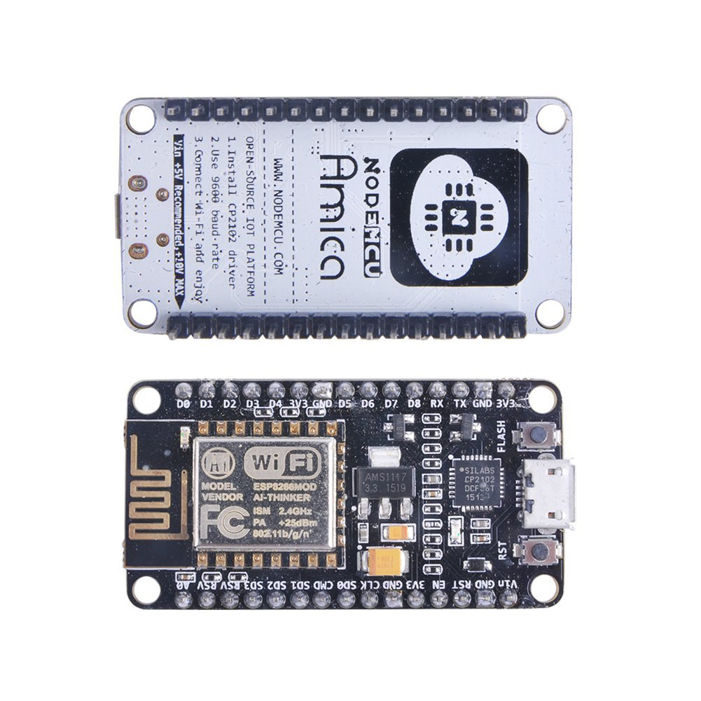

Fig. 3.3 Official Amica NodeMCU

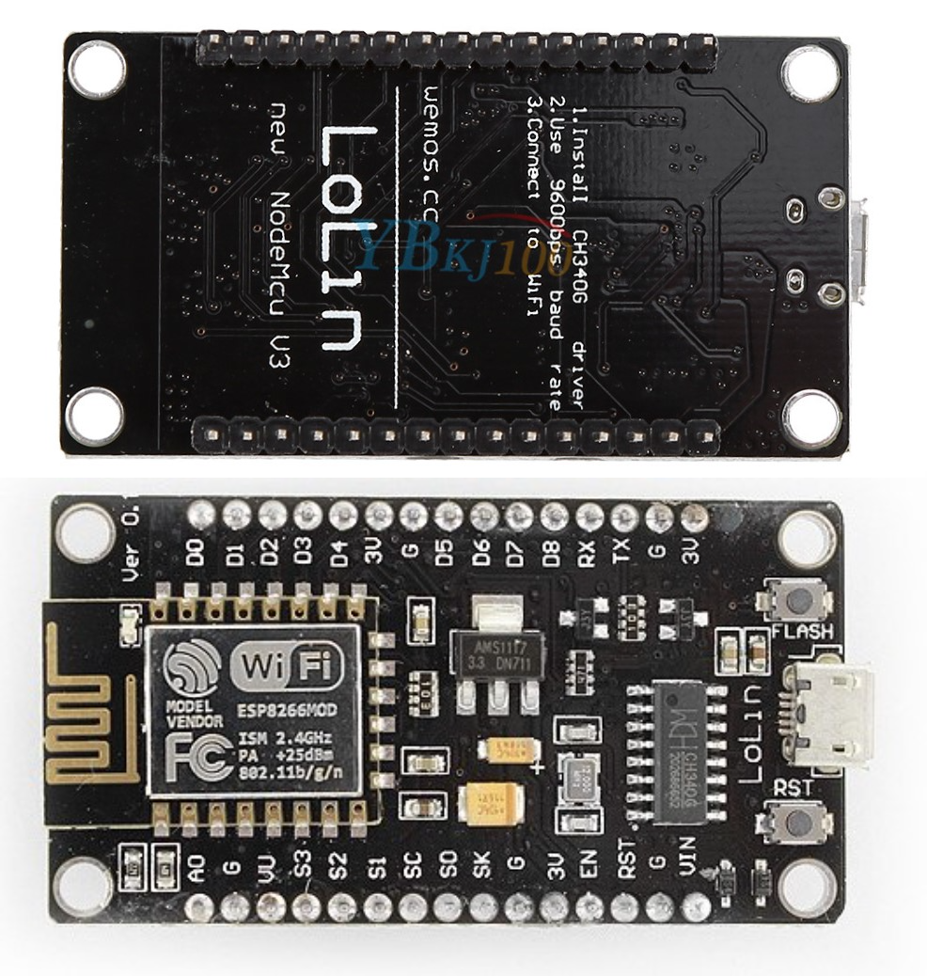

Fig. 3.3 LoLin NodeMCU

### 3.4.2 Pinout Configuration

Table 3.4 provides the standard pinout configuration of any NodeMCU development board model in a tabular form.

Table 3.4 Pinout configuration

|  |  |  |
| --- | --- | --- |
| **Pin Category** | **Name** | **Description** |
| Power | Micro-USB, 3.3V, GND, Vin | **Micro-USB:** NodeMCU can be powered through the USB port    **3.3V:** Regulated 3.3V can be supplied to this pin to power the board    **GND:** Ground pins    **Vin:**External Power Supply |
| Control Pins | EN, RST | The pin and the button resets the microcontroller |
| Analog Pin | A0 | Used to measure analog voltage in the range of 0-3.3V |
| GPIO Pins | GPIO1 to GPIO16 | NodeMCU has 16 general purpose input-output pins on its board |
| SPI Pins | SD1, CMD, SD0, CLK | NodeMCU has four pins available for SPI communication. |
| UART Pins | TXD0, RXD0, TXD2, RXD2 | NodeMCU has two UART interfaces, UART0 (RXD0 & TXD0) and UART1 (RXD1 & TXD1). UART1 is used to upload the firmware/program. |
| I2C Pins |  | NodeMCU has I2C functionality support but due to the internal functionality of these pins, you have to find which pin is I2C. |

(Source: Components101, n.d.)

The standard pinout configuration of NodeMCU V3 development board is shown graphically by Fig. 3.2.

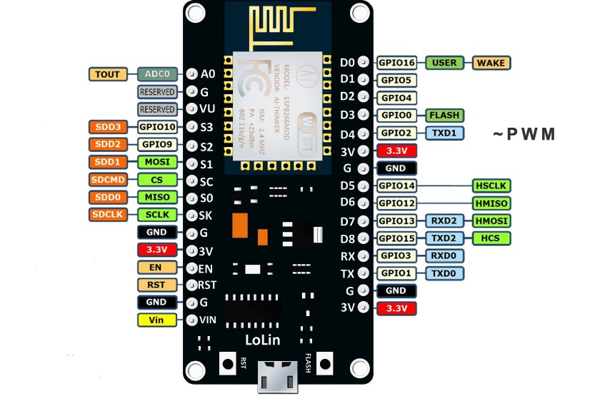

Fig. 3.4 Pinout configuration of Nodemcu V3 (Source: teachmemicro, n.d.)

## 3.5 POWER SUPPLY

The Power Supply Unit consists of a 240 V, 50 Hz alternating current source that is stepped down to approximately 9.5 V by a step-down transformer. The 9.5 V AC is rectified using a full wave bridge rectifier and smoothened by shunt capacitor filter to 12 V DC. The 12 V is regulated to 5 V, which is fed to the microcontroller, buzzer and gas sensor.

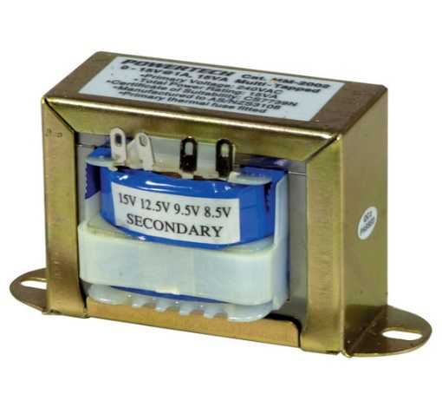

Fig. 3.5 Step-down Transformer (Source: Anon., 2016d)

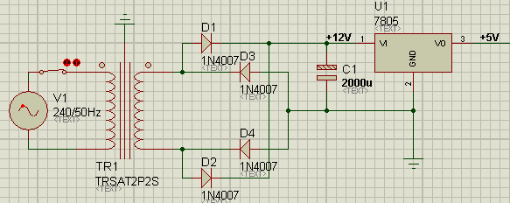

Fig. 3.6 Circuit Diagram of Power Supply Unit

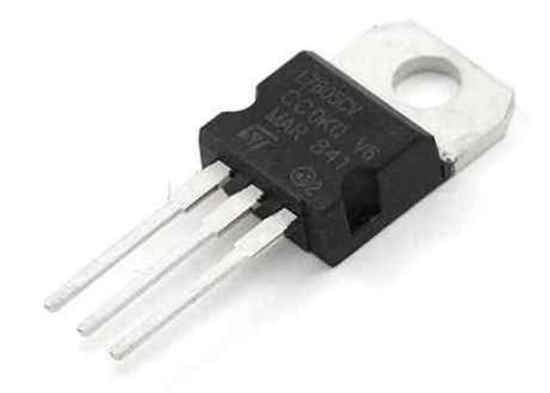

Fig. 3.7 LM7805 Voltage Regulator (Source: Anon., 2016c)

Fig. 3.5, Fig. 3.6 and Fig. 3.7 show a typical example of a step-down transformer, circuit diagram of the proposed power supply and an LM7805 voltage regulator respectively.

## 3.6 RELAY

A Relay is an electromechanical device that can be used to make or break an electrical connection. It consists of a flexible moving mechanical part which can be controlled electronically through an electromagnet, basically, a relay is just like a mechanical switch but you can control it with an electronic signal instead of manually turning it on or off. Again this **working principle of relay**fits only for the electromechanical relay.

There are many **types of relay** and each relay has its own application, a standard, and generally used relay is made up of electromagnets which in general used as a switch. Dictionary says that relay means the act of passing something from one thing to another, the same meaning can be applied to this device because the signal received from one side of the device controls the switching operation on the other side. So relay is a switch which controls (open and close) circuits electromechanically. The main operation of this device is to make or break contact with the help of a signal without any human involvement in order to switch it ON or OFF. It is mainly used to control a high powered circuit using a low power signal. Generally, a DC signal is used to control the circuit which is driven by high voltage like controlling AC home appliances with DC signals from microcontrollers.

### 3.6.1 Construction

On a casing, a core with copper windings (forms a coil) winded on it is placed. A movable armature consists of a spring support or stand like structure connected to one end, and a metal contact connected to another side, all these arrangements are placed over the core such that, when the coil is energized, it attracts the armature. The movable armature is generally considered as a common terminal which is to be connected to the external circuitry.

Fig. 3.8 shows how a Relay looks internally and how it can be constructed.

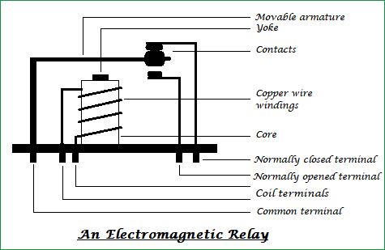

Fig. 3.8 Internal Structure of a relay (Source: Vamshidhar, 2017)

### 3.6.2 Operation

The relay has two pins namely normally closed and normally opened (NC and NO),the normally closed pin is connected to the armature or the common terminal whereas the normally opened pin is left free (when the coil is not energized). When the coil is energized the armature moves and is get connected to the normally opened contact till there exists flow of current through the coil. When it is de-energized it goes to its initial position.

**Relay in NORMALLY CLOSED condition:**

When no voltage is applied to the core, it cannot generate any magnetic field and it doesn’t act as a magnet. Therefore, it cannot attract the movable armature. Thus, the initial position itself is the armature connected in normally closed position (NC)

**Relay in NORMALLY OPEN condition:**

When sufficient voltage is applied to the core it starts to create a magnetic field around it and acts as a magnet. Since the movable armature is placed within its range, it gets attracted to that magnetic field created by the core, thus the position of the armature is being altered. It is now connected to the normally opened pin of the relay and external circuit connected to it function in a different manner.

So finally, we can say that when a coil is energized the armature is attracted and the switching action can be seen, if the coil is de-energized it loses its magnetic property and the armature goes back to its initial position.

Fig. 3.9 shows the single pole double throw working of a relay.

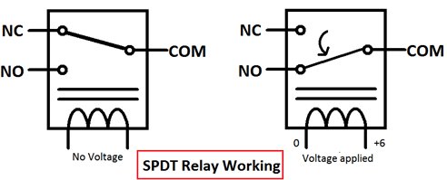

Fig. 3.9 Single Pole Double Throw (SPDT) Working of Relay (Source: Vamshidhar, 2017)

## 3.7 SERVO MOTOR

Servo is an electromagnetic device uses a negative feedback mechanism to converts an electric signal into controlled motion. Basically, servos behave like as actuators which provide precise control over velocity, acceleration, and linear or angular position. It consists of four things: DC motor, position sensor, gear train, and a control circuit. The gear mechanism connected with the motor provides the feedback to the position sensor.

If the motor of the servo is operated by DC then it is called a DC servo motor and if it is operated by AC then it is called as AC servo motor. The gear of the servo motor is generally made up of plastic but in high power servos, it is made up of metal.

### 3.7.1 Construction

The Servo motor is DC motor which has 5 following parts:-

* **Stator Winding**: This type of winding wound on the stationary part of the motor. It is also known as field winding of the motor.
* **Rotor** **Winding**: This type of winding wound on the rotating part of the motor. It is also known as an armature winding of the motor.
* **Bearing**: These are of two types,i.e, font bearing and back bearing which are used for the movement of the shaft.
* **Shaft**: The armature winding is coupled on the iron rod is known as the shaft of the motor.
* **Encoder**: It has the approximate sensor which determines the rotational speed of motor and revolution per minute of the motor.

Fig. 3.10 shows the internal construction of servo motors.

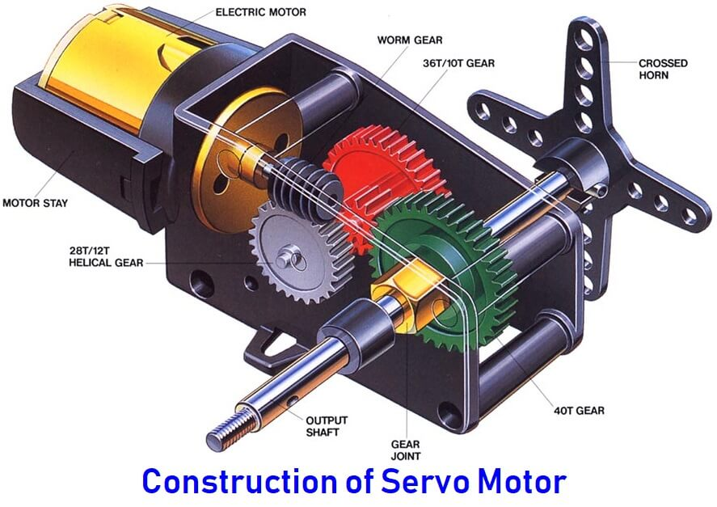

Fig. 3.10 Internal Construction of Servo Motors (Source: electricaltechnology, n.d.)

### 3.7.2 Operation

It consists of three basic types:

* Controlling Device
* Output Sensor
* Feedback system

The servo motor works on the phenomenon of the automatic closed-loop system. The controller is required for this closed-loop system. This controller is composed of a comparator and a feedback path. It has one output and two inputs. In this, for producing an output signal, the comparator is used to compare the required reference signal and this output signal is sensed by the sensor. The input signal for the motor is termed as a feedback signal. On the basis of the feedback signal, the motor starts working. Comparator signal is called a logic signal of the motor. The motor would be ON for the desired time when the logical difference is higher and the motor would be OFF for the desired time when the logical difference is lower. Basically, a comparator is used to decide that motor would be ON or OFF. Proper functioning of the motor can be done with the help of a good controller.

The servo motors can be controlled by the method PWM i.e., Pulse Width Modulation. These send electric signals of inconsistent width to the motor. The width pulse is varied in the range of 1 millisecond to 2 milliseconds and transfers this to the servo motors with repeating 50 times in a second. The width of the pulse controls the angular position of the rotating shaft. In this, three terms are used which shows the controlling of the servomotor i.e., a maximum pulse, minimum pulse and repetition rate.

For example, the servo moves with the pulse of 1 millisecond to turn motor towards 0˚ whereas a pulse of 2 milliseconds to turn motor towards 180˚ Between the angular positions, the pulse width interchange by itself. Therefore, the servo turns to the 90˚ with the pulse of width 1.5 milliseconds as shown in Fig. 3.11.

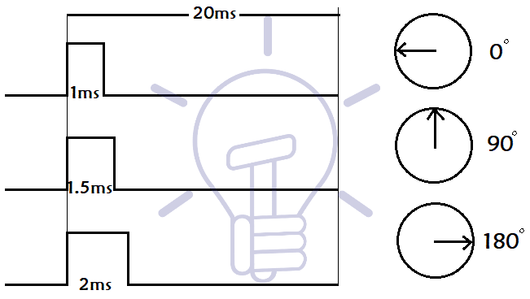

Fig. 3.11 Controlling of Servo Motors (Source: electricaltechnology, n.d.)

There are three wires or leads in every servo motors. The two wires used from positive supply and ground supply whereas the third wire is used to control the signal.

## 3.8 PROPELLER

A propeller is a device with a rotating hub and radiating blades that are set at a pitch to form a helical spiral, that, when rotated, performs an action which is similar to [Archimedes' screw](https://en.wikipedia.org/wiki/Archimedes%27_screw). It transforms rotational power into linear thrust by acting upon a working fluid, such as water or air. The [rotational](https://en.wikipedia.org/wiki/Rotational) motion of the blades is converted into [thrust](https://en.wikipedia.org/wiki/Thrust) by creating a pressure difference between the two surfaces. A given mass of working fluid is accelerated in one direction and the craft moves in the opposite direction. Propeller dynamics, like those of aircraft wings, can be modeled by [Bernoulli's principle](https://en.wikipedia.org/wiki/Bernoulli%27s_principle) and [Newton's third law](https://en.wikipedia.org/wiki/Newton%27s_laws_of_motion). Most marine propellers are screw propellers with helical blades rotating on a [propeller shaft](https://en.wikipedia.org/wiki/Propeller_shaft_(ship)) with an approximately horizontal axis. Fig. 3.12 shows a propeller exhaust fan.

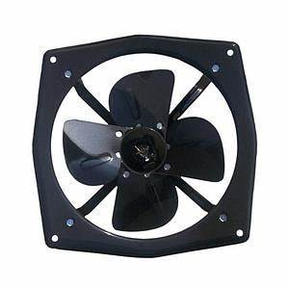

Fig. 3.12 Propeller Exhaust fan (Source: industrylane.com, n.d.)

## 3.9 PIEZO BUZZER

**Piezo buzzer** is an electronic device commonly used to produce sound. Light weight, simple construction and low price make it usable in various applications like car/truck reversing indicator, computers, call bells etc. Piezo buzzer is based on the inverse principle of piezo electricity discovered in 1880 by Jacques and Pierre Curie. It is the phenomena of generating electricity when mechanical pressure is applied to certain materials and the vice versa is also true. Such materials are called piezo electric materials. Piezo electric materials are either naturally available or manmade. Piezoceramic is class of manmade material, which poses piezo electric effect and is widely used to make disc, the heart of piezo buzzer. When subjected to an alternating electric field they stretch or compress, in accordance with the frequency of the signal thereby producing sound.

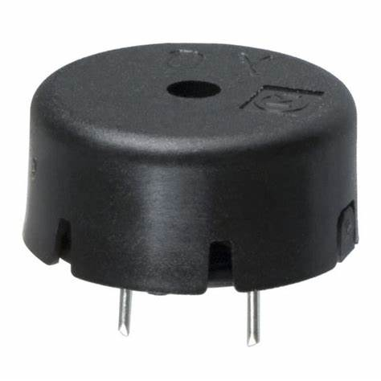

Fig. 3.13 Piezo Electric Buzzer (Source: Ashutosh, 2011)

Fig. 3.13 given above shows a very commonly used piezo buzzer also called **piezo transducer** operating at DC voltage. Encapsulated in a cylindrical plastic coating, it has a hole on the top face for sound to propagate.

## 3.10 PRINTED CIRCUIT BOARD

## See the source image

Fig. 3.13 Blank Printed Circuit Board (Source: Pcbcart, n.d.)

PCB is a copper laminated and non-conductive **Printed Circuit Board**, in which all electrical and electronic components are connected together in one common board with physical support for all components with base of board. When PCB is not developed, at that time all components are connected with a wire which increases complexity and decreases reliability of the circuit, by this way we cannot make a very large circuit like motherboard. In PCB, all components are connected without wires, **all components are connected internally**, so it will reduce the complexity of the overall circuit design. PCB is used to provide electricity and connectivity between the components, by which it functions the way it was designed. PCBs can be customized for any specifications to user requirements. It can be found in many electronics devices like; TV, Mobile, Digital camera, Computers parts like; Graphic cards, Motherboard, etc. It also used in many fields like; medical devices, industrial machinery, automotive industries, lighting, etc.

## 3.11 ARDUINO SOFTWARE IDE



The Arduino Integrated Development Environment (IDE) is a cross-platform application (for Windows, macOS, Linux) that is written in functions from C and C++. programming language makes it easy to write code and upload it to the board. Besides any Arduino board this software can be used with other boards if we upload the Arduino sketch on it. For example here we’ve erased the Nodemcu firmware and replaced it by Arduino sketch.

Active development of the Arduino software is [hosted by GitHub](https://github.com/arduino/Arduino/).

Fig. 3.14 shows the flowchart of the proposed design.

Check for Leakage

MQ6, MQ3 sensor O/P>=Threshold Value

FALSE

Turn OFF gas regulator

Turn ON Exhaust fan

Turn ON Buzzer

TRUE

Fig. 3.14 Flowchart of the Proposed Design