**DESIGN OF LPG, SMOKE, AND ALCOHOL DETECTION SYSTEM WITH AUTOMATIC MAINS CUT-OFF**

***A Report submitted***

***in partial fulfillment for the Degree of***

**B. Tech**

**in**

**Electronics & Communication Engineering**

***by***

**ANUPAM ROY, ACHINTYA ROY, ADITI RAY, ADITI DAS, PRATIMA MAITI, DEBAYAN MUKHERJEE**

pursued in

**Department of Electronics & Communication Engineering**

**Techno International New Town**

To



**TECHNO INTERNATIONAL NEW TOWN**

**KOLKATA**

**OCTOBER, 2020**

**TECHNO INTERNATIONAL NEW TOWN**

**NEWTOWN, KOLKATA**

**DEPARTMENT OF ELECTRONICS & COMMUNICATION ENGINEERING**



CERTIFICATE

This is to certify that the project report entitled **Design of LPG, Smoke, and Alcohol Detection System with Automatic Mains cut-off** submitted by **Anupam Roy, Achintya Roy, Aditi Ray, Aditi Das, Pratima Maiti, and Debayan Mukherjee** to the Techno International New Town, Kolkata, in partial fulfillment for the award of the degree of **B. Tech in (Electronics & Communication Engineering)** is a *bona fide* record of project work carried out by them under our supervision. The contents of this report, in full or in parts, have not been submitted to any other Institution or University for the award of any degree or diploma.

Prof. (Dr.) Pradip Kumar Ghosh Prof. (Dr.) Subhankar Bhattcharjee

Supervisor Co-Supervisor

Department of Electronics & Department of Electronics &

Communication Engineering Communication Engineering

Kolkata

October, 2020

DECLARATION

We declare that this project report titled **Design of LPG, Smoke, and Alcohol Detection System with Automatic Mains cut-off** submitted in partial fulfillment of the degree of **B. Tech in (Electronics & Communication Engineering)** is a record of original work carried out by us under the supervision of **Prof. (Dr.) Pradip Kumar Ghosh and Prof. (Dr) Subhankar Bhattcharjee**, and has not formed the basis for the award of any other degree or diploma, in this or any other Institution or University. In keeping with the ethical practice in reporting scientific information, due acknowledgements have been made wherever the findings of others have been cited.

1. Anupam Roy
2. Achintya Roy
3. Aditi Ray
4. Aditi Das
5. Pratima Das
6. Debayan Mukherjee

Signature(s):

Kolkata

Date: -

ACKNOWLEDGMENTS

We would like to make our deepest appreciation and gratitude to Prof. (Dr.) Pradip Kumar Ghosh and Prof. (Dr.) Subhankar Bhattacharjee for his invaluable guidance, constructive criticism and encouragement during the course of this project.

We are also grateful to Prof. (Dr.) Manabendra Maiti, Head of the Department, Electronics & Communication Engineering for providing the necessary opportunities for the completion of this project.

In the last we would like to thank the management of Techno International New Town, for providing us such an opportunity to learn from these experiences.

Anupam Roy

Achintya Roy

Aditi Ray

Aditi Das

Pratima Maiti

Debayan Mukherjee

# TABLE OF CONTENTS

**Contents Page**

**DECLARATION i**

**ABSTRACT ii**

**DEDICATION iii**

**ACKNOWLEDGEMENT iv**

**TABLE OF CONTENTS v**

**LIST OF FIGURES vii**

**LIST OF TABLES viii**

**CHAPTER 1 INTRODUCTION 1**

1.1 Problem Definition 1

1.2 Objectives 2

1.3 Methods Used 2

1.4 Facilities Used 2

1.5 Scope of Work 3

1.6 Work Organization 3

**CHAPTER 2 LITERATURE REVIEW 4**

2.1 Introduction 4

2.2 Classifications of Leakage Detection Technology 4

2.3 MQ Series Semiconductor Gas Sensors 16

2.4 Related Works 17

**CHAPTER 3 PROPOSED DESIGN AND COMPONENT SELECTION 19**

3.1 Introduction 19

3.2 MQ-6 Sensor Module 19

3.2.1 Features 19

3.2.2 Pin Configuration 20

3.3 MQ-3 Sensor Module 21

3.3.1 Features 23

3.3.2 Pin Configuration 24

3.4 Arduino Uno Rev3 27

3.4.1 Features 28

3.4.2 Pin Configuration 28

3.5 Micro Servo Motor 30

3.5.1 Features 31

3.5.2 Operation 32

3.5.3 Wire Configuration 32

3.6 Piezo Active Buzzer 32

3.6.1 Features 33

3.6.2 Pinout Configuration 33

3.7 Light Emitting Diode 33

3.7.1 Features 33

3.7.2 Pinout Configuration 33

3.8 Printed Circuit Board 33

3.9 Arduino Software IDE 33

3.10 Proteus Design Suite 33

3.11 Power Adapter & USB(A to B) Cable 33

3.11.1 Features of Power Adapter 33

3.11.2 Features of USB(A to B) Cable 33

3.12 Box Enclosure Case 33

3.12.1 Features 33

3.13 Flow chart of Proposed Design 33

**CHAPTER 4 RESULT ANALYSIS AND DISCUSSION 36**

4.1 Introduction 36

4.2 Circuit Simulator 36

4.3 Analysis of Simulation 36

4.4 Cost Estimation 40

**CHAPTER 5 CONCLUSION AND RECOMMENDATIONS 41**

5.1 Conclusion 41

5.2 Recommendations 41

**REFERENCES 42**

**APPENDICES 47**

APPENDIX A SOURCE CODE 47

APPENDIX B DATASHEETS OF SENSORS USED 47

# LIST OF FIGURES

**Figure Title Page**

1.1 Graphical inference of NSS 2018 report 5

2.1 Gas Leak Detection Techniques based on Technical Nature 15

3.1 MQ-6 Sensor Module 20

3.2 Pinout diagram of an MQ-6 Sensor Module 22

3.3 MQ-3 Sensor Module 24

3.4 Pinout Diagram of an MQ-3 Sensor Module 25

3.5 Arduino Uno Rev3 27

3.6 Pinout Diagram of Arduino Uno Rev3 28

3.7 Micro Servo Motor, gear horns and screws 28

3.8 Controlling of Servo Motors 30

3.9 Wire Configuration of Micro Servo Motor 31

3.10 Piezo Active Buzzer 32

3.11 Pinout Diagram of a Piezo Active Buzzer 34

3.12 Light Emitting Diode 35

3.13 Pinout Diagram of a LED 37

3.14 Printed Circuit Board 38

3.15 Arduino Integrated Development Platform (IDE) 38

3.16 Proteus Design Suite 39

3.17 Micromax Power Adapter 40

3.18 USB (A to B) Cable 40

3.19 Box Enclosure Case 41

3.20 Flowchart of the Proposed Design 40

4.1 System’s Simulated Diagram under Normal Conditions 39

4.2 System’s Simulated Diagram when MQ-6 sensor detects leakage 40

4.3 System’s Simulated Diagram when MQ-3 sensor detects leakage 41

4.4 System’s Simulated Diagram when MQ-6 and MQ-3 sensor

Detects Leakage 42

# LIST OF TABLES

**Table Title Page**

1.1 Injuries and Deaths due to Cooking Gas Cylinder Leakage in 2019 17

1.2 Injuries and Deaths due to Cooking Gas Cylinder Leakage in 2018 20

1.3 Percentage of Rural Households with the type of cooking fuel used 21

1.4 Percentage of Urban Households with the type of cooking fuel used 22

1.5 Percentage of Rural-urban combined Households with the type of cooking

fuel used 23

2.1 MQ Series Target gases 21

3.1 Pinout Configuration and description of an MQ-6 Sensor Module 21

3.2 Pinout Configuration and description of an MQ-3 Sensor Module 23

3.3 Pinout configuration and description of Arduino Uno Rev3 30

3.4 Wire Configuration and description of Micro Servo Motor 34

3.5 Pinout Configuration and description of a Piezo Active Buzzer 40

3.6 Pinout Configuration and description of a LED 41

4.1 Cost Analysis 41

ABSTRACT

Household and Hotel fires have been taking place frequently and the threat to human lives and properties is growing in recent years. Liquid petroleum gas (LPG) is very inflammable and may burn even at a long way from the leakage. Most fire accidents are caused due to rubber tube being poor-quality and/or the gas regulator not turned off when it is not being used. Therefore, developing the gas leakage alert and control system is very essential. Hence, in this project we have proposed a LPG, Smoke, and Alcohol detection system with automatic mains gas supply cut-off.

The system will work such that if there’s a LPG leakage from gas cylinders, it will ring an alarm, turn off the gas regulator key to stop further gas leakage. It will also detect smoke and inflammable liquids like Ethanol (Alcohol) near the gas cylinders which pose a threat to normal working of the gas cylinders.

So, our build up will be a hit for household, hotel kitchen and small scale industries as it is smart and cheap which not only acts as a detecting system but also can take care of the leakage. Our work was also focused on how to make it affordable to general public.

CHAPTER 1

# INTRODUCTION

## Problem Definition

Leakage of gas poses great danger during this era where the utilization of gas has become a crucial source of industrial, household, vehicular energy. The leakage of LPG is understood to cause serious accidents which have resulted in loss of lives and assets amounting a billion of dollars whole world across.

Table 1.1 is an excerpt from the cooking gas accidents section of the Accidental Deaths and Suicides in India (ADSI) 2019 report whose data is collected by State Crime Records Bureaux (SCRBx) from the District Crime Records Bureaux (DCRBx) and sent to National Crime Records Bureau (NCRB) working under the Ministry of Home Affairs, Government of India at the end of the year under reference, which shows that 346 people died in Tamil Nadu because of accidental fire which occurred while using cooking gas cylinders. Maharashtra registered 285 such deaths. Tamil Nadu tops the southern states in the category, far above Andhra Pradesh (93), Karnataka (286) and Kerala (53). This means more than 6 people in Tamil Nadu only die every week because of accidental fire due to cooking gas cylinders. On the whole, there have been 2143 such deaths in 2019.

Table 1.2 in an excerpt from the cooking gas accident section of the same ADSI report published by NCRB mentioned in the previous paragraph, but of the year 2018, where Maharashtra (646), Tamil Nadu (391), Madhya Pradesh (331) are the major contributors to deaths due to accidental fire which occurred while using cooking gas cylinders.

LPG is one of the most commonly used fuels in India as indicated by a survey conducted by National Statistical Office (NSO) working under the Ministry of Statistics and Programme Implementation, Government of India in its 76th round of National Sample Survey (NSS) between July and December 2018 shown by Table 1.3, Table 1.4 and Table 1.5, which revealed that 48.3% household in rural areas and 86.6% household in urban areas making the average 61.4% Indians who use LPG as cooking fuel. Figure 1.1 published in an electronic news article in Business Standards written by (Jha & Jacob, 2019) draws a graphical inference from the statistical raw data presented by Table 1.3, Table 1.4 and Table 1.5 comparatively studying the rural, urban and rural-urban combined areas.

With Pradhan Mantri Ujjwala Yojana (PMUY) started by PM Narendra Modi Ji in 2016, the numbers are rapidly rising especially in the rural areas of India.

Mixture of inflammable gases like propane and butane forms LPG. As these gases are odourless, Ethyl Mercaptan is added as odorant to detect these gases by smell. But this technique doesn’t work in all cases as some people have poor sense of smell especially at low concentrations. Therefore a better, reliable and effective way of detecting the gas has to be adopted in industries, households and vehicles that use LPG. Installing gas leakage detection devices can help.

Some improvements are still feasible, though there have been grant leaps in developing effective LPG leakage detection and response systems during the past few years. The systems that are invented focus on the leakage detection and sounding of an alarm in response. Many other build ups detect LPG and using a microcontroller they ring an alarm and send Short Message Service (SMS) to proper person. These designs do not solve the problem of leakage, even though being helpful to an extent.

The aim of this build up is to deploy a system capable of LPG leakage detection and shutting down the supply of the gas automatically. The system consists of an MQ-6 gas sensor which is highly sensitivity to propane (C3H8) and butane (C4H10), MQ-3 alcohol sensor which are highly sensitivity to Ethanol (Alcohol) and smoke, an alarm, a microcontroller and a servo motor. This build up does not only detect LPG leakage but shuts down supply to minimise accidents and cut down price in lieu with the leakage.

It will also detect smoke and inflammable liquids like Ethanol (Alcohol) near the gas cylinders which pose a threat to normal working of the gas cylinders.

**Table 1.1** *Injuries and Deaths due to Cooking Gas Cylinder Leakage in 2019*

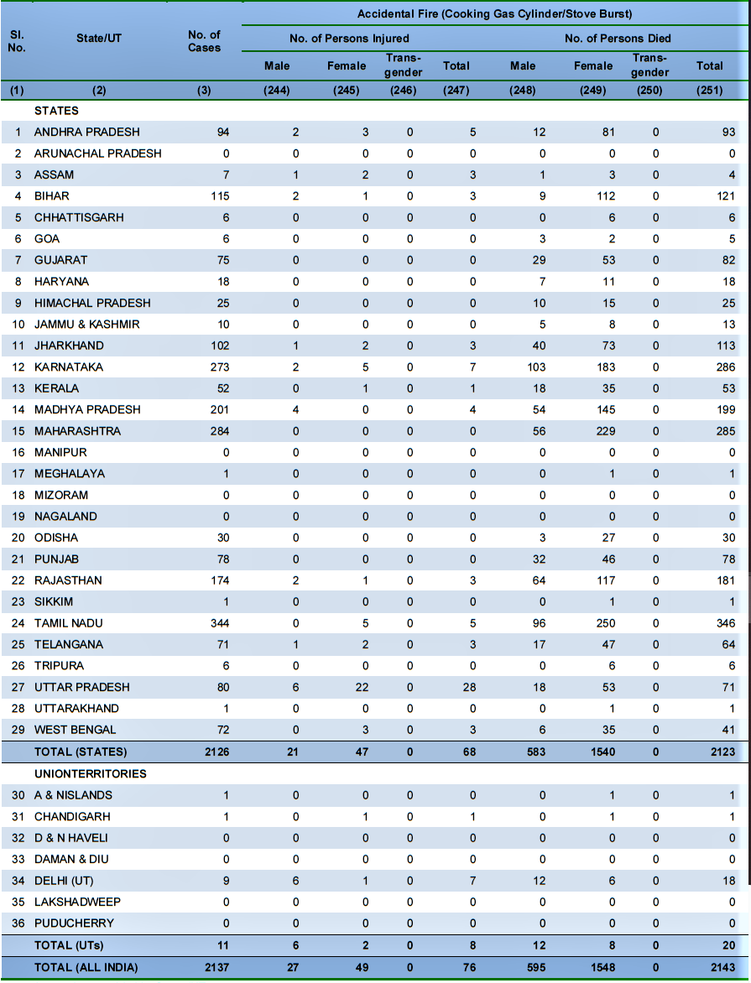

(Source: NCRB, 2019)

Table 1.1 above shows the number of deaths and injuries gender wise that were related to cooking gas leakage in various states and union territories of India in the year 2019.

**Table 1.2** *Injuries and Deaths due to Cooking Gas Cylinder Leakage in 2018*

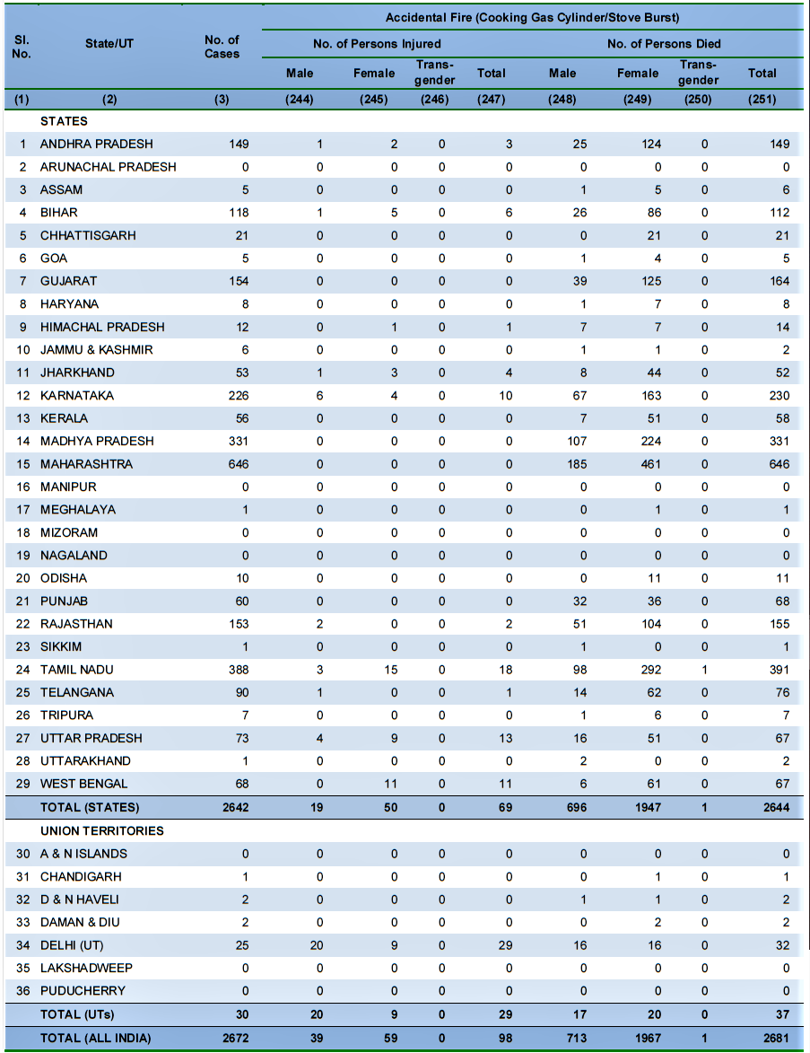

(Source: NCRB, 2018)

Table 1.2 above shows the number of deaths and injuries gender wise that were related to cooking gas leakage in various states and union territories of India in the year 2018.

**Table 1.3** *Percentage of Rural Households with the type of cooking fuel used*

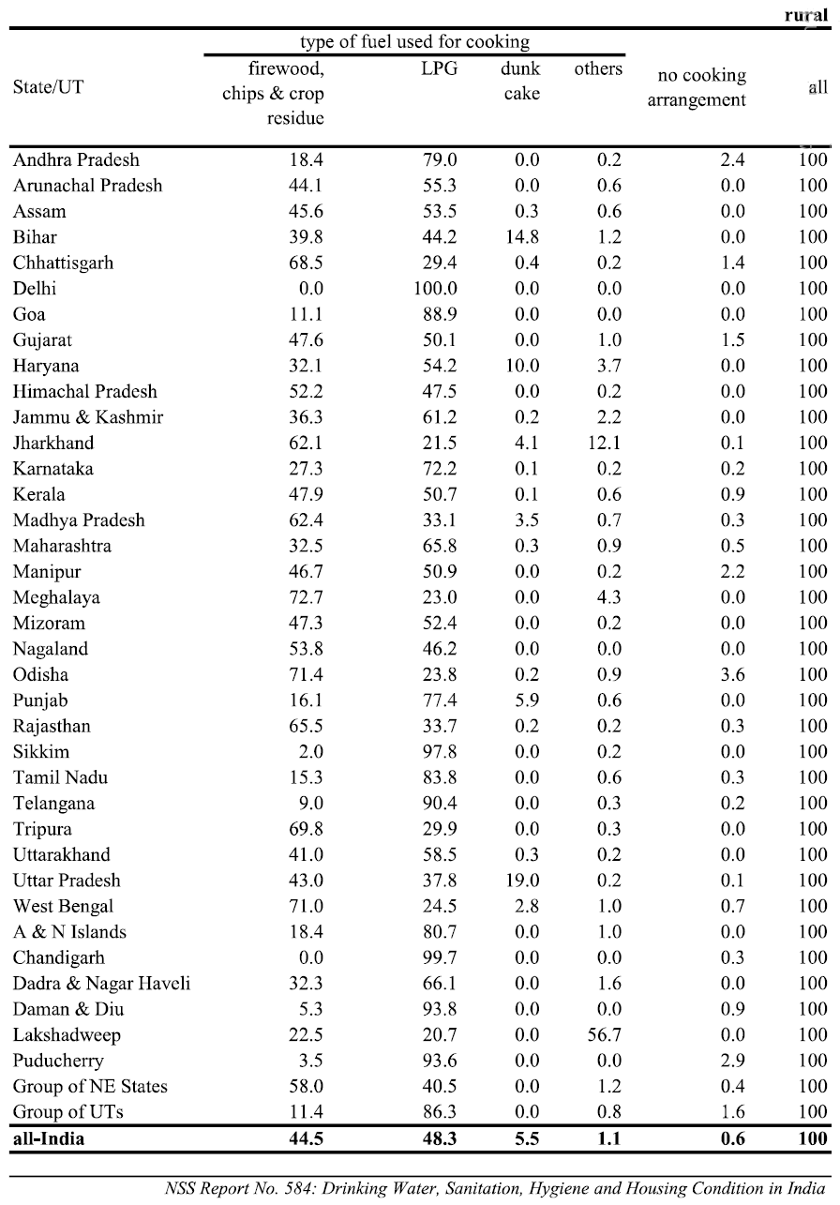

(Source: NSS, 2018)

Table 1.3 shows the percentage of rural households in different States and Union Territories of India by the type of cooking fuel they use.

**Table 1.4** *Percentage of Urban Households with the type of cooking fuel used*

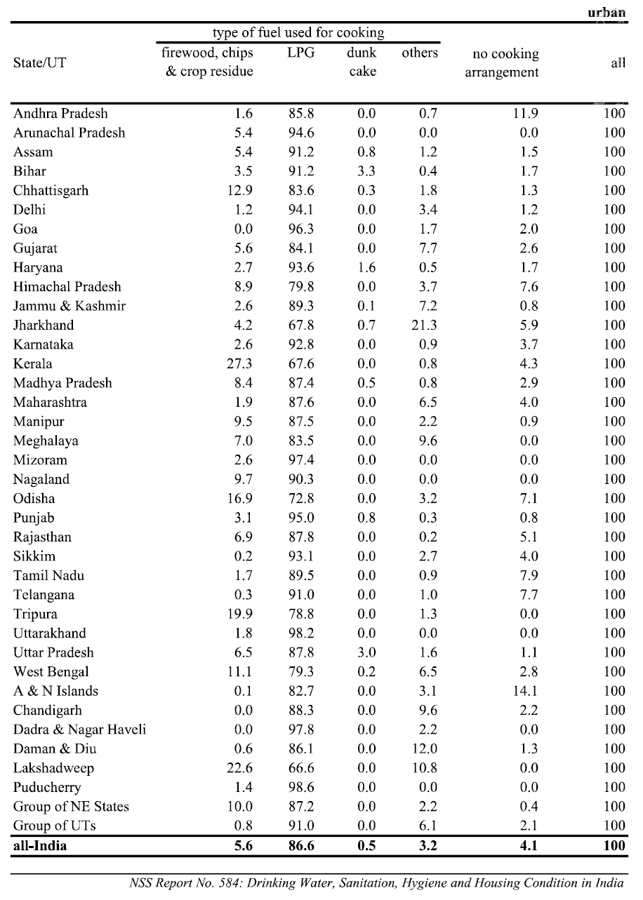

(Source: NSS, 2018)

Table 1.4 shows the percentage of urban households in different States and Union Territories of India by the type of cooking fuel they use.

**Table 1.5** *Percentage of rural-urban combined Households with the type of cooking fuel used*

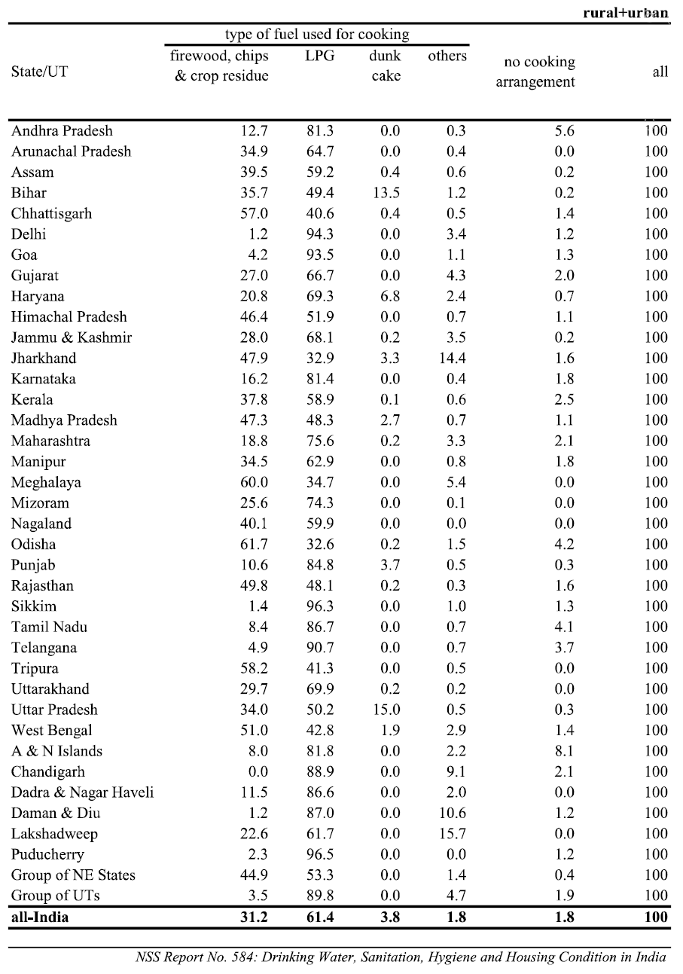

(Source: NSS, 2018)

Table 1.5 shows the percentage of rural households in different States and Union Territories of India by the type of cooking fuel they use.

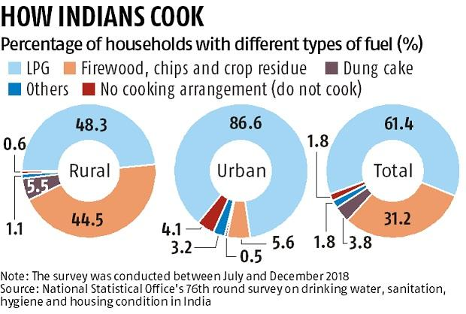

**Figure 1.1** *Graphical inference of NSS 2018 report* (Source: Jha & Jacob, 2019)

Figure 1.1 is a graphical inference from the statistical raw data presented by Table 1.3, Table 1.4 and Table 1.5 comparatively studying the rural, urban and rural-urban combined areas.

## 1.2 Objectives

The objectives of this project are:

* To design a system that monitors LPG leakage in an enclosed area;
* To design a system that alarms the user of the leakage;
* To design a system that switch off the gas regulator key during leakage;
* To design a system that propels out the already leaked gas; and
* To design a system that detects fire and alcohol near a gas cylinder.

## 1.3 Methods Used

The research methods adopted include:

* Review of literature related to this idea;
* Use of datasheet in selecting suitable components for the circuit design;
* Circuit design and simulation; and
* Analysis of results from simulation.

## 1.4 Facilities Used

The facilities used during this project include:

* Personal computer
* Internet access;

## 1.5 Scope of Work

This work is limited to the design of an efficient system for monitoring LPG leakage in a susceptible area, alerting the user and shutting down the mains gas supply using an arduino based system.

## 1.6 Work Organization

This work is organised into five chapters. Chapter one engages with the statement of the problem, aims of the project, methods being used, facilities being used to build up the project and the scope of work. Second chapter gives the review of the literature related to the idea. Third chapter focuses on the proposed design, hardware and software selection for the LPG leakage detection and response system. The fourth chapter gives an insight into the definition and importance of simulation; it also provides a detailed analysis of results from simulation and finally, the last chapter talks about discussion and conclusion.

CHAPTER 2

# LITERATURE REVIEW

## 2.1 Introduction

A mixture of commercial Butane and commercial Propane having saturated as well as unsaturated hydrocarbons makes up the LPG. Ethyl Mercaptan is added as strong odorant to detect leakage as it is devoid of odour. LPG is commonly used in homes for cooking as a convenient source of energy. This conventional non renewable energy source is highly inflammable.

In the year 1910, Walter Snelling first produced LPG (Didpaye1, 2015) and is declared as dangerous because of its flammable nature and explosive potential when kept under pressure. The presence of LPG was detected with a chemically infused paper that changed colour when exposed to gas, before the invention of electronics based gas detectors in the 1980s (Didpaye1, 2015). Since then, a number of technologies and devices have been devised to detect and alert the leakage of a wide array of gases. So, the requirement of an efficient system to detect leakage of LPG is inevitable, which may be used for commercial and household requirements.

Few of the important reasons to have an intelligent detection system are to avoid any casualties and damage of property. The smoke detection system which are self-monitoring and has the ability to initiate both audio and visual warnings in a spaced building as needed.

Smoke detector has been reviewed as a most fundamental component of active fire extinguishing strategy. In the late twentieth century, industries started using the smoke detectors to avoid any fatal accidents. Also, during the recent times, a lot of research work is going on to improve the existing system. Accurate prediction of the smoke detector is a very significant way of assessing its performance. Many times, it has been found that the detector gives faulty alarms, which should be rectified. Fire Dynamic Stimulator Software can be used to predict the response of the smoke detector system.

## 2.2 Classification of Leakage Detection Technologies

Leakage detection is classified into numerous categories, the physical quantity measured, the technical nature of the methods, and the amount of human intervention needed are some of them (Murvaya, 2011). In accordance to the degree of human intervention needed, detection method is classified into three categories (Murvaya, 2011):

Automated detection – After successful installation, we get a complete monitoring systems that, can report the leakage of gas without the need of a human, (e.g cable sensors and fibre optic);

Semi-automated detection – After successful installation, we get a complete monitoring systems that, can report the leakage of gas with the need of a little quantity of human input (e.g. digital and/or statistical signal processing methods); and

Manual detection – A person actively runs these devices and systems (e.g.Light Detection and Ranging (LIDAR) devices and thermal imagers).

Several techniques of detection depend on the measurement of the manifestation of certain physical phenomenon or a certain physical quantity. This fact is utilized for classification as there are many popularly known physical phenomena and parameters, which are, optics, gas sampling, pressure, flow rate, acoustics, and many times a hybrid of these. Due to this huge variety of detection solutions, technologies finding leakage are many times divided into optical and non-optical methods (Batzias *et al*., 2011).

Few authors see this division as fitting into two popular categories, which are direct methods and indirect methods (Folga, 2007 and Liu *et al*., 2008). The direct method involves patrolling along the pipelines checking gas emanations utilizing handheld devices and/or visual inspection (Liu *et al*., 2008). Indirect methods detect leaks by measuring the change of certain pipe specifications such as pressure and flow rate.

Leakage Detection Method

Non-technical Method

Hardware Based Method

Acoustic

Cable Sensor

Vapour Sampling

Optical

Soil Monitoring

Ultrasonic Flow Meter

Software Based Method

Pressure Point Analysis

Statistical

Real Time Transient Modelling

Mass/Volume Balance

Negative Pressure Wave

Digital Signal Processing

**Figure 2.1** *Gas Leak Detection Techniques based on Technical Nature* (Source: Murvaya, 2011).

Technical nature is the most famous way of classification of leakage detection methods (Scottand, 2003). Thus, two main categories can be distinguished; software based methods and hardware based methods. These two divisions are few times described as internally or externally based leakage detection systems. Fig. 2.1 illustrates these principle categories and the different methods involved with each of them. This division is close to the one presented in the earlier paragraph with the remark that indirect methods overlap with the software based methods whereas the direct methods cover both non-technical and hardware methods.

Non-technical leakage detection methods do not make use of any device and depend wholly on the natural senses (i.e. seeing, smelling and hearing) of humans and/or animals.

Hardware based method depends mainly on the use of special sensing devices in the gas leakage detection. According to the equipment and sensor type utilized for detection, these hardware methods can be further divided as: vapour sampling, ultrasonic flow meters, acoustic, soil monitoring, optical and cable sensor.

Software programs are installed at their core in software based models which consists of smart, predefined computer algorithms regularly checking the flow rate, temperature, pressure or other pipeline parameters and can decide, on the basis of evolution of these amounts, when leakage has happened.

## 2.3 MQ Series Semiconductor Gas Sensors

MQ-2 to MQ-9, MQ303, MQ306, MQ307, MQ131 and MQ135 to MQ138 with sensitivity to different kind of gases are available in the market. These are highly sensitive devices utilized for detection of a plethora of gases in a space. Various types of MQ sensors and their target gas are shown by Table 2.1.

**Table 2.1** *MQ Series Target gases.*

|  |  |
| --- | --- |
| **Semiconductor Sensor for Flammable Gas, Plastic or Metal Cover** | |
| **Model** | **Target Gas** |
| MQ-2 | General combustible gas |
| MQ-3 | Alcohol |
| MQ-4 | Natural gas, Methane |
| MQ-5 | LPG, Natural gas, Coal gas |
| MQ-6 | LPG, Propane, Smoke |
| MQ-7 | Carbon Monoxide |
| MQ-8 | Hydrogen |
| MQ-9 | CO and Combustible gas |
| MQ306 | LPG, Propane |
| MQ307 | Carbon Monoxide |
| MQ303 | Alcohol |
| MQ131 | Ozone |
| MQ135 | Air Quality Control |
| **Semiconductor Sensor for Toxic Gas** | |
| MQ136 | Sulphureted Hydrogen (H2S) |
| MQ137 | Ammonia (NH3) |
| MQ138 | Volatile Organic Compound (Mellow, Benzene, Aldehyde, Ketone, Ester ) |

(Source: Anon., 2015)

## 2.4 Related Works

Several number of research groups are working around the globe with the aim of development of LPG leakage detectors and response systems. The presence of gas was detected with a chemically infused paper that changed its color when exposed to the gas, before the development of electronic household gas detectors in the 1980s. After that, many technologies and devices have been engineered for detection, monitor, and alerting the leakage of a huge variety of gases.

“Design and Development of a Flexible Reliable Smart Gas Detection System” was engineered by Bhattacharjee et al, 2011. The buildup is a combination of three modules; firstly the base station, secondly the wireless sensor array and lastly an intelligent wireless alarm unit, which offers high reliability, flexibility and uninterrupted sensing. These are possible by tailoring various smart protocols like auto sensor calibration, sensor handover, wireless threshold fixation and smart alarm mechanism. The sensor node consists of a pyro-electric infrared sensor, a temperature sensor, three gas sensors, and a Passive Infrared sensor which enhances the sensing smartness.

Somov et al., 2012, designed an Energy-Aware Gas Sensing Using Wireless Sensor Networks focusing on a sensor node, a relay node, a wireless actuator and a network coordinator. WSN is the main unit of the network coordinator. It supports the operation of network using wireless communication based on the Zigbee specification and IEEE 802.15.4 standard. The network coordinator has the responsibility of alerting an emergency service or a network operator by sending a SMS using a GSM/GPRS modem or using the Ethernet network. The network coordinator can perform the first reaction by deactivating the source of gas emission via the wireless actuator, upon receiving the alert message from the sensor node.

Sunithaa and Sushmitha, 2012 engineered a similar build-up which detects the leakage of the LPG and alerts the consumer about the leak and as an emergency measure. The system turns on an exhaust fan for gas circulation. The proposed system makes use of GSM module in order to warn the user about the leakage of gas via a SMS. When the system detects a rise in LPG concentration it quickly alerts by activating an alarm and simultaneously sending message to the predefined cell phones and the propeller is turned on. Suffocation and explosion due to leakage of the gas is prevented by the device.

Ashish et al., 2013 engineered a GSM based LPG detection build up which consisted of a Philip microcontroller, MQ-6 sensor and a GSM module. The MQ-6 sensor largely sensitive to LPG and Propane, therefore capable of detection even the least gas leakage. A SMS is sent through the GSM module to the predefined authority for appropriate response by the microcontroller.

Hitendra Rawat, Ashish Kushwah, Khyati Asthana, and Akanksha Shivhare, designed a system in 2014, where they addressed security issues against fire accidents, leakage and thieves. In those cases their product sends SMS to the emergency number pre loaded to it. In the proposed system they have designed “LPG gas monitoring and automatic cylinder booking with alert system”. This work emphasized on detection of non-renewable and conventional resources like LPG, petroleum, alcohol etc., and alerts the surrounding people about the leakage through SMS. It also sense ambient temperature, to prevent fire accidents.

# CHAPTER 3

# PROPOSED DESIGN HARDWARE & SOFTWARE SELECTION

## 3.1 Introduction

This project as stated earlier on is aimed at designing an efficient system that would be capable of detecting LPG leakage and turning off the gas regulator key in order to prevent wastage and accidents in Indian homes, hotels and small scale industries where the use of LPG is very common. The system consists of a microcontroller with an MQ-6 gas sensor used to detect gas leakages if leakage is detected, it will ring an alarm, turn off the gas regulator key to stop further gas leakage. It will also detect smoke due to fire and inflammable liquids like Ethanol (Alcohol) near the gas cylinders which poses a threat to normal working of the gas cylinders. To implement this idea we have used Arduino platform to code into the hardware assembled on a PCB.

## 3.2 MQ-6 Sensor Module

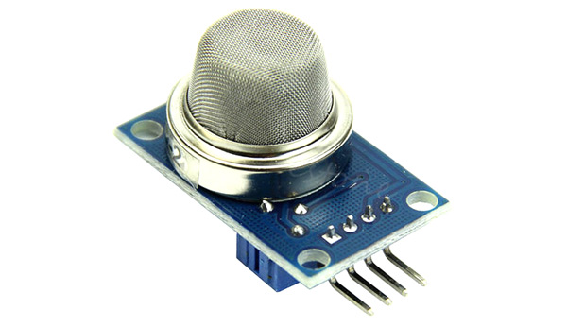

**Figure 3.1** *MQ-6 Sensor Module* (Source: MQ-6 Sensor, 2018)

The MQ-6 sensor module as shown in Fig 3.1 comes with an Analog pin (Transistor Transistor Logic driven) and a Digital Pin, by which the sensor operates devoid of a microcontroller and measures gas concentration in parts per million (ppm) respectively.

Tin dioxide (SnO2) is the sensitive material of MQ-6 sensor (Ashish, *et al*., 2013). It has sensitivity to butane, propane and smoke. 200-1000 ppm is the concentration range of MQ-6 gas sensor.

### 3.2.1 Features

The features of an MQ-6 sensor module are:

* Operating Voltage is +5V
* Can be used to detect LPG or Butane gas
* Analog output voltage: 0V to 5V
* Digital Output Voltage: 0V or 5V (TTL Logic)
* Preheat duration 20 seconds
* Can be used as a Digital or analog sensor
* The Sensitivity of Digital pin can be varied using the potentiometer.

### 3.2.2 Pinout Configuration

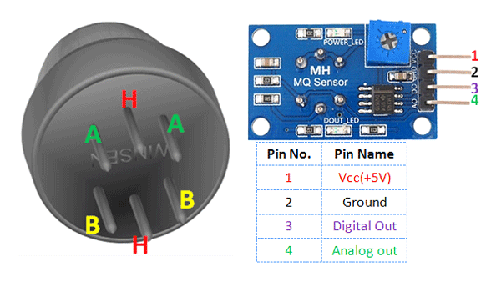

**Figure 3.2** *Pinout diagram of an MQ-6 Sensor Module* (Source: MQ-6 Sensor, 2018)

Figure 3.2 shown above gives the standard pinout diagram of an MQ-6 Sensor Module. Table 3.1 provides the standard pinout configuration and description of an MQ-6 Sensor Module in a tabular form.

**Table 3.1** *Pinout Configuration and description of an MQ-6 Sensor Module*

|  |  |  |
| --- | --- | --- |
| 1 | Vcc | This pin powers the module, typically the operating voltage is +5V |
| 2 | Ground | Used to connect the module to system ground |
| 3 | Digital Out | You can also use this sensor to get digital output from this pin, by setting a threshold value using the potentiometer |
| 4 | Analog Out | This pin outputs 0-5V analog voltage based on the intensity of the gas |

(Source: MQ-6 Sensor, 2018)

## 3.3 MQ-3 Sensor Module

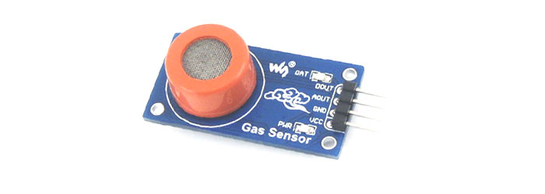

**Figure 3.3** *MQ-3 Sensor Module* (Source: MQ-3 Sensor, 2018)

MQ-3 gas sensor module as shown in figure 3.3 is suitable for detecting Alcohol, Benzene, CH4, Hexane, LPG, CO. Tin Dioxide (SnO2) is the sensitive material of MQ-3 gas sensor. This module is very useful for gas leakage detection. It is very much useful in detecting Alcohol, Benzene, CH4, Hexane, LPG, CO. Due to its high sensitivity and fast response time; measurements can be taken very fast. We can also adjust the sensitivity of the sensor by using the potentiometer. In the figure 3.6 below, the blue colored square shaped component on the module is a potentiometer which is used to set the sensitivity of the sensor. By rotating it we can set the sensitivity of the sensor (rotating anti-clockwise will result decrease in sensitivity and rotating clockwise will result the increase in sensitivity). There are two LEDs on the module. One is power LED and other one is D0-LED. D0-LED will show the output of the sensor i.e whether alcohol is present in the environment or not. The IC present on the module is a comparator IC; it will compare the signal coming from the potentiometer and the signal coming from the sensor. The output will be shown through D0 pin (Either 0 or 1). A0 is the direct analog output; the quantity of alcohol sensed by the sensor will be shown by A0. A0 and D0 will be fed to the Arduino board for further programming. Whenever the amount of alcohol sensed by the sensor will increase the voltage at A0 pin will also increase and vice-versa.

### 3.3.1 Features

The features of an MQ-3 gas sensor module are:

* Sensor Type - Semiconductor
* It has high sensitivity to alcohol and has small sensitivity to Benzene.
* It has a stable and long life and also has low cost.
* It has a very fast response and high sensitivity.
* Easy SIP header interface
* Compatible with most of the microcontrollers
* Low-power standby mode
* Requires heater voltage
* Requires simple Drive circuit.

### 3.3.2 Pinout Configuration



**Figure 3.4** *Pinout Diagram of an MQ-3 Sensor Module* (Source: MQ-3 Sensor, 2018)

Fig. 3.4 shown above gives the standard pinout diagram of an MQ-3 Sensor Module. Table 3.2 provides the standard pinout configuration and description of an MQ-3 Sensor Module in a tabular form.

**Table 3.2** *Pinout Configuration and description of an MQ-3 Sensor Module*

|  |  |  |
| --- | --- | --- |
| 1 | Vcc | Operating voltage of +5V is supplied to this pin which powers the module. |
| 2 | Ground | This pin connects the module to system ground |
| 3 | Digital Out | By setting a threshold value using the potentiometer, we get digital output from this pin. |
| 4 | Analog Out | Based on the intensity of the gas, this pin outputs analog voltage in the range of 0-5 V. |

(Source: MQ-3 Sensor, 2018)

## 3.4 Arduino Uno Rev-3

## https://store-cdn.arduino.cc/usa/catalog/product/cache/1/image/500x375/f8876a31b63532bbba4e781c30024a0a/a/0/a000066_front_8.jpg

**Figure 3.5** *Arduino Uno Rev3* (Source: Arduino Uno Rev-3, 2021)

In this project, an Arduino Uno Rev3 microcontroller board as shown in Fig. 3.5 i.e used to control the automatic mains gas supply and the Buzzer. After the MQ-6 gas sensor has detected the leakage of LPG, the microcontroller acts by turning off the LPG gas regulator, rings the alarm bell to alert the household members.

**As we know, Arduino Uno** is a microcontroller board based on the ATmega328P. It has 14 digital input/output pins (in which 6 can be used as PWM outputs), 6 analog inputs, 16 MHz ceramic resonator (CSTCE16M0V53-R0), a USB connection, a power jack, an ICSP header and a reset button. It consists of everything needed to support the microcontroller; we can simply connect it to a computer with a USB cable or power it with a AC-to-DC adapter or battery to get started. We can tinker with our Uno in every way without worrying too much about doing something wrong, worst case scenario we can replace the chip for a few dollars and start over again.

The word “Uno” means “one” in Italian and it was actually chosen to mark the release of Arduino Software (IDE) 1.0. The Uno board and Arduino Software (IDE) 1.0 are actually the reference versions of Arduino, which now evolved to newer releases. The Uno board is the first in a series of USB Arduino boards, and also the reference model for the Arduino platform; for an extensive list of current, past or for outdated boards.

### 3.4.1 Features

The following are the features of an Arduino Uno Rev3:

* Microcontroller: ATmega328
* Operating Voltage: 5V
* Input Voltage (recommended): 7-12V
* Input Voltage (limits): 6-20V
* Digital I/O Pins: 14 (of which 6 provide PWM output)
* Analog Input Pins: 6
* DC Current per I/O Pin: 40 mA
* DC Current for 3.3V Pin: 50 mA
* Flash Memory: 32 KB of which 0.5 KB used by bootloader
* SRAM: 2 KB (ATmega328)
* EEPROM: 1 KB (ATmega328)
* Clock Speed: 16 MHz

### 3.4.2 Pinout Configuration

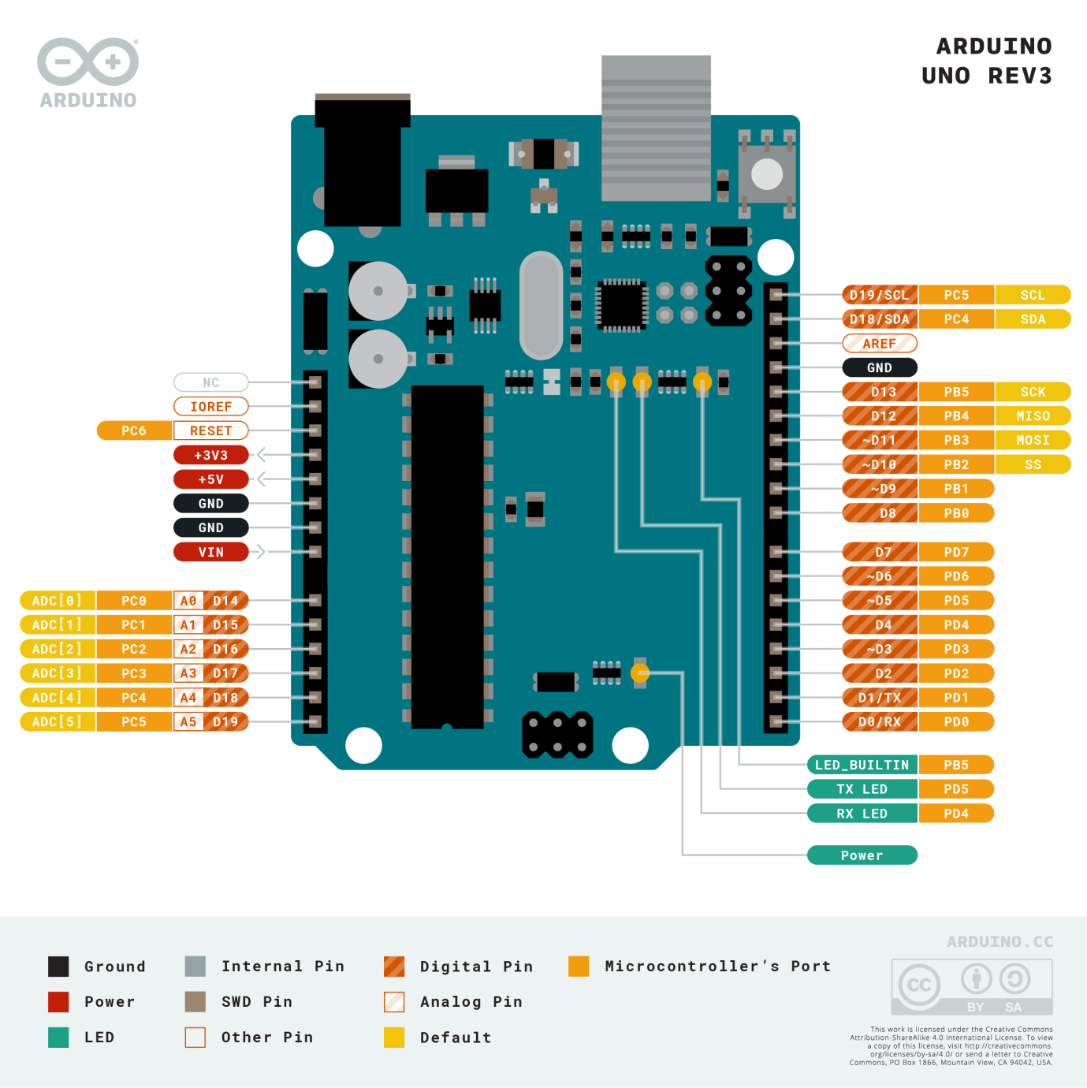

**Figure 3.6** *Pinout Diagram of Arduino Uno Rev3* (Source: Arduino Uno Rev-3, 2021)

Figure 3.6 shown above gives the standard pinout diagram of an Arduino Uno Rev3. Table 3.3 provides the standard pinout configuration and description of Arduino Uno Rev3 in a tabular form.

**Table 3.3** *Pinout configuration and description of Arduino Uno Rev-3*

|  |  |  |
| --- | --- | --- |
| Pin Category | Pin Name | Details |
| Power | Vin, 3.3V, 5V, GND | Vin: Input voltage to Arduino when using an external power source.  5V: Regulated power supply used to power microcontroller and other components on the board.  3.3V: 3.3V supply generated by on-board voltage regulator. Maximum current draw is 50mA.  GND: ground pins. |
| Reset | Reset | Resets the microcontroller. |
| Analog Pins | A0 – A5 | Used to provide analog input in the range of 0-5V |
| Input/Output Pins | Digital Pins 0 - 13 | Can be used as input or output pins. |
| Serial | 0(Rx), 1(Tx) | Used to receive and transmit TTL serial data. |
| External Interrupts | 2, 3 | To trigger an interrupt. |
| PWM | 3, 5, 6, 9, 11 | Provides 8-bit PWM output. |
| SPI | 10 (SS), 11 (MOSI), 12 (MISO) and 13 (SCK) | Used for SPI communication. |
| Inbuilt LED | 13 | To turn on the inbuilt LED. |
| TWI | A4 (SDA), A5 (SCA) | Used for TWI communication. |
| AREF | AREF | To provide reference voltage for input voltage. |

(Source: Arduino Uno, 2018)

## 3.5 Micro Servo Motor SG 90

## https://www.electronicscomp.com/image/cache/catalog/sg90-servo-motor-india-800x800.jpg

**Figure 3.7** *Micro Servo Motor, gear horns and screws* (Source: SG90 Servo, n.d.)

Micro Servo Motor as shown by figure 3.7 (along with gear horns and screws) is an electromagnetic device uses a negative feedback mechanism to converts an electric signal into controlled motion. It functions as actuators, providing precise control over linear position, angular position, velocity and acceleration. Mainly, it consists of four things: DC motor, position sensor, gear train, and a control circuit. The gear mechanism connected with the motor provides feedback to the position sensor.

If the motor of the servo is operated by DC then it is categorized as DC servo motor and if it is operated by AC then it is known as AC servo motor.

### 3.5.1 Features

* Operating Voltage: +4.8 to +6V
* Torque: 2.5kg/cm
* Operating speed is 0.1s/60°
* Gear Type: Plastic
* Rotation : 0°-180°
* Weight of motor : 9gm
* Package includes gear horns and screws

### 3.5.2 Operation

It consists of three basic types:

* Controlling Device
* Output Sensor
* Feedback system

The servo motor basically works on the phenomenon of an automatic closed-loop system. The controller required for this closed-loop system, is composed of a comparator and a feedback path. It has two inputs and one output. In servos, for producing an output signal, the comparator is used to compare this with a required reference signal and that output signal is sensed by the sensor. The input signal for the motor is coined as a feedback signal. On the basis of that feedback signal, the motor starts working. Comparator signal is also known as logic signal of the motor. Basically, the motor would be ON for the desired time when the logical difference is higher and the motor would be OFF for the desired time when the logical difference is lower. So, we can say that a comparator is used to decide that motor would be ON or OFF. Proper functioning of this motor can be done with the help of a good controller.

The servo motors is controlled by the method PWM i.e., Pulse Width Modulation which send electric signals of inconsistent width to the motor. The width pulse varies in range about (1 to 2) milliseconds to transfers this to the servo motors with repeating 50 times in a second. The width of the pulse actually controls the angular position of the rotating shaft. In this, three terms are used to show the controlling of the servomotor i.e., a maximum pulse, minimum pulse and repetition rate.

For instance, the servo moves receiving a pulse of one millisecond, turns motor towards 0˚, whereas pulse of two milliseconds turns motor towards 180˚. Between the angular positions, the pulse width interchanges by itself. Therefore, the servo turns to the 90˚ with the pulse of width 1.5 milliseconds as shown in figure 3.8.

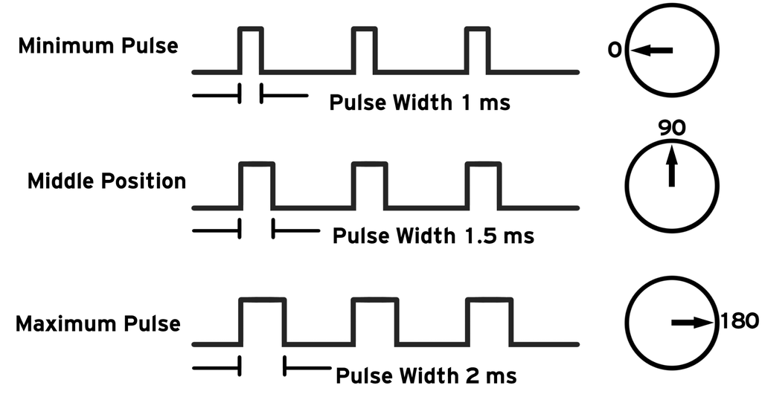

**Figure 3.8** *Controlling of Servo Motors* (Source: [Cornelam](https://www.instructables.com/member/cornelam/) , 2021)

### 3.5.3 Wire Configuration

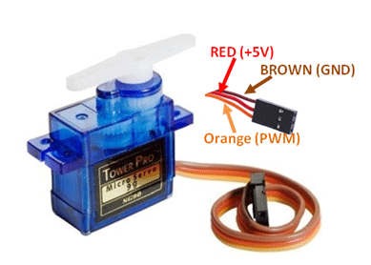

**Figure 3.9** *Wire Configuration of Micro Servo Motor* (Source: Servo Motor SG-90, 2017)

The wire configuration of a micro servo motor is shown by Fig. 3.9. Table 3.4 provides the standard wire configuration and description of Micro Servo Motor in a tabular form.

**Table 3.4** *Wire Configuration and description of Micro Servo Motor*

|  |  |  |
| --- | --- | --- |
| Wire Number | Wire Colour | Description |
| 1 | Brown | Ground wire connected to the ground of system |
| 2 | Red | Powers the motor typically +5V is used |
| 3 | Orange | PWM signal is given in through this wire to drive the motor |

(Source: Servo Motor SG-90, 2017)

## 3.6 Piezo Active Buzzer

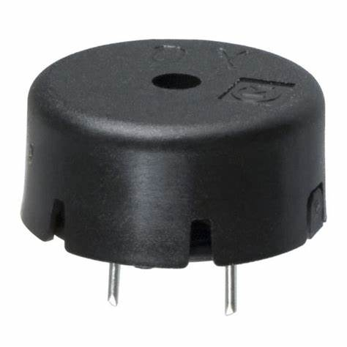

**Figure 3.10** *Piezo Active Buzzer* (Source: Ashutosh, 2011)

**Piezo Active Buzzer as shown in** Figure 3.10.It is generally an electronic device that is commonly used to produce sound, using an internal oscillator. Therefore, we can say that Piezo buzzer is basically based on the inverse principle of piezo electricity discovered in 1880 by Jacques and Pierre Curie. It is the process of generating electricity when mechanical pressure is applied to certain materials and the vice versa is also true. Such materials are called piezo electric materials. So, Piezo electric materials are either found or naturally available, or manmade. Piezoceramic is class example of manmade material, which poses piezo electric effect and is widely used to make disc, the heart of piezo buzzer. When subjected to an alternating electric field, it just get stretched or compressed, in accordance with the frequency of the signal thereby producing sound. It has a hole on the top face for sound to propagate which is encapsulated in a cylindrical plastic coating.

### 3.6.1 Features

The following are the features of a Piezo Active Buzzer are:

* Operating Voltage: 3-12V DC
* Rated current: <30mA
* Sound Type: Continuous Beep
* Resonant Frequency: ~4 kHz
* Round shape
* Small and neat sealed package
* Breadboard and PCB friendly

### 3.6.2 Pinout Configuration

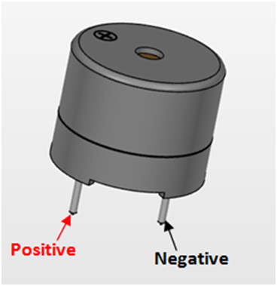

**Figure 3.11** *Pinout Diagram of a Piezo Active Buzzer* (Source: Active Passive Buzzer, 2017)

Fig. 3.11 shown above gives the standard pinout diagram of a Piezo Active Buzzer. Table 3.5 provides the standard pinout configuration and description of a Piezo Active Buzzer in a tabular form.

**Table 3.5** *Pinout Configuration and description of a Piezo Active Buzzer*

|  |  |  |
| --- | --- | --- |
| Pin Number | Pin Name | Description |
| 1 | Positive | Identified by (+) symbol or longer terminal lead. Can be powered by 6V DC |
| 2 | Negative | Identified by short terminal lead. Typically connected to the ground of the circuit |

(Source: Active Passive Buzzer, 2017)

## 3.7 Light Emitting Diode

## 

**Figure 3.12** *Light Emitting Diode* (Source: 5mm Round LED, 2018)

We are quite familiar with a Light emitting diode (LED) as shown in figure 3.12, it is normally a two-lead semiconductor light source, which emits lights when activated. As we know, when an appropriate voltage is applied to the terminals of LED, then the electrons are able to recombine with the electron holes within the device and release energy in the form of photons. This effect is known as electro-luminescence. The **color of the LED** is determined by the energy band gap of the semiconductor. We have used a 5mm round led emitting red color wavelength in our project hardware.

### 3.7.1 Features

The Following are the features of a 5mm Round LED is:

* Superior weather resistance
* 5mm Round Standard Directivity
* UV Resistant Eproxy
* Forward Current (IF): 30mA
* Forward Voltage (VF): 1.8V to 2.4V
* Reverse Voltage: 5V
* Operating Temperature: -30℃ to +85℃
* Storage Temperature: -40℃ to +100℃
* Luminous Intensity: 20mcd

### 3.7.2 Pinout Configuration

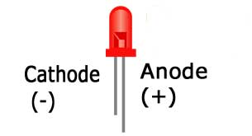

**Figure 3.13** *Pinout Diagram of a LED* (Source: 5mm Round LED, 2018)

Figure 3.13 shown above gives the standard pinout diagram of a Piezo Active Buzzer. Table 3.6 provides the standard pinout configuration and description of a Piezo Active Buzzer in a tabular form.

**Table 3.6** *Pinout Configuration and description of a LED*

|  |  |
| --- | --- |
| Pin Name | Description |
| Anode | Positive terminal of LED |
| Cathode | Negative terminal of LED |

(Source: 5mm Round LED, 2018)

## 3.8 Printed Circuit Board

## 

**Figure 3.14** *Printed Circuit Board* (Source: Pcbcart, 2021)

A PCB as shown in figure 3.14 is generally a copper laminated and non-conductive **Printed Circuit Board**, in which all electrical and electronic components are connected together in one common board with physical support for all components with base of board. When a PCB is not developed, at that time all components are connected with a wire which increases complexity and decreases reliability of the circuit, by this way we cannot make a very large circuit like motherboard. Here, all components are connected without wires and **all components are connected internally**, so that, it will reduce the complexity of the overall circuit design. Printed Circuit Board is used to provide electricity and connectivity between the components, by which it functions the way it was designed without the problems of short circuit. These PCBs can be customized for user requirements as well as in any specifications. PCB’s applications are all around us as it can be found in many electronics devices like; TV, Mobile, Digital camera, Computers parts like; Graphic cards, Motherboard, etc. It also used in many industrial fields like; medical devices, industrial machinery, automotive industries, lighting, etc.

## 3.9 Arduino Software IDE

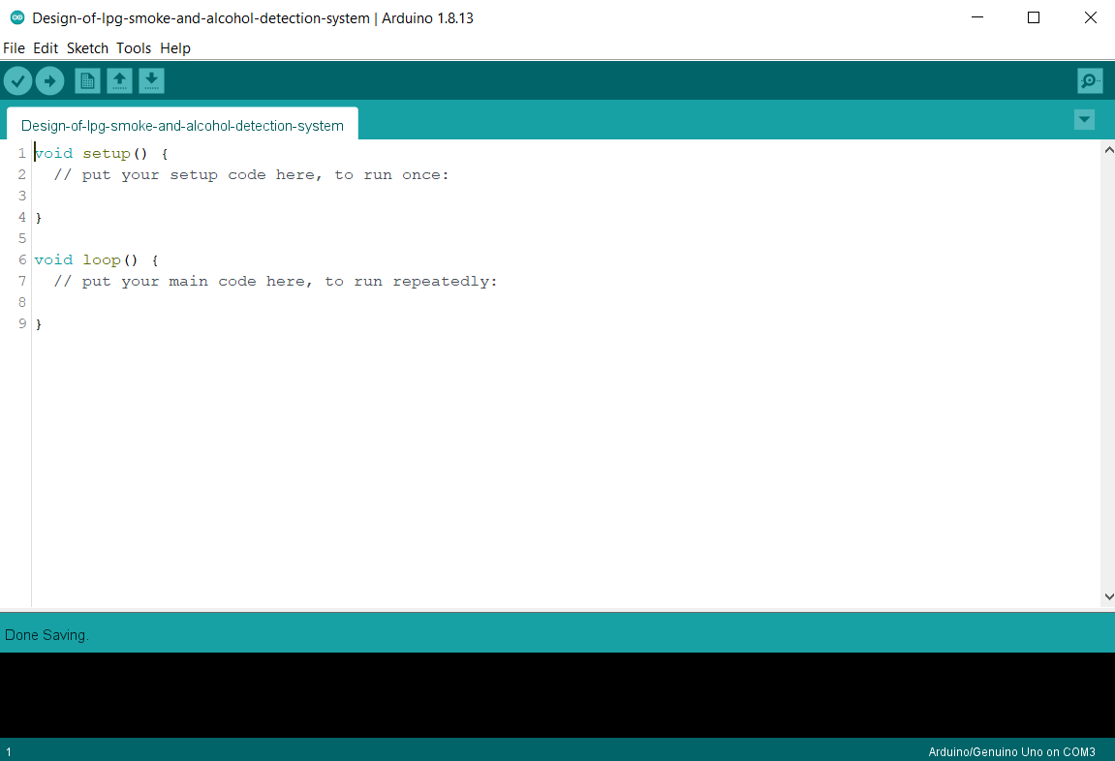

**Figure 3.15** *Arduino Integrated Development Platform (IDE)* (Source: My Screenshot, 2020)

The Arduino Integrated Development Environment (IDE) as shown in Fig. 3.15.This is a cross-platform used in applications (for Windows, macOS, Linux) that is general written in functions from C and C++. Programming language makes it easier to write the code and upload it to the board. Apart from any Arduino board, this software can be used with other boards if we upload the Arduino sketch on it and the active development of the Arduino software is [hosted by GitHub](https://github.com/arduino/Arduino/).

## 3.10 Proteus Design Suite

## 

**Figure 3.16** *Proteus Design Suite* (Source: My Screenshot, 2020)

The Proteus Design Suite as shown in Fig. 3.18. This is a proprietary software tool suite which is used primarily for [electronic design automation](https://en.wikipedia.org/wiki/Electronic_design_automation). The software is mainly used to create schematics and electronic prints for manufacturing printed circuit boards by electronic [design engineers](https://en.wikipedia.org/wiki/Design_engineer) and technicians.

Proteus Virtual System Modeling (VSM) blends mixed-mode SPICE simulation with world leading the fastest microcontroller simulation. This enables the rapid prototyping of both hardware and firmware designs, in software Design, Test and also helps to debug your embedded projects in the Proteus electronic circuit simulator before a physical prototype is ordered.And ofcourse,it provides an agile development for the embedded systems workflow.

For embedded engineers, Proteus VSM actually bridges the gap in the design life cycle between the schematic capture and the PCB layout. It enables us to write and apply our firmware to a [supported microcontroller](https://www.labcenter.com/buy-vsm/) on the schematic and then co-simulate the program within a mixed-mode SPICE circuit simulation, including MCU peripherals. One major property is that we can interact with the design using on screen indicators such as LED and LCD displays as well as actuators such as switches and buttons. Proteus VSM also provides facilities like extensive debugging including breakpoints, single stepping and variable display for both assembly code and high level language source.

## 3.11 Power Adapter & USB (A to B) Cable

## https://goodstrolley.in/wp-content/uploads/2020/06/micromax-chgacc15c02bbla-original-imaexcravpzpupr7.jpeg

**Figure 3.17** *Micromax Power Adapter* (Source: Micromax ACC15C02-B, n.d.)

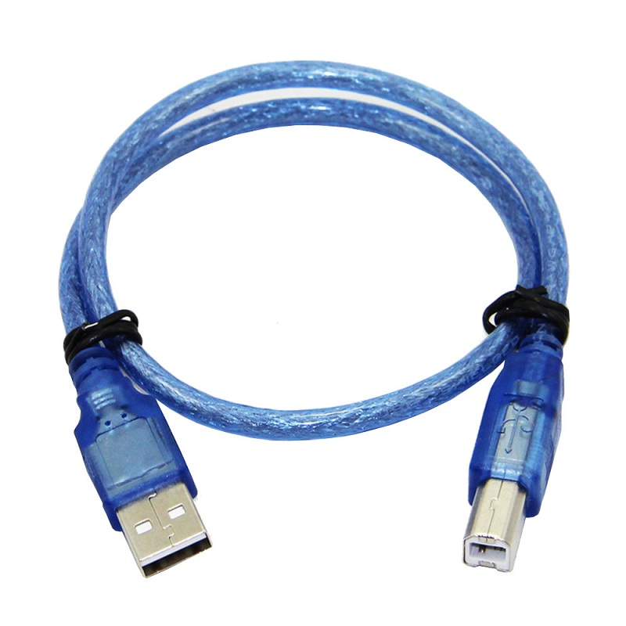

**Figure 3.18** *USB (A to B) Cable* (Source: Cable for Arduino, n.d.)

We have used a power adapter as shown in figure 3.17 manufactured by Micromax Informatics, an Indian multinational electronics company and the USB cable as shown in figure 3.18 which is provided along with the Arduino Uno Rev-3 development board to power the system. This power adapter has an inbuilt short circuit and output overload protection which would be a step further to our aim of building the system involving low maintenance cost and high reliability quotient.

### 3.11.1 Features of Power Adapter

* Model: ACC15C02-B
* Wall Charger
* Universal Voltage
* Maximum Output Current : 1.5 A
* Short Circuit Protection
* Output overload Protection
* Very wide AVR range 120 ~275V
* High Load Regulation with Low Ripple Output

### 3.11.2 Features of USB (A to B) Cable

* Color: Blue
* Length: 100 cm
* USB Type: Type-A to Type-B
* Weight: 40gm
* Cable length: 1 m

## 3.12 Box Enclosure Case

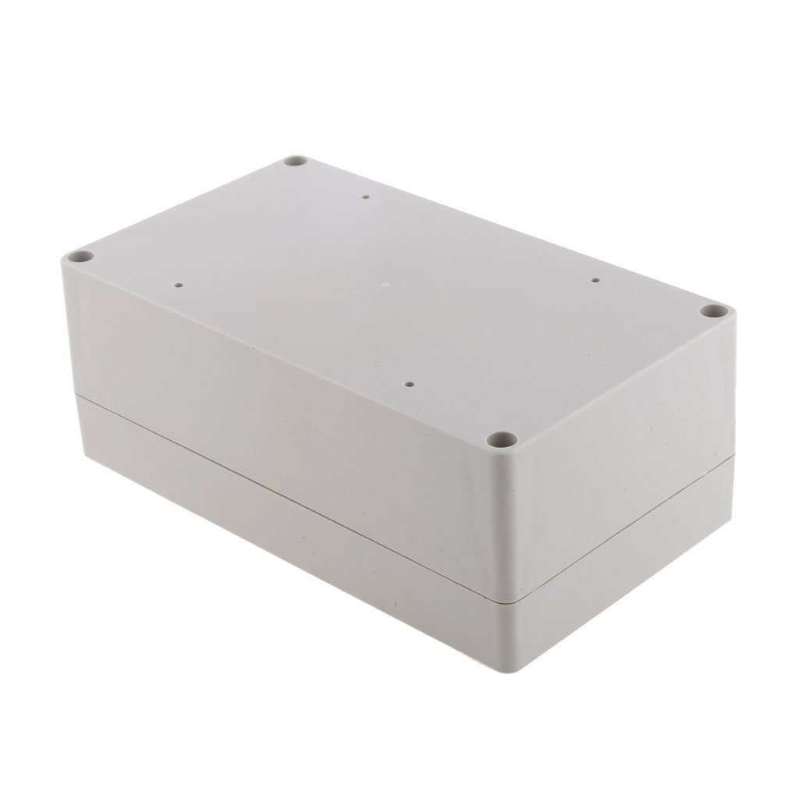

**Figure 3.19** *Box Enclosure Case* (Source: Electronic Project Box, n.d.)

Box Enclosure Case as shown in figure 3.19 is used to protect the PCB with all the electronic components soldered on it from high corrosive gases, water attachments and short circuit related hazards. This enclosure is generic, high quality, durable and easy to install adding more reliability and maintenance to the engineered system.

### 3.12.1 Features

* Non-corrosive, anti-static, insulation resistance
* High quality, durable, easy install
* Waterproof, damp-proof
* Dimensions: 158x90x60mm

## 3.13 Flowchart of Proposed Design

Figure 3.17 shows the flowchart of the proposed design.

Check for Leakage

MQ6, MQ3 sensor O/P>=Threshold Value

FALSE

Turn OFF gas regulator

Turn ON Buzzer

TRUE

Turn ON LED

**Figure 3.20** *Flowchart of the Proposed Design*

# CHAPTER 4

# RESULT, ANALYSIS AND DISCUSSION

## 4.1 Introduction

Simulation is the mimicry of the operation of a process or system over time which happens in the real world. Real-world situations are solved by simulation modeling efficiently safely which enhances a valuable way of analysis which is easily understood, communicated, verified. Computer simulation can be defined as the utilization of a computer system to represent the dynamic response of a system by the behavior of another system animated considering it, which utilizes a mathematical description in the form of a program running in computer. Variables are changed in the simulation to predict about the behavior of the system under different situations. Simulation is used to virtually investigate the behavior of the system under study. Simulation can avoid danger and loss of life, critical situations can be investigated without risk and can to be economical avoiding losses at later stages of the project development life cycle.

On various contexts simulation is utilized, which are simulating an upcoming technology for performance optimizing and tuning, training, testing and safety engineering. System engineering support is applied for the procurement, development and testing of systems. At early phases this support can start and include topics like executable system architectures, and by providing a virtual environment where tests are conducted, it can support testing. There are some applications shown below are

Objective of our simulation done in this report is to determine the feasibility and operation of the arduino based LPG, smoke and alcohol leakage detection and response system. A detailed analysis of result and discussion of the simulation is mentioned in this chapter 4.

## 4.2 Circuit Simulator

The simulation software employed for testing the validity and performance of the proposed design is Proteus Design Suite 8.9 simulator. The software makes it possible for the design to be simulated by mimicking real life situations and also provides the possibility of generating a PCB layout. This makes it easier for the prototype of a design to be engineered devoid of errors (see appendix for source code).

## 4.3 Analysis of Simulation

Fig. 4.1 shows the operation of the proposed design under normal conditions when both the mq-6 sensor and the mq-3 sensor have not detected any LPG, smoke and alcohol in the ambient environment respectively. The red color LED, piezo active buzzer remains off and the micro servo motor is at 0 degrees.

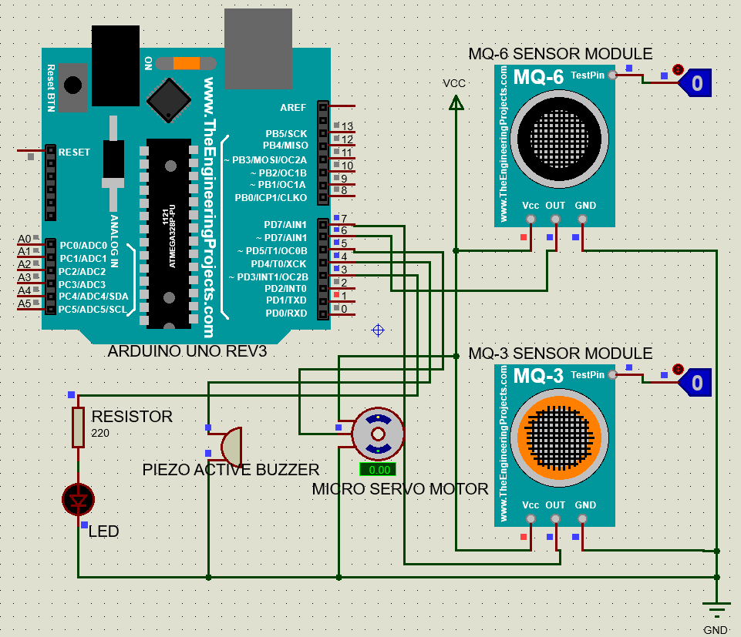

**Figure 4.1** *System’s Simulated Diagram under Normal Conditions*

Fig. 4.2 shows the operation of the proposed design when LPG leakage or smoke is detected by the MQ-6 Sensor Module in its ambient environment. The red color LED, piezo active buzzer switch on and the micro servo motor is at 85 degrees clockwise.

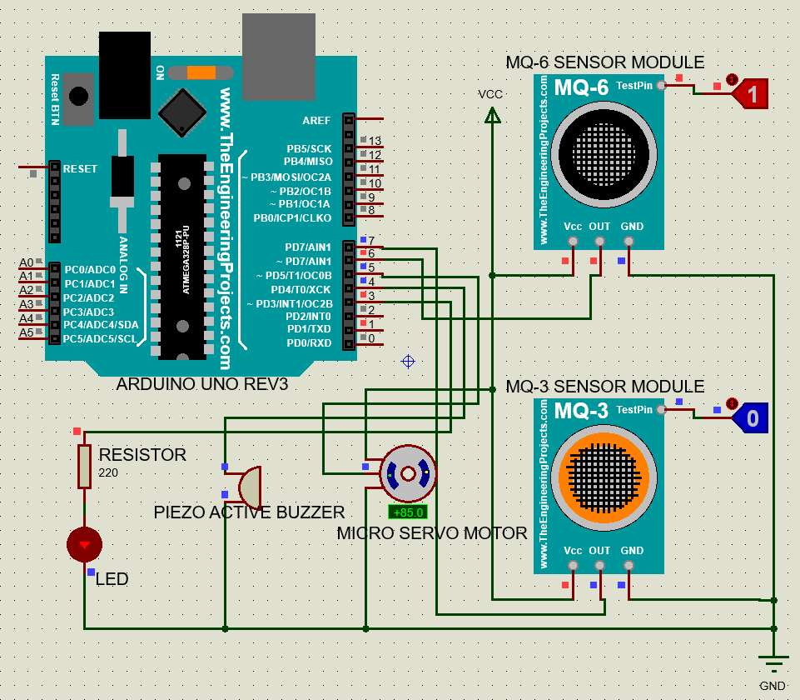

**Figure 4.2** *System’s Simulated Diagram when MQ-6 sensor detects leakage.*

Fig. 4.3 shows the operation of the proposed design when Alcohol is detected by the MQ-3 sensor in its ambient environment. The red color LED, piezo active buzzer switch on and the micro servo motor is at 85 degrees clockwise.

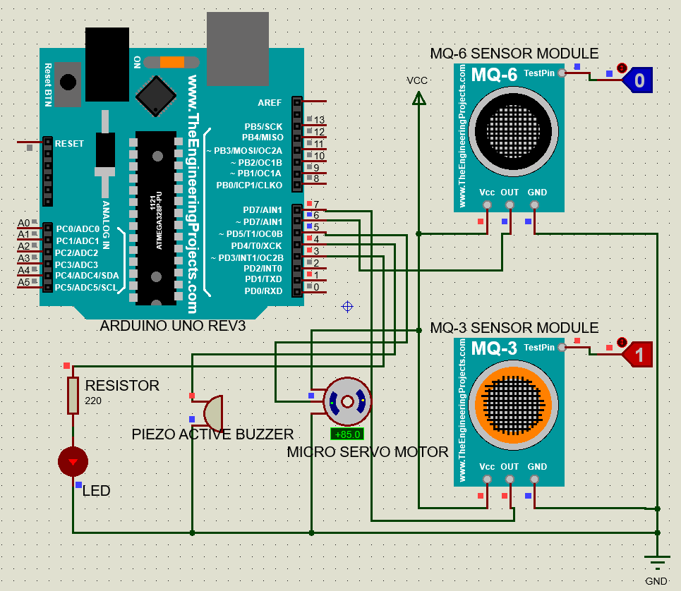

**Figure 4.*3*** *System’s Simulated Diagram when MQ-3 sensor detects leakage.*

Fig. 4.4 shows the operation of the proposed design when both the mq-6 sensor and the mq-3 sensor have detected LPG, smoke or alcohol in the ambient environment respectively. The red color LED, piezo active buzzer switch on and the micro servo motor is at 85 degrees clockwise.

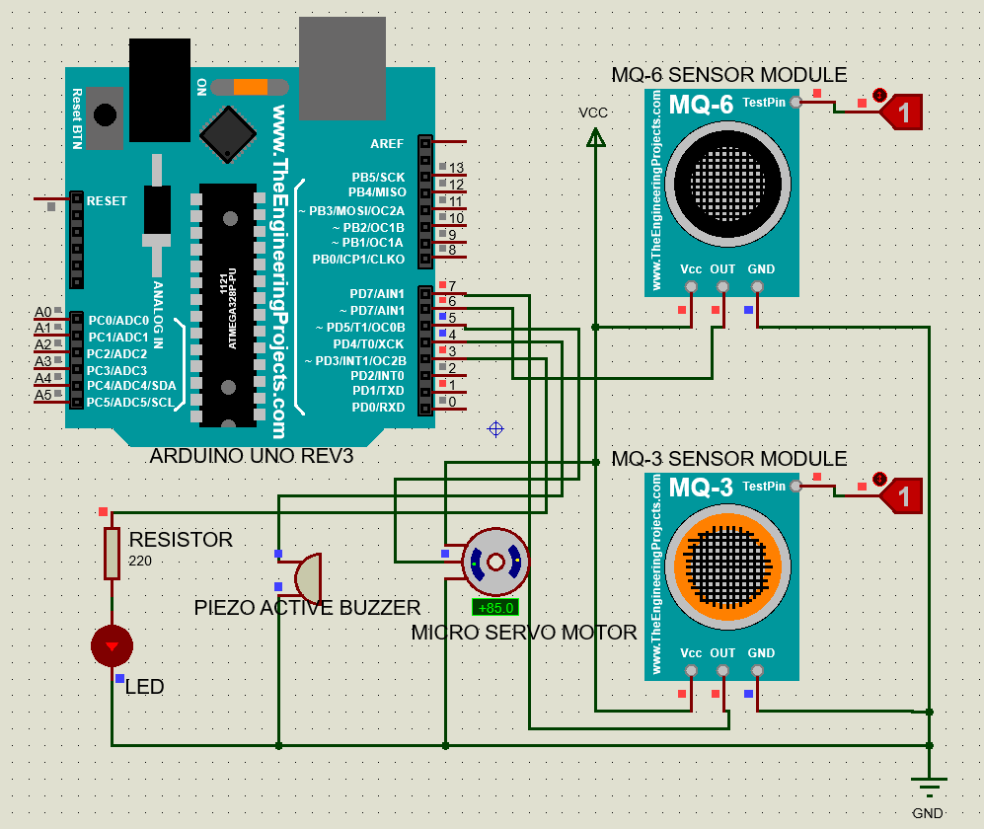

**Figure 4.4** *System’s Simulated Diagram when MQ-6 and MQ-3 sensor detects leakage*

When leakage is detected, signal is sent to the buzzer to blow an alarm, a red color led is turned on, the servo rotates 85 degrees clockwise to turn off the gas regulator key to cut off the mains gas supply.

## 4.4 Cost Estimation

Table 4.1 shows the cost analysis of the proposed design of LPG, smoke and alcohol detection system with automatic mains gas supply cut off useful in household and small scale industries. We have analyzed on the basis of the cheapest individual price of each component used in the simulation while not compromising with the quality of the components, to make the installation and maintenance of the system popular and affordable for use as promised earlier in the abstract of the project report. This analysis is an estimate of the prices of components used in the simulation based on review at online Indian stores like Flipkart, PayTM mall and other electronic stores popular in India.

**Table 4.1** *Cost Analysis*

|  |  |  |  |  |
| --- | --- | --- | --- | --- |
| **Items** | **Quantity** | **Unit Price** | | **INR** |
| **USD** | **INR** |
| MQ-6 Sensor Module | 1 | 1.08 | 80.00 | 80.00 |
| MQ-3 Sensor Module | 1 | 1.15 | 85.00 | 85.00 |
| Arduino Uno R3 with USB Cable | 1 | 6.11 | 449.00 | 449.00 |
| Micro Servo Motor SG90 | 1 | 1.75 | 129.00 | 129.00 |
| Piezo Active Buzzer | 1 | 0.34 | 25.00 | 25.00 |
| LED (red) | 1 | 0.03 | 2.00 | 2.00 |
| Resistor (220 ohm) | 1 | 0.03 | 2.00 | 2.00 |
| PCB (15*10 cm) | 1 | 0.68 | 50.00 | 50.00 |
| Box Enclosure Case  (16*9*6 cm) | 1 | 24.46 | 1799.00 | 1799.00 |
| Power Adapter | 1 | 4.35 | 320.00 | 320.00 |
| **Total Price** | | | | **2941.00** |

The USD to INR exchange rate as at the time of this analysis was:

INR

# CHAPTER 4

# CONCLUSION AND RECOMMENDATIONS

## 5.1 Conclusion

Our project report works on the problem of LPG, smoke and alcohol leakages that have contributed to casualties involving life and properties which amount to billions of rupees as a hardware that is capable of detection of those leakages and turning off the supply of gas engineered and simulated successfully with the use of simulator, Proteus 8.9.

When leakage is detected, the device is capable of sending a signal to the buzzer to blow an alarm, a red color led is turned on, the servo rotates 85 degrees clockwise to turn off the gas regulator key to cut off the mains gas supply.

The target group of our system is household, hotel kitchens and small scale industries as it will be affordable for them keeping into account the installation and maintenance charges. This plug and play system is also easy to operate as this system is fully automatic in detection and response. This entire design is also well maintained and protected from the highly corrosive gases, water proof, damp proof, anti-static, short-circuit, insulation resistant and output overload protected.

## 5.2 Recommendations

The recommend based on the design are as following:

* Any group or individual who has an interest in the project can take up this design, fund and implement it, as it has a significant potential of saving against accidents associated gas and alcohol leakage; and
* A propeller exhaust fan can be incorporated into the design to fan out the already leaked gas from the surrounding of the gas supply.
* A notification can be sent to dedicated smart phones when any abnormal situation is encountered by the system.

# REFERENCES

5mm Round LED (2018). Retrieved from <https://components101.com/diodes/5mm-round-led>.

Active Passive Buzzer (2017). Retrieved from <https://components101.com/buzzer-pinout-working-datasheet>.

Anon. (2015). Technical Data MQ-6 Gas Sensor. [www.sparkfun.com/datasheets/Sensors/Biometric/MQ-6](http://www.sparkfun.com/datasheets/Sensors/Biometric/MQ-6). Accessed: December 20, 2015.

Arduino Uno (2018). Retrieved from <https://components101.com/microcontrollers/arduino-uno>.

Arduino Uno Rev-3 (2021). Retrieved from <https://store.arduino.cc/usa/arduino-uno-rev3>.

Ashish, S., Ratnesh, P., Rajeev, K. and Rahul, V. (2013). GSM Based Gas Leakage Detection System. *International Journal of Technical Research and Applications, Vol. 1, No. 2*, pp. 42-45.

Ashutosh Bhatt (2011). Insight- How Piezo Buzzer works. Retrieved from <https://www.engineersgarage.com/insight/insight-how-piezo-buzzer-works/>.

Batzias, F., Siontorou, C. and Spanidis, P.M. (2011). Designing a Reliable Leak Biodetection System for Natural Gas Pipelines. Journal of *Hazardous Materials, Vol. 186, No.1*, pp. 35-58.

Bhattacharjee D., Bhatnagar P., Choudhury S. (2011). Design and Development of a Flexible Reliable Smart Gas Detection System. International *Journal of Computer Applications (0975 –8887)Volume 31–No.9*

Cable for Arduino (n.d.). Cable for Arduino UNO/MEGA (USB A to B)-1M. Retrieved from <https://robu.in/product/cable-for-arduino-uno-mega-usb-a-to-b-1m/?gclid=CjwKCAiAxp-ABhALEiwAXm6Iyf-eCfKy0pkGchr0xsM7seTMxTUZA2WM0pTM4tCCfUlpxjRq6XGZGRoCDhgQAvD_BwE>

Cornelam (2021). Arduino Servo Motors. Retrieved from <https://www.instructables.com/Arduino-Servo-Motors/>.

Didpaye1, B. B. and Nanda, S. K. (2015). Automated Unified System for LPG using Microcontroller and GSM Module- A Review. *International Journal of Advanced Research in Computer and Communication Engineering, Vol. 4, No. 1*, pp. 209 -212.

Electronic Project Box (n.d.). Generic ABS Damp-Proof Waterproof White Electronics Project Box 158x90x60mm. Retrieved from <https://www.amazon.in/Generic-Damp-Proof-Waterproof-Electronics-158x90x60mm/dp/B01LN02W0G/ref=pd_day0_5?pd_rd_w=rml62&pf_rd_p=9e10c3a0-2de0-4d88-9f69-0146072f9df1&pf_rd_r=3V3PVJZA3EMFZRT46WPS&pd_rd_r=434500ce-cb20-4e4c-a7db-9ab19253c6b3&pd_rd_wg=PzfYe&pd_rd_i=B01LN02W0G&psc=1>

Folga, S. M. (2007), Natural Gas Pipeline Technology Overview, Argonne National Laboratory, Lemont, USA, pp. 45-48.

Jha S. and Jacob S. (2018) How Indians cook. *Business Standards.* Retrieved from <https://www.business-standard.com/article/economy-policy/only-61-households-use-lpg-for-cooking-not-91-as-govt-claimed-nso-data-119112501446_1.html>

Liu, J., Yao, J., Gallaher, M., Coburn, J. and Fernandez, R. (2008). Study on Methane Emission Reduction Potential in Chinas Oil and Natural Gas Industry, *US EPA, Research Triangle Park, NC*, pp. 32-44.

Micromax ACC15C02-B ( n.d.). Micromax ACC15C02-B Power Adapter (Black). Retrieved from <https://goodstrolley.in/product/micromax-acc15c02-b-power-adapter-black/?utm_source=Google%20Shopping&utm_campaign=GT1_feed2&utm_medium=cpc&utm_term=20838&gclid=CjwKCAiAxp-ABhALEiwAXm6IydhLWKeaSJSc67Z35lcC0-TN_ll9QhnoxcWfr2IR87gshjZvgUIOQBoCoLYQAvD_BwE>

Murvaya, P.S. (2011). A survey on Gas Leak Detection and Localization Techniques. *Journal of Loss Prevention in the Process Industries*, pp. 11-24.

MQ-3 Sensor (2018). Retrieved from <https://components101.com/sensors/mq-3-alcohol-gas-sensor>.

MQ-6 Sensor (2018), Retrieved from <https://components101.com/sensors/mq-6-gas-sensor-pinout-equivalent-datasheet>.

National Crime Records Bureau (2017). Accidental Deaths and Suicides in India survey 2017 [Data set]. Ministry of Home Affairs, Government of India. <https://ncrb.gov.in/sites/default/files/ADSI2017-FULL-REPORT-2017.pdf>.

National Crime Records Bureau (2018). Accidental Deaths and Suicides in India survey 2018 [Data set]. Ministry of Home Affairs, Government of India. <https://ncrb.gov.in/sites/default/files/ADSI-2018-FULL-REPORT-2018_0.pdf>.

National Statistical Office (2018). National Sample Survey 76th round 2018 [Data set]. Ministry of Statistics & Programme Implementation, Government of India. <http://www.mospi.nic.in/sites/default/files/publication_reports/Report_584_final_0.pdf>

Pcbcart (2021). Retrieved from <https://www.pcbcart.com/pcb-fab/standard-pcb.html>

Scott, S. and Barrufet, M. (2003). Worldwide Assessment of Industry Leak Detection Capabilities for Single & Multiphase Pipelines, Technical Report, Dept. of Petroleum Engineering, Texas A&M University, 121pp.

Servo Motor SG-90 (2017). Retrieved from <https://components101.com/servo-motor-basics-pinout-datasheet>

SG90 Servo (n.d.). Tower Pro SG90 Servo - 9 gms Mini/Micro Servo Motor. Retrieved from <https://www.electronicscomp.com/towerpro-sg90-9gm-micro-servo-motor?gclid=CjwKCAiAxp-ABhALEiwAXm6IyetVA3iQD9AhBvZ6313O_SYf9tIG1iear4PkvspoKsU7AwZjOWlJQRoChk0QAvD_BwE>

Sunithaa, J. and Sushmitha, D. (2012). Embedded Control System for LPG Leakage Detection and Prevention, International Conference on Computing and Control Engineering (ICCCE), TamilNadu, India, pp. 76-84.

# APPENDIX A

# Source Code

#define led 3

#define buzz 4

#define servo 5

#define mq6 6

#define mq3 7

#include<Servo.h>

int mq6value=LOW;

int mq3value=LOW;

Servo servoA;

void setup()

{

Serial.begin(9600);

pinMode(led, OUTPUT);

pinMode(buzz, OUTPUT);

pinMode(servo, OUTPUT);

pinMode(mq6, INPUT);

pinMode(mq3, INPUT);

servoA.attach(servo);

}

void loop()

{

servoA.write(0);

digitalWrite(led, LOW);

noTone(buzz);

mq6value = digitalRead(mq6);

# APPENDIX A (Cont’d)

mq3value = digitalRead(mq3);

if ((mq6value == HIGH) || (mq3value == HIGH))

{

digitalWrite(led, HIGH);

servoA.write(85);

tone(buzz,1000);

delay(1000);

}

}

# APPENDIX B

# Datasheet of Sensors Used

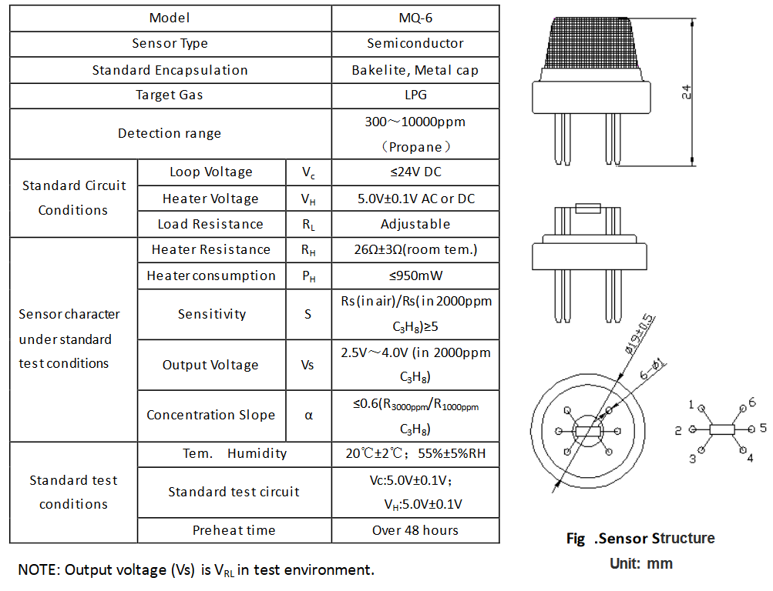

# APPENDIX B (Cont’d)

