1. Program to find all Numbers divisible by 7 and not multiple of 5 between 2000 and 3200.

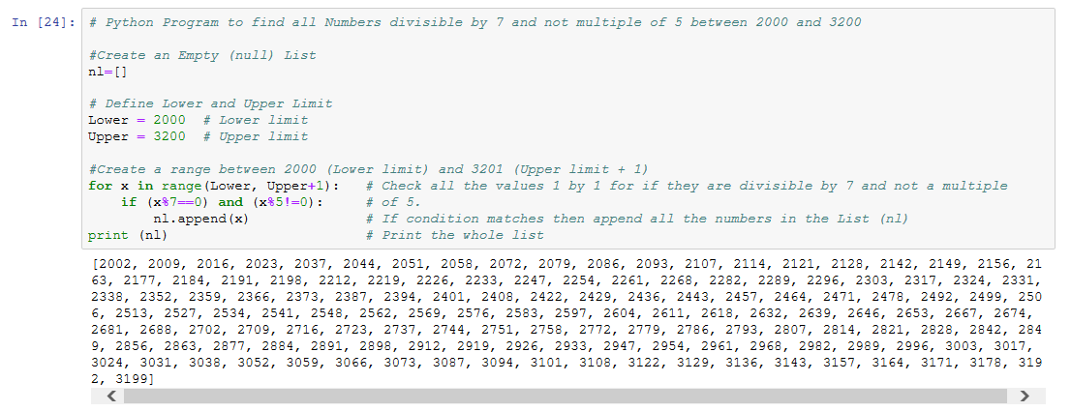

2. Program to accept user name and then getting them printed in reverse order.

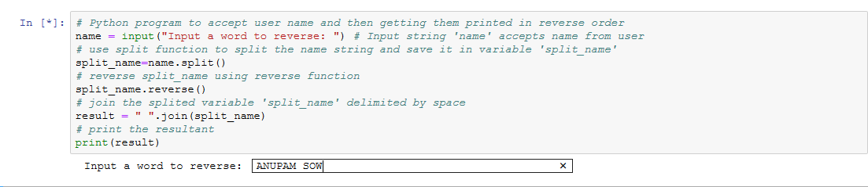

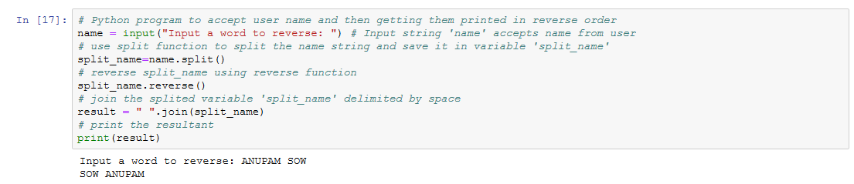

3. Program to calculate volume of sphere with diameter 12 cm.

