1. Program to accept a sequence of comma separated numbers from user and generare a list

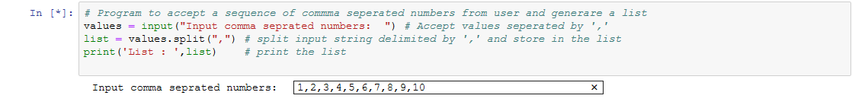

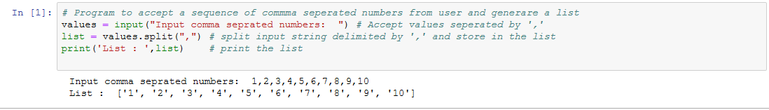

2. Create Pattern.

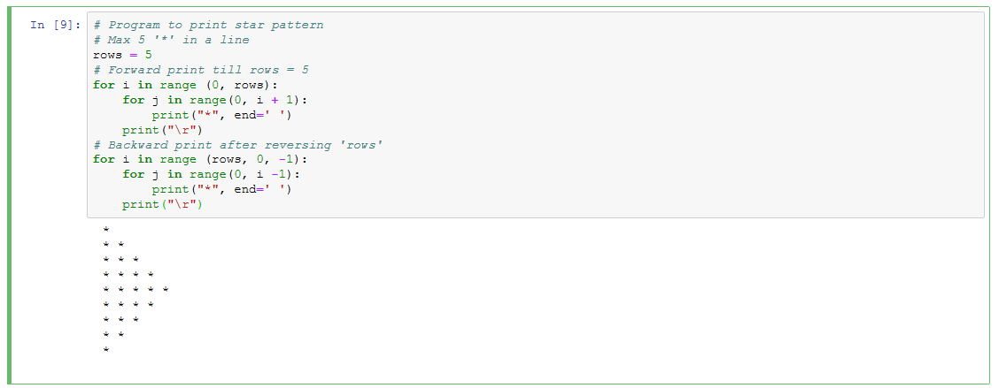

3. Python program to reverse a word after accepting the input from user.

