#1: Changes the color value of the first 100x100 pexels of an image to black

import cv2 as cv

img=cv.imread('lenna.jpg')

for i in range(100):

    for j in range(100):

        img[i,j]=(0,0,0)

img_RGB =cv.cvtColor(img,cv.COLOR_BGR2RGB)

plt.imshow(img_RGB)

plt.show()

**OUTPUT:**

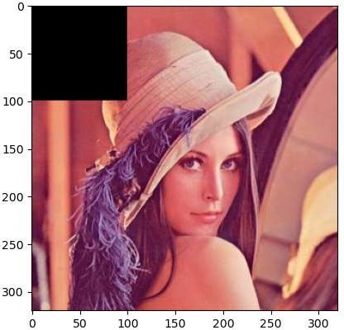

#2 : Combining 2 images using opencv

import cv2 as cv

import numpy as np

img1=cv.imread('lata.jpg')

img2=cv.imread('lenna.jpg')

img1=cv.resize(img1,(500,500))

img2=cv.resize(img2,(500,500))

res_img=np.concatenate((img1,img2),axis=1)

res_img_RGB =cv.cvtColor(res_img,cv.COLOR_BGR2RGB)

imageplot=plt.imshow(res_img_RGB)

plt.show()

#cv.imshow('cmbimg',res_img)

#cv.waitKey(0)

#cv.destroyAllWindows()

**OUTPUT:**

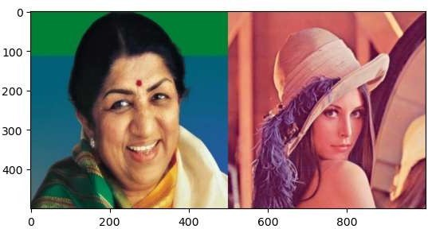

#3 : Extract a specific image region

import cv2 as cv

import numpy as np

from matplotlib import pyplot as plt

rows = 1

columns = 2

img=cv.imread('lenna.png')

ext_img=img[200:300,80:550]

f = plt.figure()

f.add_subplot(rows, columns, 1)

img_RGB =cv.cvtColor(img,cv.COLOR_BGR2RGB)

plt.imshow(img_RGB)

plt.title("original")

f.add_subplot(rows, columns, 2)

ext_img_RGB =cv.cvtColor(ext_img,cv.COLOR_BGR2RGB)

plt.imshow(ext_img_RGB)

plt.title("extracted")

**OUTPUT:**

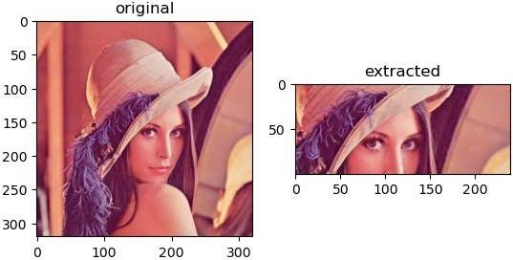

#4  Read an image which calculates and plots the histogram of its greyscale version. Save the histogram plot to an image file

import cv2 as cv

from matplotlib import pyplot as plt

img = cv.imread('lenna.jpg',0)

histr = cv.calcHist([img],[0],None,[256],[0,256])

plt.title('Histogram of gray scale')

plt.xlabel('values')

plt.ylabel('frequency')

plt.plot(histr)

plt.show()

**OUTPUT:**

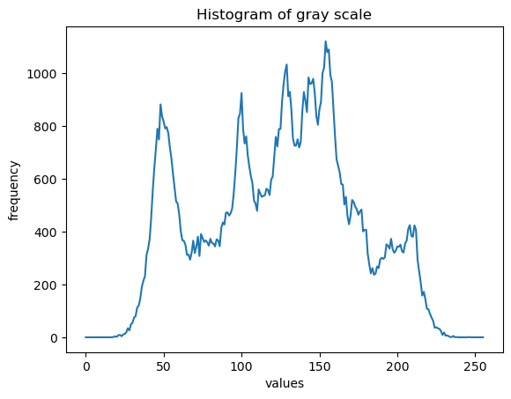

#5 :Guassian Blur

import cv2 as cv

import numpy as np

filter = [[1,2,1],[2,4,2],[1,2,1]]

img = cv.imread("lenna.jpeg")

m,n,r = img.shape

new_h=m-2

new_w=n-2

new_img=np.zeros((new_h,new_w,3),np.uint8)

for i in range(new_h):

    for j in range(new_w):

        res1=0

        res2=0

        res3=0

        for k in range(3):

            for q in range(3):

                res1 = res1 + img[i+k][j+q][0]*filter[k][q]

                res2 = res2 + img[i+k][j+q][1]*filter[k][q]

                res3 = res3 + img[i+k][j+q][2]*filter[k][q]

        new_img[i][j][0]=(res1//16)

        new_img[i][j][1]=(res2//16)

        new_img[i][j][2]=(res3//16)

print(new_img.shape)

plt.subplot(1, 2, 1)

img1=cv2.cvtColor(img,cv2.COLOR_BGR2RGB)

plt.imshow(img1)

plt.title('Original Image')

plt.subplot(1, 2, 2)

plt.imshow(new_img)

plt.title('Convolved Image')

plt.show()

**OUTPUT:**

(64, 64, 3)

(512, 512)

(62, 62)

