Week_1 Report:

1. Introduction to NIDS and Snort:
Introduction to NIDS A Network Intrusion Detection System (NIDS) monitors network traffic to detect malicious or suspicious activity. It captures packets, analyzes protocols, and alerts the user when abnormal behavior occurs.

2. Install Linux (Ubuntu/Kali):
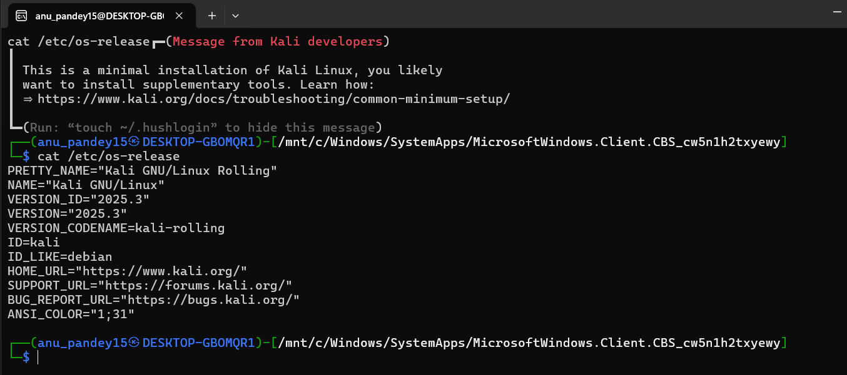

3. Install and verify Snort:
Command: sudo apt install snort -y
Verify installation: snort -V
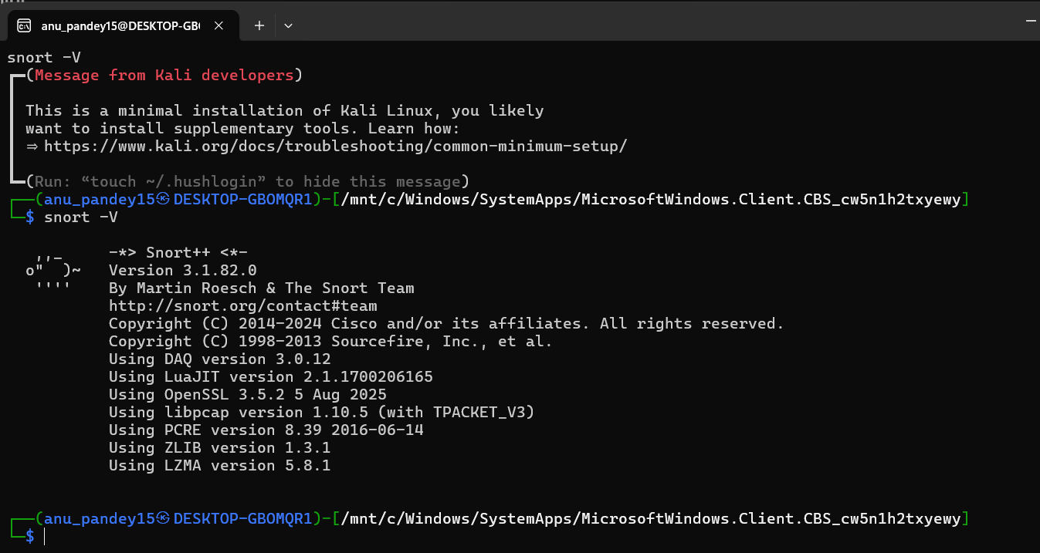

4. Basic Linux command-line navigation:
ls – list files
cd – change directory
pwd – print working directory
mkdir – create folder
nano – edit file
