Week 1 Task Report
Data Acquisition, Cleaning and Exploratory Data Analysis
Dataset: Breast Cancer Wisconsin (Diagnostic)
Prepared by: Anup Dubey | Virtual Internship - Data Science

1. Introduction and Objective
This report documents the data preparation stage of a data science project: acquiring a public dataset, auditing and cleaning it with Python and pandas, and exploring it with summary statistics and visualisations. Every step is documented together with the reason it was chosen.
Good data preparation determines the quality of everything that follows. Models trained on unchecked data inherit its errors, so this stage is treated as a project in its own right.

1.1 Summary of Approach
Step | What was done
Acquire | Loaded the Wisconsin Diagnostic Breast Cancer dataset and saved a raw CSV copy
Audit | Checked shape, data types, missing values, duplicates, impossible and suspicious values
Clean | Removed duplicates, corrected data types, labelled the target
Missing-value study | Simulated 5% missing data and compared mean, median and KNN imputation
Explore | Summary statistics, distributions, outliers, skewness, class comparisons, correlations
Insights | Patterns found and areas for further analysis

2. Data Acquisition

2.1 Dataset
The Breast Cancer Wisconsin (Diagnostic) dataset is a public dataset originating from the UCI Machine Learning Repository (Wolberg, Street and Mangasarian). Features are computed from digitised images of fine-needle aspirates of breast masses and describe the characteristics of cell nuclei. The task is to relate these measurements to the diagnosis (malignant or benign).
The dataset was chosen because it is a well-documented, real-world healthcare problem where data quality has clear consequences, and it is freely available without licensing barriers.

2.2 How the Data Was Obtained
The data was loaded through the scikit-learn library, which bundles a copy of the UCI dataset. A raw copy was written to disk before any change was made, so the original can always be recovered.
import pandas as pd, numpy as np
from sklearn.datasets import load_breast_cancer

raw = load_breast_cancer(as_frame=True)
df = raw.frame.copy()
df.to_csv('breast_cancer_raw.csv', index=False) # untouched backup
print(df.shape) # (569, 31)

The dataset has 569 rows and 31 columns: 30 numeric features (the mean, standard error and worst value of ten nuclear measurements, such as radius, texture, smoothness and concavity) and one target column.

3. Data Quality Audit
Before changing anything, the data was audited to find out what needed fixing. The checks and their results are below.
df.info() # types and non-null counts
df.isna().sum().sum() # total missing values
df.duplicated().sum() # duplicate rows
(df.drop(columns='target') < 0).sum().sum() # impossible negatives
(df == 0).sum() # suspicious zeros

Check | Result | Interpretation
Missing values | 0 | No imputation needed for the original data
Duplicate rows | 0 | None to remove, but the removal step is kept in the pipeline
Constant columns | 0 | Every feature carries information
Negative values | 0 | All measurements are physically valid
Data types | 30 float, 1 integer | Target is numeric code and should be a labelled category
Zero values | 13 rows in 6 features | Concavity features are exactly 0 for 13 samples (see below)

Zero values. The same 13 samples have a value of exactly 0 in all six concavity-related features. Because concavity measures how deeply the outline curves inward, a perfectly smooth, convex nucleus legitimately scores zero. These zeros are real measurements, not disguised missing data, so they were kept.
Honest note. This dataset is already clean, which is typical of curated benchmark data. Real-world data rarely is, so Section 4.3 includes a clearly labelled simulation to demonstrate how missing values would be handled.

4. Data Cleaning and Preprocessing

4.1 Removing Duplicates
Duplicate rows would count the same patient twice, inflating the importance of those cases and leaking identical rows into both training and test sets later. The step was applied even though none were found, so the pipeline works on future data.
df = df.drop_duplicates().reset_index(drop=True)

4.2 Correcting Data Types
The target was stored as the integers 0 and 1, which software could mistake for a quantity. It was mapped to readable labels and stored as a categorical type, which also reduces memory use and prevents arithmetic on it. All features were explicitly set to float64 for consistency.
df['diagnosis'] = df['target'].map({0: 'Malignant', 1: 'Benign'}).astype('category')
feats = [c for c in df.columns if c not in ('target', 'diagnosis')]
df[feats] = df[feats].astype('float64')

After cleaning, the class counts are 357 benign (62.7%) and 212 malignant (37.3%), a mild imbalance that should be kept in mind when evaluating models.

4.3 Missing-Value Handling (Simulation)
Important: this subsection is a simulation. The original data has no missing values. To demonstrate and compare handling strategies, about 5% of the values (841 cells) were removed completely at random from a copy of the features. Because the true values are known, each imputation method can be scored against them.
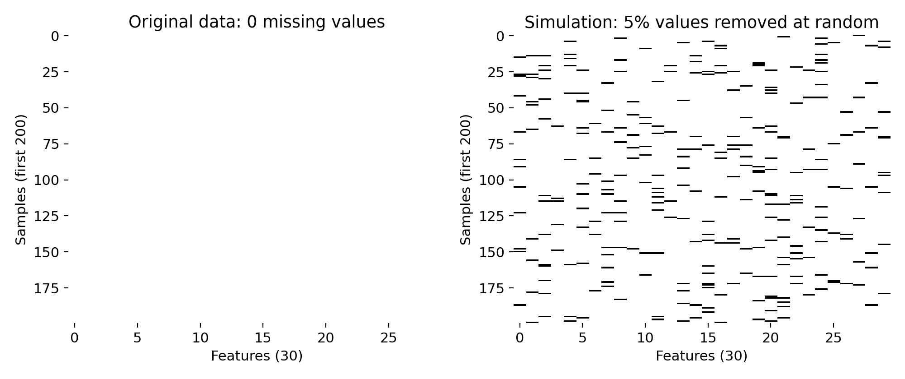
Figure 1: Missing-value map. Left: the real data is complete. Right: the simulation, where each dark mark is a removed value
mask = np.random.default_rng(42).random(X.shape) < 0.05
Xm = X.mask(mask) # copy with ~5% missing

from sklearn.impute import SimpleImputer, KNNImputer
mean_imp = SimpleImputer(strategy='mean').fit_transform(Xm)
median_imp = SimpleImputer(strategy='median').fit_transform(Xm)
knn_imp = KNNImputer(n_neighbors=5).fit_transform(scaled_Xm)

Each method was scored by the normalised mean absolute error (NMAE) on the hidden cells: the average gap between imputed and true values, divided by each feature's standard deviation. Lower is better.
Method | NMAE (lower is better) | Comment
Mean | 0.710 | Pulled by skewed values
Median | 0.682 | Slightly better, robust to outliers
KNN (k = 5) | 0.335 | Best: uses similar patients

KNN imputation roughly halved the error of the simple methods (0.335 versus about 0.68). The reason is that the features are highly correlated (Section 5.5): a missing radius can be estimated well from the same patient's perimeter and area, while a mean or median ignores that information. Recommendation: use KNN imputation when missing data appears, and fit it on training data only to avoid leakage. Median is a good fast fallback because it is more robust than the mean on skewed features.

4.4 Outlier Treatment Decision
The 1.5 x IQR rule flagged 608 extreme values across features, touching 171 of 569 samples. The features with the most outliers are area error (65), radius error (38) and perimeter error (38).
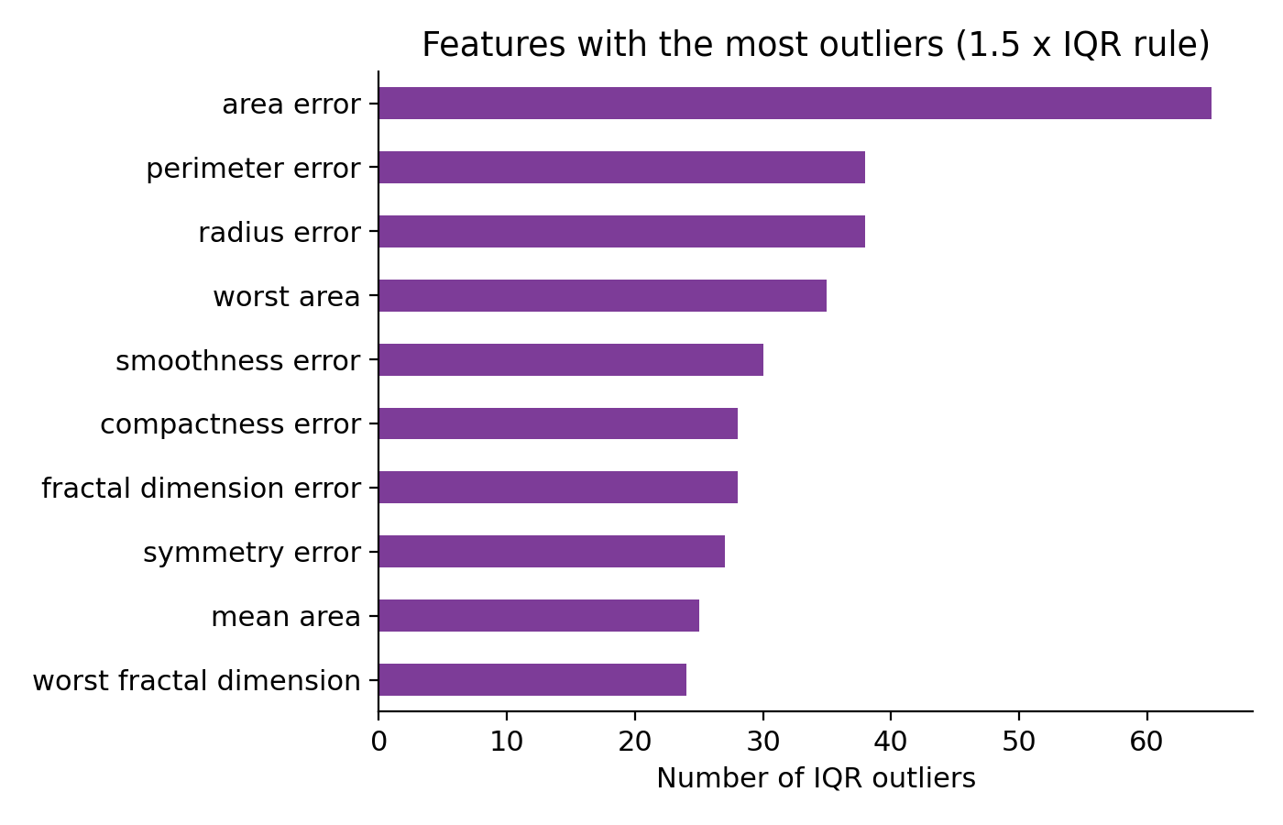
Figure 2: Number of IQR outliers in the ten most affected features
The outliers were kept, for two reasons. First, they are valid measurements: no values are negative or physically impossible. Second, they are not random noise. 114 of the 171 outlier rows (about 54% of all malignant cases) are malignant, compared with 57 benign rows (about 16% of benign cases). Large, irregular tumours are exactly what the dataset is meant to detect, so deleting them would remove the most informative cases and bias the data towards benign samples.

4.5 Skewness and Transformation
22 of the 30 features have an absolute skewness above 1, mostly the standard-error features. The most skewed is area error (5.45), followed by concavity error (5.11). A log(1 + x) transform reduces the skewness of area error from 5.45 to 0.85.
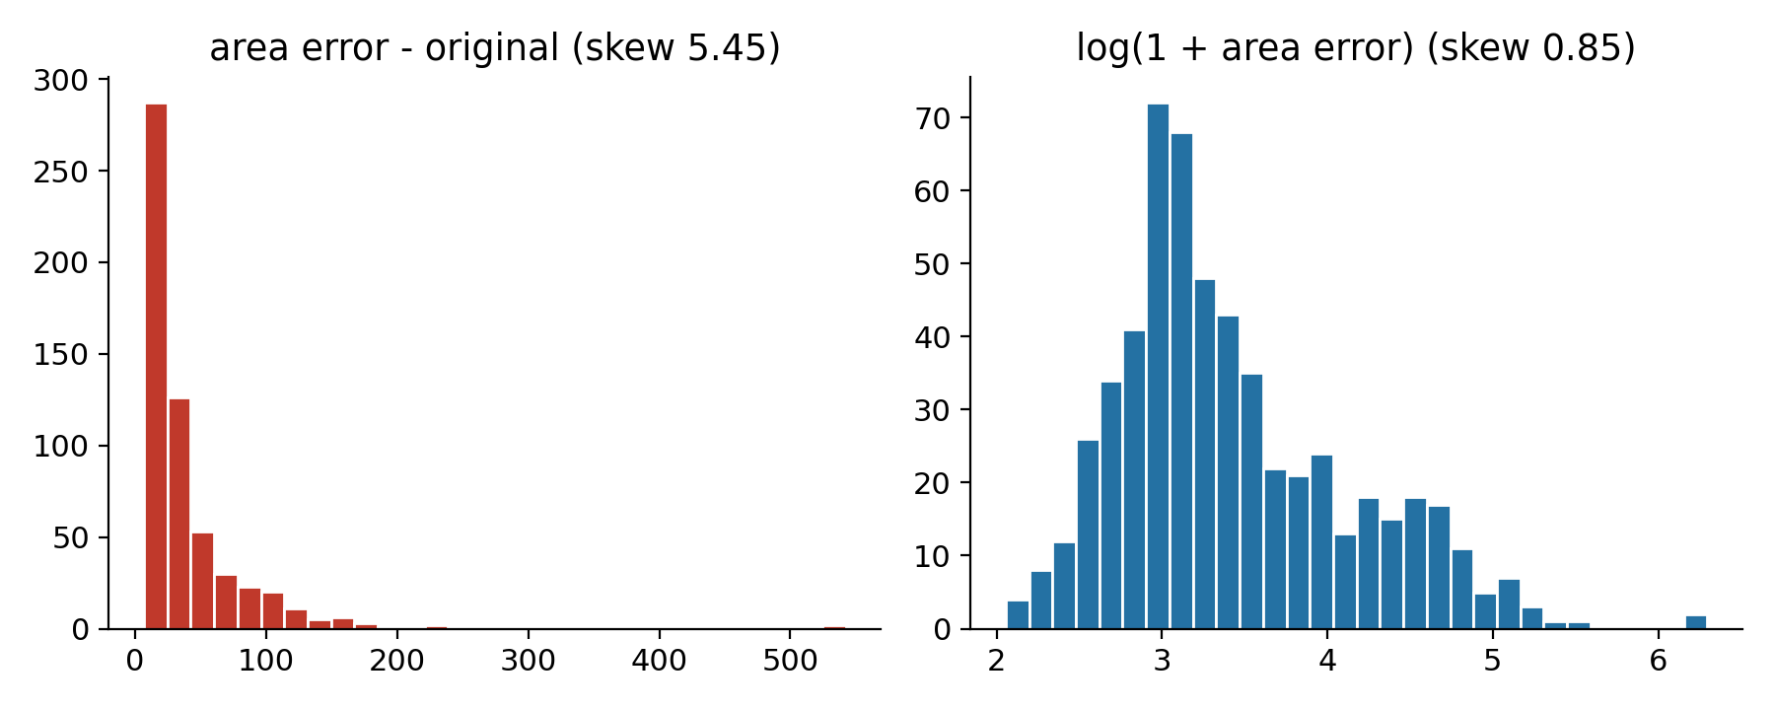
Figure 3: Effect of a log transform on the heavily skewed area error feature
The transform is recommended for linear models and distance-based methods, which are sensitive to skew. Tree-based models do not need it. The original features were left unchanged in the saved clean file so that later steps can choose.

4.6 Output of the Cleaning Stage
The cleaned dataset was exported as breast_cancer_clean.csv: 569 rows, 30 float features and a categorical diagnosis label. Feature scaling (standardisation) is deliberately deferred to the modelling stage, where it is placed inside a pipeline fitted on training data only.

5. Exploratory Data Analysis

5.1 Summary Statistics
df[feats].describe()

Feature | Mean | Std | Min | Median | Max
mean radius | 14.127 | 3.524 | 6.981 | 13.37 | 28.11
mean area | 654.889 | 351.914 | 143.5 | 551.1 | 2501
mean concave points | 0.049 | 0.039 | 0 | 0.034 | 0.201

The features sit on very different scales (area is in the hundreds, concave points is below 0.2), which is why scaling is required before modelling. For mean area the mean (655) is above the median (551), a first sign of right skew.

5.2 Distributions
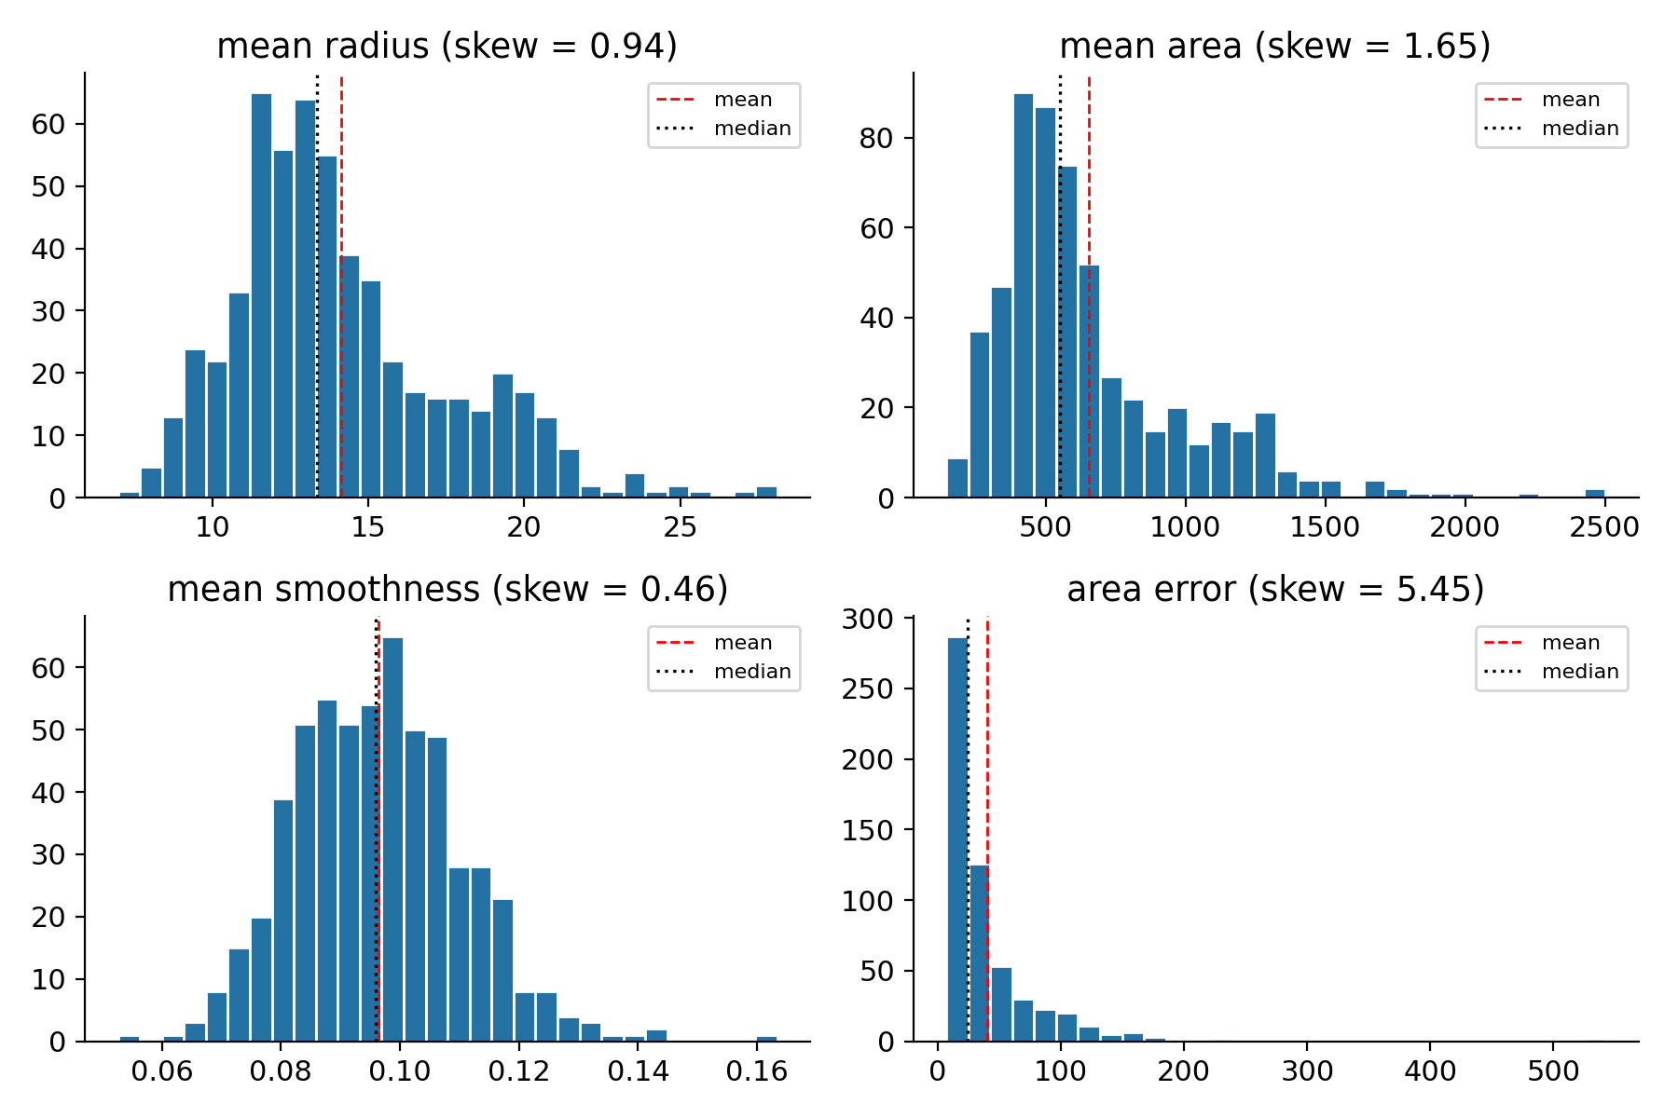
Figure 4: Histograms with mean (red dashed) and median (black dotted). Larger skew means a longer right tail
Mean radius is close to bell-shaped, while mean area and especially area error have long right tails. Mean smoothness is nearly symmetric. These shapes explain which features benefit from transformation.

5.3 Comparison Between Classes
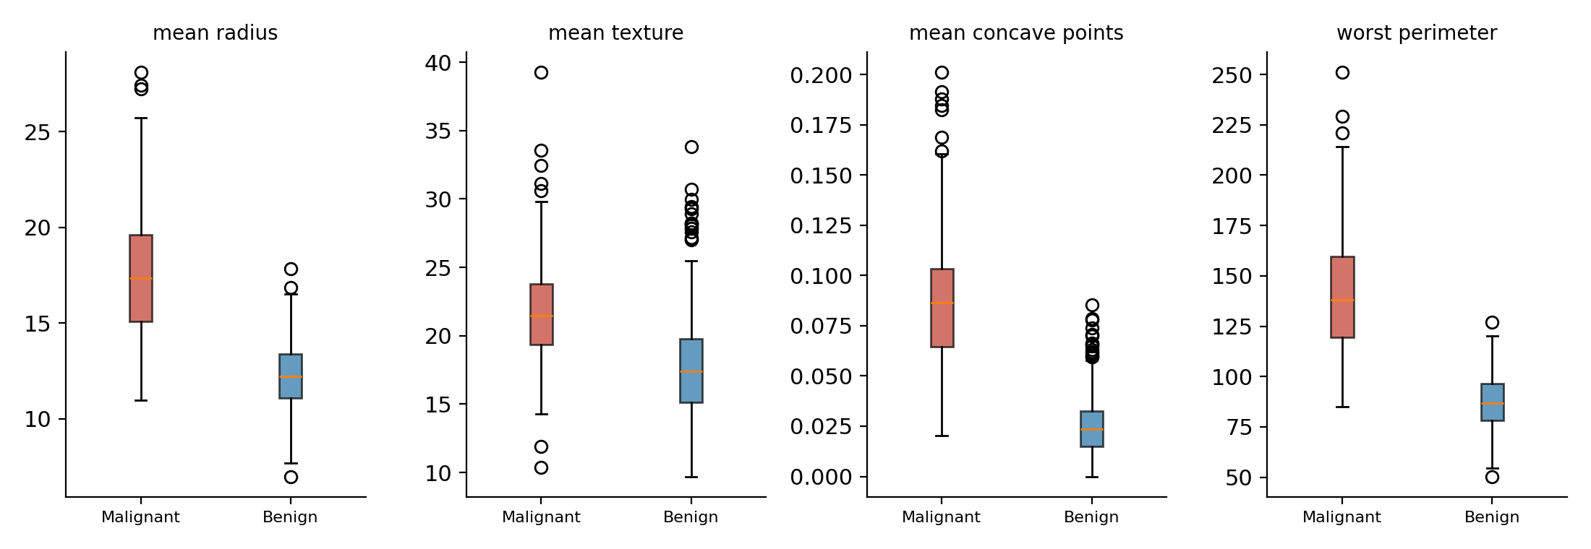
Figure 5: Box plots of four features by diagnosis
Malignant tumours have clearly higher medians for radius, concave points and perimeter, with little overlap between the boxes. Texture shows a smaller but still visible difference.
Feature | Benign mean | Malignant mean | Difference
mean radius | 12.147 | 17.463 | +44%
mean concave points | 0.026 | 0.088 | +238%
mean texture | 17.915 | 21.605 | +21%
mean smoothness | 0.092 | 0.103 | +12%

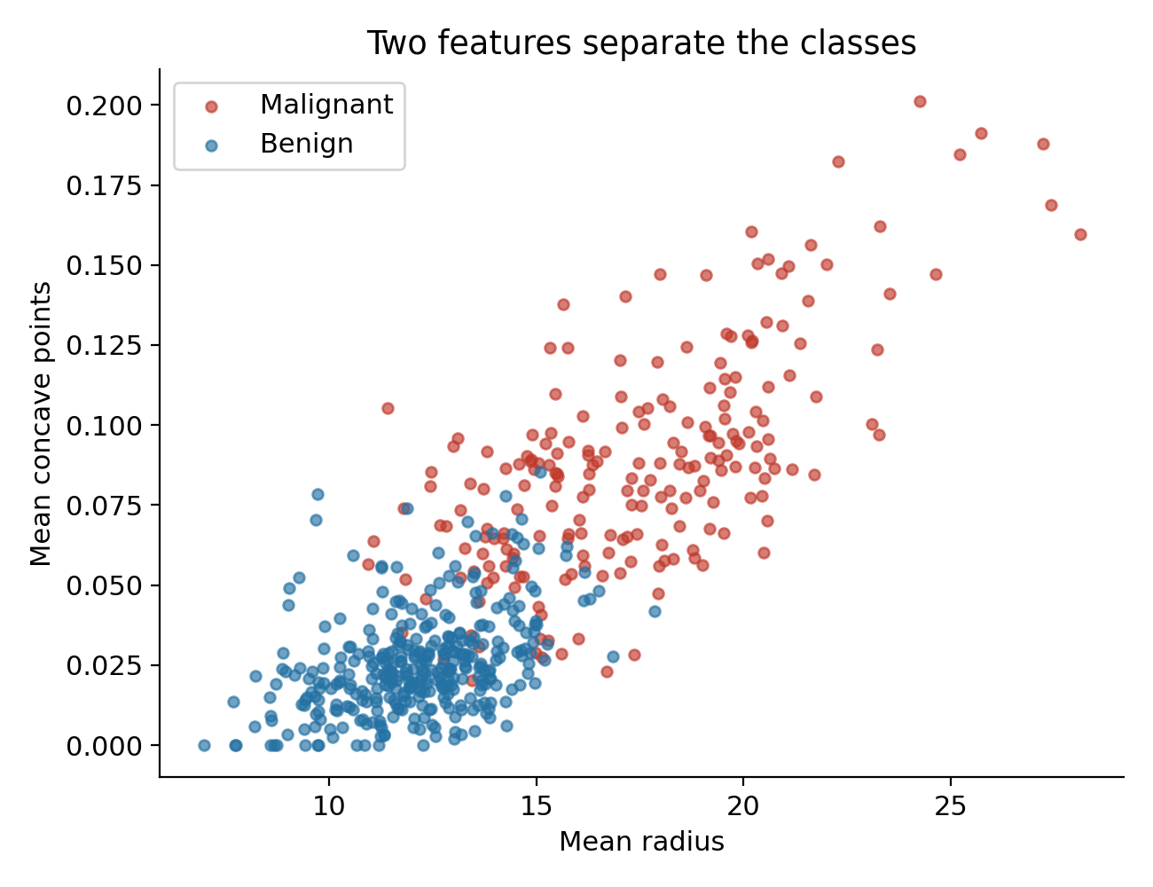
Figure 6: Scatter plot of mean radius against mean concave points, coloured by diagnosis
Plotting just two features already produces two largely separate clusters: malignant cases sit at the upper right (larger and more concave), benign cases at the lower left. A small overlap region in the middle is where classification errors are most likely.

5.4 Which Features Separate the Classes Best?
Cohen's d measures the gap between the class means in standard-deviation units (above 0.8 is considered a large effect).
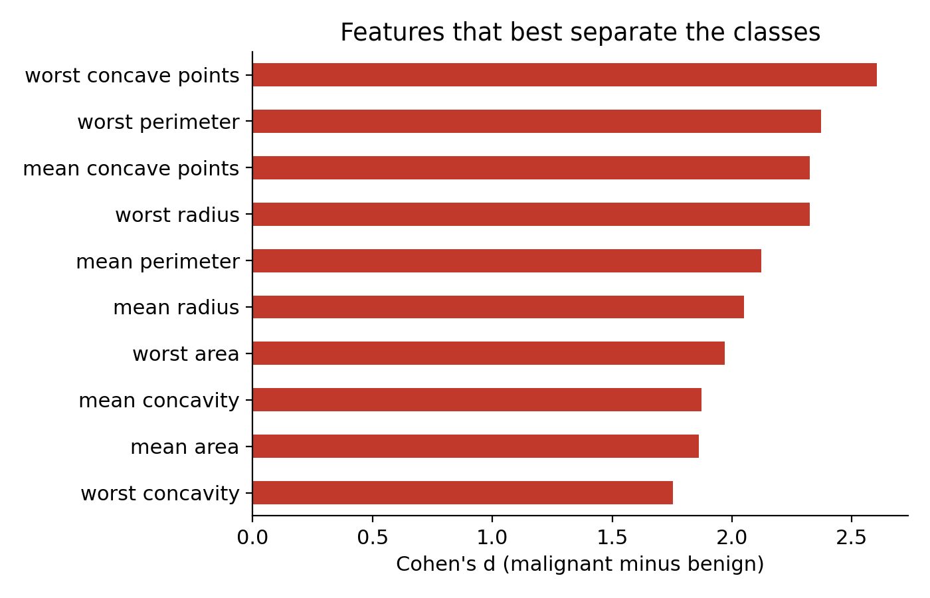
Figure 7: Ten features with the largest class separation (Cohen's d)
All of the top ten features have d above 1.8. The strongest are worst concave points (2.6), worst perimeter (2.37) and mean concave points (2.33). Features describing size and concavity dominate.

5.5 Correlations
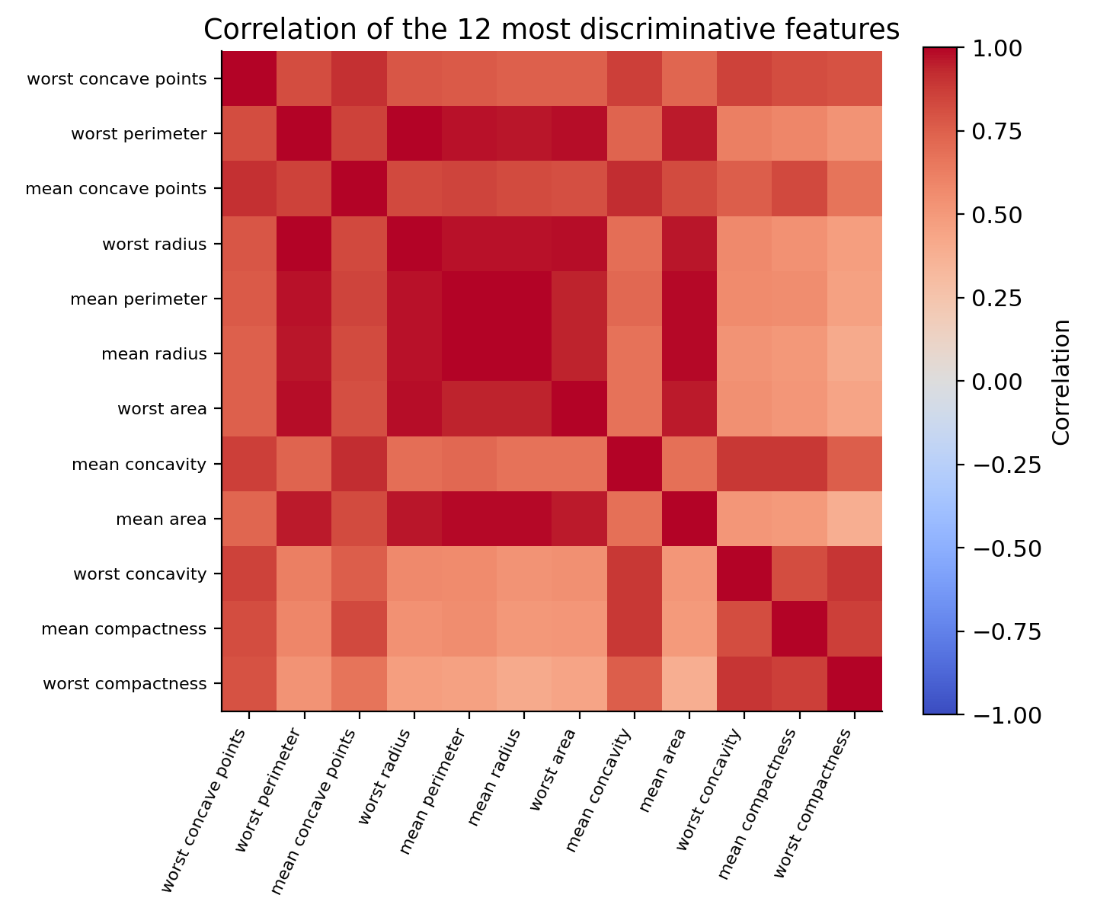
Figure 8: Correlation heatmap of the 12 most discriminative features
21 feature pairs have an absolute correlation above 0.9. The strongest are mean radius with mean perimeter (0.998) and worst radius with worst perimeter (0.994), because radius, perimeter and area all measure size. This redundancy (multicollinearity) does not hurt prediction much, but it makes individual coefficients in linear models unstable and means the 30 features contain far fewer than 30 independent pieces of information.

6. Key Insights
- The data is complete, valid and free of duplicates, and zero values in concavity are genuine measurements.
- Malignant tumours are larger, more irregular and slightly more textured. Size and concavity features separate the classes strongly (Cohen's d above 1.8).
- Two features alone (mean radius and mean concave points) give nearly separate clusters, so even simple models should perform well.
- Outliers are concentrated in malignant cases and are informative, so they were kept.
- 22 of 30 features are strongly skewed, and 21 pairs are highly correlated, which affect modelling choices.
- When missing values do occur, KNN imputation recovers values about twice as accurately as mean or median imputation, because correlated features carry information.

7. Areas for Further Analysis
- Reduce redundancy with feature selection or PCA, since many features duplicate size information.
- Test log transforms and scaling in a modelling pipeline and measure their effect on accuracy.
- Study the overlap region between classes, to understand which cases are hard to classify.
- Build and compare classification models with proper cross-validation (continued in Week 4).
- Examine whether outlier malignant cases behave differently from typical malignant cases (possible sub-types).
- Validate on a second dataset from another source to check that these patterns generalise.

8. Conclusion
A public healthcare dataset was acquired, audited, cleaned and explored using Python. The audit confirmed high data quality, a simulation compared methods for handling missing data, and the exploration revealed strong, clinically sensible patterns that separate malignant from benign tumours. These findings, together with the documented decisions on outliers, skewness and scaling, provide a solid foundation for the modelling work that follows.

Appendix: Files
- week1_eda.py - full reproducible script for every step and figure
- breast_cancer_raw.csv - original data; breast_cancer_clean.csv - cleaned data
- w1_fig1 to w1_fig8 PNG files - all figures in this report

