SportsOS: An AI-Powered Sports ERP for
IIT (ISM) Dhanbad
Thesis Mid-Evaluation Report
submitted in partial fulfilment of the requirements for the degree of
Integrated Master of Technology
in
Mathematics and Computing
Submitted by
Anup Kumar
Admission No.: 22JE0143
Under the guidance of
Prof. Scindhiya Laxmi
Department of Mathematics and Computing
Indian Institute of Technology (Indian School of Mines), Dhanbad
Dhanbad, Jharkhand, India
13 November 2026

ABSTRACT
Sports administration at IIT (ISM) Dhanbad depends on paper registers, spreadsheets and informal messaging, which leaves facility usage, attendance and equipment stock without real-time visibility or a reliable audit trail. This thesis designs and develops SportsOS, a role-aware sports Enterprise Resource Planning system that unifies facility booking, verified attendance, equipment inventory, tournaments, complaints, announcements and analytics for the institute's sports ecosystem.
The work is positioned in Software Engineering and Information Systems. Requirements were derived from the approved proposal and modelled as 18 stakeholder roles, 70 permissions and four scope types. The system is built as a TypeScript monorepo with a Next.js 15 web client, an Expo SDK 54 mobile client, and a NestJS 11 REST API over a 31-entity PostgreSQL schema managed with Prisma. Its main engineering contributions are: scope-aware, time-bounded role-based access control with two-person approval for privileged roles; proof-of-presence attendance combining time-based one-time passwords, GPS geofencing and device binding; database-enforced consistency for bookings and stock; and a SHA-256 hash-chained audit ledger. An optional retrieval-augmented assistant operates on permission-filtered aggregate data.
The prototype was verified on 12 November 2026 against a freshly migrated database. All 71 unit tests, 83 API end-to-end checks, 200 access-control and workflow checks covering all 18 roles, and 21 browser checks passed. The evaluation also identifies the work that remains: password reset, a shared cache, mobile device testing, live evaluation of the AI layer, validation with real institutional data, and load and penetration testing. These form the plan for the second half of the project.
Keywords: sports management information system, enterprise resource planning, role-based access control, verified attendance, geofencing, web application security, NestJS, Next.js, PostgreSQL.
TABLE OF CONTENTS
Abstract i
List of Figures iii
List of Tables iii
List of Abbreviations iii
CHAPTER 1: INTRODUCTION 1
1.1 Background 1
1.2 Sports Ecosystem at IIT (ISM) 1
1.3 Problem Statement 2
1.4 Motivation 2
1.5 Research Objectives and Scope 2
1.6 Contributions and Report Organisation 3
CHAPTER 2: LITERATURE REVIEW 4
2.1 Digital Transformation and Sports Information Systems 4
2.2 Enterprise Systems and Multi-Stakeholder Design 4
2.3 Access Control and Web Security 5
2.4 Comparative Analysis and Research Gap 5
CHAPTER 3: REQUIREMENTS ENGINEERING 6
3.1 Stakeholders and Roles 6
3.2 Use Cases and Methodology 6
3.3 Functional Requirements 7
3.4 Non-Functional Requirements 8
CHAPTER 4: SYSTEM ARCHITECTURE AND DATABASE DESIGN 9
4.1 Architecture Overview 9
4.2 Frontend, Backend and API Design 10
4.3 Database Design 10
4.4 Authentication and Access Control 11
4.5 Data Flow, Security and Deployment 12
CHAPTER 5: IMPLEMENTATION 14
5.1 Technology Stack 14
5.2 Core Platform 14
5.3 Facilities and Booking 15
5.4 Verified Attendance 16
5.5 Inventory, Tournaments and Complaints 16
5.6 Analytics, Mobile Application and AI Features 17
5.7 Implementation Status 17
CHAPTER 6: TESTING AND EVALUATION 18
6.1 Testing Strategy 18
6.2 Test Cases 18
6.3 Evaluation 19
CHAPTER 7: RESULTS AND FUTURE WORK 20
7.1 Achievement Against Objectives 20
7.2 Contributions 20
7.3 Limitations 20
7.4 Future Work and Revised Roadmap 21
7.5 Conclusion 21
REFERENCES 22
LIST OF FIGURES
Figure 3.1: Use case diagram of principal actors and use cases 7
Figure 4.1: System architecture of SportsOS 9
Figure 4.2: Entity relationship diagram of core entities 11
Figure 4.3: RBAC enforcement pipeline 12
Figure 4.4: Level-1 data flow diagram 12
Figure 5.1: Sports Officer dashboard (demonstration data) 15
Figure 5.2: Facility booking workflow 15
Figure 5.3: Attendance check-in validation workflow 16
Figure 7.1: Revised development roadmap 21
LIST OF TABLES
Table 1.1: Research objectives from the approved proposal 2
Table 2.1: Comparison of related work with SportsOS 5
Table 3.1: Role groups, responsibilities and default permission counts 6
Table 3.2: Functional requirements and status 7
Table 3.3: Non-functional requirements (ISO/IEC 25010) 8
Table 4.1: Security controls mapped to ASVS 5.0.0 areas 13
Table 5.1: Technology stack 14
Table 5.2: Module-wise implementation status 17
Table 6.1: Test levels and results 18
Table 6.2: Representative test cases 18
Table 7.1: Achievement against objectives 20
Table 7.2: Current limitations and planned actions 20
LIST OF ABBREVIATIONS
Abbr. | Expansion | Abbr. | Expansion
API | Application Programming Interface | KPI | Key Performance Indicator
ASVS | Application Security Verification Standard | MIS | Management Information System
CORS | Cross-Origin Resource Sharing | ORM | Object-Relational Mapping
CSP | Content Security Policy | OTP | One-Time Password
DFD | Data Flow Diagram | OWASP | Open Worldwide Application Security Project
DTO | Data Transfer Object | QR | Quick Response (code)
ERD | Entity Relationship Diagram | RAG | Retrieval-Augmented Generation
ERP | Enterprise Resource Planning | RBAC | Role-Based Access Control
GPS | Global Positioning System | REST | Representational State Transfer
HSTS | HTTP Strict Transport Security | SPEC | Sports & Physical Education Center
IS | Information Systems | SW | Students' Welfare
IST | Indian Standard Time | TOTP | Time-based One-Time Password
JWT | JSON Web Token | 2FA | Two-Factor Authentication

CHAPTER 1
INTRODUCTION

1.1 Background
Institutional sport generates a continuous stream of records, from practice attendance and ground allocations to equipment loans, fixtures and complaints. Several offices must create, approve, reconcile and report on these records. When they are kept in paper registers, spreadsheets and messaging groups, the institution cannot see its operations in real time, audit them afterwards or plan from evidence.
This thesis addresses that problem for IIT (ISM) Dhanbad through SportsOS, a role-aware sports Enterprise Resource Planning (ERP) system comprising a web application, a mobile application and a REST API over a single relational database. The work belongs to Software Engineering and Information Systems. Artificial-intelligence features form an optional layer above the transactional core and are reported only to the extent verified. This report presents the state of the project on 13 November 2026, three months into the nine-month plan of the approved proposal.

1.2 Sports Ecosystem at IIT (ISM)
Sport at the institute is administered under the Dean (Students' Welfare) through the Sports & Physical Education Center (SPEC). SPEC's remit includes intramural competitions such as the Annual Sports Meet and the Inter-Hostel General Championship [1].
The facilities listed by SPEC [1] are:
- a Lower Ground with a football ground and a floodlit eight-lane, 400 m track;
- a Sports Complex with floodlit basketball, volleyball and tennis courts;
- a Students Activity Centre with a gymnasium, four badminton courts, a yoga centre, a boxing ring and a billiards room;
- a 50 m swimming pool.
Participation is competitive, inter-hostel and recreational, and SportsOS models all three.

1.3 Problem Statement
The approved proposal identifies five operational areas that currently rely on registers, spreadsheets and messaging groups: facility allocation, participation and attendance, tournaments, equipment, and administrative coordination. This fragmentation causes three problems:
- administrators lack real-time visibility of facility usage, attendance and stock;
- records are vulnerable to manipulation, such as proxy attendance;
- audit and analysis are impractical.
The institute therefore needs an integrated, role-aware web and mobile ERP that converts these operations into reliable, auditable data, while giving each stakeholder access only to the functions their role requires.

1.4 Motivation
Research on sports digitalisation has largely examined single solutions for single stakeholders and calls for multi-stakeholder work [2]. Integrated sports-facility information systems are associated with improved service quality but remain little studied [3]. Broken access control is also the leading web-application security risk in the OWASP Top 10. A campus sports ERP with eighteen roles is therefore both a practical institutional need and a demanding setting for rigorous access control.

1.5 Research Objectives and Scope
The six objectives of the approved proposal are retained unchanged (Table 1.1).
Table 1.1: Research objectives from the approved proposal
ID | Objective
O1 | Centralise facility booking, tournaments, attendance, inventory and event management in one platform
O2 | Automate scheduling, approvals, record management and reporting
O3 | Provide role-based access control for students, administrators, coaches, SPEC, the Sports Council and other stakeholders
O4 | Enable real-time analytics and reporting
O5 | Enhance the student experience through a single portal
O6 | Build a secure, scalable, future-ready system able to support AI-driven features

The scope covers authentication and scoped, time-bound role-based access control (RBAC); facilities and booking; clubs; OTP- and GPS-verified attendance; QR-based inventory; tournaments and complaints; notifications and announcements; analytics; a mobile client; and an optional AI assistant.
Payments, integration with institute single sign-on, and the use of real student data before institutional approval are out of scope.

1.6 Contributions and Report Organisation
The expected contributions are:
- a requirements model of the sports ecosystem with 18 roles, 70 permissions and four scope types;
- a 31-entity database design with concurrency-safe booking and inventory and a hash-chained audit ledger;
- a working prototype across web, mobile and API tiers;
- a verification method that tests every protected endpoint class against every role.
Chapter 2 reviews related work. Chapter 3 presents the requirements. Chapter 4 describes the architecture and database. Chapter 5 reports the implementation, Chapter 6 the testing, and Chapter 7 the results and future work.

CHAPTER 2
LITERATURE REVIEW

2.1 Digital Transformation and Sports Information Systems
Digital transformation involves more than digitising records. For sports administration, the approvals, escalations and reporting built around a paper register must themselves be redesigned.
Haffner, Oshri and Kotlarsky review information-systems research on sports digitalisation from a stakeholder perspective [2]. They find that most studies examine one solution for one stakeholder group, and they call for multi-stakeholder research. A single SportsOS booking involves a requesting student, an approving officer, gate security and leadership reading utilisation data, which is the multi-stakeholder setting they describe.
Saputra and Asmawati systematically review integrated management information systems for sports facilities, covering seven studies from 2018 to 2023 [3]. They identify inventory, reservations, cleanliness supervision and performance reporting as the integrated components, and they associate integration with improved user experience and service quality.
Shahrom and Mohamad Sukri present a swimming-facility management system for a university sport centre, with bookings, payments, role-based access control and two-factor authentication [4]. Their one-time password secures login. In SportsOS, a one-time password combined with GPS proves physical presence instead.

2.2 Enterprise Systems and Multi-Stakeholder Design
Enterprise systems integrate an organisation's information flows into a single database and process model. SportsOS adopts two of their properties. The first is a single shared data model, in which bookings, sessions, tournaments and complaints all reference one facility record. The second is process orientation, in which every approval or escalation is a recorded state transition.
A multi-stakeholder design also implies two requirements that the role model encodes explicitly. First, seniority does not imply operational authority: a Director views dashboards but does not approve bookings. Second, student office-bearers act only within a limited scope, such as their own hostel.

2.3 Access Control and Web Security
The NIST RBAC model defines flat, hierarchical, constrained and symmetric RBAC [5]. SportsOS implements core RBAC with a validated active-role selection. It deliberately omits role inheritance and adds scoped assignments (club, hostel, sport or facility) and time-bounded assignments. Separation of duty applies where it matters: proposers cannot approve their own proposals, and privileged roles require a second approver.
The security design follows OWASP ASVS 5.0.0 and the OWASP Top 10. It uses bcrypt password hashing, JSON Web Tokens, input whitelisting and rate limiting, and time-based one-time passwords as a proof-of-presence factor.

2.4 Comparative Analysis and Research Gap
Table 2.1: Comparison of related work with SportsOS
Work | Setting | Attendance proof | Access control | Audit trail
Haffner et al., 2025 [2] | IS review, sports digitalisation | — | Stakeholder lens | —
Saputra & Asmawati, 2025 [3] | Review, sports facilities | Not reported | Not reported | Not reported
Shahrom & Mohamad Sukri, 2025 [4] | University pool system | No (OTP for login) | RBAC + 2FA | Not reported
Sandhu et al., 2000 [5] | RBAC reference model | — | Flat to symmetric RBAC | —
SportsOS (this work) | Institute-wide campus sports | TOTP + GPS + device binding | Scoped, time-bound RBAC | SHA-256 hash chain

The literature supplies principles but no integrated, verifiable system for an academic sports ecosystem that meets four conditions together:
- student office-bearers hold only scoped authority;
- attendance must be provably physical;
- booking and stock records remain consistent under concurrent use and are auditable;
- authorisation is tested systematically across every role.
SportsOS addresses this gap.

CHAPTER 3
REQUIREMENTS ENGINEERING

3.1 Stakeholders and Roles
Requirements were derived from the approved proposal. They are written to the ISO/IEC/IEEE 29148 criteria of being necessary, unambiguous and verifiable, and quality attributes follow ISO/IEC 25010. Each stakeholder in the proposal's governance structure became a role, giving 17 organisational roles plus a System Administrator.
The governance hierarchy is the proposal's requirements model and is to be validated with SPEC. The system therefore uses it only to draw the organisation chart, never to grant permissions. Table 3.1 groups the roles; the permission counts are the defaults measured from the running system.
Table 3.1: Role groups, responsibilities and default permission counts
Group | Roles | Responsibility | Permissions
Leadership | Director, Dean (SW), President SPEC | Dashboards, escalations, approval of privileged roles and events | 18–27
Administration | Sports Officer (PESO) | Facilities, bookings, inventory, staff tasks, analytics | 61
Staff | Coach, Ground, Equipment, Security, Operations staff | Sessions for coached clubs, facility status, stock, gate passes, tasks | 11–17
Student council | General Secretary, Sports Council, Sport Coordinator, Hostel Secretary, Media Nominee | Proposals; sport- or hostel-scoped rosters and teams; announcements | 14–20
Events | Event Committee | Tournaments, fixtures, results | 18
Students | Club Member, Student | Bookings, verified check-in, complaints, own records | 12–13
Platform | System Administrator | Users, roles, permission matrix, imports | 22

3.2 Use Cases and Methodology
Figure 3.1 shows the principal actors and use cases, all of which are implemented. The project follows an iterative, incremental process framed as design science research: an artefact is built to address an identified organisational problem and is then evaluated rigorously. Each increment refined the requirements, extended the schema and its migration, implemented the service with permission checks, built the user interface, and added tests before the full suite was re-run.
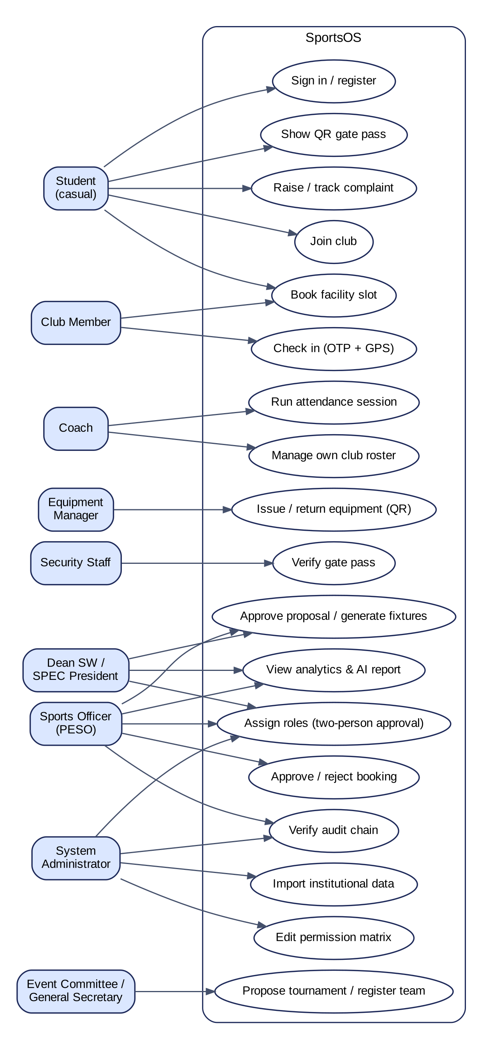
Figure 3.1: Use case diagram of principal actors and use cases

3.3 Functional Requirements
Table 3.2: Functional requirements and status
ID | Requirement | Obj. | Status
FR-01 | Email and password sign-in; institute-domain self-registration yields the Student role only | O3 | Implemented, tested
FR-02 | Self-service password reset | O5 | Not implemented
FR-03 | Scoped, time-bound role assignment; privileged roles need a second approver | O3 | Implemented, tested
FR-04 | Run-time editable role–permission matrix with lock-out protection | O3 | Implemented, tested
FR-05 | Facility catalogue, availability grid and status management | O1 | Implemented, tested
FR-06 | Validated bookings, auto-approved or queued; QR gate pass verified at entry | O1, O2 | Implemented, tested
FR-07 | Coach-run sessions; check-in with rotating OTP and GPS geofence; reasoned corrections | O1 | Implemented, tested
FR-08 | Equipment issue and return by QR with damage and loss; stock ledger; alerts | O1, O2 | Implemented, tested
FR-09 | Tournament proposals, hostel-scoped registration, fixtures and results | O1 | Implemented, tested
FR-10 | Complaint lifecycle with escalation and attachments | O2 | Implemented, tested
FR-11 | Notifications, club announcements and approval-gated official announcements | O5 | Implemented, tested
FR-12 | KPIs, participation, utilisation, demand forecast and attendance integrity | O4 | Implemented, tested
FR-13 | Assistant answering questions and drafting reports from permission-filtered data | O6 | Partial
FR-14 | Mobile app for check-in, QR scanning, bookings and gate passes | O5 | Partial
FR-15 | Tamper-evident audit ledger with verification | O2, O6 | Implemented, tested

3.4 Non-Functional Requirements
Table 3.3: Non-functional requirements (ISO/IEC 25010)
ID | Characteristic | Requirement | Status
NFR-01 | Confidentiality | Password hashes, OTP secrets and device IDs are never returned | Verified
NFR-02 | Authenticity | A valid token is needed on every protected route; role changes apply immediately | Verified
NFR-03 | Integrity | No double-booking and no negative stock under concurrent requests | Verified (small scale)
NFR-04 | Accountability | Every state change is recorded in a hash-chained ledger | Verified
NFR-05 | Maintainability | Typed end to end; shared role definitions; lint-clean | Verified
NFR-06 | Performance | Pages respond within 2 s for 500 concurrent users | Not tested
NFR-07 | Privacy | Minimal data shown to security staff; AI never receives personal records | Verified

CHAPTER 4
SYSTEM ARCHITECTURE AND DATABASE DESIGN

4.1 Architecture Overview
SportsOS is a three-tier system (Figure 4.1). A Next.js web client and an Expo mobile client call a NestJS REST API, which persists all state in PostgreSQL through the Prisma ORM. A shared TypeScript package defines roles, permissions and data types once for both server and clients.
The API is a modular monolith of 20 modules, each consisting of a controller, a service and validated data-transfer objects. A monolith was chosen for three reasons:
- related changes must commit atomically (a booking and its audit entry, for example);
- the load of a single institute does not justify microservices;
- one deployable unit suits a small campus IT team.
An external large language model (LLM) service and a vector database are optional, and the system operates fully without them.
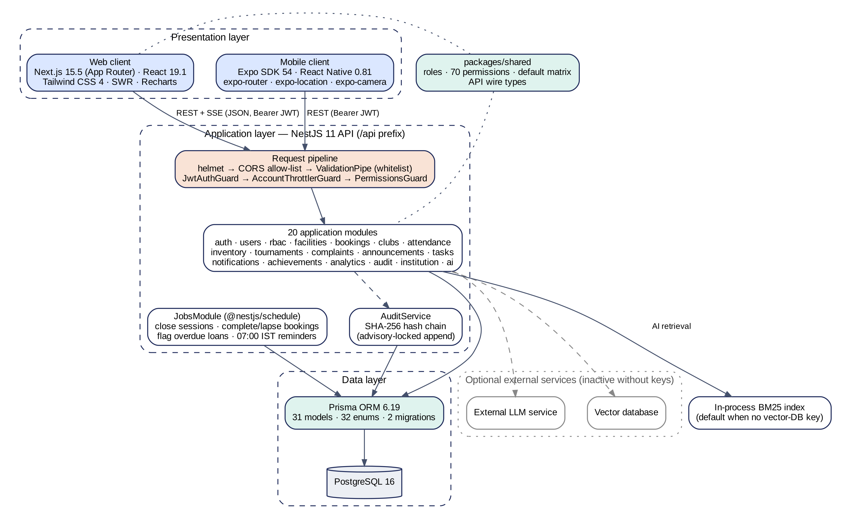
Figure 4.1: System architecture of SportsOS

4.2 Frontend, Backend and API Design
Web client. The web client uses the Next.js 15 App Router. Its authenticated pages share a shell with permission-driven navigation, notifications and an active-role switcher, and the production build contains 28 routes. Navigation is a usability aid only: every action is authorised again on the server.
API pipeline. Each request passes through security headers (helmet), a CORS allow-list and a global validation pipe that rejects unknown fields. Three global guards then run in order: authentication, per-account rate limiting, and permission checking. Services hold the business rules and use database transactions for every multi-row change.
Endpoints. The REST API exposes 143 route handlers. State transitions are modelled as sub-resource actions, such as POST /bookings/:id/approve, and each maps to one audit entry.

4.3 Database Design
The schema defines 31 models and 32 enumerations across two migrations. Figure 4.2 shows the core entities. Integrity is enforced by the database itself in four ways:
- Unique constraints, for example at most one attendance record per student per session;
- PostgreSQL advisory locks, which serialise bookings per facility and appends to the audit chain;
- Conditional updates of the form UPDATE … WHERE availableQty >= n, so stock can never become negative;
- Append-only history for role assignments, stock transactions and attendance corrections.
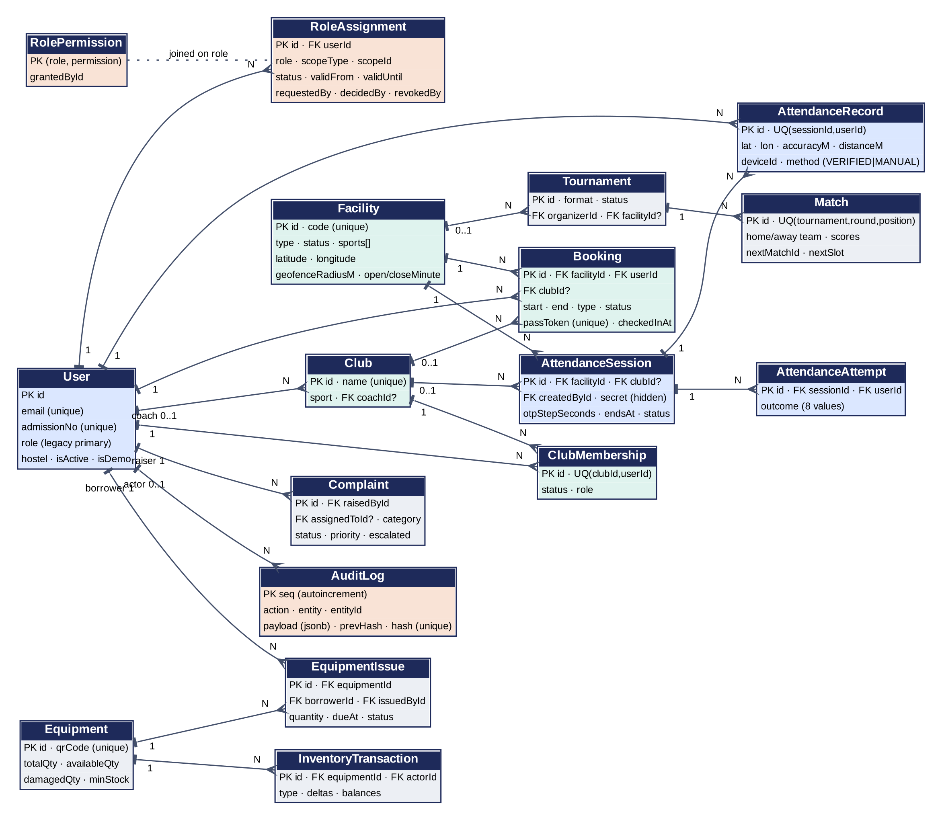
Figure 4.2: Entity relationship diagram of core entities

4.4 Authentication and Access Control
Authentication. Passwords are stored as bcrypt hashes. Login is rate-limited, and its response timing does not reveal whether an account exists. A successful login returns a JSON Web Token valid for 12 hours. On every request the server reloads the user's roles and permissions from the database rather than trusting the token, so revocation and deactivation take effect immediately.
Access control. Figure 4.3 shows the enforcement pipeline. An assignment links a user to one of 18 roles, together with a scope, a validity window and a status. The role–permission matrix (70 permissions and 346 default grants) is stored in the database and is editable at run time.
A pure, unit-tested function resolves each request's permissions. Route guards check the permission, and services additionally check that the target lies within the user's scope; a coach, for example, can manage only clubs they coach. Privileged roles remain pending until a second person approves them.
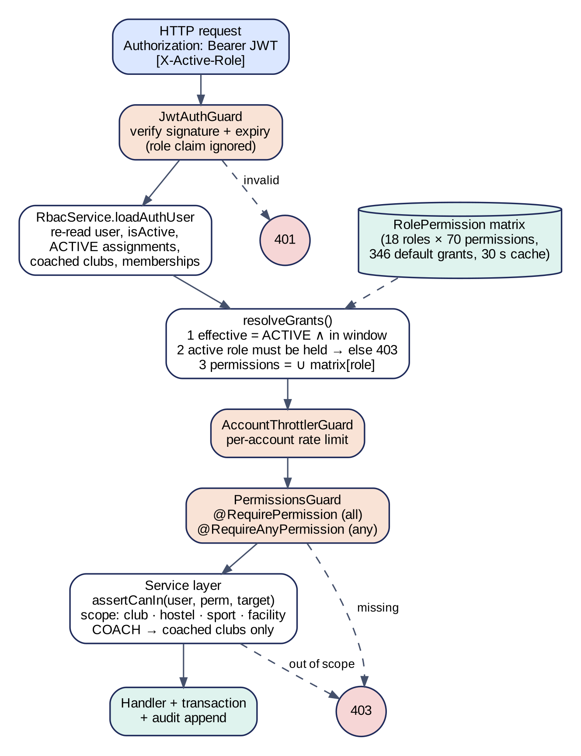
Figure 4.3: RBAC enforcement pipeline

4.5 Data Flow, Security and Deployment
Figure 4.4 is the level-1 data flow diagram. Booking, attendance and inventory processes append to the audit ledger, while analytics only reads operational data.
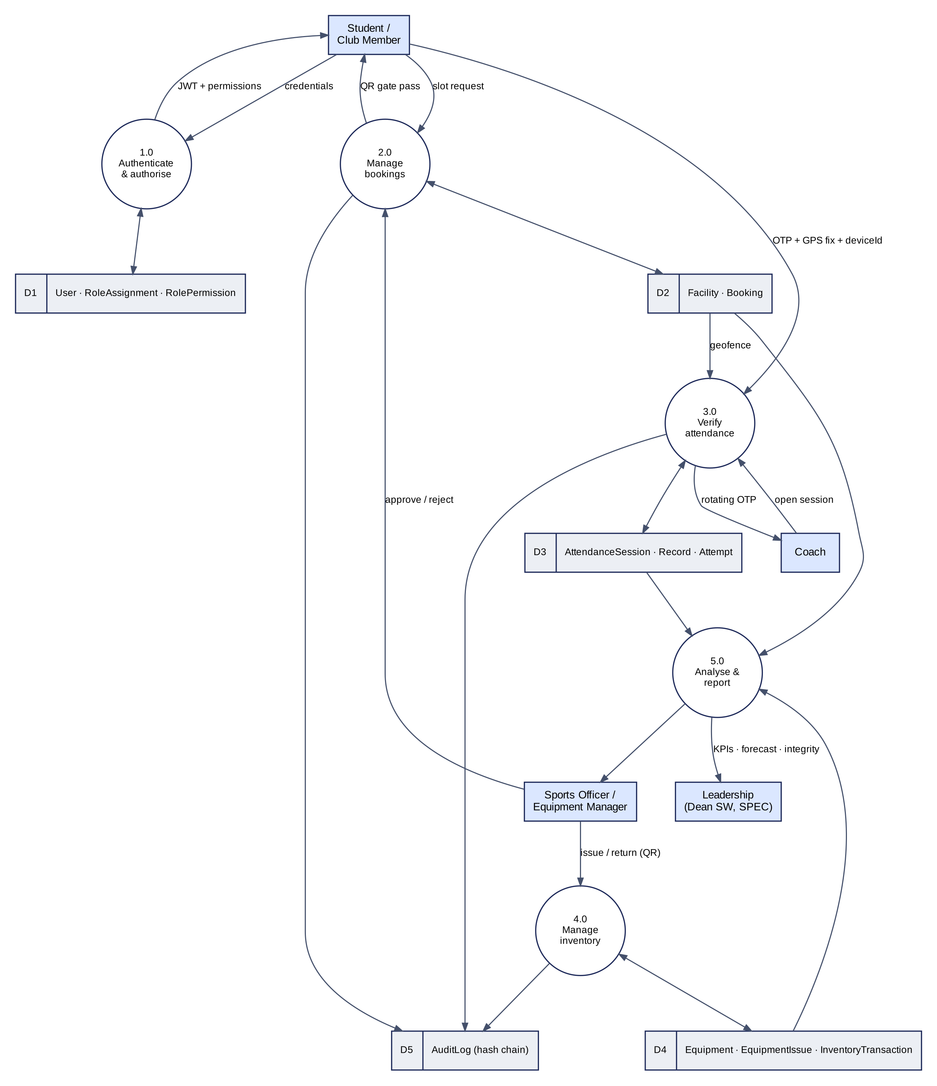
Figure 4.4: Level-1 data flow diagram
The implemented security controls are mapped to OWASP ASVS 5.0.0 areas in Table 4.1. The mapping is indicative and is not a formal ASVS assessment.
Table 4.1: Security controls mapped to ASVS 5.0.0 areas
Area | Implemented control | Open gap
Authentication | bcrypt (12 rounds); timing-equalised login; login rate limit | No password reset
Session | 12-hour token; principal reloaded on every request | Web token in browser storage
Authorisation | Permission guards; object-level scope checks; spoofed roles refused | No penetration test
Validation | Whitelisted DTOs; parameterised queries; upload content checks | —
Configuration | Security headers (CSP, HSTS, nosniff); CORS allow-list | Dependency advisories
Audit | SHA-256 hash-chained audit log with verification endpoint | —

For deployment, Docker Compose defines three containers (PostgreSQL 16, the API and the web server). The API applies database migrations automatically on start-up. Cloud hosting is planned for the hardening phase.

CHAPTER 5
IMPLEMENTATION

5.1 Technology Stack
The repository is an npm-workspaces monorepo of about 28,000 lines of TypeScript, comprising the API, the web client, the shared package and the separately installed mobile app. Table 5.1 summarises the stack.
Table 5.1: Technology stack
Layer | Technology | Use in SportsOS
Web | Next.js 15.5, React 19.1, Tailwind CSS 4, SWR, Recharts | Role-aware pages, data fetching, charts
Mobile | Expo SDK 54, React Native 0.81 | GPS check-in, QR scanning, secure token storage
API | NestJS 11 (JWT, throttler, scheduler) | Modules, global guards, scheduled jobs
Data | Prisma 6.19, PostgreSQL 16 | Typed queries, migrations, transactions, advisory locks
Security | bcrypt, helmet, class-validator | Hashing, headers, input validation
AI (optional) | External LLM service; vector database | Question answering and reports
Infrastructure | Docker Compose | Containerised local deployment

5.2 Core Platform
Dashboards. The web client provides 24 authenticated pages. A role-aware dashboard (Figure 5.1) assembles each role's work queues: approvals and live sessions for the Sports Officer, upcoming bookings for students, and the entry log for security staff.
Services. Controllers declare the permissions each route requires. Services enforce ownership, scope and state rules, and they append an audit entry inside the same transaction as each change. Four scheduled jobs close expired sessions, complete or lapse bookings, flag overdue loans and send daily reminders.
Users and roles. Login, registration and user administration are implemented, and roles change only through RBAC assignments. Administrators manage the 18 × 70 permission matrix and scoped or temporary roles from the web interface.
Demonstration data. A deterministic seed generates synthetic demonstration data, including 79 users, 9 facilities, 2,798 bookings and 1,080 check-ins. Every seeded record is flagged as demo data.
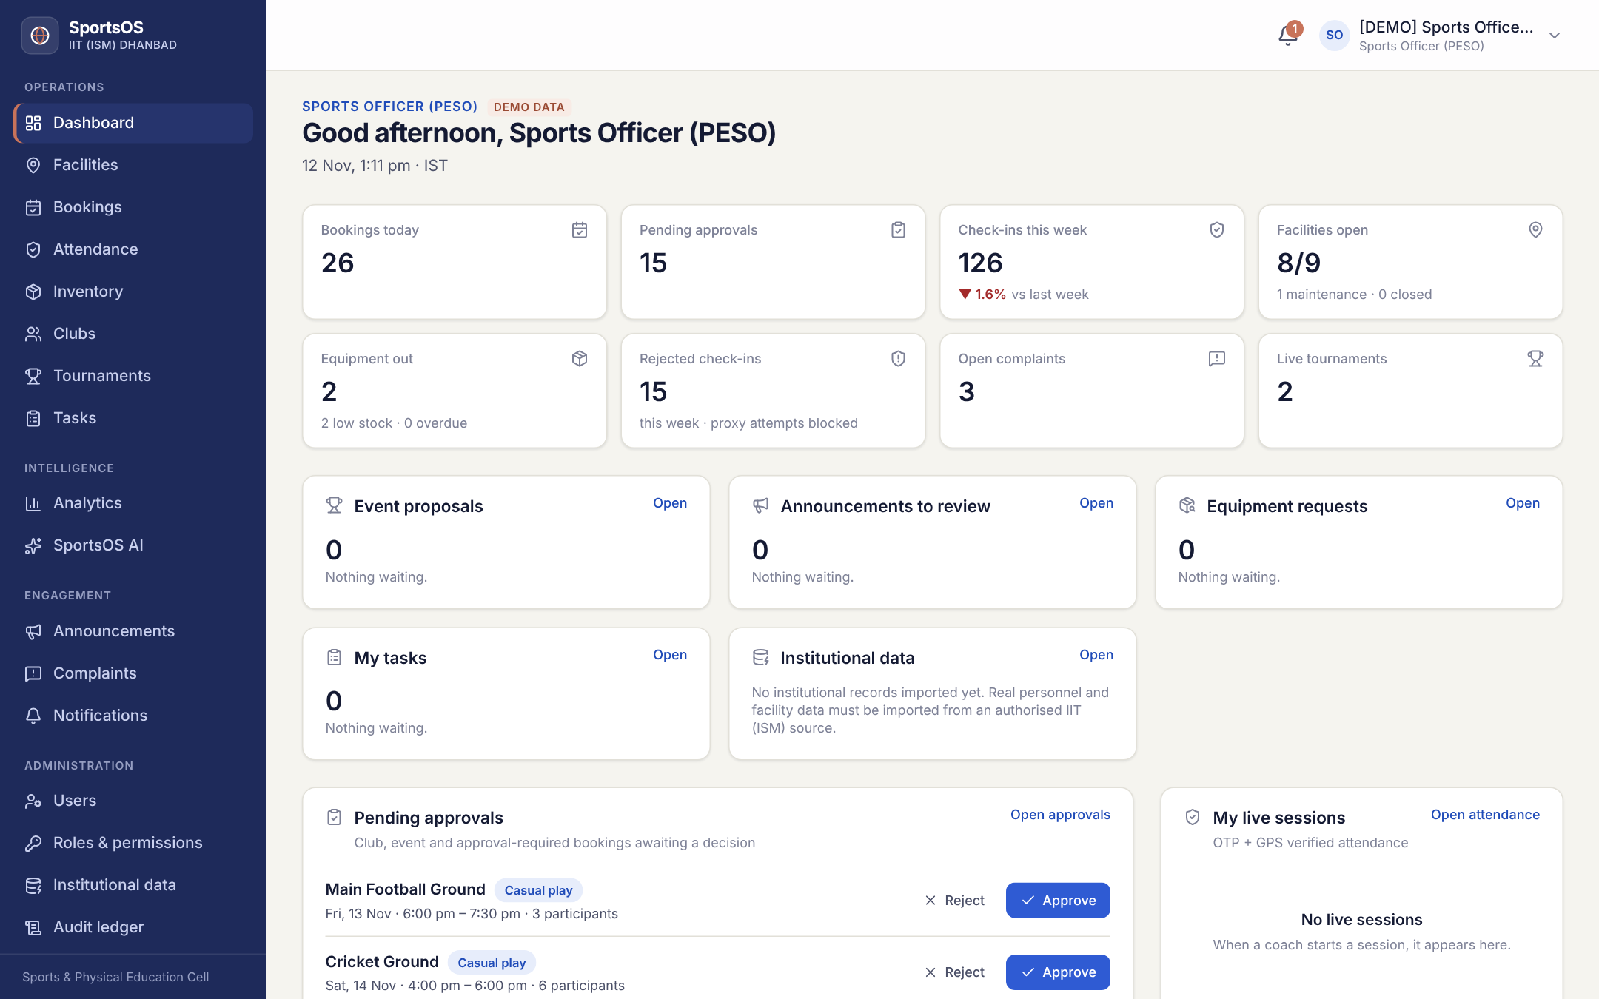
Figure 5.1: Sports Officer dashboard (demonstration data)

5.3 Facilities and Booking
Each facility stores opening hours, slot length, capacity, an approval flag and its GPS geofence. A booking request follows the workflow in Figure 5.2:
- validate duration, booking horizon, opening hours and capacity;
- lock the facility and reject any overlapping slot;
- auto-approve eligible casual bookings, or queue the request for an approver;
- issue a QR gate pass, which security staff scan at entry.
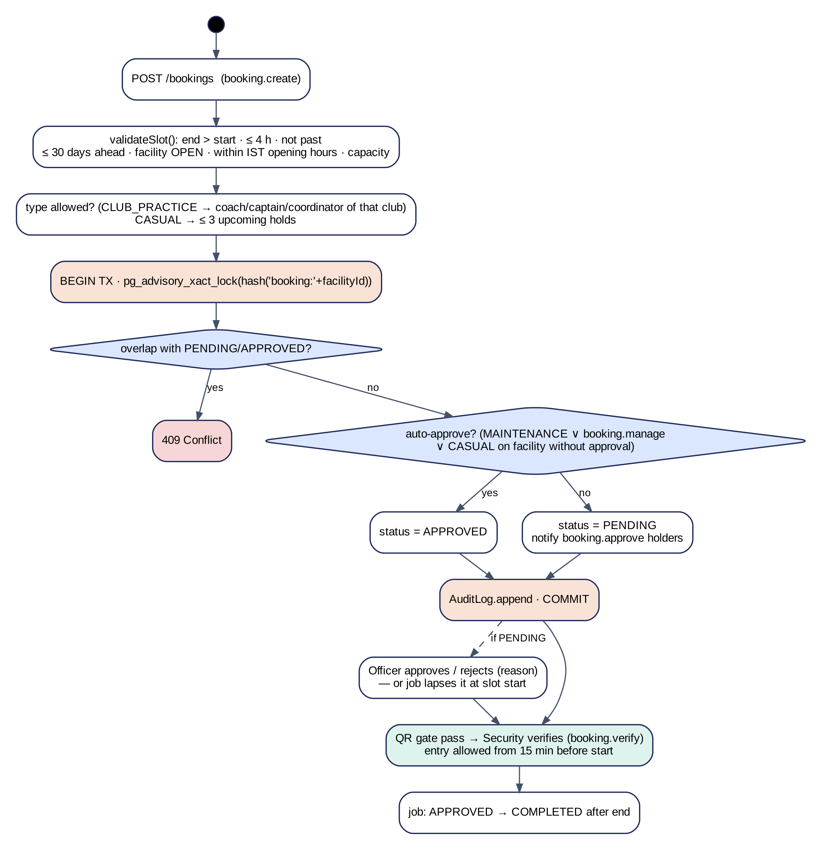
Figure 5.2: Facility booking workflow

5.4 Verified Attendance
A coach opens a session for a facility and club, and the server generates a secret key that is never sent to any client. The coach's screen displays a six-digit time-based one-time password (TOTP) that changes every 30 seconds.
A student checks in by submitting the code, a GPS fix with its reported accuracy, and a device identifier. The server applies the checks in the order shown in Figure 5.3. The geofence test uses the haversine distance and accepts a position within the facility radius plus min(accuracy, 25 m); fixes less accurate than 100 m are rejected. A device may check in only one student per session, and reuse alerts the coach.
Every attempt, accepted or rejected, is stored and feeds an attendance-integrity report. Manual corrections require a reason and never record fabricated coordinates.
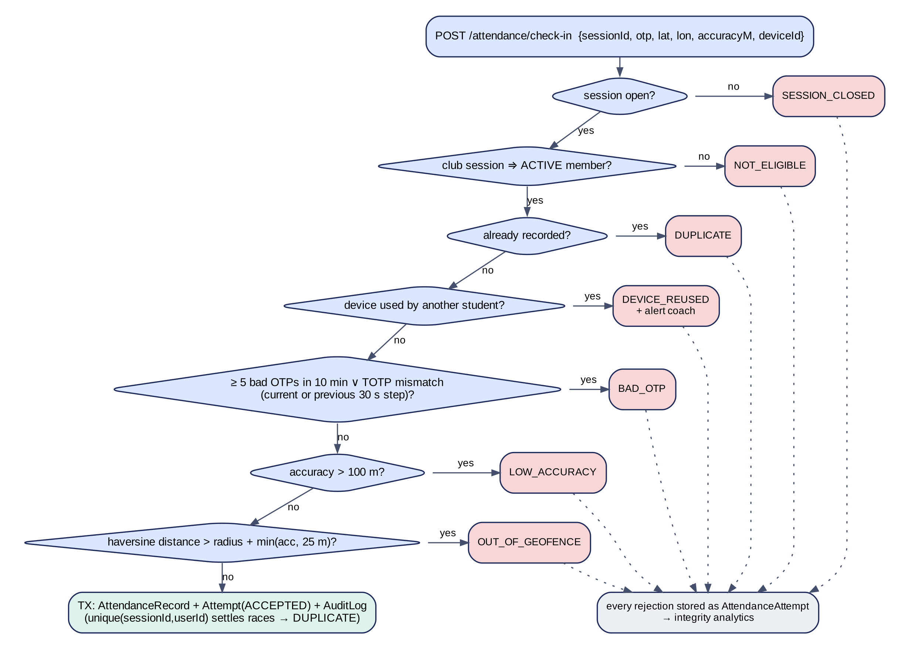
Figure 5.3: Attendance check-in validation workflow

5.5 Inventory, Tournaments and Complaints
Inventory. Each equipment item carries a QR code and available, damaged and total quantities. Every stock change passes through a single function that applies a conditional update and writes a ledger entry with the resulting balances. A return records good, damaged and lost units together, and low-stock and overdue alerts are raised automatically.
Tournaments. Tournament proposals require approval by someone other than the proposer, and hostel secretaries register only residents of their own hostel. Fixtures are generated as seeded single elimination, with byes and automatic advancement, or as round robin with 3/1/0 standings.
Complaints. Complaints move through open, in-progress, resolved and closed states. Resolution requires a note, the complainant cannot resolve their own complaint, and escalation brings it to the Dean (Students' Welfare).

5.6 Analytics, Mobile Application and AI Features
Analytics. The analytics module provides KPIs, participation trends, utilisation heatmaps, equipment wear, attendance integrity and a Holt–Winters demand forecast.
Mobile app. The Expo app provides check-in, QR scanning, bookings and gate passes across 11 screens. It passes strict type checking but has not yet been run on physical devices.
AI assistant. The assistant uses retrieval-augmented generation over documents containing aggregate figures only. Documents are filtered by the user's permissions before retrieval, so restricted data never reaches the language model. Without a vector-database key, retrieval uses an in-process BM25 index; without a language-model key, the assistant returns the retrieved facts and a templated report. The offline mode has been verified. The live language-model path has been tested only with mocked clients.

5.7 Implementation Status
Table 5.2: Module-wise implementation status
Module | Status
Authentication, users, RBAC | Implemented, tested
Facilities, booking, QR gate pass | Implemented, tested
Clubs and rosters | Implemented, tested
OTP + GPS attendance | Implemented, tested
Inventory ledger and QR | Implemented, tested
Tournaments, complaints, announcements, tasks | Implemented, tested
Analytics and audit ledger | Implemented, tested
AI assistant and reports | Partial (offline mode verified)
Mobile application | Partial (type-checked)
Password reset; shared cache (Redis) | Not implemented
Cloud deployment | Planned

CHAPTER 6
TESTING AND EVALUATION

6.1 Testing Strategy
All tests were executed on 12 November 2026 against production builds and a freshly migrated database seeded with demonstration data. The strategy has three layers:
- unit tests for security-critical logic: OTP generation, geofencing, hash chaining, fixtures, forecasting and permission resolution;
- API tests against the running server and a real database;
- browser tests of each role's interface.
Because broken access control is the leading web-application risk, the access-control suite calls 23 protected endpoints as every one of the 18 roles. Permitted roles must not be refused, and all other roles must receive HTTP 403. Table 6.1 summarises the results.
Table 6.1: Test levels and results
Level | Scope | Result
Static analysis | TypeScript and ESLint across API, web and mobile | 0 errors
Unit tests | 8 suites | 71 / 71 passed
API end-to-end | All modules | 83 / 83 passed
Access control and workflows | 23 endpoints × 18 roles, plus workflows | 200 / 200 passed
Browser | 9 role views and 12 interactive flows | 21 / 21 passed
Demo accounts | Sign-in for every seeded role | 19 / 19 passed

6.2 Test Cases
Table 6.2 lists representative test cases for the key scenarios.
Table 6.2: Representative test cases
ID | Scenario | Expected | Actual | Status
T-01 | Login with valid credentials (19 accounts) | HTTP 200 + token | 19 / 19 succeeded | PASS
T-02 | Login with an unknown account | HTTP 401 | 401 | PASS
T-03 | API call without a token | HTTP 401 | 401 | PASS
T-04 | Student requests analytics | HTTP 403 | 403 | PASS
T-05 | Student claims the Sports Officer role in the request header | HTTP 403 | 403 | PASS
T-06 | Coach opens a session for a club they do not coach | HTTP 403 | 403 | PASS
T-07 | Six concurrent requests for one slot | One succeeds | 1 × 201, 5 × 409 | PASS
T-08 | Check-in with the correct code from 1.1 km away | Rejected | OUT_OF_GEOFENCE | PASS
T-09 | Check-in with the correct code inside the geofence | Accepted | ACCEPTED (11 m) | PASS
T-10 | Second check-in by the same student | Rejected | DUPLICATE | PASS
T-11 | Eight concurrent issues against three units | Three succeed | 3 × 201, 5 × 409 | PASS
T-12 | Return with one damaged unit | Stock updated | Available 13 → 12 | PASS
T-13 | Complaint resolved, then reopened | Status transitions | As expected | PASS
T-14 | Audit chain verification | Valid | Valid (589 entries) | PASS
T-15 | Forgot-password request | Reset flow | Not available | Not impl.

6.3 Evaluation
Every executed test passed. The concurrency tests (T-07 and T-11) confirm that the locking and conditional-update design prevents double-booking and stock overdraw. The access-control suite confirms that every role is confined to its permissions and scopes. Response headers include CSP, HSTS and X-Frame-Options, and requests from origins outside the allow-list are refused.
This evaluation is preliminary. It establishes functional and authorisation correctness at prototype scale. It does not yet cover performance under load, GPS behaviour on real grounds, mobile usability, the quality of AI answers, or penetration testing. A dependency audit also reported ten advisories (seven high), which are scheduled for triage.

CHAPTER 7
RESULTS AND FUTURE WORK

7.1 Achievement Against Objectives
In three months the project has progressed from proposal to a tested prototype with 31 database models, 143 API endpoints, 28 web routes, a mobile client and 375 passing automated checks. The September to November milestones are complete, and the December tournament milestone was delivered early. Table 7.1 assesses each objective.
Table 7.1: Achievement against objectives
Obj. | Evidence | Assessment
O1 | One schema and API for all operational modules | Met
O2 | Approval workflows, scheduled jobs, conflict detection | Met
O3 | 18 roles, 70 permissions, scoped and time-bound; 200/200 checks | Met
O4 | Dashboards and forecast on demonstration data | Partly met
O5 | Student web portal; mobile client not yet device-tested | Partly met
O6 | Modular, containerised, AI-ready; no cloud deployment or load test yet | Partly met

7.2 Contributions
- Scope-aware, time-bounded RBAC with two-person approval for privileged roles and no implicit seniority.
- Proof-of-presence attendance combining TOTP, accuracy-aware geofencing, device binding and a complete attempt log.
- Database-enforced consistency for bookings and stock, with a reconciled ledger and a hash-chained audit log.
- A role-exhaustive verification method covering all 18 roles.

7.3 Limitations
Table 7.2: Current limitations and planned actions
Limitation | Planned action
No self-service password reset | Email-based reset once a mail channel is approved
Web token kept in browser storage | Move to secure httpOnly cookies
No shared cache (Redis) | Redis-backed rate limiting and caching
Mobile app not tested on devices | Android and iOS device testing
AI verified in offline mode only | Evaluation with live service keys
Demonstration data and placeholder geofences | Ground survey and verified institutional data
No load or penetration testing | Load tests, ASVS review and staging deployment

7.4 Future Work and Revised Roadmap
Because the core modules were completed early, the remaining months are re-planned towards validation and hardening (Figure 7.1):
- November–January: validation with SPEC and a ground survey;
- December–January: security hardening;
- January–February: live AI evaluation;
- February: mobile device testing;
- March–April: load and penetration testing, deployment and the final thesis.
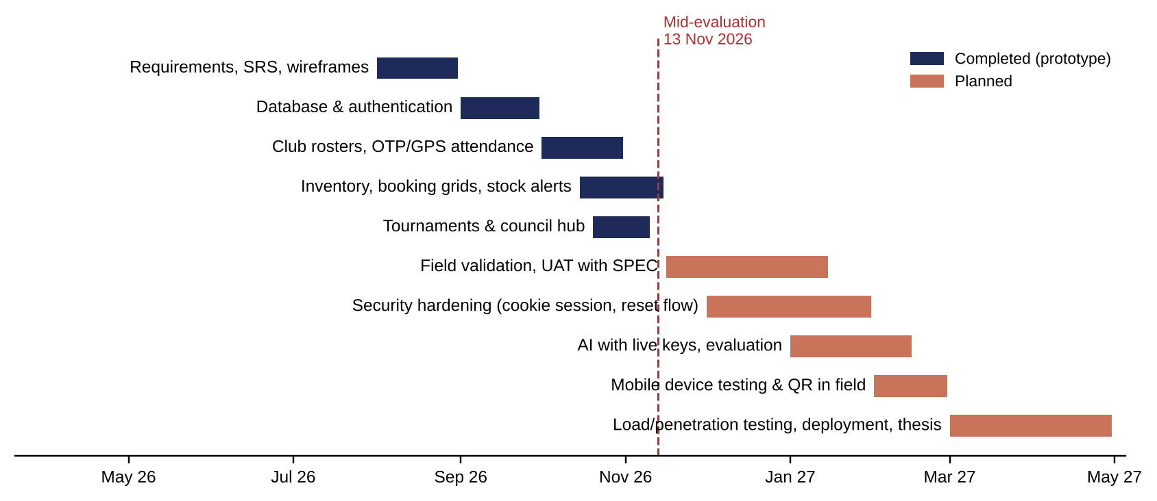
Figure 7.1: Revised development roadmap

7.5 Conclusion
SportsOS has progressed from proposal to a working prototype that unifies facility booking, verified attendance, inventory, tournaments, complaints and analytics for eighteen stakeholder roles. Automated tests verify its central claims:
- access is confined to each role's permissions and scopes;
- attendance requires physical presence;
- data remains consistent under concurrent use;
- every change is recorded in a verifiable audit chain.
The remaining work, comprising stakeholder validation, field testing and security hardening, is clearly scoped for the second half of the project.

REFERENCES
[1] Sports & Physical Education Center (SPEC), Indian Institute of Technology (Indian School of Mines) Dhanbad, "Activities" and "Facilities." [Online]. Available: https://people.iitism.ac.in/~dsw/spec/activity.html; https://people.iitism.ac.in/~dsw/spec/facilities.html (accessed Nov. 12, 2026).
[2] L. Haffner, I. Oshri, and J. Kotlarsky, "Directions for future IS research on sports digitalisation: A stakeholder perspective," The Journal of Strategic Information Systems, vol. 34, no. 2, Art. no. 101905, 2025, doi: 10.1016/j.jsis.2025.101905. [Online]. Available: https://doi.org/10.1016/j.jsis.2025.101905
[3] D. E. W. Saputra and P. Asmawati, "Elevating user experience and service excellence in sports facilities via integrated management information systems: A systematic review," Sports Science and Health, vol. 15, no. V, pp. 111–118, 2025, doi: 10.7251/SSH25V111S. [Online]. Available: https://doi.org/10.7251/SSH25V111S
[4] M. D. Shahrom and K. A. Mohamad Sukri, "Swimming facilities management system for Universiti Tun Hussein Onn Malaysia Sport Centre with two-factor authentication," Applied Information Technology and Computer Science, vol. 6, no. 2, pp. 625–643, 2025. [Online]. Available: https://penerbit.uthm.edu.my/periodicals/index.php/aitcs/article/view/20507
[5] R. Sandhu, D. Ferraiolo, and R. Kuhn, "The NIST model for role-based access control: Towards a unified standard," in Proc. 5th ACM Workshop on Role-Based Access Control (RBAC '00), Berlin, Germany, 2000, pp. 47–63, doi: 10.1145/344287.344301. [Online]. Available: https://doi.org/10.1145/344287.344301

