1. **Interface AIM:**

Enabling faster user performance without taking a hit on time to learn and retention of skills.

The user interface is primarily designed keeping novice and intermediate users with some computer science background in mind. The UI mainly uses user’s visual understanding/mapping of the subject matter as primary mode to communication, which enables faster performance.

2. **User Profile:**

In general site was designed with an assumption that a visitor has some “Computer Science Background” (i.e. familiarity with computer science terms like programming, databases, web design and so on). Hence forth in this document, when we refer to “user/visitor” it means “a user with some computer science background”.

The interface built mostly caters to novice and intermediate users. Definitions of novice and intermediate users are as given below:

Novice users:

Very little computer skills and has fair understanding of computer science terms like programming, operating systems, databases etc. Technically someone who knows and understand what subject is about but not to extent where he can make a decision about a book solely on bases like code coverage, no of pages etc.

Novices are most of the times are looking for assessment than assertions (that is they are looking for decisions not opinions).

Intermediate Users:

Has familiarity to what books/commodities related websites functions like, (may be familiarity with sites like amazon.com). Fair knowledge of what one is looking for and how the books are evaluated.

Intermediate/Advanced user would look for assertions than assessments, they like to read reviews and opinions about the book along with its technical details.

3. Interface Goals

Shniderman's Criteria and how they are taken care in the interface. All individually explained

Time to learn – 1:

Is taken takes as primary concern for all design decisions reasons being.

* Given that a user would not visit this site on a daily basis, visitor should not be wasting time on learning very time he visits. Could be a frustrating experience.
* A novice can easily get lost if takes too long to get started with

Design decisions minimizing time to learn.

* Maintains the user syntax. Like on hovering change of pointer, starts to communicate rating of a book, hyper link’s default behavior. Example1 below demonstrates the use of user systax
* Clear distinct side bar menu, with contextual changes to it.

Speed of performance -2:

Enabling user to find rating of a book and reviews with minimal of click or keystrokes is important as

* We know what a user has come in for, its either to rate a book or find out about a book. It would be no pleasant experience when user have to just spend minutes just searching for books its not physical library after all.
* Users give up search for a book within first few minutes, they just move on.

Design decisions to improve speed of a user

* Color combinations are maintained (like orange fade) is used to display prominent information on site. Especially the ones would miss user attention and is important
* Side menu items most of the time would need just a glance, instead of reading full item, as we have prominent icons to communicate the meaning of the menu items.
* We have graphical representations to convey if a books is Available in Paper back, Kindle and if its DRM free and so on. A screenshot attached below.

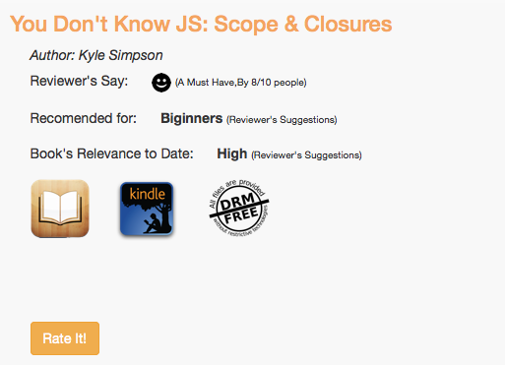

(Example1 Demonstrating Combination of Visual and textual elements to enable better performance speeds)

Rate of user errors -4

Retention of skills -3

Subjective satisfaction -5

4. Information about the rating system

Why 5 star rating was chosen

What different rating on the site mean.

5. Interface Screen Design:

What are different screens and what is the aim of that screen

How are different elements supposed to work

6. Features:

Once that were planned and implemented

once that was planned and dropped

Once that were planned and was not implemented.

Interface Goals:

---------------

Shniderman's Criteria

1. Time to Learn: Interface minimizes time to learn by.

* Time to learn takes a higher importance, given the frequency of the

* The default browser behaviour is maintained, Like, on hover over clickable elements the pointer shape changes thus letting the user know that it is a clickable element. Hyper links turn blue, maintaining consistency with default behaviour.

* Approximately 7+/- Elements, less no of things for a user to parser and understand

2. Speed Of Performance:

Often Conflicts with time to learn, faster systems are harder to learn.

3. Rate of user Error:

Consistency

instructions

Logical arrangements of the screen.

Importnace:

4. Retention Of Skills:

User Systax, Matching user understanding

5. Subjective Satisfication:

individual taste

Matching backgroud

All features functionality

Rating System:

Star rating system

Rating System values and there meaning

Semantic:

What do various ratings mean

Interface Screen Design:

Most of the design decisions where made with the following questions in mind

-What kind of users is expected on to this site?

One with some computer science background and browser familiarity

- Why would a user visit this site?

To find about a book, what reviews a book has got or to rate a book one has read

-How frequently a user would visit this site?

May be once in 15 days

Interactions details of the screen design and how they operate.

Features:

--------

Thubnail Size

Comments Readibility and Details display

Navigation Bar under the top navigation

Books Relevence matrix, Software platform compatiblity display