Name: Anup Jyoti Kalita

Email: [ajyotikalita@presidio.com](mailto:ajyotikalita@presidio.com)

Assignment: K8s final lab assessment

**For base Environment**

1. **Build the dockerfile of fitness app and create image and push it to the docker hub**

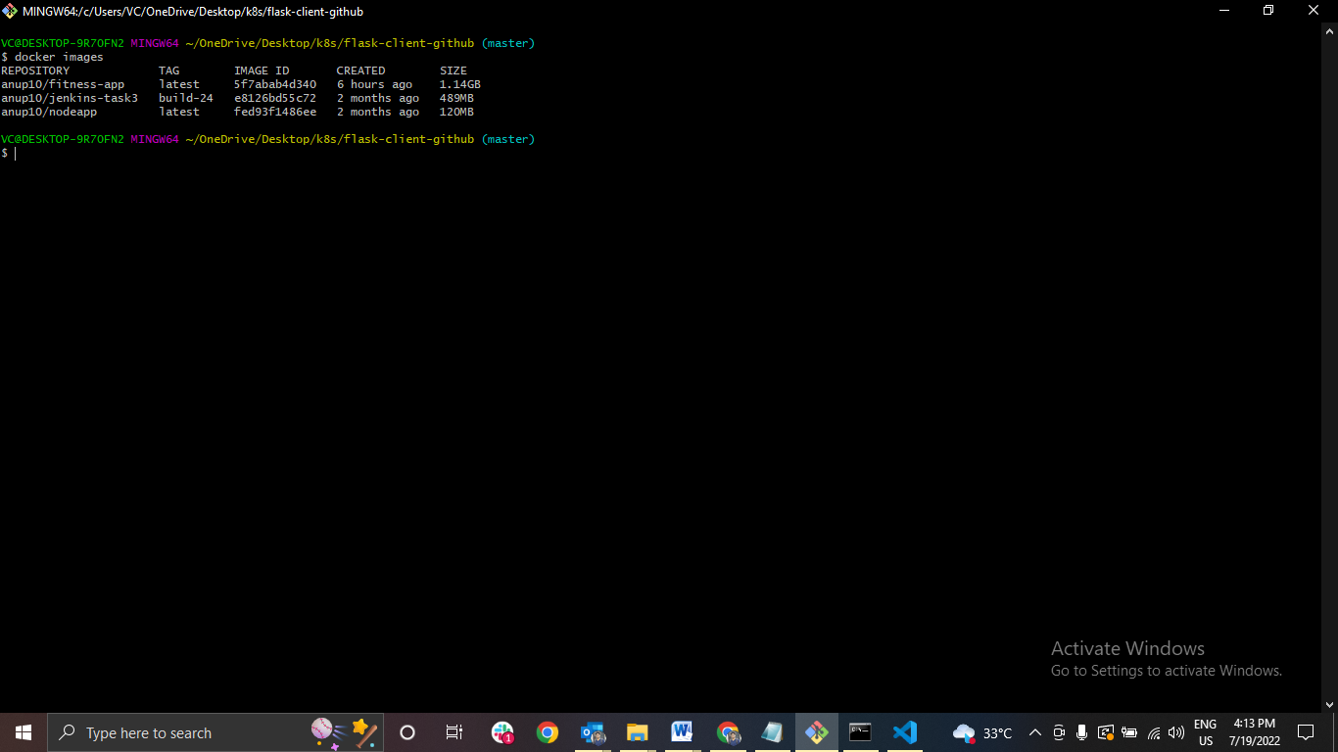

1. **Kustomize project structure**

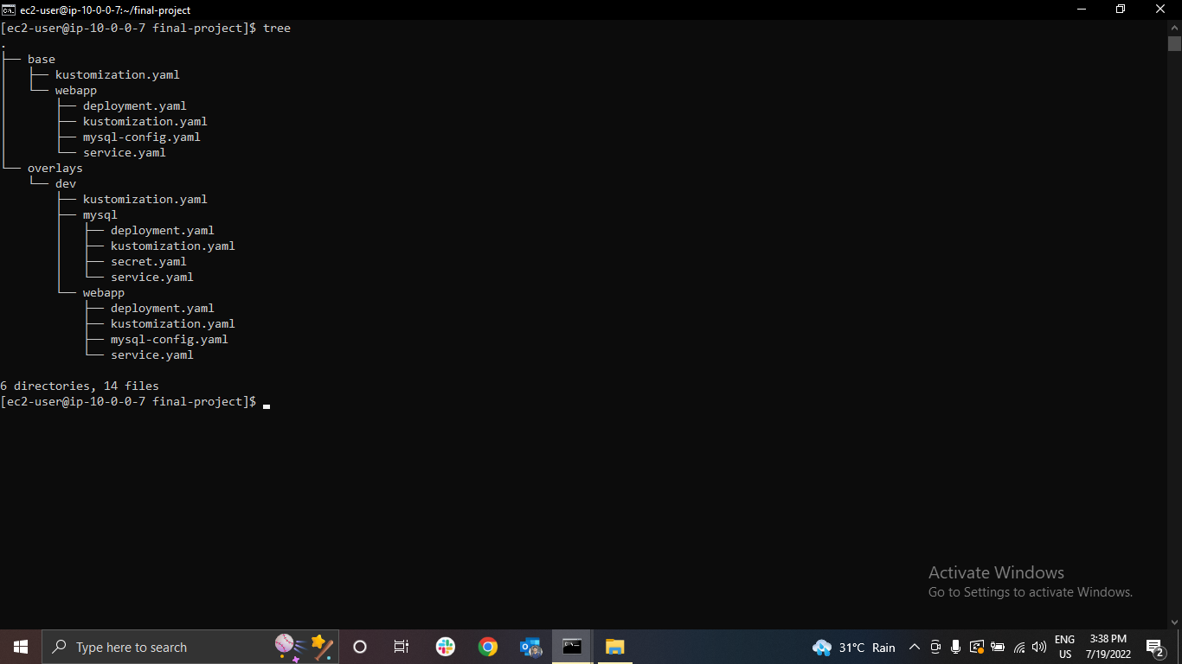

1. **RDS Database created**

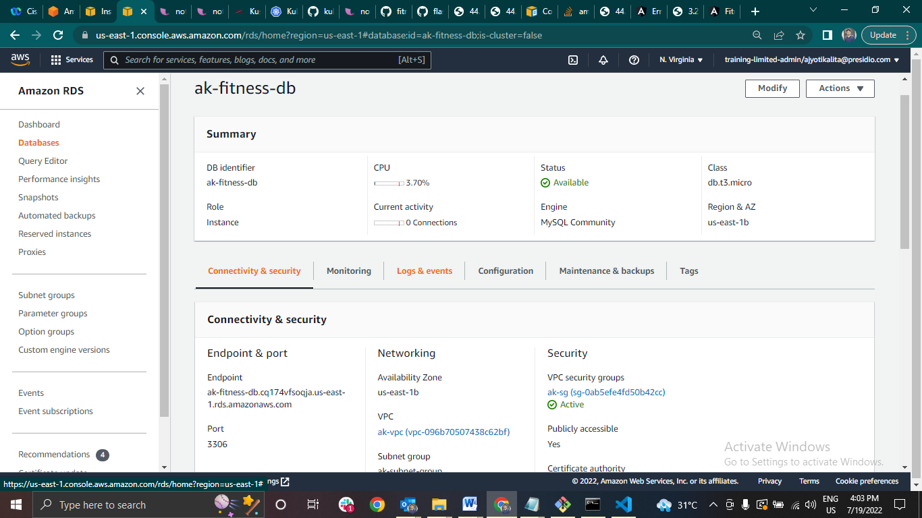

1. **The resources created after applying configuration in base environment (service type as LoadBlancer)**

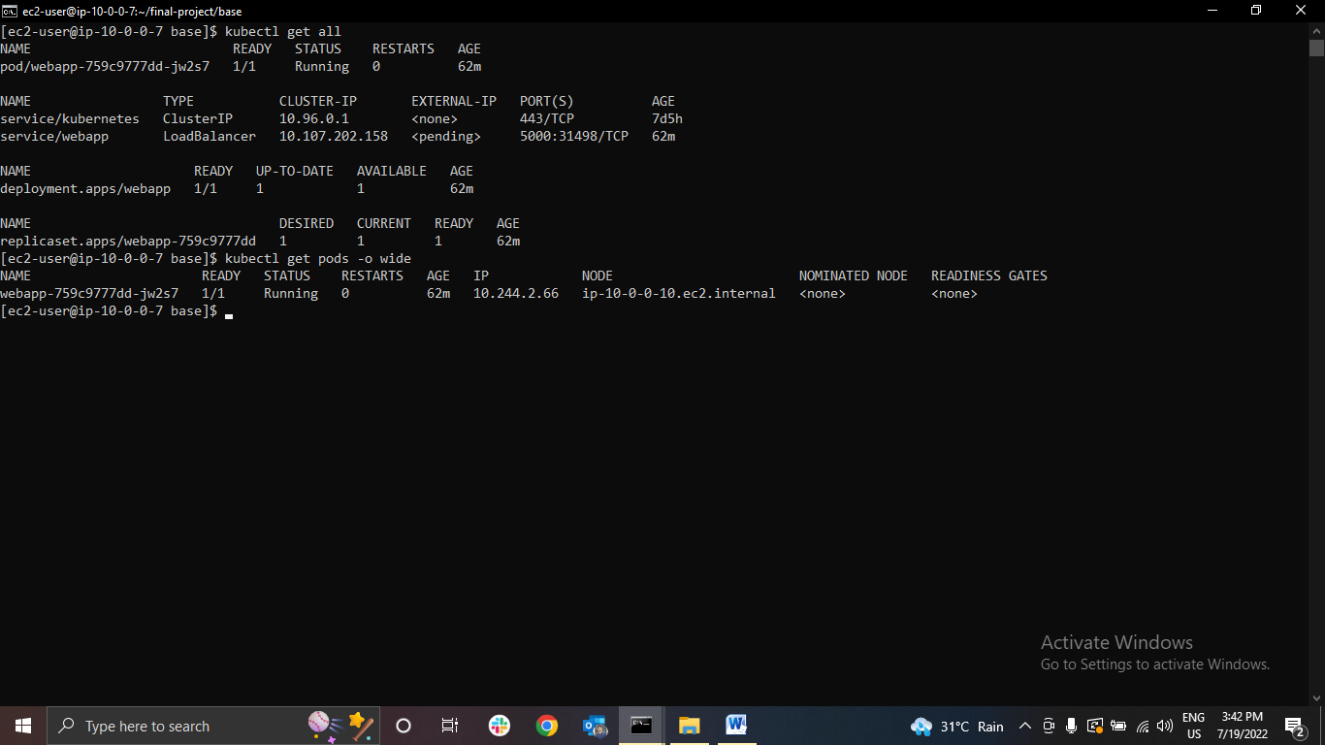

1. **After Replacing the end point and serve the web application using live server**

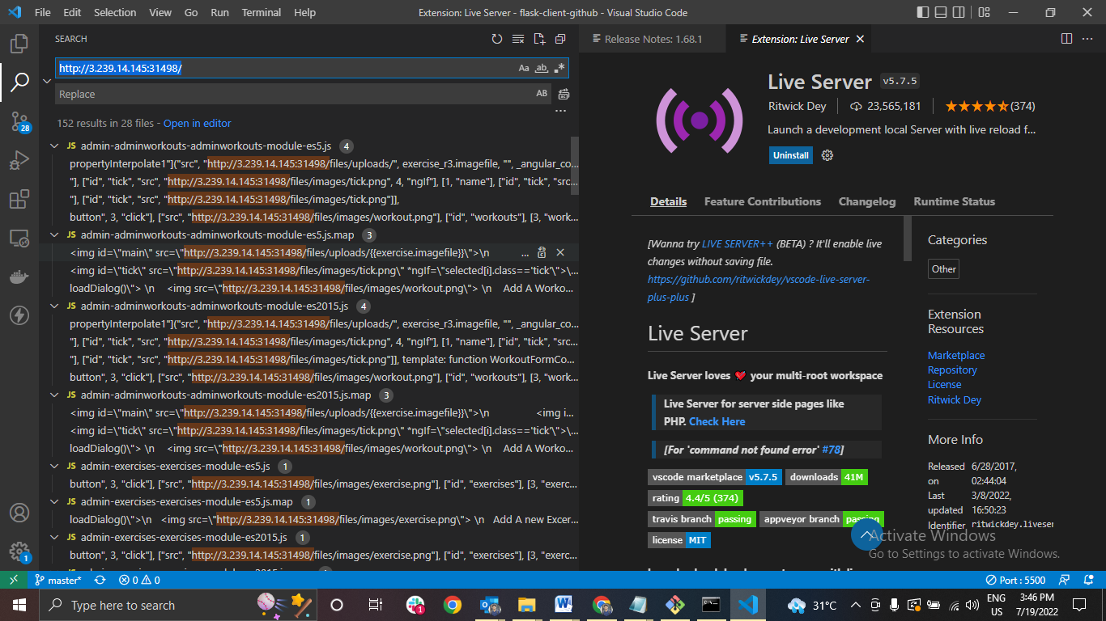

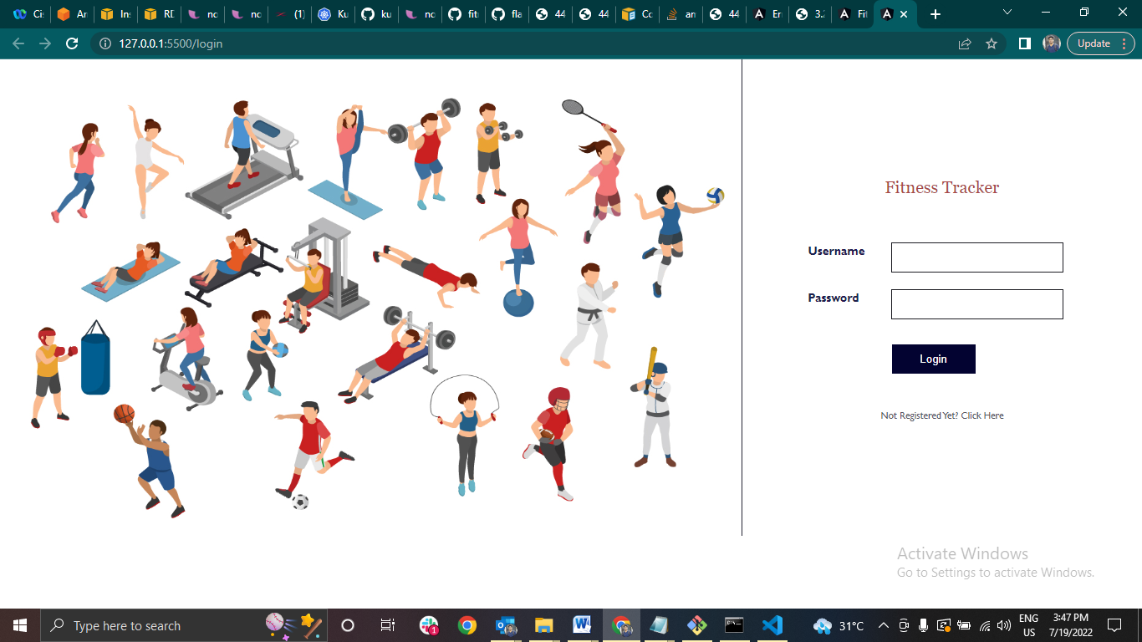

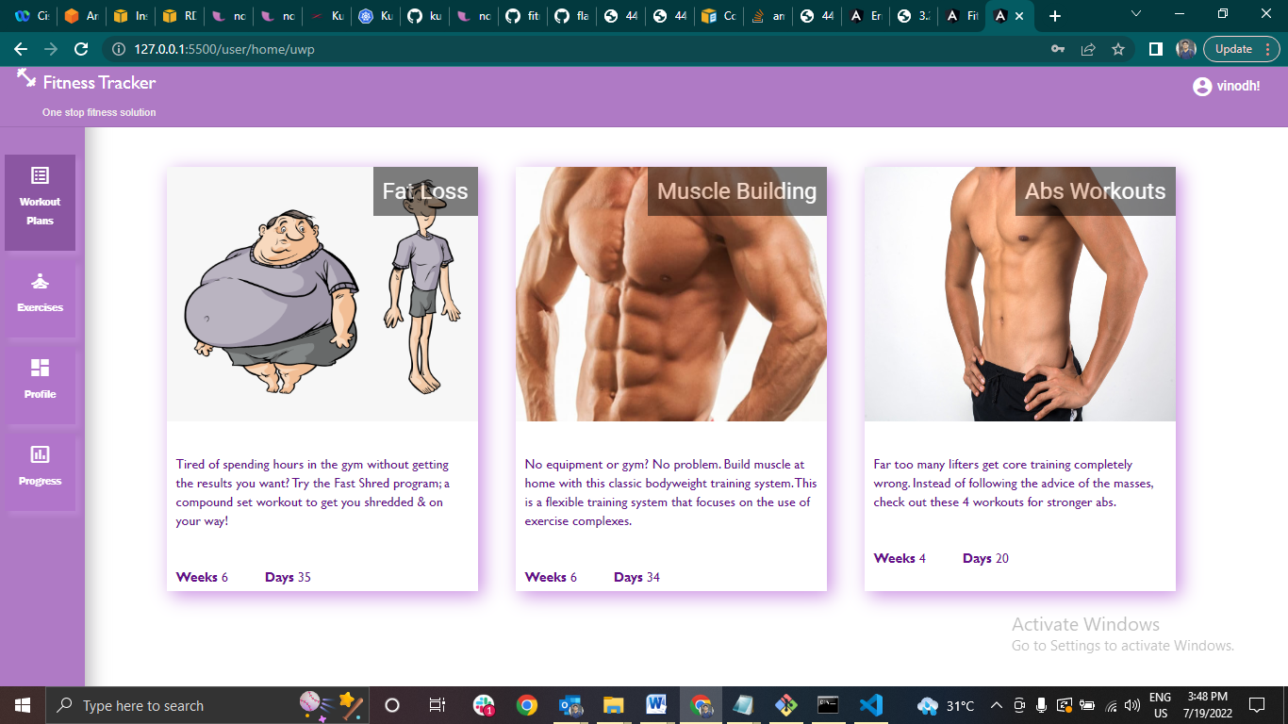

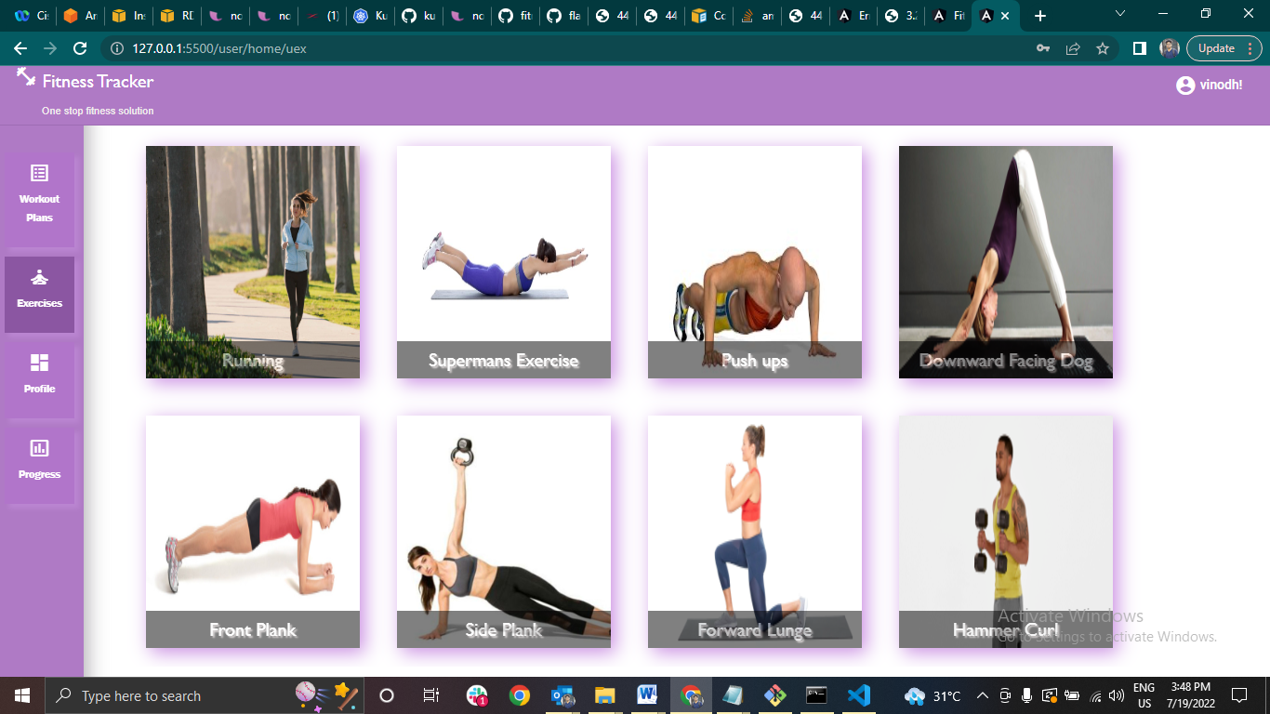

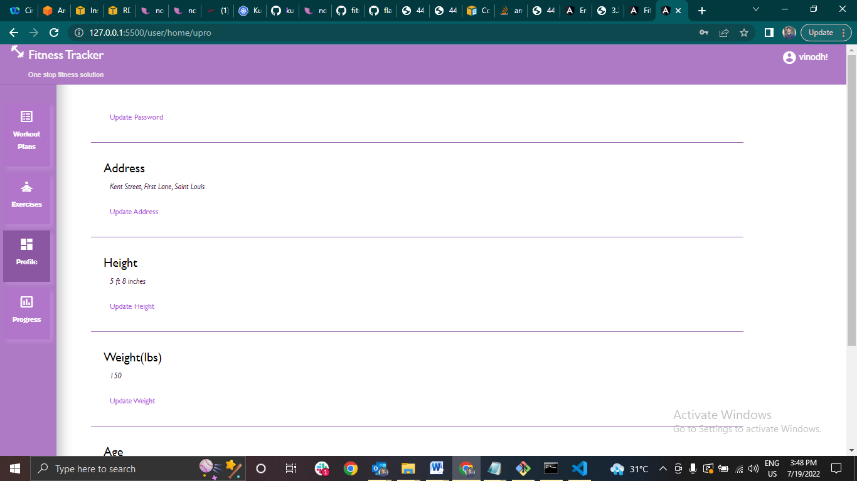

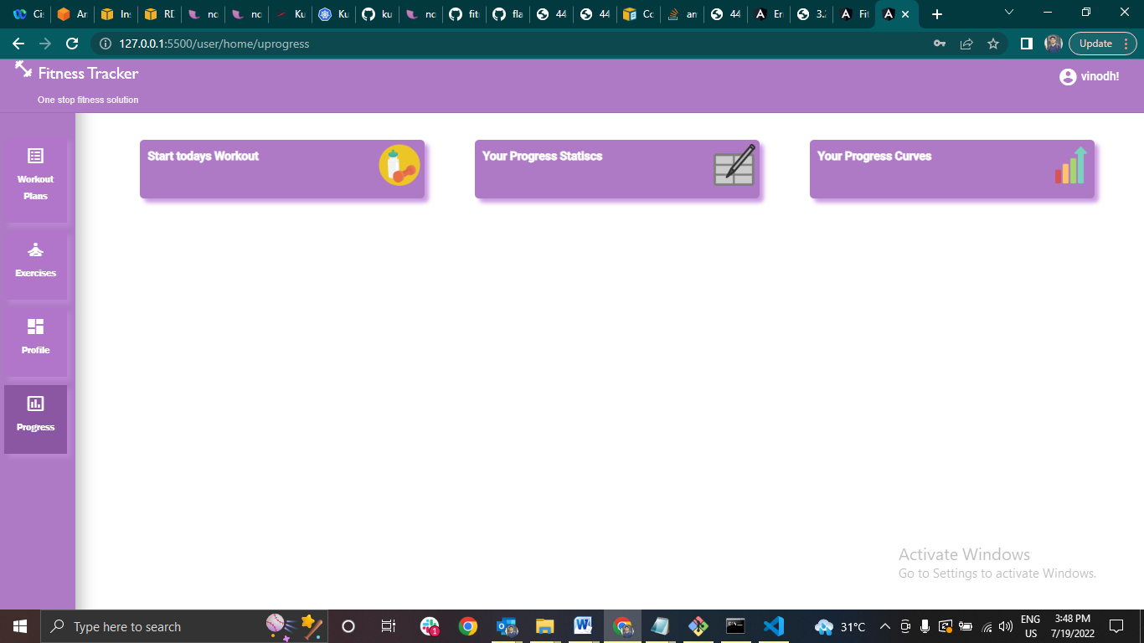

**For Dev Environment**

1. **Created a mysql image and initializing it with mbackup.sql(init.sql) file and push it to docker hub**

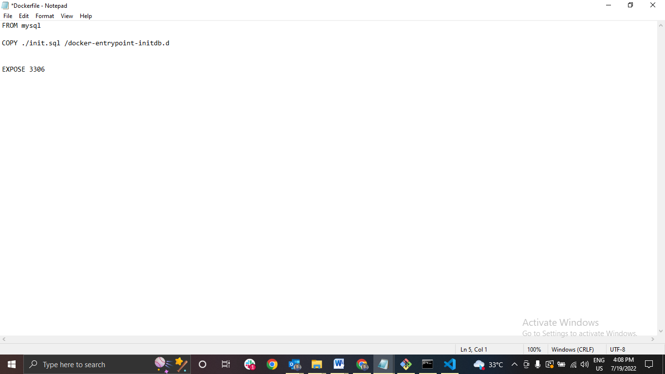

1. **The resources created after applying configuration in dev environment (service type as NodePort)**

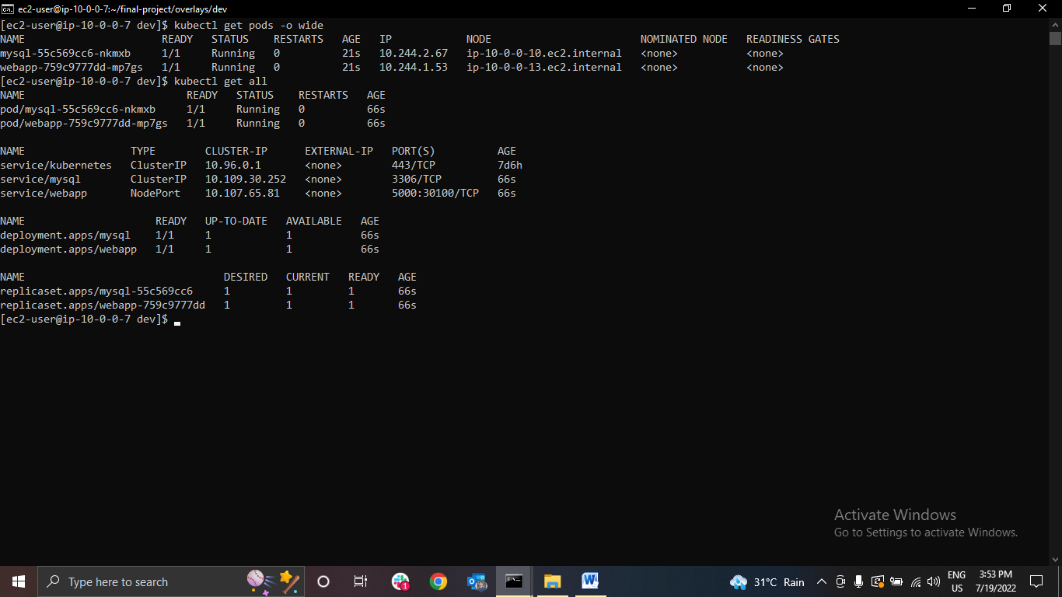

1. **After Replacing the end point and serve the web application using live server**

