|  |
| --- |
| Wolters Kluwer |
| Standard Operating Procedures to Add Server to specific domain |
| Version 0.1 |

|  |
| --- |
| Anubhav Verma  4/26/2017 |

# ****Document Control­­­­­­****

## **Revision History**

|  |  |  |  |
| --- | --- | --- | --- |
| **Version No.** | **Date** | **Prepared by / Reviewed by** | **Change Description** |
| 0.1 | May 17,2017 | Siddhant Sharma | Initial Draft |
|  |  |  |  |
|  |  |  |  |

## **Approval Details**

|  |  |  |  |
| --- | --- | --- | --- |
| **Version No.** | **Date** | **Approval by** | Change Description |
|  |  |  |  |
|  |  |  |  |

Table of Contents

Document Control 1

Revision History 1

Approval Details 1

1 Preface 3

2 Overview 3

3 Assumptions/Pre-requisites 3

4 Procedural Activities 3

4.1 Action required on server before domain join 3

4.1.1 Steps 3

4.1.2 Adding VM/Machine on domain steps 5

4.2 How to confirm that server is on domain Joined? 7

4.2.1 Steps to check that the VM/Machine is on domain or not. 7

4.3 Supporting Documents 8

# Preface

The purpose of this document is to explain the process “How to join Server to wkraininer.com domain”.

# Overview

* We use Active directory because we want to manage the objects from a centralized location. Also without Active Directory, the computers in your office are set up in workgroups “individual devices that are running on the same Local Area Network (LAN). This means that each computer is a standalone machine; they don’t communicate with each other and require users to go through an authentication process every time you want to exchange information from one to another”.
* All of the machines would be connected on a domain which means all of the information is stored in a central location, not locally on the individual computers’ hard drives. The domain is controlled by a global catalogue which keeps track of all of the devices that are registered to the network. The global catalogue stores the IP addresses, computer names and users, so that the global administrator can oversee everything that happens on the domain. In order to access someone else’s computer, a user would just need that computer’s name because everything is already linked on the back end.
* When we use Active Directory, everything is already permissioned from the domain controller. This means that the network administrator has already told the domain controller what permissions to assign to each user. This makes all digital communication more efficient because everything is easily accessible and information is ready available.

# Assumptions/Pre-requisites

* The Engineer must have access to access the AD object creation level so that Engineer will be able to join machine on domain.
* Machine local admin username and password is required.

# Procedural Activities

## Action required on server before domain join

### Steps

1. Login to client machine on which you want to add domain with Admin account ID.
2. Press Windows key + R, type CMD and hit enter. Type ipconfig/all and hit enter. You will get your machine IP along with Subnet, default gateway and DNS information.
3. Press Windows key + R, type CMD and hit enter and then type Ping DNS IP address.

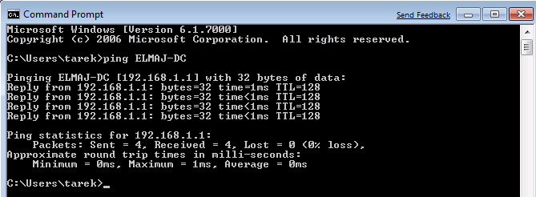

1. If you get the ping status, then you can check NSLOOKUP and hit enter.
2. Make sure that you are able to resolve the domain name on which you want to put your machine.
3. You can also check your IP address and DNS IP’s from TCP/IP property.
4. Type RUN -> **ncpa.cpl** and hit enter. You will be able to see the network ICON, right click on that and go to properties.

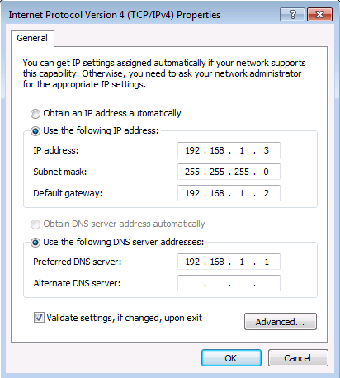

### Adding VM/Machine on domain steps

1. Right click on my Computer and go to properties.

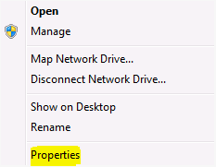

1. On the **System Properties** page, click on Change button.

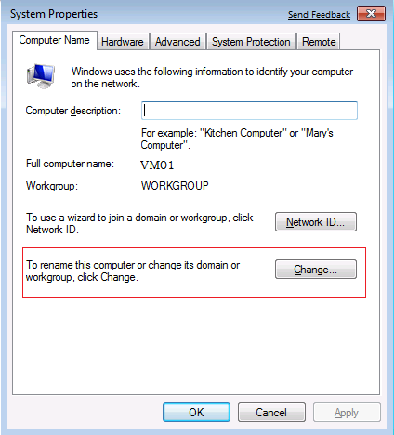

1. Under Member of, select the radio button beside Domain: type the name of the domain you want your server to join and then click OK

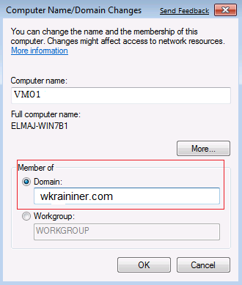

1. A pop up box requesting to enter credentials of an account with rights to join the domain (with rights to create computer accounts). For example - such user is one that is member of the Domain Admins Active Directory group. Once the username and password are entered, click on OK

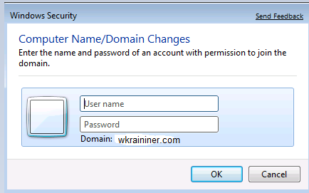

1. A confirmation pop up box will welcome you to the domain. Clicking on OK button will result in having another message informing that a reboot for the machine is required to apply the changes. Click on OK button.

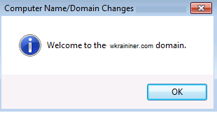

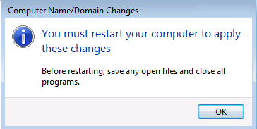

1. Close System properties page and on ‘You must restart your computer’ pop up message box, click on **Restart Now**

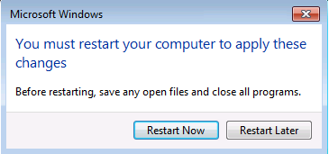

## How to confirm that server is on domain Joined?

### Steps to check that the VM/Machine is on domain or not.

1. Once your machine is rebooted, press CTRL + ALT + Del to log on



1. Type the user name in this format: **domain name\username**

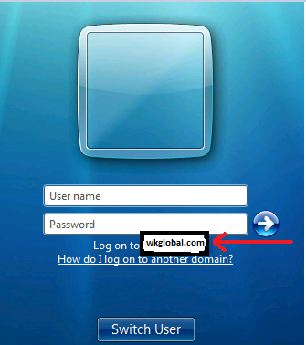

1. After you log in to the machine, open the basic system properties page (Right Click Computer > Properties) and check your computer full name and the name of the domain your machine is joined to.

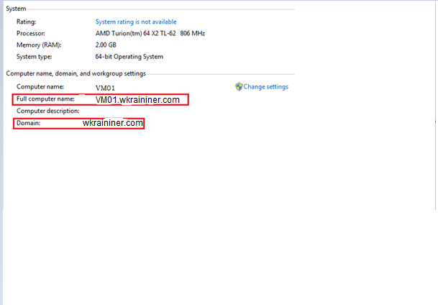

## Supporting Documents

<https://technet.microsoft.com/en-us/library/cc770919(v=ws.10).aspx>