|  |
| --- |
| Wolters Kluwer |
| Standard Operating Procedures on How to modify DNS entries. |
| Version 0.1 |

|  |
| --- |
| Siddhant Sharma  5/16/2017 |

# ****Document Control­­­­­­****

## **Revision History**

|  |  |  |  |
| --- | --- | --- | --- |
| **Version No.** | **Date** | **Prepared by / Reviewed by** | **Change Description** |
| 0.1 | May 16, 2017 | Siddhant Sharma | Initial Draft |
|  |  |  |  |
|  |  |  |  |

## **Approval Details**

|  |  |  |  |
| --- | --- | --- | --- |
| **Version No.** | **Date** | **Approval by** | Change Description |
|  |  |  |  |
|  |  |  |  |

Table of Contents

Document Control 1

Revision History 1

Approval Details 1

1 Preface 3

2 Overview 3

3 Assumptions/Pre-requisites 3

4 Procedural Activities 4

4.1 Action required modify A DNS record: 4

4.1.1 Steps 4

4.1.2 Modify CNAME record on DNS server. 7

4.2 How to validate if DNS records are modified? 8

4.3 Supporting Documents 8

# Preface

The purpose of this document is to explain the process “How to modify DNS entries”

# Overview

Domain Name System (DNS) is one of the industry-standard suite of protocols that comprise TCP/IP. DNS is implemented using two software components: the DNS server and the DNS client (or resolver). Both components are run as background service applications.

Network resources are identified by numeric IP addresses, but these IP addresses are difficult for network users to remember. The DNS database contains records that map user-friendly alphanumeric names for network resources to the IP address used by those resources for communication. In this way, DNS acts as a mnemonic device, making network resources easier to remember for network users

There are a few different types of records that are primarily used for most of the devices on the Internet and inside company intranets. The following is a list of these primary record types:

* **Address (A) record –** This type of record is used to translate a domain name to a specific IPv4 address.
* **Address (AAAA) record –** This type of record is used to translate a domain name to a specific IPv6 address.
* **Canonical name (CNAME) record –** This type of record is used to specify a secondary name (commonly referred to as *alias*) for an existing A or AAAA record.
* **Mail Exchange (MX) record –** This type of record is used to direct the mail communications for specific domains on the Internet. The record includes a priority and mail exchange agent domain name (this references an existing A, AAAA, or CNAME).
* **Start of Authority (SOA) record –** This type of record is typically configured with the creation of a zone and includes authoritative information about a specific domain name.
* **Name Server (NS) record –** This delegates the authoritative name servers for a specific domain, this record is also typically configured with the creation of the zone (in simple configurations).

# Assumptions/Pre-requisites

* The Engineer must have access to DNS server as an administrator to create these records.

# Procedural Activities

## Action required modify A DNS record:

### Steps

1. This walkthrough is on Windows Server 2012, but similar steps can be taken on Windows Server 2008 R2. As a starting point, the Server Manager dashboard is used but any method can be used to access the DNS Manager. Screenshot below shows that the DNS Server role has been installed and can be selected from the left pane. These steps apply to wkglobal.com domain DNS servers.

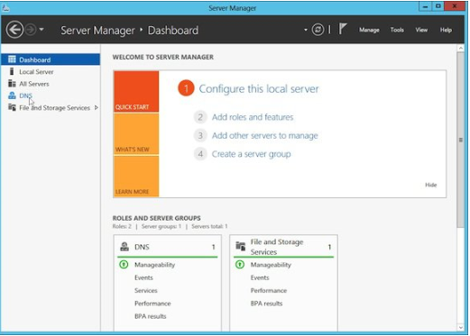

1. Once DNS has been selected, the available DNS servers will be displayed. Right-click on the target server and select **DNS Manager**, as shown in screenshot below:

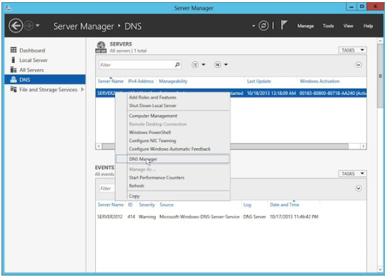

1. This will now bring up the DNS Manager. In the image below you can see that both a forward and reverse lookup zone has been created.

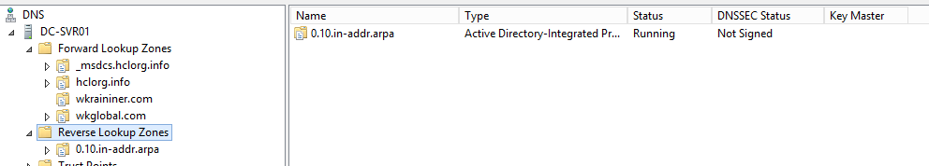

1. Choose the **forward lookup zone**, which will bring up a list of the existing zone records. To get a DNS record modify right click on DNS host A record and click on Properties. In this case, for example - we have selected “myhost” record.

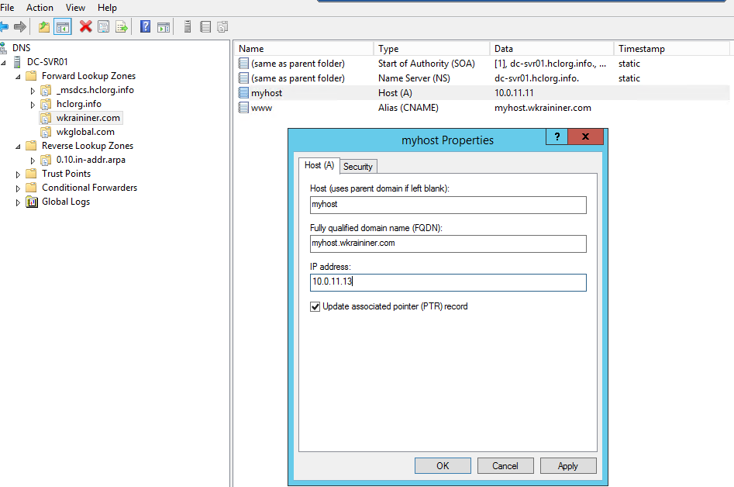

1. On this property Windows either you can change modify IP address or hostname itself, in this case we have modified IP address and changed it to 10.0.11.11 to 10.0.11.13 and clicked on Apply button.

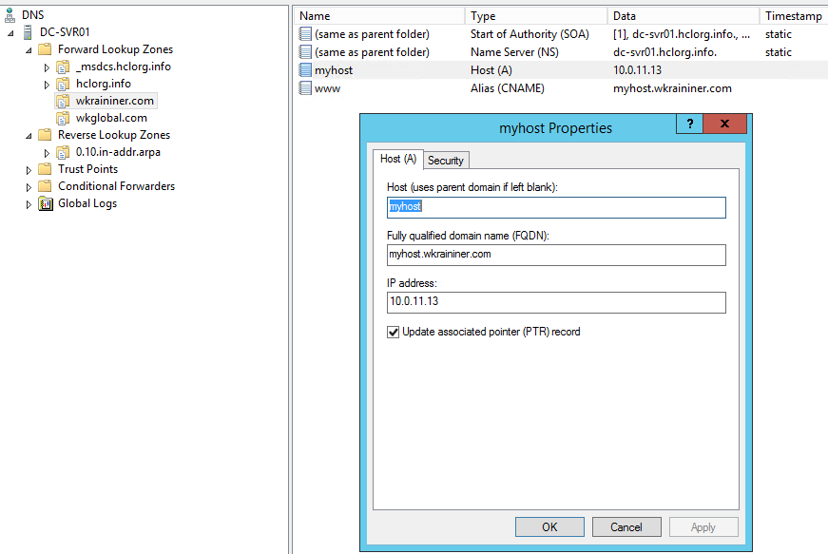

1. Click on OK button and we have successfully Modified Host A record on DNS server.

### Modify CNAME record on DNS server.

1. Click back on the forward zone, then right-click www CNAME record and go to Properties.

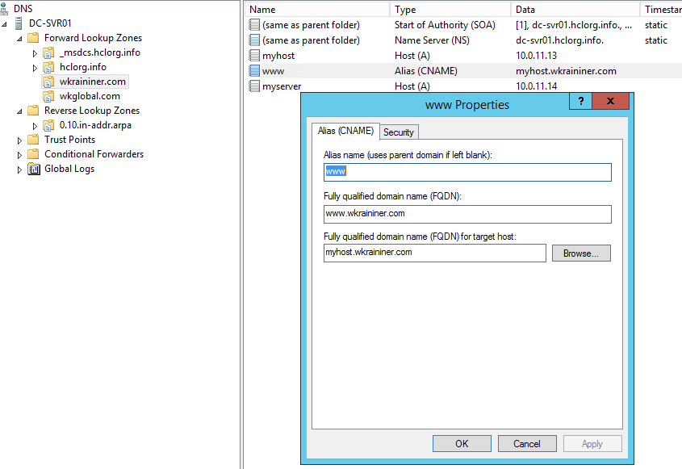

1. At this point it is *www* in the Alias Name textbox and [www.wkraininer.com](http://www.wkraininer.com) as **Fully Qualified Domain name (FQDN) for target host** textbox. In this case for example we are modifying “Fully qualified domain name (FQDN) for target host” from “myhost. wkraininer.com” to “myserver. wkraininer.com”.

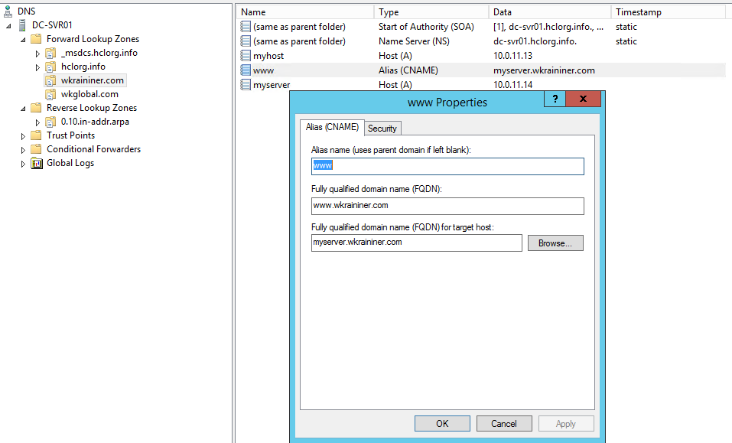

1. Click on Apply and then OK to finish.

## How to validate if DNS records are modified?

1. Finally, these records can be tested by using the Windows nslookup command. As shown below, the various records are looking up correctly. You need to open command prompt.

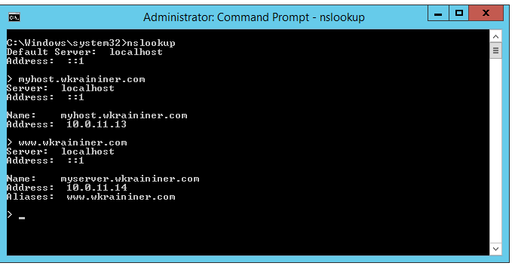

## Supporting Documents

* <https://msdn.microsoft.com/en-us/library/bb727018.aspx>