CAPSTONE B · WEEK 3
Industry Investigation Report
Secure Retail – Product Catalogue System · Option B: Online Investigation

How to use this template
- Product investigated on all three websites: iPhone 18 Pro Max (256GB).
- All observations were made on 30 September 2026; prices and stock may have changed since.
- Screenshots are embedded as numbered figures; the Evidence column in each table shows which figure supports each note.
- Rows marked 'Not checked – please verify' still need to be looked at yourself.
- Do not buy anything – stop at the cart / checkout page.

Task 1.1 – JB Hi-Fi
Detail | Your notes
Website | jbhifi.com.au
Date investigated | 30 September 2026
Investigated by
Product searched | iPhone 18 Pro Max (256GB)

Observations
Short, factual notes of what was seen. The Evidence column points to the numbered figures in the Screenshots section below.
Area | What I observed | Evidence
Home page – navigation & categories | Yellow header with search bar, Track order, Stores, Log in and Cart. Menu bar: New, Products, Brands, Deals & Catalogues, Clearance, Services, Gift Cards, Join JB Perks. | Fig 1
Home page – promotions / banners | Top banner 'iPhone 18 Pro Out Now! Trade-in & Upgrade!'. Badges 'NEW AT JB!' and 'TRADE IN YOUR OLD PHONE'. 'Seen it cheaper? Ask for a JB Deal' banner. | Fig 1, 3
Search bar (suggestions while typing?) | Search for 'iphone 18 pro max' returned 16 results. | Fig 1
Listing page – filters | Only a Price filter on the search results page. | Fig 1
Listing page – sort options | 'Sort by' dropdown (Best Match, Price, Newest, Title A–Z, Highest rated) and results per page (36 / 72 / 100). | Fig 1
Product card (image, price, rating, stock badge) | Image, name (with storage + colour), star rating and count, price, Add to cart, wishlist heart. | Fig 1
Product page – price / discount / was-price | $2,299 (256GB), $2,699 (512GB), $3,499 (1TB), $4,699 (2TB). Each storage option shows its own price. Afterpay, Zip and Latitude payment options. | Fig 2, 3
Product page – images (how many, zoom?) | Multiple images in a thumbnail gallery (11 images). | Fig 2
Product page – specifications | Key features list plus a SPECS table with 30+ fields (OS, SIM type, screen size, resolution, chip, cameras, IP68, Wi-Fi 7, Bluetooth). Shows MODEL and SKU codes. | Fig 2, 4, 5
Customer reviews & star ratings | 2.7 stars from 7 reviews, 'Write a review' link and a Reviews section. | Fig 2, 6
Stock availability (online / in store / location) | 'AVAILABILITY – Enter postcode or suburb / Use my location'. 'Limit 2 per customer'. | Fig 3, 4
Delivery options, cost & estimated date | Not checked – please verify | —
Warranty & returns information | Manufacturer's warranty: 1 year. Footer links: Faulty goods returns, Refunds & Warranties guide. | Fig 6, 7
Compare / 'You may also like' | Compare checkbox, 'Similar items', 'Frequently bought together', 'Recommended for you'. | Fig 3, 4, 6
Cart – subtotal, delivery, promo code | Not checked – please verify (did not add to cart) | —
Wishlist / save for later | Wishlist button on the product page (needs an account to save). | Fig 3
Sign-up – required fields & password rules | Not checked – please verify | —
Order tracking page | 'Track order' in the header and 'Track my order' in the footer. | Fig 1, 7
Trust signals (secure payment, Afterpay/PayPal, help centre) | Live chat and phone 13 52 44 (9am–8pm), Scam alerts, Product recalls, Consumer guarantees; accepted payments: Visa, Mastercard, Amex, PayPal, Apple Pay, Afterpay, Zip, Latitude. | Fig 4, 7

Key findings
- Every storage option shows its own price, so customers see the price difference straight away.
- Stock availability is checked by postcode or current location.
- Products carry very detailed data: model, SKU and a 30+ field specification table.
- Trust features are prominent: price-match (JB Deal), live chat, phone support, scam alerts and many payment options.
- Reviews for this new phone are low (2.7 stars), which shows that rating data is displayed even when it isn't flattering.

Ideas for our Secure Retail project
- Add storage/colour variants with a price per variant to our product data.
- Add a specifications table and SKU field to our product catalogue.
- Add a 'Check stock' field (stock level per store or online) to the product page.

Screenshots
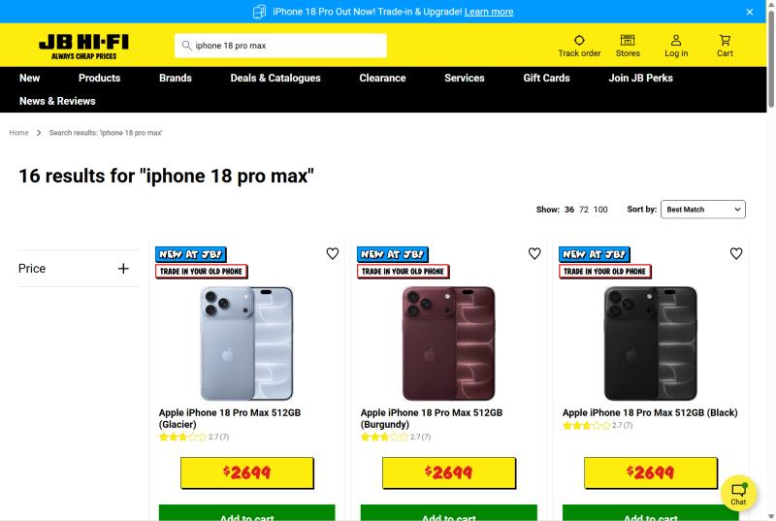
Figure 1 – JB Hi-Fi search results: menu, search bar, Track order/Stores/Log in/Cart, Price filter, sort and product cards
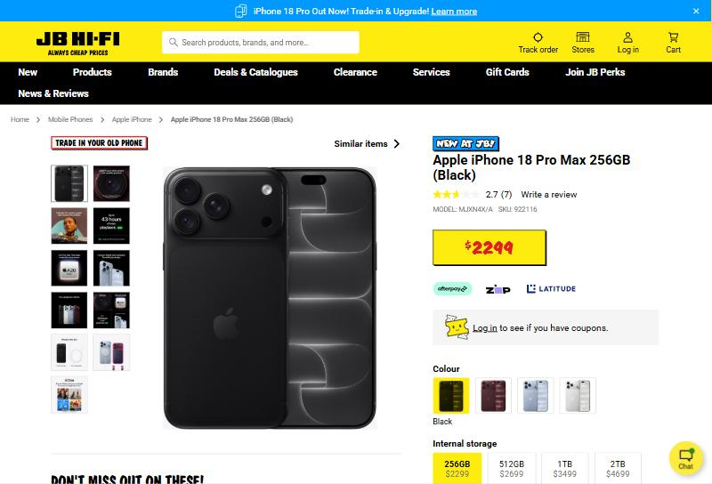
Figure 2 – JB Hi-Fi product page: price, rating, model/SKU, payment options, colour and storage options
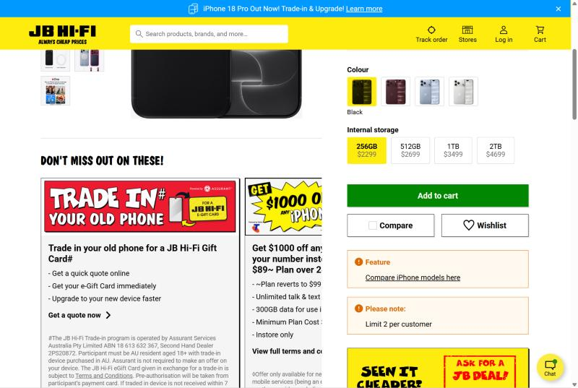
Figure 3 – JB Hi-Fi: Add to cart, Compare, Wishlist, 'Limit 2 per customer' and trade-in offer
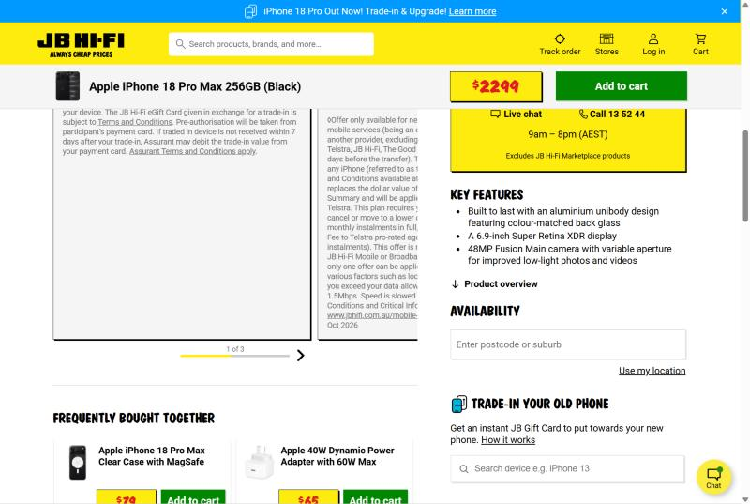
Figure 4 – JB Hi-Fi: live chat/phone, key features, stock availability by postcode, 'Frequently bought together'
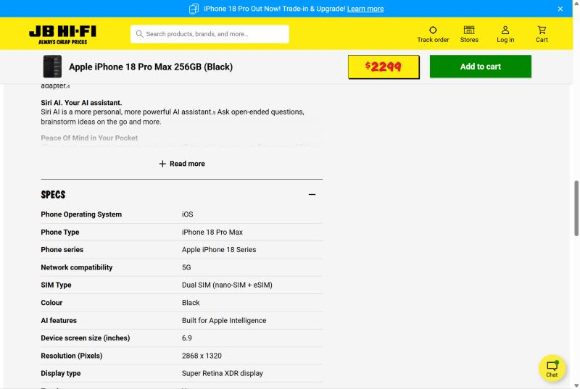
Figure 5 – JB Hi-Fi: specifications table
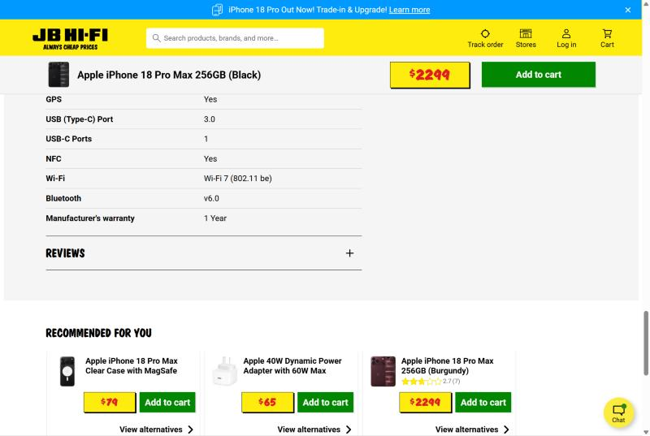
Figure 6 – JB Hi-Fi: 1-year manufacturer's warranty, Reviews section and 'Recommended for you'
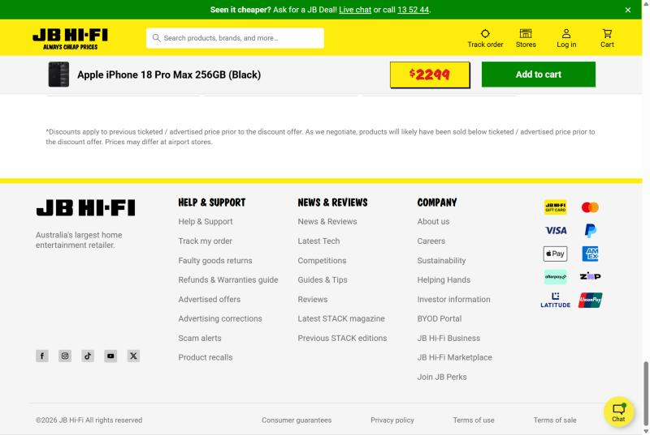
Figure 7 – JB Hi-Fi footer: Track my order, returns, warranties guide, scam alerts, accepted payment methods

Task 1.2 – Officeworks
Detail | Your notes
Website | officeworks.com.au
Date investigated | 30 September 2026
Investigated by
Product searched | iPhone 18 Pro Max (256GB)

Observations
Short, factual notes of what was seen. The Evidence column points to the numbered figures in the Screenshots section below.
Area | What I observed | Evidence
Home page – navigation & categories | Header with search, 'Ask Ollie' AI assistant, Shopping method, Login, Cart. Menu: Technology, Office Supplies, Furniture, Education, New & Trending, Low Prices. | Fig 8
Home page – promotions / banners | Service banner: Collect within 2 hours, Free 2-hour metro delivery, Price Beat Guarantee, OnePass free standard delivery. 'NEW' badges on products. | Fig 8, 9
Search bar (suggestions while typing?) | Search returned 59 results: iPhones plus cases and screen protectors. | Fig 8
Listing page – filters | 'Show filters' opens: Availability (Delivery / In Store / Click & Collect), Search in Category, Price ranges. | Fig 8
Listing page – sort options | 'Sort by' dropdown, List/Grid view and items per page (24 / 48 / 100). | Fig 8
Product card (image, price, rating, stock badge) | Price, name, rating, Add to Cart, Add to List, Add to Compare, 'Free Delivery'. | Fig 8, 9
Product page – price / discount / was-price | $2,297 (256GB), $2,697 (512GB), $3,497 (1TB), $4,697 (2TB), $2 below JB Hi-Fi on each. Product code IP18PX2BK. | Fig 8, 10
Product page – images (how many, zoom?) | Thumbnail image gallery with a scroll arrow. | Fig 10, 11
Product page – specifications | Features section plus separate sections: Specifications, Customer Reviews, Q & As, Delivery. | Fig 12
Customer reviews & star ratings | 0 reviews so far (new product). Has a Q & A section for customer questions. | Fig 10, 12
Stock availability (online / in store / location) | 'Ways you can get it: Pick up in-store / Deliver to me' with 'Set Your Store'. | Fig 11
Delivery options, cost & estimated date | Delivery section: 'We'll confirm your delivery options at checkout' (add to cart → checkout → see options and fees). Free 2-hour metro delivery banner. | Fig 8, 12
Warranty & returns information | 365-day returns (OnePass); 'Returns policy' and 'Extra cover' links in the footer. | Fig 9, 13
Compare / 'You may also like' | 'These Might Interest You' and 'You might also like' product carousels; Add to Compare. | Fig 8, 12
Cart – subtotal, delivery, promo code | Not checked – please verify (did not add to cart) | —
Wishlist / save for later | Heart (wishlist) icon on the product page and 'Add to List' on product cards. | Fig 8, 10
Sign-up – required fields & password rules | 'Create account' and 'Password reset' links in the footer (form not checked). | Fig 13
Order tracking page | 'Track my order' link in the footer. | Fig 13
Trust signals (secure payment, Afterpay/PayPal, help centre) | Price Beat Guarantee, Scam warnings, Product recalls notice, Help centre; Upgrade+ plan ($0 upfront via Latitude); accepted payments: Mastercard, Visa, Amex, PayPal, Apple Pay, Zip, Afterpay, Latitude. | Fig 8, 11, 13

Key findings
- Customers choose how to get the item (pick up in-store or delivery) before adding it to the cart.
- Filters include Availability (Delivery / In Store / Click & Collect), so stock and fulfilment are part of search.
- Product information is split into clear sections: Specifications, Reviews, Q&As and Delivery.
- Strong trust signals: Price Beat Guarantee, 365-day returns and a product recalls notice.
- An AI shopping assistant ('Ask Ollie') helps customers find products.

Ideas for our Secure Retail project
- Add an availability/fulfilment field (Delivery, Click & Collect) to our product data.
- Organise our product page into sections: Description, Specifications, Reviews, Delivery.
- Add sort options, a List/Grid view and 'Add to Compare' to our catalogue.

Screenshots
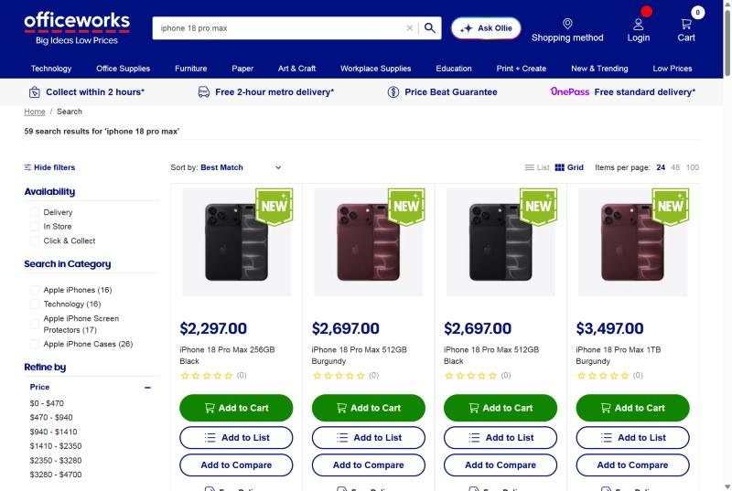
Figure 8 – Officeworks search results: service banner, filters (Availability, Category, Price), sort, List/Grid view, Add to List / Add to Compare
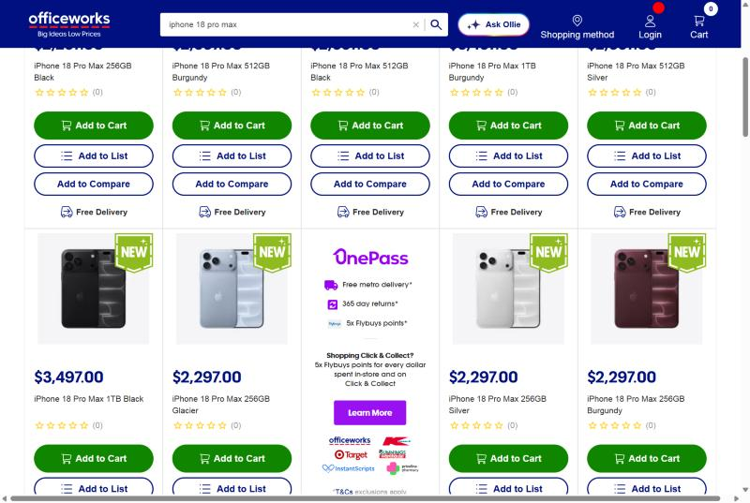
Figure 9 – Officeworks: 'Free Delivery' on each product card and OnePass promotion (free delivery, 365-day returns, Flybuys points)
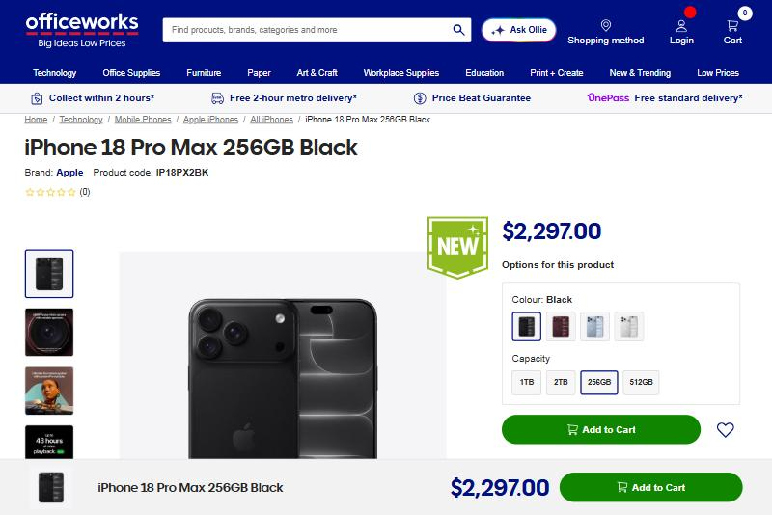
Figure 10 – Officeworks product page: breadcrumbs, product code, price, colour and capacity options, wishlist heart
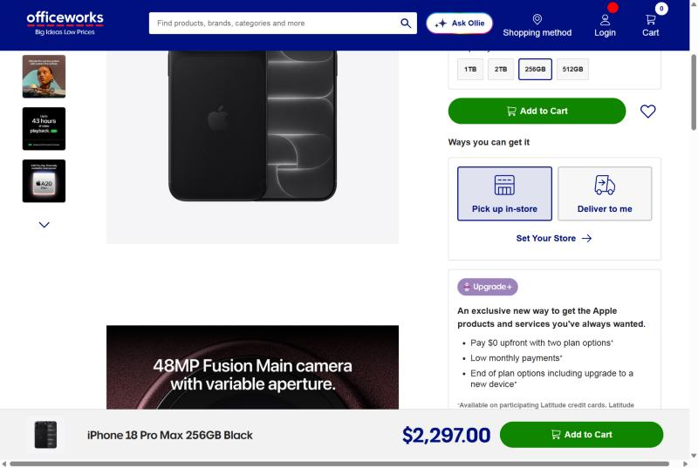
Figure 11 – Officeworks: 'Ways you can get it' (Pick up in-store / Deliver to me) and Upgrade+ payment plan
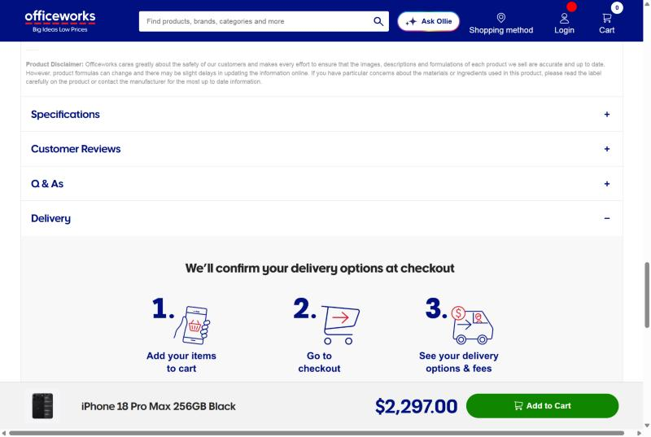
Figure 12 – Officeworks: Specifications, Customer Reviews, Q & As and Delivery sections
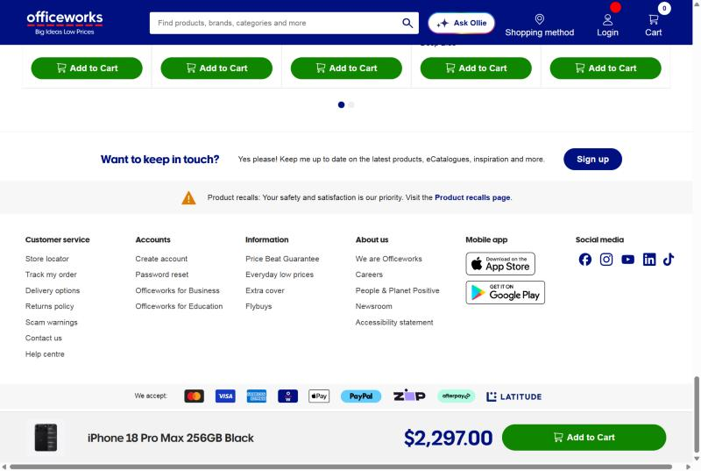
Figure 13 – Officeworks footer: Track my order, delivery options, returns policy, account links, Price Beat Guarantee, accepted payments

Task 1.3 – Amazon Australia
Detail | Your notes
Website | amazon.com.au
Date investigated | 30 September 2026
Investigated by
Product searched | iPhone 18 Pro Max (256GB)

Observations
Short, factual notes of what was seen. The Evidence column points to the numbered figures in the Screenshots section below.
Area | What I observed | Evidence
Home page – navigation & categories | Header with location, search with category dropdown, language, 'Hello, sign in / Account & Lists', 'Returns & orders', Basket. 'All' menu plus deal links; Apple products sub-menu. | Fig 16
Home page – promotions / banners | 'Savings 20% on Apple iPhone accessories', 'Prime Savings Get $50 off $300 with Latitude'. 'Best Seller' badges and 'Sponsored' (paid) results. | Fig 14, 16
Search bar (suggestions while typing?) | Search returned iPhone 18 Pro Max, iPhone 18 Pro, older models and accessories, with sponsored items mixed in. | Fig 14
Listing page – filters | Many filters: Prime, Delivery Day (Tomorrow / Two Days), Free Delivery, Customer Review 4★ & up, Brand, Price slider + ranges, Condition (New / Renewed / Used), Seller, Include Out of Stock, Display Resolution. | Fig 14, 15
Listing page – sort options | Sort: Featured, Price Low–High / High–Low, Avg. Customer Review, Newest Arrivals, Best Sellers. | Fig 14
Product card (image, price, rating, stock badge) | Image, colour swatches, title, options ('4 sizes'), star rating and count, price, delivery date, stock message, Add to cart. | Fig 14, 15
Product page – price / discount / was-price | $2,297 for 256GB (same as Officeworks). Price shown under each colour option. | Fig 16
Product page – images (how many, zoom?) | Thumbnail gallery including a video. | Fig 16
Product page – specifications | Key specs under the options (Brand, OS, storage, screen size, model) and 'About this item' bullet points. | Fig 16, 17
Customer reviews & star ratings | 2.4 out of 5 (3 ratings) with a star breakdown: 5★ 21%, 2★ 59%, 1★ 20%. Reviews show 'Verified Purchase', 'Helpful' and 'Report' buttons. | Fig 18
Stock availability (online / in store / location) | 'Temporarily out of stock. Order now and we'll deliver when available'; account charged only when the item ships. Accessory shows 'Only 2 left in stock'. | Fig 14, 17
Delivery options, cost & estimated date | FREE delivery; delivery dates on cards ('FREE delivery Sat, 3 Oct', 'fastest delivery Fri, 2 Oct'); delivery location by postcode. | Fig 14, 16
Warranty & returns information | 'Eligible for change of mind returns within 30 days of receipt'. Shipper / Seller: Amazon AU. | Fig 17
Compare / 'You may also like' | iPhone model strip (18 Pro Max, 18 Pro, Duo, 17, 17e, Accessories) at the top of the product page. | Fig 16
Cart – subtotal, delivery, promo code | Buy box has 'Add to cart' and 'Buy Now' (cart page not checked). | Fig 16, 17
Wishlist / save for later | 'Add to Wish List' button in the buy box. | Fig 17
Sign-up – required fields & password rules | 'Sign in' pop-up and 'New customer? Start here' link (form not checked). | Fig 16
Order tracking page | 'Returns & orders' link in the header (tracking page not checked). | Fig 16
Trust signals (secure payment, Afterpay/PayPal, help centre) | 'Secure transaction' label, seller name, returns policy, Prime membership offer. | Fig 16, 17

Key findings
- Amazon has by far the most filters, including delivery speed, condition and seller.
- Reviews show a star breakdown (%) and 'Verified Purchase' labels, not just an average.
- Out-of-stock products can still be ordered, and payment is only taken when the item ships.
- Delivery dates are shown on search results before the customer opens the product.
- Sponsored results and 'Best Seller' badges are mixed into search results.

Ideas for our Secure Retail project
- Store a rating breakdown (count per star level) and a 'verified purchase' flag with each review.
- Add estimated delivery date and returns policy to our product page.
- Add a 'Buy Now' option that skips the cart for single-item purchases.

Screenshots
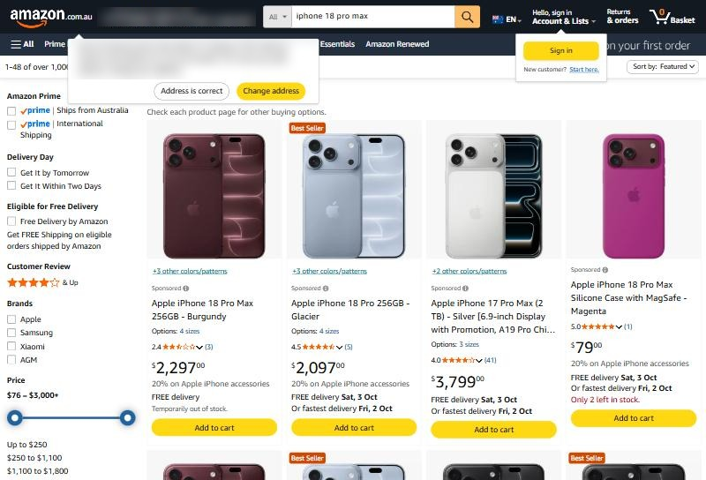
Figure 14 – Amazon search results: filters (Prime, Delivery Day, Free Delivery, Customer Review, Brand, Price), sponsored results, Best Seller badges, delivery dates, stock messages (delivery location blurred)
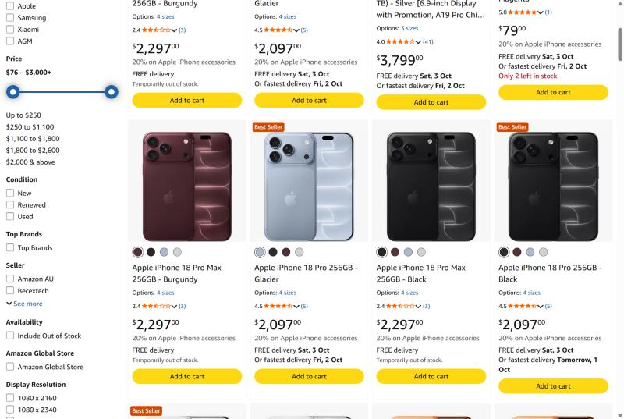
Figure 15 – Amazon: more filters (Condition, Seller, Availability, Display Resolution) and colour swatches on product cards
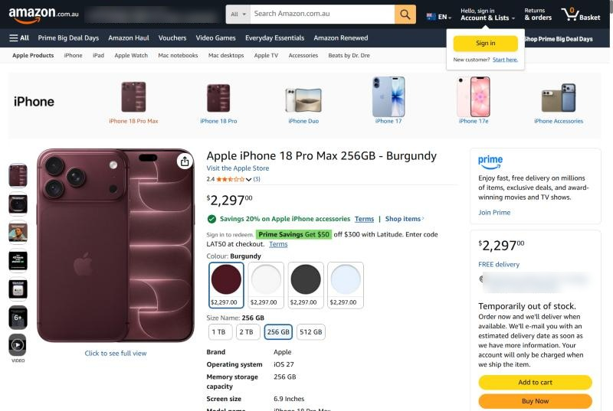
Figure 16 – Amazon product page: rating, price, promotions, colour and size options with prices, key specs, buy box (location blurred)
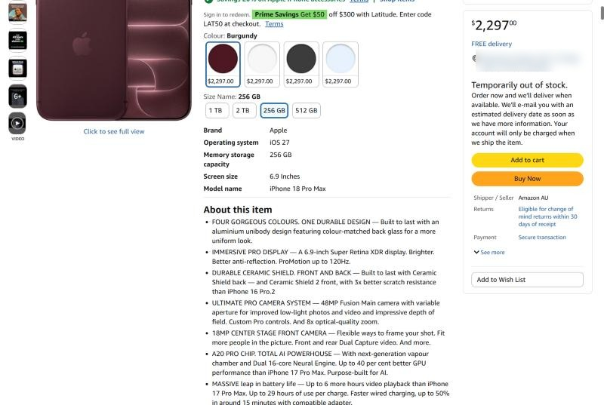
Figure 17 – Amazon buy box: out-of-stock pre-order, Add to cart / Buy Now, seller, 30-day returns, secure transaction, Add to Wish List; 'About this item'
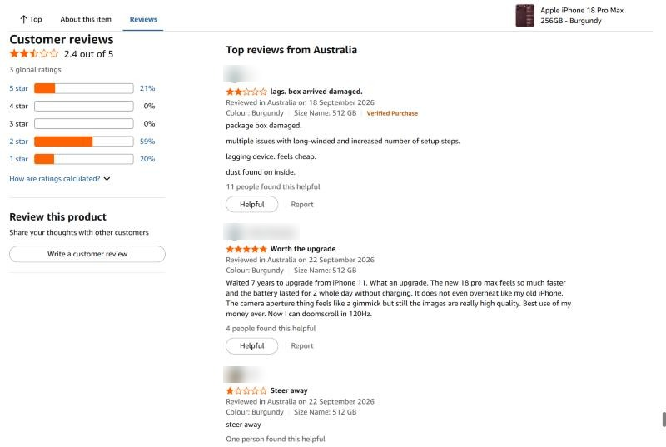
Figure 18 – Amazon customer reviews: 2.4 average with star breakdown, Verified Purchase, Helpful and Report buttons (reviewer names blurred)

Task 1.4 – Summary of Findings
Organisation | Type | Areas investigated | Key findings
JB Hi-Fi | Online electronics retailer | Search, filters, product page, specs, stock, warranty, help links | 16 results; $2,299–$4,699; 2.7★ (7 reviews); stock by postcode; 30+ spec fields; trade-in and price-match (JB Deal); wishlist needs an account
Officeworks | Online office & tech retailer | Search, sort, product page, delivery options, help links | 59 results (phones + accessories); $2,297–$4,697; no reviews yet; free delivery badge on every card; Pick up in-store vs Deliver; 365-day returns; AI assistant 'Ollie'
Amazon AU | Online marketplace | Search, filters, product page, buy box, reviews | Many filters (Prime, delivery day, condition, seller); 2.4★ with star breakdown; out-of-stock pre-order; 30-day returns; Buy Now + Wish List; sponsored results

What all three do that our MVP does not yet do
- Real product search with sort options and filters
- Customer reviews and star ratings on products
- Live stock availability (by store/postcode or online)
- Product variants (colour and storage) with a price for each option
- Detailed specification table per product
- Delivery options, returns policy and order tracking
- Wishlist linked to a user account

Task 2 – Data Discovery Investigation
The table below lists the data items used by the three systems investigated in Task 1. The 'Seen On' column links each item to the screenshot evidence (figure numbers) in Task 1.
# | Data Item | Why Is It Important? | Who Uses It? | Seen On
1 | Product Name / Title | Identifies the product and appears in search results | Customers, Staff | All sites (Fig 1, 8, 14)
2 | Product Price | Supports purchasing decisions | Customers, Finance | All sites (Fig 2, 10, 16)
3 | Variant Price (per storage/colour) | Shows the cost difference between options | Customers | All sites (Fig 2, 10, 16)
4 | Product Variants (colour, storage) | Lets customers pick the exact version they want | Customers, Inventory staff | All sites (Fig 2, 10, 16)
5 | SKU / Model / Product Code | Uniquely identifies stock for inventory and orders | Staff, Inventory system | JB (Fig 2), Officeworks (Fig 10)
6 | Product Images / Video | Help customers see the product before buying | Customers | All sites (Fig 2, 10, 16)
7 | Specifications | Allow detailed comparison of features | Customers | JB (Fig 5), Officeworks (Fig 12), Amazon (Fig 16)
8 | Product Category | Groups products for browsing and filtering | Customers, Admin | Officeworks (Fig 8)
9 | Average Star Rating | Quick signal of product quality | Customers, Managers | All sites (Fig 1, 10, 18)
10 | Review Count | Shows how reliable the rating is | Customers | All sites (Fig 1, 14)
11 | Rating Breakdown (% per star) | Shows the spread of opinions, not just the average | Customers, Managers | Amazon (Fig 18)
12 | Review Text + Verified Purchase flag | Builds trust and shows real customer experiences | Customers, Admin (moderation) | Amazon (Fig 18)
13 | Stock Level / Availability | Prevents selling items that aren't available | Customers, Inventory staff | All sites (Fig 4, 14, 17)
14 | Store Location / Postcode | Checks local stock and delivery options | Customers, Logistics | JB (Fig 4), Officeworks (Fig 11)
15 | Fulfilment Method (Delivery / Click & Collect) | Lets customers choose how to receive the item | Customers, Store staff | Officeworks (Fig 8, 11)
16 | Delivery Cost | Affects the total price and the buying decision | Customers, Finance | All sites (Fig 9, 14)
17 | Estimated Delivery Date | Sets customer expectations | Customers, Logistics | Amazon (Fig 14)
18 | Promotion / Discount Details | Encourages purchases and drives sales | Customers, Marketing | JB (Fig 1), Amazon (Fig 16)
19 | Purchase Limit per Customer | Stops bulk buying of popular stock | System, Staff | JB (Fig 3)
20 | Payment Methods | Offers flexible, trusted ways to pay | Customers, Finance | All sites (Fig 2, 7, 13)
21 | Warranty Period | Gives confidence in the purchase | Customers, Support staff | JB (Fig 6)
22 | Returns Policy (30 / 365 days) | Reduces purchase risk and builds trust | Customers, Support staff | Officeworks (Fig 9), Amazon (Fig 17)
23 | Seller / Shipper | Tells customers who they are buying from | Customers | Amazon (Fig 17)
24 | Wishlist Items | Saves products for later and shows demand | Customers, Marketing | All sites (Fig 3, 10, 17)
25 | Order Number / Tracking Status | Lets customers follow their delivery | Customers, Support staff | JB (Fig 7), Officeworks (Fig 13)

New data compared with our Week 2 Data Inventory
These items were not in our Week 2 inventory and should be considered for the Capstone B database:
- Variant price and product variants (colour, storage)
- SKU / model / product code
- Rating breakdown and verified purchase flag on reviews
- Store location / postcode and fulfilment method (Delivery / Click & Collect)
- Estimated delivery date and delivery cost
- Purchase limit per customer
- Warranty period and returns policy
- Seller / shipper

Task 3 – Module Investigation Summary
Module: Product Catalogue. Question: What information helps customers choose products?
From the investigation, customers choose products using five groups of information:

1. Price and value
- Clear price for every variant (e.g. 256GB $2,297 vs 512GB $2,697) shown directly on the option buttons (Fig 2, 10, 16).
- Promotions, trade-in offers and price-match promises (JB Deal, Price Beat Guarantee) help customers feel they are getting the best price (Fig 1, 8).
- Flexible payment options (Afterpay, Zip, Latitude, Upgrade+) make expensive products more affordable (Fig 2, 11).

2. Product details
- Image galleries (6–11 images, plus video on Amazon) (Fig 2, 16).
- Key features summary followed by a full specifications table (Fig 4, 5, 12).
- Model/SKU/product code so customers and staff can identify the exact item (Fig 2, 10).

3. Social proof
- Star rating and review count on every product card (Fig 1, 14).
- Rating breakdown and 'Verified Purchase' labels on Amazon (Fig 18).
- Q&A section on Officeworks for customer questions (Fig 12).
- The iPhone 18 Pro Max had low ratings (2.4–2.7★) on JB Hi-Fi and Amazon, which shows reviews strongly affect buying decisions.

4. Availability and delivery
- Stock availability checked by postcode, store or location (Fig 4, 11).
- Fulfilment choice: delivery, click & collect or pick up in-store (Fig 8, 11).
- Delivery cost and estimated delivery date shown before checkout (Fig 9, 14).

5. Finding and comparing
- Search with a results count, filters (price, availability, brand, rating, condition) and sort options (Fig 1, 8, 14, 15).
- Compare feature and 'Frequently bought together' / 'You might also like' suggestions (Fig 3, 4, 12).

Conclusion
Our Product Catalogue currently shows name, image, price and category. Real systems show much more: variant prices, specifications, reviews, stock and delivery information. These are the most important additions for Capstone B Version 2.

Task 4 – User Insights Activity
Note: The three people below are FICTIONAL user personas created by the team from the Task 1–3 findings. They are not real interview participants. Real interviews should be added to the table at the end of this section.

Proto-personas
Question | Persona A – 'Maya', 21, university student | Persona B – 'Daniel', 44, small business owner | Persona C – 'Margaret', 66, retiree
Profile | Shops mostly on her phone; budget-conscious; compares prices across sites | Buys laptops and phones for 5 staff; values time and reliable delivery | Less confident online; buys a new phone every few years; worried about scams
1. What information do you expect before making a purchase? | Price of each storage option, reviews, Afterpay/Zip options | Exact specs, SKU/model, warranty, bulk or business pricing | Clear price, what's in the box, whether it's in stock nearby
2. What information helps you trust an online system? | Lots of reviews with photos; 'verified purchase' | Returns policy, warranty and a known seller | Phone number, secure payment logos, scam warnings
3. What information saves you time? | Filters and sort by price; comparing variants side by side | Stock availability and delivery date before checkout | Simple layout, big 'Add to cart' button, click & collect
4. What information is commonly missing? | Honest reviews on new products | Stock across multiple stores; business invoice options | Plain-English explanation of specifications
5. What would improve your experience? | Price-drop alerts and a saved wishlist | Order tracking and saved accounts for re-ordering | Live chat or phone help, and larger text

Persona Insight Summary
- All three personas depend on clear price and stock information before buying, which supports the 'Must Have' items in Task 6.
- Trust signals differ by user: reviews for younger shoppers, warranty/returns for business buyers, phone support and scam warnings for older users.
- Time-saving features (filters, delivery dates, click & collect) matter to every persona.
- Accessibility (simple layout, readable text, plain-English specs) is a gap not covered by our MVP.

Real interviews (to be added)
Question | Person 1 | Person 2 | Person 3
Name / description
Q1 – Info expected before purchase
Q2 – What builds trust
Q3 – What saves time
Q4 – What is commonly missing
Q5 – What would improve experience

Task 5 – Data Gap Analysis
Comparison of our Capstone A Frontend MVP with the systems investigated in Task 1.
Our MVP | Industry System | Missing Opportunity
Featured products on the Home page only | Search returning all matching products with a results count (JB 16, Officeworks 59) (Fig 1, 8) | Product search
Browse by category only | Filters: price, availability, brand, rating, condition, seller (Fig 8, 14, 15) | Product filters
No sorting | 6–9 sort options: price, newest, rating, best sellers (Fig 1, 14) | Sort options
Product cards only, no product page | Dedicated product page with image gallery, key features and specs table (Fig 2, 5, 16) | Product detail page + specifications data
One price per product | Colour and storage variants, each with its own price (Fig 2, 10, 16) | Product variants and variant pricing
No product code | Model, SKU and product code on every product (Fig 2, 10) | SKU field for inventory
Store testimonials (general) | Product reviews with star rating, count, breakdown and Verified Purchase (Fig 6, 18) | Product reviews and ratings
No stock information | Stock by postcode/store, 'Temporarily out of stock', 'Only 2 left' (Fig 4, 14, 17) | Stock level and availability
No delivery information | Delivery cost, estimated date, click & collect, 2-hour delivery (Fig 8, 11, 14) | Delivery and fulfilment options
Add to Cart button (UI only) | Working cart plus 'Buy Now' (Fig 16, 17) | Functional cart and checkout
Wishlist button (UI only) | Wishlist saved to a customer account (Fig 3, 17) | Wishlist linked to user account
No user accounts | Sign in, create account, password reset (Fig 13, 16) | Secure user accounts
No order tracking | 'Track my order' links (Fig 1, 7, 13) | Order tracking
No compare feature | Compare / Add to Compare (Fig 3, 8) | Product comparison
Contact form only | Live chat, phone, AI assistant, help centre (Fig 4, 8) | More customer support channels
No policy information | Warranty, returns (30/365 days), secure transaction, payment logos (Fig 6, 9, 17) | Warranty, returns and payment trust information

Task 6 – Product Improvement Workshop
Improvements for Capstone B Version 2, prioritised using MoSCoW.

Must Have – critical improvements
- Product search across the full catalogue
- Product detail page with specifications and SKU
- Stock level shown on products (in stock / out of stock)
- Secure user accounts (registration, login, hashed passwords, roles)
- Functional shopping cart stored in the database
- Product variants (colour, storage) with a price per variant

Should Have – important UX improvements
- Filters (price, category, availability) and sort options
- Product reviews with star rating, review count and rating breakdown
- Delivery cost, estimated delivery and returns policy on the product page
- Wishlist saved to the user's account
- Order tracking page

Nice To Have – future enhancements
- Product comparison
- Stock by store/postcode and click & collect
- 'Frequently bought together' recommendations
- 'Notify me when back in stock'
- Live chat or AI shopping assistant
- 'Buy Now' one-step purchase

Task 7 – Jira and GitHub Updates

New Jira items
Key | Type | Summary | Priority | Source
SR-20 | Research Finding | Week 3 industry investigation: JB Hi-Fi, Officeworks, Amazon AU | Medium | Task 1
SR-21 | Data Requirement | Add SKU, variants (colour/storage) and variant price to product data | High | Task 2, 5
SR-22 | Data Requirement | Add stock level / availability field to products | High | Task 2, 5
SR-23 | Data Requirement | Add review data: rating, review text, verified purchase, date | Medium | Task 2, 5
SR-24 | User Story | As a customer, I want to search products so that I can quickly find what I need | High | Task 5, 6
SR-25 | User Story | As a customer, I want to view a product detail page with specifications so that I can compare features | High | Task 5, 6
SR-26 | User Story | As a customer, I want to see if a product is in stock so that I don't order unavailable items | High | Task 5, 6
SR-27 | User Story | As a customer, I want to create an account and log in securely so that my cart and wishlist are saved | High | Task 5, 6
SR-28 | Feature Request | Filters (price, category, availability) and sort options on the catalogue | Medium | Task 5, 6
SR-29 | Feature Request | Product reviews and ratings with star breakdown | Medium | Task 5, 6
SR-30 | Enhancement | Show delivery cost, estimated delivery and returns policy on product page | Medium | Task 5, 6
SR-31 | Enhancement | Save wishlist to user account (currently UI only) | Medium | Task 5, 6
SR-32 | Feature Request | Product comparison and 'frequently bought together' (future) | Low | Task 6
SR-33 | Research Finding | User personas created; real user interviews still to be completed | Medium | Task 4

GitHub
- Folder: docs/week3/
- docs/week3/week3-industry-investigation.md – summary of findings
- docs/week3/Week3_Investigation_Report.docx – this report
- docs/week3/evidence/ – 18 screenshots (figure-01 to figure-18)
- Changes submitted through a Pull Request for team review

