Analysis

## 1. Top 5 states for order quantity between 2007 and 2008 for the product, 800 (Road-550-W Yellow, 44), together with a gain/loss percentage of 2008 when compared to 2007

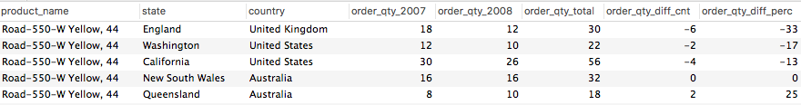

*Reference SQL query: Query 1*

Findings & Business Decisions  
*[Your findings and business decisions/suggestions]*

## 2.