Analysis

## 1. Top 5 states for order quantity between 2007 and 2008 for the product, 800 (Road-550-W Yellow, 44), together with a gain/loss percentage of 2008 when compared to 2007

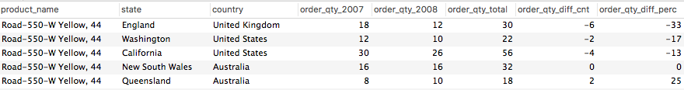

*Reference SQL query: Query 1*

Findings & Business Decisions  
*[Your findings and business decisions/suggestions]*

## 2.

**-- Query 2**

**-- Analysis: Top 10 Products_Categories which has been distibuted in various states of "United States"**

**-- Findings & Business Decisions: Accessories is mostly famous in all the States. California is a state which has the highest sales in terms of Accessories, Bikes, Clothing. So probably a good market to invest in.**

SELECT c.home_address_country AS country, c.home_address_state AS state, p.product_category AS product_category, SUM(f.order_qty) AS quantity

FROM fact_sales f,

dim_customer c,

dim_product p

WHERE f.customer_skey = c.customer_skey

AND f.product_skey = p.product_skey

AND c.home_address_country = "United States"

GROUP BY c.home_address_country, c.home_address_state, p.product_category

ORDER BY 4 DESC

LIMIT 10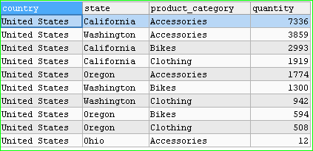

3.

**-- Query 3**

**-- Analysis: Top 10 Product whos sales are highest in different contries and states between 2007 and 2008. The differece in the product is recorded and also the change percentage.**

**-- Findings & Business Decisions: Watter Bottle - 30oz product is the one which is sold almost everywhere in all the Countries. It just shows that the bottled water is famous everywhere and the sales of the water are increasing each year.**

SELECT b.*

FROM (

SELECT a.product_name, a.state, a.country

, SUM(IF(a.the_year=2007, a.order_qty, NULL)) AS quantity_2007

, SUM(IF(a.the_year=2008, a.order_qty, NULL)) AS quantity_2008

, SUM(a.order_qty) AS total

, IFNULL(SUM(IF(a.the_year=2008, a.order_qty, NULL)), 0) - IFNULL(SUM(IF(a.the_year=2007, a.order_qty, NULL)),0) AS quantity_diff

, ROUND(CASE WHEN SUM(IF(a.the_year=2007, a.order_qty, NULL)) > 0

THEN (IFNULL(SUM(IF(a.the_year=2008, a.order_qty, NULL)), 0) - IFNULL(SUM(IF(a.the_year=2007, a.order_qty, NULL)),0)) / SUM(IF(a.the_year=2007, a.order_qty, NULL))

END*100) AS perc_difference_2007_2008

FROM (

SELECT p.product_name, c.home_address_state AS state, c.home_address_country AS country, d.the_year, SUM(f.order_qty) AS order_qty

FROM fact_sales f, dim_product p, dim_customer c, dim_date d

WHERE f.product_skey = p.product_skey

AND f.customer_skey = c.customer_skey

AND f.date_skey = d.date_skey

AND d.the_year IN (2007, 2008)

GROUP BY p.product_name, c.home_address_state, d.the_year

) a

GROUP BY a.product_name, a.state, a.country

ORDER BY SUM(a.order_qty) DESC

LIMIT 10

) b

ORDER BY b.perc_difference_2007_2008

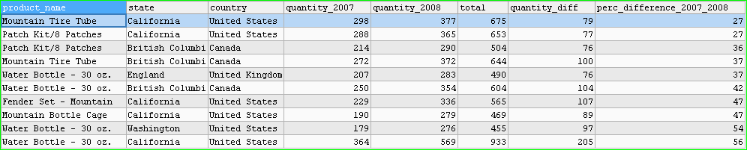

**4. The Accessories which are sold in all the countries**

**-- Query 4**

**-- Analysis: Sales in different countries between 2007 and 2008. The total sales is recorded and the difference in the product is recorded and also the change percentage.**

**-- Findings & Business Decisions: It can be seen that United States has largest sales. If we look at the percentage difference between 2007 to 2008 France, Germany and Australia are the emerging Markets and should be consolidated**

SELECT a.country

, SUM(a.quantity) AS total

, SUM(IF(a.the_year=2007, a.quantity, NULL)) AS quantity_2007

, SUM(IF(a.the_year=2008, a.quantity, NULL)) AS quantity_2008

, IFNULL(SUM(IF(a.the_year=2008, a.quantity, NULL)), 0) - IFNULL(SUM(IF(a.the_year=2007, a.quantity, NULL)),0) AS quantity_diff_cnt

, ROUND(CASE WHEN SUM(IF(a.the_year=2007, a.quantity, NULL)) > 0

THEN (IFNULL(SUM(IF(a.the_year=2008, a.quantity, NULL)), 0) - IFNULL(SUM(IF(a.the_year=2007, a.quantity, NULL)),0)) / SUM(IF(a.the_year=2007, a.quantity, NULL))

END*100) AS perc_difference_2007_2008

FROM (

SELECT c.home_address_country AS country, p.product_category AS product_category, SUM(f.order_qty) AS quantity, d.the_year AS the_year

FROM fact_sales f,

dim_customer c,

dim_product p,

dim_date d

WHERE f.customer_skey = c.customer_skey

AND f.product_skey = p.product_skey

AND f.date_skey = d.date_skey

AND p.product_category = "Accessories"

GROUP BY c.home_address_country, p.product_category, d.the_year

) a

GROUP BY a.country

ORDER BY perc_difference_2007_2008 DESC

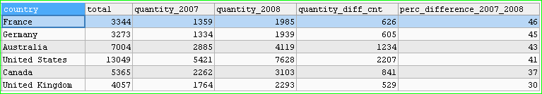

**5. Distribution of all the product according to Country**

**-- Query 5**

**-- Analysis: Sales in different countries according to the Product Category though all the years are listed.**

**-- Findings & Business Decisions: It can be seen that United States has largest sales for all product categories. As a sales we would focus on more accessories product to be shipped and sold to the customer as it is famous (highest value) in all countries.**

SELECT a.country

, SUM(IF(a.product_category = 'Accessories', a.quantity, NULL)) AS Accessories

, SUM(IF(a.product_category = 'Bikes', a.quantity, NULL)) AS Bikes

, SUM(IF(a.product_category = 'Clothing', a.quantity, NULL)) AS Clothing

FROM (

SELECT c.home_address_country AS country, p.product_category AS product_category, SUM(f.order_qty) AS quantity

FROM fact_sales f,

dim_customer c,

dim_product p

WHERE f.customer_skey = c.customer_skey

AND f.product_skey = p.product_skey

GROUP BY c.home_address_country, p.product_category

) a

GROUP BY a.country

ORDER BY a.quantity DESC

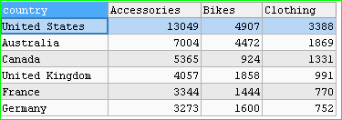

**6. Product type and Gender for various Country**

**-- Query 6**

**-- Analysis: Sales in different countries according to the Product Category and according to the gender though all the years are listed.**

**-- Findings & Business Decisions: It can be seen that United States has largest sales for all product categories both for Male and Female. Interestingly we can see some trends that male and Female buy clothing almost equally. And accessories irrespective of the countries and gender they are most bought**

SELECT a.country

, SUM(IF(a.product_category = 'Accessories' AND a.gender = "F", a.quantity, NULL)) AS Accessories_Female

, SUM(IF(a.product_category = 'Accessories' AND a.gender = "M", a.quantity, NULL)) AS Accessories_Male

, SUM(IF(a.product_category = 'Bikes' AND a.gender = "F", a.quantity, NULL)) AS Bikes_Female

, SUM(IF(a.product_category = 'Bikes' AND a.gender = "M", a.quantity, NULL)) AS Bikes_Male

, SUM(IF(a.product_category = 'Clothing' AND a.gender = "F", a.quantity, NULL)) AS Clothing_Female

, SUM(IF(a.product_category = 'Clothing' AND a.gender = "M", a.quantity, NULL)) AS Clothing_Male

FROM (

SELECT c.home_address_country AS country, p.product_category AS product_category, SUM(f.order_qty) AS quantity, c.gender AS gender

FROM fact_sales f,

dim_customer c,

dim_product p

WHERE f.customer_skey = c.customer_skey

AND f.product_skey = p.product_skey

GROUP BY c.home_address_country, p.product_category, c.gender

) a

GROUP BY a.country

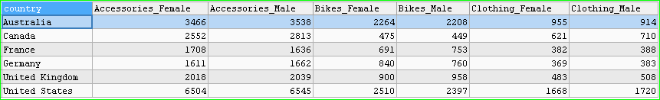

**7.**

**-- Query 7**

**-- Analysis: Sales in United States according to the Product Category and according to the gender though each years are listed.**

**-- Findings & Business Decisions: It can be argued that the data for 2005 and 2006 is not recorded for the Accessories and clothing. But looking at the stats we can find that from 2007 to 2008 Male show growth in the Accessories than the Female counterparts. Also, looking at trends we can estimate a inrease of Accessories and can reach about 5000 for male and 4800 for Females.**

SELECT a.country,a.the_year

, SUM(IF(a.product_category = 'Accessories' AND a.gender = "F", a.quantity, NULL)) AS Accessories_Female

, SUM(IF(a.product_category = 'Accessories' AND a.gender = "M", a.quantity, NULL)) AS Accessories_Male

, SUM(IF(a.product_category = 'Bikes' AND a.gender = "F", a.quantity, NULL)) AS Bikes_Female

, SUM(IF(a.product_category = 'Bikes' AND a.gender = "M", a.quantity, NULL)) AS Bikes_Male

, SUM(IF(a.product_category = 'Clothing' AND a.gender = "F", a.quantity, NULL)) AS Clothing_Female

, SUM(IF(a.product_category = 'Clothing' AND a.gender = "M", a.quantity, NULL)) AS Clothing_Male

FROM (

SELECT c.home_address_country AS country, p.product_category AS product_category, SUM(f.order_qty) AS quantity, c.gender AS gender,d.the_year AS the_year

FROM fact_sales f,

dim_customer c,

dim_product p,

dim_date d

WHERE f.customer_skey = c.customer_skey

AND f.product_skey = p.product_skey

AND f.date_skey = d.date_skey

AND c.home_address_country = "United States"

GROUP BY c.home_address_country, p.product_category, c.gender,d.the_year

) a

GROUP BY a.country,a.the_year

