**High-Level ETL Architecture**

SOURCE_DB

app_profile

app_college

app_recommender

adm_decision

adm_department

adm_program

adm_messages

adm_review

adm_tag

adm_term

DATAMART_DB

dim_applicant

dim_ethnicity

dim_date

dim_program

dim_recommendor

fact_applicant

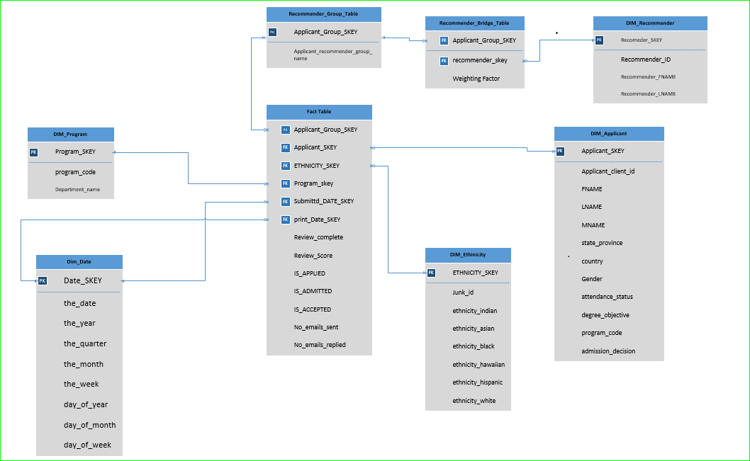

SOURCE_DB

