Program-1

#include<iostream>
using namespace std;
int main()
{
cout<<"welcome\n";
return 0;
}
output:-

Program-2

#include<iostream>
using namespace std;
int main()
{
int a,b;
cout<<"enter values for a and b"<<endl;
cin>>a>>b;
cout<<"addition="<<a+b<<endl;
cout<<"subtraction="<<a-b<<endl;
cout<<"multiplication="<<a*b<<endl;
cout<<"quotient="<<a/b<<endl;
return 0;
}

output:-
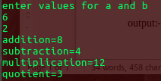

Program-3

#include<iostream>
using namespace std;
int main()
{
char ch;
cout<<"enter a character"<<endl;
cin>>ch;
cout<<ch+1<<endl;
cout<<ch+2<<endl;
cout<<ch-1<<endl;
return 0;
}

output:-
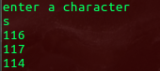

Program-4

#include<iostream>
using namespace std;
int main()
{
int a,b;
cout<<"enter values for a and b"<<endl;
cin>>a>>b;
if(a>b)
cout<<a<<" is the greatest"<<endl;
else
cout<<b<<" is the greatest"<<endl;
return 0;
}

output:-
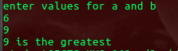

Program-5

#include<iostream>
using namespace std;
int main()
{
int a,b,c;
cout<<"enter values for a and b and c"<<endl;
cin>>a>>b>>c;
((a>b)&&(a>c))?cout<<a<<" is the largest"<<endl:(b>c)?cout<<b<<" is the largest"<<endl:cout<<c<<" is the largest"<<endl;
return 0;
}

output:-
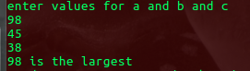

Program-6

#include<iostream>
using namespace std;
int main()
{
int i=0;
while(i<5)
{
i=i+1;
cout<<i<<endl;
}
return 0;
}

output:-
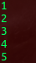

Program-7

#include<iostream>
using namespace std;
int main()
{
int i=0;
cout<<"while loop"<<endl;
while(i<5)
{
i=i+1;
cout<<i<<endl;
}
cout<<"do while loop"<<endl;
i=0;
do
{
i=i+1;
cout<<i<<endl;
}
while(i<5);
cout<<"for loop"<<endl;
for(i=0;i<=5;i++)
{
cout<<i<<endl;
}
return 0;
}

output:-
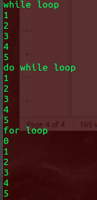

Program-8

#include<iostream>
using namespace std;
int main()
{
float feet,inches,meter,cm;
cout<<"enter the feet and inches"<<endl;
cin>>feet>>inches;
meter=0.3048*feet;
cm=2.54*inches;
cout<<"length in meter"<<meter<<endl;
cout<<"length in centimeter"<<cm<<endl;
return 0;
}

output:-
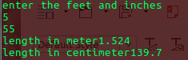

Program-9

#include<iostream>
using namespace std;
int main()
{
int a=10;
cout<<a<<endl;
++a;
cout<<a<<endl;
a++;
cout<<a<<endl;
--a;
cout<<a<<endl;
a--;
cout<<a<<endl;
char ch='b';
cout<<ch<<endl;
++ch;
cout<<ch<<endl;
ch++;
cout<<ch<<endl;
--ch;
cout<<ch<<endl;
ch--;
cout<<ch<<endl;
return 0;
}

output:-
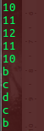

program-10
#include<iostream>
#include<string.h>
using namespace std;
int main()
{
char str[10];
cout<<"enter the string"<<endl;
cin>>str;
int n;
n=strlen(str);
int i,s=0;
for(i=0;i<n;i++)
{
if(str[i]=='a'||str[i]=='e'||str[i]=='i'||str[i]=='o'||str[i]=='u'||str[i]=='A'||str[i]=='E'||str[i]=='I'||str[i]=='o'||str[i]=='U')
{
s=s+1;
}
}
cout<<"s="<<s<<endl;
return 0;
}

program-11

#include<iostream>
#include<string.h>
using namespace std;
int main()
{
char i,str[100];
int n,c=0;
cout<<"enter the string"<<endl;
cin>>str;

for(i=0;str[i]!='\0';i++)
{
switch (str[i])
{
case 'a' :
case 'e' :
case 'i' :
case 'o' :
case 'u' : c=c+1;
}
}
cout<<"c="<<c<<endl;
return 0;
}
output:-
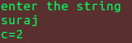

program-12
#include<iostream>
#include<string.h>
using namespace std;
int main()
{
int i,n,flag=0;
cout<<"enter the value of n"<<endl;
cin>>n;
for(i=2;i<=n/2;i++)
{
if(n%i==0)
{
flag=1;
break;
}
}
if(flag==0)
cout<<" prime"<<endl;
else
cout<<"not prime"<<endl;
return 0;
}
output:-
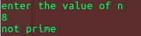

#include<iostream>
#include<math.h>
using namespace std;
int main()
{
int a,b,c;
float d,rp,ip,x1,x2;
cout<<"enter the values"<<endl;
cin>>a>>b>>c;
d=(b*b)-(4*a*c);
if(d>0)
{
x1=(-b+sqrt(d))/(2*a);
x1=(-b-sqrt(d))/(2*a);
cout<<"x1="<<x1<<endl;
cout<<"x2="<<x2<<endl;
}
else if(d==0)
{
x1=-b+sqrt(d)/(2*a);
cout<<"x1=x2 are same"<<x1<<endl;
}
else
{
rp=(-b/(2*a));
ip=sqrt(-d)/(2*a);
cout<<"rp="<<rp<<"+i"<<"ip="<<ip<<endl;
}

return 0;
}
output:-
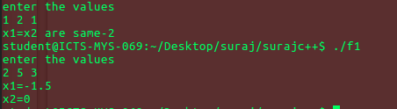
program-12

//sum of digits//
#include<iostream>
using namespace std;
int main()
{
int n,dig,sum=0,rem;
cout<<"enter a number"<<endl;
cin>>n;
while(n>0)
{
rem=n%10;
sum=sum+rem;
n=n/10;
}
int n1,rev=0,rem1;
cout<<"sum of given digits "<<sum<<endl;
cout<<"enter a number"<<endl;
cin>>n1;
while(n1>0)
{
rem1=n1%10;
rev=rev*10+rem1;
n1=n1/10;
}
cout<<"reverse of a given number is "<<rev<<endl;
return 0;
}
output:-
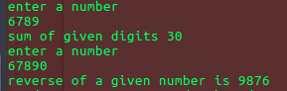

program=14

//searching and sorting and searching in 1-D array
#include<iostream>
using namespace std;
int main()
{
int n,a[10],i;
cout<<"enter a length "<<endl;
cin>>n;
cout<<"enter the array elements "<<endl;
for(i=0;i<n;i++)
{
cin>>a[i];
}
cout<<"displaying elements "<<endl;
for(i=0;i<n;i++)
{
cout<<a[i]<<endl;
}
int ele,flag=0;
cout<<"enter the searching element "<<endl;
cin>>ele;
for(i=0;i<n;i++)
{
if(a[i]==ele)
{
flag=1;
break;
}
}
if(flag==1)
cout<<"element found"<<endl;
else
cout<<"element not found"<<endl;
//selection sort
int j,temp;
for(i=0;i<n;i++)
{
for(j=i+1;j<n;j++)
{
if(a[i]>a[j])
{
temp=a[i];
a[i]=a[j];
a[j]=temp;
}
}
}
for(i=0;i<n;i++)
{
cout<<a[i]<<endl;
}

return 0;
}
output:-
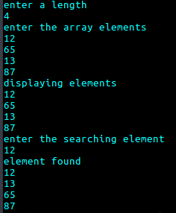

Program-15
//addition of two matrix
#include<iostream>
using namespace std;
int main()
{
int n,a[3][3],i,j,b[3][3],c[3][3];
cout<<"enter order of the matrix"<<endl;
cin>>n;
cout<<"enter the elements of matrix "<<endl;
for(i=0;i<n;i++)
{
for(j=0;j<n;j++)
{
cin>>a[i][j];
}
}
cout<<"matrix is "<<endl;
for(i=0;i<n;i++)
{
for(j=0;j<n;j++)
{
cout<<a[i][j]<<"\t";
}
cout<<endl;
}
cout<<"enter elements of second matrix"<<endl;
for(i=0;i<n;i++)
{
for(j=0;j<n;j++)
{
cin>>b[i][j];
}
}
cout<<"matrix is "<<endl;
for(i=0;i<n;i++)
{
for(j=0;j<n;j++)
{
cout<<b[i][j]<<"\t";
}
cout<<endl;
}

for(i=0;i<n;i++)
{
for(j=0;j<n;j++)
{
c[i][j]=a[i][j]+b[i][j];
}
}
cout<<"addition of two matrix is"<<endl;
for(i=0;i<n;i++)
{
for(j=0;j<n;j++)
{
cout<<c[i][j]<<"\t";
}
cout<<endl;
}
return 0;
}

output:-

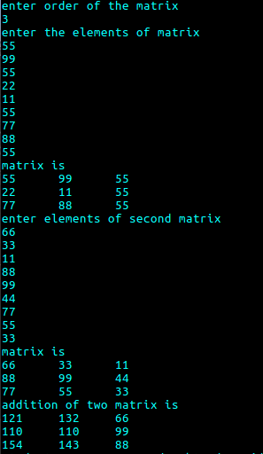

Program-16

//multiplication of 2 matrix
#include<iostream>
using namespace std;
int main()
{
int n,a[3][3],i,j,b[3][3],c[3][3],k;
cout<<"enter order of the matrix"<<endl;
cin>>n;
cout<<"enter the elements of matrix "<<endl;
for(i=0;i<n;i++)
{
for(j=0;j<n;j++)
{
cin>>a[i][j];
}
}
cout<<"matrix is "<<endl;
for(i=0;i<n;i++)
{
for(j=0;j<n;j++)
{
cout<<a[i][j]<<"\t";
}
cout<<endl;
}
cout<<"enter elements of second matrix"<<endl;
for(i=0;i<n;i++)
{
for(j=0;j<n;j++)
{
cin>>b[i][j];
}
}
cout<<"matrix is "<<endl;
for(i=0;i<n;i++)
{
for(j=0;j<n;j++)
{
cout<<b[i][j]<<"\t";
}
cout<<endl;
}
for(i=0;i<n;i++)
{
for(j=0;j<n;j++)
{
c[i][j]=0;
for(k=0;k<n;k++)
{
c[i][j]=c[i][j]+a[i][k]*b[k][j];
}
}
}
cout<<"multiplication of two matrix is"<<endl;
for(i=0;i<n;i++)
{
for(j=0;j<n;j++)
{
cout<<c[i][j]<<"\t";
}
cout<<endl;
}
return 0;
}
outpurt:-

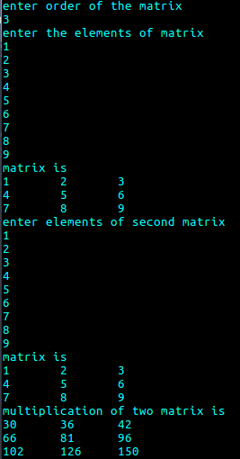

Program-17

//to accept student details and print total and average
#include<iostream>
using namespace std;
class student
{
int sid,age,s1,s2,s3,s4,s5,s6,sem;
char name[20],course[20];
public:
void read()
{
cout<<"enter sid,name,age,s1,s2,s3,s4,s5,s6,sem,course"<<endl;
cin>>sid>>name>>age>>s1>>s2>>s3>>s4>>s5>>s6>>sem>>course;
cout<<"sid is="<<sid<<endl;
cout<<"name is="<<name<<endl;
cout<<"age is="<<age<<endl;
cout<<"s1 is="<<s1<<endl;
cout<<"s2 is="<<s2<<endl;
cout<<"s3 is="<<s3<<endl;
cout<<"s4 is="<<s4<<endl;
cout<<"s5 is="<<s5<<endl;
cout<<"s6 is="<<s6<<endl;
cout<<"sem is="<<sem<<endl;
cout<<"course is="<<course<<endl;
}
void compute()
{
int total;
float avg;
total=s1+s2+s3+s4+s5+s6;
avg=total/6;
cout<<"total = "<<total<<endl;
cout<<"average = "<<avg<<endl;
}
};
int main()
{
student s;
s.read();
s.compute();
}

output:-

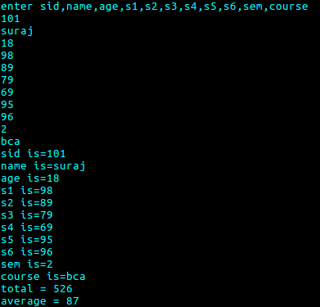

Program-18
//to accept student details and print total and average
#include<iostream>
using namespace std;
class student
{
int sid,age,s1,s2,s3,s4,s5,s6,sem;
char name[20],course[20];
public:
void read()
{
cout<<"enter sid,name,age,s1,s2,s3,s4,s5,s6,sem,course"<<endl;
cin>>sid>>name>>age>>s1>>s2>>s3>>s4>>s5>>s6>>sem>>course;
cout<<"sid is="<<sid<<endl;
cout<<"name is="<<name<<endl;
cout<<"age is="<<age<<endl;
cout<<"s1 is="<<s1<<endl;
cout<<"s2 is="<<s2<<endl;
cout<<"s3 is="<<s3<<endl;
cout<<"s4 is="<<s4<<endl;
cout<<"s5 is="<<s5<<endl;
cout<<"s6 is="<<s6<<endl;
cout<<"sem is="<<sem<<endl;
cout<<"course is="<<course<<endl;
}
void compute()
{
int total;
float avg;
total=s1+s2+s3+s4+s5+s6;
avg=total/6;
cout<<"total = "<<total<<endl;
cout<<"average = "<<avg<<endl;
}

};
int main()
{
int n,i;
student s1,s2[10];

s1.read();
s1.compute();
cout<<"how many students details to read"<<endl;
cin>>n;
for(i=0;i<n;i++)
{
s2[i].read();
s2[i].compute();
}
}

output:-

Program-19

//to implemaent telephone bill class with name,address,telephone no,no. of calls as data members.comute the amout to be paid if the charges per call is 2rs
#include<iostream>
using namespace std;
class telebill
{
long int tno,noofcalls ;
char name[20],address[20];
public:
void read()
{
cout<<"enter name,address,tno,number of calls"<<endl;
cin>>name>>address>>tno>>noofcalls;
cout<<"name="<<name<<endl;
cout<<"address ="<<address<<endl;
cout<<"tno ="<<tno<<endl;
cout<<"no of calls ="<<noofcalls<<endl;
}
void compute()
{
int bill;
bill=noofcalls*2;
cout<<"bill = "<<bill<<endl;
}

};
int main()
{
telebill b;
b.read();
b.compute();
}

output:-

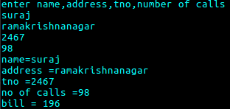

Program-20
//to check number is even or odd and sum
#include<iostream>
using namespace std;
class evenodd
{
int n;
public:
evenodd()
{
n=0;
}
void read();
void compute();
};
void evenodd::read()
{
cout<<"enter the value"<<endl;
cin>>n;
cout<<"n="<<n<<endl;
}
void evenodd::compute()
{
int s1=0,s2=0,i;
for(i=0;i<n;i++)
{
if(i%2==0)
s1=s1+i;
else
s2=s2+i;
}
cout<<"even sum="<<s1<<endl;
cout<<"odd="<<s2<<endl;
}

int main()
{
evenodd object;
object.read();
object.compute();
}

o/p:-
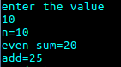

Program-21

//class to represent banks details and display the details of the banks
#include<iostream>
using namespace std;
class bank
{
int accnumber,balance;
string name,type;
public:
void getdata(int,int,string,string);
void putdata();
void deposit(int);
void withdraw(int);
};
void bank::getdata(int accno,int bal,string name1,string type1)
{
accnumber=accno;
balance=bal;
name=name1;
type=type1;
}
void bank::putdata()
{
cout<<"account_number="<<accnumber<<endl;
cout<<"balance="<<balance;
cout<<"name="<<name<<endl;
cout<<"account type="<<type<<endl;
}
void bank::deposit(int amt)
{
balance=balance+amt;
cout<<"after deposit balance="<<balance<<endl;
}
void bank::withdraw(int amt)
{
if(balance>amt)
{
balance=balance-amt;
cout<<"withdraw balance="<<balance<<endl;
}
else
{
cout<<"cannot withdraw the amount"<<endl;
}
}
int main()
{
bank icici;
icici.getdata(3456,5000,"NACY","FD");
icici.putdata();
icici.deposit(6000);
icici.withdraw(2000);
return 0;
}
o/p:-
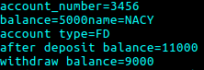

Program-22
//inline function
#include<iostream>
using namespace std;
inline int sqr(int x)
{
int y;
y=x*x;
return y;
}
int main()
{
int a,b;
cout<<"enter the number"<<endl;
cin>>a;
b=sqr(a);
cout<<b<<endl;
return 0;
}
o/p:-
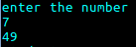

Program-23
//inline function
#include<iostream>
using namespace std;
class line
{
public:
inline float mul(float x,float y)
{
return(x*y);
}
inline float cube(float x)
{
return(x*x*x);
}
};
int main()
{
line obj;
float vol1,vol2;
cout<<"enter two values"<<endl;
cin>>vol1>>vol2;
cout<<"multiplication value is="<<obj.mul(vol1,vol2)<<endl;
cout<<"cube="<<obj.cube(vol2)<<endl;
}
o/p:-

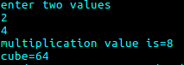

Program-24

//constructor type(constructor overloading)
#include<iostream>
using namespace std;
class a
{
int a2,b;
public:
a(){
cout<<"default constructor"<<endl;
a2=0;
b=0;
}
a(int a1)
{
cout<<"parameterized constructor with one parameter"<<endl;
a2=a1;
}
a(int a1,int b1)
{
cout<<"parameterized constructor with two"<<endl;
a2=a1;
b=b1;
}
a(a &object)
{
cout<<"copy constructor"<<endl;
a2=object.a2;
}
};
int main()
{
a object1,object2(10),object3(20,30),object4(object1);
}
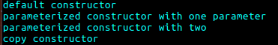
o/p:-

Program-24
//function type(function overloading) function having same name but different signatures
#include<iostream>
using namespace std;
void function();
void function(int);
void function(int,int);
void function()
{
cout<<"function invalid"<<endl;
}
void function(int a)
{
cout<<"second functionwith one parameter"<<endl;
cout<<"a="<<a<<endl;
}
void function(int a,int b)
{
cout<<"this function with two parameters"<<endl;
cout<<"a="<<a<<endl<<"b="<<b<<endl;
}
int main()
{
function();
function(10);
function(20,30);
}
o/p:-

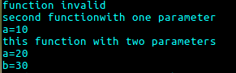

Program:-25

//class
#include<iostream>
using namespace std;
class x
{
int a,b;
public:
void function()
{
cout<<"function invalid"<<endl;
}
void function(int a1)
{
cout<<"second functionwith one parameter"<<endl;
cout<<"a="<<a1*a1*a1<<endl;
}
void function(int a1,int b1)
{
cout<<"this function with two parameters"<<endl;
cout<<"value="<<a1*b1<<endl;
}
};
int main()
{
x obj;
obj.function();
obj.function(10);
obj.function(20,30);
}

o/p:-
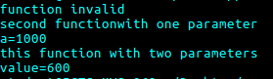

//class
#include<iostream>
using namespace std;
class x
{
int a,b,r,s;
public:
void area()
{
cout<<"area of square"<<endl;
cin>>s;
cout<<"s*s="<<s*s<<endl;
}
void area(int r)
{
cout<<"area of circle"<<endl;
cout<<3.14*r*r<<endl;
}
void area(int a1,int b1)
{
cout<<"area of triangle"<<endl;
cout<<0.5*b1*b1<<endl;
}
};
int main()
{
x obj;
obj.area();
obj.area(10);
obj.area(20,30);
}
o/p:-
