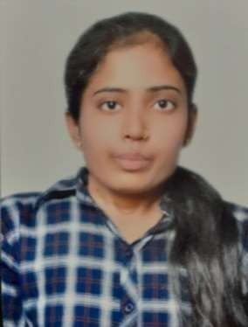**EDUCATION**

Bachelors in Computer Science Engineering | Chandigarh University, Gharuan

*Session: 2020-2024 | Score: 8.73 CGPA(Present)*

Intermediate (CBSE) |Cambridge Senior Secondary School, Buxar

*Session: 2017-2019 | Percentage: 69.8%*

ANUPMA KUMARI

Address: Buxar, BIHAR- 802117 E-mail:

[anupmakumari07122001@gamil.com](mailto:anupmakumari07122001@gamil.com) Phone: +91 9142104921

LinkedIn: https://[www.linkedin.com/in/anupma-](http://www.linkedin.com/in/anupma-) kumari-a833b9200/

**PROFESSIONAL SUMMARY**

# Enthusiastic engineer eager to contri- bute to team success through hard work, attention to detail and excellent organizational skills. Clear understand- ing of task and training in skills. Moti- vated to learn, grow and excel in soft- ware industry.

**TECHNICAL COMPETENCIES**

# C++ | JAVA | PYTHON | MYSQL | MERN





**INTERPERSONAL SKILLS**

# Team Work**|** Leadership **|** Management & Coordination **|** Decision Making

**INTERESTS & HOBBIES**

# Cooking **|** Sketch Painting

**LANGUAGES KNOWN**

# English **|** Hindi

**PERSONAL DETAILS**

# Mother’s Name: Anita Singh Father’ Name: Om Prakash Singh

D.O.B.: 07/12/2001

Matriculation (CBSE) | Foundation School, Buxar

*Session: 2016-2017 | Percentage: 89.3%*

**TRAINING & CERTIFICATIONS**

## Machine Learning Certificate

March 2021- May 2021

* Introduction to machine learning.
* Data mining, and statistical pattern recognition.

## Android Development Training Certificate

May 2022- July 2022

* The training consisted of Introduction to Android.
* World of Kotlin, Android Kick-Off, Higher Order Functionalities.

## Software Testing Certificate

August 2022- October 2022

* Techniques for test case design.
* Testing of software artifacts including requirements, design and code.

## Data Mining Certificate

January 2023- March 2023

* + Introduction to KDD Process.
  + Data mining algorithms and applications of extracted knowledge.

**PROJECTS**

## Alan AI News Application

April 2022- June 2022

* This is a react js news application based project which uses voice based functionality by Alan AI to give responses according to commands given by the user.

## Food Runner App

July 2022- August 2022

* This Food Runner is an android based pr ject for food ordering and its management which uses kotlin and xml for backend and frontend.

## Travel Advisor Application

September 2022- November 2022

* This Geolocation, Google Maps API & Google Places API, fetching API data based on the location, data filtering are just some features that make this Travel Advisor App

**EXTRA CURRICULAR & CO-CURRICULAR ACHIEVEMENTS**

* + **CodeChef CU Chapter -** Student Coordinator September 2021- November 2021

Organized and contributed for the CodeChef Learning Program held at Chandigarh University.