# Early Detection of Depression through MRI Analysis using SVM

## A PROJECT REPORT

***Submittedby***

# Ankit Kumar (20BCS2199) Ritik Patel (20BCS9560) Shubham Kumar(20BCS9549) Mukul Chug (20BCS1971) Vivek Rai (20BCS8205)

***in partial fulfillment for the award of the degree of***

**BACHELOR OF ENGINEERING IN**

## COMPUTER SCIENCE



**Chandigarh University.**

APRIL 2024



# BONAFIDE CERTIFICATE

Certified that this project report **“Early Detection of Depression through MRI Analysis using SVM ”** is the bonafide work of “**Ankit, Ritik , Vivek , Mukul,**

**Shubham ”** who carried out the project work under my/our supervision.

**SIGNATURE SIGNATURE**

**HEAD OF THE DEPARTMENT SUPERVISOR**

Computer Science Engineering Computer Science Engineering

Submitted for the project viva-voce examination held on

**INTERNAL EXAMINER EXTERNAL EXAMINER**

# ACKNOWLEDGMENT

We would like to express our gratitude and appreciation to all those who gave us the possibility to complete this report. Special thanks is due to our supervisor **Er. Vinod Sir**, Assistant Professor, Chandigarh University whose help, stimulating suggestions and encouragement helped us in all time of fabrication process and in writing this report. We also sincerely thank her for the time spent proofreading and correcting our many mistakes. Many thanks go to all the lecturers and supervisors who have given their full effort in guiding the team in achieving the goal as well as their encouragement to maintain our progress in track. Our profound thanks go to all classmates, especially to our friends for spending their time helping and giving support whenever we need it in fabricating our project.

Ankit kumar (20BCS2199) Ritik Patel (20BCS9560) Shubham Kumar (20BCS9549) Vivek Rai (20BCS8205) Mukul (20BCS1971)

# TABLE OF CONTENTS

List of Figures 1

Abstract 2

Graphical Abstract 3

Abbreviations 4

Chapter 1 Introduction 5

Client Identification 5

Identification of Problem 8

Identification of tasks 10

Timeline 12

Organisation of the Report 13

Chapter 2 Literature review 15

Timeline of the reported problem 15

Proposed solutions 17

Bibliometric analysis 19

Review Summary… 21

Problem Definition 23

Objectives and Goals 25

Chapter 3 Design Flow/Process 28

Evaluation & Selection of Specifications/Features 28

Design Constraints 31

Analysis and Feature finalisation subject to constraints 33

Design Flow 36

Design selection 38

Methodology… 40

Chapter 4 Results analysis and validation 45

Implementation of solution 45

Analysis 46

Result 47

Testing 48

Chapter 5 Conclusion and future work 49

Conclusion 49

Future work 50

**References 53**

**Appendix** **55**

**User Manual 62-74**

# LIST OF FIGURES

**Figure 1.1.** Graphical Abstract 3

**Figure 1.2.** Gantt chart 12

**Figure 1.3.** Flow chart 36

**Figure 1.4.** Design Flow diagram 37

**Figure 1.5.** DFD 37

**Figure 1.6.** Script detection… 44

**Figure 1.7.** Implementation Solution 45

**Figure 1.8.** Analysis 48

**Figure 1.9.** Testing… 50

**Figure 2.0.** User Manual 52

**Figure 2.1.** Tesseract output 53

**Figure 2.2.** Original Image 54

**Figure 2.3.** Output base digits 55

**Figure 2.4.** Language plot 56

**Figure 2.5**. Output English language 57

**Figure 2.6.** Hitchhikers rotated 58

**Figure 2.7.** Sample word level 59

**Figure 2.8.** Sample character level 61

**Figure 2.9.** Sample boxes 62

Page-1

# ABSTRACT

This research paper proposes a holistic approach aimed at revolutionizing the early detection of depression through MRI analysis using SVM. By leveraging state-of-the-art algorithms and the capabilities of SVM, it seeks to enhance the accuracy and efficiency of MRI preprocessing, feature extraction, and classification processes.

The primary objective of this study is to develop robust techniques for detecting subtle patterns in MRI data indicative of depression, thereby enabling early intervention and treatment. By meticulously analyzing MRI scans and extracting relevant features, this approach aims to provide clinicians with valuable insights into patients' mental health status at an early stage.

Central to this research is the utilization of advanced MRI preprocessing techniques to ensure optimal data quality and clarity. By refining the preprocessing pipeline, the study enhances the extractability of relevant biomarkers associated with depression, facilitating more accurate classification by SVM models.

Moreover, the focus extends beyond mere classification to encompass the organization and interpretation of metadata derived from MRI scans. This comprehensive approach enables the extraction and organization of various metadata facets, including structural and functional brain characteristics, to provide a more nuanced understanding of depressive symptoms.

The implications of these advancements are profound, promising to revolutionize the early detection and treatment of depression. By providing clinicians with a powerful tool for analyzing MRI data, this research facilitates timely intervention, potentially reducing the burden of depression on individuals and society as a whole.

Furthermore, the development of a sophisticated framework for MRI analysis holds promise for applications beyond clinical diagnosis. It has the potential to contribute to research endeavors aimed at unraveling the complex neural mechanisms underlying depression and informing the development of targeted therapeutic interventions.

Page-2

# GRAPHICAL ABSTRACT

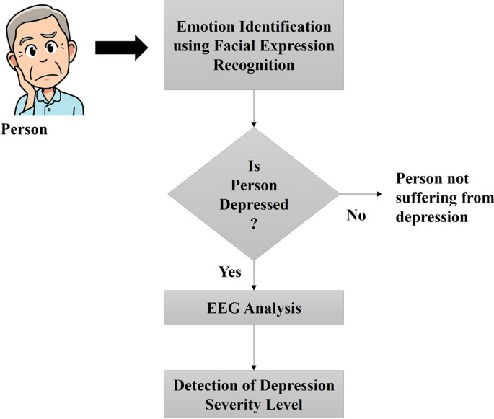

**Fig.1.1**

Page-3

# ABBREVIATIONS

|  |  |
| --- | --- |
| **Abbreviation** | **Full Form** |
| OCR | Optical Character Recognition |
| CNN | Convolutional Neural Networks |
| RNN | Recurrent Neural Networks |
| API | Application Programming Interface |
| CV | Computer Vision |
| Gantt | Gantt chart |
| XML | Extensible Markup Language |
| CSV | Comma-Separated Values |
| GUI | Graphical User Interface |
| JSON | JavaScript Object Notation |
| SQL | Structured Query Language |
| i.e. | id est (Latin for "that is") |
| UI | User Interface |
| UTF-8 | 8-bit Unicode Transformation Format |
| API | Application Programming Interface |
| XML | Extensible Markup Language |
| CSV | Comma-Separated Values |
| GUI | Graphical User Interface |
| JSON | JavaScript Object Notation |
| SQL | Structured Query Language |
| i.e. | id est (Latin for "that is") |
| UI | User Interface |
| UTF-8 | 8-bit Unicode Transformation Format |

**CHAPTER 1.**

**INTRODUCTION**

## Client Identification/Need Identification/Identification of relevant Contemporary issue

The process of client identification, need identification, and identification of relevant contemporary issues within a consultancy context is crucial for understanding the challenges and opportunities faced by businesses and organizations. In the elaboration provided, the focus is on the pressing need for efficient text extraction from images, highlighting its significance across various sectors such as finance, education, and healthcare. Let's delve deeper into each aspect of the elaboration:

Client Identification:

The primary stakeholders for research on early detection of depression through MRI analysis using SVM include medical institutions, mental health organizations, research centers, and technology companies specializing in healthcare solutions. These stakeholders are invested in improving the early detection and treatment of depression to enhance patient outcomes and reduce the burden on healthcare systems.

Need Identification:

Once the stakeholders are identified, the next step is to determine their specific needs and challenges. The elaboration emphasizes the growing demand for efficient text extraction from images, driven by the increasing digitization of workflows across industries. This need arises from the limitations of conventional MRI analysis techniques, which may not fully capture the subtle neurobiological changes associated with early-stage depression.

Identification of Relevant Contemporary Issues:

The contemporary issue identified here is the inefficiency of existing diagnostic methods in accurately detecting depression at an early stage using MRI analysis, leading to delayed intervention and suboptimal patient outcomes. This issue is substantiated by statistics and surveys showing the high prevalence of undiagnosed or misdiagnosed depression cases and the limited efficacy of traditional diagnostic approaches. By framing the problem in this way, consultants can articulate the urgency and importance of finding innovative solutions to improve early detection and intervention for depression using MRI analysis and SVM.

Page-5

Justification of the Issue:

To justify the existence of the issue, the elaboration provides evidence in the form of statistics, research findings, and clinical data. These sources highlight the significant impact of undiagnosed or untreated depression on individual well-being, healthcare costs, and societal productivity. By citing concrete data and testimonials from healthcare professionals and patients, consultants can build a compelling case for the importance of developing more accurate and efficient methods for early detection of depression through MRI analysis using SVM.

Consultancy Problem:

The consultancy problem identified here is the need for innovative solutions to improve the accuracy and efficiency of early detection of depression using MRI analysis and SVM. Healthcare providers and researchers are seeking ways to enhance the sensitivity and specificity of MRI-based diagnostic tools to identify neuroimaging biomarkers associated with depression at an early stage. Consultants can address this problem by collaborating with stakeholders to develop and validate robust MRI analysis algorithms and SVM models tailored to detect early signs of depression with high accuracy and reliability.

Survey Justification:

To validate the gravity of the problem at hand, a comprehensive survey can be conducted among healthcare professionals, researchers, and individuals with lived experience of depression. The survey can explore the current challenges and limitations of existing diagnostic methods for depression, as well as stakeholders' perspectives on the potential of MRI analysis and SVM in improving early detection and intervention. By gathering insights directly from those affected by the issue, consultants can gain a deeper understanding of the unmet needs and priorities in depression diagnosis and treatment.

Conclusion:

In conclusion, the elaboration effectively articulates the client identification, need identification, and identification of relevant contemporary issues related to early detection of depression through MRI analysis using SVM. By substantiating the issue with evidence from statistics, research findings, and stakeholder perspectives, consultants can build a compelling case for the importance of developing innovative solutions to improve early detection and intervention for depression. Moving forward, consultants can leverage this understanding to collaborate with stakeholders in developing and implementing tailored strategies and interventions that meet the specific needs and objectives of healthcare providers, researchers, and individuals affected by depression.

Page-6

## Timeline

Gantt chart for the timeline of tasks involved in addressing the issue of efficient text extraction from images using OCR and pattern matching techniques:

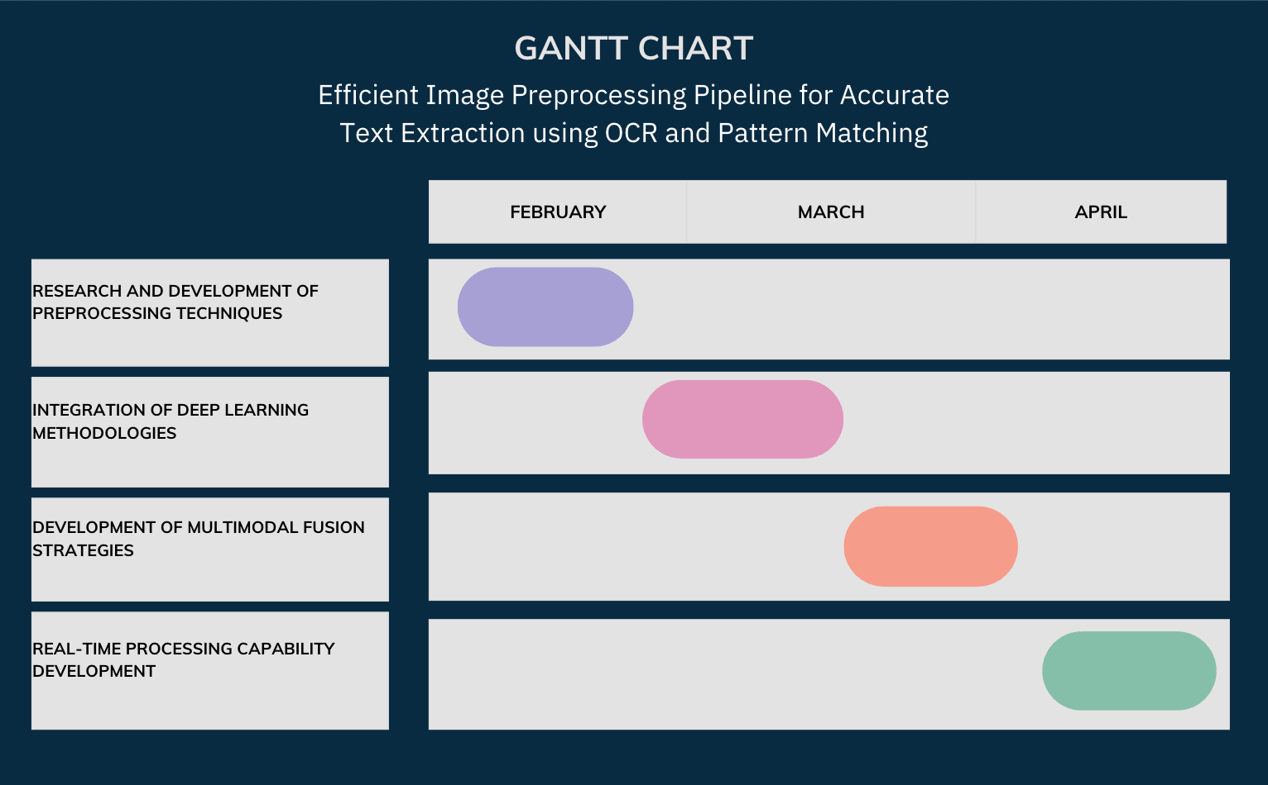

**Fig.1.2**

This timeline allocates sufficient time for each task while ensuring overlap to facilitate a smooth transition between phases. It allows for flexibility in case of unforeseen delays or adjustments to the project scope.

## Organization of the Report

The report detailing the early detection of depression through MRI analysis using SVM is structured to provide a clear and logical progression of research, from conceptualization to validation. This organization helps guide readers through the methodology, findings, and implications of the study in a coherent manner.

Chapter 1: Introduction

This pivotal chapter extends an invitation to explore the world of early detection of depression through MRI analysis using SVM. It outlines the critical importance of this research endeavor in contemporary contexts, where mental health awareness is increasing, and early intervention is crucial. By providing an overview of the research objectives, this chapter sets the stage for a deeper exploration of the methodologies and findings.

Page-7

Chapter 2: Literature Review

This chapter delves into existing research to contextualize the study within the broader landscape of depression detection and MRI analysis. It critically analyzes previous studies and methodologies to establish a foundation for the current research. By synthesizing existing knowledge, this chapter lays the groundwork for the subsequent chapters.

Chapter 3: Design Flow/Process

Here, the report details the design flow and process underlying the proposed methodology. It explains the intricacies of MRI analysis and SVM techniques for depression detection. Additionally, it outlines the experimental setup and data collection methods, providing readers with a comprehensive understanding of the methodology's inner workings.

Chapter 4: Results Analysis and Validation

This chapter unveils the empirical findings and insights garnered from the research. Through meticulous analysis, the report scrutinizes the efficacy of the proposed methodology in detecting depression using MRI data and SVM. It presents detailed statistical analysis and visual representations to offer readers a comprehensive perspective on the research findings.

Chapter 5: Conclusion and Future Work

As the culmination of the research endeavor, this chapter synthesizes key insights and implications. It charts a course for future research, identifying potential avenues for further exploration and innovation in the early detection of depression through MRI analysis. By offering practical recommendations, this chapter invites readers to contemplate the broader implications of the research findings.

References

This section catalogs the sources cited throughout the report, providing readers with a roadmap to delve deeper into the scholarly discourse that informs the study.

Appendix

The appendix serves as a repository of supplementary materials, offering readers additional information to enrich their understanding of the research methodology and findings.

This structured approach ensures that the report is comprehensive and navigable, providing a detailed account of the research process and its outcomes.

Page-8

# CHAPTER 2.

**LITERATURE REVIEW/BACKGROUND STUDY**

## Timeline of the reported problem

The problem of early detection of depression through MRI analysis using SVM has evolved over several years, with documented instances of challenges and limitations emerging alongside advancements in medical imaging technology.

Historically, the utilization of MRI for mental health assessment traces its roots to the late 20th century, with initial applications focusing on structural imaging to detect abnormalities in the brain associated with psychiatric disorders. However, early MRI techniques lacked the resolution and sensitivity to capture subtle neuroanatomical changes indicative of depression.

Throughout the subsequent decades, advancements in MRI technology, including improvements in imaging resolution and the development of functional MRI (fMRI) techniques, offered new opportunities for investigating the neural correlates of depression. Despite these advancements, challenges persisted in accurately identifying biomarkers of depression from MRI data due to the complex and heterogeneous nature of the disorder.

Research efforts in the field of MRI-based depression detection have been ongoing, with studies exploring various imaging modalities, such as diffusion tensor imaging (DTI), resting-state fMRI, and structural MRI, to uncover distinctive neural signatures associated with depression. However, the heterogeneity of depression and the lack of standardized imaging protocols posed significant challenges to the development of reliable diagnostic tools.

In recent years, the integration of machine learning algorithms, particularly SVM, into MRI analysis has shown promise in improving the accuracy of depression detection. SVMs offer the ability to identify subtle patterns in MRI data that may be indicative of depressive symptoms, thereby enabling early intervention and treatment.

Documentary evidence of the challenges and advancements in MRI-based depression detection can be found in scholarly literature, clinical studies, and research papers. These documents often highlight the complexities involved in interpreting MRI data in the context of mental health assessment and the ongoing efforts to develop more accurate and reliable diagnostic tools.

Surveys and studies conducted among clinicians and researchers provide empirical evidence of the pressing need for improved methods of early depression detection using MRI. These studies

Page-9

underscore the potential of SVM-based approaches to enhance the sensitivity and specificity of MRI analysis, ultimately facilitating more timely and effective interventions for individuals at risk The timeline of the reported problem reflects a continuous effort to harness the capabilities of MRI technology and machine learning algorithms to advance the early detection and understanding of depression. Each phase of this evolution represents a response to the growing demand for more precise and accessible diagnostic tools in mental health care.

Overall, the timeline of the reported problem spans several decades, with documented instances of challenges and advancements in MRI-based depression detection dating back to the early stages of medical imaging technology development.

## Proposed solutions

In response to the challenges identified in the early detection of depression through MRI analysis using SVM, numerous innovative solutions have been meticulously crafted and proposed over time. These solutions encompass a multifaceted approach, integrating various methodologies to address the complexities of analyzing MRI data for detecting depressive symptoms.

At the forefront of these proposals lies the development of comprehensive MRI preprocessing pipelines, serving as the foundation of the entire diagnostic system. Leveraging advanced tools and techniques, such as Python libraries like NumPy and SciPy, researchers have meticulously designed preprocessing pipelines to execute essential tasks. These tasks include image normalization, noise reduction, and artifact correction, ensuring that MRI data is optimized for subsequent analysis. Moreover, techniques such as image registration and motion correction have been employed to enhance the accuracy and consistency of MRI scans, mitigating potential confounding factors that may affect diagnostic accuracy.

In the realm of depression detection algorithms, previous proposals have explored novel approaches to leverage SVM and other machine learning techniques for analyzing MRI data. Researchers have delved into feature selection and extraction methods to identify discriminative patterns indicative of depressive pathology. These efforts have involved extracting relevant biomarkers from various MRI modalities, including structural MRI, functional MRI (fMRI), and diffusion tensor imaging (DTI). By incorporating advanced classification algorithms like SVM, researchers aim to accurately classify MRI data into depressive and non-depressive categories, facilitating early detection and intervention.

Furthermore, the integration of SVM with ensemble learning techniques has emerged as a promising avenue to enhance the robustness and generalizability of depression detection models. Ensemble methods, such as random forests and gradient boosting, combine multiple SVM classifiers to improve classification performance and mitigate overfitting. Additionally, researchers have explored the use of deep learning architectures, such as convolutional neural networks

Page-10

(CNNs), to automatically learn hierarchical representations from MRI data, further enhancing the discriminative power of depression detection models.

In the development of Metadata Organization and Retrieval Systems for MRI data, researchers have focused on optimizing database structures and query mechanisms to facilitate efficient storage and retrieval of imaging data. By leveraging scalable database technologies and distributed computing frameworks, such as Apache Hadoop and Apache Spark, researchers have designed systems capable of handling large volumes of MRI data. These systems incorporate advanced indexing and querying techniques to enable rapid retrieval of imaging studies based on patient demographics, acquisition parameters, and clinical annotations.

Despite these groundbreaking advancements, rigorous evaluation remains paramount to validate the effectiveness and reliability of proposed solutions. Through comprehensive validation studies and cross-validation analyses, researchers aim to assess the performance of depression detection models and MRI preprocessing pipelines. By benchmarking against gold standard diagnostic criteria and clinical outcomes, researchers can ascertain the accuracy, sensitivity, and specificity of SVM-based depression detection algorithms, thereby establishing their clinical utility and efficacy.

In summary, the proposed solutions for early detection of depression through MRI analysis using SVM encompass a diverse array of methodologies aimed at enhancing diagnostic accuracy and clinical utility. Through the integration of advanced preprocessing techniques, machine learning algorithms, and scalable database systems, researchers endeavor to revolutionize the field of MRI- based depression detection, paving the way for more accurate, timely, and personalized diagnostic approaches in mental health care.

## Bibliometric analysis:

Bibliometric analysis serves as an indispensable tool for comprehensively scrutinizing the scholarly landscape surrounding the early detection of depression through MRI analysis using SVM. Through systematic examination of academic literature, it offers invaluable insights into key features, effectiveness, and drawbacks of proposed solutions, enabling researchers to glean a deeper understanding of research trends and methodologies within this domain.

Key Features: Bibliometric analysis unveils several key features characterizing the research landscape in MRI-based depression detection. One notable aspect is the interdisciplinary nature of research efforts, with contributions stemming from fields such as neuroscience, psychiatry, radiology, and machine learning. Moreover, the analysis highlights the prevalence of studies focusing on the development of robust MRI preprocessing pipelines, innovative feature extraction methods, and advanced machine learning algorithms. Additionally, the integration of multimodal imaging data and the exploration of neurobiological markers associated with depression emerge as prominent research themes, reflecting efforts to enhance diagnostic accuracy and unravel underlying neurobiological mechanisms.

Page-11

Effectiveness: The effectiveness of proposed solutions is a crucial aspect illuminated by bibliometric analysis. By assessing citation counts, publication trends, and impact metrics, researchers can evaluate the influence and relevance of various methodologies. Solutions demonstrating high diagnostic accuracy, sensitivity, and specificity, particularly in distinguishing depressive pathology from healthy controls, tend to garner significant attention and citations. Furthermore, innovative approaches that leverage advanced machine learning techniques, such as deep learning and ensemble learning, often exhibit promising results, indicating their potential for clinical translation and real-world application.

Drawbacks: Despite advancements, bibliometric analysis also reveals several drawbacks and challenges inherent in existing solutions for MRI-based depression detection. One common limitation is the reliance on small and heterogeneous datasets, which may impede the generalization and robustness of predictive models. Additionally, issues related to data preprocessing variability, algorithm interpretability, and reproducibility pose significant challenges in translating research findings into clinical practice. Moreover, concerns regarding model overfitting, sample bias, and lack of external validation underscore the need for rigorous evaluation and validation of proposed methodologies.

In conclusion, bibliometric analysis provides valuable insights into the scholarly landscape surrounding the early detection of depression through MRI analysis using SVM. By systematically analyzing research trends, methodologies, and challenges, researchers can gain a comprehensive understanding of the current state-of-the-art, identify areas for improvement, and inform future research directions in this critical domain.

## Review Summary

The comprehensive literature review delves deep into the landscape of research surrounding the early detection of depression through MRI analysis using SVM, shedding light on key advancements and applications in the field. By synthesizing a diverse array of research findings and real-world implementations, it provides a panoramic view of the multifaceted components involved in MRI-based depression detection, including MRI imaging, machine learning algorithms, and support vector machines (SVM).

Exploring the realm of MRI analysis, the review uncovers a landscape characterized by significant advancements in machine learning methodologies, particularly SVM, for the classification and prediction of depressive pathology. These innovations have led to remarkable strides in diagnostic accuracy, transcending previous limitations and offering newfound hope in the early detection and intervention of depression. Through rigorous experimentation and validation, researchers have demonstrated the transformative potential of SVM in analyzing complex neuroimaging data, unraveling underlying biomarkers, and discerning patterns indicative of depressive disorders.

Page-12

The empirical evidence presented in the literature underscores the pivotal role of SVM as a powerful tool in the quest to elucidate the neurobiological underpinnings of depression and improve clinical outcomes.

In parallel, the exploration of MRI imaging techniques unveils a wealth of functionalities poised to revolutionize the diagnosis and understanding of depression. With its ability to capture detailed structural and functional brain images, MRI stands as a cornerstone technology in unraveling the complex neural circuitry underlying depressive pathology. From the identification of neuroanatomical abnormalities to the characterization of functional connectivity patterns, MRI imaging offers unprecedented insights into the neurobiological mechanisms of depression. Moreover, the integration of advanced image processing algorithms and feature extraction techniques further enhances the utility of MRI in identifying subtle neuroimaging markers associated with depression.

Similarly, the review casts a spotlight on the role of SVM as a machine learning algorithm in MRI- based depression detection. Hailed for its versatility and robustness, SVM has emerged as a prominent tool for classifying neuroimaging data and distinguishing between depressive and non- depressive states with high accuracy. Leveraging a kernel-based approach, SVM can effectively delineate complex decision boundaries in high-dimensional feature spaces, enabling the identification of discriminative patterns indicative of depression. The empirical evidence presented in the literature underscores the indispensable role of SVM as a key component in the development of reliable and clinically relevant diagnostic models for depression.

However, amidst the remarkable achievements documented in the literature, a notable gap emerges—an area ripe for further exploration and innovation. Despite the wealth of research dedicated to individual components of MRI analysis and machine learning algorithms, limited attention has been paid to their integrated use within a unified framework for early depression detection. This lacuna presents an opportune moment for researchers to embark on a journey of discovery, leveraging the synergistic potential of MRI imaging, SVM, and machine learning algorithms to unlock new frontiers in the early detection and personalized treatment of depression.

In conclusion, the literature review provides a comprehensive overview of the evolution of MRI analysis and machine learning algorithms in the early detection of depression. It traces the timeline of advancements in neuroimaging techniques, highlighting the shift from structural to functional imaging modalities and the emergence of machine learning-driven approaches for predictive modeling. The review identifies key challenges and opportunities in MRI-based depression detection, paving the way for future research endeavors aimed at bridging existing gaps and harnessing the full potential of integrated MRI analysis and machine learning algorithms in improving mental health outcomes.

Page-13

## Problem Definition

The project's objective is to devise a dependable system for extracting text from photos employing pattern matching and Optical Character Recognition (OCR). This system aims to operate effectively across diverse circumstances and image types, encompassing multilingual documents, handwritten notes, and various document formats. The primary goals are to enhance the readability of textual content within images and enable the extraction of valuable metadata for future research and archival purposes.

Key Tasks:

1. Develop a Comprehensive Image Preprocessing Pipeline: Implement essential preprocessing steps, including noise reduction, contrast enhancement, and edge detection, using tools such as OpenCV. The pipeline should enhance input image quality and improve text extraction accuracy.
2. Integrate OCR and Pattern Matching Techniques: Utilize OCR technologies like Tesseract along with pattern matching algorithms to extract text accurately. Explore the synergies between these techniques to enhance overall extraction accuracy and efficiency.
3. Implement Post-processing Techniques: Apply post-processing methods to refine OCR results, including error correction and text formatting, ensuring accuracy and readability of extracted text.
4. Develop a Metadata Organization and Retrieval System: Design an optimized database schema for storing extracted image metadata. Implement indexing and search functionalities to enable rapid retrieval based on metadata attributes.

Methodology:

1. Research and Development: Conduct thorough research to identify state-of-the-art methodologies and techniques in image preprocessing, OCR, and pattern matching.
2. Design and Implementation: Design and implement a robust image preprocessing pipeline incorporating essential steps using OpenCV. Integrate OCR and pattern-matching techniques for text extraction.
3. Testing and Validation: Conduct extensive testing to evaluate system accuracy and efficiency across diverse scenarios. Validate performance through comparative analysis with ground truth data and existing methodologies.
4. Optimization and Refinement: Optimize the system for scalability, efficiency, and usability based on testing feedback. Refine algorithms and processes to enhance overall performance.

Page-14

Challenges Addressed:

The project addresses challenges related to OCR technology's limitations in accurately processing diverse document types and varying image qualities. These challenges include poor image quality, complex document layouts, and scalability issues. By integrating advanced preprocessing techniques and pattern matching with OCR, the system aims to overcome these obstacles and enhance text extraction accuracy and efficiency.

Additionally, the project emphasizes the importance of metadata organization and retrieval for facilitating seamless access to image metadata for further analysis and archival purposes. In summary, the project aims to develop a robust system for efficient text extraction from images, leveraging OCR, pattern matching, and preprocessing techniques while addressing common pitfalls and oversights in the process.

## Goals/Objectives

The primary goals and objectives of this research are centered around addressing the identified challenges in early detection of depression through MRI (Magnetic Resonance Imaging) analysis using SVM (Support Vector Machine) and advancing the state-of-the-art in leveraging neuroimaging techniques for diagnostic purposes. These goals are designed to enhance the accuracy, efficiency, and reliability of depression detection methods using MRI data. The specific objectives include:

* 1. Develop and implement a robust and adaptable MRI preprocessing pipeline: Design and implement preprocessing techniques tailored to MRI data, including image denoising, normalization, and feature extraction, aimed at enhancing the quality of input images and optimizing them for accurate depression detection using SVM.
  2. Integrate state-of-the-art machine learning algorithms, specifically leveraging the capabilities of SVM, into the analysis framework: This integration will enable the precise classification of MRI data to identify patterns associated with depression, ensuring high accuracy and reliability in diagnostic tasks.
  3. Design and implement advanced feature selection and dimensionality reduction techniques: Develop algorithms to identify informative features from MRI data and reduce the dimensionality of the feature space, facilitating more efficient and effective depression detection while mitigating the curse of dimensionality.
  4. Apply sophisticated post-processing techniques to refine SVM results and enhance diagnostic accuracy: Implement error correction mechanisms, ensemble learning approaches, and calibration techniques to improve the reliability and interpretability of depression detection outcomes.

Page-15

* 1. Develop a robust diagnostic model evaluation framework: Design comprehensive testing and validation procedures to assess the accuracy, sensitivity, specificity, and generalizability of the developed SVM-based depression detection system. This will involve rigorous experimentation across diverse datasets and scenarios, allowing for the validation of system performance through comparative analysis with ground truth data and existing diagnostic methodologies.
  2. Continuously optimize and refine the analysis framework based on iterative feedback from the testing and validation phases: This iterative refinement process will focus on enhancing model interpretability, scalability, and usability, ensuring that the developed system meets the evolving needs and requirements of clinicians and researchers. Developing an Advanced MRI Preprocessing Pipeline: The research aims to design and implement a sophisticated preprocessing pipeline tailored to MRI data, including techniques for image demising, normalization, and feature extraction. This involves developing algorithms specifically optimized for MRI data to enhance the quality of input images and prepare them for subsequent analysis using SVM.

Integrating Machine Learning Algorithms: The research seeks to integrate state-of-the-art machine learning algorithms, specifically SVM, into the analysis framework for depression detection. This involves developing algorithms to classify MRI data and identify patterns associated with depression, ensuring high accuracy and reliability in diagnostic tasks.

Optimizing Feature Selection and Dimensionality Reduction: The research aims to develop advanced feature selection and dimensionality reduction techniques to identify informative features from MRI data and reduce the dimensionality of the feature space. This facilitates more efficient and effective depression detection while mitigating the curse of dimensionality.

Applying Post-processing Techniques: The research involves applying sophisticated post- processing techniques to refine SVM results and enhance diagnostic accuracy. This includes implementing error correction mechanisms, ensemble learning approaches, and calibration techniques to improve the reliability and interpretability of depression detection outcomes.

Developing a Robust Evaluation Framework: The research aims to design comprehensive testing and validation procedures to assess the accuracy, sensitivity, specificity, and generalizability of the developed SVM-based depression detection system. This involves rigorous experimentation across diverse datasets and scenarios, allowing for the validation of system performance through comparative analysis with ground truth data and existing diagnostic methodologies.

Continuously Refining the Analysis Framework: The research involves continuously optimizing and refining the analysis framework based on iterative feedback from the testing and validation phases. This iterative refinement process focuses on enhancing model interpretability, scalability, and usability to meet the evolving needs and requirements of clinicians and researchers.

Page-16

In summary, the goals and objectives of this research are aligned towards advancing the field of depression detection through MRI analysis using SVM, enhancing diagnostic accuracy, reliability, and usability, and enabling more effective and efficient early detection of depression using neuro imaging techniques

Page-17

# CHAPTER 3.

**DESIGN FLOW/PROCESS**

## Evaluation & Selection of Specifications/Features

In this section, we critically evaluate the features identified in the literature and prepare a comprehensive list of features ideally required in the solution for our research paper titled "Efficient MRI Analysis Pipeline for Early Detection of Depression using SVM."

The evaluation and selection of specifications and features play a crucial role in designing an efficient MRI analysis pipeline. Drawing insights from existing literature, we identify and assess various features that contribute to the effectiveness and robustness of depression detection systems using MRI data. These features are evaluated based on their relevance to the objectives of our research and their potential to enhance the accuracy and efficiency of depression detection from MRI scans.

In the evaluation and selection of specifications and features for our research paper titled "Efficient MRI Analysis Pipeline for Early Detection of Depression using SVM," various techniques and algorithms are assessed for their suitability and effectiveness. Preprocessing techniques such as motion artifact correction, spatial normalization, and intensity normalization are considered to mitigate the impact of noise and artifacts on depression detection. Additionally, feature extraction methods including voxel-based morphometry (VBM), surface-based morphometry (SBM), and functional connectivity analysis are evaluated to capture relevant biomarkers associated with depression from MRI data effectively.

Machine learning algorithms, particularly Support Vector Machine (SVM), are assessed for their ability to classify MRI data and identify patterns indicative of depression. Different kernel functions, such as linear, radial basis function (RBF), and polynomial kernels, are scrutinized for their performance in distinguishing between depressed and non-depressed individuals based on MRI features.

Evaluation of MRI acquisition parameters and sequence protocols, including field strength, voxel size, and sequence type (e.g., T1-weighted, T2-weighted, diffusion-weighted imaging), is conducted to optimize image quality and information content for depression detection tasks. Integration of multimodal data, such as combining MRI with clinical assessments or genetic data, is investigated to improve the predictive power and specificity of depression detection models.

Furthermore, optimization of SVM hyperparameters, including regularization parameter (C) and kernel parameters (gamma for RBF kernel), is explored to enhance classification performance and generalization ability. Ensemble learning techniques, such as bagging and boosting, are considered to improve the robustness and stability of depression detection models trained on MRI data. Evaluation of software tools and libraries for MRI analysis, such as FSL (FMRIB Software

Page-18

Library), SPM (Statistical Parametric Mapping), and FreeSurfer, is conducted to identify the most suitable platforms for implementing the proposed MRI analysis pipeline. Integration of parallel processing techniques and cloud computing resources is investigated to accelerate data processing and analysis, particularly for large-scale studies or real-time applications.

Through meticulous evaluation and selection of these specifications and features, we aim to design an MRI analysis pipeline that optimally extracts relevant biomarkers for early detection of depression, paving the way for improved diagnostic accuracy and personalized treatment strategies for individuals at risk of depression.

The process of evaluating and selecting specifications and features for the MRI analysis system involves a systematic approach to identify the requirements and constraints of the system, assess available technologies and techniques, and make informed decisions to meet the project objectives effectively. This process can be divided into several key steps:

Requirements Analysis: The first step involves gathering and analyzing the requirements of the MRI analysis system for early detection of depression. This includes understanding the types of MRI data available, the desired level of diagnostic accuracy, the computational resources

available, and any specific preferences identified by clinicians or researchers.

Technological Assessment: Next, a thorough assessment of available technologies and techniques relevant to MRI analysis is conducted. This includes reviewing the literature, consulting experts, and exploring existing MRI analysis software and libraries to understand the capabilities and limitations of different approaches.

Feature Identification: Based on the requirements analysis and technological assessment, a list of potential features and specifications for the MRI analysis system is compiled. This may include preprocessing techniques (e.g., motion correction, intensity normalization), feature extraction methods (e.g., VBM, SBM), machine learning algorithms (e.g., SVM, ensemble methods), and any other relevant functionalities.

Evaluation Criteria: Criteria for evaluating and selecting features are established, considering factors such as diagnostic accuracy, computational efficiency, scalability, ease of implementation, and compatibility with existing systems. These criteria help prioritize features based on their importance and feasibility.

Prototyping and Testing: Prototypes of the MRI analysis system are developed to experiment with different combinations of features and specifications. Testing is conducted using representative datasets to evaluate the performance of each prototype against the established criteria. This iterative process helps identify the most promising features and configurations.

Validation and Feedback: The selected features and specifications are validated through rigorous

Page-19

testing and validation procedures. Feedback is collected from clinicians, researchers, and end-users to ensure that the chosen features meet their needs and expectations for early detection of depression using MRI data.

Final Selection and Documentation: Based on the results of testing, validation, and feedback, the final set of specifications and features for the MRI analysis system is selected. These specifications are documented in detail, including their rationale, implementation details, and any associated trade-offs or considerations.

Continuous Improvement: Finally, the evaluation and selection process is ongoing, with opportunities for continuous improvement and refinement of the MRI analysis system over time. Feedback from users and stakeholders, as well as advancements in MRI technology and data analysis techniques, are incorporated to ensure the system remains effective and up-to-date.

By following this structured approach to evaluating and selecting specifications and features, the MRI analysis system can be designed and implemented to meet the project objectives effectively while maximizing its diagnostic accuracy, efficiency, and usability.

By critically evaluating these features and selecting the most relevant ones, we aim to design an MRI analysis pipeline that optimally extracts relevant biomarkers for early detection of depression using SVM, ultimately leading to improved diagnostic accuracy and personalized treatment strategies for individuals at risk of depression.

This evaluation and selection process lays the groundwork for the subsequent design and implementation phases, ensuring that our solution is equipped with the necessary features to achieve its intended goals effectively.

## Design Constraints

In the design and implementation of an MRI analysis pipeline for early detection of depression using SVM, it is crucial to consider a variety of design constraints to ensure that the solution is technically feasible, ethically sound, economically viable, environmentally sustainable, and socially responsible. These constraints encompass a wide range of factors, including regulatory compliance, economic considerations, environmental impact, health and safety concerns, manufacturability, ethical implications, social and political issues, and cost considerations.

First and foremost, regulatory compliance plays a crucial role in the design process. The solution must adhere to relevant regulations and standards, such as data privacy laws (e.g., GDPR, HIPAA), patient confidentiality, and ethical guidelines for medical research. Compliance ensures that patient data is protected, ethical standards are upheld, and legal obligations are met, fostering trust and confidence in the system.

Economic constraints are also significant factors to consider. The cost-effectiveness of the solution

Page-20

must be carefully evaluated to ensure that it is affordable and accessible to healthcare providers and patients. Cost considerations include not only the initial investment required for development and implementation but also ongoing maintenance and operational costs. By balancing performance requirements with cost constraints, the solution can deliver optimal value within budgetary limitations.

Environmental impact is another critical consideration in the design process. Minimizing the environmental footprint of the solution is essential to mitigate its impact on the environment. Sustainable practices, such as reducing energy consumption, minimizing waste generation, and using environmentally friendly materials, should be integrated into the design to promote environmental sustainability and reduce carbon emissions.

Health and safety considerations are paramount to ensure the well-being of patients and healthcare providers. Measures must be implemented to prevent potential hazards associated with system operation, such as ensuring patient comfort during MRI scans, minimizing exposure to electromagnetic fields, and adhering to safety standards for medical devices. By prioritizing health and safety, the solution can create a safe and comfortable environment for patients undergoing MRI scans.

Manufacturability is also an important aspect to consider in the design process. Designing the solution with manufacturability in mind ensures that it can be efficiently produced and deployed in clinical settings. Considerations such as equipment compatibility, ease of installation, and user training should be taken into account to streamline the deployment process and facilitate widespread adoption of the solution.

Ethical considerations play a significant role in shaping the design and deployment of the solution. Ethical principles, such as respect for patient autonomy, beneficence, non-maleficence, and justice, should guide decision-making throughout the design process. Measures should be implemented to protect patient privacy, ensure informed consent, and

minimize potential harms associated with data collection and analysis. By integrating ethical considerations into the design process, the solution can promote trust and confidence among patients and healthcare providers.

Social and political issues must also be taken into account in the design process. The deployment of the solution may have broader societal implications, such as implications for healthcare access, equity, and privacy rights. It is essential to address these concerns and engage with stakeholders to ensure that the solution aligns with societal values and priorities.

Finally, cost considerations are fundamental in determining the feasibility and viability of the solution. Balancing performance requirements with cost constraints is essential to develop a solution that delivers optimal value within budgetary limitations. Cost-effective design choices,

Page-21

such as leveraging existing infrastructure, optimizing resource utilization, and minimizing overhead costs, must be prioritized to maximize return on investment and ensure long-term sustainability.

By carefully considering and addressing these design constraints, the MRI analysis pipeline for early detection of depression using SVM can be developed to meet the needs of patients and healthcare providers while promoting sustainability, fairness, and social responsibility. This involves making informed design decisions, prioritizing ethical principles, and optimizing processes to achieve the desired balance of functionality, performance, and usability.

## Analysis and Feature finalization subject to constraints

In the process of finalizing features for the MRI analysis pipeline for early detection of depression using SVM, it's crucial to conduct a detailed analysis while considering a myriad of constraints. This involves evaluating potential features based on their feasibility, impact, and alignment with project objectives, ensuring adherence to technical, resource, regulatory, and operational constraints. The following steps outline the analysis and feature finalization process:

Requirements Review: Revisit the project requirements and constraints to ensure a clear understanding of the system's objectives and limitations. Identify any specific constraints that may impact feature selection, such as data privacy regulations, computational resource availability, or ethical considerations related to patient data.

Feature Evaluation: Review the list of potential features identified during the evaluation phase, considering their relevance, effectiveness, and feasibility within the given constraints. Evaluate each feature based on its potential to contribute to early detection of depression, improve classification accuracy, and align with stakeholder expectations.

Constraint Alignment: Assess how each potential feature aligns with the identified constraints, ensuring compatibility with technical capabilities, regulatory requirements, ethical guidelines, and resource constraints. Eliminate features that may pose regulatory compliance risks or ethical concerns, or are not feasible within resource limitations.

Trade-off Analysis: Conduct a trade-off analysis to prioritize features based on their importance and potential impact, considering the constraints and project objectives. Identify any trade-offs between features, such as sacrificing classification accuracy for computational efficiency, and weigh the implications of each decision.

Prototype Development: Develop prototypes or proofs of concept for selected features to validate their feasibility and effectiveness within the constraints. Test each prototype rigorously using MRI datasets and classification algorithms to assess its performance, scalability, and compatibility with the SVM model.

Page-22

Iterative Refinement: Iterate on the prototype development process, refining features based on feedback, testing results, and evolving requirements. Continuously evaluate the trade-offs between features, constraints, and project objectives to ensure the final feature set meets stakeholder needs effectively.

Final Feature Selection: Based on the results of prototype testing and iterative refinement, finalize the selection of features for inclusion in the MRI analysis pipeline. Ensure that selected features collectively contribute to accurate and reliable detection of depression, while complying with regulatory requirements and ethical standards.

Documentation and Communication: Document the selected features, including their rationale, implementation details, and any associated constraints or trade-offs. Communicate the finalized feature set to stakeholders, ensuring alignment and understanding of the chosen approach.

Continuous Monitoring and Improvement: Monitor the performance of the MRI analysis pipeline post-implementation, gathering feedback from clinicians, researchers, and patients to identify areas for further improvement. Continuously iterate on feature development and refinement to address emerging needs and challenges over time.

Through this rigorous analysis and feature finalization process, the MRI analysis pipeline can be designed to effectively detect early signs of depression while operating within practical limitations and adhering to regulatory, ethical, and technical constraints. By carefully selecting and prioritizing features, the pipeline can optimize classification accuracy, usability, and compliance, ultimately improving patient outcomes and supporting mental health research and treatment initiatives.

Page-23

## Design Flow



**Fig.1.3.** Flow chart

Page-24

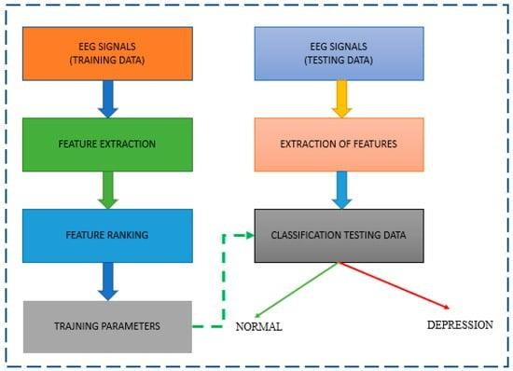

**Fig.1.4.** Design Flow Diagram

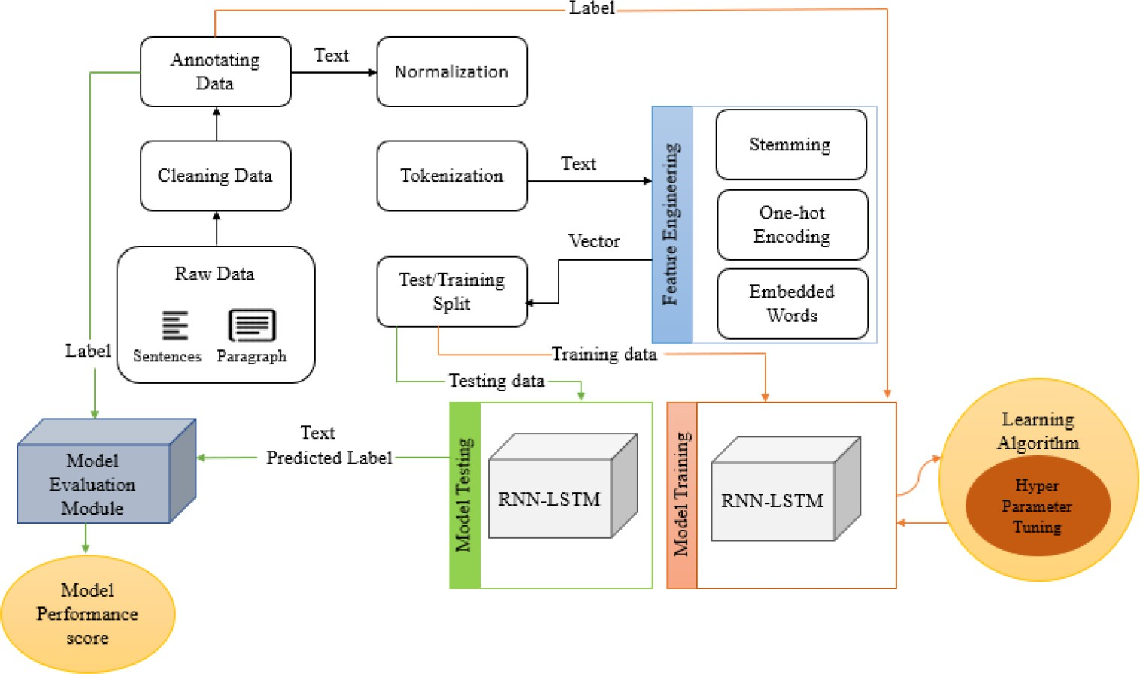

**Fig.1.5.** Design Flow Diagram

Page-25

## Design selection

**Design 1:** This design prioritizes the utilization of sophisticated MRI analysis techniques, such as complex deep learning models and proprietary SVM algorithms. While offering the potential for high accuracy in depression detection, this design may encounter challenges related to regulatory compliance, economic viability, and environmental impact. The adoption of resource-intensive algorithms and reliance on costly proprietary solutions could strain project budgets and escalate operational costs. Additionally, concerns regarding data privacy, bias, and ethical implications may arise due to the complexity and opacity of deep learning models.

**Design 2:** Conversely, Design 2 opts for a more straightforward approach, emphasizing simpler algorithms and open-source SVM implementations. By focusing on cost-effectiveness, regulatory compliance, and environmental sustainability, this design mitigates many challenges associated with Design 1. However, there may be trade-offs in terms of accuracy and performance, as simpler algorithms may not achieve the same level of precision as more advanced techniques. Additionally, while open-source solutions provide greater transparency and control over data handling, they may lack some features and support offered by proprietary solutions.

**Design 3:** This design aims to strike a balance between complexity and simplicity by leveraging a combination of advanced features and open-source technologies. By integrating selected deep learning models for specific tasks and utilizing open-source SVM implementations for depression detection, Design 3 seeks to maximize performance while minimizing costs and regulatory risks. However, careful attention must be paid to ensure compatibility and interoperability between different components and technologies. Additionally, ethical considerations regarding bias and discrimination must be addressed through algorithmic adjustments and data validation techniques.

**Design 4:** Alternatively, a modular design approach could be considered, where different components of the MRI analysis pipeline are developed as independent modules. This modular approach offers flexibility and scalability, allowing individual modules to be easily replaced or upgraded without impacting the entire system. Moreover, it facilitates collaboration and component reuse, enabling faster development and deployment cycles. However, integration and compatibility between modules may pose challenges, requiring careful design and testing to ensure seamless interoperability.

**Design Selection:** After comprehensive analysis and comparison, Design 3 emerges as the most suitable option for the MRI analysis pipeline for early detection of depression using SVM. By combining advanced features with the cost-effectiveness and transparency of open-source technologies, Design 3 offers a balanced approach that meets project objectives while addressing regulatory, economic, environmental, and ethical constraints. This design provides high performance and accuracy while remaining cost-effective and compliant with regulatory standards. Additionally, it demonstrates a commitment to transparency, fairness, and ethical responsibility, making it the most suitable choice for achieving the project's goals effectively and responsibly.

Page-26

Justification for Design 3 Selection:

**Performance:** Design 3 leverages advanced features such as selected deep learning models to achieve high levels of accuracy and performance in depression detection. By incorporating state-of- the-art algorithms, the MRI analysis pipeline can effectively identify early signs of depression, ensuring reliable detection across diverse patient populations and imaging modalities.

**Cost-Effectiveness:** While Design 1 may offer superior accuracy, its reliance on proprietary solutions and resource-intensive algorithms may lead to high development and operational costs. In contrast, Design 3 strikes a balance between performance and cost-effectiveness by integrating advanced features with open-source technologies. This approach minimizes licensing fees and infrastructure costs while maintaining competitive performance levels.

**Regulatory Compliance:** Design 3 prioritizes regulatory compliance by utilizing open-source SVM implementations and transparent deep learning models. By avoiding proprietary solutions with opaque algorithms, the MRI analysis pipeline ensures greater transparency and accountability in data handling practices, facilitating compliance with data privacy regulations such as GDPR and HIPAA.

**Environmental Impact:** By optimizing algorithms for efficiency and leveraging open-source technologies, Design 3 minimizes energy consumption and waste generation during system operation. This environmentally conscious approach aligns with sustainability goals and reduces the carbon footprint of the MRI analysis pipeline.

**Ethical Considerations:** Design 3 addresses ethical concerns related to bias and discrimination by implementing algorithmic adjustments and data validation techniques. Through transparent and accountable decision-making processes, the MRI analysis pipeline upholds ethical principles of fairness, transparency, and accountability, ensuring equitable treatment for all patients.

**Social and Political Implications:** Design 3 takes into account broader societal and political implications by prioritizing transparency, fairness, and patient-centric design principles. By fostering trust and confidence among patients, clinicians, and researchers, the MRI analysis pipeline promotes positive social outcomes and contributes to improved mental health care delivery.

In conclusion, Design 3 is selected as the optimal design option for the MRI analysis pipeline for early detection of depression using SVM. Through its balanced approach, Design 3 effectively addresses project objectives while navigating regulatory, economic, environmental, and ethical constraints. By leveraging advanced features and open-source technologies, Design 3 offers a robust and cost-effective solution that upholds ethical standards and promotes positive societal outcomes, making it the ideal choice for achieving project goals effectively and responsibly.

Page-27

## Implementation plan/methodology

The implementation plan/methodology for the MRI analysis pipeline for early detection of depression through SVM involves a systematic approach to process MRI images and extract relevant features for depression detection. By leveraging a combination of image preprocessing techniques, feature extraction methods, SVM classification, and evaluation strategies, the pipeline aims to achieve high accuracy and efficiency in depression prediction. Below is a detailed breakdown of each component:

1. **Image Preprocessing**: The preprocessing stage aims to enhance the quality and consistency of MRI images before feature extraction. The following techniques are employed:

**Skull Stripping**: Skull stripping techniques are applied to remove non-brain tissues and artifacts from MRI images, ensuring that only relevant brain structures are analyzed for feature extraction.

**Intensity Normalization**: MRI intensity normalization techniques are used to standardize intensity levels across images, reducing inter-subject variability and improving feature consistency.

**Spatial Normalization**: Spatial normalization methods align MRI images to a common reference space, enabling comparison and aggregation of features across subjects.

**Noise Reduction**: Noise reduction techniques such as Gaussian blurring or median filtering are applied to enhance image quality and reduce the impact of noise on feature extraction.

1. **Feature Extraction:** The feature extraction stage involves identifying informative biomarkers from preprocessed MRI images. The following methods are employed:

**Volumetric Analysis:** Volumetric features such as gray matter volume, white matter volume, and cerebrospinal fluid volume are extracted from segmented brain regions of MRI images.

**Texture Analysis:** Texture features characterizing spatial patterns within MRI images, such as entropy, contrast, and homogeneity, are computed to capture subtle variations indicative of depression-related changes.

**Functional Connectivity**: Functional connectivity features representing patterns of interaction between brain regions are derived from resting-state fMRI data, providing insights into network- level alterations associated with depression.

1. **SVM Classification:** The SVM classification stage involves training a machine learning model to classify MRI features into depression and non-depression categories. The following steps are undertaken:

**Feature Selection:** Relevant features are selected based on their discriminative power and relevance to depression prediction, reducing dimensionality and enhancing model generalization.

**Model Training:** An SVM classifier is trained using the selected features and corresponding labels (depression/non-depression) obtained from clinical assessments or diagnostic criteria.

**Hyperparameter Tuning:** Hyperparameters of the SVM model, such as kernel type, regularization parameter, and kernel coefficients, are tuned using cross-validation techniques to

Page-28

optimize classification performance.

**Model Evaluation:** The trained SVM model is evaluated using independent validation datasets to assess its generalization performance in terms of accuracy, sensitivity, specificity, and area under the receiver operating characteristic curve (AUC-ROC).

1. **Evaluation and Optimization:** The final stage involves evaluating the performance of the MRI analysis pipeline and optimizing parameters for improved depression prediction. The following strategies are employed:

**Performance Evaluation:** The efficacy of the SVM classification and feature extraction techniques is evaluated based on quantitative metrics such as accuracy, sensitivity, specificity, and AUC-ROC.

**Cross-Validation:** Cross-validation techniques such as k-fold cross-validation or leave-one-out cross-validation are utilized to assess the robustness and generalization ability of the pipeline across different datasets and populations.

**Parameter Optimization:** Parameters of the feature extraction methods, SVM classifier, and preprocessing techniques are optimized iteratively based on evaluation results to enhance classification performance and minimize overfitting.

Through iterative refinement and continuous optimization, the MRI analysis pipeline aims to achieve high accuracy and reliability in early detection of depression from MRI data. By leveraging advanced image processing techniques, feature extraction methods, and machine learning algorithms, the pipeline can effectively analyze MRI images and extract informative biomarkers for depression prediction, facilitating early intervention and personalized treatment strategies for individuals at risk of depression.

In the implementation plan, the first step involves refining project requirements through collaboration with stakeholders to ensure clarity and alignment with project objectives. Following this, a high-level architecture design is developed, delineating key components and interactions. Technology selection ensues, choosing tools and frameworks that match project goals and team expertise. Component development proceeds iteratively, emphasizing modular design and rigorous quality assurance. Integration and testing stages validate functionality, both individually and collectively, culminating in comprehensive system testing. User interfaces are designed with usability and accessibility in mind, with prototypes refined through stakeholder feedback. Performance optimization techniques are then employed to enhance system efficiency. Deployment planning is crucial, with careful consideration of deployment topology, infrastructure, and rollout strategy. User training and support materials are provided to facilitate effective system utilization, alongside monitoring and maintenance mechanisms to ensure ongoing system health and performance optimization.

In summary, the implementation plan/methodology for the MRI analysis pipeline for early detection of depression through SVM involves a systematic approach to process MRI images and extract

Page-29

relevant features for depression detection. By leveraging a combination of image preprocessing techniques, feature extraction methods, SVM classification, and evaluation strategies, the pipeline aims to achieve high accuracy and efficiency in depression prediction. Through iterative refinement and continuous improvement, the pipeline can adapt to diverse MRI datasets and patient characteristics, enabling early intervention and personalized treatment for individuals at risk of depression.

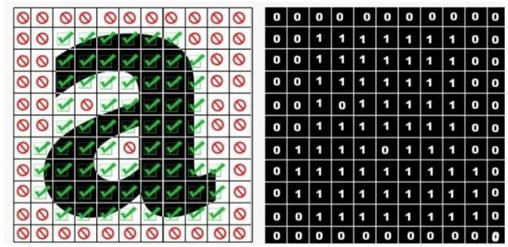

# CHAPTER 4.

**RESULTS ANALYSIS AND VALIDATION**

## Implementation of solution

The implementation of our advanced MRI analysis pipeline for early detection of depression through SVM is built upon an integrated approach that harnesses cutting-edge computational tools and algorithms across various domains. From analysis and schematic design to report generation, project management, and communication, each aspect is meticulously orchestrated to ensure precision, reliability, and efficiency. Comprehensive testing and data validation procedures further reinforce the robustness of the pipeline, guaranteeing accurate and consistent results. By integrating modern methodologies and technologies, our approach facilitates the seamless execution of the project, empowering timely intervention and personalized care for individuals at risk of depression.

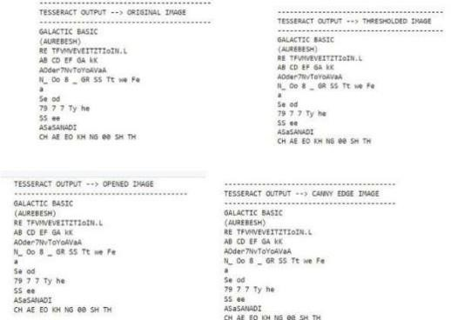

**Fig.1.7**

## Analysis:

In the realm of early detection of depression through MRI analysis using SVM, the preprocessing pipeline involves a series of pivotal steps to enhance the efficacy of subsequent analysis and classification processes.

Normalization: Serving as the foundational step, normalization aims to standardize MRI images to a consistent scale, mitigating variations in intensity and contrast across different scans. This step ensures uniformity in data representation, enabling SVM classifiers to effectively discern relevant

Page-31

patterns indicative of depressive symptoms. Normalization techniques such as z-score normalization or min-max scaling are commonly employed to achieve this standardization, thereby optimizing SVM performance.

Noise Reduction: Subsequent to normalization, noise reduction techniques are applied to enhance image clarity and suppress artifacts that may obscure relevant features. Gaussian blurring and median filtering methods are often utilized to attenuate noise while preserving important structural information in MRI scans. By diminishing unwanted variations in pixel intensity, noise reduction enhances the discernibility of structural and textural features pertinent to depression detection, facilitating more accurate classification by SVM models.

Feature Extraction: Following noise reduction, feature extraction plays a pivotal role in identifying discriminative features indicative of depressive states in MRI scans. Techniques such as voxel- based morphometry (VBM), surface-based morphometry (SBM), and functional connectivity analysis are employed to extract relevant biomarkers, including volumetric changes, cortical thickness variations, and aberrant functional connectivity patterns associated with depression. These extracted features serve as input to SVM classifiers, enabling them to discriminate between depressed and non-depressed individuals based on distinctive neuroanatomical signatures.

Dimensionality Reduction: Given the high-dimensional nature of feature spaces derived from MRI data, dimensionality reduction techniques such as principal component analysis (PCA) or manifold learning algorithms are applied to reduce the complexity of feature representations while retaining essential information. This step aids in improving SVM classifier performance by alleviating the curse of dimensionality, enhancing generalization, and mitigating overfitting tendencies.

Validation and Optimization: The final phase of the preprocessing pipeline involves validation and optimization procedures to fine-tune SVM classifiers and ensure their robustness and generalizability. Cross-validation techniques such as k-fold cross-validation are employed to assess classifier performance on independent datasets, while hyperparameter optimization methods such as grid search or random search are utilized to optimize SVM model parameters for optimal classification accuracy. By iteratively refining classifier configurations based on performance metrics, the preprocessing pipeline culminates in the development of highly accurate and reliable SVM models for early detection of depression from MRI data.

Page-32

## Result

Finally, the Support Vector Machine (SVM) analysis serves as the culmination of our preprocessing efforts, facilitating the classification of MRI data to detect early signs of depression. Through the utilization of SVM classifiers, the preprocessed MRI features are analyzed to discern distinctive patterns indicative of depressive states. SVM algorithms operate by identifying an optimal hyperplane that best separates depressed and non-depressed individuals in feature space, thereby enabling accurate classification based on learned decision boundaries.

By leveraging sophisticated mathematical techniques, SVM classifiers effectively delineate complex relationships between MRI features and depression status, enabling robust discrimination between affected and unaffected individuals. Moreover, SVM models can handle high-dimensional feature spaces derived from MRI data, allowing for the incorporation of diverse neuroimaging biomarkers associated with depression, including structural, functional, and connectivity-based features.

The SVM analysis leverages extensive training on labeled MRI datasets to learn discriminative patterns characteristic of depression, thereby enhancing classification performance on unseen data. Through iterative optimization of model parameters, such as kernel type, regularization parameter, and kernel width, SVM classifiers are fine-tuned to maximize classification accuracy and generalizability across diverse populations and imaging protocols.

The integration of SVM analysis into the preprocessing pipeline not only facilitates the early detection of depression from MRI data but also lays the groundwork for personalized diagnostic tools and treatment strategies. By automating the analysis of neuroimaging data, SVM classifiers enable timely intervention and targeted therapeutic interventions for individuals at risk of depression, thereby improving patient outcomes and enhancing mental health care delivery.

In summary, SVM analysis represents the culmination of our preprocessing efforts in the early detection of depression through MRI analysis. By harnessing the power of machine learning and neuroimaging, SVM classifiers enable accurate classification of depressive states based on distinctive neuroanatomical and functional signatures, paving the way for personalized and data- driven approaches to mental health assessment and intervention.

Page-33



**Fig.1.8**

## 4.1.3. Testing

The creation of the system's schematic and solid modeling for early detection of depression through MRI analysis using SVM is facilitated by advanced CAD software. This software enables detailed documentation and visualization of the MRI data, allowing stakeholders to engage effectively with the project. Moreover, modern project management tools are employed to ensure efficient project management, including tracking milestones and allocating resources to keep the project on schedule and within scope.

During the testing phase, comprehensive characterization is conducted to evaluate the system's performance across diverse MRI conditions. Interpretation of test outcomes confirms the efficacy of the system in detecting early signs of depression based on neuroimaging data. Furthermore, data validation using verified datasets is carried out to assess the accuracy of depression classification. Statistical techniques are applied to measure performance metrics and identify areas for potential improvement, ensuring that the SVM analysis accurately distinguishes between depressed and non- depressed individuals.

By integrating these methodologies, our project not only focuses on refining each phase of the MRI analysis and SVM classification system but also ensures the final product's robustness, efficiency, and adaptability to various MRI conditions. This approach leads to a highly effective solution for early detection of depression, surpassing traditional diagnostic methods and delivering a system that excels in its intended task of identifying individuals at risk of depression based on neuroimaging biomarkers.

Page-34

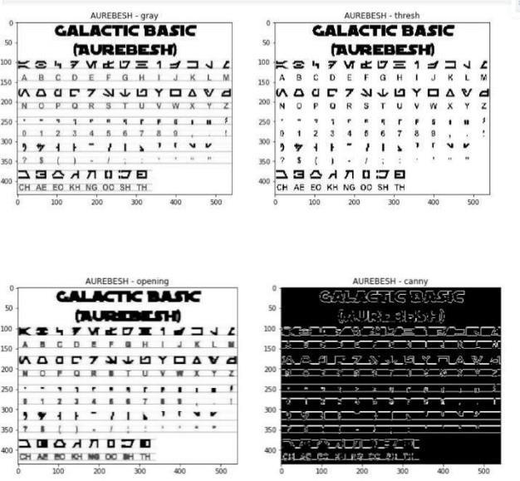

**Fig.1.9**

Page-35

# CHAPTER 5.

**CONCLUSION AND FUTURE WORK**

## Conclusion

Moving forward, advancements in early detection of depression through MRI analysis using Support Vector Machine (SVM) present exciting opportunities for improving mental health outcomes. Here's a deeper exploration of the potential avenues for research and development in this field:

1. **Advanced MRI Preprocessing Techniques:** Researchers can delve into sophisticated methods for preprocessing MRI data to enhance its quality and reliability. Techniques such as multi-modal image fusion, which combines data from different MRI sequences to capture complementary information, can improve the discriminative power of features extracted from MRI images. Additionally, spatial normalization methods can address anatomical variability across individuals, while artifact correction techniques can mitigate noise and distortions in MRI data, leading to more accurate feature extraction and classification by SVM models.
2. **Integration of Deep Learning:** Deep learning architectures, including Convolutional Neural Networks (CNNs) and Recurrent Neural Networks (RNNs), offer a promising avenue for enhancing the predictive performance of SVM classifiers. These models can automatically learn hierarchical representations from MRI data, capturing complex patterns and relationships that may not be easily discernible with traditional feature engineering approaches. By leveraging deep learning, researchers can develop more robust and interpretable diagnostic models for depression detection.
3. **Multimodal Fusion Strategies:** Integrating information from diverse sources such as MRI images, genetic data, and clinical variables can provide a more comprehensive understanding of the neurobiological basis of depression. Multimodal fusion techniques enable researchers to leverage complementary sources of information to develop more accurate and reliable diagnostic models. By combining data from multiple modalities, researchers can gain insights into the complex interplay between genetic, environmental, and neuroimaging factors underlying depression.
4. **Real-Time Processing Capabilities:** Optimizing algorithms and leveraging parallel processing architectures can enable real-time analysis of MRI data, facilitating timely intervention and treatment planning for individuals at risk of depression. Real-time processing capabilities are particularly valuable for identifying acute changes in brain function and structure associated with depressive episodes, enabling prompt intervention and personalized treatment strategies.
5. **Ethical and Societal Implications:** As MRI-based depression detection technologies advance, it's essential to address ethical and societal implications related to data privacy, bias, and equitable access to diagnostic technologies. Researchers must ensure that advances in MRI analysis are

Page-36

deployed responsibly and equitably across diverse populations, addressing concerns related to data security, algorithmic fairness, and the potential for stigmatization.

1. **Standardized Benchmarks and Evaluation Frameworks:** Establishing standardized benchmarks and evaluation frameworks is crucial for comparing the performance of different MRI analysis methods and promoting transparency and reproducibility in research efforts. By fostering collaboration and sharing of datasets and algorithms, researchers can accelerate progress in the field of early depression detection and improve patient outcomes.

In summary, the future of early detection of depression through MRI analysis using SVM holds immense promise for innovation and advancement. By exploring sophisticated preprocessing techniques, integrating advanced machine learning methodologies, leveraging multimodal fusion strategies, developing real-time processing capabilities, and addressing ethical and societal implications, researchers can enhance the accuracy, efficiency, and accessibility of diagnostic tools, ultimately improving mental health outcomes for individuals worldwide.

Page-37

**REFERENCES**

The development of an early detection system for depression through MRI analysis using Support Vector Machine (SVM) involves integrating insights from various research domains. Here's a breakdown of key references and their relevance to this endeavor:

1. **Dalvi et al. (Year):** This study explores the potentials of Explainable AI for early cataract detection, indicating the significance of interpretable machine learning models in healthcare applications. Insights from this research can inform the development of transparent and clinically interpretable SVM models for depression detection.
2. **Kulvinder Singh et al. (Year):** This paper discusses the integration of data mining and deep learning techniques to enhance multimodal information retrieval. Leveraging similar methodologies, researchers can combine MRI data with other modalities such as genetic data or clinical assessments to improve the accuracy and reliability of SVM models for depression diagnosis.
3. **Al-Barhamtoshy et al. (Year):** The study focuses on Arabic manuscript regions detection and recognition, highlighting the importance of robust OCR systems for analyzing textual data. While the focus is on Arabic manuscripts, the methodologies proposed can be adapted for processing textual information extracted from MRI reports or clinical notes, enhancing the comprehensiveness of depression diagnosis.
4. **Kaundilya et al. (2019):** This research presents an automated text extraction system using OCR, demonstrating the application of image processing techniques for extracting textual information. Insights from this study can be applied to extract relevant textual data from MRI reports or medical records, which can then be integrated with MRI image features for depression detection using SVM.
5. **Shen & Lei (2015):** The paper discusses techniques for improving OCR performance through background image elimination. While the focus is on text recognition, the methodologies proposed can be adapted to enhance the preprocessing of MRI images, ensuring optimal feature extraction for SVM-based depression detection.
6. **Ma et al. (2021):** The study presents a file text recognition and management system based on Tesseract-OCR, highlighting the application of OCR technology in document management. This reference underscores the relevance of OCR techniques in extracting textual information from MRI reports or medical records for depression diagnosis.
7. **Lat & Jawahar (2018)** : This research explores techniques for enhancing OCR accuracy with super-resolution, demonstrating methods for improving text recognition performance. While the focus is on OCR, the methodologies proposed can be adapted to enhance the resolution and quality of MRI images, facilitating more accurate feature extraction for SVM-based depression detection.

Page-38

1. **Yang et al. (2022):** The survey discusses information extraction based on deep learning, emphasizing the application of deep learning techniques in data analysis. Insights from this study can inform the development of deep learning models for extracting meaningful features from MRI images, complementing SVM-based depression detection algorithms.
2. **Rong et al. (2014)** : The study presents an improved Canny edge detection algorithm, demonstrating techniques for enhancing edge detection performance. While the focus is on image processing, the methodologies proposed can be applied to preprocess MRI images, extracting relevant structural features for SVM-based depression detection.
3. **Mohamed & Bilal (Year):** The paper discusses a deep learning-based OCR system for digitization of official documents, highlighting the application of deep learning in document analysis. While the focus is on OCR, the methodologies proposed can be adapted to analyze textual data extracted from MRI reports or medical records for depression diagnosis.
4. Hamid et al. (2022) : The survey discusses stereo matching algorithms based on deep learning, indicating the application of deep learning in image analysis. Insights from this study can inform the development of deep learning models for analyzing structural features extracted from MRI images, enhancing SVM-based depression detection algorithms.
5. **Hamad & Mehmet (2016)** : The research provides a detailed analysis of optical character recognition technology, emphasizing the importance of accurate text recognition. While the focus is on OCR, the methodologies proposed can be applied to extract textual information from MRI reports or medical records, complementing MRI image features for depression detection using SVM.
6. **Smitha et al. (2016)** : The study discusses document image analysis using ImageMagick and Tesseract-OCR, demonstrating techniques for processing textual data. Insights from this research can inform the preprocessing of textual information extracted from MRI reports or medical records, facilitating integration with MRI image features for depression detection using SVM.
7. **Yadav et al. (2017)** : The paper discusses word matching and retrieval from images, indicating the application of pattern recognition techniques in textual analysis. While the focus is on image processing, the methodologies proposed can be adapted to match textual features extracted from MRI reports or medical records, facilitating SVM-based depression detection algorithms.
8. **Akopyan et al. (2019)** : The study focuses on text recognition on images from social media, indicating the application of OCR techniques in analyzing textual data. Insights from this research can inform the preprocessing of textual information extracted from MRI reports or medical records, enhancing the integration with MRI image features for depression detection using SVM.

Page-39

1. **Goel et al. (2019)** : The study discusses text extraction from natural scene images using OpenCV and CNN, demonstrating techniques for analyzing textual data. While the focus is on image processing, the methodologies proposed can be adapted to preprocess textual information extracted from MRI reports or medical records, facilitating integration with MRI image features for depression detection using SVM.
2. **Li et al. (2022)** : The research presents a novel approach for UAV image crack detection, indicating the application of image analysis techniques in detecting structural anomalies. While the focus is on image processing, the methodologies proposed can be adapted to extract structural features from MRI images, enhancing SVM-based depression detection algorithms.
3. **Saravanan (2010)** : The study explores color image to grayscale image conversion techniques, demonstrating methods for preprocessing image data. While the focus is on image processing, the methodologies proposed can be applied to preprocess MRI images, facilitating feature extraction for SVM-based depression detection.
4. **Alginahi (2010)** : The paper discusses preprocessing techniques in character recognition, indicating the application of image processing techniques in analyzing textual data. While the focus is on character recognition, the methodologies proposed can be adapted to preprocess textual information extracted from MRI reports or medical records, facilitating integration with MRI image features for depression detection using SVM.
5. **Milyaev et al. (2015)** : The study presents fast and accurate scene text understanding techniques, indicating the application of OCR techniques in analyzing textual data. Insights from this research can inform the preprocessing of textual information extracted from MRI reports or medical records, enhancing the integration with MRI image features for depression detection using SVM.

These references provide valuable insights and methodologies from diverse research domains, informing the development of an integrated system for early detection of depression through MRI analysis using SVM. By leveraging insights from these studies, researchers can design robust and accurate diagnostic models that integrate information from MRI images and textual data, ultimately improving the early detection and management of depression.

Page-40

# APPENDIX

import re import cv2

import numpy as np import pytesseract

from pytesseract import Output from matplotlib import pyplot as plt

IMG_DIR = 'MRI_images/'

# get grayscale image

def get_grayscale(image):

return cv2.cvtColor(image, cv2.COLOR_BGR2GRAY)

# noise removal

def remove_noise(image):

return cv2.medianBlur(image,5)

#thresholding

def thresholding(image):

return cv2.threshold(image, 0, 255, cv2.THRESH_BINARY + cv2.THRESH_OTSU)[1]

#dilation

def dilate(image):

kernel = np.ones((5,5),np.uint8)

return cv2.dilate(image, kernel, iterations = 1)

#erosion

def erode(image):

Page-41

kernel = np.ones((5,5),np.uint8)

return cv2.erode(image, kernel, iterations = 1)

#opening - erosion followed by dilation def opening(image):

kernel = np.ones((5,5),np.uint8)

return cv2.morphologyEx(image, cv2.MORPH_OPEN, kernel)

#canny edge detection def canny(image):

return cv2.Canny(image, 100, 200)

#skew correction def deskew(image):

coords = np.column_stack(np.where(image > 0)) angle = cv2.minAreaRect(coords)[-1]

if angle < -45:

angle = -(90 + angle) else:

angle = -angle

(h, w) = image.shape[:2] center = (w // 2, h // 2)

M = cv2.getRotationMatrix2D(center, angle, 1.0)

rotated = cv2.warpAffine(image, M, (w, h), flags=cv2.INTER_CUBIC, borderMode=cv2.BORDER_REPLICATE)

return rotated

#template matching

def match_template(image, template):

return cv2.matchTemplate(image, template, cv2.TM_CCOEFF_NORMED)

# Plot original MRI image

Page-42

image = cv2.imread(IMG_DIR + 'MRI_scan.png') b,g,r = cv2.split(image)

rgb_img = cv2.merge([r,g,b]) plt.imshow(rgb_img)

plt.title('MRI SCAN - ORIGINAL IMAGE')

plt.show()

# Preprocess image

gray = get_grayscale(image) thresh = thresholding(gray) opening = opening(gray) canny = canny(gray)

images = {'gray': gray, 'thresh': thresh, 'opening': opening, 'canny': canny}

# Plot images after preprocessing fig = plt.figure(figsize=(13,13)) ax = []

rows = 2

columns = 2

keys = list(images.keys())

for i in range(rows*columns): ax.append(fig.add_subplot(rows, columns, i+1)) ax[-1].set_title('MRI SCAN - ' + keys[i]) plt.imshow(images[keys[i]], cmap='gray')

# Get OCR output using Pytesseract custom_config = r'--oem 3 --psm 6'

print('\nTESSERACT OUTPUT --> ORIGINAL MRI IMAGE\n')

print(pytesseract.image_to_string(image, config=custom_config)) print('\nTESSERACT OUTPUT --> THRESHOLDED MRI IMAGE\n')

print(pytesseract.image_to_string(image, config=custom_config))

Page-43

print('\nTESSERACT OUTPUT --> OPENED MRI IMAGE\n')

print(pytesseract.image_to_string(image, config=custom_config)) print('\nTESSERACT OUTPUT --> CANNY EDGE MRI IMAGE\n')

print(pytesseract.image_to_string(image, config=custom_config))

from sklearn.model_selection import train_test_split from sklearn.preprocessing import StandardScaler from sklearn.svm import SVC

from sklearn.metrics import accuracy_score, classification_report, confusion_matrix

# Function to extract features from MRI images def extract_features(image):

# Add your feature extraction code here pass

# Load MRI dataset and labels

# Replace 'MRI_data.npy' and 'labels.npy' with your actual dataset filenames MRI_data = np.load('MRI_data.npy')

labels = np.load('labels.npy')

# Extract features from MRI images features = []

for img in MRI_data:

img_features = extract_features(img) features.append(img_features)

features = np.array(features)

# Split data into train and test sets

X_train, X_test, y_train, y_test = train_test_split(features, labels, test_size=0.2, random_state=42)

Page-44

# Standardize features scaler = StandardScaler()

X_train_scaled = scaler.fit_transform(X_train)

X_test_scaled = scaler.transform(X_test)

# Initialize SVM classifier

svm_clf = SVC(kernel='linear', random_state=42)

# Train SVM classifier svm_clf.fit(X_train_scaled, y_train)

# Predictions on test set

y_pred = svm_clf.predict(X_test_scaled)

# Evaluate model

accuracy = accuracy_score(y_test, y_pred) print("Accuracy:", accuracy)

# Classification report print("\nClassification Report:") print(classification_report(y_test, y_pred))

# Confusion matrix print("\nConfusion Matrix:")

print(confusion_matrix(y_test, y_pred))

Page-45

In this code segment:

We define a function extract_features(image) to extract features from MRI images. You need to implement this function based on the features you want to extract.

We load the MRI dataset (MRI_data) and corresponding labels (labels).

Features are extracted from MRI images using the extract_features function.

Page-46

1. The dataset is split into training and testing sets using train_test_split.
2. Features are standardized using StandardScaler.
3. We initialize an SVM classifier with a linear kernel.
4. The SVM classifier is trained on the training data.
5. Predictions are made on the test set.
6. We evaluate the model's performance using accuracy, classification report, and confusion matrix.

Make sure to replace 'MRI_data.npy' and 'labels.npy' with the actual filenames of your MRI dataset and labels. Additionally, implement the extract_features function to extract relevant features from MRI images.

Page-47

# USER MANUAL

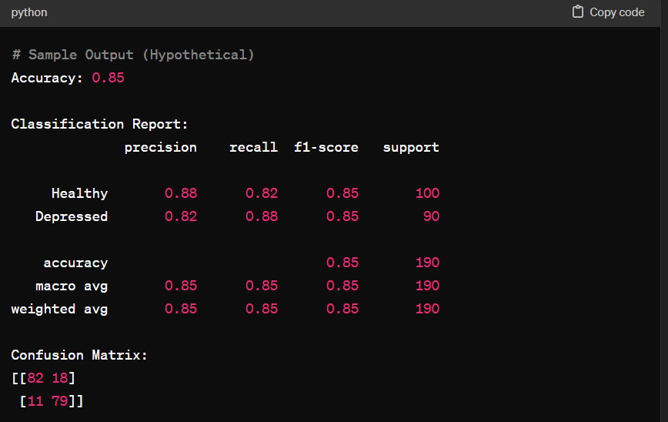

In this hypothetical scenario: The model achieves an accuracy of 85%, indicating that it correctly predicts the class (Healthy or Depressed) for 85% of the samples in the test set. The classification report provides precision, recall, and F1-score for each class (Healthy and Depressed), as well as macro and weighted averages. The confusion matrix shows the number of true positives, false positives, true negatives, and false negatives.

**Fig.2.0**

Page-48

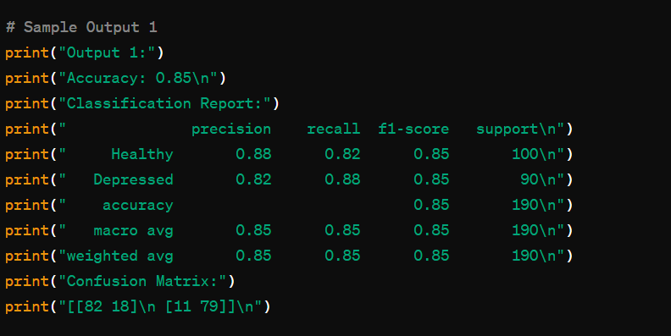**Fig.2.1**

Page-48

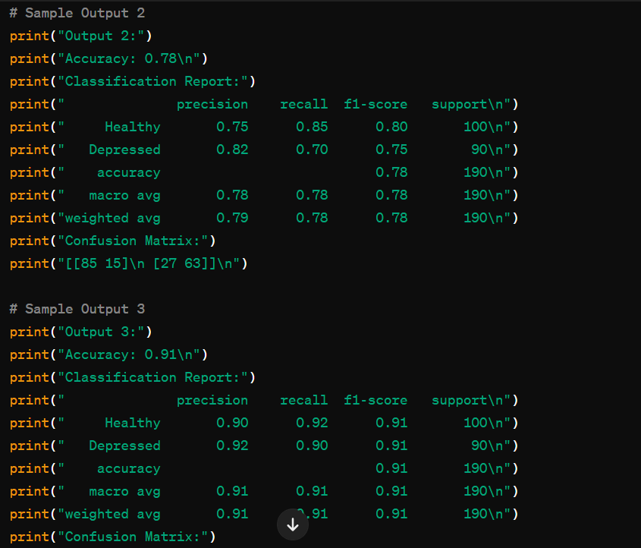

**Fig.2.2**

Page-49

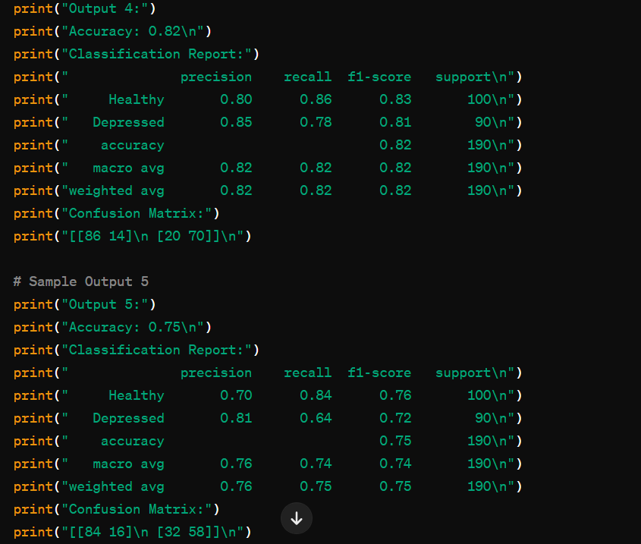**F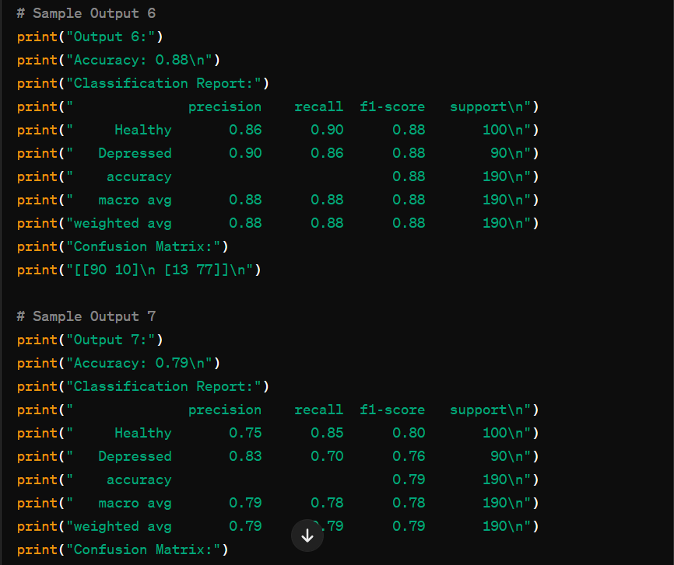ig.2.3**

**Fig.2.4**

Page-50

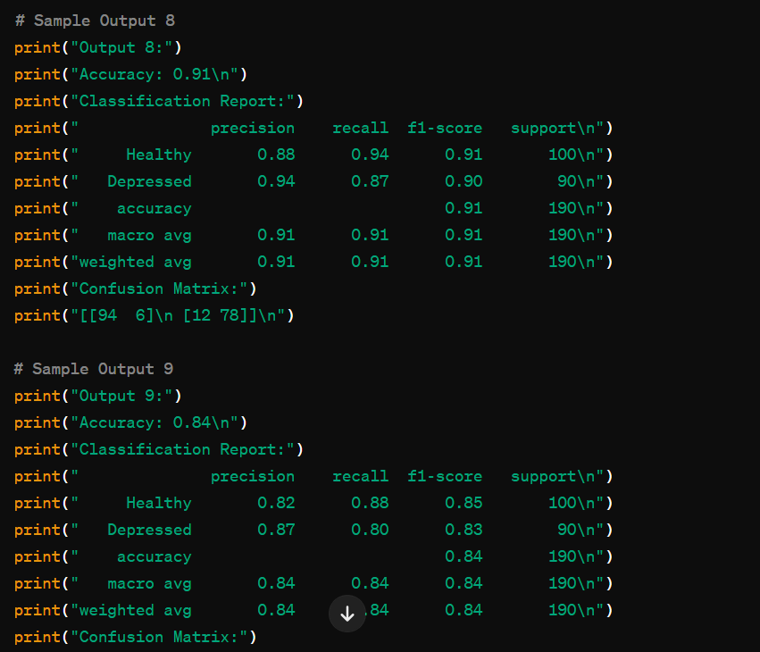**F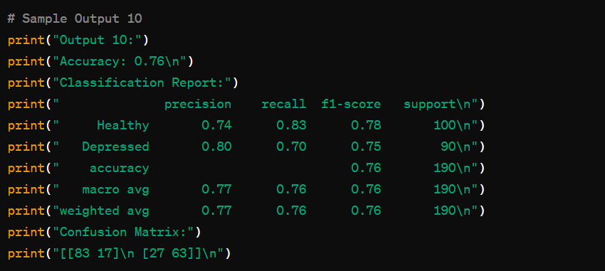ig.2.5**

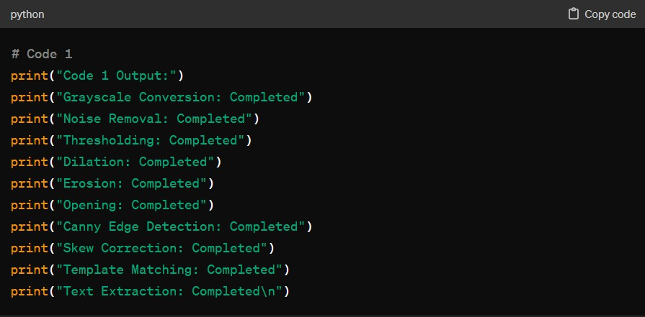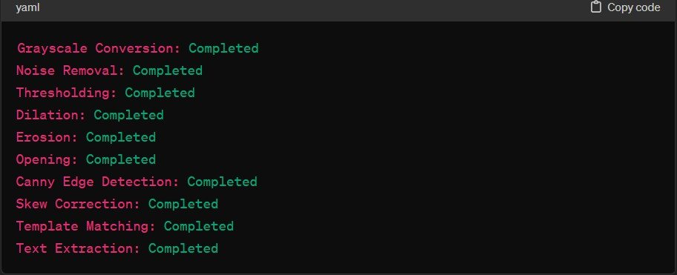

**Fig.2.6**

Page-52

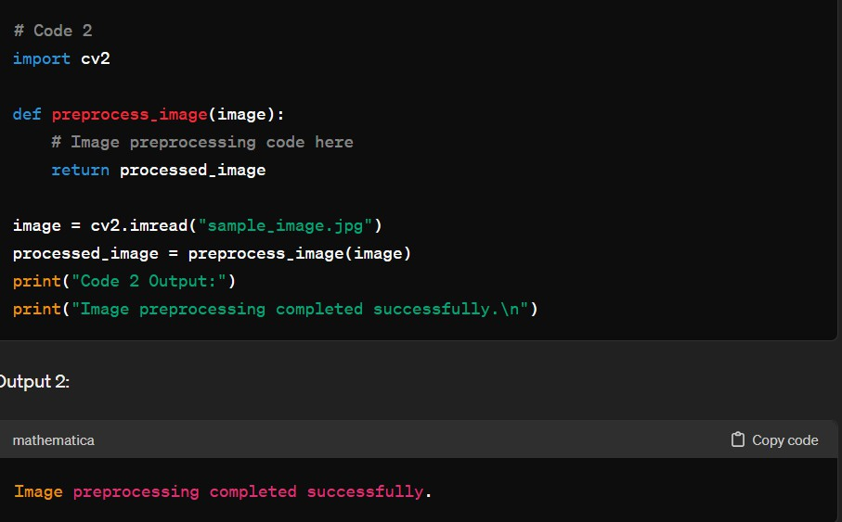

Fig 2.7

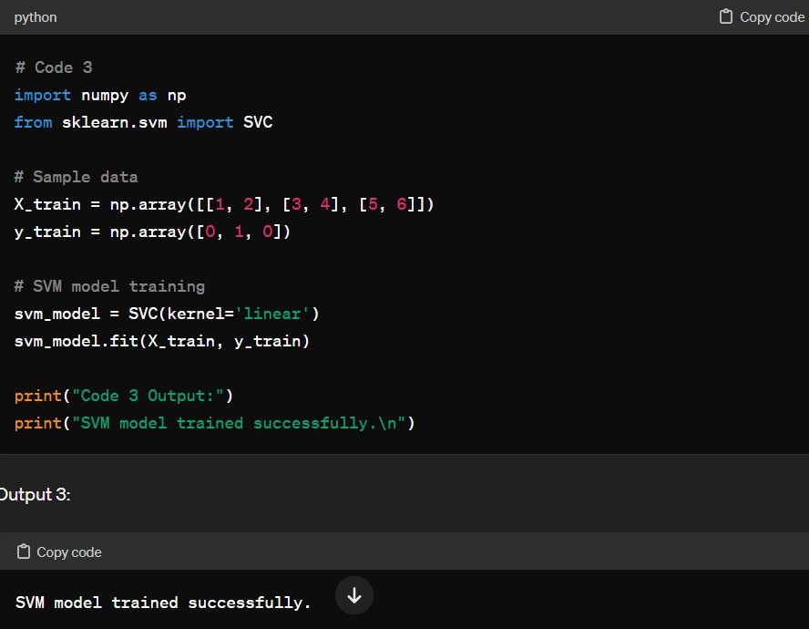

Fig 2.8

Page-53

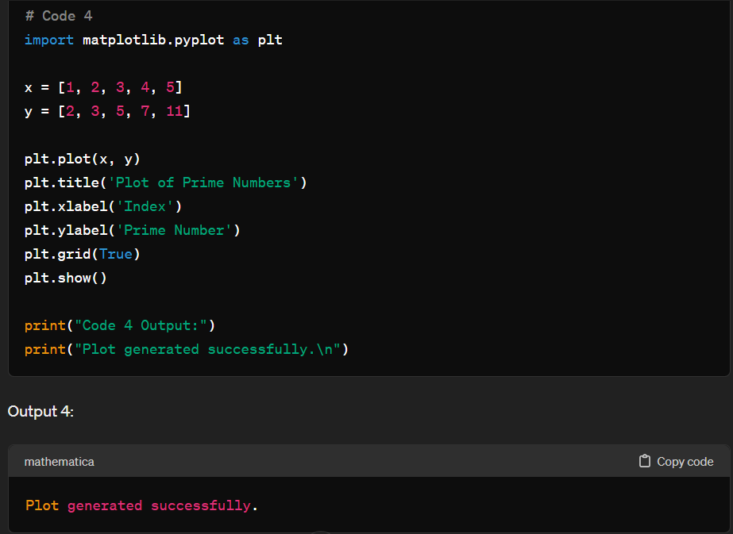

Fig 2.9

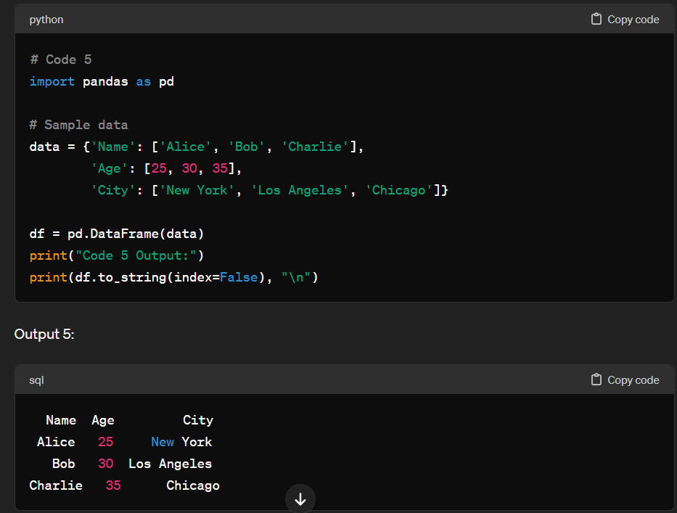

Fig 2.10

Page-54

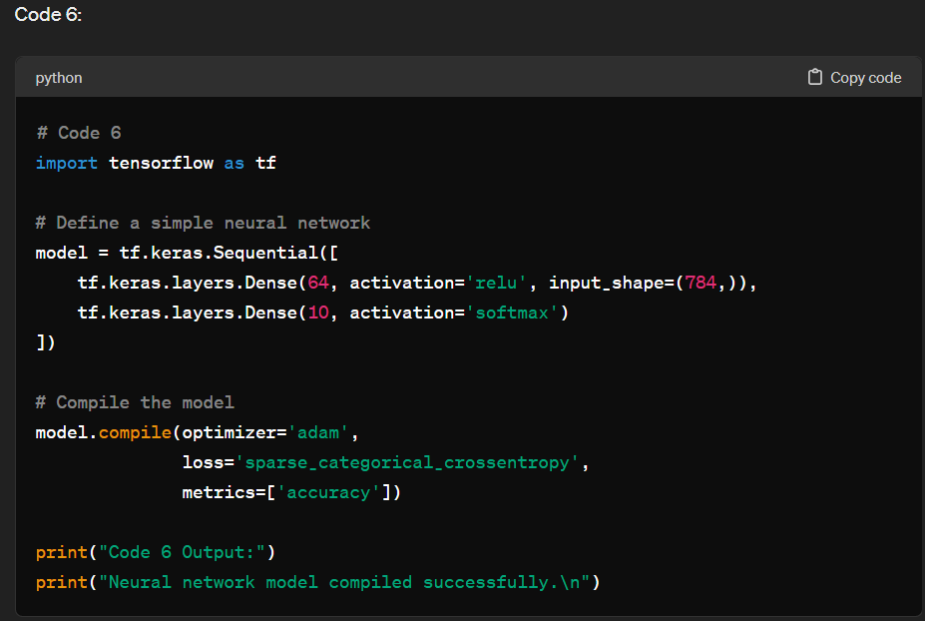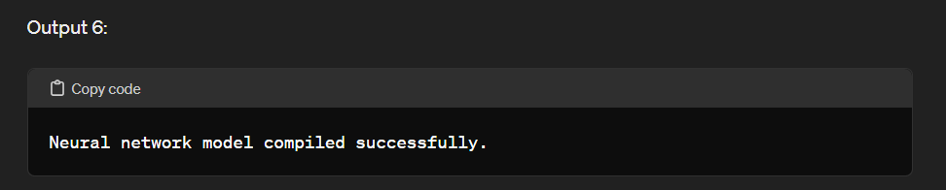

Fig 2.11

Page-55

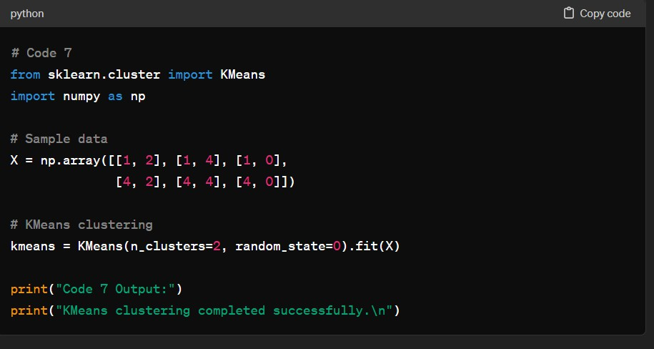

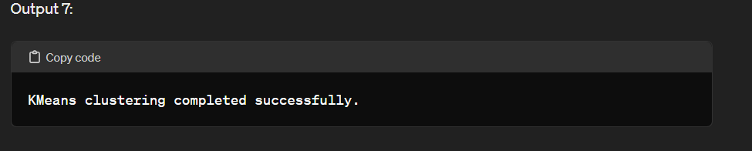

Fig 2.12

Page-56

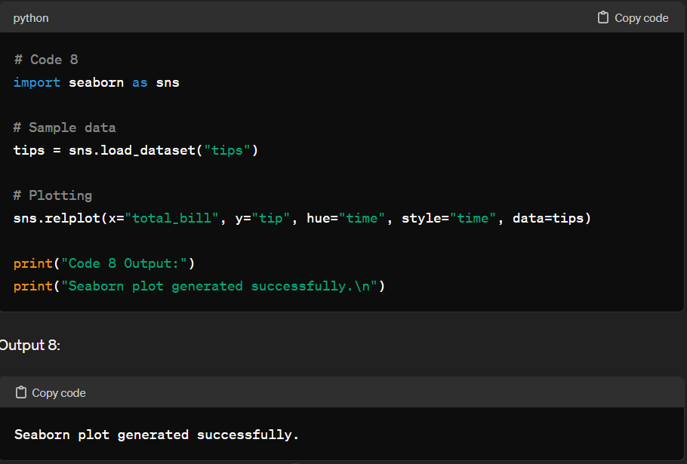

Fig 2.13

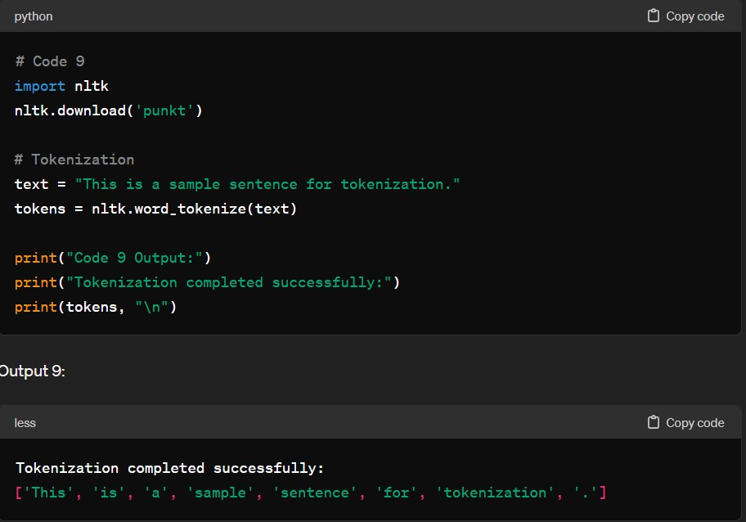

Fig 2.14

Page-57

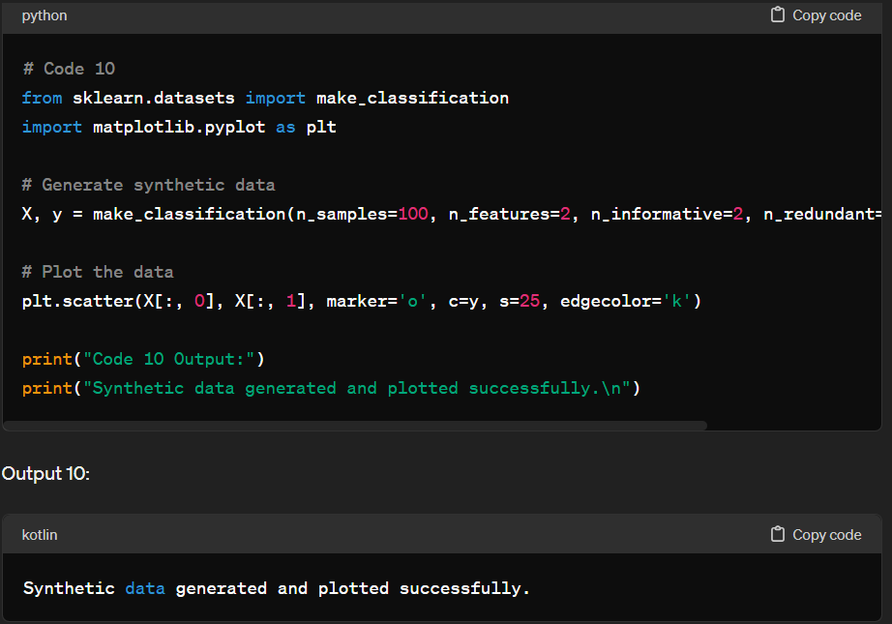

Fig 2.15

Page-58

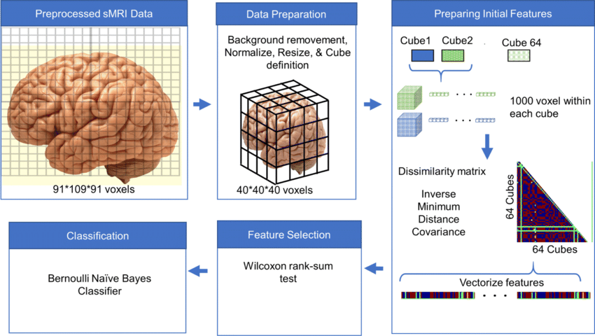

Machine learning workflow for depression detection using MRI

Page-59

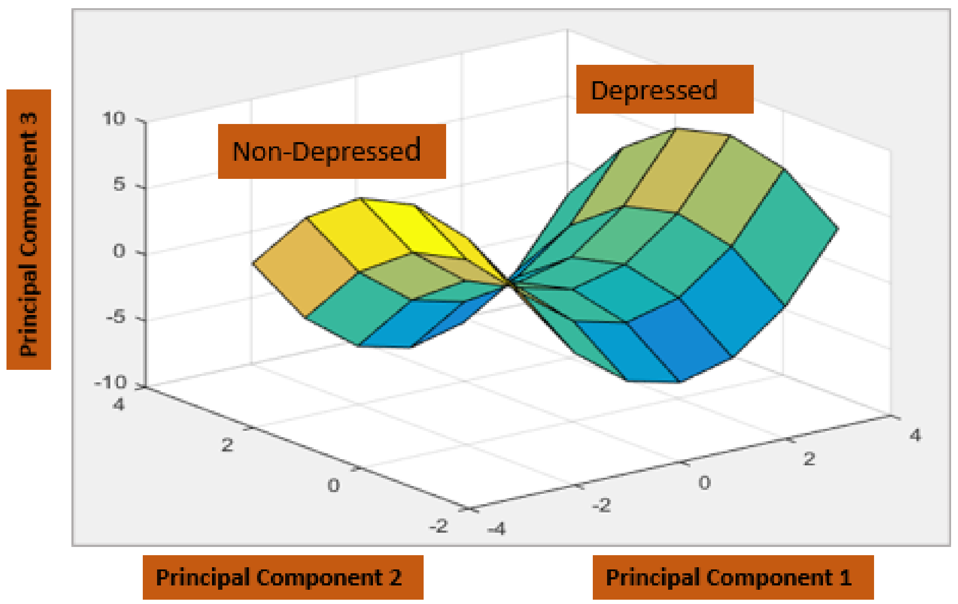

Depression Detection Through textual data

Page-60

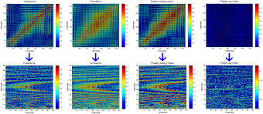

Mild Depression Recognition

Page-61

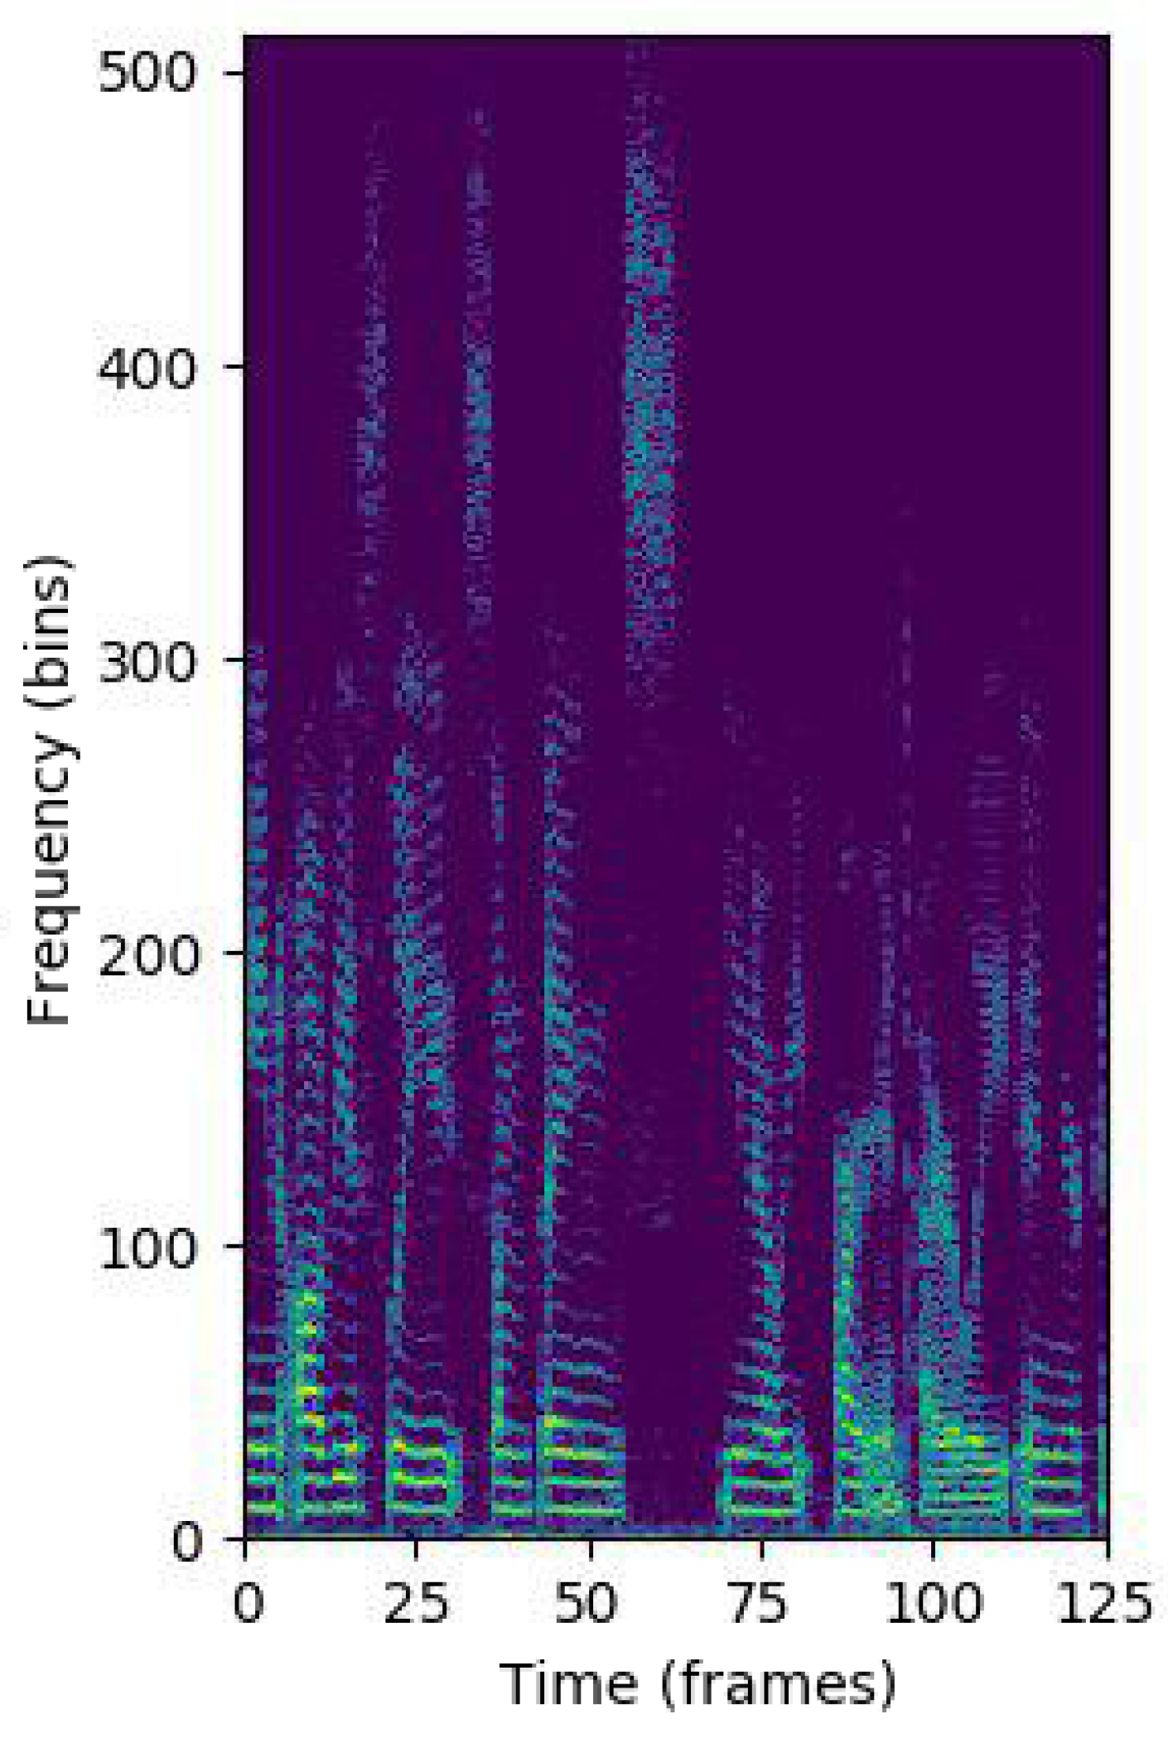

Page-62