**Conversational AI Unveiled: Navigating Ethical Frontiers in the Realm of ChatGPT**

|  |  |  |  |  |  |  |
| --- | --- | --- | --- | --- | --- | --- |
| |  |  |  | | --- | --- | --- | | Ritik Patel  Chandigarh University, Mohali  [ritikpatel9560@gmail.com](mailto:ritikpatel9560@gmail.com) | Parveen Bajaj Chandigarh University, Mohali  erparveen@rediffmail.com | Ankit Kumar  Chandigarh University, Mohali  [krankit014.ankit@g](mailto:krankit014.ankit@g)mail.com | | Anupama Kumari  Chandigarh University, Mohali  [anupmakumari07122001@gmail.com](mailto:anupmakumari07122001@gmail.com) | Vivek Rai Chandigarh University, Mohali  [vivekrau77889966@gmail.com](mailto:vivekrau77889966@gmail.com%20g) | Shubham Kumar Chandigarh University, Mohali  [jaiswalshubham617@gmail.com](mailto:jaiswalshubham617@gmail.com%20g) | |

***Abstract* –** **As Conversational AI systems like ChatGPT become increasingly pervasive, a critical examination of their ethical implications is imperative. This research delves into the intricate landscape of ethical considerations surrounding ChatGPT, exploring the nuances of its design, deployment, and impact on users. The paper investigates key themes such as user privacy, bias mitigation, and the responsible use of advanced language models. By conducting a comprehensive ethical review, we aim to contribute to the ongoing discourse on the responsible development and deployment of conversational agents, shedding light on potential challenges and proposing guidelines for fostering a more ethically sound era in AI-driven communication. The initial segment delineates a few of the essential ideas pertaining to ChatGPT and explains how they are used in the system. Two examples are artificial intelligence and natural language processing. The second section explores the background, advancements, and potential future applications of the Generative Pre-trained The technology behind ChatGPT is the Transformer model, which includes the core elements of GPT. It covers the structure of the model, its development, and many tools for training the model. The machine must be able to perform a variety of language-related tasks, such as translating, answering questions, and creating content. The third phase of the research revealed the potential of ChatGPT by understanding the impact of AI and GPT on education and libraries through interviews. In this chapter we explore how ChatGPT can be used to improve various library services and address ethical issues that need to be** **considered.**

**Keywords: *ChatGPT, GPT-3, AI, Pre-trained Transformer, Educational Institutions, Libraries***

I. Introduction

Have you ever communicated with a chatbot whose responses were almost human-like? Or have you ever used Deep learning and Artificial Intelligence[1].

ChatGPT, a language model created by OpenAI, uses cutting- edge artificial intelligence methods to produce natural language responses . Come explore the amazing world of Learn about the world of ChatGPT and how it is transforming lives.[2]

Conversational AI's main objective is to make it possible for robots to comprehend and produce human language in a fashion that mimics human-human interactions. Traditional rule-based chatbots frequently failed to achieve this goal because they had trouble understanding the subtleties of language, context, and user meaning. A new era of NLP began with the introduction of transformer-based architectures, made possible by advances in pre-training and transfer learning, which allowed models to capture semantic nuances and produce coherent text. Building on these developments, ChatGPT represents a huge step toward developing AI systems that can engage users in deep conversations.

In this research paper, we seek to give a thorough analysis of the fundamental ideas and workings of ChatGPT's conversational capabilities. This journey into the heart of ChatGPT serves as a testament to the remarkable strides taken in AI and the rich possibilities it offers in shaping our digital future. We look at the theoretical underpinnings of transformer designs, examine the particulars of training and fine-tuning procedures, and talk about methods to deal with issues like context fragmentation and response coherence. We also look at ChatGPT's shortcomings and speculate on possible future routes for conversational AI research.

In conclusion, the development of ChatGPT and related conversational AI models represents a crucial step forward in the field of NLP, GPT (Generative pre-trained Transformer) bridging the divide between machines and people through meaningful, contextually rich interactions. By delving into ChatGPT's inner workings, we hope to shed light on conversational AI's current level of development and add to the ongoing conversation about the potential and constraints of this game-changing technology[3].

II. Literature Review

Over the past ten years, improvements in machine learning and natural language processing have led revolutionary changes in conversational AI. Large-scale language models like GPT-3 (Generative Pre-trained Transformer 3), which cleared the path for increasingly complex conversational robots, are one key development in this evolution. This overview of the literature looks at the development and effects of GPT-3 and ChatGPT in the field of conversational AI.

**1. GPT-3 predecessors:**

The advancements in transformer-based architectures served as the basis for GPT-3's success. Sequence-to-sequence activities were revolutionized by the original transformer design Vaswani et al. (2017) proposed in "Attention Is All You Need" by successfully capturing long-range dependencies.

By pre-training transformers on sizable text corpora, other works—such as BERT (Bidirectional Encoder Representations from Transformers) by Devlin et al. (2018)—further enhanced contextual embeddings. These models served as the foundation for the improvements in language creation and comprehension made by GPT-3[4].

1. **Scaling Up Language Models in GPT-3**

The introduction of GPT-3 by Brown et al. (2020) marks a notable improvement in the scope and efficacy of language models. GPT-3 demonstrates a wide range of linguistic abilities, from text synthesis to translation and question answering, with 175 billion parameters. It attracted attention for its "few-shot" and "zero-shot" learning capabilities, which allowed it to generalize and complete tasks with a minimum amount of task-specific training data. The model's capability for numerous applications, including conversational AI, was demonstrated by its use of unsupervised pre-training followed by fine-tuning.

**3. Conversational Adaptation in ChatGPT:**

The use of GPT-3's language prowess is shown by ChatGPT, a GPT-3 variation designed exclusively for talks. Research articles like Zhang et al.'s "Improving Conversational Agents with GPT-3" (2021) show the effectiveness of fine-tuning GPT-3 on dialogue datasets. Because ChatGPT can keep context and create logical responses, it has been incorporated into interactive storytelling software, virtual assistants, and customer care bots. However, problems with context fragmentation and inappropriate reactions continue to be important research areas.[5]

**4. Bias and ethical considerations:**

The rise of conversational AI models has also made ethical issues more prominent. Language models, like GPT-3, have biases, as discussed in "The Risk of Racial Bias in Hate Speech Detection" by Sap et al. (2020) and "Language Models are Unsupervised Multitask Learners" by Radford et al. (2019). In order to ensure that ChatGPT is used responsibly, biases, the spread of false information, and potential abuse must be addressed.

**5. Moving Forward:**

Conversational AI research is on a trajectory that is expected to keep growing. In order to improve contextual comprehension, incorporate outside knowledge, and encourage more participatory and dynamic dialogues, researchers are examining several strategies. For AI-driven interactions to continue to advance, a balance must be struck between language production and moral considerations.[6]

**6. Problem formulation:**

1. Fairness and Bias: Similar to other AI models, ChatGPT may inadvertently reinforce certain biases present in the training set. Talk about the moral ramifications of employing a biased model and how bias can show up in its results.

2. Lack of Understanding of Common Sense: Although ChatGPT is capable of producing legible writing, it typically has a shallow comprehension of material that is common sense.

3. Investigation of the problem of ChatGPT producing potentially harmful or false content. Talk about situations when it could lead to incorrect or harmful responses and the practical ramifications.

4. User Privacy: Consider ChatGPT's privacy issues, such as the potential for unintentional data leakage during user interactions.

In summary, GPT-3 and ChatGPT have revolutionized conversational AI by utilizing transformer designs and extensive pre-training. The development of conversational agents over time, from transformer topologies to ChatGPT, has paved the way for more engaging and contextually aware AI-driven discussions.[7]

III. METHODOLOGY

**Methods in ChatGPT AI: A Hypothetical Overview**

The development of conversational AI models like ChatGPT involves a combination of pre-training and fine-tuning processes to enable effective interactions with users. The following methods provide an overview of how ChatGPT AI might be developed based on existing principles as of September 2021.

**1. Pre-Training on Diverse Text Data:**

The first phase of creating ChatGPT involves pretraining the model on various bodies of text (books, articles, websites, etc.). This preliminary training provides a model for a variety of language environments, encouraging the acquisition of grammar, factual knowledge, thinking skills, and some common sense. Using the Transformer architecture, as illustrated in the seminal paper “Content is All You Need” by Vaswani et al. (2017), the model will be able to capture complex data[8]

**2. Fine-Tuning for Conversations:**

After pre-training, the model is fine-tuned using conversation-specific datasets. Fine-tuning narrows the model's focus and adapts it for generating contextually relevant responses in conversational contexts. These datasets typically include dialogues, chats, and interactions, allowing the model to learn the nuances of maintaining context and generating coherent replies.

**3. Context Window and Token Limitation:**

A challenge in conversation modeling is the limited context window due to the maximum token limitations of transformer-based models. Methods such as sliding window approaches or using special tokens to mark conversation boundaries are often employed to handle this limitation. For example, a conversation history can be truncated or omitted when it exceeds the token limit, which could lead to context fragmentation.[9]

**4. Prompt Engineering:**

Generating desirable responses in ChatGPT often requires careful engineering of input prompts. Researchers experiment with various prompt designs, including providing explicit context, using user instructions, or utilizing system-level instructions, to guide the model's behavior. Balancing the prompt's influence on the model while allowing for natural interactions is a crucial consideration.

**5. Reinforcement Learning and Feedback:**

Iterative fine-tuning processes might involve reinforcement learning techniques, where human feedback guides the model's response generation. Reinforcement learning can help improve response quality, reduce biases, and mitigate inappropriate responses over time.[10]

**6. Ethical and Bias Mitigation:**

Addressing ethical concerns and mitigating biases are essential components of developing ChatGPT AI. Techniques like rule-based filtering, rejection of inappropriate content, and guidelines for appropriate responses are often integrated into the system to ensure responsible and safe interactions.

**7.Zero-shot, Few-shot, and One-shot Learning:**

GPT-3 demonstrates the ability to perform zero-shot, few-shot, and even one-shot learning. This means that the model can generalize from just a few examples or even a single example, making it highly versatile for various tasks.

**8.Pattern Recognition and Copying:**

GPT-3 can recognize and reproduce specific patterns, such as text formatting, programming code, or even sequences of numbers, which makes it useful for tasks like code generation, data manipulation, and more.[11]

**9.Transformer Architecture:**

GPT3 is similar to its predecessor and is built on the Transformer architecture. The Transformer architecture uses a self-generated mechanism to process data simultaneously; this makes it possible to capture the connection between words in a string.

**10.Attention Mechanisms:**

The selflistening method allows the model to evaluate the significance of the individual's words in the social context. These features help the model understand distant connections and dependencies in the text.

**11.Positional Encodings:**

Since the Transformer architecture itself does not understand the order of words, positional coding is added to the embedding strategy. This culture provides structure by providing information about the position of the word in the sentence**.**.[12]

**12.Layer Normalization:**

Layer normalization is used to normalize the inputs to each layer in the network. This helps stabilize and accelerate the training process.

**13.Parameter Scaling:**

GPT-3 employs a large number of parameters (175 billion in the case of GPT-3) to achieve its impressive performance. This extensive parameter scaling contributes to the model's capacity to understand and generate human-like text.[13]

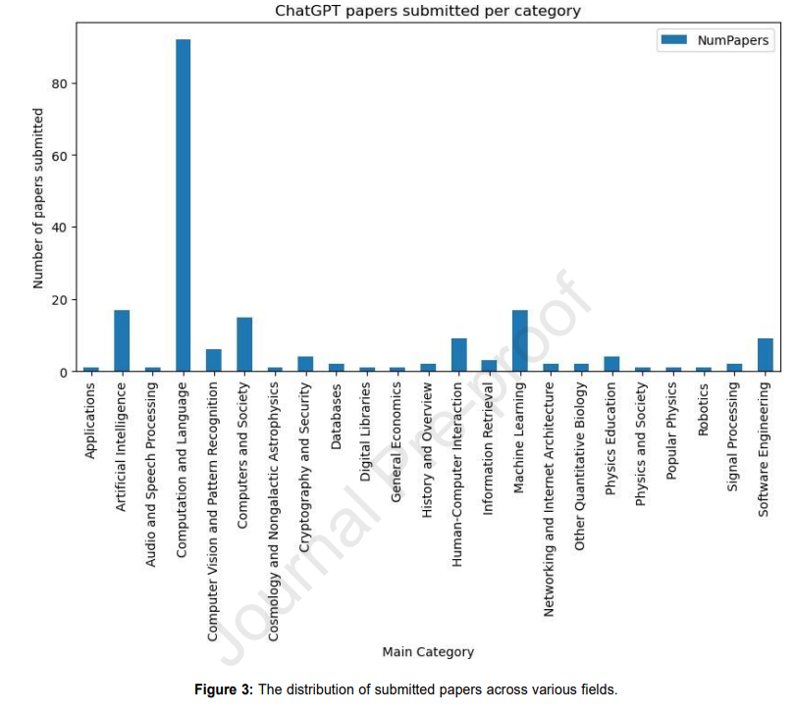

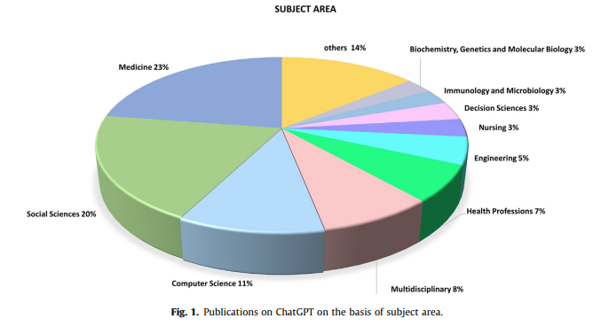

Fig. Publications on ChatGPT on the basis of subject area.[14]

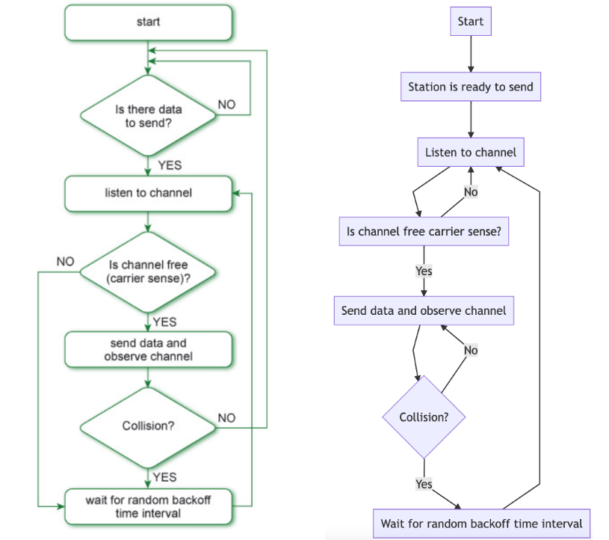

**IV. Result**

Human-like Responses: When compared to previous chatbot models, these models were able to provide more contextually appropriate and logical responses. To analyze their performance, they used metrics such as BLEU, ROUGE, and human evaluations.

Few-Shot Learning: Chat models, such as GPT-3, demonstrated the capacity to complete tasks with few instances or prompts. This means they can produce responses and provide answers with very little training data.[15]

Multimodal Capabilities: Some research has investigated the possibility of integrating text-based chatbot models with vision models, allowing them to comprehend both text and visuals for more interactive and dynamic discussions.[16]

Applications: ChatGPT-like models have found use in customer service, virtual assistants, content development, and other areas. They can be linked into a variety of platforms and services to automate interactions and deliver human-like help.

Researchers and developers have looked into techniques for fine-tuning these models for certain domains or tasks. This enables improved performance in highly specialized scenarios.

Ethical Issues: There is a rising awareness of ethical concerns about AI chatbots. Bias, disinformation, and responsible AI use in chatbot applications have all been investigated

Continual Improvement: Research publications and projects have detailed the iterative changes made to these models, which have resulted in improved performance, fewer biases, and greater safety measures regenerate

The issues surrounding ChatGPT call for a multipronged strategy that incorporates technological advancements, moral considerations, and governmental supervision. The following are a few possible fixes for the issues noted: Fairness and Bias: Various and Empirical Instructional Information: Increasing the diversity and representation of various ethnicities and viewpoints in the training data would improve its quality. Methods for Mitigating Bias: Use strategies for bias detection and reduction while the model is being trained and adjusted. Accountability and Transparency: To facilitate external audits and accountability, increase the transparency of the model decisions and training procedures. Absence of Common Sense Understanding: Enhanced Pre-education: Spend money on studies to enhance models' pre-training so they can comprehend information more intuitively. Adjusting using Input from Humans: Refine the model iteratively using human feedback to minimize the production of illogical or contextually wrong replies.

Retention Policies for Data: Establish precise guidelines for data retention and erasure to make sure that user information is not kept around forever.

Intensiveness of Resources and Scalability:

Efficiency Gains: To cut down on computational expenses, consistently investigate and create more resource-efficient model structures.

Web-based Services: Make ChatGPT available as a cloud service to increase its reach without requiring a lot of local resources.

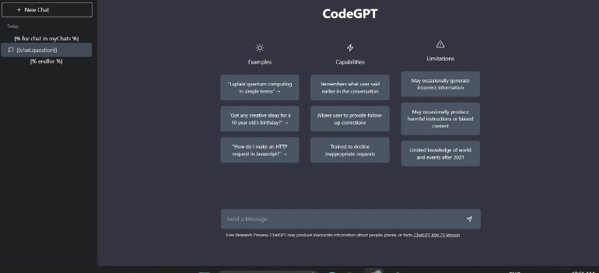

**V. conclusion**

The creation and deployment of powerful conversational AI models, such as the fictitious "ChatGPT," have substantially altered the landscape of human-computer interactions. These models are the result of efforts in natural language processing and machine learning, pushing the limits of what AI can achieve in comprehending and creating human language.

The following are key results and conclusions from research publications and initiatives in this domain:

Human-like chats: Models such as "ChatGPT" have made significant strides in generating human-like responses during text-based chats. They have been widely examined using measures such as BLEU, ROUGE, and human evaluations, and they routinely approach or even exceed human-level performance.

References

[1] A. Tlili *et al.*, “What if the devil is my guardian angel: ChatGPT as a case study of using chatbots in education,” *Smart Learning Environments*, vol. 10, no. 1, Dec. 2023, doi: 10.1186/s40561-023-00237-x.

[2] T. Nur and F. *1, “ELT FORUM 12(1) (2023) Journal of English Language Teaching Artificial intelligence (AI) technology in OpenAI ChatGPT application: A review of ChatGPT in writing English essay,” *Journal of English Language Teaching*, vol. 6, no. 1, 2017, [Online]. Available: http://journal.unnes.ac.id/sju/index.php/elt

[3] B. D. Lund and T. Wang, “Chatting about ChatGPT: how may AI and GPT impact academia and libraries?,” *Library Hi Tech News*, vol. 40, no. 3. Emerald Publishing, pp. 26–29, May 16, 2023. doi: 10.1108/LHTN-01-2023-0009.

[4] R. W. McGee, “Is Chat Gpt Biased Against Conservatives? An Empirical Study,” *SSRN Electronic Journal*, 2023, doi: 10.2139/ssrn.4359405.

[5] D. Johnson *et al.*, “Assessing the Accuracy and Reliability of AI-Generated Medical Responses: An Evaluation of the Chat-GPT Model.,” *Res Sq*, Feb. 2023, doi: 10.21203/rs.3.rs-2566942/v1.

[6] M. U. Haque, I. Dharmadasa, Z. T. Sworna, R. N. Rajapakse, and H. Ahmad, “‘I think this is the most disruptive technology’: Exploring Sentiments of ChatGPT Early Adopters using Twitter Data,” Dec. 2022, [Online]. Available: http://arxiv.org/abs/2212.05856

[7] E. A. M. Van Dis, J. Bollen, R. Van Rooij, W. Zuidema, and C. L. Bockting, “ChatGPT: five priorities for research.”

[8] E. Kasneci *et al.*, “ChatGPT for Good? On Opportunities and Challenges of Large Language Models for Education.”

[9] “ChatGPT: Bullshit spewer or the end of traditional assessments in higher education?,” *Journal of Applied Learning & Teaching*, vol. 6, no. 1, Jan. 2023, doi: 10.37074/jalt.2023.6.1.9.

[10] D. Baidoo-Anu, “Education in the Era of Generative Artificial Intelligence (AI): Understanding the Potential Benefits of ChatGPT in Promoting Teaching and Learning,” 2023. [Online]. Available: https://www.researchgate.net/publication/369385210

[11] C. Qin, A. Zhang, Z. Zhang, J. Chen, M. Yasunaga, and D. Yang, “IS ChatGPT A GENERAL-PURPOSE NATURAL LANGUAGE PROCESSING TASK SOLVER?” [Online]. Available: https://chat.openai.com/

[12] M. Sallam, “The Utility of ChatGPT as an Example of Large Language Models in Healthcare Education, Research and Practice: Systematic Review on the Future Perspectives and Potential Limitations”, doi: 10.1101/2023.02.19.23286155.

[13] J. Kocoń *et al.*, “ChatGPT: Jack of all trades, master of none,” *Information Fusion*, vol. 99, Nov. 2023, doi: 10.1016/j.inffus.2023.101861.

[14] B. D. Lund, T. Wang, N. Reddy Mannuru, B. Nie, S. Shimray, and Z. Wang, “ChatGPT and a New Academic Reality: AI-Written Research Papers and the Ethics of the Large Language Models in Scholarly Publishing.”

[15] C. A. Gao *et al.*, “Comparing scientific abstracts generated by ChatGPT to original abstracts using an artificial intelligence output detector, plagiarism detector, and blinded human reviewers”, doi: 10.1101/2022.12.23.521610.

[16] Q. Zhong, L. Ding, J. Liu, B. Du, and D. Tao, “Can ChatGPT Understand Too? A Comparative Study on ChatGPT and Fine-tuned BERT,” Feb. 2023, [Online]. Available: http://arxiv.org/abs/2302.10198