

Gold in Nome: Key Concepts

- Gold is Alaska's state mineral. The discovery of gold brought thousands of men and women to Alaska. The period from 1880 to 1914 is known as the gold rush era.

- Gold is a ‘precious metal’ because it can only be changed by a small number of rare chemicals. Almost all of the gold ever mined is still in existence.

- Gold is deposited from very very hot water containing compounds of gold. These compounds are gold combined with natural chemicals that allow the gold to dissolve. Most substances (including gold) are more soluble in higher temperature water and will precipitate (deposit) as the water cools.

- Quartz (a hard, clear mineral) is almost always dissolved in the water and also precipitates with the gold. The gold concentration in the mixture of quartz + gold is usually much less than 0.1%. Rocks with gold + quartz are called ‘lode’ gold.

- There are two main types of gold deposits: lode and placer. When gold moves away from its original location through erosion and transport by wind, water, ice, or gravity, it can concentrate in another place to form a placer. Historically 2/3 of Alaska’s gold was mined from placers (in large part because placer deposits are easier to find). Four of the largest lode gold deposits known in Alaska were discovered within the last 30 years.
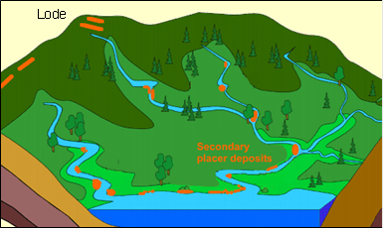

- In a placer deposit gold can be found as clumps (nuggets), as small particles, or as gold dust usually in stream gravels. In the Nome area gold is also present in the present (and past!) beach sand. Gold concentrates in part because smashing gold grains (with rocks or a hammer) causes them to flatten, not break into tiny pieces. This property makes gold ‘ductile’, not brittle. Most other minerals are brittle instead.

- Gold also concentrates because it is very dense; coarse gold does not travel far by water from the source (but can be pushed a long ways by glaciers). Fine-grained gold can sometimes float on water and can travel a long distance—often out to the ocean. A traditional way to look for lode gold was to find placer gold in streams (by panning) and pan one’s way up the stream until the general source area is discovered. In many cases (like Nome) the lodes are covered by vegetation, soil or rocks, and are not easily found.

- In the Nome area the vast vast bulk of the gold mined was placer, often with huge floating factories called ‘dredges’. Many abandoned dredges are present in the area. Dredges dig up and process (extract gold from) huge amounts of gravel and dump them out their back ends, producing huge piles of ‘tailings’. These tailings are easily recognized on remote images and topographic maps and show where placer gold was mined in the past. Topographic maps of the Nome area are consequently records of gold mining from long ago.

- Rivers that drain gold-bearing streams—the Nome and Snake Rivers—contain almost no placer gold. Almost certainly their placers were removed by glaciers moving down from the mountains about 20,000 years ago. The gold was dumped into the ocean where some was concentrated as beach placers.

- Nome IS UNIQUE among Alaskan gold deposits because much of the gold was in modern and ancient beach placers. Thousands of people swarmed to Nome to ‘mine’ gold from the beaches. Even Wyatt Earp was here!

