Annie Worden
Remote Sensing HW#2

- Using Planck’s equation plot blackbody curves for a hot surface at 0C, 17C, 500C, 800C, 3000C, 5700C (Note: Plot Spectral Radiant Exitance on the y-axis and Wavelength on the x-axis). On the plot identify the visible portion of the spectrum.

From the wording of the above task I was not sure if we were supposed to plot the spectral radiance (using both π terms) or the spectral exitance (using only one π term). I went ahead and did the calculations for both equations and plotted them. I also created some plots comparing the radiance and exitance to see how much and in what manner they differ.

Spectral Radiance: Spectral Exitance:
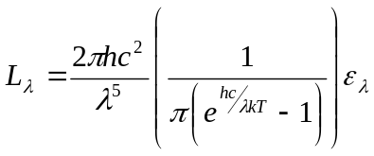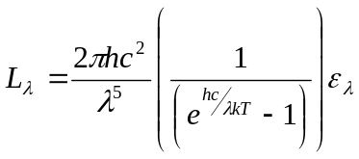

For all temperatures the Spectral Exitance is higher than the Spectral Radiance, by a power of π. This is due to the fact that Spectral Exitance covers all angles and Spectral Radiance is only over one solid angle.

One final comment: The only way to produce plots where all temperatures were visible was to plot the range in three groups. The ‘cool’ group is 0C and 17C. The ‘mid’ group is 500C and 800C. The ‘high’ group is 3000C and 5700C.

All of the plots that I produced are also included in the power point presentation that I attached to the email. They have been sorted and labeled. This might be an easier format to look at them than in this word document.

Plots of Spectral Radiance.
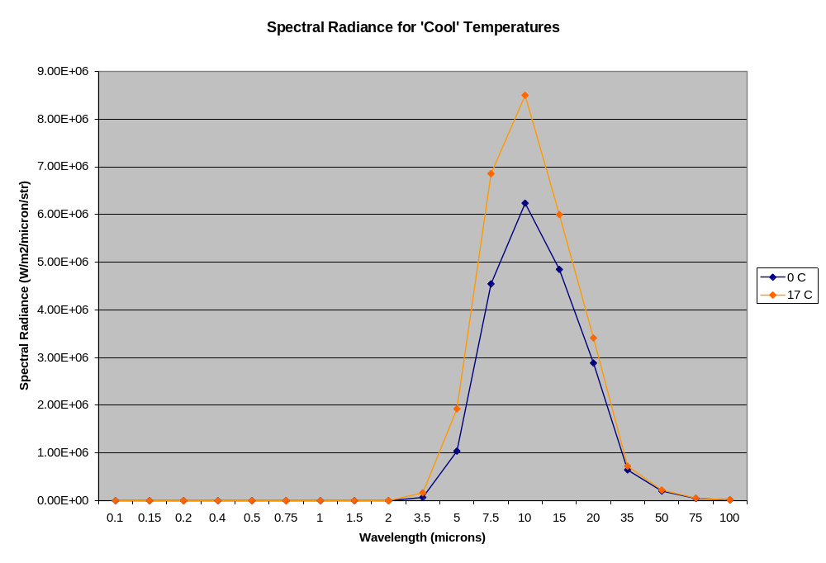
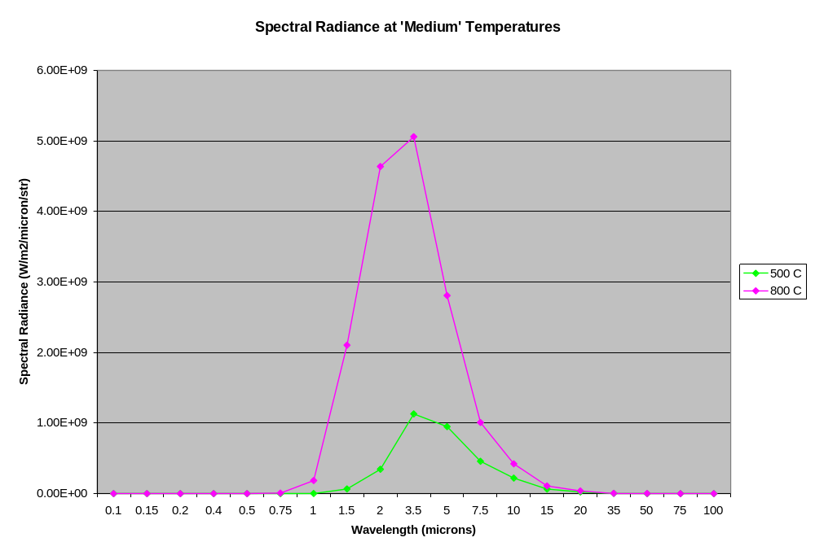
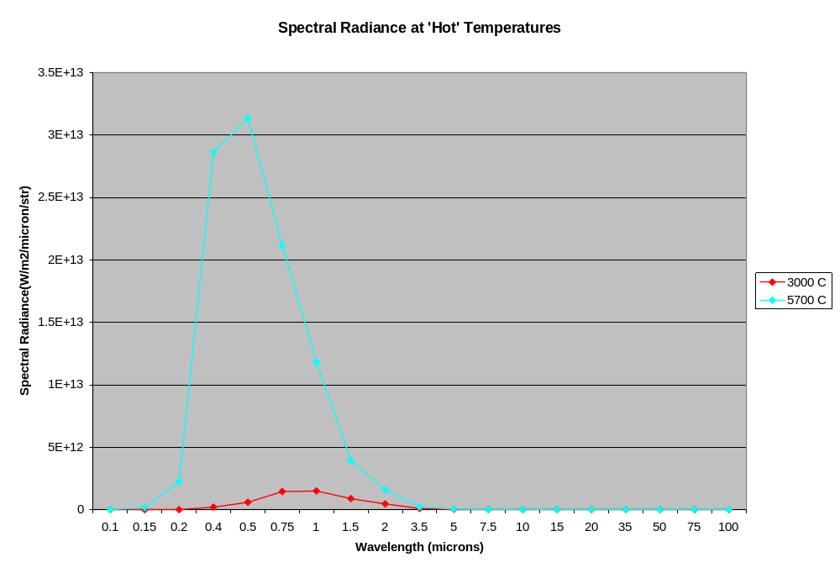
Plots of Spectral Exitance
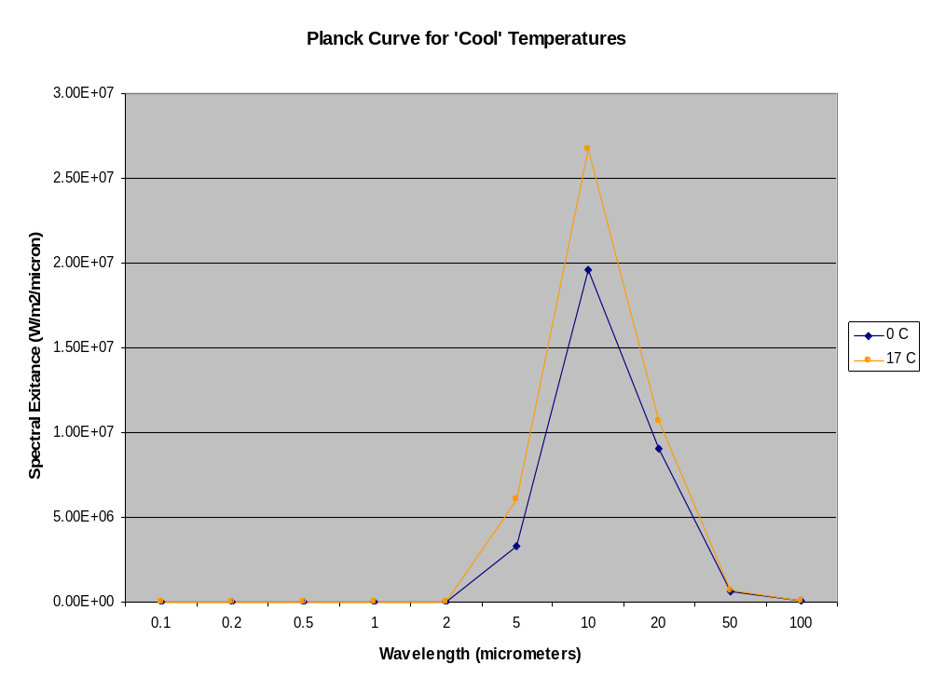
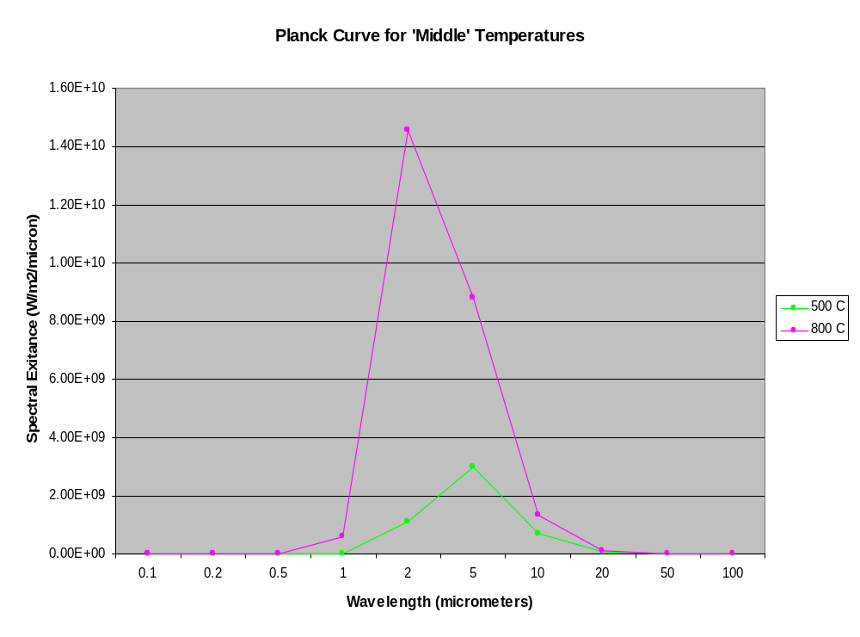
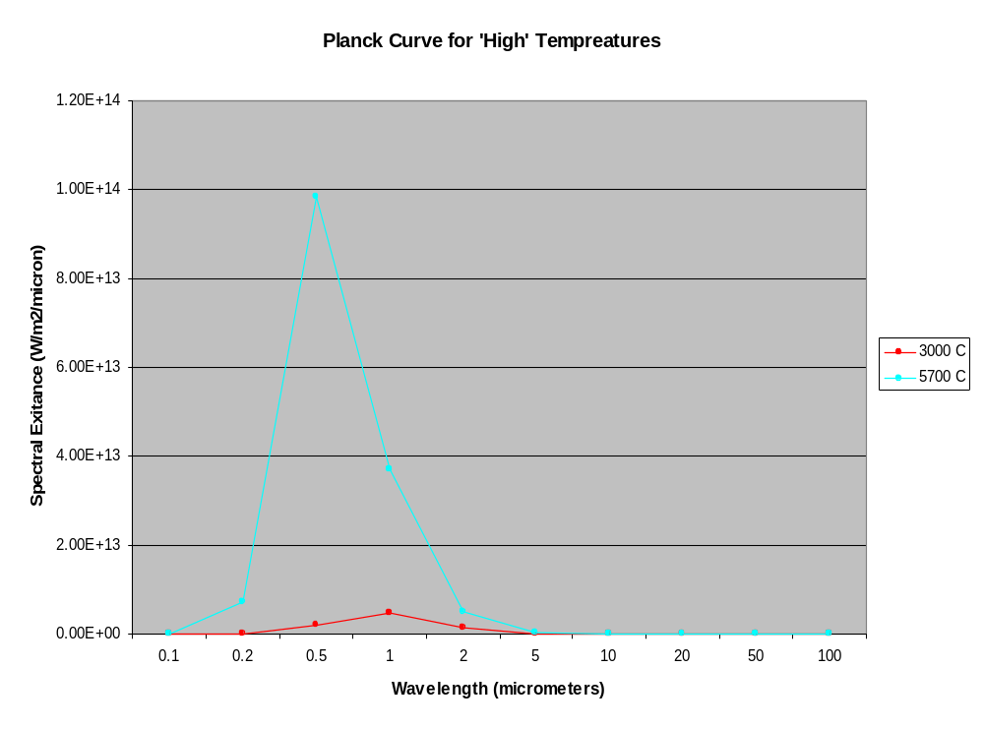
Comparisons of Spectral Radiance to Spectral Exitance.
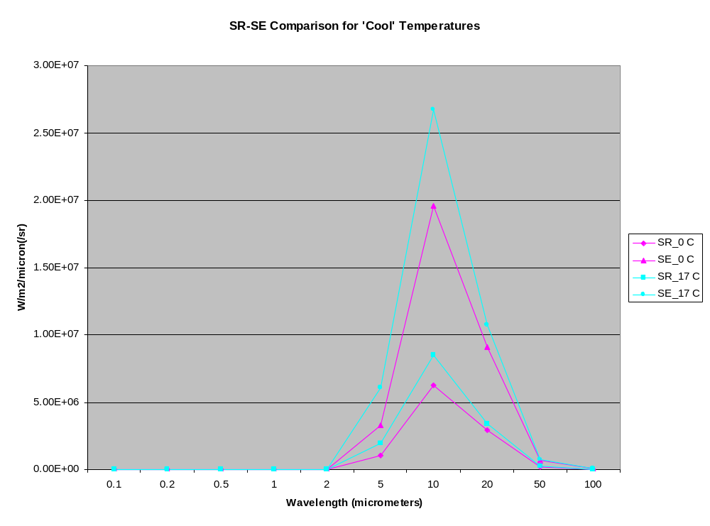
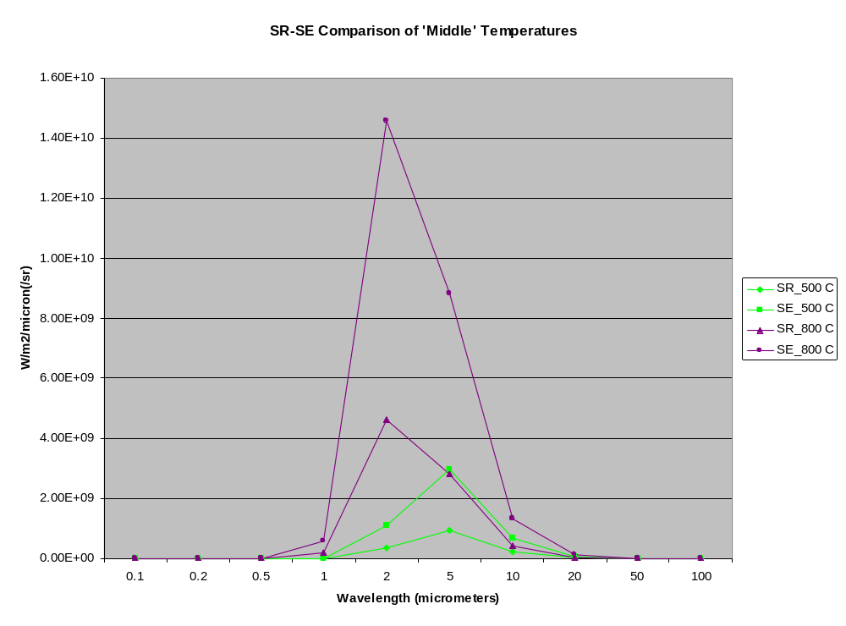
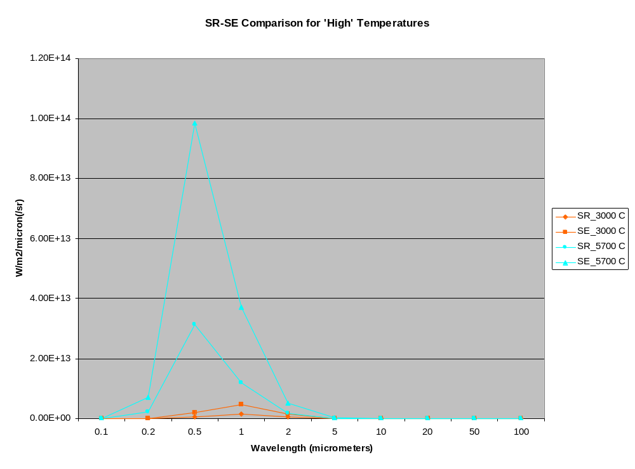

- For the following objects, find out either the temperature or the wavelength of maximum emittance. Determine the correct number of significant figures.

  - Iron Bar: 1.0x10³ C (1273.15 K) = 2300 nm, 2.3 μm, 0.0000023m.
  - Soil: 33.0 C (306.15 K) = 947 nm, 9.47 μm, 0.00000947 m.
  - Lamp: 2945.0 K = 984.00 nm, 0.98400 μm, 0.00000098400m.
  - Star: 5560 K = 521 nm, 0.521 μm, 0.000000521 m.

- Draw a temperature profile along the section line A-A’ for the candle flame shown here. Describe why the flame glows red around the periphery, followed by yellow and then white in the center.

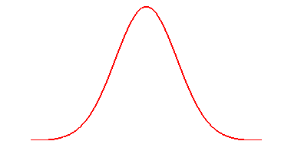
A
A’
Temperature (approx.)
A’
A

The flame is white in the center because it is closest to the fuel source and therefore hottest at that location. The temperature lessens as you move away from the fuel source.

The hottest area will have the highest energy and also the brightest color (white). The area of flame farthest from the fuel source will have the least energy in the flame and will therefore the least bright.

