Matthew Balazs

0 Celsius 17 Celsius

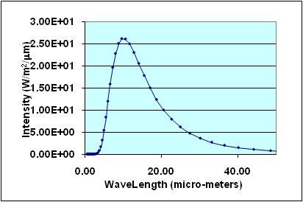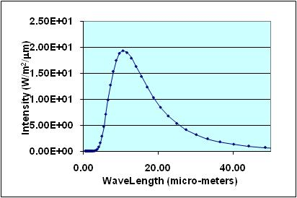

500 Celsius 800 Celsius

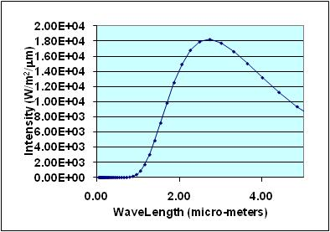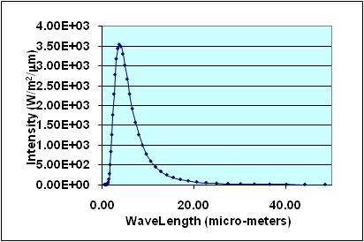

3000 Celsius 5700 Celsius

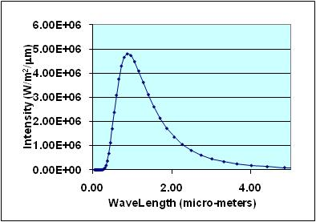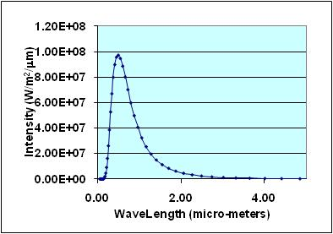

For the following objects, find out either the

temperature or the wavelength of maximum

emittance. Determine the correct number of

significant figures.

• Iron bar: 1.0 × 103 °C __7980____ nm ____7.98___μm 0.00000798______m

• Soil: 33.0 °C ___9800____ nm ___9.8_____μm ___.0000098____m

• Lamp: 2,945.0 K __1020____nm __1.02_____μm ___.00000102_____m

• Star: __5561_______K 521 nm 0.521 μm 0.000000521 m

The Candle

The core of the flame is typically the hottest part with temperatures around 1670 K (1400 °C). The blue (white) part of the flame is where the most oxygen is being burnt up. The red portion is around 1070 K (800 °C), and the yellow portion is less hot than the red.

The changes in color of the flame are directly related to the temperatures at the given point. The blue area, which has higher temperatures will emit energy at the same wavelength as the blue part of the spectrum, roughly 4.40E+05 watts/meter^2.

The red and yellow parts have a lower temp and the wavelengths will be longer, and thus have less energy.