Project Report on
Face Recognition Based Attendance System



Submitted By:
Anup Mazumdar
University Roll No.- 230130718869

Submitted to the K. B. College, Bermo
in partial fullfillment of the requirements for the award of the degree

Bachelor of Computer Application (BCA)
(2022 – 2025)

Under Guidance of :
Kanchan Raju


K. B. College
Bermo, Bokaro, Jharkhand - 829113

CERTIFICATE FOR PROJECT

This is to certify that this is a bonafide record of the project work done satisfactory at “BRIZTECH INFOSYSTEMS PVT. LTD” by Anup Mazumdar (230130718869), in partial fulfilment of BCA Examination. This report or similar report on the topic has not been submitted for any other examination and doesn’t form part of any other course undergone by the candidate.

Date: Kanchan Raju
Place: RANCHI GUIDE, BRIZTECH INFO SYSTEM
RANCHI JHARKHAND

ACKNOWLEDGEMENT

These work has been an intellectually invigorating experience for me. I am sure that the knowledge and experience gathered during the course of this work will make me stand in good stead in future.
With immense pleasure and due respect, I express my sincere gratitude to Prof. P.P KUSHWAHA SIR, in charge, KB College, Bermo, Jharkhand, for all his support and co-operation in successfully completing this thesis work by providing excellent facilities.
I am highly grateful to the College Coordinator Dr. Gopal Prajapati for his ever helping attitude and encouraging us to excel in studies, besides, she has been a source of inspiration during my entire period of BCA.
I would also like to extend my sincere gratitude to all faculties’ members and staff for helping me in my college during my BCA course.
I would like to take this opportunity to extend my sincere gratitude and thanks to my Pioneer Prof. P.P KUSHWAHA, firstly for coming up with such an innovative thesis idea. He has not only made us to work but guided us to orient toward research. It has been real pleasure working under her guidance and it is chiefly her encouragement and motivation that has made this thesis a reality.
Last, but not the last I am heartily thankful to almighty God for showering his blessing forever during my entire life and also to my family members for providing me a great support.

Anup Mazumdar (230130718869)

CERTIFICATE OF APPROVAL

The foregoing project “Face Recognition Based Attendance System”entitled is hereby approved as a creditable work on the topic and has been presented in satisfactory manner to warrant its acceptance as prerequisite to the degree for which it has been submitted.

It is understood that by this approval, the undersigned do not necessarily endorse any conclusion drawn or opinion expressed therein, but approve the project for the purpose for which it is submitted.

(Internal Examiner) (External Examiner)

Bachelor of Computer Application
KB College, Bermo, Jharkhand

DECLARATION BY THE CANDIDATE

By Anup Mazumdar (230130718869), hereby declare that the work, which is being presented in the dissertation, entitled “Face Recognition Based Attendance System”in partial fulfilment of requirement for the award of the degree of “Bachelor of Computer Application” submitted in Binod Bihari Mahto Koyalanchal University, Dhanbad is an authentic record of our work carried out under the guidance of Kanchan Raju .
I have not submitted the matter embodied in this dissertation for the award of any other degree.

Anup Mazumdar (230130718869)

Date:
Place: RANCHI

CONTENTS

ABSTRACT |  |  | i
LIST OF FIGURES |  |  | ii
LIST OF TABLES |  |  | iii
CHAPTER 1 INTRODUCTION |  |  | 1-8
1.1 | Project Objective |  | 2
1.2 | Background |  | 3,4
1.3 | Problem Statement |  | 4,5
1.4 | Aims and Objective |  | 6
1.5 Flow chart |  |  | 7
1.6 | Scope of the project |  | 8
CHAPTER 2 LITERATURE REVIEW |  |  | 9-20
2.1 |  | Student Attendance System | 10
2.2 |  | Digital Image Processing | 10
2.3 |  | Image Representation in a Digital Computer | 11
2.4 Steps in Digital Image Processing |  |  | 11
2.5 Definition of Terms and History |  |  | 12,13
2.5.1 Face Detection |  |  | 12-16
2.5.2 Local Binary Pattern Histogram |  |  | 16
CHAPTER 3 MODAL IMPLEMENTATION AND ANALYSIS |  |  | 21–41
3.1 |  | Introduction | 22
3.2 |  | Modal Implementation | 22
3.3 |  | Design Requirements | 24

3.3.1 Software Implementation |  | 23-25
3.3.2 Hardware Implementation |  | 25
3.3.2.1 NVIDIA Jetson Nano Developer Kit |  | 26-38
3.3.2.2 Webcam |  | 38,39
3.4 | Experimental Results | 39-41
CHAPTER 4 CODE IMPLEMENTATION |  | 42-54
4.1 | Code Implementation | 43
 | 4.1.1 main.py | 43-45
 | 4.1.2 automail py | 46
 | 4.1.3 capture_image,py | 46-48
 | 4.1.4 checkcamera.py | 49
 | 4.1.5 Train_image.py | 50
 | 4.1.6 Recognize.py | 51,52
 | 4.1.7 requirement.txt | 52,53
4.2 | Sample Images | 54
CHAPTER 5 WORKPLAN |  | 55-58.
5.1 | Introduction | 56
5.2 | Work Breakdown Structure | 56
 | 5.2.1 Work plan | 57
 | 5.2.2 Financial Plan | 58
CHAPTER 6 PERFORMANCE ANALYSIS |  | 59-60
6.1 | Introduction | 60
6.2 | Analysis | 60
 |  | 63-64

CONCLUSION | 62
REFERENCES | 63-64

ABSTRACT

In colleges, universities, organizations, schools, and offices, taking attendance is one of the most important tasks that must be done on a daily basis. The majority of the time, it is done manually, such as by calling by name or by roll number. The main goal of this project is to create a Face Recognition-based attendance system that will turn this manual process into an automated one. This project meets the requirements for bringing modernization to the way attendance is handled, as well as the criteria for time management. This device is installed in the classroom, where and student's information, such as name, roll number, class, sec, and photographs, is trained. The images are extracted using Open CV. Before the start of the corresponding class, the student can approach the machine, which will begin taking pictures and comparing them to the qualified dataset. Logitech C270 web camera and NVIDIA Jetson Nano Developer kit were used in this project as the camera and processing board. The image is processed as follows: first, faces are identified using a HaarCascade classifier, then faces are recognized using the LBPH (Local Binary Pattern Histogram) Algorithm, histogram data is checked against an established dataset, and the device automatically labels attendance. An Excel sheet is developed, and it is updated every hour with the information from the respective class instructor.

Keywords: Face Detection, Face Recognition, HaarCascade classifier, NVIDIA Jetson Nano

i

LIST OF FIGURES:

Figure 1.1 Project outline | 10
Figure 2.1 A diagram showing the steps in digital image processing | 12
Figure 2.2 Haar Feature | 15
Figure 2.3 Integral of Image | 15
Figure 2.4 LBP Operation | 17
Figure 2.5 The LBP operation Radius charge | 18
Figure 2.6 Extracting the Histogram | 19
Figure 3.1 Model Implement | 22
Figure 3.2 Installing OpenCV | 24
Figure 3.3 Jetson Nano Board | 25
Figure 3.4 The first step to configure your NVIDIA Jetson Nano for computer | 28
vision and deep learning
is to download the Jetpack SD card image
Figure 3.5 Download and install balena Etcher for your OS. You will use it to flash | 28
your Nano image to a microSD card.
Figure 3.6: Flashing NVIDIA’s Jetpack image to a microSD card with balenaE | 29
tcher is one of the first steps for configuring
Figure 3.7 To insert your Jetpack-flashed microSD after it has been flashed, find | 29
the microSD slot as shown by the red circle in the image. Insert your microSD until
it clicks into place.
Figure3.8: Use the icon near the top right corner of your screen to configure | 30
networking settings on your NVIDIA Jetson Nano. You will need internet access to download and install computer vision and deep learning software
Figure 3.9 Each Python virtual environment you create on your NVIDIA Jetson | 34
Nano is separate and independent from the others.
Figure 3.10 Terminal output from the virtual env wrapper setup installation | .36
indicates that there are no errors. We now have a virtual environment management
system in place so we can create computer vision and deep learning virtual
environments on our NVIDIA Jetson Nano.
Figure 3.11 Ensure that your bash prompt begins with your virtual environment | 38
name for the remainder of this tutorial on configuring your NVIDIA Jetson Nano
for deep learning and co mputer vision.
Figure 3.12 Web cam | 41
Figure 4.1 Output Image | 54

ii

LIST OF TABLES:

Table 2.1 Advantages and Disadvantages of Difference Biometric |  | 10
System
Table 2.2 Advantages and Disadvantages of Face Detection Method |  | 14
Table 3.1 Specifications of Jetson Nano Developer kit |  | 26-27
Table 3.2 Experimental Results-1 |  | 40
Table 3.3 | Experimental Results-2 | 41
Table 5.1 | Work plan | 56,57
Table 5.2 | Financial Plan | 58

iii

CHAPTER-1

INTRODUCTION

1

1.1 Project Objective:

Attendance is prime important for both the teacher and student of an educational organization. So it is very important to keep record of the attendance. The problem arises when we think about the traditional process of taking attendance in class room.

Calling name or roll number of the student for attendance is not only a problem of time consumption but also it needs energy. So an automatic attendance system can solve all above problems.

There are some automatic attendances making system which are currently used by much institution. One of such system is biometric technique and RFID system. Although it is automatic and a step ahead of traditional method it fails to meet the time constraint. The student has to wait in queue for giving attendance, which is time taking.

This project introduces an involuntary attendance marking system, devoid of any kind of interference with the normal teaching procedure. The system can be also implemented during exam sessions or in other teaching activities where attendance is highly essential. This system eliminates classical student identification such as calling name of the student, or checking respective identification cards of the student, which can not only interfere with the ongoing teaching process, but also can be stressful for students during examination sessions. In addition, the students have to register in the database to be recognized. The enrolment can be done on the spot through the user-friendly interface.

2

1.2 Background:

Face recognition is crucial in daily life in order to identify family, friends or someone we are familiar with. We might not perceive that several steps have actually taken in order to identify human faces. Human intelligence allows us to receive information and interpret the information in the recognition process. We receive information through the image projected into our eyes, by specifically retina in the form of light. Light is a form of electromagnetic waves which are radiated from a source onto an object and projected to human vision. Robinson-Riegler, G., & Robinson-Riegler, B. (2008) mentioned that after visual processing done by the human visual system, we actually classify shape, size, contour and the texture of the object in order to analyze the information. The analyzed information will be compared to other representations of objects or face that exist in our memory to recognize. In fact, it is a hard challenge to build an automated system to have the same capability as a human to recognize faces. However, we need large memory to recognize different faces, for example, in the Universities, there are a lot of students with different race and gender, it is impossible to remember every face of the individual without making mistakes. In order to overcome human limitations, computers with almost limitless memory, high processing speed and power are used in face recognition systems.

The human face is a unique representation of individual identity. Thus, face recognition is defined as a biometric method in which identification of an individual is performed by comparing real-time capture image with stored images in the database of that person (Margaret Rouse, 2012).

3

Nowadays, face recognition system is prevalent due to its simplicity and awesome performance. For instance, airport protection systems and FBI use face recognition for criminal investigations by tracking suspects, missing children and drug activities (Robert Silk, 2017). Apart from that, Facebook which is a popular social networking website implement face recognition to allow the users to tag their friends in the photo for entertainment purposes (Sidney Fussell, 2018). Furthermore, Intel Company allows the users to use face recognition to get access to their online account (Reichert, C., 2017). Apple allows the users to unlock their mobile phone, iPhone X by using face recognition (deAgonia, M., 2017).

The work on face recognition began in 1960. Woody Bledsoe, Helen Chan Wolf and Charles Bisson had introduced a system which required the administrator to locate eyes, ears, nose and mouth from images. The distance and ratios between the located features and the common reference points are then calculated and compared. The studies are further enhanced by Goldstein, Harmon, and Lesk in 1970 by using other features such as hair colour and lip thickness to automate the recognition. In 1988, Kirby and Sirovich first suggested principle component analysis (PCA) to solve face recognition problem. Many studies on face recognition were then conducted continuously until today (Ashley DuVal, 2012).

1.3 Problem Statement:

Traditional student attendance marking technique is often facing a lot of trouble. The face recognition student attendance system emphasizes its simplicity by eliminating classical student attendance marking technique such as

4

calling student names or checking respective identification cards. There are not only disturbing the teaching process but also causes distraction for students during exam sessions. Apart from calling names, attendance sheet is passed around the classroom during the lecture sessions. The lecture class especially the class with a large number of students might find it difficult to have the attendance sheet being passed around the class. Thus, face recognition attendance system is proposed in order to replace the manual signing of the presence of students which are burdensome and causes students get distracted in order to sign for their attendance. Furthermore, the face recognition based automated student attendance system able to overcome the problem of fraudulent approach and lecturers does not have to count the number of students several times to ensure the presence of the students.

The paper proposed by Zhao, W et al. (2003) has listed the difficulties of facial identification. One of the difficulties of facial identification is the identification between known and unknown images. In addition, paper proposed by Pooja G.R et al. (2010) found out that the training process for face recognition student attendance system is slow and time-consuming. In addition, the paper proposed by Priyanka Wagh et al. (2015) mentioned that different lighting and head poses are often the problems that could degrade the performance of face recognition based student attendance system.

Hence, there is a need to develop a real time operating student attendance system which means the identification process must be done within defined time constraints to prevent omission. The extracted features from facial images which represent the identity of the students have to be consistent towards a change in background, illumination, pose and expression. High accuracy and fast computation time will be

5

the evaluation points of the performance.

1.4 Aims and Objectives:

The objective of this project is to develop face recognition attendance system.

Expected achievements in order to fulfill the objectives are:

- To detect the face segment from the video frame.

- To extract the useful features from the face detected.

- To classify the features in order to recognize the face detected.

- To record the attendance of the identified student.

6

1.5 Flow chart
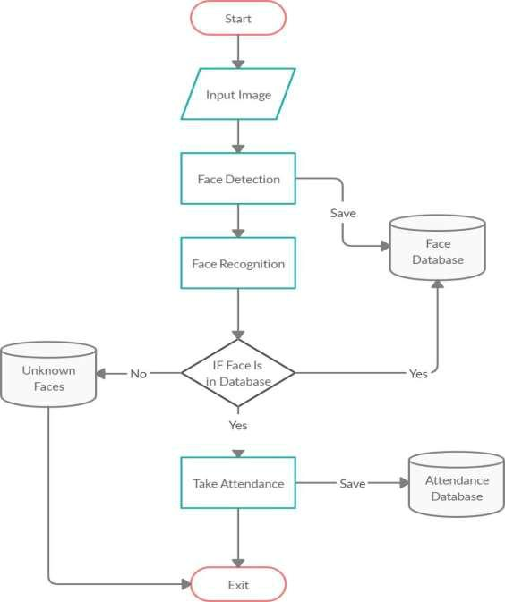

1.1 Project Outline

7

1.6 Scope of the project:

We are setting up to design a system comprising of two modules. The first module (face detector) is a mobile component, which is basically a camera application that captures student faces and stores them in a file using computer vision face detection algorithms and face extraction techniques. The second module is a desktop application that does face recognition of the captured images (faces) in the file, marks the students register and then stores the results in a database for future analysis.

8

CHAPTER-2

LITERATURE REVIEW

9

2.1 Student Attendance System:

Arun Katara et al. (2017) mentioned disadvantages of RFID (Radio Frequency Identification) card system, fingerprint system and iris recognition system. RFID card system is implemented due to its simplicity. However, the user tends to help their friends to check in as long as they have their friend’s ID card. The fingerprint system is indeed effective but not efficient because it takes time for the verification process so the user has to line up and perform the verification one by one. However for face recognition, the human face is always exposed and contain less information compared to iris. Iris recognition system which contains more detail might invade the privacy of the user. Voice recognition is available, but it is less accurate compared to other methods. Hence, face recognition system is suggested to be implemented in the student attendance system.

System Type | Advantage | Disadvantages
RFID card system | Simple | Fraudulent usage
Fingerprint system | Accurate | Time-consuming
Voice recognition system |  | Less accurate compared
 |  | to Others
Iris recognition system | Accurate | Privacy Invasion

Table 2.1: Advantages & Disadvantages of Different Biometric System

2.2 Digital Image Processing:

Digital Image Processing is the processing of images which are digital in nature by a digital computer. Digital image processing techniques are motivated by three major applications mainly:

- Improvement of pictorial information for human perception

10

- Image processing for autonomous machine application

- Efficient storage and transmission.

2.3 Image Representation in a Digital Computer:

An image is a 2-Dimensional light intensity function

(,)= (,)× (,)-(2.0)

Where, r (x, y) is the reflectivity of the surface of the corresponding image point. i (x,y) Represents the intensity of the incident light. A digital image f(x, y) is discretized both in spatial co-ordinates by grids and in brightness by quantization. Effectively, the image can be represented as a matrix whose row, column indices specify a point in the image and the element value identifies gray level value at that point. These elements are referred to as pixels or pels.

Typically following image processing applications, the image size which is used is × , elements, × pels or × pixels. Quantization of these matrix pixels is done at 8 bits for black and white images and 24 bits for colored images (because of the three color planes Red, Green and Blue each at 8 bits)[.

2.4 Steps in Digital Image Processing:

Digital image processing involves the following basic tasks:

- Image Acquisition - An imaging sensor and the capability to digitize the signal produced by the sensor.

- Preprocessing – Enhances the image quality, filtering, contrast enhancement etc.

- Segmentation – Partitions an input image into constituent parts of objects.

11

- Description/feature Selection – extracts the description of image objects suitable for further computer processing.

- Recognition and Interpretation – Assigning a label to the object based on the information provided by its descriptor. Interpretation assigns meaning to a set of labelled objects.

- Knowledge Base – This helps for efficient processing as well as inter module cooperation.
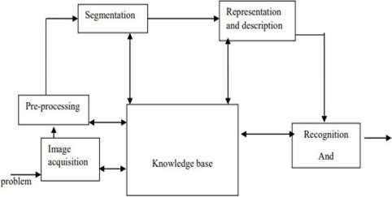

Figure 2.1 : A diagram showing the steps in digital image processing

2.5 Definition of Terms and History:

Face Detection

Face detection is the process of identifying and locating all the present faces in a single image or video regardless of their position, scale, orientation, age and expression. Furthermore, the detection should be irrespective of extraneous illumination conditions and the image and video content[⁵].

2.5.1 Face Recognition

Face Recognition is a visual pattern recognition problem, where the face, represented as a three dimensional object that is subject to varying illumination,

12

pose and other factors, needs to be identified based on acquired images[⁶].

Face Recognition is therefore simply the task of identifying an already detected face as a known or unknown face and in more advanced cases telling exactly whose face it is[⁷].

Difference between Face Detection and Face Recognition

Face detection answers the question, Where is the face? It identifies an object as a “face” and locates it in the input image. Face Recognition on the other hand answers the question who is this? Or whose face is it? It decides if the detected face is someone .It can therefore be seen that face detections output (the detected face) is the input to the face recognizer and the face Recognition’s output is the final decision i.e. face known or face unknown.

Face Detection

A face Detector has to tell whether an image of arbitrary size contains a

human face and if so, where it is. Face detection can be performed based on several cues: skin color (for faces in color images and videos, motion (for faces in videos), facial/head shape, facial appearance or a combination of these parameters. Most face detection algorithms are appearance based without using other cues. An input image is scanned at all possible locations and scales by a sub window. Face detection is posed as classifying the pattern in the sub window either as a face or a non-face. The face/nonface classifier is learned from face and non-face training examples using statistical learning methods[⁹]. Most modern algorithms are based on the Viola Jones object detection framework, which is based on Haar Cascades.

13

Face Detection | Advantages | Disadvantages
Method | Advantages | Disadvantages
 | 1. High detection | 1. Long Training Time. 2.Limited
Viola Jones | 1. High detection | Head Pose. 3.Not able to detect dark
Viola Jones | Speed. | Head Pose. 3.Not able to detect dark
Algorithm | Speed. | faces.
Algorithm | 2. High Accuracy. | faces.
 | 1.Simple computation. | 1.Only used for binary and grey
Local Binary | 2.High tolerance against | images. 2.Overall performance is
Pattern Histogram | the monotonic | inaccurate compared to Viola-Jones
 | illumination changes. | Algorithm.
 | Need not to have any prior | The result highly depends on the training
Ada Boost | knowledge about face | The result highly depends on the training
Ada Boost | knowledge about face | data and affected by weak classifiers.
Algorithm | structure. | data and affected by weak classifiers.
 | 1. Capable to deal with
SMQT Features | lighting problem in object | The region contain very similar to grey
and SNOW | detection. | value regions will be misidentified as face.
Classifier Method | 2. Efficient in
 | computation.
 |  | 1. Detection process is slow and
 | High accuracy only if large | computation is complex.
Neural-Network | size of image were trained. | 2. Overall performance is weaker
 |  | than Viola-Jones
 |  | algorithm.

Table 2.2: Advantages & Disadvantages of Face Detection Methods

Viola-Jones algorithm which was introduced by P. Viola, M. J. Jones (2001) is the most popular algorithm to localize the face segment from static images or video frame. Basically the concept of Viola-Jones algorithm consists of four parts. The first part is known as Haar feature, second part is where integral image is created, followed by implementation of Adaboost on the third part and lastly cascading process.

14
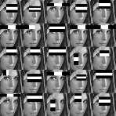
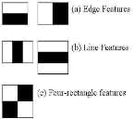

Figure 2.2: Haar Feature

Viola-Jones algorithm analyses a given image using Haar features consisting of multiple rectangles (Mekha Joseph et al., 2016).

In the fig shows several types of Haar features. The features perform as window function mapping onto the image. A single value result, which representing each feature can be computed by subtracting the sum of the white rectangle(s) from the sum of the black rectangle(s).
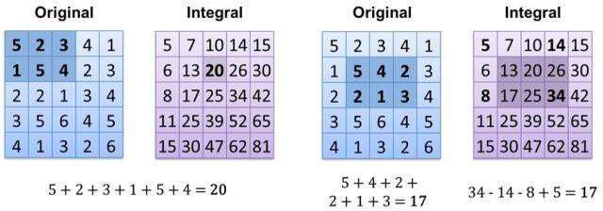

Figure 2.3: Integral of Image

The value of integrating image in a specific location is the sum of pixels on the left and the top of the respective location. In order to illustrate clearly, the value of the integral image at location 1 is the sum of the pixels in rectangle A. The values

15

of integral image at the rest of the locations are cumulative. For instance, the value at location 2 is summation of A and B, (A + B), at location 3 is summation of A and C, (A + C), and at location 4 is summation of all the regions, (A + B + C + D). Therefore, the sum within the D region can be computed with only addition and subtraction of diagonal at location 4 + 1 − (2 + 3) to eliminate rectangles A, B and C.

2.5.2 Local Binary Pattern Histogram

Local Binary Pattern (LBP) is a simple yet very efficient texture operator which labels the pixels of an image by thresholding the neighborhood of each pixel and considers the result as a binary number.

It was first described in 1994 (LBP) and has since been found to be a powerful feature for texture classification. It has further been determined that when LBP is combined with histograms of oriented gradients (HOG) descriptor, it improves the detection performance considerably on some datasets. Using the LBP combined with histograms we can represent the face images with a simple data vector.

LBPH algorithm work step by step:

LBPH algorithm work in 5 steps.

- Parameters: the LBPH uses 4 parameters:

  - Radius: the radius is used to build the circular local binary pattern and represents the radius around the central pixel. It is usually set to 1.

  - Neighbors: the number of sample points to build the circular local

binary pattern. Keep in mind: the more sample points you include, the higher the computational cost. It is usually set to 8.

  - Grid X: the number of cells in the horizontal direction. The more cells, the finer the grid, the higher the dimensionality of the resulting feature vector. It is usually set to 8.

16

  - Grid Y: the number of cells in the vertical direction. The more cells, the finer the grid, the higher the dimensionality of the resulting feature vector. It is usually set to 8.

- Training the Algorithm: First, we need to train the algorithm. To do so, we need to use a dataset with the facial images of the people we want to recognize. We need to also set an ID (it may be a number or the name of the person) for each image, so the algorithm will use this information to recognize an input image and give you an output. Images of the same person must have the same ID. With the training set already constructed, let’s see the LBPH computational steps.

- Applying the LBP operation: The first computational step of the LBPH is to create an intermediate image that describes the original image in a better way, by highlighting the facial characteristics. To do so, the algorithm uses

a concept of a sliding window, based on the parameters radius and neighbors.

The image below shows this procedure:
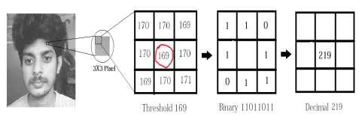

Figure 2.4: LBP Operation

Based on the image above, let’s break it into several small steps so we can understand it easily:

- Suppose we have a facial image in grayscale.

- We can get part of this image as a window of 3x3 pixels.

17

- It can also be represented as a 3x3 matrix containing the intensity of each pixel (0~255).

- Then, we need to take the central value of the matrix to be used as the threshold.

- This value will be used to define the new values from the 8 neighbors.

- For each neighbor of the central value (threshold), we set a new binary value. We set 1 for values equal or higher than the threshold and 0 for values lower than the threshold.

- Now, the matrix will contain only binary values (ignoring the central value). We need to concatenate each binary value from each position from the matrix line by line into a new binary value (e.g. 10001101). Note: some authors use other approaches to concatenate the binary values (e.g. clockwise direction), but the final result will be the same.

- Then, we convert this binary value to a decimal value and set it to the central value of the matrix, which is actually a pixel from the original image.

- At the end of this procedure (LBP procedure), we have a new image which represents better the characteristics of the original image.
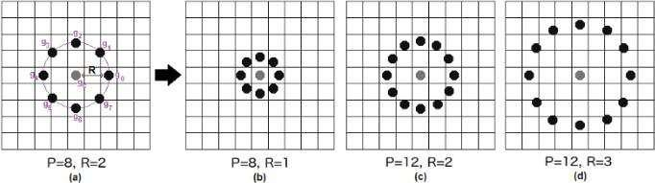

Figure 2.5: The LBP operation Radius Change

It can be done by using bilinear interpolation. If some data point is between the pixels, it uses the values from the 4 nearest pixels (2x2) to estimate the

18

value of the new data point.

- Extracting the Histograms: Now, using the image generated in the last step, we can use the Grid X and Grid Y parameters to divide the image into multiple grids, as can be seen in the following image:
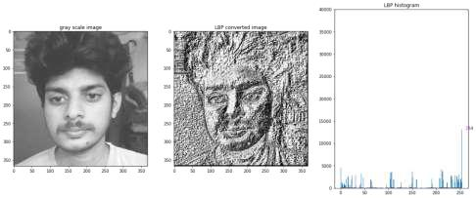

Figure 2.6: Extracting The Histogram

Based on the image above, we can extract the histogram of each region as follows:

  - As we have an image in grayscale, each histogram (from each grid) will contain only 256 positions (0~255) representing the occurrences of each pixel intensity.

  - Then, we need to concatenate each histogram to create a new and bigger histogram. Supposing we have 8x8 grids, we will have 8x8x256=16.384 positions in the final histogram. The final histogram represents the characteristics of the image original image.

- Performing the face recognition: In this step, the algorithm is already trained. Each histogram created is used to represent each image from the training dataset. So, given an input image, we perform the steps again for this new image and creates a histogram which represents the image.

19

- So to find the image that matches the input image we just need to compare two histograms and return the image with the closest histogram.

- We can use various approaches to compare the histograms (calculate the distance between two histograms), for example: Euclidean distance, chi-square, absolute value, etc. In this example, we can use the Euclidean distance (which is quite known) based on the following formula:
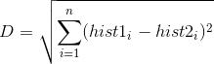

- So the algorithm output is the ID from the image with the closest histogram. The algorithm should also return the calculated distance, which can be used as a ‘confidence’ measurement.

- We can then use a threshold and the ‘confidence’ to automatically estimate if the algorithm has correctly recognized the image. We can assume that the algorithm has successfully recognized if the confidence is lower than the threshold defined.

20

CHAPTER-3
MODAL IMPLEMENTATION
AND ANALYSIS

21

3.1 INTRODUCTION:

Face detection involves separating image windows into two classes; one containing faces (turning the background (clutter). It is difficult because although commonalities exist between faces, they can vary considerably in terms of age, skin colour and facial expression. The problem is further complicated by differing lighting conditions, image qualities and geometries, as well as the possibility of partial occlusion and disguise. An ideal face detector would therefore be able to detect the presence of any face under any set of lighting conditions, upon any background. The face detection task can be broken down into two steps. The first step is a classification task that takes some arbitrary image as input and outputs a binary value of yes or no, indicating whether there are any faces present in the image. The second step is the face localization task that aims to take an image as input and output the location of any face or faces within that image as some bounding box with (x, y, width, height).After taking the picture the system will compare the equality of the pictures in its database and give the most related result.

We will use NVIDIA Jetson Nano Developer kit, Logitech C270 HD Webcam, open CV platform and will do the coding in python language.

3.2 Modal Implementation:
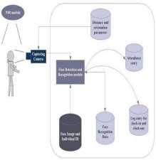

Figure 3.1: Model Implement

22

The main components used in the implementation approach are open source computer vision library (OpenCV). One of OpenCV’s goals is to provide a simple-to-use computer vision infrastructure that helps people build fairly sophisticated vision applications quickly. OpenCV library contains over 500 functions that span many areas in vision. The primary technology behind Face recognition is OpenCV. The user stands in front of the camera keeping a minimum distance of 50cm and his image is taken as an input. The frontal face is extracted from the image then converted to gray scale and stored. The Principal component Analysis (PCA) algorithm is performed on the images and the eigen values are stored in an xml file. When a user requests for recognition the frontal face is extracted from the captured video frame through the camera. The eigen value is re-calculated for the test face and it is matched with the stored data for the closest neighbour.

3.3 Design Requirements:

We used some tools to build the system. Without the help of these tools it would not be possible to make it done. Here we will discuss about the most important one.

3.3.1 Software Implementation:

- OpenCV: We used OpenCV 3 dependency for python 3. OpenCV is library where there are lots of image processing functions are available. This is very useful library for image processing. Even one can get expected outcome without writing a single code. The library is cross-platform and free for use under the open-source BSD license. Example of some supported functions are given bellow:
  - Derivation: Gradient/Laplacian computing, contours delimitation

  - Hough transforms: lines, segments, circles, and geometrical shapes detection

23

- Histograms: computing, equalization, and object localization with back projection algorithm

- Segmentation: thresholding, distance transform, foreground/background detection, watershed segmentation

- Filtering: linear and nonlinear filters, morphological operations

- Cascade detectors: detection of face, eye, car plates

- Interest points: detection and matching

- Video processing: optical flow, background subtraction, camshaft (object tracking)

- Photography: panoramas realization, high definition imaging (HDR), image inpainting

So it was very important to install OpenCV. But installing OpenCV 3 is a complex process. How we did it is given below:
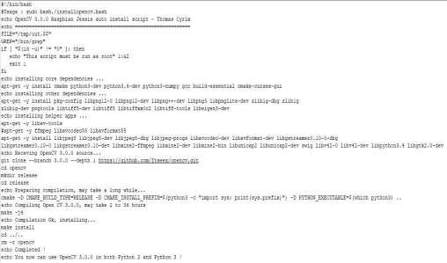

Fig 3.2: Installing OpenCV

24

We copied this script and place it on a directory on our raspberry pi and saved it.

Then through terminal we made this script executable and then ran it.

Sudo chmod 755 /myfile/pi/installopencv.bash

sudo /myfile/pi/installopencv.bash

these are the command line we used.

- Python IDE: There are lots of IDEs for python. Some of them are PyCharm, Thonny, Ninja, Spyder etc. Ninja and Spyder both are very excellent and free but we used Spyder as it feature- rich than ninja. Spyder is a little bit heavier than ninja but still much lighter than PyCharm. You can run them in pi and get GUI on your PC

1. sudo apt-get isntall spyder

through ssh-Y. We installed Spyder through the command line below.

3.3.2 Hardware Implementation:
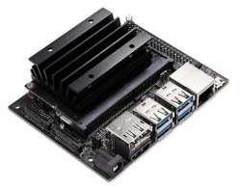

Figure 3.3 Jetson Board

25

3.3.2.1 NVIDIA Jetson Nano Developer kit:

NVIDIA® Jetson Nano™ Developer Kit is a small, powerful computer lets you run multiple neural networks in parallel for applications like image classification, object detection, segmentation, and speech processing. All in an easy-to-use platform that runs in as little as 5 watts.

It’s simpler than ever to get started! Just insert a microSD card with the system image, boot the developer kit, and begin using the same NVIDIA JetPack SDK used across the entire NVIDIA Jetson™ family of products. JetPack is compatible with NVIDIA’s world-leading AI platform for training and deploying AI software, reducing complexity and effort for developers.

Specifications:

GPU | 128-core NVIDIA Maxwell™
CPU | Quad-core ARM® A57 @ 1.43 GHz
Memory | 2 GB 64-bit LPDDR4 25.6 GB/s
Storage | microSD (Card not included)
Video Encode | 4Kp30 | 4x | 1080p30 | 9x 720p30 (H.264/H.265)
Video Decode | 4Kp60 | 2x | 4Kp30 | 8x 1080p30 | 18x 720p30 (H.264/H.265)
Connectivity | Gigabit Ethernet, 802.11ac wireless†

26

Camera | 1x MIPI CSI-2 connector
Display | HDMI
USB | 1x USB 3.0 Type A,2x USB 2.0 Type A, USB 2.0 Micro-B
Others | 40-pin header (GPIO, I2C, I2S, SPI, UART)
 | 12-pin header (Power and related signals, UART)
 | 4-pin Fan header†
Mechanical | 100 mm x 80 mm x 29 mm

Table 3.1 Specifications of Jetson Nano Developer kit

The developer kit uses a microSD card as boot device and for main storage. It’s important to have a card that’s fast and large enough for your projects; the minimum requirement is a 32GB UHS-1 card.

So we used 64Gb microSD card.

Before utilizing it, we have to configure our NVIDIA Jetson Nano Board for Computer Vision and Deep Learning with TensorFlow, Keras, TensorRT, and OpenCV.

The NVIDIA Jetson Nano packs 472GFLOPS of computational horsepower. While it is a very capable machine, configuring it is not easy to configure.

Step #1: Flash NVIDIA’s Jetson Nano Developer Kit .img to a microSD for Jetson Nano

In this step, we will download NVIDIA’s Jetpack 4.2 Ubuntu-based OS image and flash it to a microSD. You will need the microSD flashed and ready to go to follow along with the next steps. So ensure that you download the “Jetson Nano Developer Kit SD Card image” as shown in the following screenshot:

27
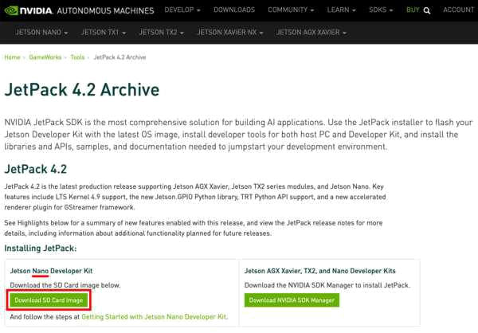

Figure 3.4: The first step to configure your NVIDIA Jetson Nano for computer vision and deep learning is to download the Jetpack SD card image

While your Nano SD image is downloading, go ahead and download and install balenaEtcher, a disk image flashing tool:
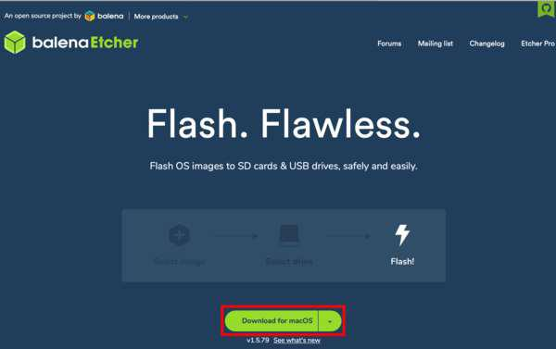

Figure 3.5: Download and install balenaEtcher for your OS. You will use it to flash your Nano image to a microSD card.

28

Once both (1) your Nano Jetpack image is downloaded, and (2) balenaEtcher is installed, you are ready to flash the image to a microSD.

Insert the microSD into the card reader, and then plug the card reader into a USB port on your computer. From there, fire up balenaEtcher and proceed to flash.
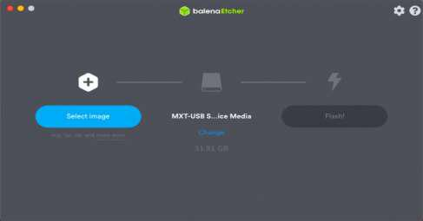

Figure 3.6: Flashing NVIDIA’s Jetpack image to a microSD card with balenaEtcher is one of the first steps for configuring your Nano for computer vision and deep learning.

When flashing has successfully completed, you are ready to move on to Step #2.

Step #2: Boot your Jetson Nano with the microSD and connect to a network

- Insert your microSD into your Jetson Nano as shown in Figure 4:
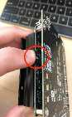

Figure 3.7: To insert your Jetpack-flashed microSD after it has been flashed, find the microSD slot as shown by the red circle in the image. Insert your microSD until it clicks into
place.

From there, connect your screen, keyboard, mouse, and network interface.

29

Finally, apply power. Insert the power plug of your power adapter into your Jetson Nano (use the J48 jumper if you are using a 20W barrel plug supply).
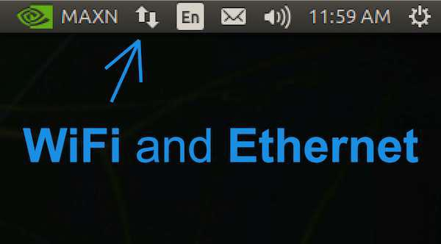

Figure 3.8: Use the icon near the top right corner of your screen to configure networking settings on your NVIDIA Jetson Nano. You will need internet access to download and install computer vision and deep learning software.

Once you see your NVIDIA + Ubuntu 18.04 desktop, you should configure your wired or wireless network settings as needed using the icon in the menubar as shown in Figure 5. When you have confirmed that you have internet access on your NVIDIA Jetson Nano, you can move on to the next step.

Step #3: Open a terminal or start an SSH session

In this step we will do one of the following:

- Option 1: Open a terminal on the Nano desktop, and assume that you’ll perform all steps from here forward using the keyboard and mouse connected to your Nano

30

- Option 2: Initiate an SSH connection from a different computer so that we can remotely configure our NVIDIA Jetson Nano for computer vision and deep learning

Both options are equally good.

Option 1: Use the terminal on your Nano desktop

For Option 1, open up the application launcher, and select the terminal app. You may wish to right click it in the left menu and lock it to the launcher, since you will likely use it often.

You may now continue to Step #4 while keeping the terminal open to enter commands.

Option 2: Initiate an SSH remote session

For Option 2, you must first determine the username and IP address of your Jetson Nano. On your Nano, fire up a terminal from the application launcher, and enter the following commands at the prompt:

$ whoami

nvidia

$ ifconfig

en0: flags=8863 mtu 1500

options=400

ether 8c:85:90:4f:b4:41

inet6 fe80::14d6:a9f6:15f8:401%en0 prefixlen 64 secured scopeid 0x8

inet6 2600:100f:b0de:1c32:4f6:6dc0:6b95:12 prefixlen 64 autoconf secured inet6 2600:100f:b0de:1c32:a7:4e69:5322:7173 prefixlen 64 autoconf temporary inet 192.168.1.4 netmask 0xffffff00 broadcast 192.168.1.255 nd6 options=201

media: autoselect

status: active

31

Grab your IP address. Then, on a separate computer, such as your laptop/desktop, initiate an SSH connection as follows:

$ ssh nvidia@192.168.1.4

Notice how I’ve entered the username and IP address of the Jetson Nano in my command to remotely connect.

Step #4: Update your system and remove programs to save space

In this step, we will remove programs we don’t need and update our system. First, let’s set our Nano to use maximum power capacity:

$ sudo nvpmodel -m 0

$ sudo jetson_clocks

The nvpmodel command handles two power options for your Jetson Nano: (1) 5W is mode 1 and (2) 10W is mode 0. The default is the higher wattage mode, but it is always best to force the mode before running the jetson_clocks command.

After you have set your Nano for maximum power, go ahead and remove LibreOffice — it consumes lots of space, and we won’t need it for computer vision and deep learning:

$ sudo apt-get purge libreoffice*

$ sudo apt-get clean

From there, let’s go ahead and update system level packages:

$ sudo apt-get update && sudo apt-get upgrade

In the next step, we’ll begin installing software.

32

Step #5: Install OpenCV system-level dependencies and other development dependencies

Let’s now install OpenCV dependecies on our system beginning with tools needed to build and compile OpenCV with parallelism:

$ sudo apt-get install build-essential pkg-config

$ sudo apt-get install libtbb2 libtbb-dev

Next, we’ll install a handful of codecs and image libraries:

$ sudo apt-get install libavcodec-dev libavformat-dev libswscale-dev $ sudo apt-get install libxvidcore-dev libavresample-dev $ sudo apt-get install libtiff-dev libjpeg-dev libpng-dev

And then we’ll install a selection of GUI libraries:

$ sudo apt-get install python-tk libgtk-3-dev

$ sudo apt-get install libcanberra-gtk-module libcanberra-gtk3-module

Lastly, we’ll install Video4Linux (V4L) so that we can work with USB webcams and install a library for FireWire cameras:

$ sudo apt-get install libv4l-dev libdc1394-22-dev

33

Step #6: Set up Python virtual environments on your Jetson Nano
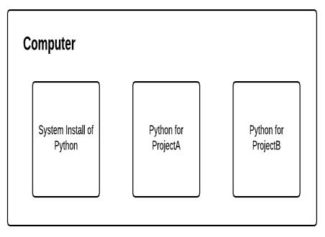

Figure 3.9: Each Python virtual environment you create on your NVIDIA Jetson Nano is separate and independent from the others.

I can’t stress this enough: Python virtual environments are a best practice when both developing and deploying Python software projects.

Virtual environments allow for isolated installs of different Python packages. When you use them, you could have one version of a Python library in one environment and another version in a separate, sequestered environment.

In the remainder of this tutorial, we’ll create one such virtual environment; however, you can create multiple environments for your needs after you complete this Step#6. Be sure to read the RealPython guide on virtual environments if you aren’t familiar with them.

First, we’ll install the de facto Python package management tool, pip:

$ wget https://bootstrap.pypa.io/get-pip.py

$ sudo python3 get-pip.py
$ rm get-pip.py

34

And then we’ll install my favorite tools for managing virtual environments, virtualenv and virtualenvwrapper:

$ sudo pip install virtualenv virtualenvwrapper

The virtualenvwrapper tool is not fully installed until you add information to your bash profile. Go ahead and open up your ~/.bashrc with the nano ediitor:

$ nano ~/.bashrc

And then insert the following at the bottom of the file:

# virtualenv and virtualenvwrapper

export WORKON_HOME=$HOME/.virtualenvs

export VIRTUALENVWRAPPER_PYTHON=/usr/bin/python3 source /usr/local/bin/virtualenvwrapper.sh

Save and exit the file using the keyboard shortcuts shown at the bottom of the nano editor, and then load the bash profile to finish the virtualenvwrapper installation:

$ source ~/.bashrc

35
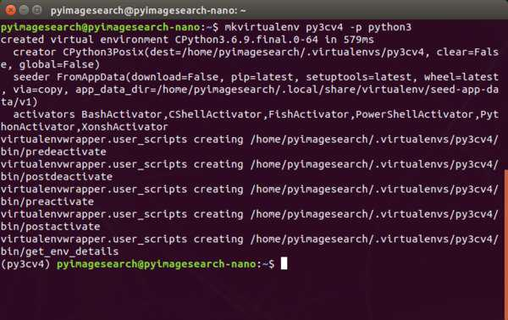

Figure 3.10: Terminal output from the virtualenvwrapper setup installation indicates that there are no errors. We now have a virtual environment management system in place so we can create computer vision and deep learning virtual environments on our NVIDIA Jetson Nano.

So long as you don’t encounter any error messages, both virtualenv

and virtualenvwrapper are now ready for you to create and destroy virtual environments as needed in Step #7.

Step #9: Create your ‘py3cv4’ virtual environment

This step is dead simple once you’ve installed virtualenv and virtualenvwrapper in the previous step. The virtualenvwrapper tool provides the following commands to work with virtual environments:

- mkvirtualenv

  - Create a Python virtual environment

- lsvirtualenv

  - List virtual environments installed on your system

36

- rmvirtualenv

  - Remove a virtual environment

- workon

  - Activate a Python virtual environment

- deactivate

  - Exits the virtual environment taking you back to your system environment

Assuming Step #6 went smoothly, let’s create a Python virtual environment on our

Nano:

$ mkvirtualenv py3cv4 -p python3

I’ve named the virtual environment py3cv4 indicating that we will use Python 3 and OpenCV 4. You can name yours whatever you’d like depending on your project and software needs or even your own creativity.When your environment is ready, your bash prompt will be preceded by (py3cv4). If your prompt is not preceded by the name of your virtual environment name, at any time you can use the workon command as follows:

$ workon py3cv4

37
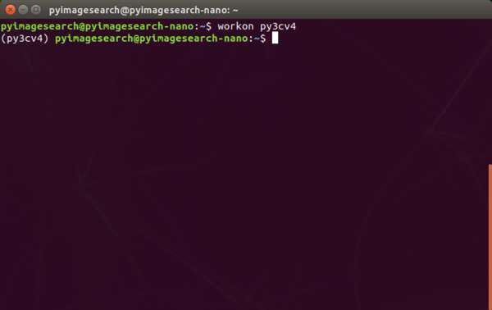

Figure 3.11: Ensure that your bash prompt begins with your virtual environment name for the remainder of this tutorial on configuring your NVIDIA Jetson Nano for deep learning and computer vision.

For the remaining steps , you must be “in” the py3cv4 virtual environment.

3.3.2.2 Webcam:
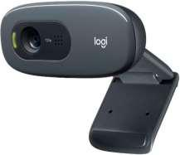

Figure 3.12 Web Camera

38

Specifications:

- Logitech C270 Web Camera (960-000694) supports for NVIDIA jetson nano developer kit.

- The C270 HD Webcam gives you sharp, smooth conference calls (720p/30fps) in a widescreen format. Automatic light correction shows you in lifelike, natural colors.

- Which is suitable to use with the NVIDIA Jetson Nano and NVIDIA Jetson Xavier NX Development Kits.

3.4 Experimental Results:

The step of the experiments process are given below:

Face Detection:

Start capturing images through web camera of the client side: Begin:

- Pre-process the captured image and extract face image

- calculate the eigen value of the captured face image and compared with eigen values of existing faces in the database.

- If eigen value does not matched with existing ones,save the new face image information to the face database (xml file).

- If eigen value matched with existing one then recognition step will done.

End

Face Recognition:

Using PCA algorithm the following steps would be followed in for face

recognition:

Begin:

39

- Find the face information of matched face image in from the database.

- update the log table with corresponding face image and system time that makes completion of attendance for an individua students.

End

This section presents the results of the experiment conducted to capture the face into a grey scale image of 50x50 pixels.

 | Test data |  | Expected Result | Observed | Pass/
 |  |  |  | Result | Fail
 | OpenCAM_CB() |  | Connects with the | Camera | pass
 |  |  | installed camera and | started.
 |  |  | starts playing.
 | LoadHaar |  | Loads the | Gets ready for | Pass
 | Classifier() |  | HaarClassifier Cascade | Extraction.
 |  |  | files for frontal face
 |  |  | Initiates the Paul-
 | ExtractFace() |  | Viola | Face extracted | Pass
 |  |  | Face extracting Frame
 |  |  | work.
 | Learn() |  | Start the PCA | Updates the | Pass
 |  |  | Algorithm | facedata. xml
 | Recognize() |  | It compares the input | Nearest face | Pass
 |  |  | face with the saved
 |  |  | faces.
 |  |  | Table 3.2 Experimental Results-1
Here is our data set sample.

40
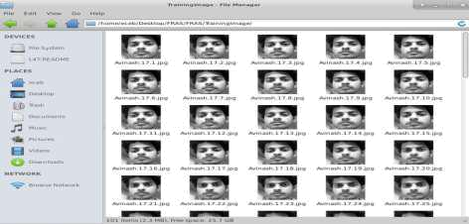

Figure 3.13 : Dataset sample

Face Orientations | Detection Rate | Recognition Rate
0º (Frontal face) | 98.7 % | 95%
18º | 80.0 % | 78%
54º | 59.2 % | 58%
72º | 0.00 % | 0.00%
90º(Profile face) | 0.00 % | 0.00%

Table 3.3 Experimental Results-2

We performed a set of experiments to demonstrate the efficiency of the proposed method. 30 different images of 10 persons are used in training set. Figure 3 shows a sample binary image detected by the ExtractFace() function using Paul-Viola Face extracting Frame work detection method.

41

CHAPTER-4

CODE IMPLEMENTATION

42

4.1 Code Implementation:

All our code is written in Python language. First here is our project directory structure and files.

FRASJN

| |  | [Attendance]
| |  | [ImagesUnknown]
| |  | [StudentDetails]
| |  | [TrainingImage]
| |  | [Traininglabel]
| |  | main.py
| |  | automail.py
| |  | CaptureImage.py
| |  | check_camera.py
| |  | haarcascade_frontalface_default.xml
| |  |  |  |  |  | recognize.py
| |  |  |  |  |  | requirements.txt

All those file in the project directory.

Note: The names inside square brackets [“folder name”] indicate it is a folder.

[Attendance] => It contains all the attendance sheets saved after taking attendance.

[ImagesUnknown] => Unknown images are placed inside this folder to avoid false positives.

[StudentDetails] => Here we place Studentdetails.csv file to use while recognizing faces.

[Trainingimage] => After capture dataset of a student, all his/her images are stored here.

4.1.1 main.py

All the work will be done here, Detect the face ,recognize the faces and take attendance.

43
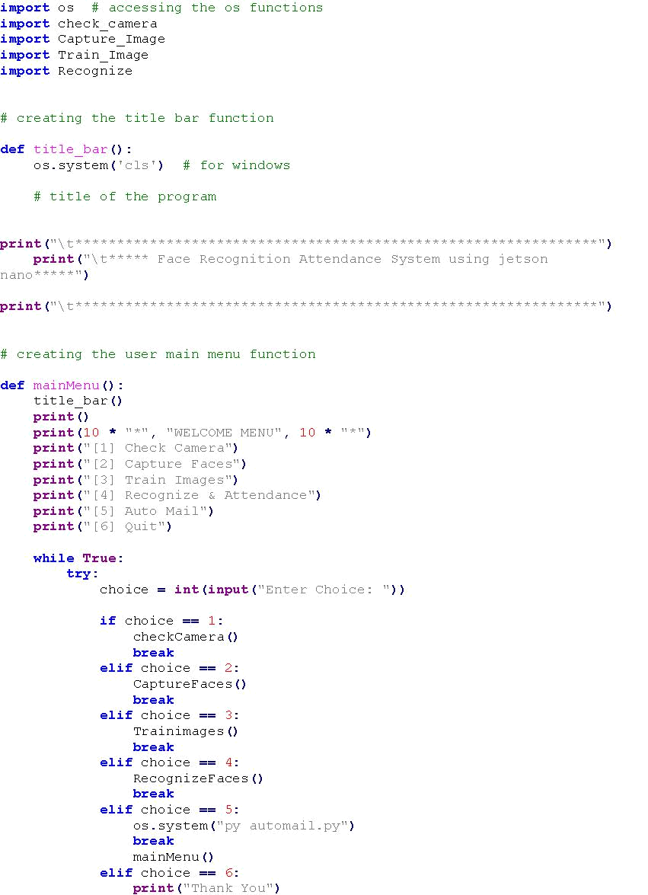

44
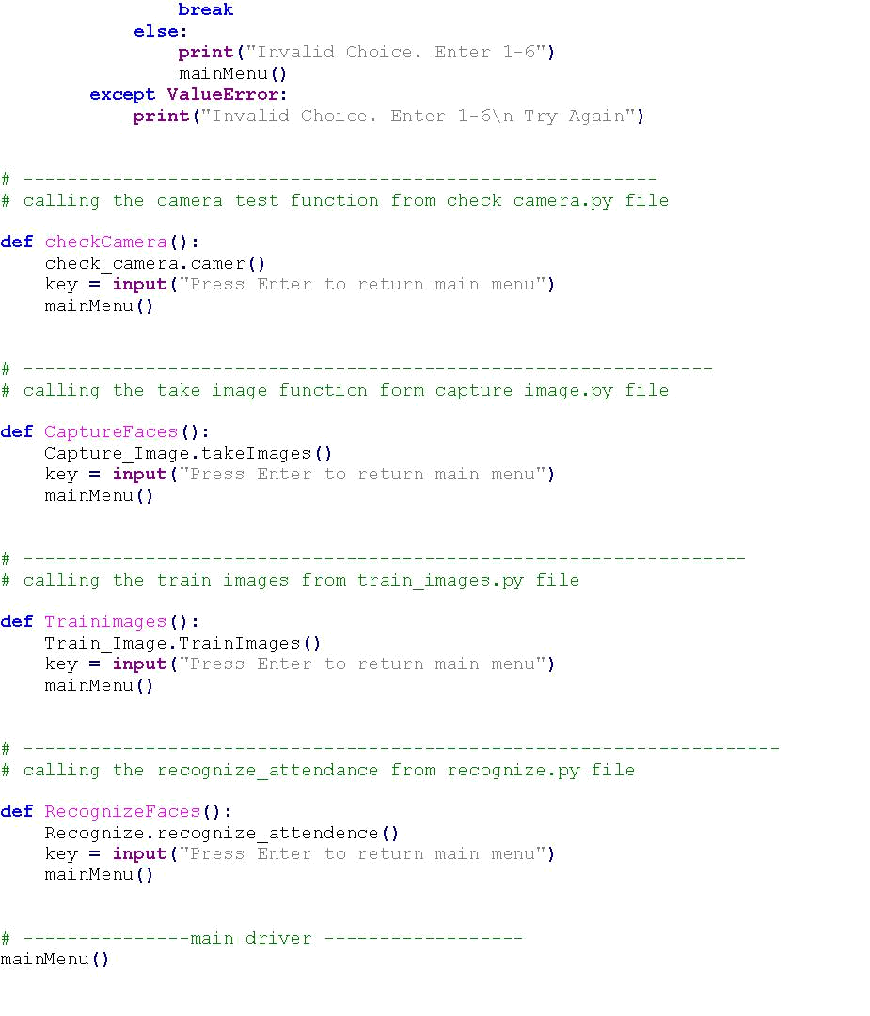

45

4.1.2 automail.py

In this project we add an extra feature called auto mail. It can automatically sent the attendance file to specific mail. Auto mail code given below.
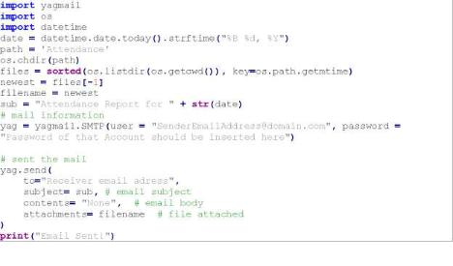

4.1.3 Capture_Image.py

This capture_image.py will collect the data set of a student and add his/her name

46

in the StudentsDetails.csv
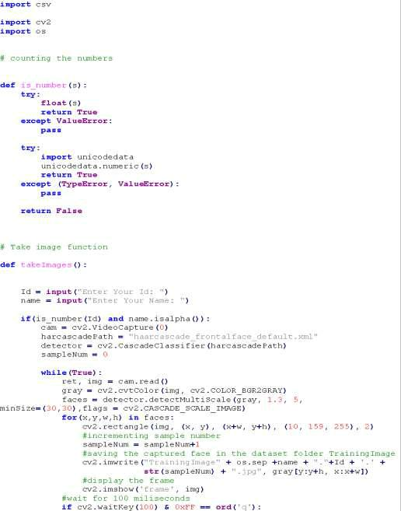

47
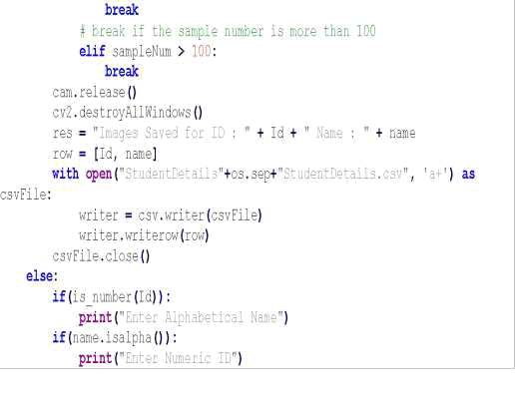

48

4.1.4 checkcamera.py

This checkcamra.py will check weather the camera is correctly connected or not, if connected whether the face is detecting or not.
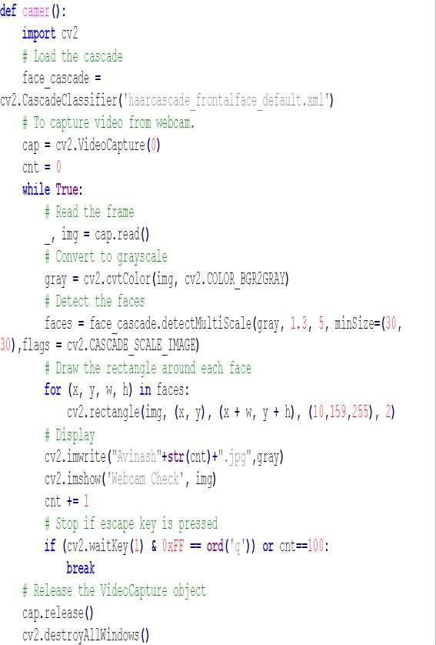

49

4.1.5 Train_Image.py

All the images in the Training Image folder will be accessed here and a model is created by using this trainimage.py file.
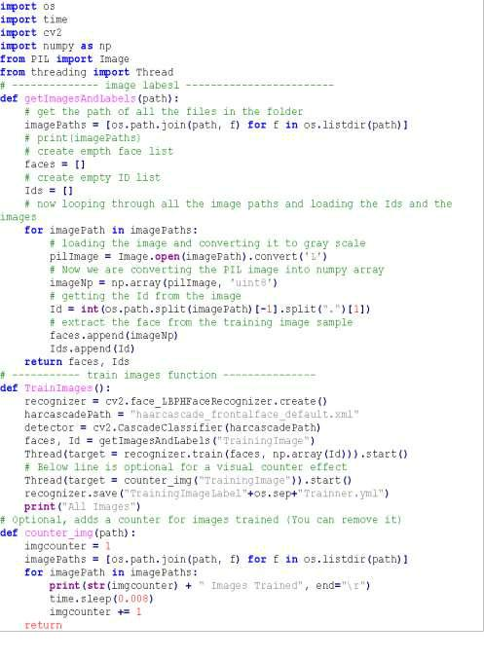

50

4.1.6 Recognize.py

When this Recognize.py file is executed, camera will be opened and it will recognize all the students present in this Students.csv file and those who are present it will mark attendance automatically and save in Attendance folder with date and time.
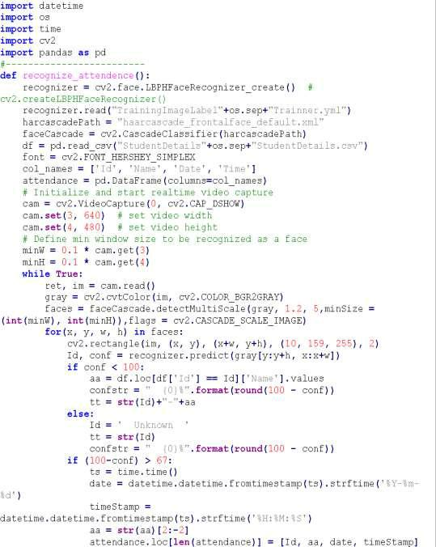

51
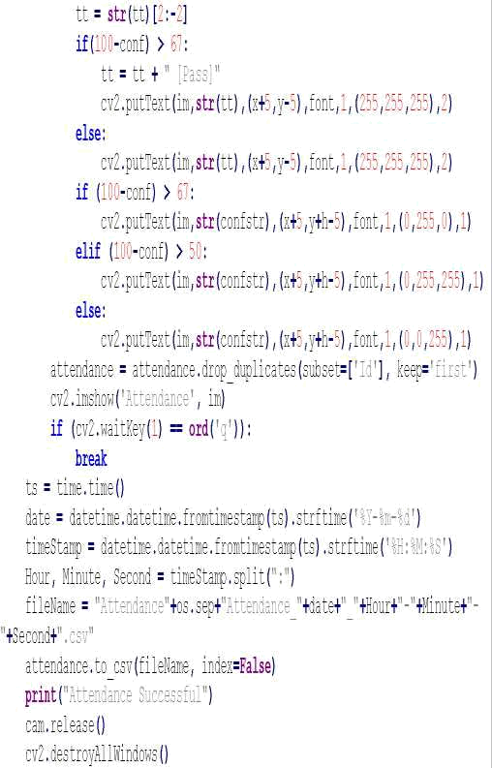

4.1.7 requirements.txt

This file consists all the required files to be install before executing the codes.

pip install opencv-contrib-python

pip install numpy

pip install pandas

pip install Pillow

pip install pytest-shutil

52

pip install python-csv

pip install yagmail

We can make use of the above commands or we can run a simple command with thw requirements.txt file

pip install –r requirements.txt

The text file consists:

opencv-contrib-python

numpy

pandas

Pillow

pytest-shutil

python-csv

yagmail

53

4.2 Sample Images:
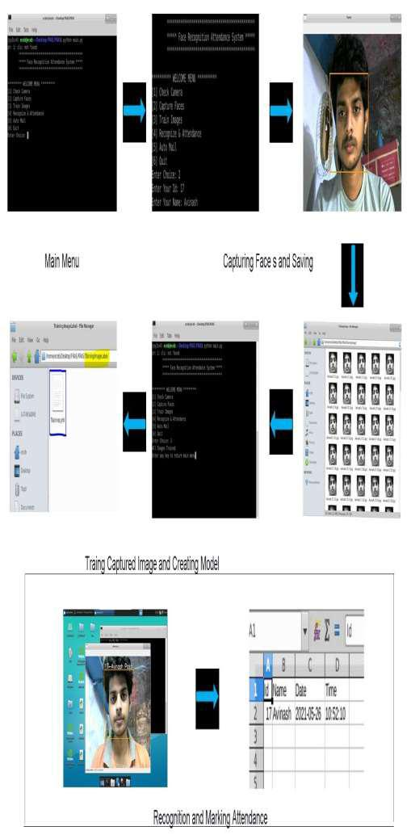

Figure 4.1 :Output Images

54

CHAPTER-5

WORK PLAN

55

5.1 Introduction:

A project work plan allows you to outline the requirements of a project, project

planning steps, goals, and team members involved in the project.Within each goal, you're going to outline the necessary Key Action Steps in project planning, the requirements, and who's involved in each action step.

Key Action Step:

- Expected Outcome -Add this as a task. The Expected outcome will be the part of Project

- Assignees – Assigning the work to the team members.

- Completion Date -Add a due date and tries to finish the work within the time

5.2 Work Breakdown Structure:

In order to develop this system, we gave enormous importance to scheduling because we believed if we want to provide the best of quality in a given period of time then we must give due importance to scheduling which also helped us to achieve a better results.we observe the entire work structure, meaning how the scheduling was maintained throughout the developmental phase. We shall also see the financial foundation of this project and furthermore the feasibility study should be also discussed.

 | Activity | status
Month
June | Selection of project area and Study of the | Completed
 | related work.
August | Literature Survey and Study of Journals | Completed
 | related to the work
September | Study on the software implementation | Completed
 | works python and image processing
 | 56

October | Study of project related works like face | Completed
 | recognition and detection techniques
November | Study of the Image processing in python | Completed
 | and Open Computer Vision
December | Study of hardware and selection of | Completed
 | components
January | Study of hardware implementation and | Completed
 | installation OS
February | Study related to creating the | Completed
 | environments and working platform
March | Study of packages/tools and installation | Completed
 | of packages
April | Implementation of algorithm in Software. | Completed
May | Implementation of code in hardware | Completed
Table 5.1 Work Plan

5.2.1 Financial Plan

Financial Plan identifies the Project Finance needed to meet specific objectives. The Financial Plan defines all of the various types of expenses that a project will incur (equipment, materials and administration costs) along with an estimation of the value of each expense. The Financial Plan also summarizes the total expense to be incurred across the project and this total expense becomes the project budget. As part of the Financial Planning exercise, a schedule is provided which states the amount of money needed during each stage of the project.

57

Components |  | price
Jetson Nano Board |  | 8500
High Definition Camera |  | 2500
Sd Card |  | 500
Hardware Accessories |  | 500
Total |  | 12000
 | Table 5.2 Financial Plan

58

CHAPTER-6
PERFORMANCE ANALYSIS

59

6.1 Introduction:

We conducted a series of experiments to illustrate the system performance under different situations. By carrying out those tests, we were able to get the graph shown above (Distance vs Confidence Level). We may deduce from the graph that when the face is closer to the camera, the confidence level is higher, and vice versa. Therefore, by keeping a threshold for confidence level, we can mark attendance to the person according to the threshold.

6.2 Analysis:

Here we consider one constant parameter intensity of light . we performed different experiments on different distance and different angles. we observed the confidence level
at the different positions by gradually increasing the distance .we plotted the graph using the x and y coordinates by considering the x values as the confidence level or accuracy rate. and y values as the distance (cms).

60

6.3 Flow Chart:
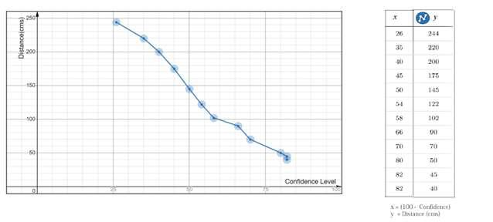

Figure 6.1 Flow Chart

61

CONCLUSION

Face recognition systems are part of facial image processing applications and their significance as a research area are increasing recently. Implementations of system are crime prevention, video surveillance, person verification, and similar security activities. The face recognition system implementation can be part of Universities. Face Recognition Based Attendance System has been envisioned for the purpose of reducing the errors that occur in the traditional (manual) attendance taking system. The aim is to automate and make a system that is useful to the organization such as an institute. The efficient and accurate method of attendance in the office environment that can replace the old manual methods. This method is secure enough, reliable and available for use. Proposed algorithm is capable of detect multiple faces, and performance of system has acceptable good results.

62

REFERENCES

- A brief history of Facial Recognition, NEC, New Zealand,26 May 2020.[Online]. Available: https://www.nec.co.nz/market-leadership/publications-media/a-brief-history-of-facial-recognition/

- Face detection,TechTarget Network, Corinne Bernstein, Feb, 2020.[Online]. Available: https://searchenterpriseai.techtarget.com/definition/face-detection

- Paul Viola and Michael Jones, Rapid Object Detection using a Boosted Cascade of Simple Features. Accepted Conference on Computer Vision and Pattern Re cognition, 2001.

- Face Detection with Haar Cascade,Towards Data Science-727f68dafd08,Girija Shankar Behera, India, Dec 24, 2020.[Online]. Available:https://towardsdatascience.com/face-detection-with-haar-cascade-727f68dafd08

- Face Recognition: Understanding LBPH Algorithm,Towards Data Science-

90ec258c3d6b,Kelvin Salton do Prado, Nov 11, 2017.[Online]. Available :https://towardsdatascience.com/face-recognition-how-lbph-works-90ec258c3d6b

- What is Facial Recognition and how sinister is it, Theguardian, IanSample, July, 2019.

[Online]. Available: https://www.theguardian.com/technology/2019/jul/29/what-is-facial-recognition-and-how-sinister-is-it

[7].Kushsairy Kadir , Mohd Khairi Kamaruddin, Haidawati Nasir, Sairul I Safie, Zulkifli Abdul Kadir Bakti,"A comparative study between LBP and Haar-like features for Face Detection using OpenCV", 4th International Conference on Engineering Technology and Technopreneuship (ICE2T), DOI:10.1109/ICE2T.2014.7006273, 12 January 2015.

[8].Senthamizh Selvi.R,D.Sivakumar, Sandhya.J.S , Siva Sowmiya.S, Ramya.S , Kanaga Suba Raja.S,"Face Recognition Using Haar - Cascade Classifier for Criminal Identification",

International Journal of Recent Technology and Engineering(IJRTE), vol.7, issn:2277-3878, , issue-6S5, April 2019.

- Robinson-Riegler, G., & Robinson-Riegler, B. (2008). Cognitive psychology: applying the

63

science of the mind. Boston, Pearson/Allyn and Bacon..

- Margaret Rouse, What is facial recognition? - Definition from WhatIs.com, 2012. [online] Available at: http://whatis.techtarget.com/definition/facial-recognition

- Robert Silk, Biometrics: Facial recognition tech coming to an airport near you: Travel Weekly, 2017. [online] Available at: https://www.travelweekly.com/Travel-News/Airline-News/Biometrics-Facial-recognition-tech-coming-airport-near-you

- Sidney Fussell, NEWS Facebook's New Face Recognition Features: What We Do (and Don't) Know, 2018. [online] Available at: https://gizmodo.com/facebooks-new-face-recognition-fea tures-what-we-do-an-1823359911

- Reichert, C. Intel demos 5G facial-recognition payment technology | ZDNet, 2017. [online] ZDNet. Available at: https://www.zdnet.com/article/intel-demos-5g-facial-recognition-payment-technology/#:~:text=Such%20%22pay%20via%20face%20identification,and%20artificial%20int elligence%20(AI). [Accessed 25 Mar. 2018].
- Mayank Kumar Rusia, Dushyant Kumar Singh, Mohd. Aquib Ansari, “Human Face

Identification using LBP and Haar-like Features for Real Time Attendance Monitoring”, 2019 Fifth International Conference on Image Information Processing (ICIIP) ,Shimla, India, DOI: 10.1109/ICIIP47207.2019.8985867 10 February 2020.

64

