AWS Personal notes Udemy course - 2

Contents

Serverless solution architecture discussions 1

# 

# Serverless solution architecture discussions

## Mobile Application – MyToDoList

We want to create a mobile application with the following requirements

• Expose as REST API with HTTPS

• Serverless architecture

• Users should be able to directly interact with their own folder in S3

• Users should authenticate through a managed serverless service

• The users can write and read to-dos, but they mostly read them

• The database should scale, and have some high read throughput

**Mobile app: REST API Layer**

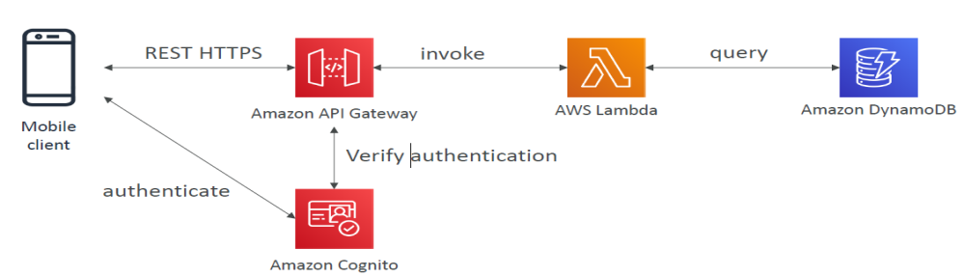

**Mobile app: giving S3 access to customer and having high read throughput (use DAX caching provided by DynamoDB)**

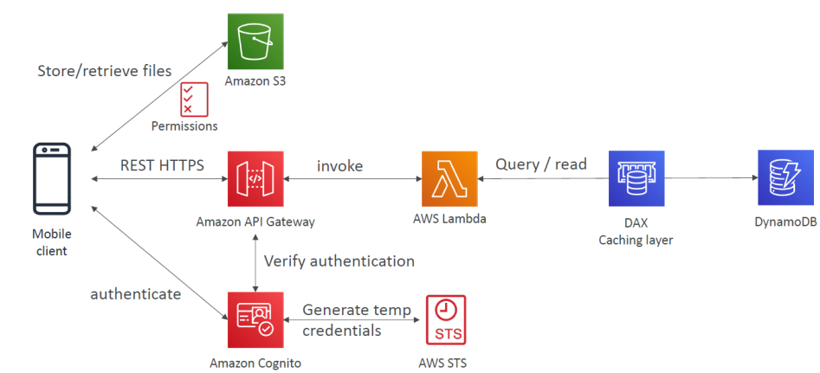

**Mobile app: caching at API gateway layer if the responses are going to be more or less static**

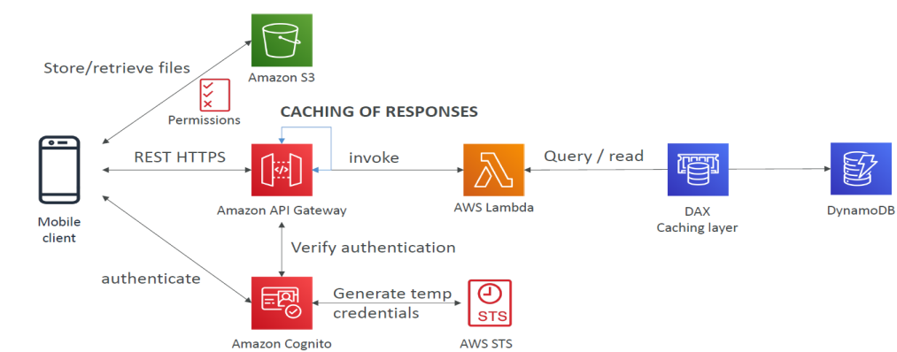

## MyBlog.com

This website should scale globally

• Blogs are rarely written, but often read

• Some of the website is purely static files; the rest is a dynamic REST API

• Caching must be implemented where possible

• Any new users that subscribes should receive a welcome email

• Any photo uploaded to the blog should have a thumbnail generated

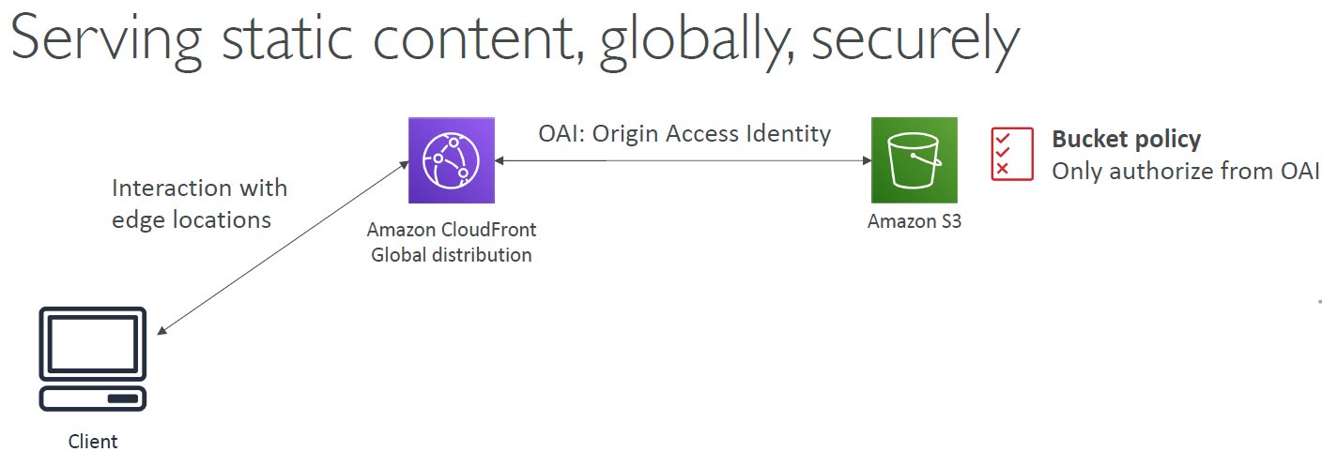

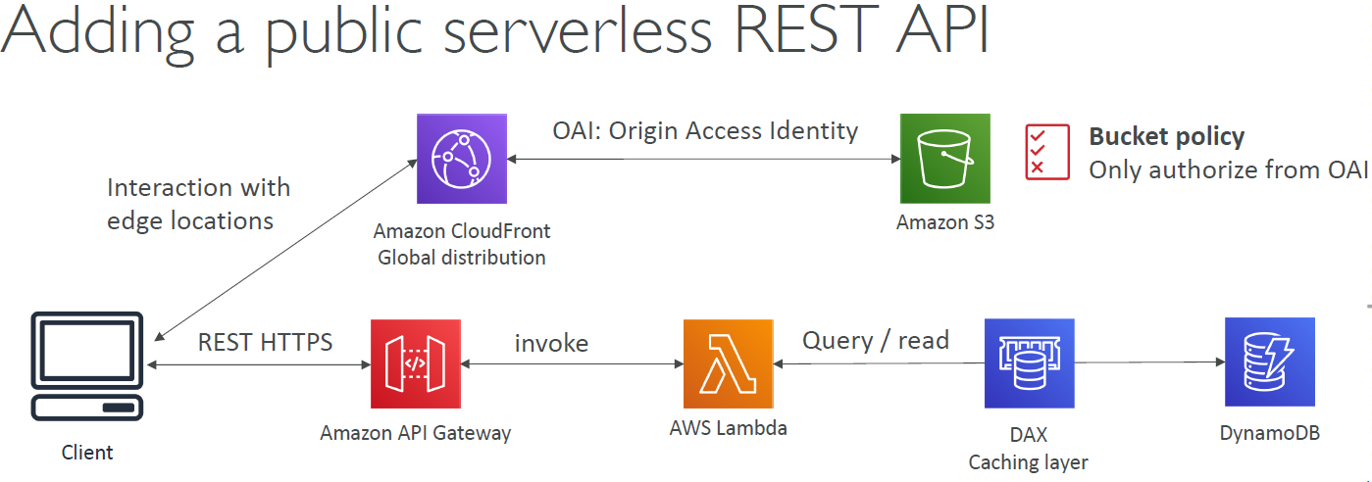

DynamoDB global table gives you active-active cross region replication and the nodes of DB can be across multiple region. This gives low latency and high performance. We could have used Aurora Global tables as well but it is not serverless.

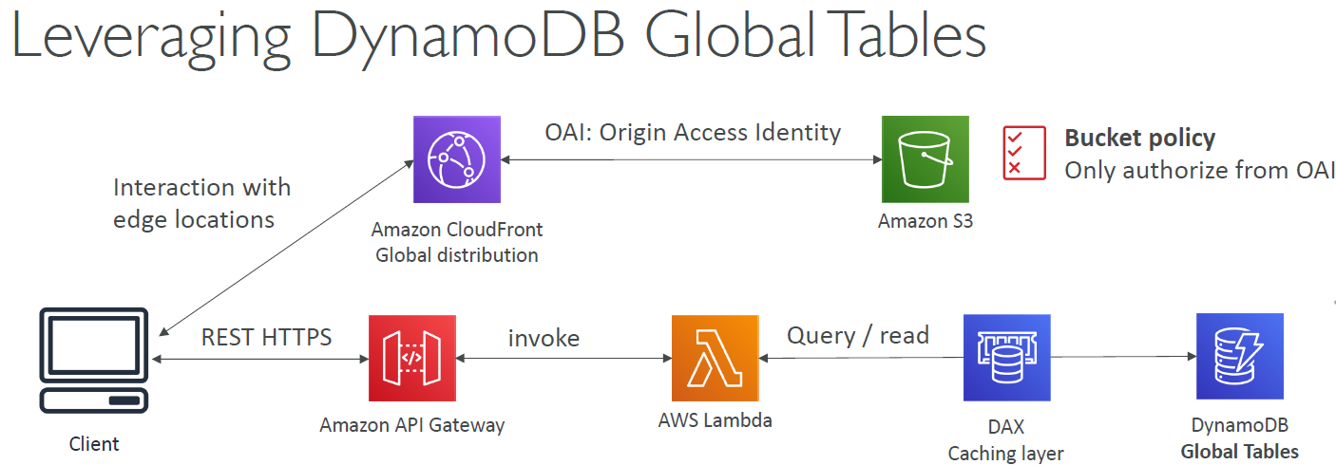

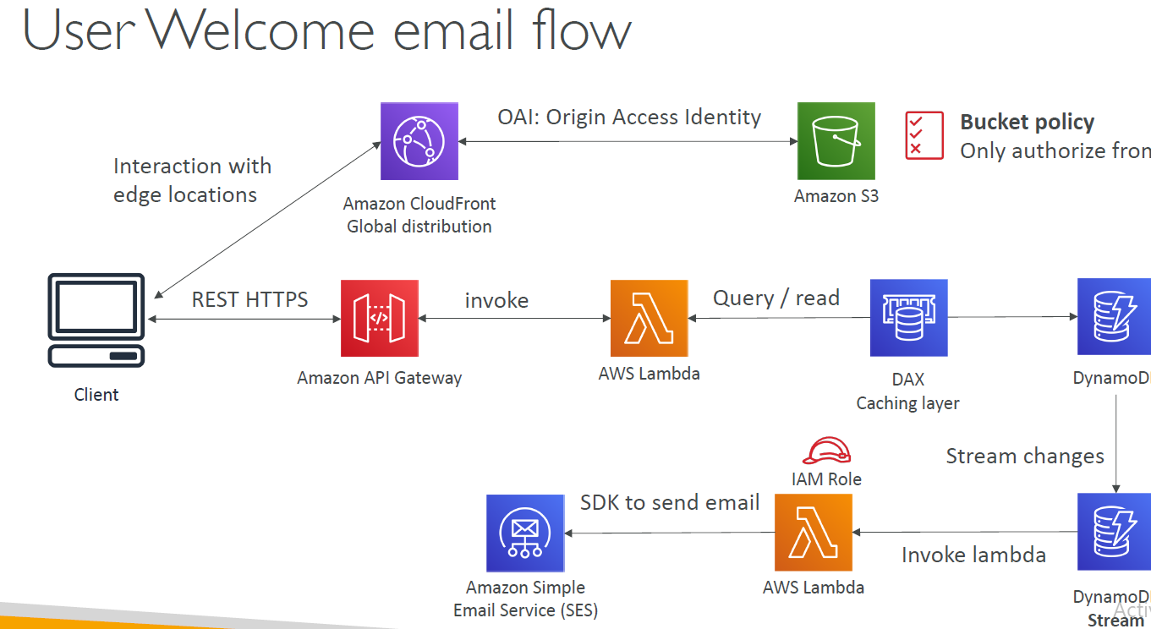

For thumbnail generation, user can directly upload to Amazon S3 bucket or upload via CloudFront using transfer acceleration

