Business Intelligence Lab · Unit 2 · Session 7
Experiment 7
Business Insight Report
Integration of Advanced Analytics with BI Reports using Microsoft Power BI
Client: Global Superstore · Prepared as: Business Intelligence Consultant · Data: Orders 2014–2017 (51,290 order lines)
Total Sales | Total Profit | Total Orders | Profit Margin | Customers
$12.64M | $1.47M | 25,728 | 11.6% | 796

1. Objective of Analysis
Global Superstore management has observed that sales are increasing but profitability is not growing at the expected rate. The objective of this analysis is to review business performance using the Power BI reports and dashboards, identify where profit is being gained or lost, and recommend corrective actions supported by data.
The analysis answers four questions:
- Where (region, category, segment, market) does the business earn and lose profit?
- How have sales, profit and margin moved over the months and years?
- What is holding profitability back?
- Which actions will improve profit, and how large is the opportunity?

2. Reports and Dashboards Used
Report / page | Content | Used for
Executive Dashboard (Exp. 6, page 1) | KPI cards; Sales by Region, Category; Monthly trend; Top 10 customers; Profit by Segment/Category | Steps 2–5: region, category, segment and trend analysis
Business Scorecard (Exp. 6, page 2) | Actual vs target with Achieved / Partially / Not Achieved status | Performance against targets
Business Analysis (Exp. 6, page 3) | Best/worst region and category | Initial hypotheses
Advanced Analytics (Exp. 7, page 4) | YoY growth, margin trend, profit by discount band, sub-category and market | Root-cause analysis of profit gap

Note: figures and charts in this report were computed from the same Orders data and the same measure definitions (Total Sales, Total Profit, Total Orders, Profit Margin %) used in the Power BI project; they can be reproduced by selecting the same slicers in the .pbip file supplied with this report.

3. Key Findings

3.1 Yearly and monthly trends
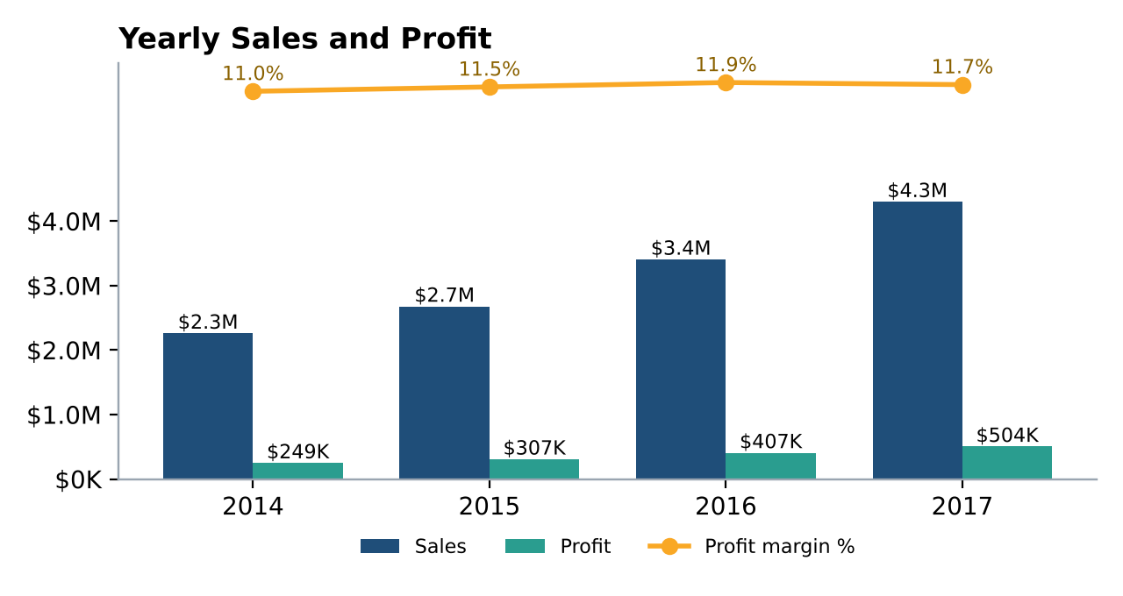
Figure 1 – Yearly sales, profit and profit margin
Year | Sales | Profit | Margin | Sales growth | Profit growth
2014 | $2.26M | $249K | 11.0% | – | –
2015 | $2.68M | $307K | 11.5% | +18.5% | +23.5%
2016 | $3.41M | $407K | 11.9% | +27.2% | +32.4%
2017 | $4.30M | $504K | 11.7% | +26.3% | +23.9%

- Sales almost doubled (+90% from 2014 to 2017, 23.9% a year) and profit grew +103%.
- Margin has plateaued. It improved from 11.0% to 11.9% by 2016 but slipped to 11.7% in 2017, when profit growth (+23.9%) fell behind sales growth (+26.3%). This confirms management's concern: growth is coming mainly from volume, not from better profitability.
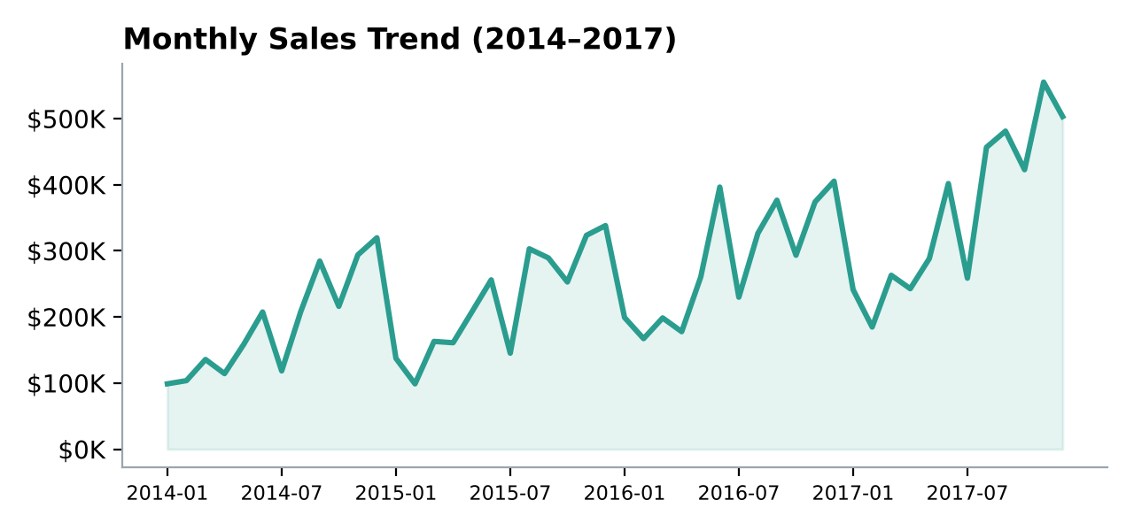
Figure 2 – Monthly sales trend
- Strong seasonality: September–December generate 45% of annual sales; November 2017 was the peak month ($555K).

3.2 Sales and profit by region
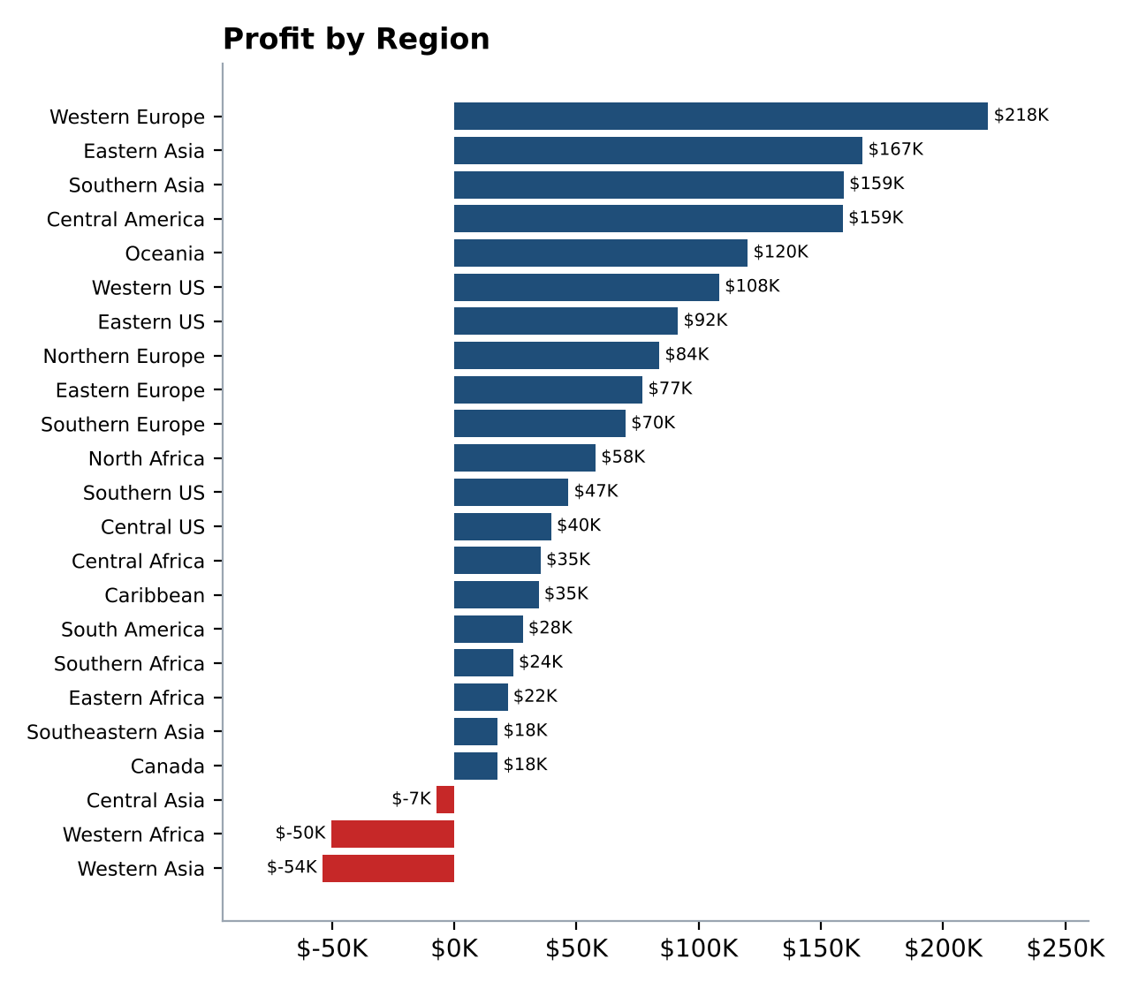
Figure 3 – Profit by region (red = loss-making)
- Largest profit pools: Western Europe ($218K profit on $1.73M sales), Eastern Asia ($167K), Southern Asia ($159K) and Central America ($159K).
- Three regions lose money: Western Asia (−$53.9K), Western Africa (−$50.4K) and Central Asia (−$7.3K) – a combined −$111.6K. Their average discounts are 35–43%.
- Big but thin: Southeastern Asia has $884K of sales but only a 2.0% margin (average discount 27%).

3.3 Profitability by product category
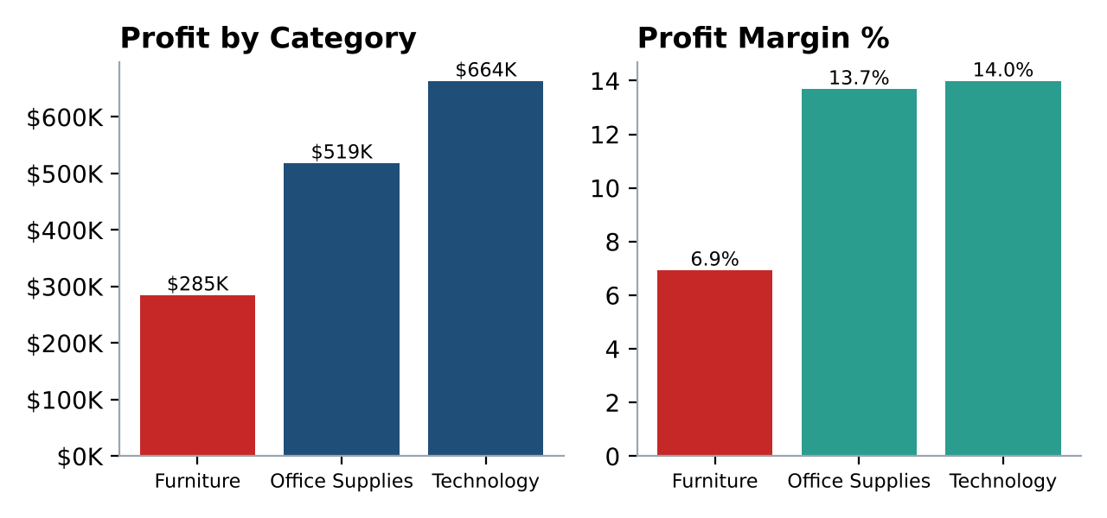
Figure 4 – Profit and margin by category
- Technology is the most profitable category ($664K, 14.0% margin) and Office Supplies is close behind ($519K, 13.7%). Together they deliver 81% of profit.
- Furniture earns only 6.9% margin ($285K on $4.11M sales). Within it, Tables lose $64.1K (−8.5% margin, average discount 29%).
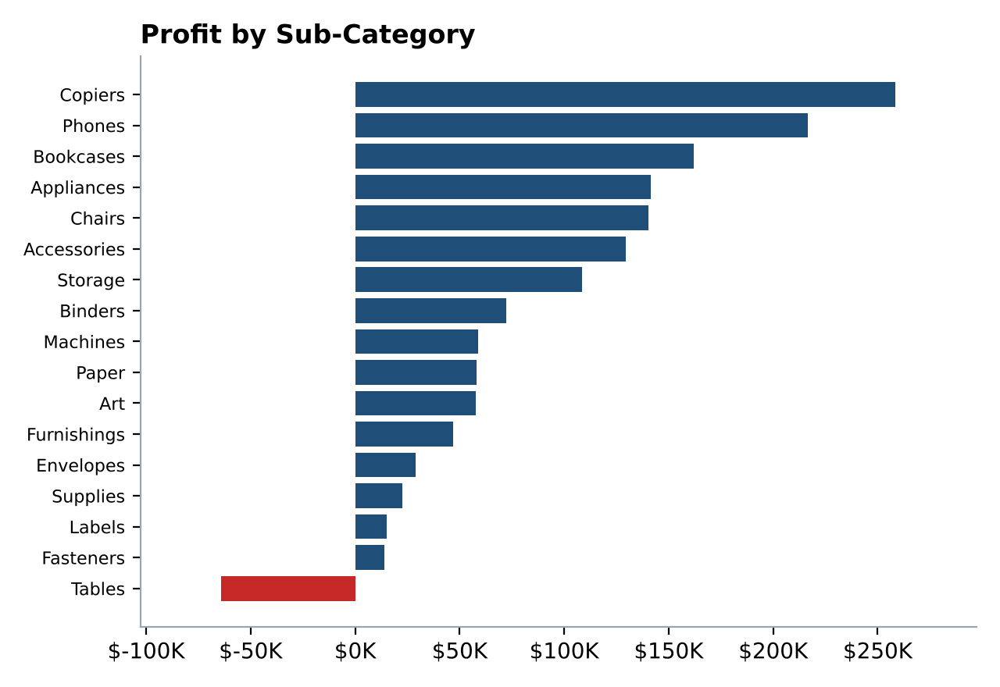
Figure 5 – Profit by sub-category

3.4 Customer segment performance
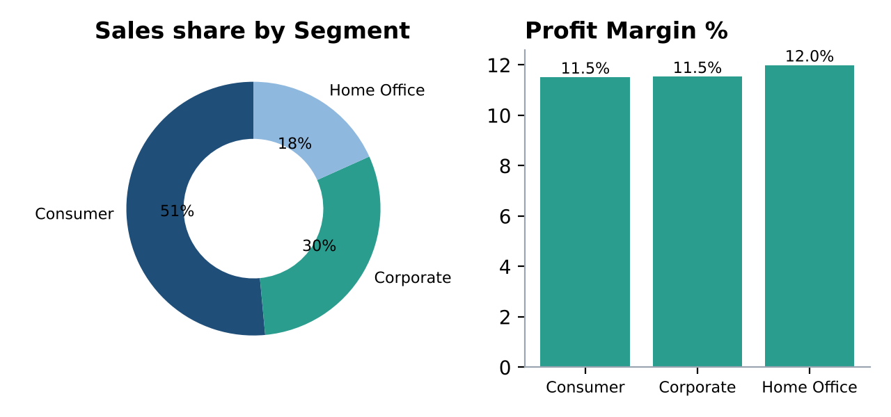
Figure 6 – Segment share of sales and profit margin
- Consumer contributes 51% of sales, Corporate 30% and Home Office 18%; margins are almost identical (11.5%, 11.5%, 12.0%). Segment is therefore not a profit driver.
- The customer base is diversified: the top 10 customers account for only 2.7% of sales. However, 68 of 796 customers are net loss-making (−$66K in total).

3.5 What is holding profit back? – Discount analysis
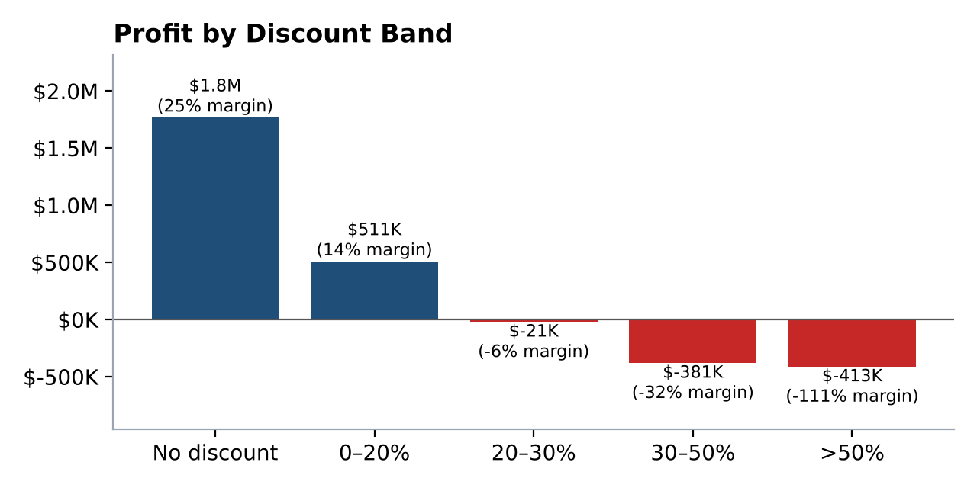
Figure 7 – Profit by discount band
This is the single most important finding. Order lines sold with no discount earn a 25.3% margin ($1.77M profit). Margin falls to 13.7% for discounts up to 20% and turns negative above 20%.
- 22% of order lines carry a discount above 20%. They generated $1.93M of sales but a loss of $815K, while lines discounted 20% or less earned $2.28M profit.
- Discounting also explains the weak regions and categories above (Western Asia, Western Africa, Central Asia and Tables all have average discounts of 29–43%, against 5–9% in the best regions).
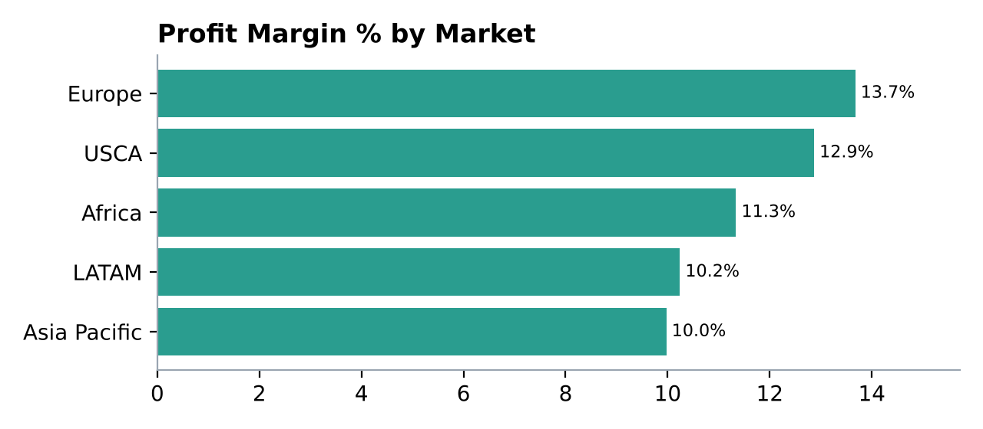
Figure 8 – Profit margin by market
- Europe has the highest market margin (13.7%); Asia Pacific (10.0%) and LATAM (10.2%) are the lowest even though Asia Pacific is the largest market ($4.04M sales).

4. Business Strengths
- S1 – Consistent, rapid growth. Sales rose every year: +18.5%, +27.2% and +26.3%; profit grew every year as well (+103% overall).
- S2 – Highly profitable core categories. Technology (14.0%) and Office Supplies (13.7%) earn 81% of all profit; Copiers (17.1% margin) and Phones ($217K) are standouts.
- S3 – Diversified customers and strong European business. No customer dependence (top 10 = 2.7% of sales), balanced segments, and Europe earns the best market margin (13.7%).

5. Business Weaknesses
- W1 – Discount-driven margin erosion. Lines discounted above 20% lose $815K; average discount has stayed ~14% every year, so margin is stuck at ~11–12%.
- W2 – Loss-making regions. Western Asia, Western Africa and Central Asia lose $111.6K; Southeastern Asia earns only 2.0% on $884K of sales.
- W3 – Weak Furniture economics. 6.9% margin versus ~14% for the other categories; Tables lose money.
- W4 – Dependence on Q4. 45% of sales fall in Sep–Dec, creating inventory and capacity peaks and an unstable monthly profit pattern.

6. Opportunities for Improvement
- O1 – Discount governance. If loss-making discounted lines were brought to break-even, profit would rise by up to $815K (+56%). Capturing even half would add ≈ $0.4M (+28%).
- O2 – Grow where margins are high. Eastern Asia (19.5%) and Southern Asia (18.4%) earn high margins with discounts below 5%; Canada (26.6%), Eastern Europe (24.9%) and North Africa (24.8%) sell with no discounts at all but are small.
- O3 – Fix Furniture. Lifting Furniture from 6.9% to the Office Supplies margin (13.7%) is worth ≈ $0.28M; removing Tables losses adds $64K.
- O4 – Seasonal planning. Plan stock, staffing and promotions around the Sep–Dec peak and use smarter (non-discount) offers in the low months.

7. Recommendations
# | Recommendation | Evidence | Expected impact / KPI
1 | Introduce a discount policy: manager approval above 20%, hard cap at 30%. | Lines >20% discount: $1.93M sales, −$815K profit. 0% discount margin is 25.3%. | Up to +$815K profit; target average discount ≤ 12% and margin ≥ 14%.
2 | Turn around or restructure Western Asia, Western Africa and Central Asia: re-price, stop deep discounts, review product mix. | Combined loss −$111.6K; average discount 35–43%. | Bring all three to break-even (+$111.6K).
3 | Re-price Furniture and stop discounting Tables; renegotiate supplier costs. | Furniture margin 6.9%; Tables −$64.1K at 29% discount. | +$0.06–0.28M; Furniture margin ≥ 10%.
4 | Shift marketing and sales effort to Technology and Office Supplies in high-margin regions (Western Europe, Eastern Asia, Southern Asia, Canada). | These categories earn 81% of profit; the listed regions earn 12.6–26.6% margin with low discounts. | Higher profit per $ of sales; track margin by region monthly.
5 | Plan inventory and promotions around the Sep–Dec peak; add profit margin, discount % and loss-making sales to the monthly scorecard. | 45% of sales in Sep–Dec; margin stuck at 11–12%. | Stable margin; scorecard alerts for lines with negative profit.

8. Conclusion
Global Superstore is growing quickly – sales have almost doubled in three years – but profit is merely keeping pace and the profit margin has stalled at about 11.7%. The data shows that the cause is not the customer segment or lack of demand but discounting: order lines discounted by more than 20% destroy about $815K of profit, and the same pattern explains the loss-making regions and the weak Furniture/Tables performance. A disciplined discount policy, fixing three loss-making regions and re-pricing Furniture can add roughly $0.4–1.0M profit a year without needing additional sales. Technology and Office Supplies in high-margin regions should be the growth engine.

Appendix – Screenshots from Power BI
Open Experiment7.pbip in Power BI Desktop and capture each page (File → Export → PDF, or Windows + Shift + S) to insert the dashboard screenshots required by Step 12. Suggested captures: (1) Executive Dashboard, (2) Business Scorecard, (3) Business Analysis, (4) Advanced Analytics. The charts in Figures 1–8 reproduce the same visuals from the same data.

