Submitted By: Anupriya Goyal

UB Person No: 50287108

Date: 10/5/2018

**CSE 586 Distributed Systems Project1 Report**

**Project1: Designing and Deploying A Service-Based Distributed Systems**

**Web Application: MyWayPoints**

**Introduction:**

This web application is used to provide information about weather on way points between any source and destination. It helps user to gain information of weather which includes features such as current temperature, temperature max and min values at particular way point and the weather description on particular way point. The web application is designed for getting way points between source and destination considering that user’s travelling mode is driving.

The diagram below (Figure1.) illustrate the System Model for this web application.

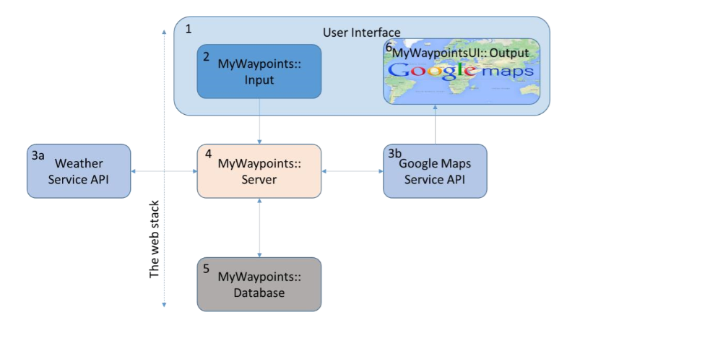

**Figure1. System Model of MyWayPoints Distributed System**

This application is developed in two phases: Phase1 and Phase2. Both of these phases description are as follows:

**Phase1:**

Referring to above Figure1 the phase1 consist of designing and implementing boxes1-6 except box5 (database).

**Box1 User Interface:** It consist of two parts one is getting input from user which refers to **box 2** and other is displaying the output to the user i.e **box 6**. To get input from user an input form is designed. To implement this box 2 an input form is created using HTML and CSS which ask user to input start location and end location of their journey. The screenshot for this is shown in Figure2.

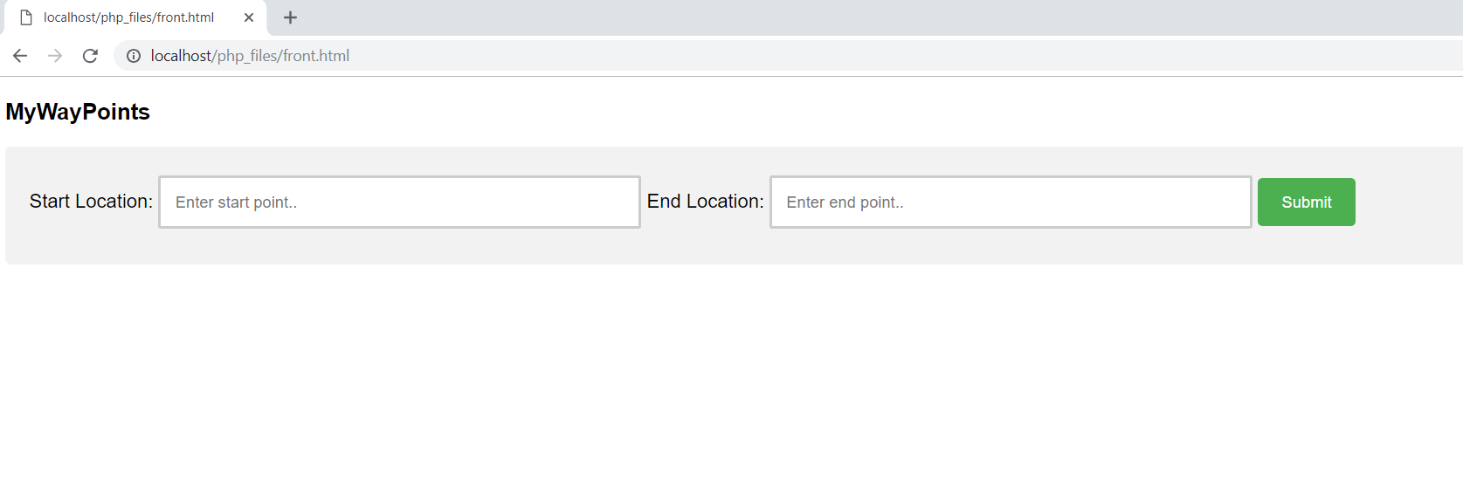

**Figure2. Screenshot of Input form**

Once the user hits the Submit button as shown in Figure2. he/she will be directed to the output page i.e where the results are displayed for particular start and end location. The output page is implemented using technologies: HTML ,CSS and javascrpit. This is shown in Figure3. which is the screenshot of output page. The screenshot is taken for **start location:** Buffalo and **end location:** New York. As it can be seen in Figure3 that the markers in between start and end location are waypoints having current temperature when anyone clicks on it.

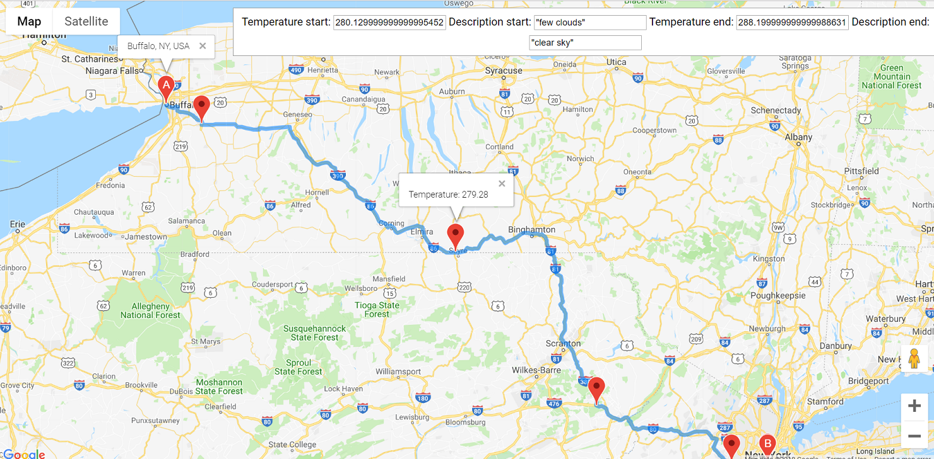

**Figure3. Screenshot of Output Screen (Waypoints and temperature)**

After taking input from user (box2) the api’s are called through server to get the json response for weather api and geocoding (google api). Php language is used for server side scripting. Input from the form goes to server(localhost) php page which then make calls to google api for geocoding to get latitude and longitude f the places and use them to make weather api call. Json file obtained is then decoded to get the waypoints between the start and end location. To display the current temperature, description and Hi/Lo temperature on the way points the json file of weather api is decoded. After getting all results they are passed to javascrpit variables to display the results to the user (as shown in Figure3). To implement box 4 ,box 3a and box 3b the technology used is PHP.

**Phase2:**

Database is used to store queries made by user so that it can be used latter for caching purpose.

When the user makes any query through the input form then that data i.e start location, end location, it’s latitude and longitude along with temperature are stored in database. MAMP is a free, local server environment. It provides tools to work with PHP, Python, Perl or Ruby for web application development. For storing in database the technology used are MAMP, MYSQL and PHP. The php server and mysql server are running through MAMP in both pahse1 and phase2.

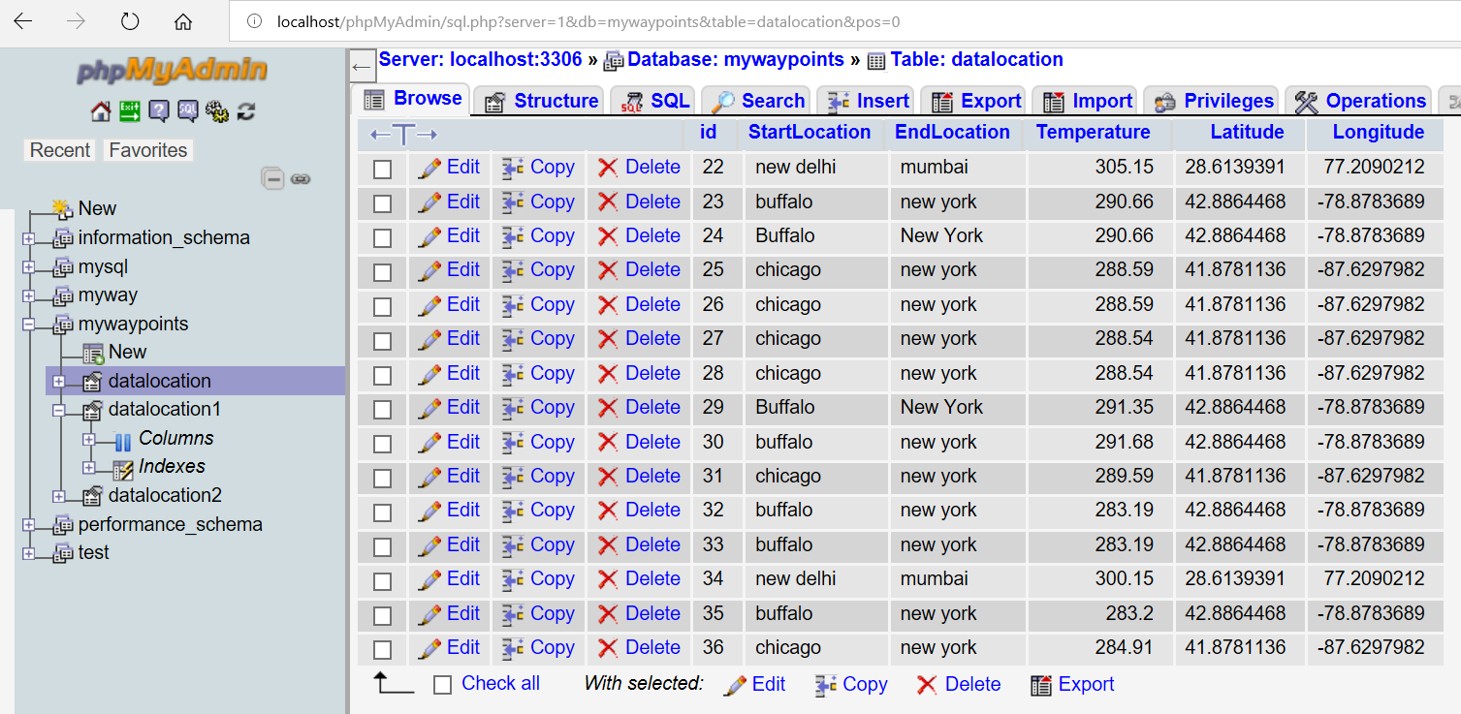

**Figure 4. Information Stored in Database**

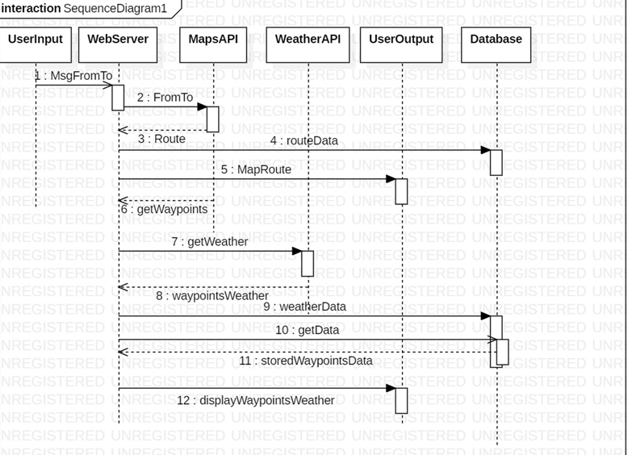

**UML Diagram for Phase1 and Phase2**

**Phase 3:**

Comparison of two implementation i.e Phase1 and Phase2

There are three cost functions: c1, c2 and c3.It takes very less time (few milliseconds approx.) to display google map on web page when user hits a submit button. The cost function c1 is about the time it takes when user hits submit query to display the way points on map. It is taking few more milliseconds then usual time to display google map because it depends on no. of way points.

The cost function c2 is related to time it takes weather api to respond to the weather of way points. The c2 is also performed in milliseconds but it is more time consuming then google map api. The value of c2 is slightly more then c1.

The cost function c3 is time it takes from database to retrieve query results and display it on google map.

This takes less time then c1+c2. As no api calls are been made so response time is fast and response comes directly from database.

Therefore it can be concluded that : c1+c2 >c3

**References:**

1. <https://developers.google.com/maps/documentation/javascript/examples/directions-waypoints>
2. <https://www.w3schools.com/php/php_forms.asp>
3. <https://www.a2hosting.com/kb/developer-corner/mysql/connect-to-mysql-using-php>
4. <https://developers.google.com/maps/documentation/javascript/mysql-to-maps>
5. <https://developers.google.com/maps/documentation/javascript/reference/directions>
6. <https://developers.google.com/maps/documentation/javascript/get-api-key>
7. <https://stackoverflow.com/questions/15461786/pass-javascript-variable-to-php-via-ajax>
8. <https://openweathermap.org/current>