Spot Customer Request Handling
High-Level Design
Scope: everything that happens after a request is identified as belonging to a spot account — admission, lease, placement, preemption and rating.
Version 0.1 — draft for review · 6 August 2026 · Prepared for Sargam Maurya

1. Scope
A request arrives from any tenant. The gateway authenticates it and the Account Service returns the account class. Where that class is STATIC or DYNAMIC, the request leaves this design entirely. Where it is SPOT, the request enters the Spot Market API and everything from that point on is this project.
The single most important framing: this subsystem does not decide how much capacity exists, nor when capacity must be taken back. Both arrive from outside as inputs. What it owns is the customer contract, the admission decision, the lease, and the faithful execution of a reclaim order.

Boundary
In scope — built here | Out of scope — consumed as an interface
Spot Market API: inventory, launch, describe, terminate, interruption feed | Account classification (STATIC / DYNAMIC / SPOT lookup)
Eligibility and quota enforcement for spot requests | Forecasting and headroom — the sellable-spot number
Spot Pool View (read model) and the Admission Controller | Capacity Ledger — the record of RECLAIMING and FREE
Spot Lease Manager and the lease state machine | Placement Scheduler — host selection
Victim selection, grace timer, escalation, teardown confirmation | Provisioning orchestrator and hypervisor operations
Notice delivery across metadata, webhook and event stream | Reserved and pay-per-use request paths
Spot metering, rating, credits and published interruption rates | The core billing system

2. Request entry and classification
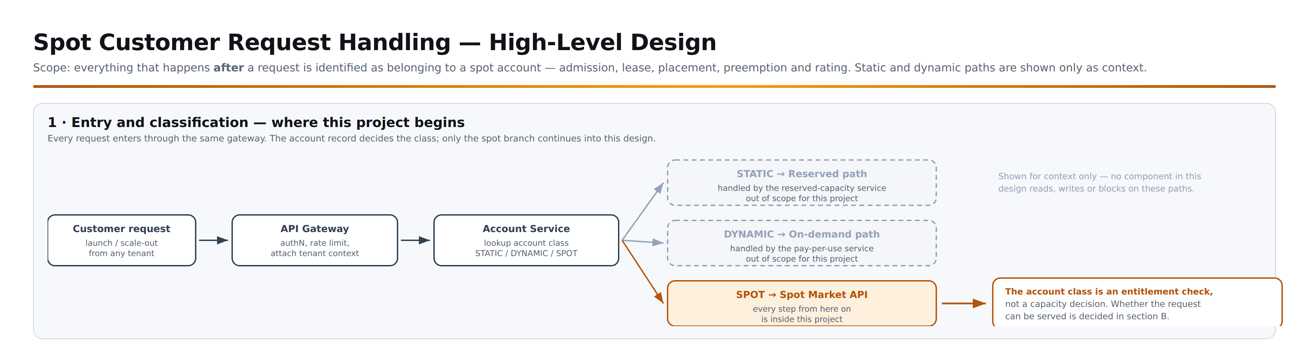
Note that account class answers only "is this tenant allowed to use spot?". It says nothing about whether the request can actually be served — that is decided by the Admission Controller in §6, against a pool whose size changes every control cycle.

3. Spot subsystem components
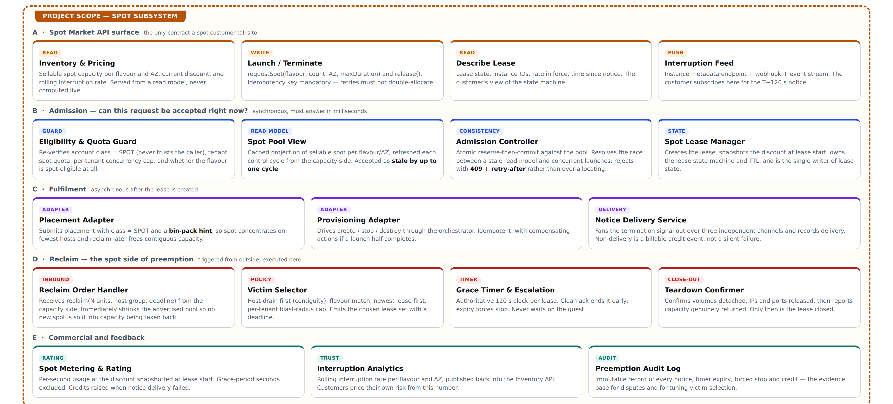

4. Component wiring — which component calls which
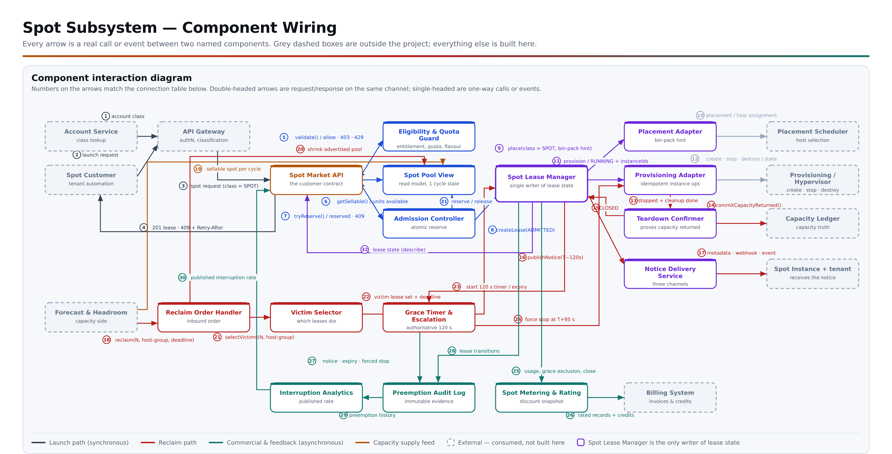

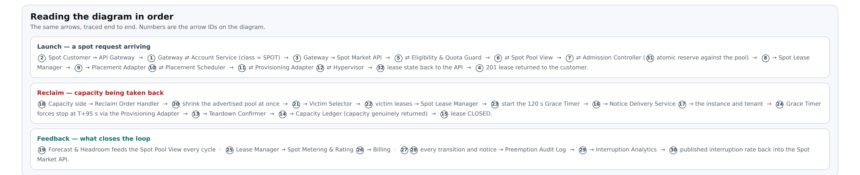

5. Connection table
Every arrow on the wiring diagram, listed. "Mode" is how the two components are coupled: sync = blocking call on the request path, async = fire-and-forget or callback, event = published to the bus, feed = periodic push, push = delivered to the customer, timer = driven by the grace clock, batch = periodic aggregation.
# | From | To | Mode | What flows
1 | Account Service | API Gateway | sync | account class
2 | Spot Customer | API Gateway | sync | launch request
3 | API Gateway | Spot Market API | sync | spot request (class = SPOT)
4 | Spot Market API | Spot Customer | sync | 201 lease · 409 + Retry-After
5 | Spot Market API | ⇄ Eligibility & Quota Guard | sync | validate() / allow · 403 · 429
6 | Spot Market API | ⇄ Spot Pool View | sync | getSellable() / units available
7 | Spot Market API | ⇄ Admission Controller | sync | tryReserve() / reserved · 409
8 | Admission Controller | Spot Lease Manager | sync | createLease(ADMITTED)
9 | Spot Lease Manager | Placement Adapter | async | place(class = SPOT, bin-pack hint)
10 | Placement Adapter | ⇄ Placement Scheduler | sync | placement / host assignment
11 | Spot Lease Manager | ⇄ Provisioning Adapter | async | provision / RUNNING + instanceIds
12 | Provisioning Adapter | ⇄ Provisioning / Hypervisor | async | create · stop · destroy / state
13 | Provisioning Adapter | Teardown Confirmer | event | stopped + cleanup done
14 | Teardown Confirmer | Capacity Ledger | sync | commitCapacityReturned()
15 | Teardown Confirmer | Spot Lease Manager | event | CLOSED
16 | Spot Lease Manager | Notice Delivery Service | async | publishNotice(T−120s)
17 | Notice Delivery Service | Spot Instance + tenant | push | metadata · webhook · event
18 | Forecast & Headroom | Reclaim Order Handler | sync | reclaim(N, host-group, deadline)
19 | Forecast & Headroom | Spot Pool View | feed | sellable spot per cycle
20 | Reclaim Order Handler | Spot Pool View | sync | shrink advertised pool
21 | Reclaim Order Handler | Victim Selector | sync | selectVictims(N, host-group)
22 | Victim Selector | Spot Lease Manager | sync | victim lease set + deadline
23 | Spot Lease Manager | ⇄ Grace Timer & Escalation | timer | start 120 s timer / expiry
24 | Grace Timer & Escalation | Provisioning Adapter | sync | force stop at T+95 s
25 | Spot Lease Manager | Spot Metering & Rating | event | usage, grace exclusion, close
26 | Spot Metering & Rating | Billing System | batch | rated records + credits
27 | Grace Timer & Escalation | Preemption Audit Log | event | notice · expiry · forced stop
28 | Spot Lease Manager | Preemption Audit Log | event | lease transitions
29 | Preemption Audit Log | Interruption Analytics | batch | preemption history
30 | Interruption Analytics | Spot Market API | feed | published interruption rate
31 | Admission Controller | ⇄ Spot Pool View | sync | reserve / release
32 | Spot Lease Manager | Spot Market API | sync | lease state (describe)

6. Component responsibilities
Component | Owns | Must not do | Key operations
Spot Market API | The only surface a spot customer touches: inventory, launch, describe, terminate, interruption feed. | Compute capacity or make placement decisions. | GET /spot/inventory, POST /spot/leases, GET|DELETE /spot/leases/{id}
Eligibility & Quota Guard | Re-verifying spot entitlement, tenant quota, concurrency cap, flavour eligibility. | Trust a class supplied by the caller. | validate(tenant, flavour, count)
Spot Pool View | A cached projection of sellable spot per flavour and AZ, refreshed each control cycle. | Be treated as authoritative — it is stale by design. | getSellable(flavour, az)
Admission Controller | The atomic reserve that resolves the race between a stale read and concurrent launches. | Over-allocate under any circumstance. It rejects instead. | tryReserve(units, key), release(key)
Spot Lease Manager | The lease record, discount snapshot, TTL, state machine and audit trail. Single writer. | Let any other component write lease state. | createLease(), transition(), close()
Placement Adapter | Submitting placement with class = SPOT and the bin-pack hint. | Choose hosts itself. | place(leaseId, hint)
Provisioning Adapter | Idempotent create / stop / destroy with compensating actions. | Leave a half-created instance without compensation. | create(), stop(mode), destroy()
Reclaim Order Handler | Accepting reclaim orders and shrinking advertised inventory immediately. | Decide how much to reclaim. | POST /internal/spot/reclaim
Victim Selector | Which leases die and in what order, under the contiguity and blast-radius policy. | Ignore the deadline in the order. | selectVictims(n, hostGroup, deadline)
Grace Timer & Escalation | The authoritative 120 s clock, forced stop, and escalation when the host agent is unreachable. | Wait on the guest beyond the timer. | startTimer(), forceStop()
Notice Delivery Service | Fan-out over three independent channels and proof of delivery. | Fail silently when no channel succeeds. | publishNotice(leaseIds)
Spot Metering & Rating | Per-second usage at the snapshotted discount, grace exclusion, credits. | Re-rate a running lease when the published discount changes. | emitUsage(), credit()

7. Spot launch sequence
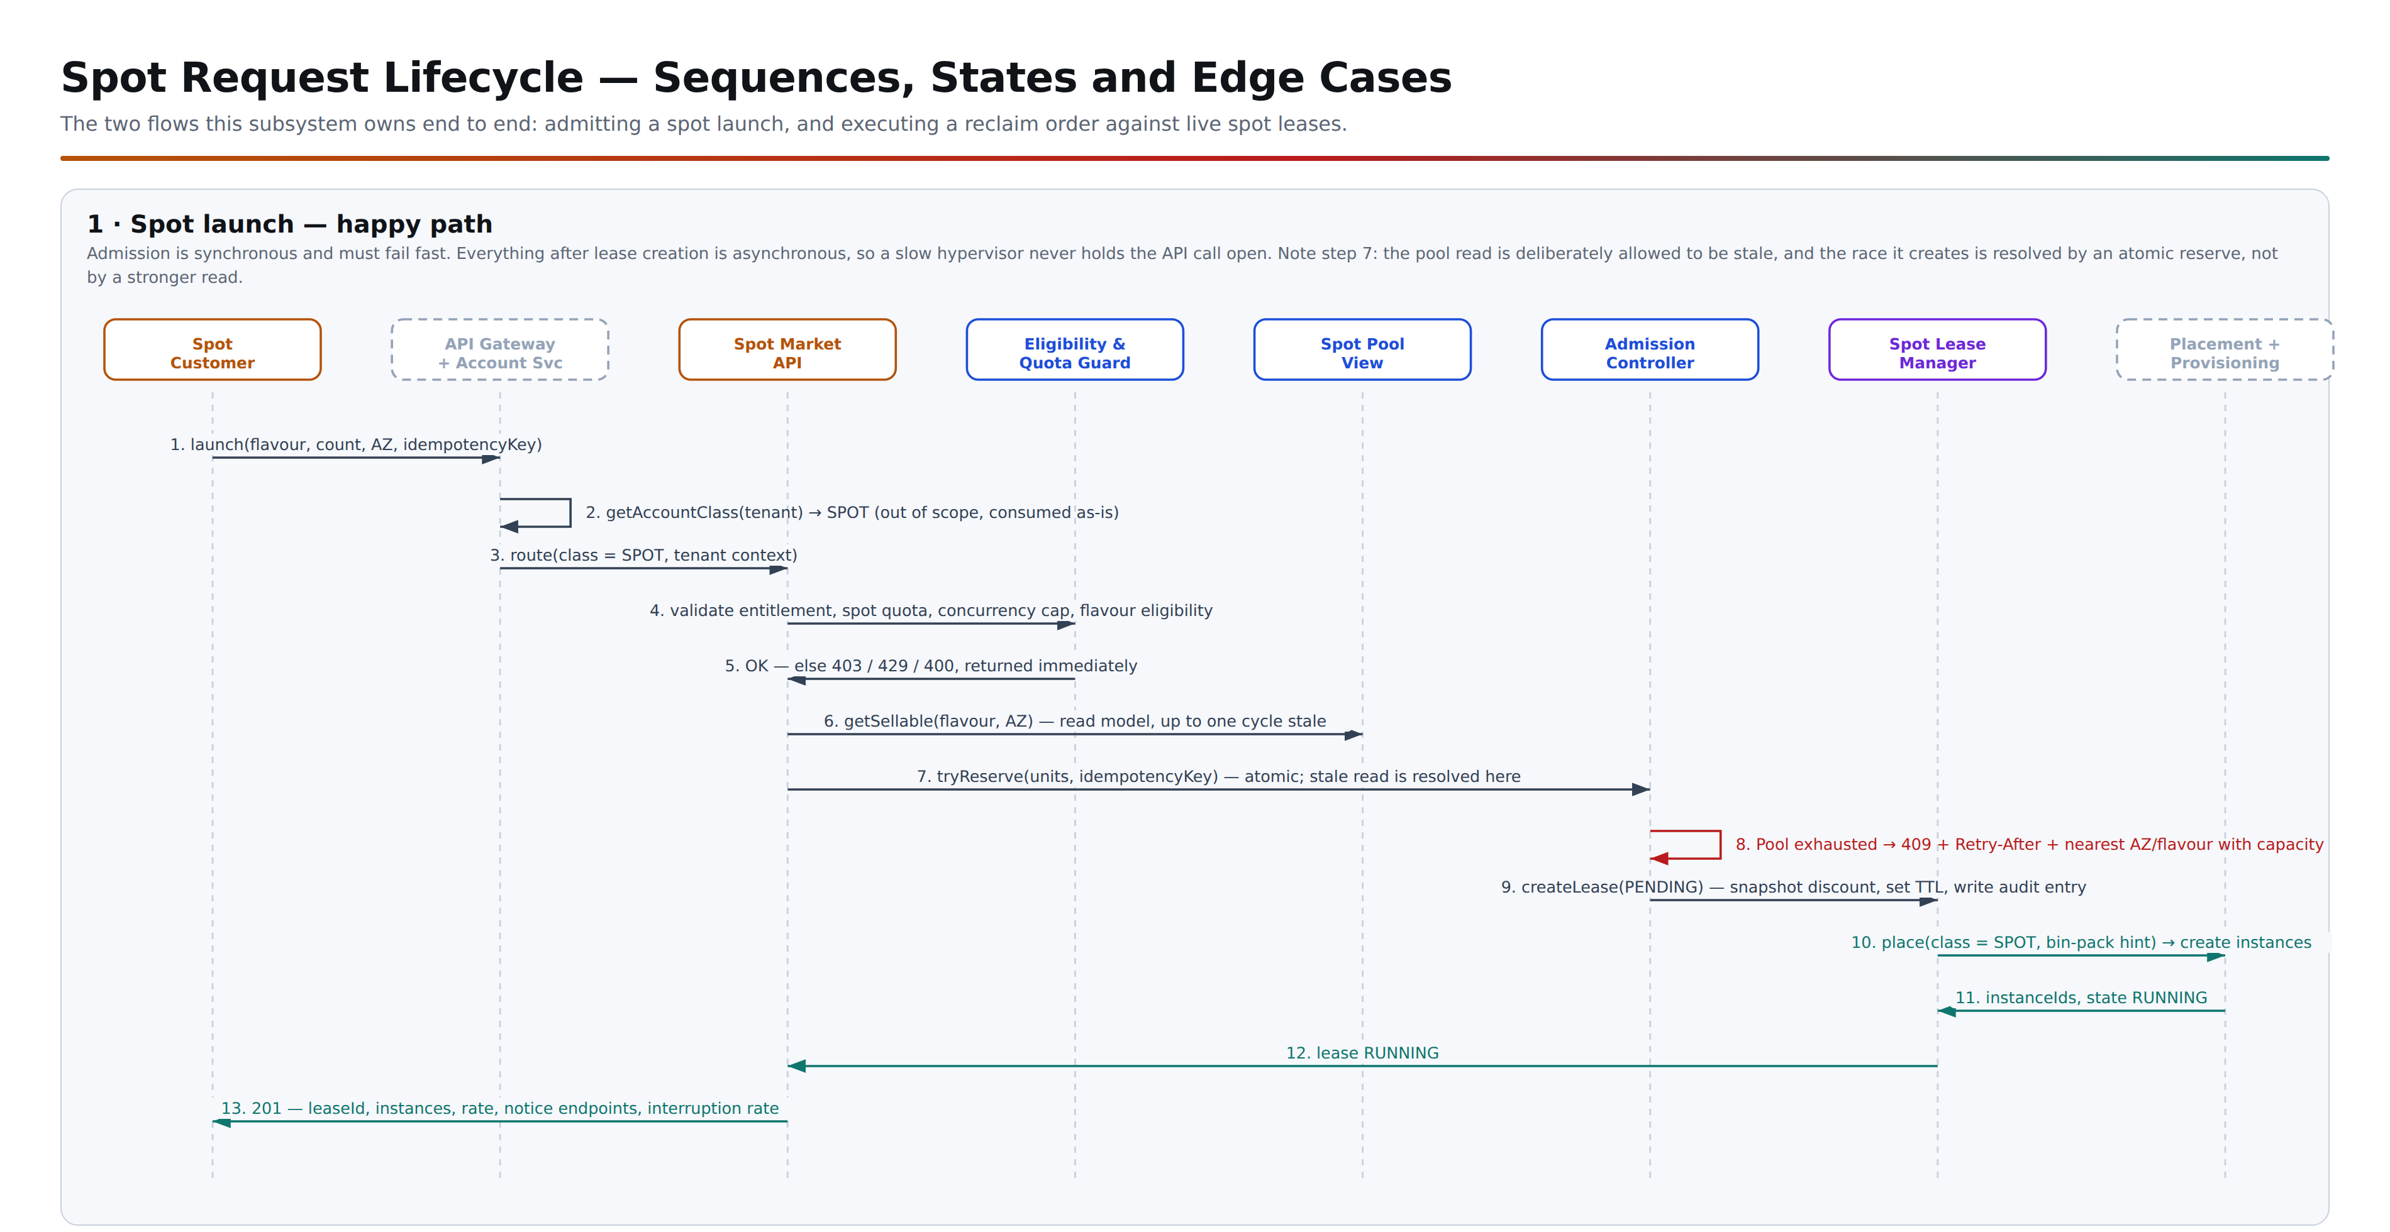

Why admission is a reserve, not a read
The Spot Pool View is refreshed once per control cycle, so at any moment it can claim capacity that another launch has already taken. Making the read stronger does not fix this — it only moves the contention. The design therefore treats the read as a hint and the reserve as the decision: tryReserve is atomic, idempotency-keyed, and cheap to fail. A 409 is normal traffic on a busy pool, not an incident.

8. Reclaim sequence
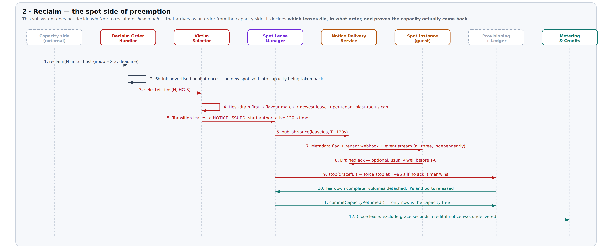
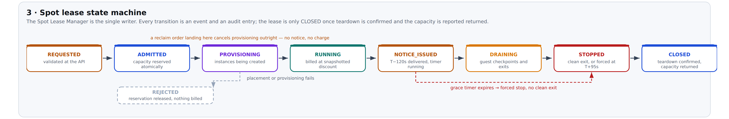

9. Rejection and edge cases
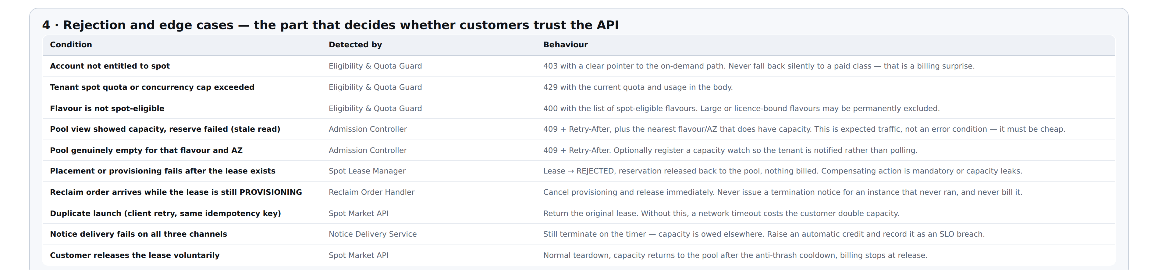
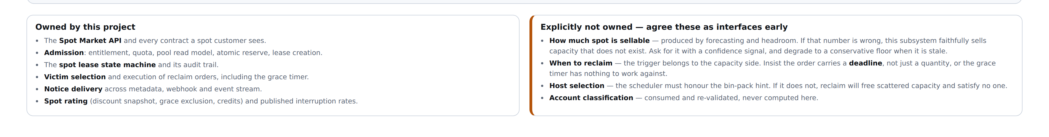

10. Spot lease record — core fields
One record per lease, written only by the Spot Lease Manager. The timestamps are what make preemption disputes and billing credits provable after the fact.
Field | Purpose | Notes
lease_id, tenant_id | Identity | Lease is the billing and preemption unit, not the instance.
idempotency_key | Retry safety | Unique per tenant; a repeat returns the original lease. Retain at least 24 h.
flavour, count, az, host_group | Placement | host_group is filled after placement and is what victim selection groups on.
state | Lease state machine | REQUESTED → ADMITTED → PROVISIONING → RUNNING → NOTICE_ISSUED → DRAINING → STOPPED → CLOSED, plus REJECTED.
discount_snapshot, rate_per_sec | Rating | Frozen at lease start. A later change to the published discount must not re-rate a running lease.
admitted_at, running_at, notice_at, stopped_at, closed_at | Evidence | notice_at → stopped_at proves the grace window; stopped_at → closed_at proves the teardown budget.
preemption_reason, reclaim_order_id | Traceability | Links the lease back to the capacity-side order that killed it.
notice_channels_delivered[] | Trust | Which of metadata / webhook / event stream actually succeeded. Empty ⇒ automatic credit.
grace_seconds_excluded, credit_raised | Billing | Makes the invoice explainable without reconstructing logs.

11. Non-functional targets for this subsystem
Dimension | Target | Why
Admission latency (p99) | < 200 ms | Spot launches are often burst automation. A slow reject is worse than a fast one.
Over-allocation | Zero | Guaranteed by atomic reserve. Any occurrence is a correctness bug, not a tuning issue.
Pool view staleness | ≤ one control cycle | Anything older and the 409 rate becomes unusable for customers.
Notice delivery | ≥ 99.99% on at least one channel | This is the trust anchor of the whole product.
Reclaim completion | 99.9% within 120 s, teardown included | The guaranteed classes are waiting on this capacity.
Idempotency retention | ≥ 24 h | A client retry after a network partition must not double-allocate.
Interruption rate publication | Refreshed at least hourly, per flavour and AZ | Customers cannot size spot workloads without it.
Audit completeness | 100% of notices, expiries and credits | Preemption disputes are settled from this log or not at all.

12. Risks and open questions in this scope
Stated bluntly, because each one changes the design if answered differently.
Issue | Why it matters | Recommendation
Class lives on the account, not the request | A tenant cannot then run reserved, on-demand and spot side by side without three separate accounts, splitting their billing, IAM and networking. Public clouds put the purchase option on the launch request precisely to avoid this. | Keep account-level entitlement, but carry purchaseOption = spot | on-demand on the request. Route on the request field; the Guard checks the account is entitled. If you keep account-only, record it as a known limitation.
Contiguity and fairness pull in opposite directions | Host-drain-first frees usable capacity; newest-lease-first is what customers perceive as fair. On a given reclaim these two rules often select different victims, and an unstated precedence will be resolved differently by every implementer. | Write the precedence into the policy explicitly: contiguity picks the host set, fairness only orders victims within it. Publish the rule so customers can reason about it.
The sellable-spot number is an input, not a fact | If forecasting hands over an optimistic number, this subsystem faithfully sells capacity that does not exist and the failure surfaces as customer-visible 409s or, worse, guaranteed-class SLA breaches. | Require a confidence signal alongside the number, and degrade to a conservative floor when the feed is stale or the confidence is low. Never extrapolate the last known value.
Retry storms on 409 | A pool that is briefly empty will reject many launches at once. Automation that retries immediately turns a capacity shortage into a self-inflicted API flood. | Return Retry-After and enforce it at the gateway. Offer a capacity-watch subscription so tenants wait on an event instead of polling.
Notice delivery is the whole trust proposition | If a customer loses instances without warning even occasionally, adoption stops. Three channels do not help if they share a failure mode. | Ensure the channels are genuinely independent (different infrastructure paths). Treat all-channel failure as an SLO breach with automatic credit, and report the rate.
Anti-thrash cooldown costs revenue | Reclaimed capacity held in cooldown before re-sale is idle capacity you are not billing for. | Make the cooldown a tunable policy value and measure the trade-off: interruption rate against spot revenue per idle core.
Reclaim arriving mid-provisioning | An in-flight launch is the easiest case to get wrong — it can produce a notice for an instance that never booted, or a charge for one that never ran. | Model it explicitly in the state machine (ADMITTED and PROVISIONING both cancel outright, no notice, no charge) and test it as a first-class path, not an exception.
Cross-tenant fairness under sustained pressure | If reclaim consistently hits the same host groups, the same tenants absorb every interruption while others never do. | Track interruption rate per tenant, not just per flavour. If the spread widens, victim selection needs a fairness term.

13. Suggested build order
Phase | Deliverable | Exit criteria
1 | Spot Market API read surface + Spot Pool View, wired to a stubbed sellable-spot feed. | Inventory endpoint returns correct, cycle-fresh numbers.
2 | Eligibility Guard, Admission Controller, Lease Manager. Launches admitted but not provisioned. | Zero over-allocation under a concurrency load test; idempotent retries proven.
3 | Placement and provisioning adapters. Real instances, no preemption yet. | End-to-end launch within the admission latency target.
4 | Reclaim path: order handler, victim selector, grace timer, notice delivery, teardown confirmation. | Reclaim SLO met at 99.9% in a controlled test; every edge case in §9 covered.
5 | Metering, rating, credits, interruption analytics. | Invoices reproducible from the lease record alone.
6 | Limited release to internal or pilot tenants in one AZ. | Published interruption rate stable enough to offer externally.
Decisions needed before detailed design: whether purchase option moves to the request, the precedence between contiguity and fairness in victim selection, the cooldown duration, and whether a longer grace tier is offered at a smaller discount.

