CAPSTONE PROJECT
Supply Chain Optimization
Database Modelling and SQL Optimization using MySQL
Student Name: Anupriya Agarwal
Roll Number: 2501420005
Course / Subject Name: B.Tech CSE (Data Science) / DBMS
Faculty Name: Mrs. Swati Gupta
Submission Date: 10 November 2026

1. Project Overview
This project models a supply chain database (SupplyChainDB) in MySQL 8.0. It covers suppliers, manufacturers, distributors, products, warehouses, inventory levels, purchase orders, logistics and inventory movements. SQL queries are then written to optimize inventory replenishment, minimize stock-outs, reduce transportation costs and streamline order fulfillment.
Every query in this report is shown together with its output screenshot and a numbered label.

1.1 Tables in the Database
Table | Purpose | Key relationships
Suppliers | Companies that supply products | Referenced by PurchaseOrders
Manufacturers | Companies that make products | Referenced by Products
Distributors | Transport / distribution partners | Referenced by Logistics
Products | Product catalogue with unit price | FK to Manufacturers
Warehouses | Storage locations | Referenced by Inventory, PurchaseOrders, InventoryMovements
Inventory | Stock level and reorder level per warehouse and product | FK to Warehouses, Products
PurchaseOrders | Replenishment orders placed with suppliers | FK to Suppliers, Products, Warehouses
Logistics | Shipment mode, distance and cost per order | FK to PurchaseOrders, Distributors
InventoryMovements | IN / OUT stock transactions | FK to Warehouses, Products

2. Table Creation and Constraints
Each table was created with constraints that protect data integrity. The CREATE TABLE statement and its screenshot are given below.

Suppliers
CREATE TABLE Suppliers (
supplier_id INT AUTO_INCREMENT PRIMARY KEY,
supplier_name VARCHAR(100) NOT NULL,
contact_email VARCHAR(100) UNIQUE,
phone VARCHAR(15),
city VARCHAR(50),
rating DECIMAL(3,2) DEFAULT 0,
CHECK (rating BETWEEN 0 AND 5)
);

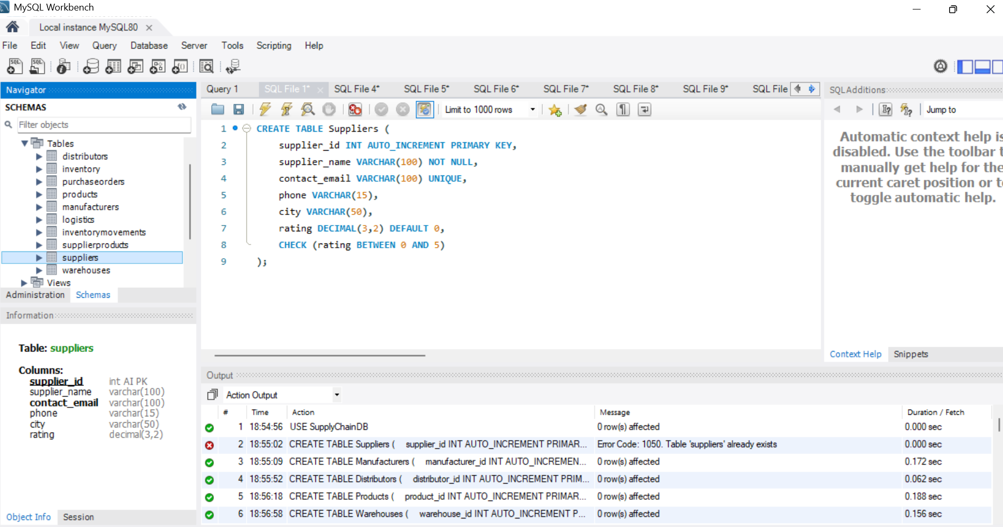
Screenshot 1: CREATE TABLE Suppliers (PRIMARY KEY, NOT NULL, UNIQUE, DEFAULT, CHECK)
Note: the first run returned Error 1050 because the Suppliers table already existed in the schema; the remaining tables were created successfully.

Manufacturers
CREATE TABLE Manufacturers (
manufacturer_id INT AUTO_INCREMENT PRIMARY KEY,
manufacturer_name VARCHAR(100) NOT NULL,
location VARCHAR(100) NOT NULL,
contact_number VARCHAR(15) UNIQUE
);

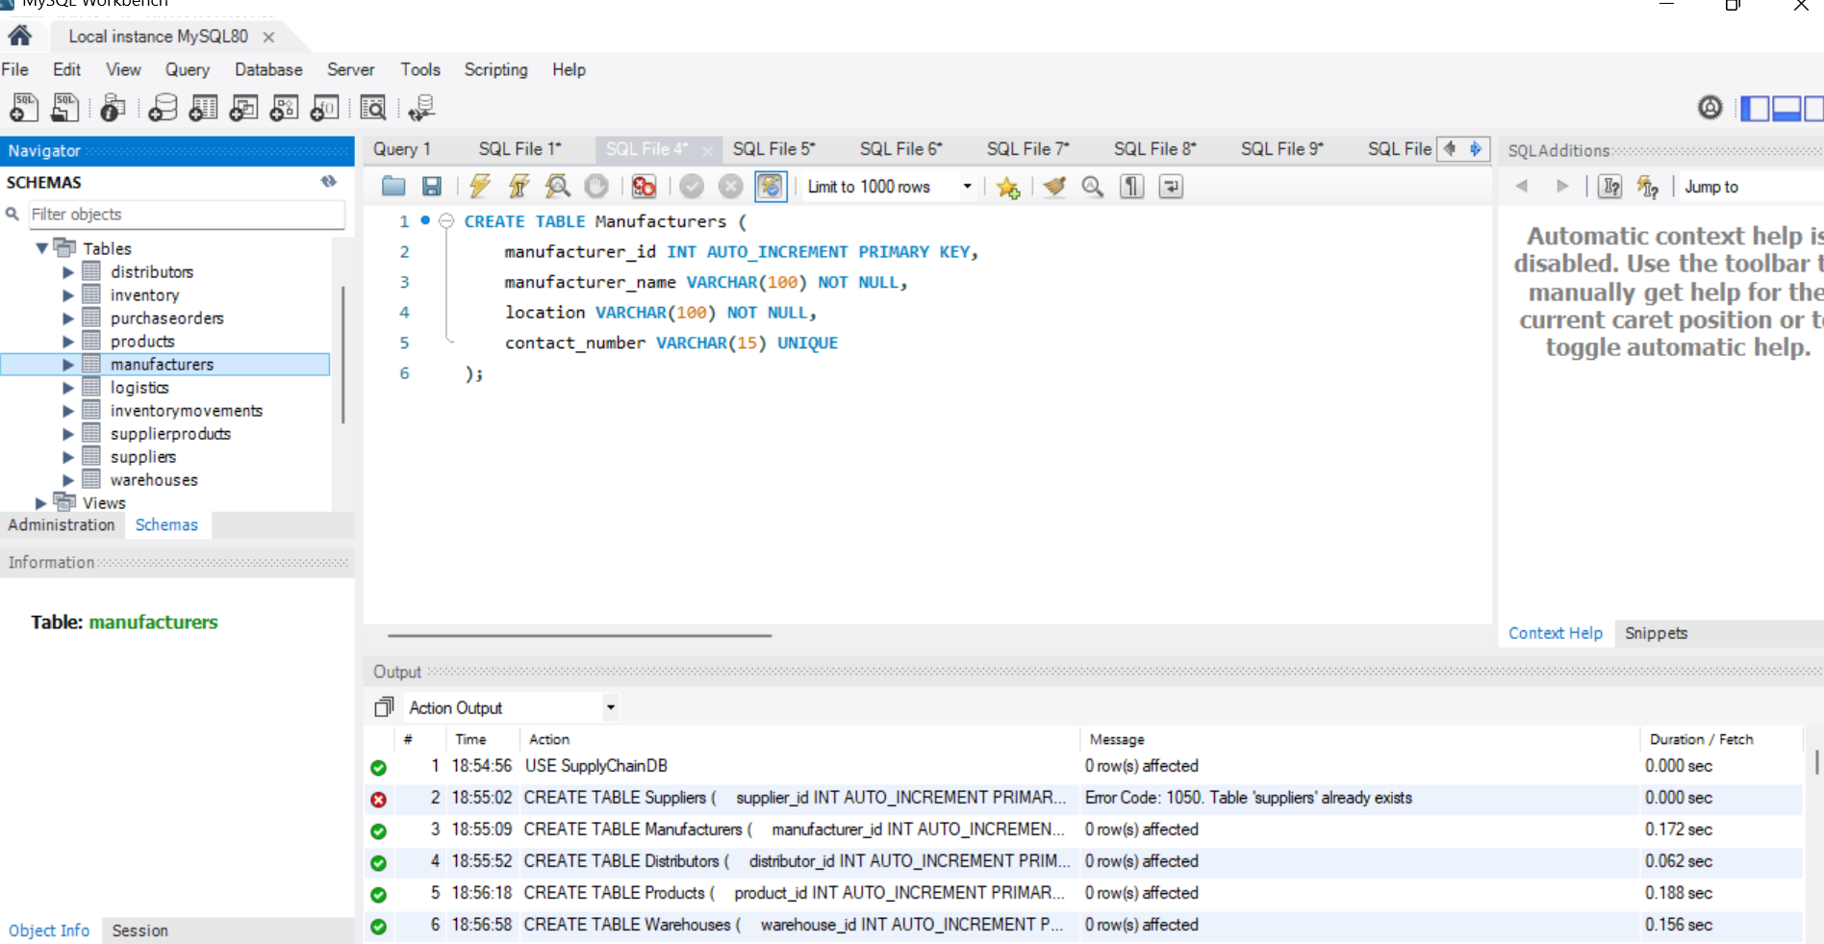
Screenshot 2: CREATE TABLE Manufacturers

Distributors
CREATE TABLE Distributors (
distributor_id INT AUTO_INCREMENT PRIMARY KEY,
distributor_name VARCHAR(100) NOT NULL,
location VARCHAR(100),
phone VARCHAR(15) UNIQUE
);

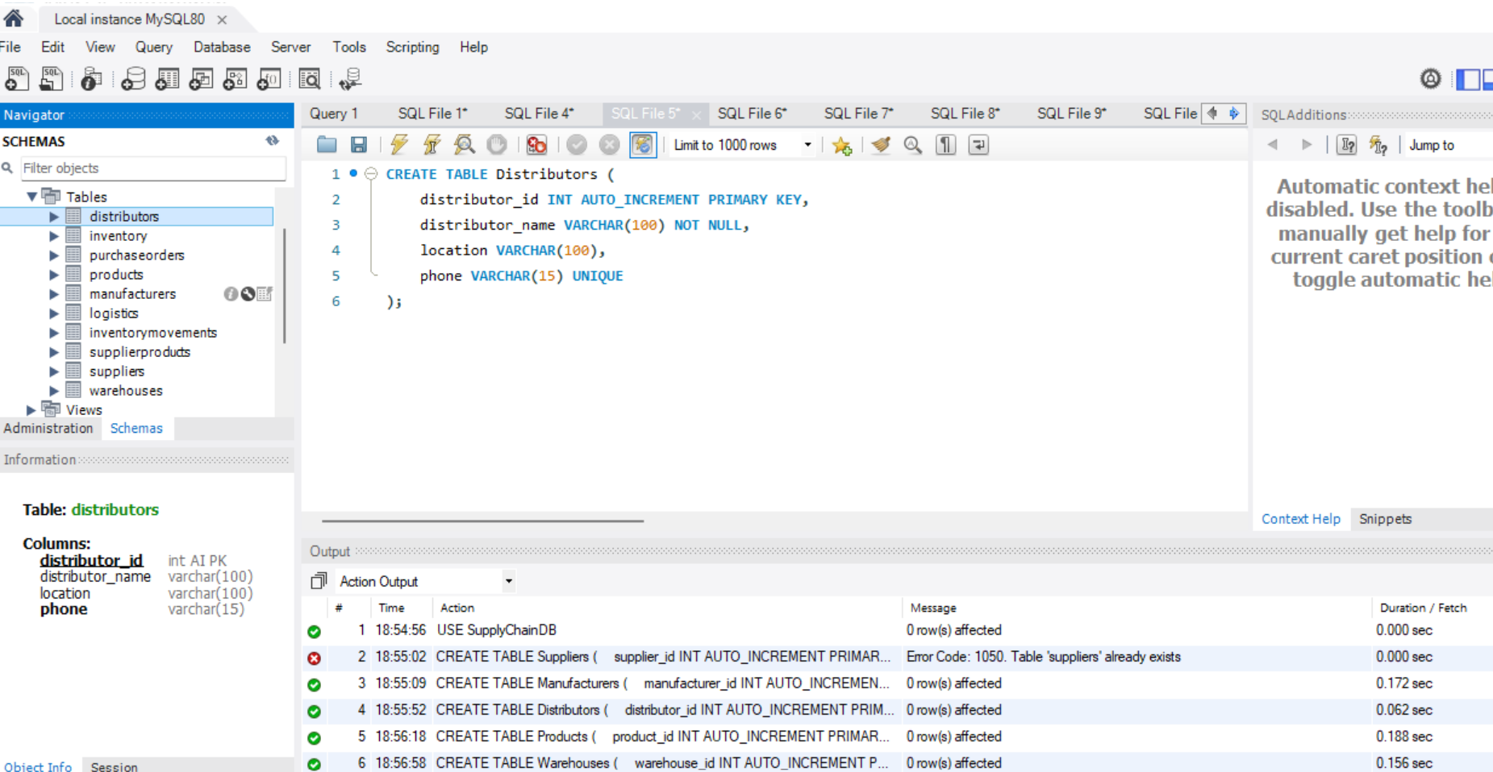
Screenshot 3: CREATE TABLE Distributors

Products
CREATE TABLE Products (
product_id INT AUTO_INCREMENT PRIMARY KEY,
product_name VARCHAR(100) NOT NULL,
manufacturer_id INT,
unit_price DECIMAL(10,2) NOT NULL,
FOREIGN KEY (manufacturer_id)
REFERENCES Manufacturers(manufacturer_id),
CHECK (unit_price >= 0)
);

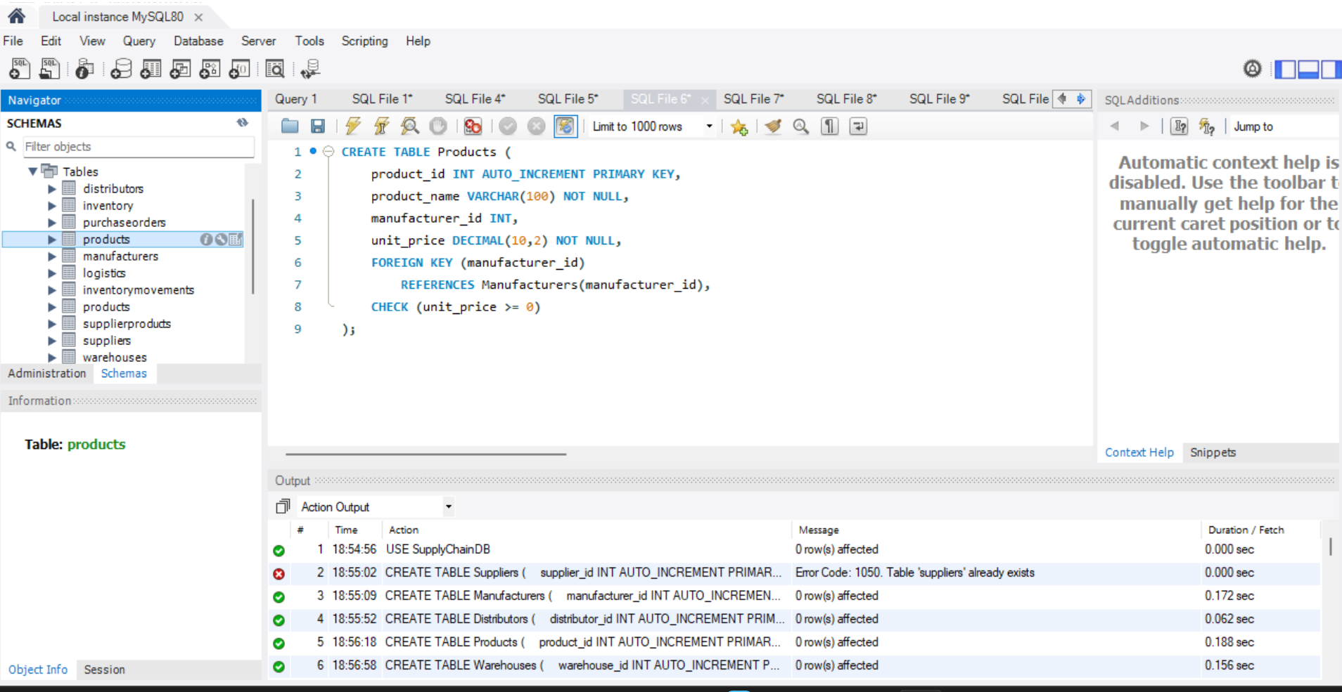
Screenshot 4: CREATE TABLE Products (FOREIGN KEY and CHECK)

Warehouses
CREATE TABLE Warehouses (
warehouse_id INT AUTO_INCREMENT PRIMARY KEY,
warehouse_name VARCHAR(100) NOT NULL,
location VARCHAR(100) NOT NULL
);

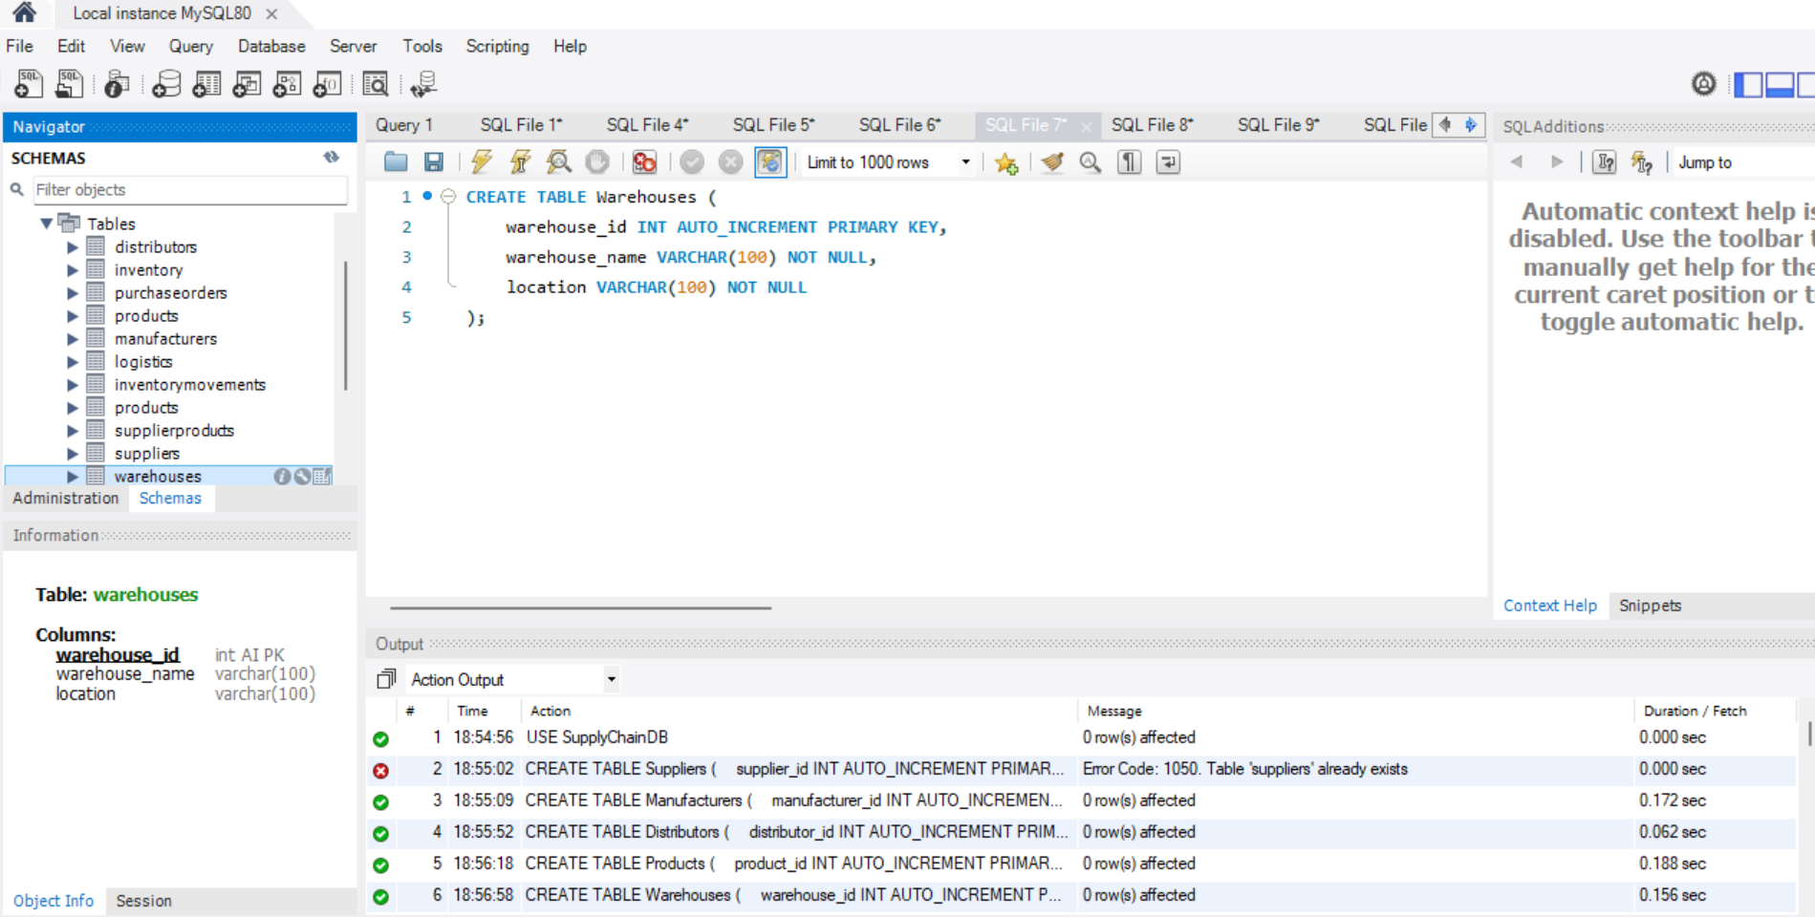
Screenshot 5: CREATE TABLE Warehouses

Inventory
CREATE TABLE Inventory (
inventory_id INT AUTO_INCREMENT PRIMARY KEY,
warehouse_id INT NOT NULL,
product_id INT NOT NULL,
quantity INT NOT NULL DEFAULT 0,
reorder_level INT NOT NULL,
FOREIGN KEY (warehouse_id) REFERENCES Warehouses(warehouse_id),
FOREIGN KEY (product_id) REFERENCES Products(product_id),
UNIQUE (warehouse_id, product_id),
CHECK (quantity >= 0),
CHECK (reorder_level >= 0)
);

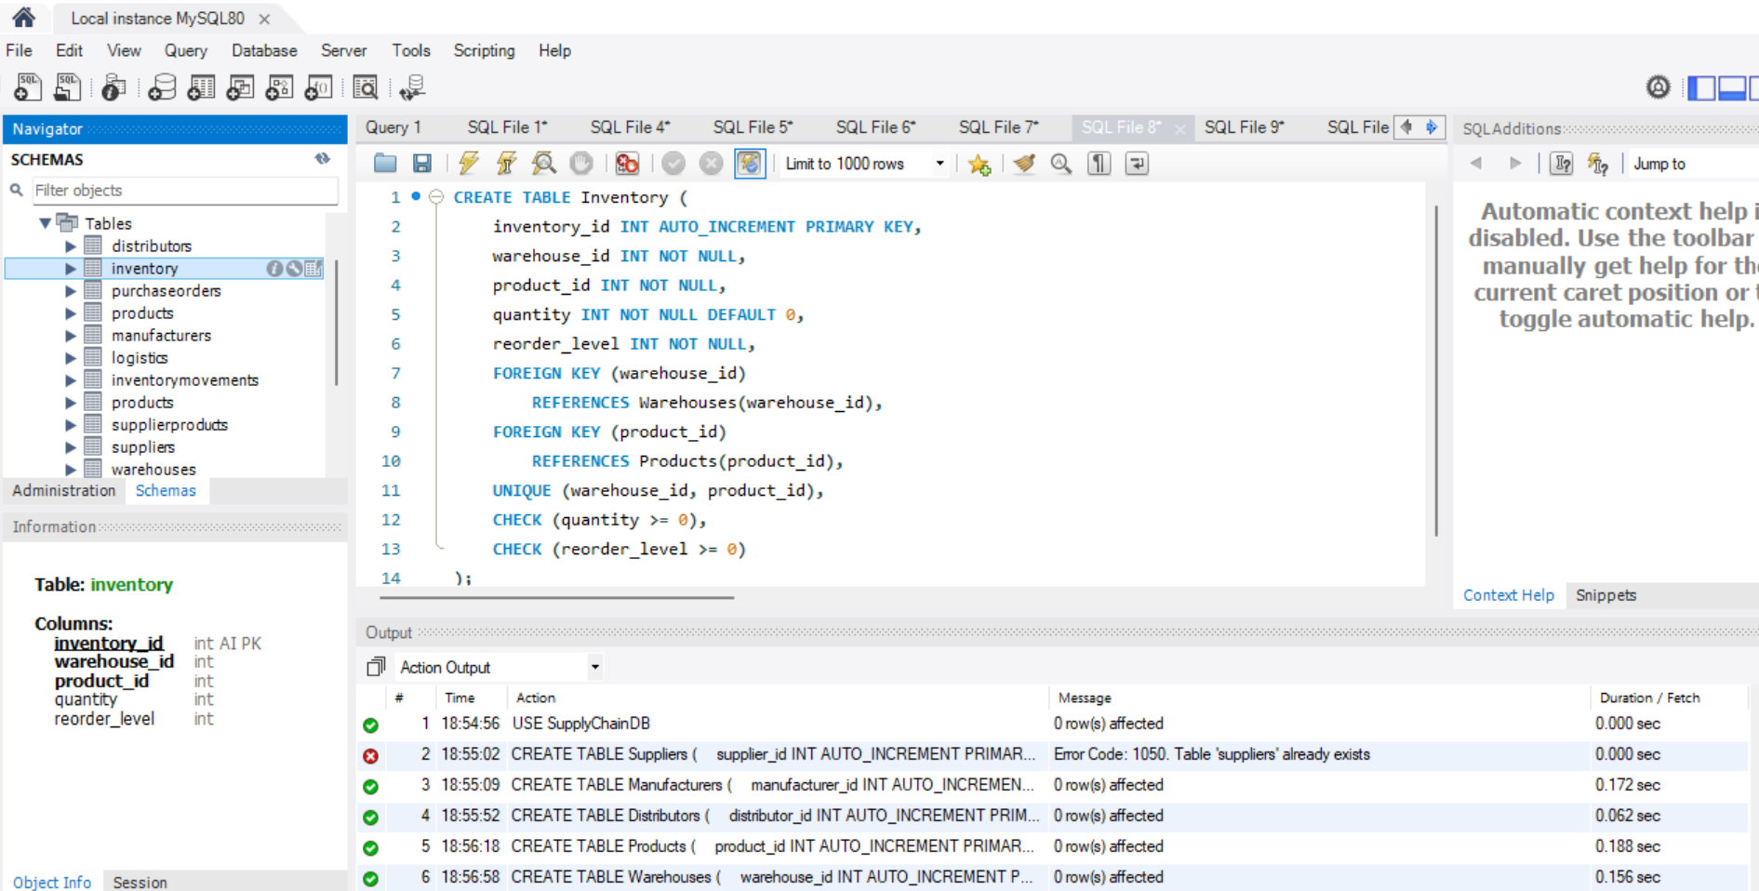
Screenshot 6: CREATE TABLE Inventory (composite UNIQUE, two FOREIGN KEYs, CHECK)

PurchaseOrders
CREATE TABLE PurchaseOrders (
po_id INT AUTO_INCREMENT PRIMARY KEY,
supplier_id INT NOT NULL,
product_id INT NOT NULL,
warehouse_id INT NOT NULL,
quantity INT NOT NULL,
order_status VARCHAR(30) NOT NULL,
order_date DATE NOT NULL,
expected_delivery_date DATE,
actual_delivery_date DATE,
FOREIGN KEY (supplier_id) REFERENCES Suppliers(supplier_id),
FOREIGN KEY (product_id) REFERENCES Products(product_id),
... -- remaining constraints as shown in the screenshot
);

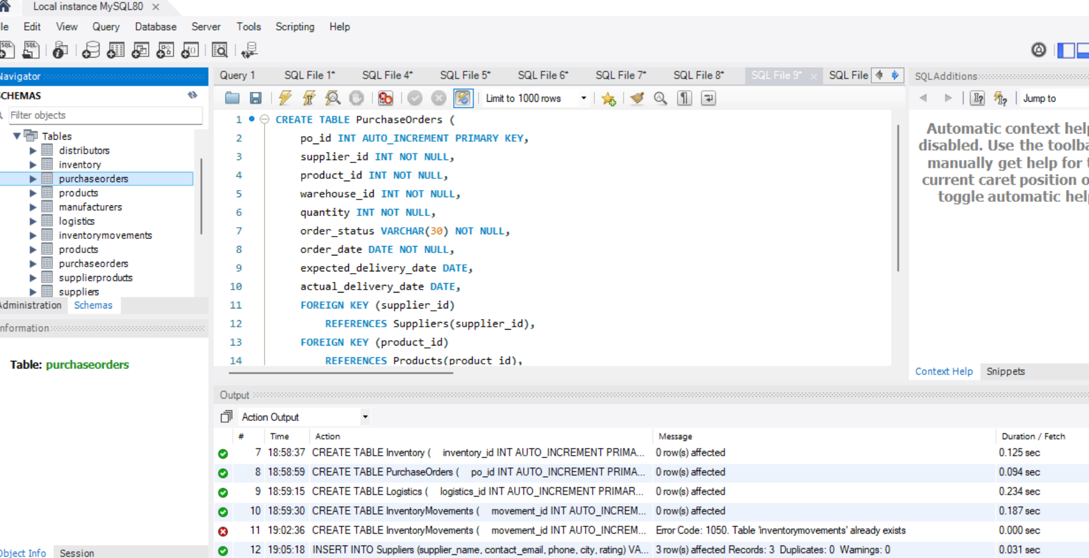
Screenshot 7: CREATE TABLE PurchaseOrders

Logistics
CREATE TABLE Logistics (
logistics_id INT AUTO_INCREMENT PRIMARY KEY,
po_id INT NOT NULL,
distributor_id INT NOT NULL,
transport_mode VARCHAR(50),
distance_km DECIMAL(10,2),
transportation_cost DECIMAL(10,2),
delivery_date DATE,
FOREIGN KEY (po_id) REFERENCES PurchaseOrders(po_id),
FOREIGN KEY (distributor_id) REFERENCES Distributors(distributor_id),
CHECK (distance_km >= 0),
CHECK (transportation_cost >= 0)
);

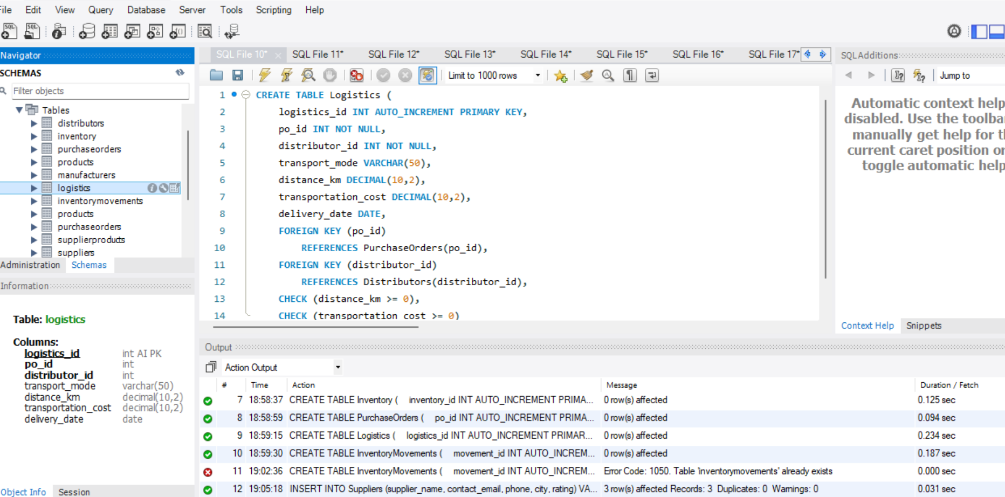
Screenshot 8: CREATE TABLE Logistics

InventoryMovements
CREATE TABLE InventoryMovements (
movement_id INT AUTO_INCREMENT PRIMARY KEY,
warehouse_id INT NOT NULL,
product_id INT NOT NULL,
movement_date DATE NOT NULL,
movement_type VARCHAR(20) NOT NULL,
quantity INT NOT NULL,
FOREIGN KEY (warehouse_id) REFERENCES Warehouses(warehouse_id),
FOREIGN KEY (product_id) REFERENCES Products(product_id),
CHECK (movement_type IN ('IN','OUT')),
CHECK (quantity > 0)
);

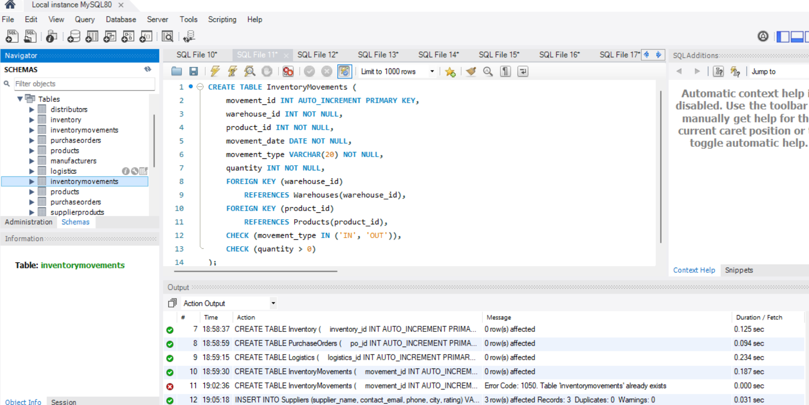
Screenshot 9: CREATE TABLE InventoryMovements (CHECK on movement_type and quantity)

2.1 Constraints Identified
Constraint | Purpose | Example in this project
PRIMARY KEY | Uniquely identifies each row; cannot be NULL | supplier_id, product_id, po_id
AUTO_INCREMENT | Generates the next numeric key automatically | All *_id primary keys
NOT NULL | Column must always have a value | supplier_name, unit_price, order_date
UNIQUE | No duplicate values allowed | Suppliers.contact_email, Distributors.phone
Composite UNIQUE | Combination of columns must be unique | Inventory (warehouse_id, product_id)
DEFAULT | Value used when none is supplied | rating DEFAULT 0, quantity DEFAULT 0
CHECK | Restricts values to a valid range or list | rating BETWEEN 0 AND 5; movement_type IN ('IN','OUT')
FOREIGN KEY | Keeps child rows linked to an existing parent row | Products.manufacturer_id, Inventory.product_id

3. Inventory Replenishment and Stock-out Queries

Query 1: Current stock by warehouse and product
Objective: view the stock level and reorder level of every product in every warehouse.
SELECT
w.warehouse_name,
p.product_name,
i.quantity,
i.reorder_level
FROM Inventory i
JOIN Warehouses w
ON i.warehouse_id = w.warehouse_id
JOIN Products p
ON i.product_id = p.product_id;

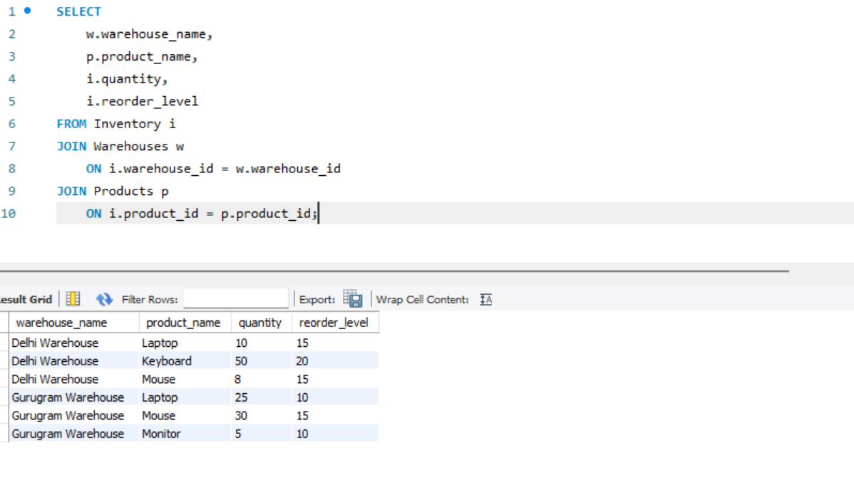
Screenshot 10: Stock level and reorder level per warehouse

Query 2: Low-stock items (stock-out risk)
Objective: list items where quantity has fallen below the reorder level. Laptop (Delhi), Mouse (Delhi) and Monitor (Gurugram) are at risk.
SELECT
p.product_name,
w.warehouse_name,
i.quantity,
i.reorder_level
FROM Inventory i
JOIN Products p
ON i.product_id = p.product_id
JOIN Warehouses w
ON i.warehouse_id = w.warehouse_id
WHERE i.quantity < i.reorder_level;

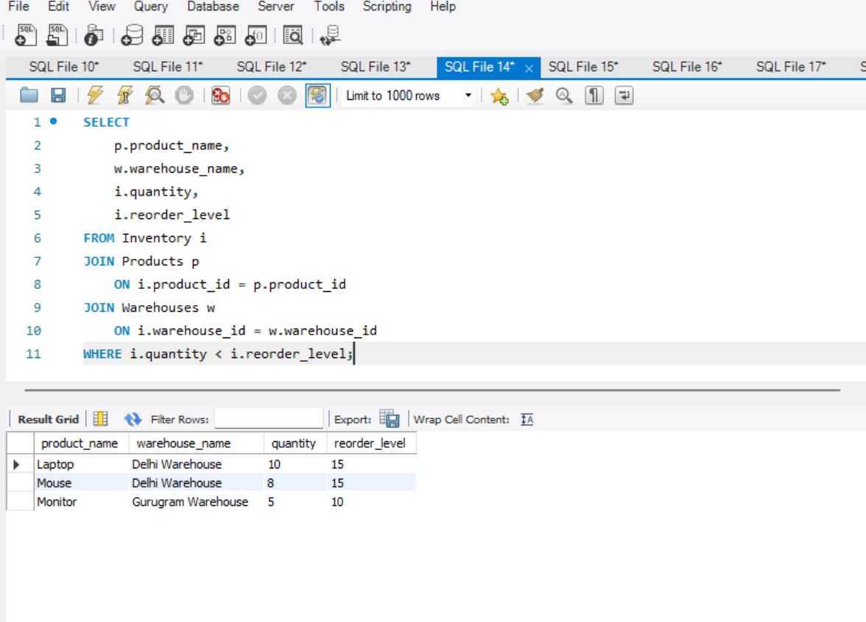
Screenshot 11: Products below reorder level

Query 3: Quantity to order
Objective: calculate how many units must be ordered to bring each low-stock item back to its reorder level.
SELECT
p.product_name,
w.warehouse_name,
i.quantity AS current_stock,
i.reorder_level,
(i.reorder_level - i.quantity) AS quantity_to_order
FROM Inventory i
JOIN Products p
ON i.product_id = p.product_id
JOIN Warehouses w
ON i.warehouse_id = w.warehouse_id
WHERE i.quantity < i.reorder_level;

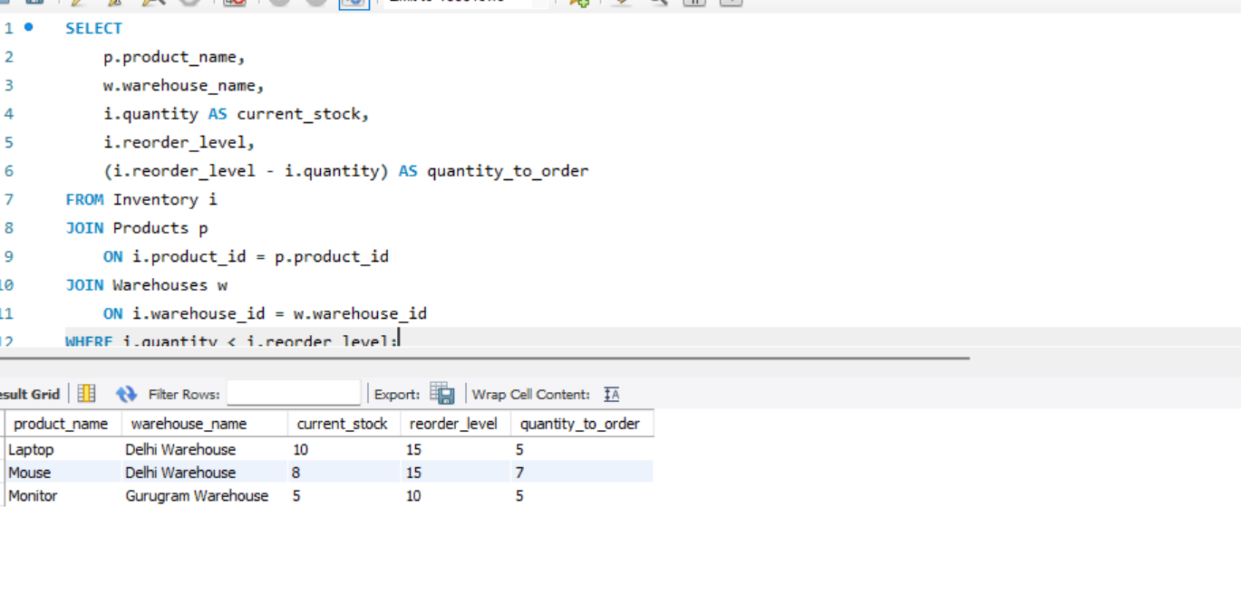
Screenshot 12: Replenishment quantity required (Laptop 5, Mouse 7, Monitor 5)

Query 4: Quantity already on pending purchase orders
Objective: find stock already on order (status Pending or Shipped) so that duplicate orders are avoided.
SELECT
product_id,
warehouse_id,
SUM(quantity) AS pending_quantity
FROM PurchaseOrders
WHERE order_status IN ('Pending', 'Shipped')
GROUP BY product_id, warehouse_id;

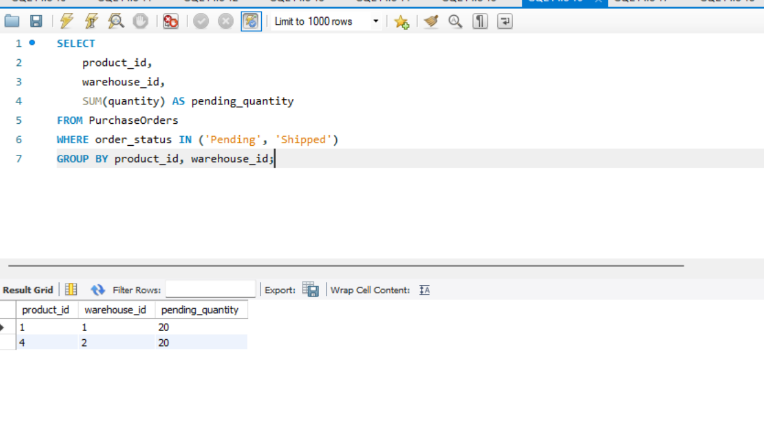
Screenshot 13: Pending purchase order quantity per product and warehouse

Query 5: Low stock after counting incoming stock
Objective: combine current stock with incoming stock. Only Mouse (Delhi Warehouse) still needs a new order, because the Laptop and Monitor shortfalls are already covered by pending orders.
SELECT
p.product_name,
w.warehouse_name,
i.quantity AS current_stock,
COALESCE(SUM(
CASE
WHEN po.order_status IN ('Pending', 'Shipped')
THEN po.quantity
ELSE 0
END
), 0) AS incoming_stock,
i.reorder_level
FROM Inventory i
... -- joins, GROUP BY and HAVING continue as shown in the screenshot

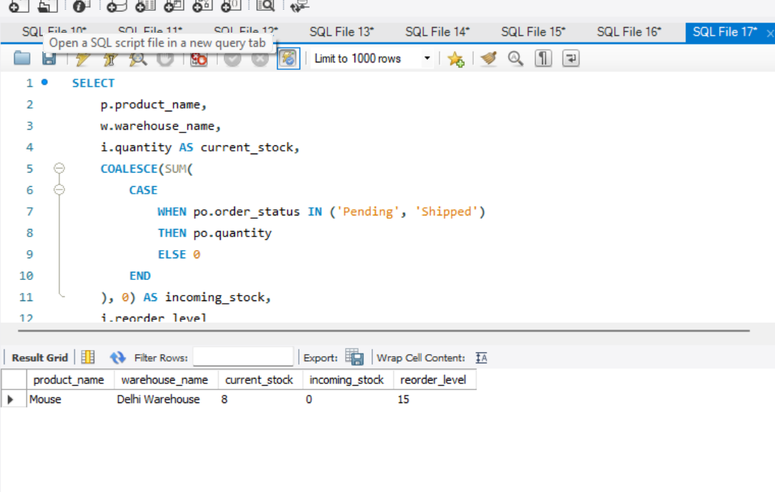
Screenshot 14: Low-stock report including incoming stock

4. Transportation Cost Optimization

Query 6: Total transportation cost by mode
SELECT
transport_mode,
SUM(transportation_cost) AS total_cost
FROM Logistics
GROUP BY transport_mode;

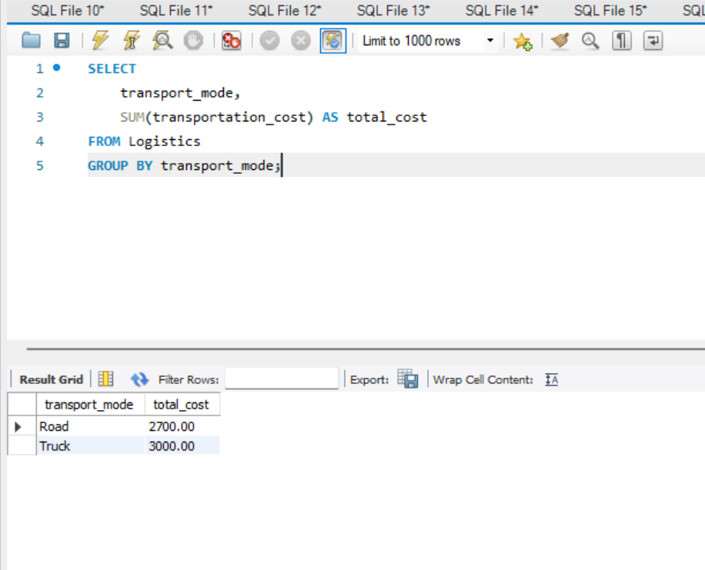
Screenshot 15: Total transportation cost per transport mode (Road 2700, Truck 3000)

Query 7: Cheapest shipment
SELECT
logistics_id,
transport_mode,
distance_km,
transportation_cost
FROM Logistics
ORDER BY transportation_cost ASC
LIMIT 1;

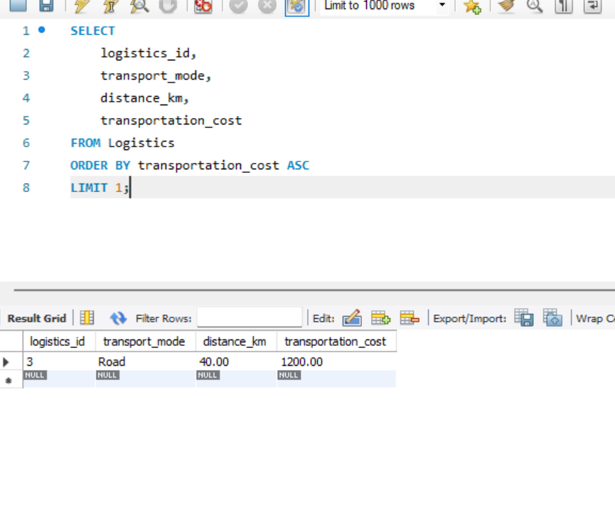
Screenshot 16: Lowest-cost shipment (logistics_id 3, Road, 40 km, 1200)

Query 8: Cost per kilometre by shipment
Objective: compare shipments on a like-for-like basis. All three shipments cost 30 per km, so total cost is driven by distance rather than by transport mode.
SELECT
logistics_id,
transport_mode,
distance_km,
transportation_cost,
ROUND(
transportation_cost / NULLIF(distance_km, 0), 2
) AS cost_per_km
FROM Logistics
ORDER BY cost_per_km ASC;

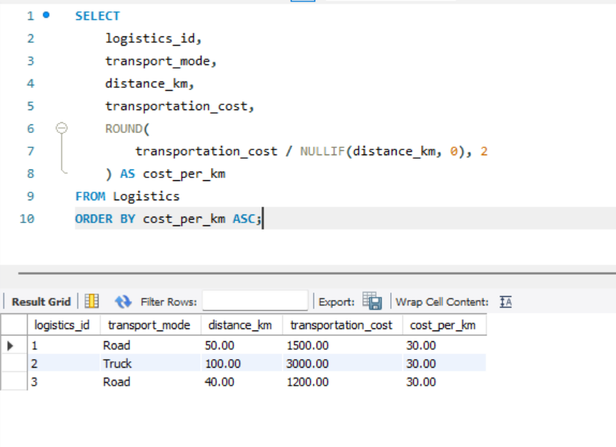
Screenshot 17: Transportation cost per km (Road and Truck both 30.00)

5. Order Fulfillment

Query 9: Total quantity ordered per supplier
SELECT
s.supplier_name,
SUM(po.quantity) AS total_orders
FROM Suppliers s
JOIN PurchaseOrders po
ON s.supplier_id = po.supplier_id
GROUP BY s.supplier_name
ORDER BY total_orders DESC;

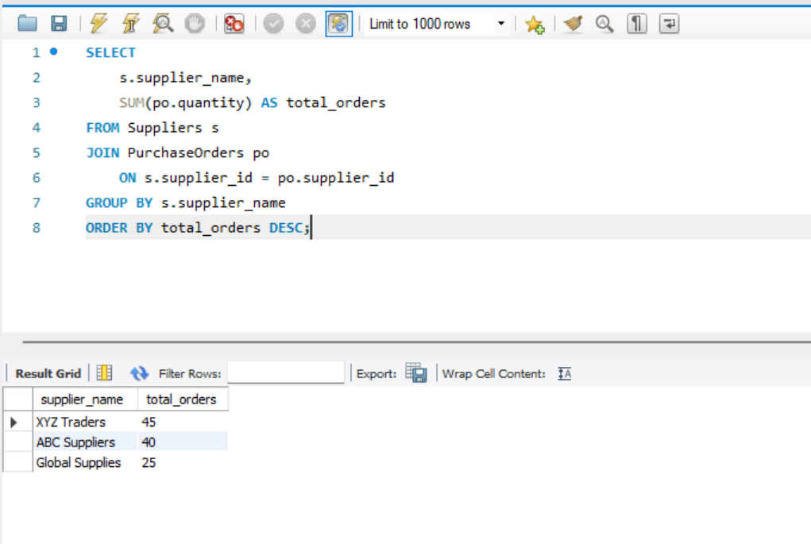
Screenshot 18: Supplier order volumes (XYZ Traders 45, ABC Suppliers 40, Global Supplies 25)

Query 10: Delayed deliveries
Objective: identify purchase orders delivered after the expected date. PO 3 from Global Supplies arrived 2 days late.
SELECT
po.po_id,
s.supplier_name,
po.expected_delivery_date,
po.actual_delivery_date
FROM PurchaseOrders po
JOIN Suppliers s
ON po.supplier_id = s.supplier_id
WHERE po.actual_delivery_date >
po.expected_delivery_date;

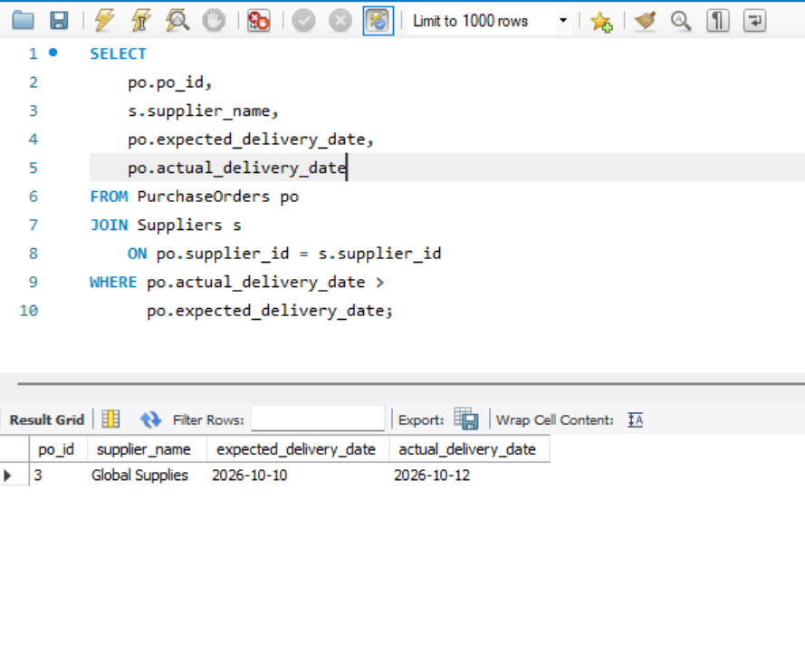
Screenshot 19: Late purchase order deliveries

Query 11: Open purchase orders awaiting delivery
Objective: list orders that are still pending, with the supplier, product, quantity and expected delivery date, so overdue follow-ups can be planned.
SELECT
po.po_id,
s.supplier_name,
p.product_name,
po.quantity,
po.order_status,
po.expected_delivery_date
FROM PurchaseOrders po
JOIN Suppliers s
ON po.supplier_id = s.supplier_id
JOIN Products p
ON po.product_id = p.product_id
... -- WHERE clause for open orders continues as shown in the screenshot

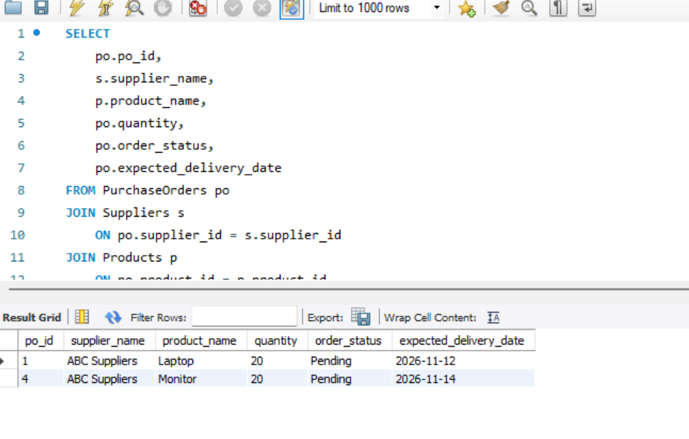
Screenshot 20: Pending purchase orders (PO 1 Laptop and PO 4 Monitor, 20 units each)

Query 12: Order status summary
SELECT
order_status,
COUNT(*) AS total_orders,
SUM(quantity) AS total_quantity
FROM PurchaseOrders
GROUP BY order_status;

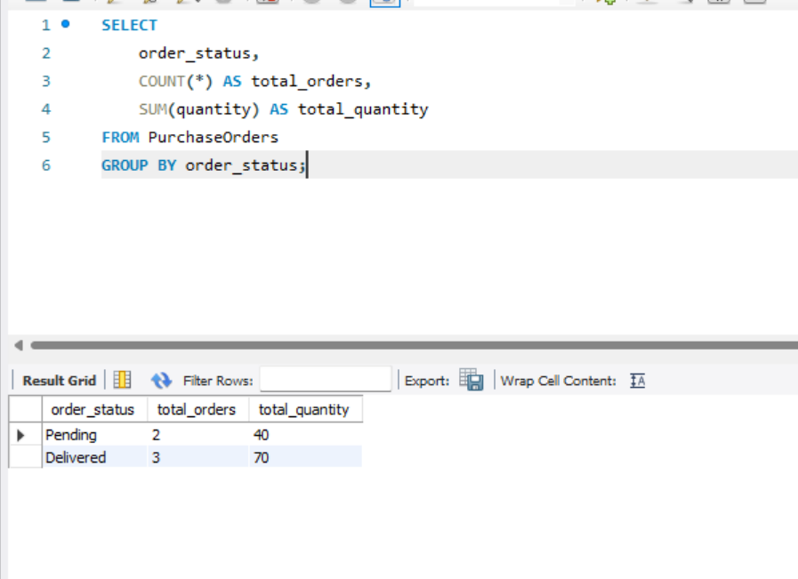
Screenshot 21: Purchase orders grouped by status (Pending 2 orders / 40 units, Delivered 3 orders / 70 units)

Query 13: Mark an order as delivered
Objective: close a purchase order when goods arrive, by recording the status and the actual delivery date.
UPDATE PurchaseOrders
SET order_status = 'Delivered',
actual_delivery_date = CURRENT_DATE()
WHERE po_id = 1;

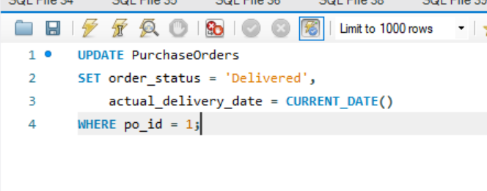
Screenshot 22: UPDATE statement marking PO 1 as Delivered

6. Inventory Valuation

Query 14: Inventory value per product
SELECT
p.product_name,
SUM(i.quantity * p.unit_price) AS inventory_value
FROM Inventory i
JOIN Products p
ON i.product_id = p.product_id
GROUP BY p.product_name
ORDER BY inventory_value DESC;

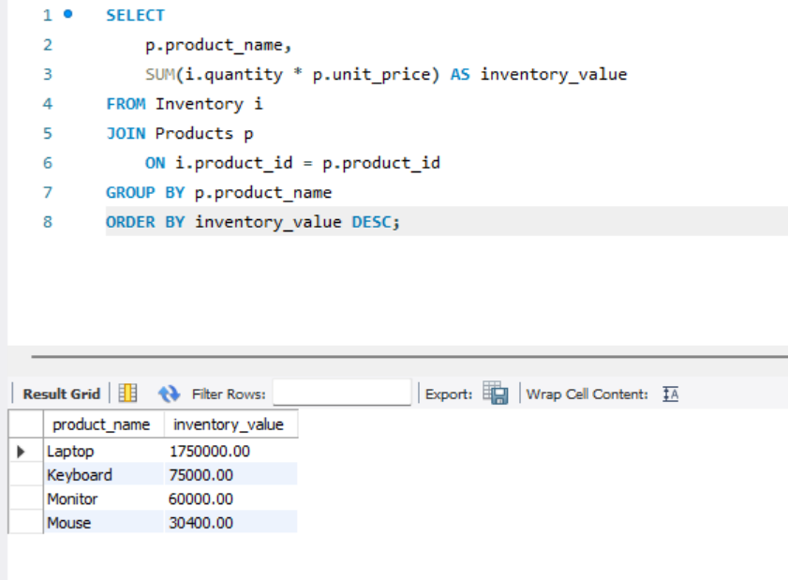
Screenshot 23: Inventory value by product (Laptop is the highest at 1,750,000)

7. Indexing

7.1 Composite Index on Inventory
CREATE INDEX idx_inventory_warehouse_product
ON Inventory (warehouse_id, product_id);

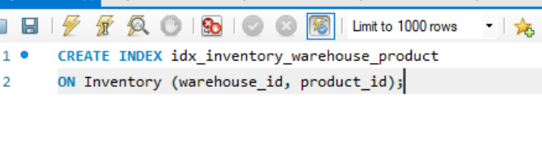
Screenshot 24: Composite index on Inventory (warehouse_id, product_id)
Note: because Inventory already has UNIQUE (warehouse_id, product_id), MySQL had already created an index on the same columns. The explicit index above is therefore equivalent to the existing one.

7.2 Composite Index on PurchaseOrders
CREATE INDEX idx_purchase_supplier_status_date
ON PurchaseOrders
(supplier_id, order_status, expected_delivery_date);

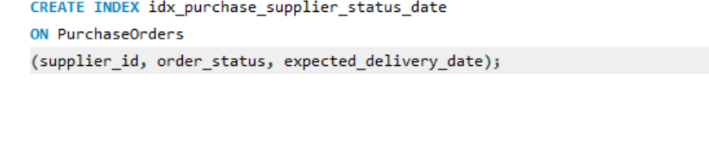
Screenshot 25: Composite index on PurchaseOrders (supplier_id, order_status, expected_delivery_date)

7.3 Covering Index for the Stock-out Report
The stock-out report reads warehouse_id, product_id, quantity and reorder_level. An index containing all four columns lets MySQL answer the query from the index alone, without reading the table rows.
CREATE INDEX idx_stockout_report
ON Inventory
(warehouse_id, product_id, quantity, reorder_level);

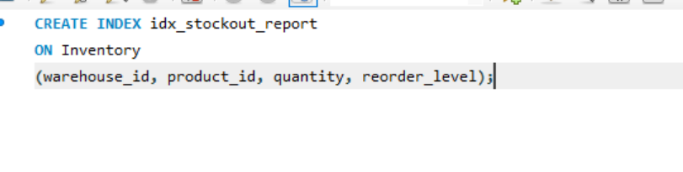
Screenshot 26: Covering index idx_stockout_report on Inventory
Stock-out report query served by this index (warehouse 1, products below reorder level):
SELECT
warehouse_id,
product_id,
quantity,
reorder_level
FROM Inventory
WHERE warehouse_id = 1
AND quantity < reorder_level;

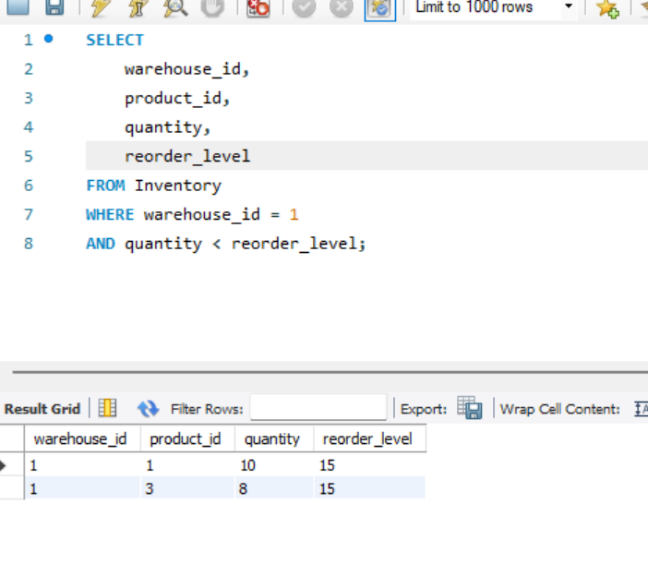
Screenshot 27: Stock-out report for warehouse 1 (products 1 and 3 are below reorder level)

7.4 Measuring the Improvement with EXPLAIN
Baseline without an index. USE INDEX () forbids MySQL from using any index, which simulates the table before indexing.
EXPLAIN
SELECT *
FROM Inventory USE INDEX ()
WHERE warehouse_id = 1
AND product_id = 2;

[ Paste output screenshot here after running the query ]
Screenshot 28: EXPLAIN without index (expected: type = ALL, full table scan)
With the composite index in place:
EXPLAIN
SELECT *
FROM Inventory
WHERE warehouse_id = 1
AND product_id = 2;

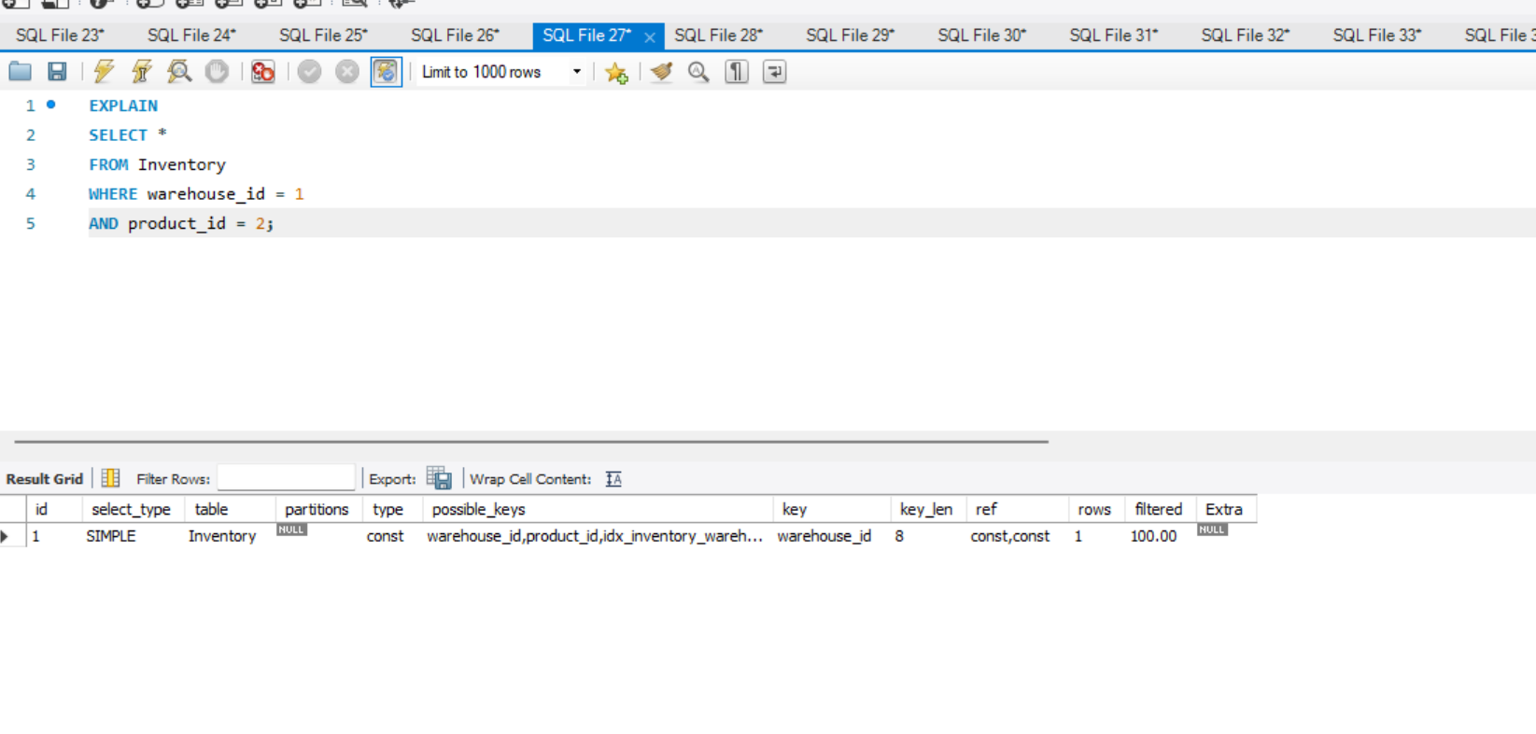
Screenshot 29: EXPLAIN with index: type = const, key_len = 8, rows = 1
Result: type const and rows 1 mean MySQL goes straight to the single matching row. key_len 8 shows that both INT columns (4 bytes each) of the composite key were used. The possible_keys column lists the composite index and the unique key.
Checking the indexes and the plan for the stock-out report:
SHOW INDEX FROM Inventory;
SHOW INDEX FROM PurchaseOrders;

EXPLAIN
SELECT *
FROM Inventory
WHERE warehouse_id = 1 ...;

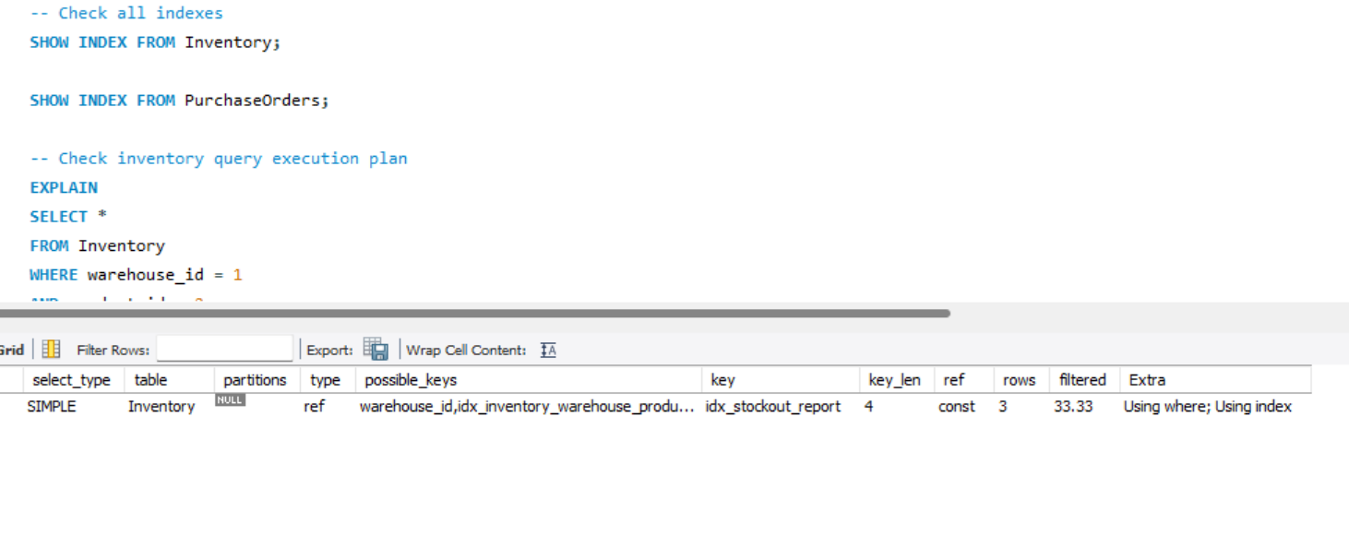
Screenshot 30: SHOW INDEX and EXPLAIN: idx_stockout_report is chosen, Extra = Using index
Result: the optimizer chooses idx_stockout_report (key column) with type ref. Using index in Extra confirms that the query is answered from the index alone (covering index), so the table rows are not read.

7.5 How Column Order Affects Index Usage
A composite index is sorted by its first column, then by the second within each first-column value, and so on. MySQL can use it only from the leftmost column onward (the leftmost-prefix rule).
- Index (supplier_id, order_status, expected_delivery_date) is used for filters on supplier_id; supplier_id + order_status; or all three columns.
- A query filtering only on order_status or only on expected_delivery_date cannot use this index efficiently, because the leading column is missing.
- Equality columns should come before range columns. Once a range condition (such as <) is applied to a column, the columns after it in the index cannot be used for seeking. This is why expected_delivery_date is placed last.
- Among equality columns, the more selective column (one that filters out more rows) is usually placed first.
- Inventory (warehouse_id, product_id) serves queries on warehouse_id alone and on both columns, but not on product_id alone. In the stock-out EXPLAIN above, key_len 4 shows that only the leading warehouse_id was used for the lookup.

8. Views

8.1 Low-Stock Alert View
This view lists products whose current stock plus pending and shipped purchase-order quantity (expected_stock) is still below the reorder level.
CREATE VIEW Low_Stock_Alert AS
SELECT
p.product_name,
w.warehouse_name,
i.quantity AS current_stock,
i.reorder_level,
COALESCE(SUM(
CASE
WHEN po.order_status IN ('Pending', 'Shipped')
THEN po.quantity
ELSE 0
END
), 0) AS pending_quantity,

(i.quantity + COALESCE(SUM(
CASE
WHEN po.order_status IN ('Pending', 'Shipped')
THEN po.quantity
ELSE 0
END
), 0)) AS expected_stock

FROM Inventory i
JOIN Products p ...
... -- joins, GROUP BY and HAVING continue as shown in the screenshot

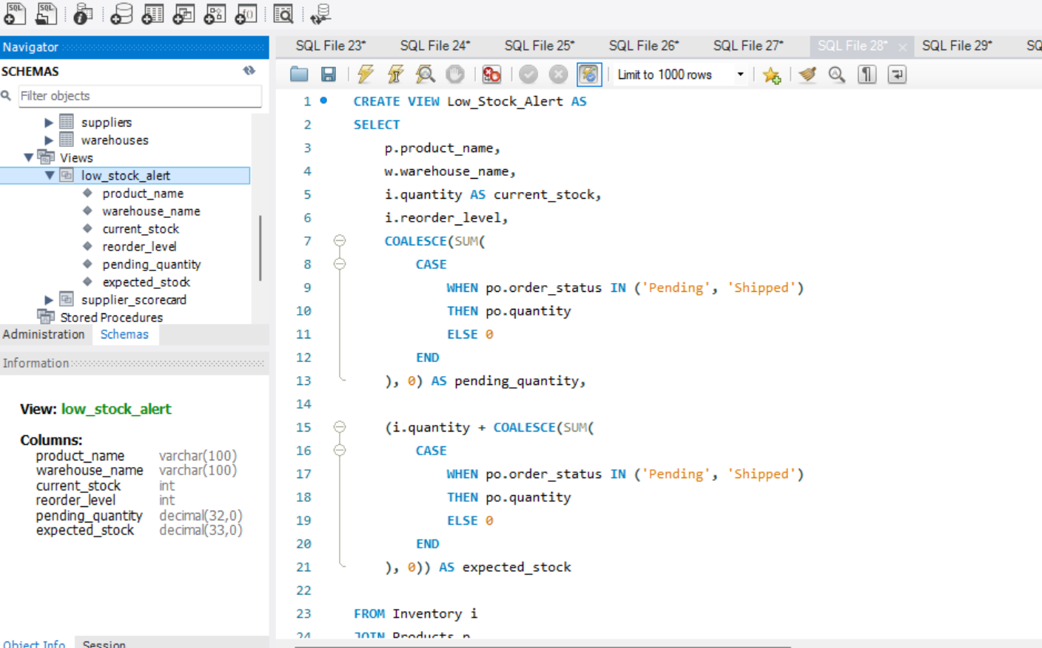
Screenshot 31: CREATE VIEW Low_Stock_Alert (columns: product_name, warehouse_name, current_stock, reorder_level, pending_quantity, expected_stock)
SELECT * FROM Low_Stock_Alert;

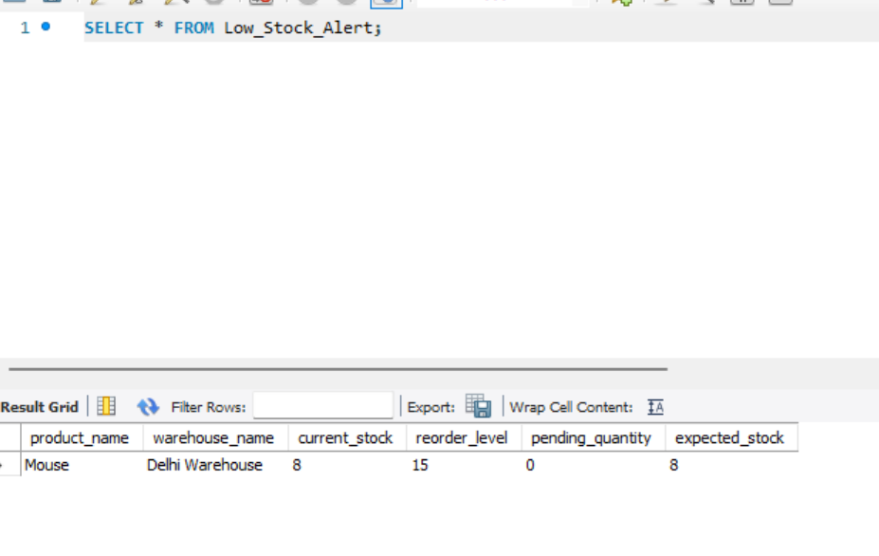
Screenshot 32: Low_Stock_Alert output: Mouse (Delhi Warehouse) is the only item still below its reorder level
Laptop (Delhi) and Monitor (Gurugram) are below their reorder levels but do not appear, because 20 units each are already on order. Mouse has no pending order, so it is flagged.

8.2 Supplier Scorecard View
The Supplier_Scorecard view reports on-time delivery percentage, average lead time and defect rate for every supplier.
[ Paste output screenshot here after running the query ]
Screenshot 33: CREATE VIEW Supplier_Scorecard (paste the view definition screenshot)
SELECT *
FROM Supplier_Scorecard
ORDER BY
on_time_delivery_percentage DESC,
average_lead_time ASC;

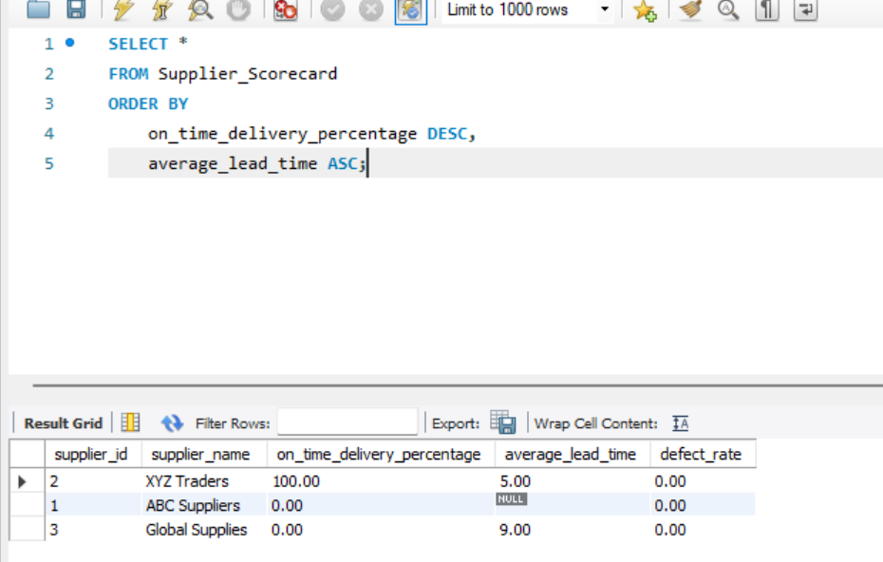
Screenshot 34: Supplier scorecard before PO 1 was marked delivered
After PO 1 (ABC Suppliers) was updated to Delivered (Query 13), the scorecard changed. ABC Suppliers now has an on-time delivery percentage of 50.00 and an average lead time of 39 days.
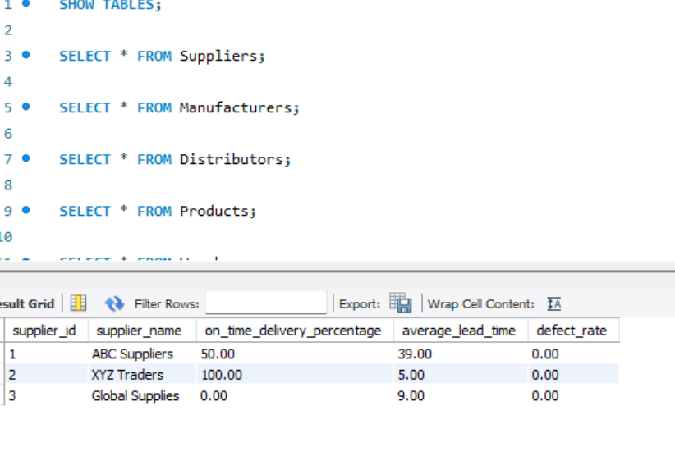
Screenshot 35: Supplier scorecard after the update (ABC Suppliers 50% on time, XYZ Traders 100%, Global Supplies 0%)

8.3 Can These Views Be Used for INSERT / UPDATE?
No. Neither view is updatable.
- Supplier_Scorecard uses GROUP BY, aggregate functions and calculated percentages and averages. Each view row represents many base rows, so MySQL cannot tell which base rows to change.
- Low_Stock_Alert joins several tables, aggregates with SUM and GROUP BY, and shows computed columns (pending_quantity, expected_stock). Computed columns cannot be written to.
In general, a MySQL view is updatable only if each view row maps to exactly one row of one base table. That rules out aggregates, GROUP BY, DISTINCT, UNION and derived tables. A simple multi-table join view can sometimes be updated, but only one base table per statement, and INSERT into it is restricted. MySQL has no INSTEAD OF triggers, so data changes must be made directly on Inventory and PurchaseOrders (for example, Query 13 updates PurchaseOrders and the scorecard recalculates automatically). The views are read-only alert and reporting tools.

9. Window Functions

9.1 Primary and Backup Supplier per Product (ROW_NUMBER)
A SupplierProducts table stores each supplier's cost and lead time for each product.
CREATE TABLE SupplierProducts (
supplier_product_id INT AUTO_INCREMENT PRIMARY KEY,
supplier_id INT NOT NULL,
product_id INT NOT NULL,
supply_cost DECIMAL(10,2) NOT NULL,
lead_time_days INT NOT NULL,

FOREIGN KEY (supplier_id)
REFERENCES Suppliers(supplier_id),

FOREIGN KEY (product_id)
REFERENCES Products(product_id),

UNIQUE (supplier_id, product_id),

CHECK (supply_cost >= 0),
CHECK (lead_time_days >= 0)
);

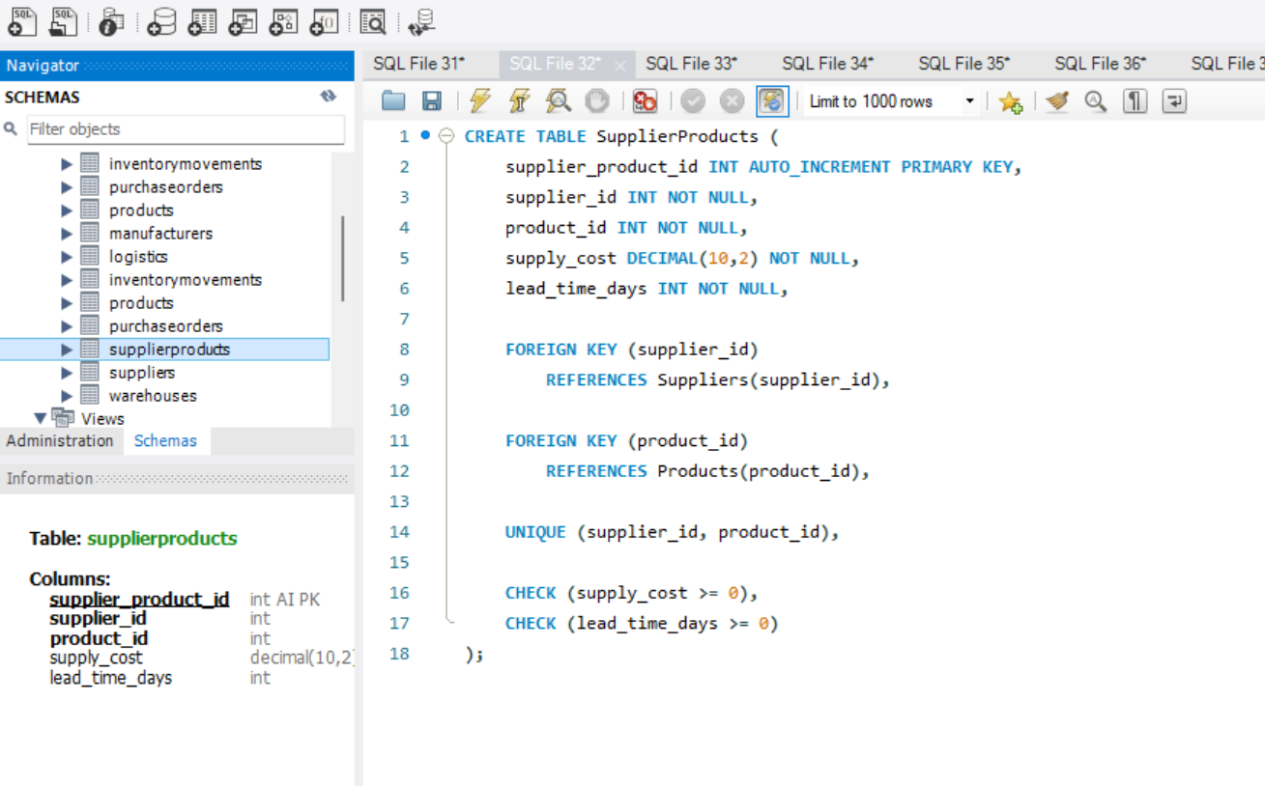
Screenshot 36: CREATE TABLE SupplierProducts
INSERT INTO SupplierProducts
(supplier_id, product_id, supply_cost, lead_time_days)
VALUES
(1, 1, 45000, 4),
(2, 1, 44000, 6),
(3, 1, 46000, 3),
(1, 2, 1200, 3),
... -- 12 rows in total, 3 suppliers for each of the 4 products

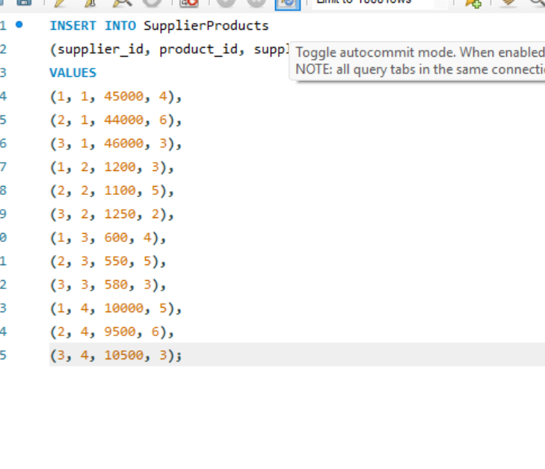
Screenshot 37: INSERT INTO SupplierProducts (supplier cost and lead time data)
Suppliers are ranked for each product by shortest lead time, then lowest cost. Rank 1 is the Primary Supplier and rank 2 is the Backup Supplier.
WITH SupplierRanking AS (
SELECT
p.product_name,
s.supplier_name,
sp.supply_cost,
sp.lead_time_days,
ROW_NUMBER() OVER (
PARTITION BY sp.product_id
ORDER BY sp.lead_time_days ASC, sp.supply_cost ASC
) AS supplier_rank
FROM SupplierProducts sp
JOIN Suppliers s ON sp.supplier_id = s.supplier_id
JOIN Products p ON sp.product_id = p.product_id
)
SELECT
product_name, supplier_name, supply_cost, lead_time_days,
CASE supplier_rank
WHEN 1 THEN 'Primary Supplier'
ELSE 'Backup Supplier'
END AS supplier_type
FROM SupplierRanking
WHERE supplier_rank <= 2;

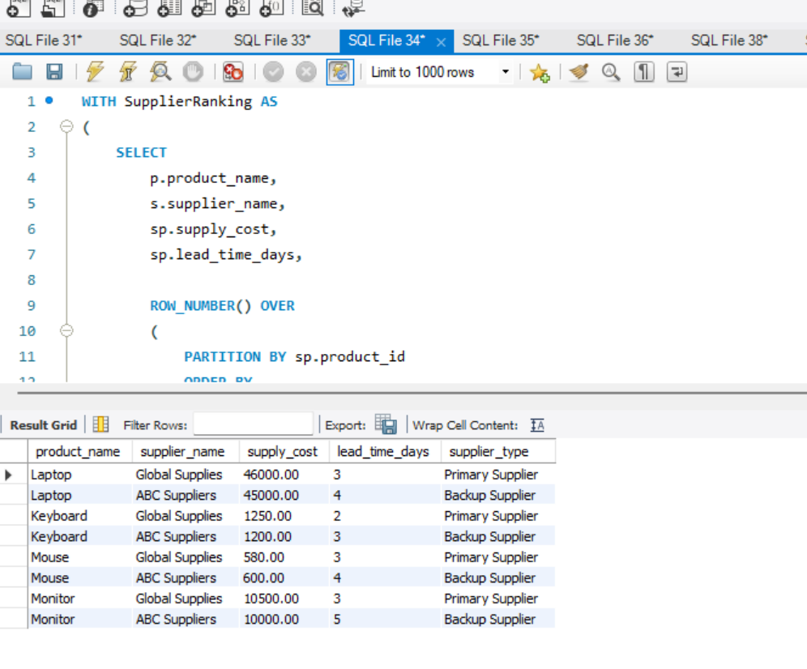
Screenshot 38: ROW_NUMBER() supplier ranking query and result
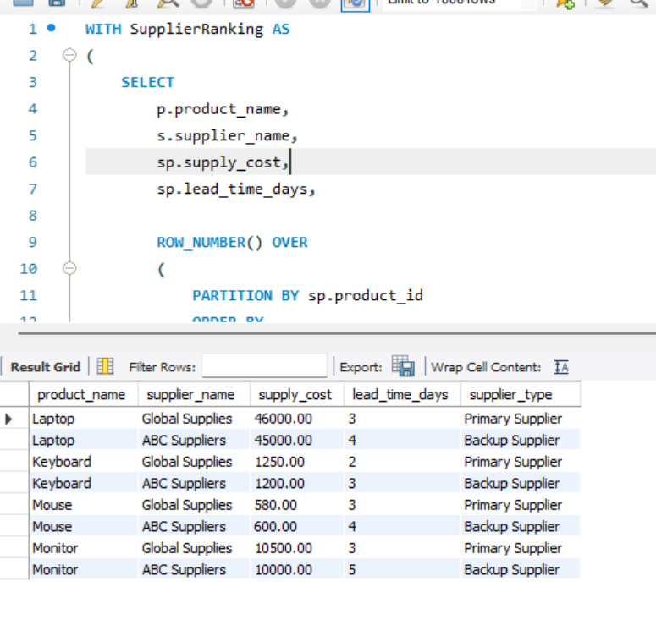
Screenshot 39: Primary and backup supplier per product (Global Supplies is primary for all four products on lead time)

9.2 Running Stock Level and Stock-out Date (SUM OVER)
An opening_quantity column is added to Inventory so that the running stock starts from the opening balance. IN movements are then added and OUT movements subtracted, per warehouse and product, in date order.
ALTER TABLE Inventory
ADD COLUMN opening_quantity INT DEFAULT 0;

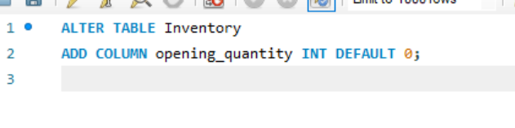
Screenshot 40: ALTER TABLE Inventory ADD COLUMN opening_quantity
SELECT
warehouse_id,
product_id,
movement_date,
movement_type,
quantity,

SUM(
CASE
WHEN movement_type = 'IN' THEN quantity
ELSE -quantity
END
) OVER (
PARTITION BY warehouse_id, product_id
ORDER BY movement_date, movement_id
ROWS BETWEEN UNBOUNDED PRECEDING
AND CURRENT ROW
) AS net_movement,

opening_quantity
+ SUM(
CASE
WHEN movement_type = 'IN' THEN quantity
... -- running stock expression continues as shown in the screenshot

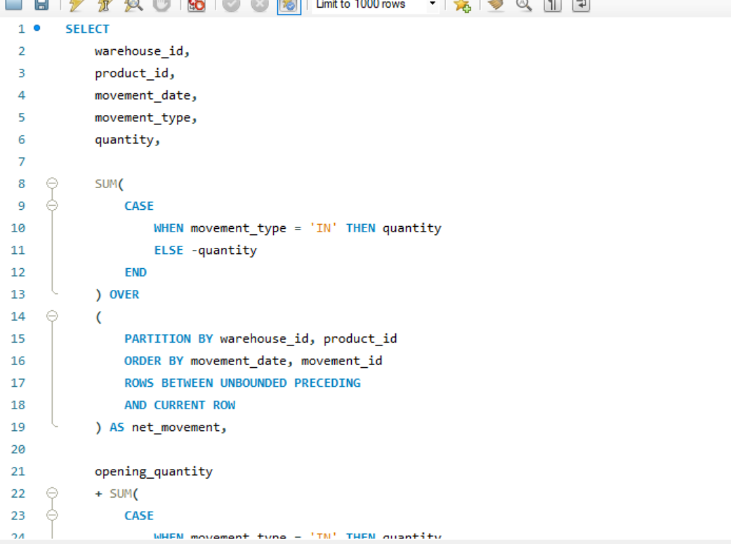
Screenshot 41: Running stock level using SUM() OVER (PARTITION BY warehouse, product ORDER BY date)
The first date on which the running stock reaches zero or below is the stock-out date:
WITH StockCalculation AS (
SELECT
m.warehouse_id,
m.product_id,
m.movement_date,

i.opening_quantity +
SUM(
CASE
WHEN m.movement_type = 'IN'
... -- running total, then MIN(movement_date) where stock <= 0, as shown in the screenshot

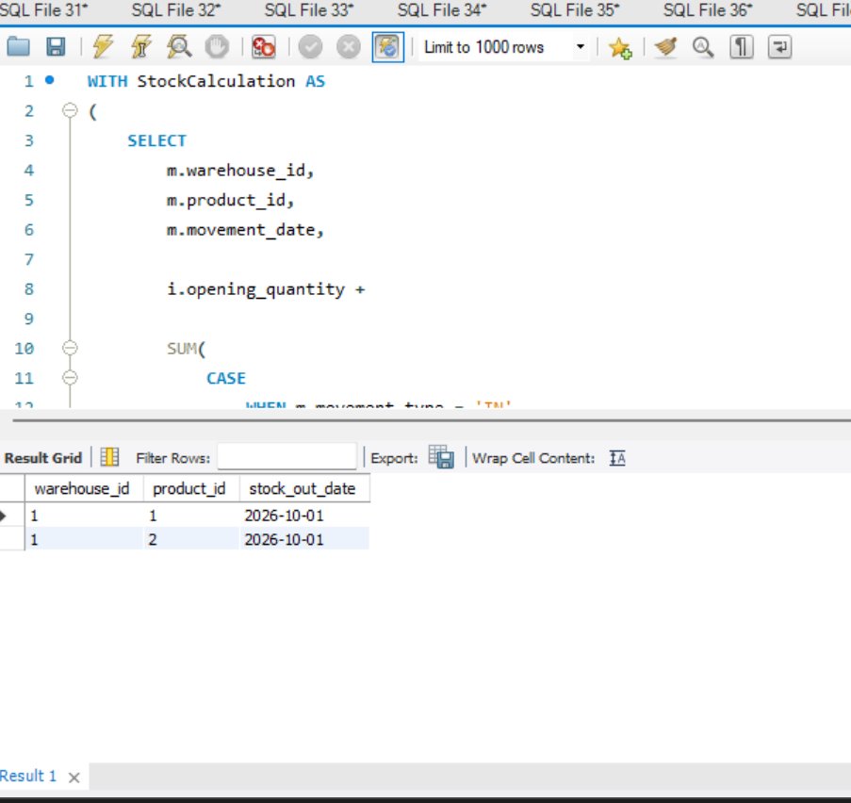
Screenshot 42: Stock-out date detection (warehouse 1, products 1 and 2 run out on 2026-10-01)

9.3 Days Between Consecutive Replenishments (LEAD)
SELECT
product_id,
warehouse_id,
movement_date AS current_replenishment,

LEAD(movement_date) OVER (
PARTITION BY product_id, warehouse_id
ORDER BY movement_date
) AS next_replenishment,

DATEDIFF(
LEAD(movement_date) OVER (
PARTITION BY product_id, warehouse_id
ORDER BY movement_date),
movement_date
) AS days_between_replenishments
FROM InventoryMovements
WHERE movement_type = 'IN';

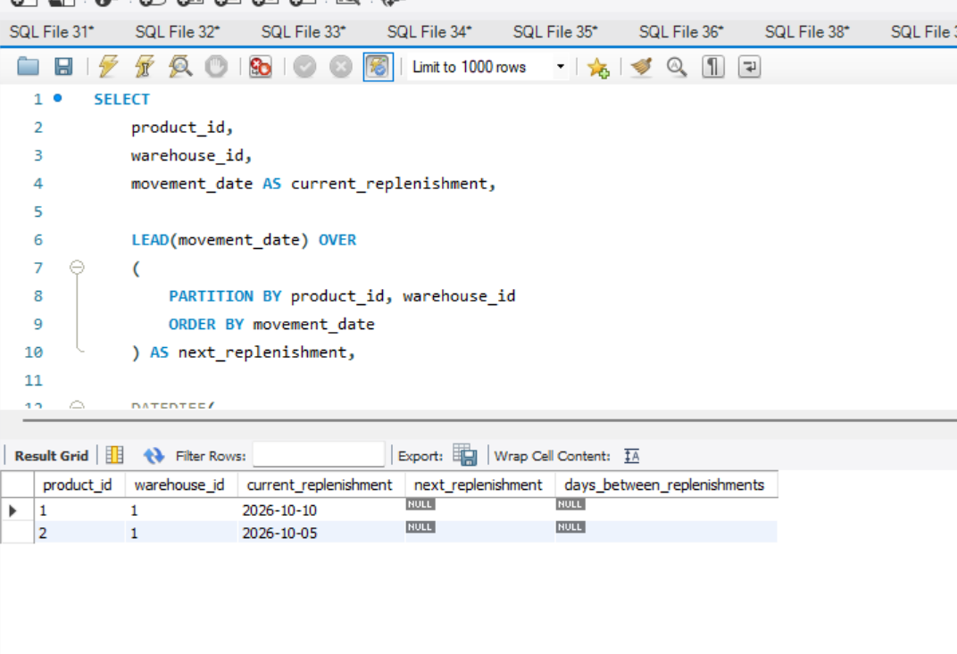
Screenshot 43: LEAD() days between replenishments (NULL where no later replenishment exists)
The next_replenishment and days_between_replenishments columns are NULL because each product currently has only one IN movement in each warehouse. LEAD() returns NULL when there is no following row; the gap is calculated once a second replenishment is recorded.

10. Conclusion
The database enforces data integrity through primary keys, foreign keys, unique, check, default and not-null constraints. The queries identify low-stock items, calculate replenishment quantities while accounting for incoming orders, compare transportation costs, track late supplier deliveries and value inventory. Composite and covering indexes speed up the most frequent lookups, views provide ready-made alert and scorecard reports, and window functions support supplier ranking, running stock levels and replenishment cycle analysis.

