|  |  |
| --- | --- |
| *Online shopping*  Documentation by 王迅虎 和丁子杰 | Stay home and shop online. You are too pretty to go outside for shopping.  Android Development Project  Done by  Name: SAHA ANUP(丁子杰)  Id:178801032  &  Name: HAIDARAH MUHAMMED ABDULMAWLA ABDO（王迅虎)  Id:178801078 |

**Table of Contents:**

|  |  |  |
| --- | --- | --- |
|  | **Title** | **Page no.** |
|  | **Project Profile:** | **1** |
|  | * Project Definition | 1 |
|  | * System Requirement | 2 |
|  | Project Tools |  |
|  | * Software Requirement | 3 |
|  | * Hardware Requirements | 3 |
|  | **Analysis** | **3** |
|  | * About existing system | 3 |
|  | * Limitation of existing system | 4 |
|  | * Feasibility System | 4 |
|  | * Merits of Proposed System | 5 |
|  | * Static View | 5 |
|  | * Dynamic View | 6 |
|  | **Design** | **7** |
|  | * Diagrams | 7 |
|  | 1. Sequence Diagram | 7 |
|  | 1. UML Diagram | 8 |
|  | 1. State Diagram | 8 |
|  | 1. Activity Diagram | 9 |
|  | 1. Class Diagram: | 11 |
|  | **Implementation and Testing:** | **14** |
|  | * Input Event (Screen Shots) | 14 |
|  | * Report Layout (Time Chart) | 23 |
|  | Testing | **26** |
|  | - Integration & System Testing | **26** |
|  | -Black box testing | **26** |
|  | -White box testing | **27** |
|  | -Testing method | **27** |
|  | -Statistical Testing | **27** |
|  | -Defect testing | **28** |
|  | -Test cases | **31** |
|  | **Future enhancements** | **32** |
|  | **Learning during Project Training** | **32** |
|  | **Conclusion** | **33** |
|  | **References** | **33** |

1. **Project profile**
   1. Project definition

E-commerce is a subset of E-business (a company that does all or most of its transaction through the internet) is the purchasing goods and services over the internet. Online shopping is a form of electronic commerce which allows customers to directly buy goods and services from a seller over the internet using our application. Our application enables to customer to view photos or images of the product along with information about the product specifications features, price, brand and feedback from others buyer. For serving our application customer must have to the internet and a valid payment method in order to complete the payment. It will reduce you to stood in line waiting and waiting for a store clerk to finally check out your items. Online shopping transactions occur instantly saving your time to get your order done.

Benefits of shopping online

* Increase in sales
* Increase in customers
* Ability to be open 24/7
* Instant processing of transactions
* Increase business reach
* Use electric payment refers to paperless monetary transactions.
* Easy to buy
* Save time and energy
  1. System requirement

1.Project Tools

|  |  |
| --- | --- |
| Front-end tool | Xml, java |
| Back-end tool | Database |
| platform | Android |

1. Software Requirements

|  |  |
| --- | --- |
| Application Front-end | Android studio |
| Database back-end | Realtime database |
| Design | Adobe XD |

1. Hardware requirement

|  |  |
| --- | --- |
| Application installation | Android enabled GSM/CDMA phone |
| Internet connection | Required |
| Ram | 8 GB (computer) |
| version | Over 8 (android for running) |

**2. Analysis**

2.1 About existing system

In day to day life, we will need to buy lots of goods or products from a shop. It maybe food items, electronic items, house items etc. Now days, it is really hard to get some time to go out and get them by ourselves sue to busy life style or lots of works. Using our application, we can buy goods or products online just by visiting the application and ordering the item online by making payments online. Many customers go for purchasing offline so as to examine the product and holds the possession of the product just after the payment for the product. In this contemporary world customer’s loyalty depends upon the consistent ability to deliver quality, value and satisfaction.

2.2 Limitations of existing system

* Time consuming
* Shipping Rates
* Refunds/Returns Disputes
* Lack of option
* Cash-back offer not present
* Bad customer service

2.3Feasibility Study

The objective of feasibility study is to determine whether or not the proposed system is feasible. The feasibility is determined in terms of four aspects.

* Technical Feasibility

In this, one has to test whether the system can be developed using existing technology or not. It is evident that necessary hardware and software are available foe development and implementation of proposed system. We acquired the technical knowledge of working in languages, and then only we have started designing our project.

* Behavioral Feasibility

The customers are using mobile phone so our system is capable of providing user friendly interface.

* Economical Feasibility

As a part of this, the costs and benefits associated with the proposed system are compared and the project is economically feasible only if tangible and intangible benefits outweigh the cost. The cost for proposed online shopping system is outweighing the cost and efforts involved in maintaining the registers, books, files and generation of various reports. The system also reduces the administrative and technical staff to do various jobs that single software can do. So, this system is economically feasible.

* Legal Feasibility

Legal feasibility determines whether the proposed system conflicts with legal requirements for example data protection act.

2.4 Merits of proposed system

* Convenience: This is one of the main reasons that online shopping has become so popular, as it allows you to switch stores and products by clicking a button rather than travelling to new store.
* Selection: Of course, a large section means that your decisions making process maybe a bit more difficult, but it also makes it more likely that you will find a high-quality product that truly pleases you.
* Quality: Needless to say, the quality of a product is also very important. And, while most online shopping offers you the ability to return faulty or imperfect products.
* Saving Money: Another very important aspect of any shopping experience is trying to save as much money as possible. One reason that people enjoy online shopping is that you can often find a product more cheaply online than you can in stores.
* Discounts and offers: Yes, online shopping is better than offline because we can shop at any of our favorite shop and can get the delivery on same day itself.

2.5 Static view

Concept of object diagram

* Object diagram Object diagrams represent an instance of a class diagram. The basic concepts are similar for class diagrams and object diagrams.
* Object diagrams also represent the static view of a system but this static view is a snapshot of the system at a particular moment.
* Object diagrams are derived from class diagrams so object diagrams are dependent upon class diagrams. Object diagrams are used to render a set of objects and their relationships as an instance.
* The purpose of a diagram should be understood clearly to implement it practically. The purposes of object diagrams are similar to class diagrams.
* The difference is that a class diagram represents an abstract model consisting of classes and their relationships. But an object diagram represents an instance at a particular moment which is concrete in nature.
* It means the object diagram is closer to the actual system behavior. The purpose is to capture the static view of a system at a particular moment.
* So, the purpose of the object diagram can be summarized as:
* Forward and reverse engineering.
* Object relationships of a system
* Static view of an interaction.
* Understand object behavior and their relationship from practical perspective

2.6 Dynamic view

Concepts of Dynamic view

* The Use Case diagram models the user’s expectation for using the system. The people and systems that interact with the target system are called actors. The features of the system that the actors use called use cases. Some use cases interact with other use cases, a relationship modeled using dependency arrows.
* The goal of the Use Case diagram is to identify all the features that the clients expect the system to support, but it does not reveal any details about the implementation of these features.
* Use Case diagrams are valuable because they
* Identify the clients' expectations for the system.
* Identify specific features of the system.
* Identify shared behavior among system features.
* Provide a simple and easily understood way for clients to view their requirements.

**3. Design**

Diagram

3.1 Sequence Diagram:

* The sequence diagram is used primarily to show the interactions between objects in the sequential order that those interactions occur. Much like the class diagram, developers typically think sequence diagrams were meant exclusively for them. However, an organization's business staff can find sequence diagrams useful to communicate how the business currently works by showing how various business objects interact. During the requirements phase of a project, analysts can take use cases to the next level by providing a more formal level of refinement. When that occurs, use cases are often refined into one or more sequence diagrams.
* An organization's technical staff can find sequence diagrams useful in documenting how a future system should behave. During the design phase, architects and developers can use the diagram to force out the system's object interactions, thus fleshing out overall system design.
* 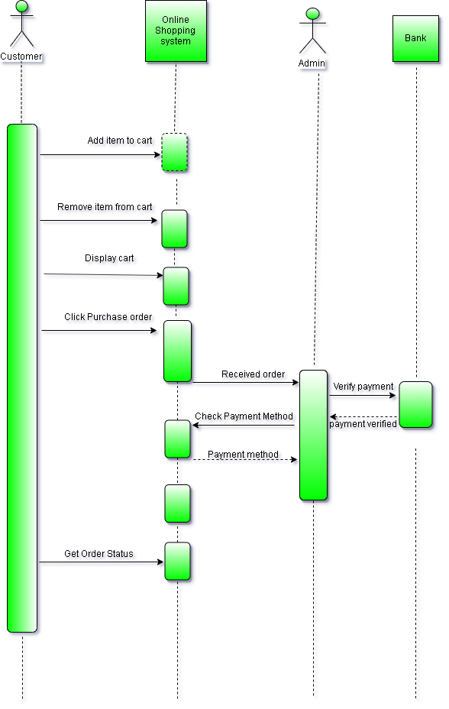One of the common uses of sequence diagrams is in the transition from requirements expressed as use cases to the next and more formal level of refinement. Use cases are often refined into one or more sequence diagrams. In addition to their use in designing new systems, sequence diagrams can be used to document how objects in an existing (call it "legacy") system currently interact. This documentation is very useful when transitioning a system to another person or organization.

Here is the seqquence diagram of our application

* 1. UML Diagram:
* UML is a way of visualizing a software program using a collection of diagrams. Improved integration between structural models like class diagrams and behavior models like activity diagrams.
* Added the ability to define a hierarchy and decompose a software system into components and sub-components.
* The original UML specified nine diagrams; UML 2.x brings that number up to 13. The four new diagrams are called: communication diagram, composite structure diagram, interaction overview diagram, and timing diagram. It also renamed state chart diagrams to state machine diagrams, also known as state diagrams.

Here is our application UML diagram.

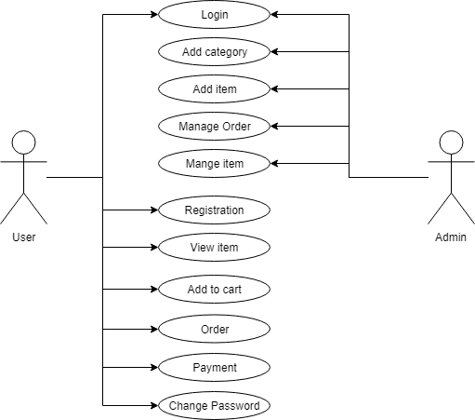

* 1. State Diagram:

State diagrams are used to give an abstract description of the behavior of a system. This behavior is analyzed and represented as a series of events that can occur in one or more possible states. State-diagrams can be used to graphically represent finite state machines. This UML diagram models the dynamic flow of control from state to state of a particular object within a system.

Here is our State diagram

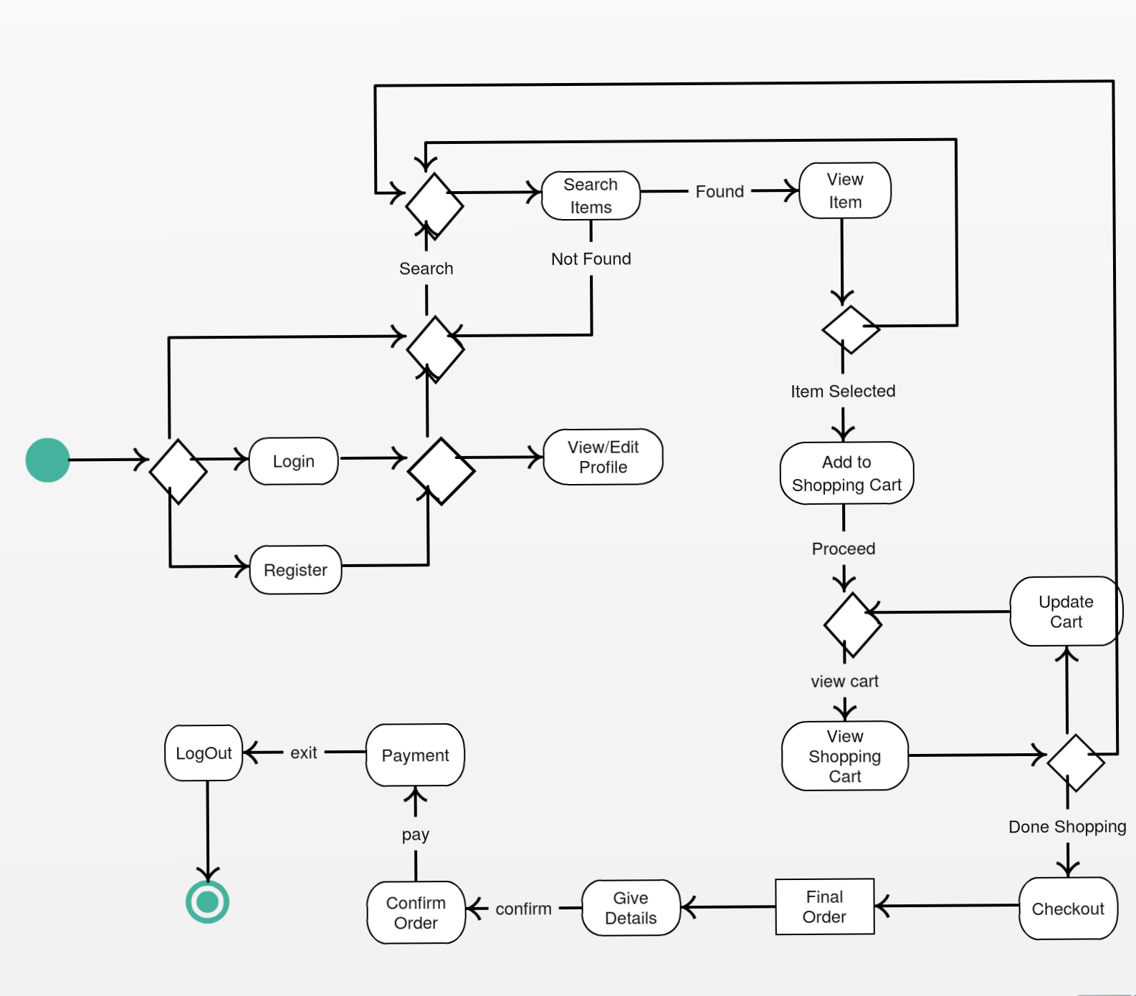

* 1. Activity Diagram:

The Activity diagram models logic-any logic-from work flow to use cases to methods. It borrows most of its notation from flowcharts, but has added the concept of concurrency to support many modern applications.

1.2 Create activity

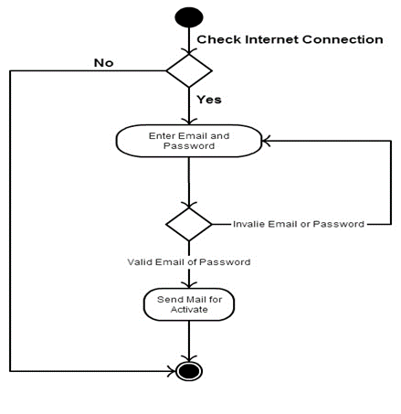

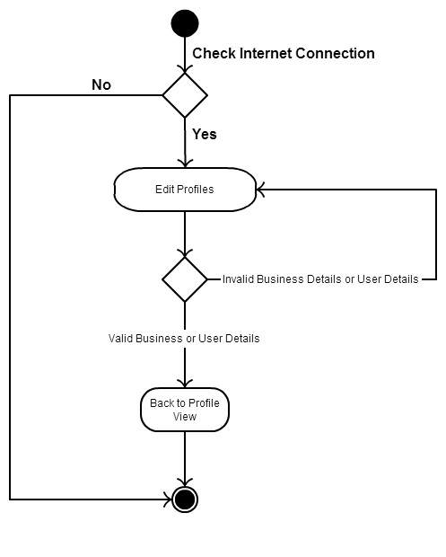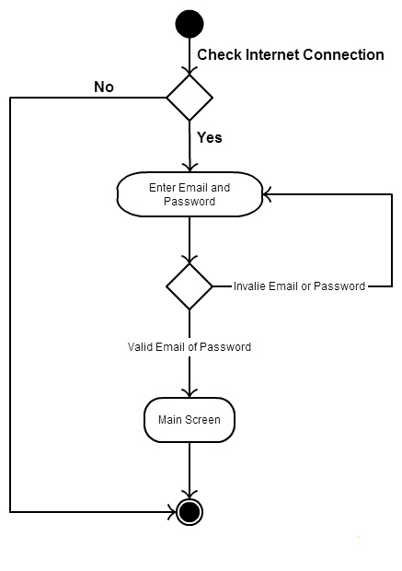 1.2 Login activity

1.3 Edit profile activity

* 1. forget password activity

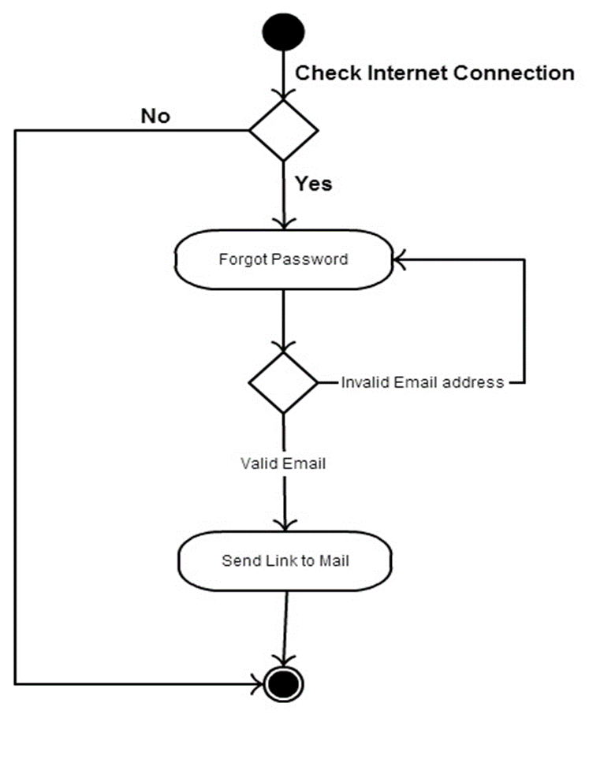

3.5 Class diagram

In software engineering, a class diagram in the Unified Modeling Language (UML) is a type of static structure diagram that describes the structure of a system by showing the system's classes, their attributes, operations (or methods), and the relationships among objects. A class diagram describes the attributes and operations of a class and also the constraints imposed on the system. Class diagrams are widely used in the modeling of object-oriented systems because they are the only UML diagrams that can be mapped directly to object-oriented languages. Purpose of Class Diagrams

Shows static structure of classifiers in a system

* Diagram provides a basic notation for other structure diagrams prescribed by UML
* Helpful for developers and other team members too
* Business Analysts can use class diagrams to model systems from a business perspective

Here is the class diagram for our class diagram we separate this in two part after that the last we combine that in a single picture.

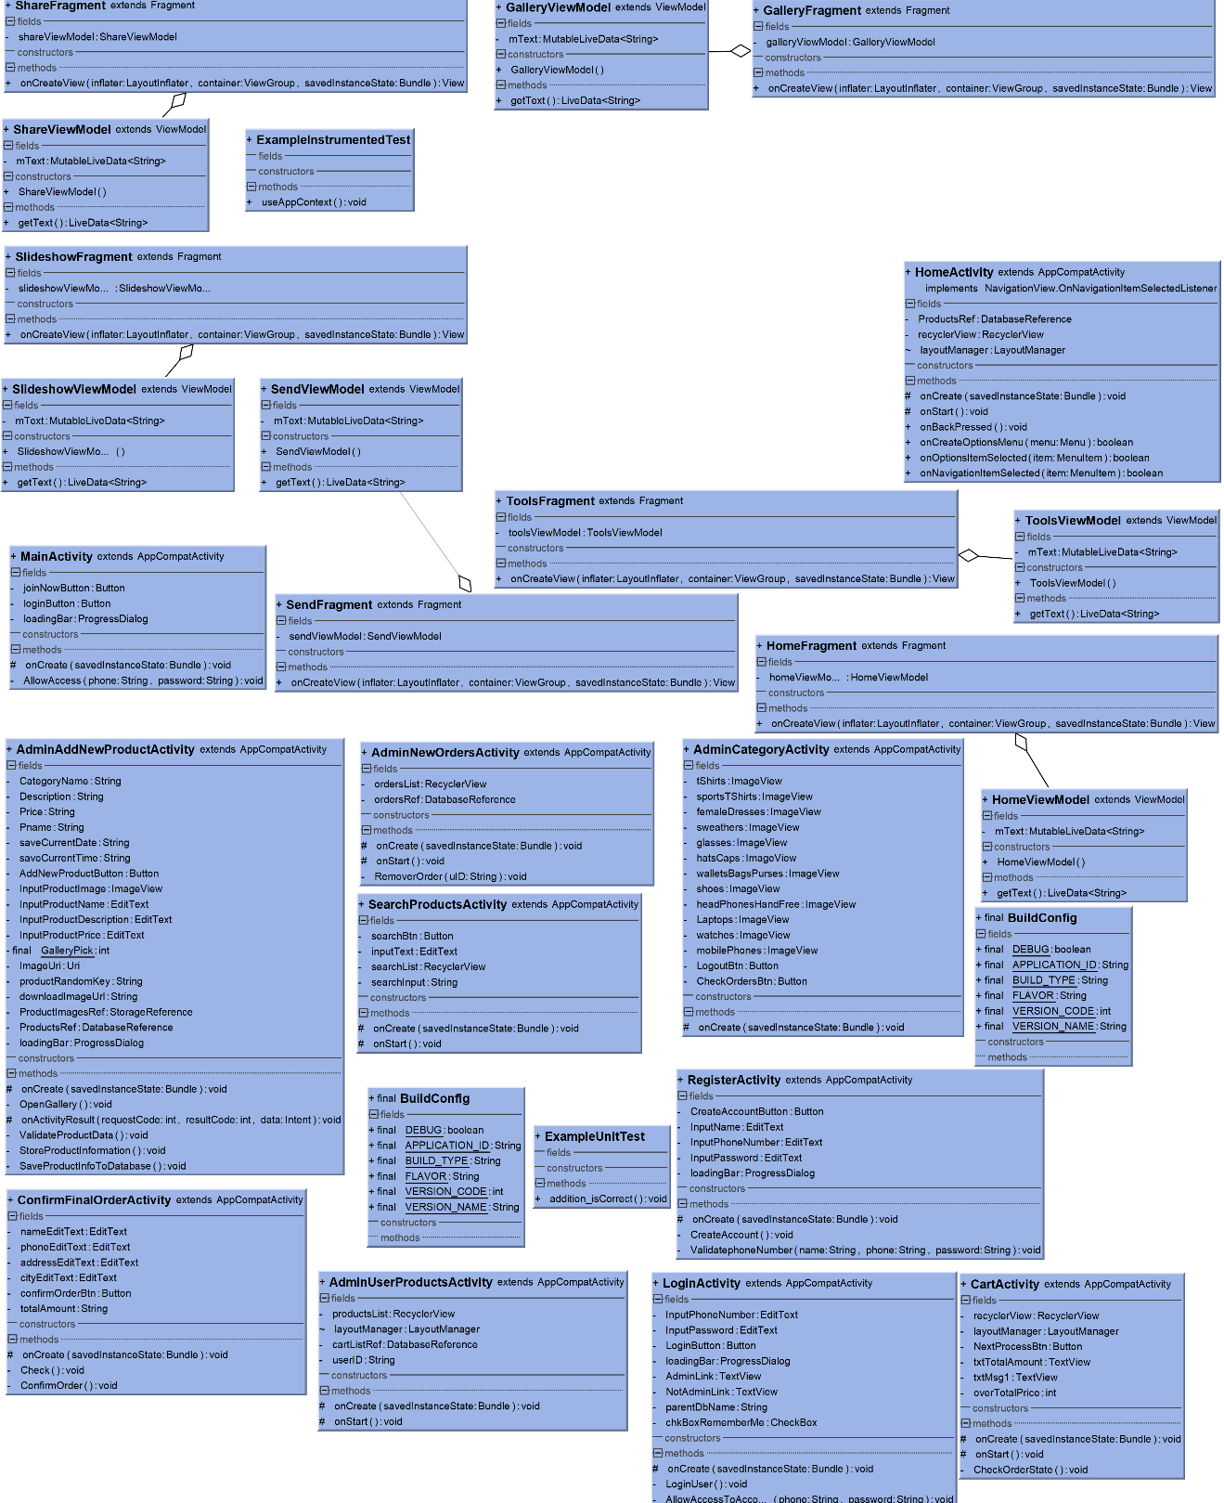

Second part of our uml class diagram

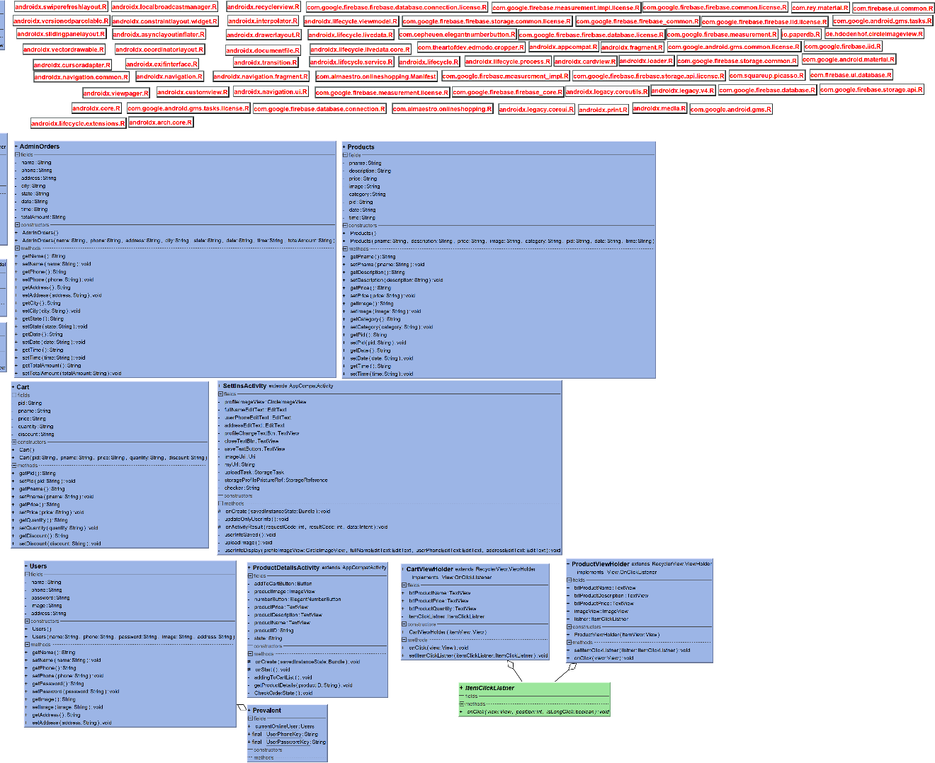 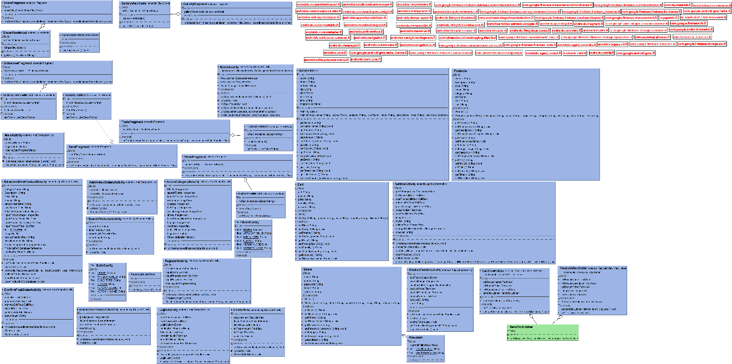

1. **Implementation:**

Here is some screenshot of our project how we implement our project, we displayed if there is error then how our application will handle that error and display the error message and we also displayed how we solve those problem.

For that we separate those frame in various way and all the frame are displayed below. In our code we wrote every class for separate activity we create more than 25 class for this application and we try to show all the events output. And for each class we have different activity. While implement our application we faced several new problems but by the help of internet we could overcome our problem.

.Here are some screenshot of our implementation of that activity

Input Event:

* 1. Main Screen:

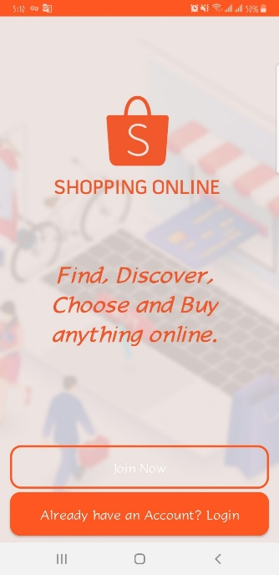

* 1. Login Screen:

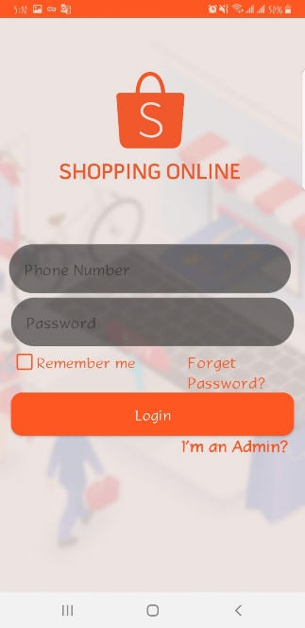

* 1. Internet Connection Error Screen

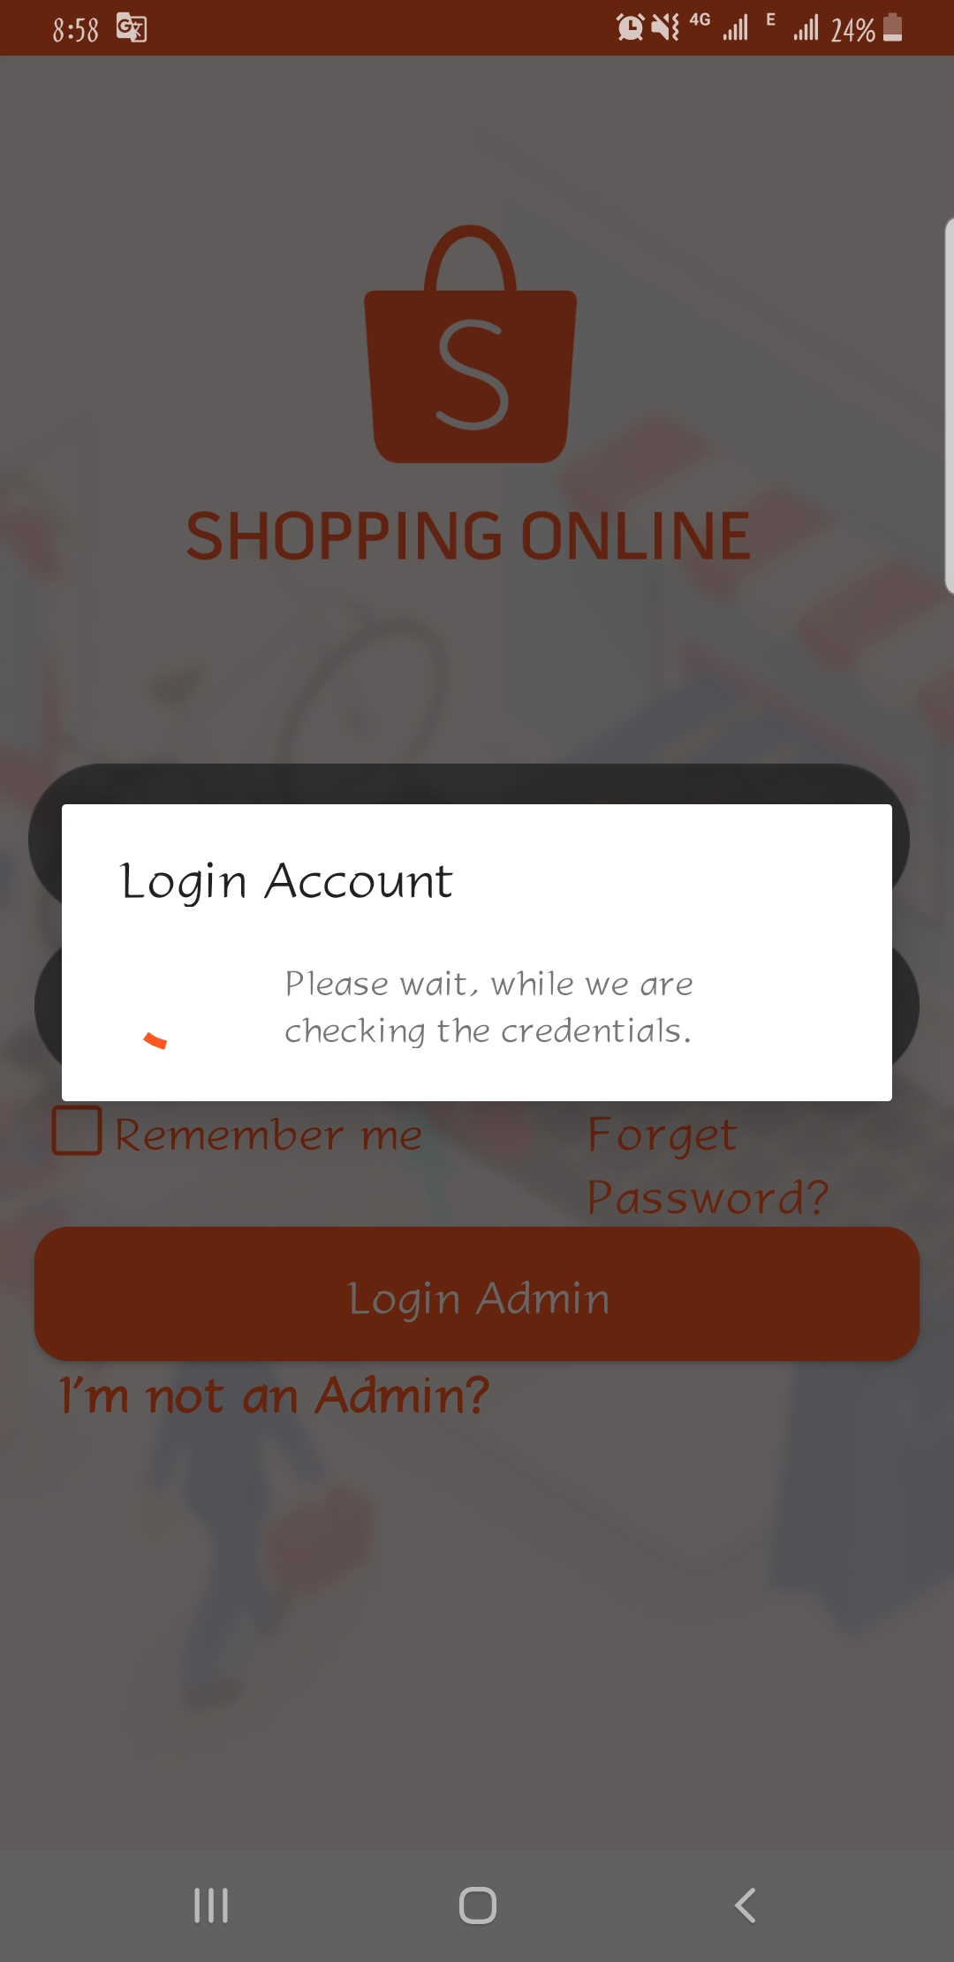

* 1. Login (password) Error Screen

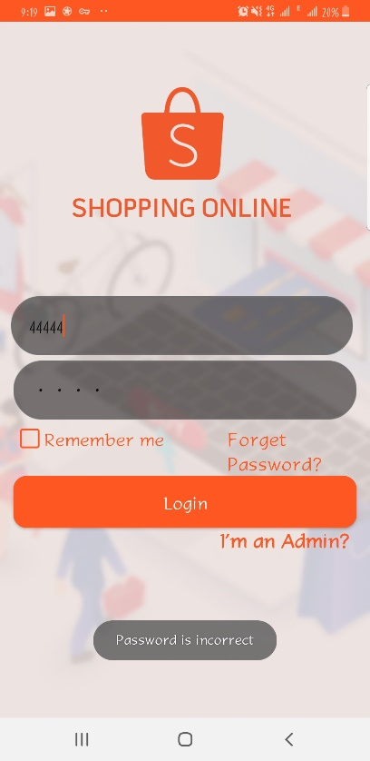

* 1. Processing for Signing:



* 1. Register Screen:

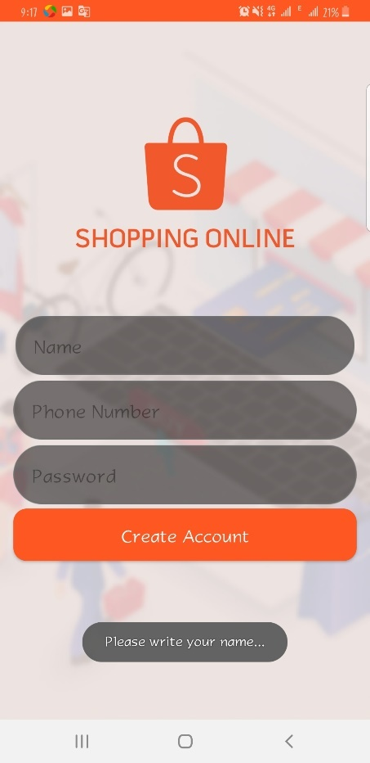

* 1. Register phone number:

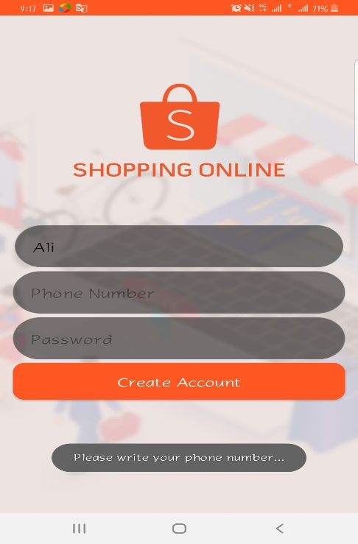

* 1. Register password:

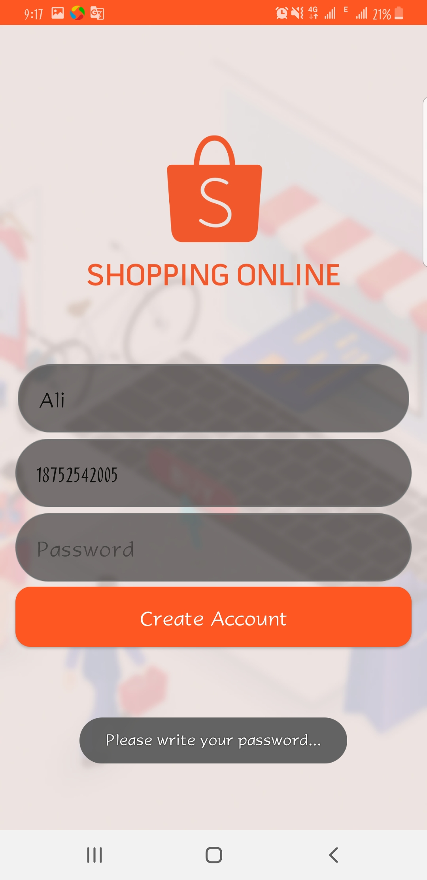

* 1. Register account don’t exist:

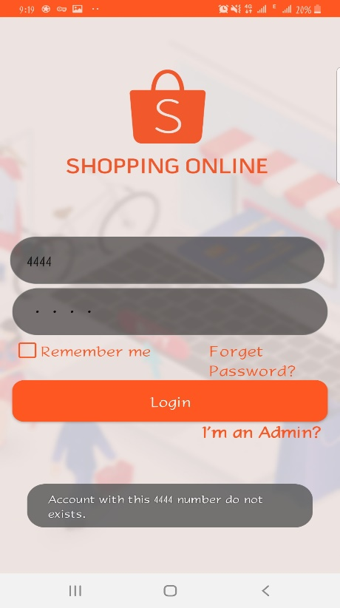

* 1. Register Success Screen:

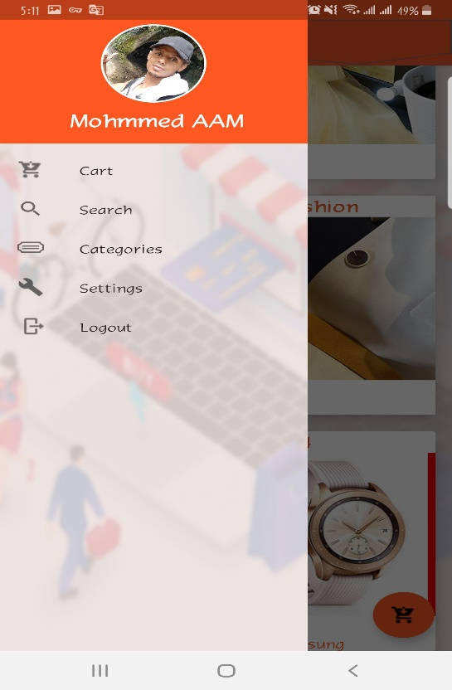

* 1. Update Profile:

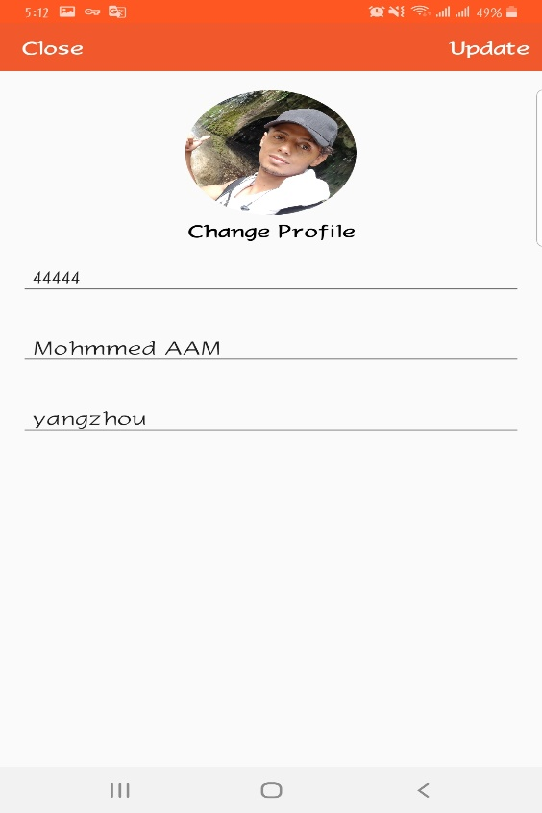

* 1. Search Product:

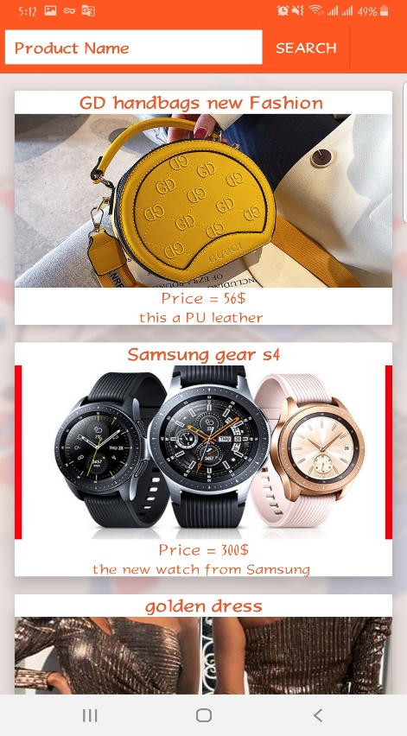

* 1. Select Product:

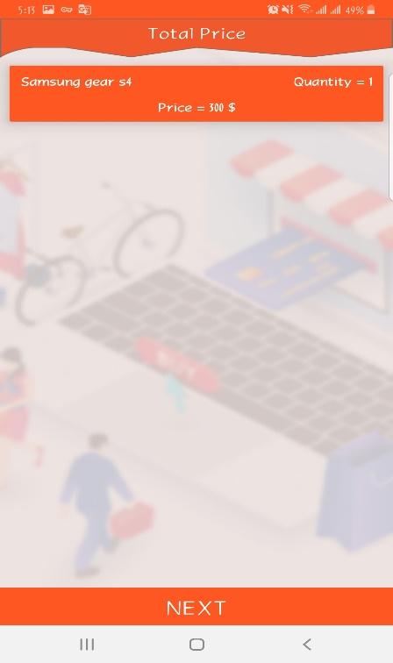

* 1. Order Product

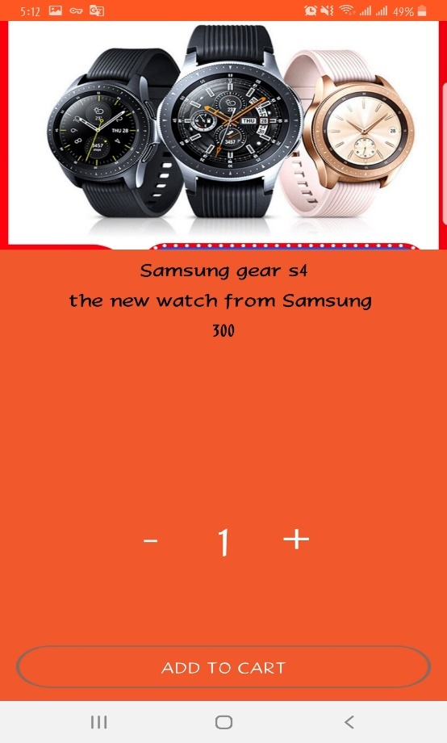

* 1. Shipment:

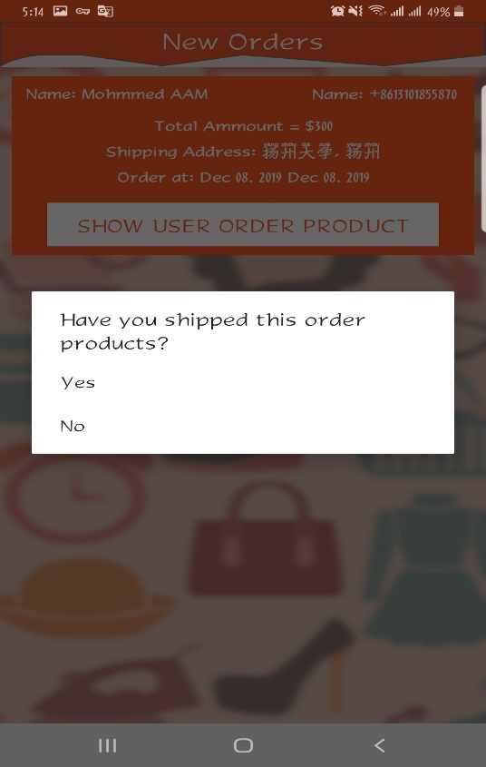

* 1. Shipment Information:

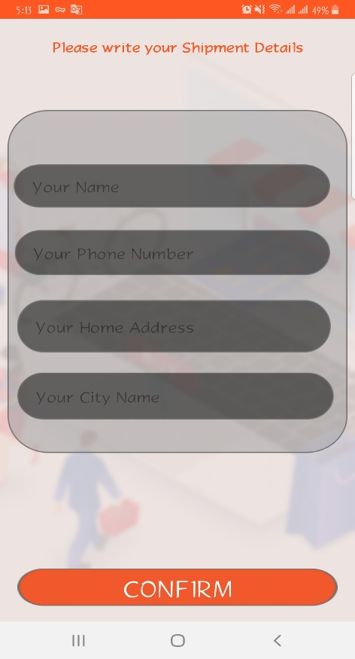

* 1. Add product:

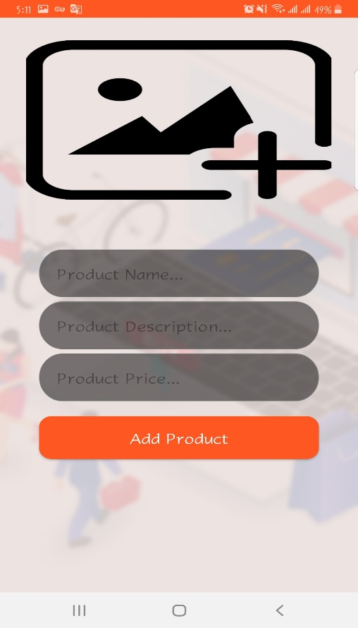

* 1. Add to cart:

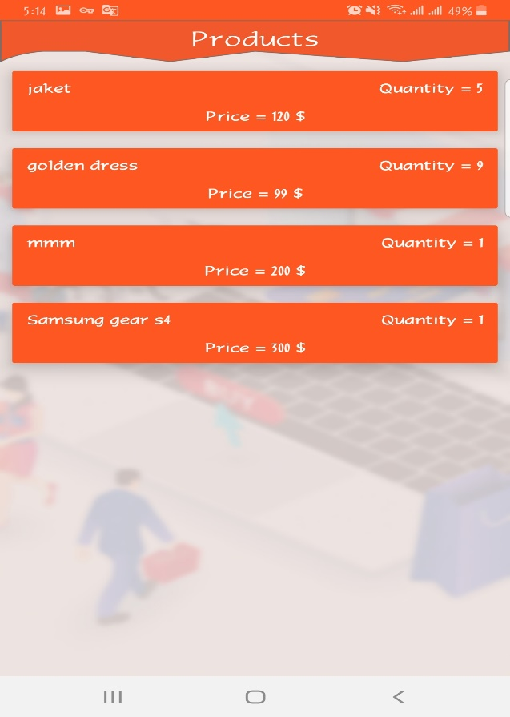

\

Here is some screenshot of our database management we use real-time database. 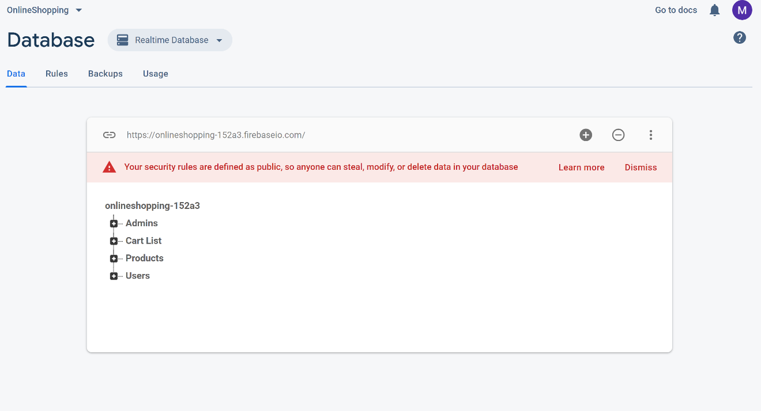

Inside real-time database we have admin user table where only admin can handle the whole application including adding the new product which I already shown up. And for user they can register into our application and can shop from our application. For cart list only admin can modify that so all the access handle by admin from the database we can easily understand that and our database will also show the time when the new product are added so it will beneficial for launching a new product and it will helpful for our shopping system and increase the sell and also helpful for the user cause they can easily know that when a product will be launched or maybe is there any chance for the product for out of stock. And this cart list is specially helpful for the user for example while an user serve this application he liked a product and maybe he want to buy that product but not at that moment this case he can save this product in his cart and later when he want to buy that product he can easily buy that product without searching and also from cart an user can order multiple product at the same time which saves users time. And if the user want to delete the product from his/her cart then he/she can also do it maybe there is case there is lot of product it’s becoming quite hard to find the wanted the product from the cart list that time user can delete some product relevant data from his cart it’s not deleting from the application database only from users cart list.

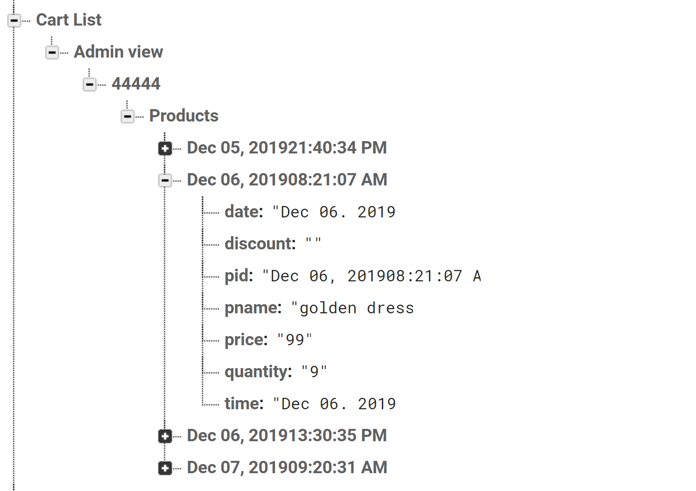

We can also find all the product information in our database this data is readable for user they can view and read the data but they can’t edit or delete the data. When you want to buy anything for that at first you need to see the product pictures and some description about the product and also you want to know the price of that product at very beginning cause price impact on the product so product is most important in our database and it need to handle by admin. Now-a-days products feature and good quality picture depends on the online business id the product picture is not good then the user will think the product is bad but that not the case maybe the product actually good and they will upload it later. So, product is really important to maintain user and admin relationship in data -base schema we can also see that on our UML class diagram. And for managing the product only the admin can manage the product

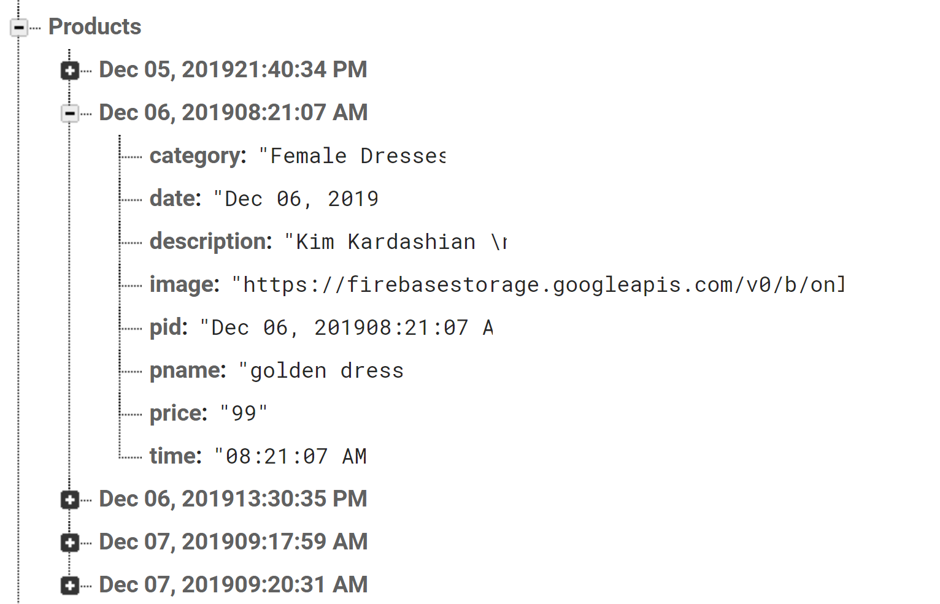

**5 Testing:**

o Testing Strategy:

Integration & System Testing:

The system is first divided in units that are developed and tested for their functionalities. These units are integrated into a complete system during Integration phase and tested to check if all modules/units coordinate between each other and the system as a whole behaves as per the specifications. After successfully testing the software, it is delivered to the customer.

5.1 Black Box Testing Strategy:

Black Box Testing is not a type of testing; it instead is a testing strategy, which does not need any knowledge of internal design or code etc. As the name "black box" suggests, no knowledge of internal logic or code structure is required. The types of testing under this strategy are totally based/focused on the testing for requirements and functionality of the work product/software application. Black box testing is sometimes also called as "Functional/Behavioral Testing" and "Closed Box Testing". The base of the Black box testing strategy lies in the selection of appropriate data as per functionality and testing it against the functional specifications in order to check for normal and abnormal behavior of the system. Now a days, it is becoming common to route the testing work to a third party as the developer of the system knows too much of the internal logic and coding of the system, which makes it unfit to test the application by the developer. In order to implement Black Box Testing Strategy, the tester is needed to be thorough with the requirement specifications of the system and as a user, should know, how the system should behave in response to the particular action. Black Box Testing strategy are: functional testing, stress testing, recovery testing, volume testing, User Acceptance Testing (also known as UAT), system testing, Sanity or Smoke testing, load testing, Usability testing, Exploratory testing, ad-hoc testing, alpha testing, beta testing etc. For our application we use black box testing most because it is easy to implement and you can see the output with in a moment. For example, while we using black box testing on our data-base we find out in specific data field you can insert only specific data type and we were stuck for few days to solve this simple problem. Using black box testing concept we fixed that how to show network error and how to show the product you are searching is not found.

5.2 White Box Testing Strategy:

White box testing strategy deals with the internal logic and structure of the code. White box testing is also called as glass, structural, open box or clear box testing. The tests written based on the white box testing strategy incorporate coverage of the code written, branches, paths, statements and internal logic of the code etc.

In order to implement white box testing, the tester has to deal with the code and hence, is needed to possess knowledge of coding and logic

Advantages of White box testing are

* As the knowledge of internal coding structure is prerequisite, it becomes very easy to find out which type of input/data can help in testing the application effectively.
* ii) The other advantage of white box testing is that it helps in optimizing the code it helps in removing the extra lines of code, which can bring in hidden defects.

But for our application we hardly used white box testing because this is new to us though we are learning testing this semester but we can’t figure it out how to implement white box testing in our application for that maybe you can find several bugs in our program. But it’s open a door for us to improve our problem in future and reduce the number of bugs in the application.

5.3 Testing Methods:

Software Testing involves executing an implementation of the software with test data and examining the outputs of the software and its operational behavior to check that it is performing as required.

5.4 Statistical Testing:

Statistical Testing is used to test the program’s performance and reliability and to check how it works under operational conditions. Tests are designed to reflect the actual user inputs and their frequency. The stages involved in the static analysis for this system are follows.

• Control flow analysis

• Unreachable code

• Unconditional branches into loops

• Data use analysis

• Variable used before initialization

• Variables declared but never used

• Variables assigned twice but never used between assignments

• Possible array bound violations

• Parameter type mismatches

• Parameter number mismatches

• Non-usage of the results of functions

• Uncalled functions and procedures

• Storage management faults

• Insufficient memory space

5.5 Defect Testing:

Defect Testing is intended to find inconsistencies between a program and its specification. These inconsistencies are usually due to the program faults or defects. There are various types of testing there here we will discuss some popular testing. Like Cross browser testing, Usability testing, Stress testing, Exploratory testing, Load testing, Integration testing, Functional testing, Localization testing, UI testing, Loop testing, Structural testing, Performance testing etc.

5.5.1 Loop Testing:

Tester has tested some conditions in code of application. So they test the looping in source code of application for finding miss rout or any error or wrong direction of flow in code.

5.5.2 Structural Testing:

Developer has done path testing to exercise every independent execution path through a component or program. If every independent path is executed then all statements in the components must have been executed at least once. The structure of our program is also checked.

5.5.3 Integration Testing

After our individual modules Developer tested out Developer go to the integrated to create a complete system. This integration process involves building the system and testing the resultant system for problems that arise from component interactions. Developer has applied top-down strategy to validate high-level components of a system before design and implementations have been completed. Because, our development process started with high-level components and Developer worked down the component hierarchy.

5.5.4 Performance Testing:

Performance testing is designed to test the runtime performance of the system within the context of the system. These tests Developer performed as module level as Developer as system level. Individual modules Developers tested for required performance.

Condition Testing:

Condition testing is a test case design method that exercises the logical conditions contained in a program module. If the condition is incorrect, then as least one part of the condition is incorrect. It may include:

• String Index out of Bound error

• Null Pointer Assignment

• Input Output Connection Exceptions

• Arithmetic expression error

Developer examined the code to be tested and explicitly list each call to an external component. In the system, standards tests for GUIs have been performed, which are as follows.

• The position and related labels for all controls checked.

• All menu functions and sub functions verified for correctness.

• Validations for all inputs done.

• Each menu functions tested, whether it invokes the corresponding functionality properly.

• Pull down controls was verified for proper functionality.

• Whether the non-editable text control is disabling and it was also verified that it doesn’t exceed the maximum length.

5.5.5 Usability Testing

Usability tests absolutely must occur when designing an e-commerce site because, in short, online shoppers are incredibly fickle. All online retailers recognize the importance of conversion, and many know that it’s no easy task—the conversion rate for most sites is a mere 2%. In fact, the difficulty of conversion in e-commerce is so well-documented that it’s given rise to a term describing it: shopping cart abandonment. A well-researched phenomenon, shopping cart abandonment is a customer filling up their cart, but exiting the site before actually purchasing. Usually, shopping cart abandonment is the result of poorly executed UX. In the list of most common reasons for shopping cart abandonment, an overwhelming majority are a direct result from a design choice causing poor usability.

5.5.6 Load testing

The most important key to load testing is to have a realistic model of how your website will perform in the real world, and model the conditions that your site will experience. You must ensure that your testing of the application will make the website react in a similar way as to the peak load conditions. In order to perform load testing correctly and accurately, the following aspects should be considered:

* Availability
* Response time under different load levels
* Maximum clients
* Bottlenecks
* Memory Leaks and database lockups
* Client-server throughput
* Memory and CPU usage
* Performance on several data volumes
* Protocols
* Load balancing
* Stress testing
* Screen refresh rate

Poor performance and slow reaction times will result in negative consequences on companies. This could be decreased sales in web commerce, customer abandonment, harmful reputation and wasted resources. Plus, nobody wants holiday shopping to last any longer than it must – it’s stressful enough as it is!

5.6 Test Cases:

The purpose of the test cases is to test the various input and see the output produce any error or not. There are different test cases according to the system. It is tested with different types of value like single value multiple value and see it can generate expected output.

• Date related Issue:

Bug: There are some data that can’t be inserted on real-time database before connecting with android studio.

Solution: After connecting the database with the android studio now the problem is fixed.

**6 Future Enhancements:**

In future, it can be made possible to:

* Using white box testing to reduce the bugs
* It’s only android based in future we can made it available for each platform
* Add the product tracker
* Add some animation to look the interface cool
* Annual discount
* Coupon System
* Different payment method

**7 Learning during Project Training**:

During project training, I got lots of experience related to real life of software developer. In that duration, we learn many things with programming on live project. Between Oct 2019 to Dec 2019, we have done our application and other many task related to live project.

List of that tasks:

* Used of Real-Time data base.
* Using Adobe xd and designing
* Create demo of ActionBarShareLock which is provide menu bar like Android latest version.
* Using More activity in android studio
* How to conclude the idea into design or on a project
* Working with team
* Reliable on team members
* Dealing with time and deadline

And there is many more small or big task performs during project training that gives us experience how to complete project on time and what is pressure of live application. After this project it will inspire me to make more project like this because it will improve my skill.

8 Conclusion:

This project was first experience for us in the software industries; hence it possesses very much importance in our career. I have learned Software Development Life Cycle. I came across important documents of projects and get idea about importance of documentation in software industries. From this project I came to know how to work with Surviving technologies with in deadline and work with team structure. I came to know what to do and what not to do to make project unbeaten. It also gives me benefits to understand how real worlds Project carried out in IT Firm.

I worked with a great Team Leader who was a great instructor though he is also new in this field but I can feel he is like professional and he admire every work which encourage me to do my best and I like to work forward with him .On the whole, the project has made me learn so many new as well as important things. The purpose of semester final training is fulfilled with this project. And above all, the things which I have learnt will be useful for all the upcoming projects.

**9 References:**

* http://www.stackoverflow.com
* http://www.developer.android.com
* http://www.Youtube.com
* https://www.github.com
* http://www.google.com