. MOTIVATION OF THE STUDY
Health makes an important contribution to economic progress, as healthy population live longer, is more productive, and save more. This has huge human and economic costs: India is losing more than six percent of its GDP annually due to premature deaths and preventable illnesses (WHO, 2013). The Indian Health Care sector is prominently the largest and fastest growing sector in the country and it comprises of Hospital (71%)*, Pharmaceutical (13%), Diagnosis (3%), Medical equipments and supplies (9%) and medical insurance (4%). In India, as per information provided by Medical Council of India (MCI) and Indian Nursing Council, there are 9,38,861 Doctors, 7,86,061 ANMs and 17,80,006 Nurses & Midwives registered in the country. The shortage of qualified medical professionals is one of the key challenges the Indian healthcare industry is facing (Source: WHO, IMH, Deloitte, Tech Sci. Research). The health care sector totally relies in the hand of health care providers and undoubtedly, doctors and nurses are the dominant personnel in health care. Job stress among healthcare staff is becoming a common occurrence in most public health services (Winstanley and Whittington, 2002).

The daily work of physicians and nurses in the hospital setting is inherently stressful (Firth-Cozens, 2003; Lee & Wang, 2002; Thomas, 2004). Long workdays, excess case loads, time pressure, poor sleep habit, and high performance expectation contribute to the well-documented rates of burnout, depression, job dissatisfaction, and workplace fatigue among nurses and physicians (Clever,2002; Geurts, Rutte, & Peeters, 1999; Hillhouse & Adler, 1997; Imai, Nakao, Tsuchiya, Kuroda, & Katoh, 2004; Papp, Stoller, Sage, Aikens, Owens, Avidan et al., 2004; Rose, Ware, Kolm, & Risser, 2000; Shanafelt, Bradley, Wipf, & Back, 2002). The consequences of these characteristics may include decreased patient satisfaction, diminished care quality, and increased rate of medical errors (DiMatteo, Sherbourne, Hays, Ordway, Kravitz, McGlynn et al., 1993; Fletcher, Davis, Underwood, Mangrulkar, McMahon, & Saint, 2004 Grol, Mokkink, Smits, van Eijk, Beek, Mesker et al., 1985; Tarnow- Mordi, Hau, Warden, & Shearer, 2000; Weinger & Ebden, 2002). Medical practitioners experience appreciable stress (Burke and Richardson, 1991), comparatively high suicide rates (Gestal, 1987), and varying degree of morbidity and early retirement (Mc Namee, Keen, Corkill, 1987). The main sources of stress that have been identified are: problems with practice administration, interruptions, patient's expectations and demands, emergencies, heavy workload, constant time pressure and work/home conflict (Cooper et al., 1989; Howie et al., 1989; Morrell et al., 1986; Porter et al., 1985; Richardson & Burke, 1991). Health Care Personnel are often stressed with their own work which some where affects their family life in an adverse manner. According to “The Ottawa Citizen, 2008”, in about 2,800 medical students and 730 second-year residents, about 93 per cent of students and 88 per cent of residents said the work-life balance was an important part of achieving a satisfying and successful medical practice. In the second study, the Australian Medical Association (2008) revealed that 81 per cent of hospital doctors surveyed want flexible working arrangements to allow them to spend more time with family and to continue further formal training. Hence, the concept of work-life balance is going to be very appropriate for the healthcare professionals who are tend to work 24*7 and involve a lot strain and stress.

  - Research Gap

After literature review it was found that there are many studies conducted in various fields and disciplines but there is a huge research gap on the study of work-life balance in health care sector in Indian perspective. Few studies has been carried out on this issue in Indian Health Care Sector, either focusing on nurses or doctors but not both together. Hence, this is the peak time to take an in depth understanding on these issues which are not only desirable but also necessary. The present research tries to find out causes of imbalances among doctors and nurses. The results of the present study would be very useful to government and health care sector to understand the causes of distress and imbalance among the health care personnel and to make policies and strategies so that they can work with making an optimum blend of work and non-work domain, so that none of the domain prevails over the other.

1.2. A Conceptual Framework of Work-Life Balance
"Work" and "Life" have been defined differently in literature (Guest,2002), where work is paid employment and life is everything outside of the formal employment but is usually used to connate the sphere of family or home life (Ransome,2007). WLB is defined as “satisfaction and good functioning at work and at home with a minimum of role conflict" (Clark, 2000). WLB is defined as “the absence of unacceptable level of conflicts between work and non-work demands. (Greenbatt,2002) Work life balance as “the extent to which an individual is equally engaged in – and equally satisfied with – his or her work role and family role” (Greenhaus et al, 2003). Work life balance is “the extent to which an individual’s effectiveness and satisfaction in work and family roles are compatible with the individual’s life priorities. (Greenhaus and Allen, 2006) Work–family balance is defined “as accomplishment of role related expectations that are negotiated and shared between an individual and his or her role-related partners in the work and family domains” (Grzywacz and Carlson, 2007). WLB for any person is having the “right” combination of participation in paid work (defined by hours and working conditions) and other aspects of lives. This combination will change as people move through life and have changing responsibilities and commitments in their work and personal lives. Frone, Russell, & Cooper, (1992). With these definitions it is clear that any imbalance that is formed either creates more pressure or psychological involvement or satisfaction towards one role as compared to other role. The origin of the research work life balance can be seen from the seminal work of rapport and rapport (1969), the research are been that both work and family needs time and energy. Work is an important source of income, financial stability and status. As work and family has no direct relationship with each other so conflicts is inevitable to arise. Khan wolf, Quinn, snoek and Rosenthal, (1964) from their seminal studies associated work life balance with role theory, that is conflicting expectations associated with different roles which the male and female has to play in their day to day life. Kanter (1977) was able to continue the research of Khan (1964) proving that work and family are not independent of each other rather have an interlink which consequently brings in conflicts between the two. With the pioneering work of Pleck (1977) there was a general consensus formed that work and family affect each other either in a positive or negative way. And there are various extraneous variables like time, task, attitudes, stress emotions, and behaviors which have an influence over work life imbalance.

Carlson and Frone (2003) discussed about the psychological involvement of the person in the organization as well as on the family front. A high degree of psychological involvement with context to role of an individual i.e. job role and family role would prioritize the individual to be somewhat mentally preoccupied with their performance in that role, such imbalance in performance will have significant implications on work to family and family to work interference. Conceptually, it seems evident that psychological involvement would have significant implications for levels of work to family and family to work interference. Carlson and Frone (2003) found that both psychological involvement and behavioral (time) involvement were significant related to WIF but the reverse did not apply with FIW or family involvement into work. Clearly more research and dynamic interplay in relationship of time and family was required to draw conclusions. Therefore, Frone (2003) summarized the findings from US based survey and noted that family boundaries may be more permeable than job boundaries and hence the levels of work to family (WFI) interference are reported higher or more intense than those of family to work interference (FWI).

2. OBJECTIVES OF THE STUDY
The objectives framed for the study are as follows:
1. To explore the variations in work-life balance indicators in the Indian and Global context;
2. To identify the important variables related to work-life balance in Health Care Sector (Hospitals);
3. To measure the dependency of work-family conflict and family-work conflict on control variables;
4. To examine the existing work-life balance variables among doctors and nurses; and
5. To assess the impact of work-life balance variables on job satisfaction, employee well- being and stress control.

3. HYPOTHESES FORMULATION
On the basis of literature review and above objectives the following hypotheses are laid down:
H_{01:} There is no variation in work-life balance variables in the Indian and Global context.
H_{02:} There is no dependency of work-family conflict and family-work conflict on control variables;
H_{03:} There is no significant relationship of work-life balance variables among doctors and nurses; and
H_{04:} Work-Life Balance variables do not significantly impact the job satisfaction, employee well-being and stress control.
4. Proposed Research Model
The present model comprises of four aspects i.e., Work-Life Balance Variables, Control Variables, Conflict Measurement and Outcome Variables. The proposed research model depicts the dependency of work-family conflict and family-work conflict on control variables, the existing work-life balance variables among doctors and nurses and the impact of work-life balance variables on job satisfaction, employee well-being and stress control.(See Figure 1)
Figure 1: Work-Life Balance: Proposed Research Model
Independent Variables
Salary, Workload, Work-autonomy, Overtime, Working conditions, Emotional Exhaustion, Family Time, Holiday Plans, Social Involvement, Creativity, Sense of Pride, Additional Burdens, Prolonged Fatigue, Work Flexibility, Self-Development, Medical Facilities, Burnout, Stress Management, Employee's Welfare
Control Variables
Name of Hospital, Type of Hospital, working as, Department, Gender, Age, Education Qualification, Gross Salary, Working Experience, Spouse Employment, Family Type, Family Size, Number of Dependents in Family, Suffering from any disease

Outcome Variables
Job Satisfaction,
Employee Well-being, and
Stress Control

Conflict Measurement
Work-Family Conflict
Family-Work Conflict

5. SIGNIFICANCE OF THE STUDY:
Work life balance is described as people who control and manage see-saw of both life and career with achievement and satisfaction (Blunsdon et al 2006). It is the term used to describe those practices at workplace that acknowledge and aim to support the needs of employees in achieving a balance between demands of their family and work life. Work life balance means adjusting the pattern of work so that the employee can benefit from a better fit between their work and areas of their personal life and in long run hope to achieve sustainable development and profitability (Verma, 2007). Finding an equal balance between work and life is the biggest challenge women face today. According to a poll of 500 Canadian female managers and executives, the majority of women today agreed that balancing work and home life is difficult for females in leadership roles. Work domain and family domain has been identified as causes of work-life conflict. Greenhaus and Beutell (1985) has defined as inter-role conflict in which pressure from the work domain and family domain are mutually mismatched that is participation in one role made difficult for women employee to perform the responsibility of another role and they have also claimed that work life conflict increases when people have to perform multiple roles, which often lead to overloads and interferences. Hence, professional women often experience a role overload due to high energy and time requirements and the commitment to family and work. It was found that long working hour, work overload, overtime, unsupportive supervisor as work issues interfered family life and on the other hand child care, elder care, unsupportive family member was found as family issue which interfered work life. Thus, both lives have been affected with each other. (Duxbury, Higgins & Lee, 1994; Gutek et al, 1994). Lakshmi,S.K & Gopinath, S.S.(2012) examined in their study the effect of work life balance on women’s performance and work attitude and also determined the factors affecting work life balance by taking the data from 30 women employees with reference to teaching faculties belonging to various disciplines. It was found that marital status, additional working hours, requirement of flexibility, number of dependents, childcare and overtime etc. were the various factors which affected the work life balance of women employees. A research study was done on Chinese women employee in administrative roles at Auckland University of Technology, New Zealand explored the work life balance experiences of Chinese women in administrative roles. Its aim was to contribute to the body of knowledge on work life balance issues and to investigate Chinese women’s coping strategies for integrating work and non-work lives. It was found that work-life balance policies offered by the university helped women employees to address their work-life balance issues. It was further observed that varieties of coping strategies such as support from family member, time management, building clear boundaries, changing mindsets etc. were actively adopted by Chinese women as mechanism to cope with tension arising from competing demand (Yan Ma, 2008).
The present study is carried in Varanasi, which is a "Medical Hub" of Purvanchal(17 districts) and western Bihar. People from these regions prefer BHU and various other recognized hospitals for their treatment. Consequently, hospitals are overburdened and it is quite challenging to manage health issues of numerous patients. There is no proper study conducted to access the work-life balance of the medical practioners. The research tries to find out causes of imbalances among doctors and nurses. The results of the present study would be very useful to Government and health care sector to understand the causes of distress and imbalance among the health care personnel and to make policies and strategies so that they can work with making an optimum blend of work and non-work domain, so that none of the domain prevails over the other.

5.RESERACH METHODS
- Sampling Method:
- Target Population: The target population comprised of 2700 doctors and nurses working in Sir Sunder Lal Hospital, BHU (1500 approx.), state government hospitals (400 approx.) and select private hospitals (800 approx.) in Varanasi City.
- Sampling Technique: The respondents have been selected on the basis of quota sampling.
- Sampling Unit: : The sampling unit consists of 6 public and 10 private hospitals (Total 16 Hospitals) in Varanasi City. Details of hospitals are as follows:
Table 1: List of Select Public & Private Hospitals*
S.No. | Name of Public Hospital | Respondents | S.No. | Name of Private Hospital | Respondents
1 | Sir Sunder LalHospital,BHU | 150 | 1 | Galaxy Hospital | 15
1 | Sir Sunder LalHospital,BHU | 150 | 2 | APEX Hospital | 15
2 | Pt.DeenDayalUpadhyayaHospital  Pandeypur | 10 | 3 | Lakshmi Hospital & Surgical Care Centre | 15
2 | Pt.DeenDayalUpadhyayaHospital  Pandeypur | 10 | 4 | Singh Medical & Research Private Centre | 15
3 | Shri Shiv Prasad Gupta Divisonal Hospital, Kabirchaura | 10 | 5 | Shubham Hospital | 15
3 | Shri Shiv Prasad Gupta Divisonal Hospital, Kabirchaura | 10 | 6 | Popular Hospital | 15
4 | A.V.M. Hospital,Bhelupur | 10 | 7 | HariBandhu Hospital | 15
4 | A.V.M. Hospital,Bhelupur | 10 | 8 | The Neuro City | 15
5 | Police Line Hospital, Pandeypur | 10 | 9 | Trimurti Hospital | 15
5 | Police Line Hospital, Pandeypur | 10 | 10 | Shivam Hospital & Research Centre | 15
6 | Divisional Hospital,Shivpur | 10 | 10 | Shivam Hospital & Research Centre | 15
TOTAL |  | 200 | TOTAL |  | 150
* Doctors and Nurses are in equal proportion

- Sample Size Determination: Sample Size for a 95% confidence level when parameter is assumed to be over 70% or under 30%, at that time when the population is 3000, then the sample for the study should be minimum 291 at 5% level of significance. Taking this criteria into account the sample taken for the study is 350 (Lin, Nan, Foundations of Social Research (New York: McGraw-Hill, 1976).

- RESEARCH MATERIALS & MEASUREMENT
Research Materials: An integrated questionnaire is prepared compiling the work-life balance related statements with demographic information of doctors and nurses working in hospital. The questionnaire comprises of four sections. The First Section is focused to gather information about respondents profile through fifteen statements. The Second section consists of Nineteen Work-Life Balance Variables. The third section is based on conflict measurement comprising of work-family conflict and family-work conflict each having four statements. Finally, the fourth section includes three outcome variables.

Table: 2: Select Constructs
Section | Specific Measures | References*
A: Respondents Profile: (15 statements  (CONTROL VARIABLES) | Name of the Hospital, Type of Hospital, Working as, Department, Gender, Age, Educational Qualification, Gross Salary(monthly), Working experience in present Hospital, Marital Status, Spouse Employment, Family Type, Family Size, Number of Dependents people in family, Suffering from any of the disease. | Saltzstein et al., (2001); and Swody & Powell ( 2007).
B:  Work-Life Balance Variables Statements: 19 Questions | Paid Domain Satisfaction, Work Load, Work-autonomy, Overtime, Healthy Working Conditions, Emotional Exhaustion, Family Time, Holiday Plans, Social Involvement, Creativity, Sense of Pride, Additional Burdens, Prolonged Fatigue Level, Relaxation, Self Development, Medical Facilities, Burnout, Stress Management Sessions, Employee’s Welfare, | Bosman, Buitendach & Rothmann (2005),) Blackburn, Horowitz, Edington, & Klos, (1986); Skakon, et al.,
C: Conflict Measurement Variables ( 8 Statements) | 1.Work-Family Conflict  2. Family-Work Conflict | Kossek & Ozeki, (1998); Thompson & Prottas, (2005);
D: Outcome Variables (3 Statements) | Job Satisfaction, Employee Well-being and Stress Control | Robbins et al., (2011). Yamamoto & Matsura (2012); Porter and Ayman, (2010);
- Research Measurement: The study uses the three levels of measurement namely- nominal, ordinal and interval scale. The scholar has used Itemized Scale (Likert Scale). Respondents were asked to reply to various statements on this scale ranging from “Always=4, Often=3, Rarely =2, Never=1” and “Very Dissatisfied =1, Dissatisfied =2, Satisfied =3 and Very Satisfied =4”.

- ANALYSIS METHODS: The analysis methods for the entire study in which objectives, related chapters, analysis purpose and appropriate statistical tools used for the data analysis is as follows:
Table 3: Strategy for Data Analysis
Objective | Chapter No. & Name | Objectives | Statistical Tools
I | 1. Empirical Review of Work-Life Balance: In the context of Health Care Sector | To explore the variations in WLB variables in the Indian and Global context. | Theoretical in Nature with appropriate Sources and References
II | 3. Identification of Important Work-Life Balance Variables | To identify important variables of work life balance | Cluster Analysis
III | 4. Conflict Measurement: Family and Work Interferences | To measure the dependency of work-family conflict and family-work conflict on control variables. | Independent Sample T-Test and One-Way ANOVA
IV | 5. Work-Life Balance existing variables among doctors and nurses. | To examine the existing work-life balance variables among doctors and nurses | Kruskal -Wallis Test & One-Way ANOVA
V | 6. Impact of Work-Life Balance on Job Satisfaction, Employee well-being and Stress Control | To assess the impact of work-life balance practices on job satisfaction, employee well-being and stress control. | Pearson Correlation and Multinomial Logistic Regression (MLR)

6. OUTLINE OF THE STUDY: Entire Study has been divided into seven chapters.
Table 4: Chapter Scheme
Chapter No. | Description
I | Empirical Review of Work-Life Balance: In the context of Health Care Sector
II | Research Strategy
III | Identification of Important Work-Life Balance Variables
IV | Conflict Measurement: Family and Work Interferences
V | Work-Life Balance existing variables among doctors and nurses
VI | Impact of Work-Life Balance on Job Satisfaction, Employee well-being and Stress Control.
VII | Summary of Findings, Conclusions and Suggestions

7. ANALYSIS AND FINDINGS
7.1 Discussion of the First Objective: To explore the variations in WLB variables in the Indian and Global context.
7.1.1. Indian Context: Vijaya Mani (2013) has uncovered the central point impacting the Work Life Parity of Ladies experts in India, for example, part clash, absence of acknowledgment, authoritative governmental issues, sex separation, elderly and youngsters consideration issues, nature of well-being, issues in time administration and absence of fitting social backing. K.Santhana Lakshmi et al, (March 2013) have examined that the Educational institutions should address the Work Life Balance related issues among their staff, specifically women and take a holistic approach to design and implement the policies to support the teaching staff to manage their WLB. Kumari K.Thriveni et al, (2012) have studied and analyzed the significant relationship between the demographic variables and WLB. Niharika and Supriya (2010) have studied the work based factors and family related factors that are considered to contribute to work life balance. Work based factors are flexi time, option to work part time and freedom to work from home and the family related factors are child care facility and flexibility to take care of emergencies at home. Eswari & Sarawan (2012) in their study found that there are many factors that contribute to dissatisfaction in the work place. Recognition of frustrations, such as turnover, lack of internal empowerment, burnout, and elimination of external sources of stress can decrease satisfaction in the nursing care setting. Stress is a concept that has sustained the interest of nurses and researchers for several decades. These concepts are highly relevant to the workforce in general and nursing in particular. In the study of Shree (2012) found that the hospital service rules such as leave transfer and promotions have provided very limited benefit to the nursing staff. The nursing staff professional development opportunities are very limited and there was no scope for them to get such training during their work hours. Vijaya Lakshmi et al (2013) in their study found that women faculty members underwent severe stress in the process of attaining Work Life Balance. Continued work pressure resulted in poor performance. The result revealed that many female teachers have neglected their health in the process of improving the life of their family members and their students. Padma & Reddy (2013) studied that the demographics of the children has no significant influence on the Work Life Balance of School Teachers. There is a statistically significant impact of Support in child care responsibilities from spouse and elder parents on WLB of school teachers. G.Shiva (2013) explained the working women having small children are forced to leave their child in daycare or in hands of maid. This creates more tension for them and less concentrate on their work and also not able to give proper care for them at times. Yadav & Dabhade (2013) have concluded that the women working in all types of professions demonstrating that there are no gender differences in work. The increasing demands at work place, the interface between work life and personal life needs more attention. It leads to stress and such situation affects person’s health both physiologically and psychologically.
7.1.2. Global Context: Haar (2004) examined work–family conflict (WFC) and family–work conflict (FWC) as a predictor of turnover intention and tested the moderating effect of perceived work–family support from employers on these relationships. The fact that WFCs force employees to quit their jobs has been extensively studied and proven (Good, Page and Young 1996; Cohen 1997; Maertz 1999; Shaffer, Harrison, Gilley and Luk 2001; Anderson, Coffey and Byerly 2002). Most of the studies on WLB have been carried out in Anglo Saxon and West European countries. Flanagan(2006) in her study stated that the influence of organizational decision making strategies, staff support systems, and employee unions on job satisfaction and stress might provide further information about intent to stay and turnover and also found that the job stress was a significant predictor of job satisfaction. Lambert et al., (2004) in their study found that in addition to work place issues that nurses find stressful, prior studies have also identified factors that influence and/or predict nurses level of well being, either physically or psychologically. Some of these factors include the likelihood to leave the current nursing position, lack of support, use of escape-avoidance as a coping mechanism, age, conflict with physicians and conflict with other nurses psychological hardiness, lack of emphatic concern and poor communication self esteem and social intimacy, work family conflict, confidence in one’s ability and use of self control and distancing as coping methods.
Maslach et. al. (1996), in their study suggested that many physicians experience professional burnout, a syndrome characterized by a loss of enthusiasm for work (emotional exhaustion), feelings of cynicism (depersonalization), and a low sense of personal accomplishment. Shanafelt, et.al, (2012) in their study found that burnout is highly prevalent among US physicians, more so than among other US workers. Physicians in specialties at the front line of care access seem to be at greatest risk. Given the evidence that burnout may adversely affect quality of care and negatively affect physician health. The work life balance condition is in general more severe in densely populated metropolitan city like Hong Kong, where the average working hour is 48.4 hours per week which is higher than the maximum working hour defined by law in many countries (Chung et al., 2009). People with poor work-life balance have bad effects like unwilling to work, more likely to change jobs, disharmony, lack of exercise, stress, poor diet, exhaustion, insomnia, depression and health problems (e.g. cancer, mental disorder) (Welford, 2008). Studies have proven that factors like improper work-life balance, work pressure, improper working environment, growth pressure, and salary and job security have greater impact on job satisfaction. The job satisfaction of a nurse is absolutely important for the smooth functioning and successful upcoming of the health care industry (Day, 2012). Over recent years there has been a gradual recognition that the stressful working environment faced by doctors is not conducive to successful medical practice or to the reduction of medical errors (Holmes, 1998). There is a growing recognition in both academic and political domains that the hours worked by doctors are unacceptable, with respect to the welfare of doctors and the patients they treat. Research has shown that the long hours worked by doctors negatively impact on their sleep, on-duty fatigue, eating habits and their ability to maintain a healthy work life balance (e.g. Nocera & Khursandi, 1998). Physicians undertaking night call work experience substantial sleep deficits (Åkerstedt, Arnetz, & Anderzén, 1990) which can result in impaired job performance. In an early study, Friedman et al (1971) demonstrated impaired performance scores of sleep deprived physicians on an electrocardiogram interpretation task. Frone et al. (2003) suggested that Work Family Conflict and Family Work Conflict are related through a bi-directional nature where one can affect the other. The work domain variables such as work stress may cause work roles to interfere with family roles; the level of conflict in the family domain impacts work activities, causing more work conflict, thus creating a vicious cycle.

Summary: The studies that are carried in India are addressing the work-life balance in context of females only as more number of females is entering the workforce, whereas in the west, work-life balance is a matter of both male and female. The present findings is same as the study carried on Work-Life Balance: Eastern and Western Perspectives by Chandra, 2012 in which he concluded in the Asian countries WLB is more a issue of women than men. Organizations are focusing more on providing better facilities for the females in order to have a proper balance between paid and non-paid domain. Asian's people view of work and family integration varies largely from western view due to differences between cultural traditions (Hasson, Dollard & Winfield,2010). Asian countries like India are more collectivist in nature compared to western countries which is more towards individualism (Yang,2005). Non-western people appear to have a high level of family-work conflict (Hassan et.al.2010).In the western countries, there is abundant literature related to doctors and nurses work-life balance whereas in India there is need to have more study on the medical professionals.
- H_{01:} Therefore, the hypothesis formed is rejected as there exists variation in work-life balance variables in the Indian and Global context

7.2 Analysis and Findings of the Second Objective: To identify the important variables related
to work-life balance in health care sector(Hospitals).
The present chapter undertakes Two step cluster analysis, it is method of the statistical software package SPSS used for large data bases, since hierarchical and k -means clustering do not scale efficiently when n is very large (Garson 2009). This analysis can be used both for categorical and continuous variables, and has its application when there are categorical variables with three or more categories. Two step cluster analysis represents method that requires only one pass throughout the data. The process is consisted of two major steps: first step, where initial clustering of observations into small sub clusters is performed and further on these sub clusters are treated as separate observations. The decision whether the observation is joined in already formed cluster or a new cluster shall be formed is made on the bases on the distance criteria. The grouping of these new observations is done by hierarchical cluster method. It is possible for the algorithm of the two step cluster analysis to determine the number of clusters, or the number of clusters can be assigned previously. The second step is groping, where the sub clusters are bases for the analysis, and they are grouped into the required number of clusters. Since the number of sub clusters is significantly smaller than the number of observations, the traditional grouping methods are easy to be used. The method is more precise if there are more sub clusters (Zhang et al. 1996).

Figure 1: Two-Step Cluster Number 1
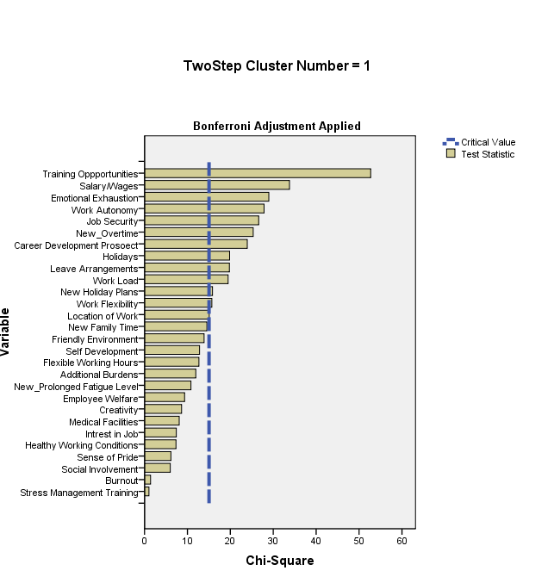

Figure 2: Two-Step Cluster Number 2

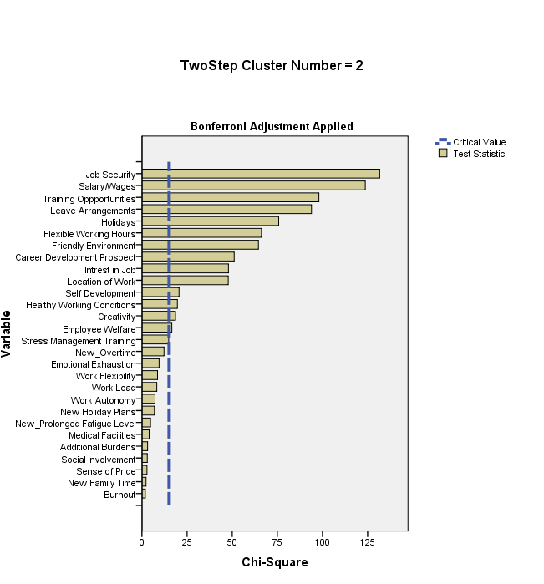
Figure 3: Two-Step Cluster Number 3

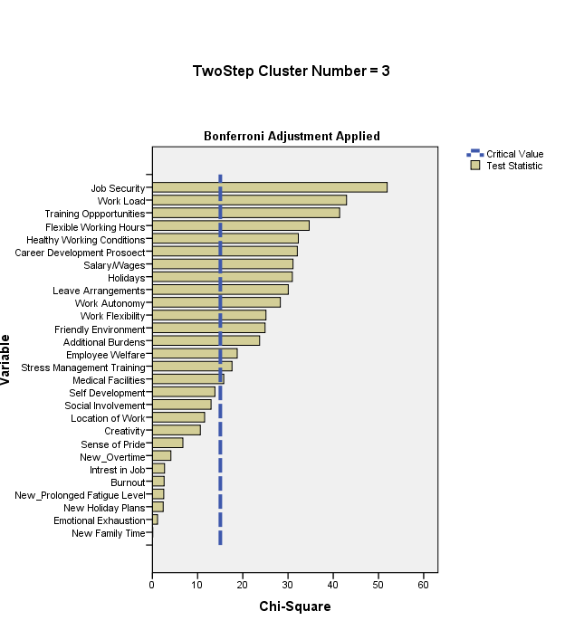

Figure 4: Two-Step Cluster Number 4

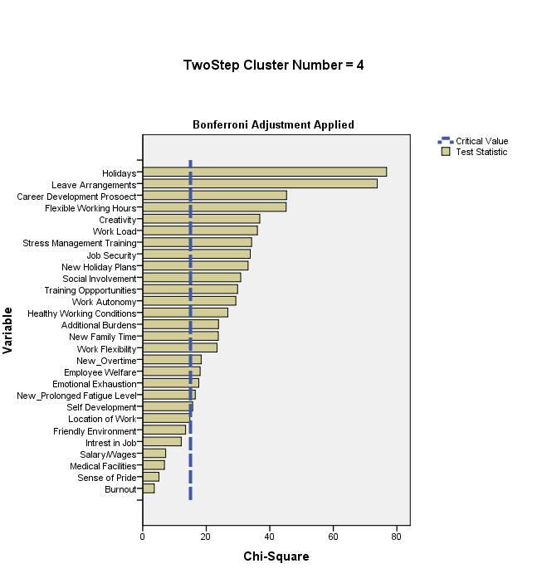

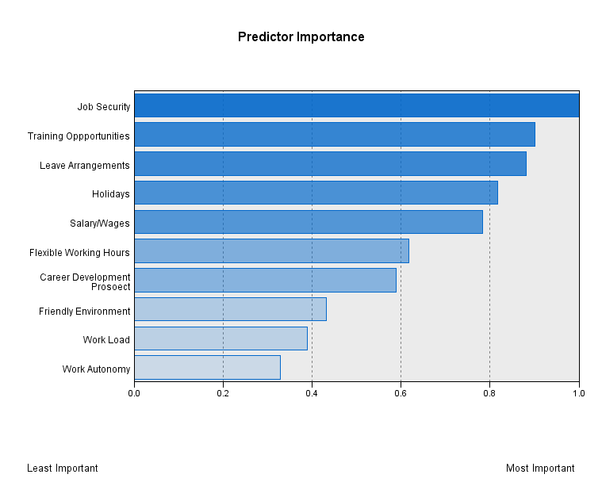
Findings: In Cluster Analysis, variables are used to cluster the individuals or items. In this context there are twenty eight work-life balance variables, cluster analysis divides the respondents mainly into four clusters, the smallest cluster comprises of 49 respondents and the largest cluster comprises of 114 respondents. The pattern of variability present in these twenty eight variables are recognized for cluster formation . In this regard out of Twenty Eight Variables of WLB, only ten variables are found important in context of Health Care Sector with regard to doctors and nurses. Ten WLB variables have been identified as important ranging from most important to least important that is Job Security, Training Opportunities, Leave Arrangements, Holidays, Salary/Wages, Flexible Working Hours, Career Development Prospect, Friendly Environment, Work Load and Work Autonomy. The remaining variables such are not considered to be the important indicators of work-life balance in hospitals.
H_{02:} The Hypothesis formed is rejected as there is dependency of work-family conflict and family-work conflict on control variables;

7.3 Analysis and Findings of the Third Objective: To measure the dependency of work-family conflict and family-work conflict on control variables.
The present chapter undertakes Independent Sample T-Test and One-Way ANOVA in order to find out whether any significant difference exists among the groups or not.
A. Work-Family Conflict: (Only those tables have been shown in which results are significant)

- Results of Independent sample T-Test has been applied in order to know the dependency of composite score of work-family conflict on control variables. Five control variables namely, type of hospital, gender, marital status, spouse employment and family type. However, in none of the case, no significant difference was found with regard to the various control variables groups.

Table-5 Dependency of Work- Family Conflict on Education
Control  Variable | Descriptive | Sum of Squares | df | F | Sig  (2-tailed) | Decision
Education
MBBS(36) | 1.95±.761 | 3.581 | 3 | 1.195 | P<0.05 | Significant
BAMS+BDS(46) | 2.15±.648
MD+MS+PhD(93) | 2.20±.710
ANM+GNM+Others (175) | 2.29±.632
Total | 2.21±.674

Table-6 Dependency of Work-Life Conflict on Profession
Control  Variable | Descriptive | Sum of Squares | df | F | Sig  (2-tailed) | Decision
Profession (N)
Doctor/Professor(15) | 2.83±.74 | 9.823 | 2 | 11.440 | P<.001 | Very High Significant
Nurse (175) | 2.29±.63
Doctor (160) | 2.07±.67
Total (350) | 2.21±.67

Table-7 Dependency of Work-Life Conflict on Family Size
Control Variable | Descriptive | Sum of Squares | df | F | Sig  (2-tailed) | Decision
Family Size
0-2(16) | 2.62±.524 | 4.853 | 3 | 3.636 | P<0.05 | Significant
3-5(207) | 2.23±.645
6-8 (81) | 2.05±.625
>=9 (46) | 2.25±.853
Total (350) | 2.21±.674

- Results of One-Way ANOVA: However, on the remaining eight control variables one-way ANOVA has been applied in order to test the differences among various groups. On the basis of profession, there is highly significant difference has been seen between those who are working as Doctor/Professor, Nurse and Doctors and also significant difference was found on the basis of education and family size of respondents. On the contrary, no significant difference was noticed on the basis of composite score of work-family conflict on control variables such as age, salary, working experience, dependents in family and disease.

Findings: It is evident that whose education qualification is ANM, GNM etc. are most affected by work-family conflict and MBBS degree holders are on the bottom for the same. Doctor/Professors face maximum work-family conflict followed by Nurses and Doctors. Most work-family conflict is faced by those personnel whose family size lies in between 0-2 and least conflict was faced by those who have 6-8 family members .

B. Family-Work Conflict: (Only those tables have been shown in which results are significant)

Table-8 Dependency of Family-Work Conflict on Control Variables
S.No | Control Variables (N) |  | Descriptive | t-test for equality of means
S.No |  |  | Descriptive | t | d.f. | Sig  (2-tailed) | Decision
1. | Type of Hospital | Government  (200) | 2.80±.765 | 3.532 | 347 | P<.001 | Very Highly Significant
1. | Type of Hospital | Non-Government (150) | 2.53±.620
2. | Gender | Female (186) | 2.79±.682 | 2.962 | 346 | P<.01 | Highly Significant
2. | Gender | Male (162) | 2.56±.735
3. | Marital Status | Married (247) | 2.63±.702 | -2.073 | 347 | P<.05 | Significant
3. | Marital Status | Unmarried (103) | 2.81±.744
4. | Family Type | Nuclear (182) | 2.76±.700 | 2.039 | 346 | P<.05 | Significant
4. | Family Type | Joint  (162) | 2.61±.731

- Results of Independent sample T-Test : On the basis of dependency of family-work conflict (composite score) on control Variables, Independent sample T-test has been applied. The result shows that there is very high significant difference between government and non-government hospitals. There is existence of highly significant difference across female and male respondents. Likely, significant differences exist on the basis of marital status and family type. However, no significant difference was found on the basis of spouse employment.

Table-9 Dependency of Family-Work Conflict on Age
Control  Variable | Descriptive | Sum of Squares | df | F | Sig  (2-tailed) | Decision
Age
21-30 | 2.80±.711 | 7.969 | 3 | 5.344 | P<0.01 | Highly Significant
31-40 | 2.58±.718
41-50 | 2.39±.688
>=51 | 2.84±.651
Total | 2.69±.718

Table-10 Dependency of Family-Work Conflict on Education
Control  Variable | Descriptive | Sum of Squares | df | F | Sig  (2-tailed) | Decision
Education
MBBS(36) | 2.64±.856 | 10.576 | 3 | 7.202 | P<0.001 | Very  High Significant
BAMS+BDS(46) | 2.25±.626
MD+MS+PhD(93) | 2.79±.754
ANM+GNM+Others (175) | 2.76±.651
Total | 2.69±.718

Table-11 Dependency of Family-Work Conflict on Salary
Control  Variable | Descriptive | Sum of Squares | df | F | Sig  (2-tailed) | Decision
Salary(p.m.)
4000-10000 | 2.70±.546 | 10.081 | 4 | 5.119 | P<0.01 | Highly Significant
10001-25000 | 2.31±.668
25001-40000 | 2.94±.699
40001-75000 | 2.69±.787
>=75001 | 2.72±.656
Total | 2.69±.718

Table-12 Dependency of Family-Work Conflict on Dependents in Disease
Control  Variable | Descriptive | Sum of Squares | df | F | Sig  (2-tailed) | Decision
Disease
None (263) | 2.70±.714 | 7.969 | 3 | 5.344 | P<0.01 | Highly Significant
Blood Pressure (32) | 2.59±.656
Heart Disease (4) | 2.81±.554
Depression (8) | 2.68±..752
Mental Disease (5) | 2.20±.715
Diabetes (12) | 2.89±.962
Any Other (26) | 2.60±.732
Total (350) | 2.69±.718
- Results of One-Way ANOVA: It has been applied in order to test the differences among various groups. On the basis of education, very high significant difference was found among various groups on the basis of composite score of family-work conflict. However, highly significant difference was found on the basis of age, salary and disease. Lastly, no significant difference was found on the basis of age, salary, working experience, dependents in family and disease.
Findings: Family-Work Conflict is reported more by government doctors and nurses as compared to non-government employees. Female employees reportedly experience more family-work conflict. However, unmarried personnel faced more family-work conflict. Doctors and Nurses having Nuclear family experience more family-work conflict. Those who are having age> 51, are most affected by family-work conflict. Professionals having qualifications of MD, MS and Ph.D. are on the maximum side being affected by the conflict whereas salaried personnel having pay between 25,000 to 40,001 are getting affected by family-work conflict most.
7.4 Analysis and Findings of the Fourth Objective: To examine the existing work-life balance variables among doctors and nurses. (Only those tables have been shown in which results are significant)

Table-13 Dependency of Job Security on Profession
Control  Variable | Descriptive | Mean Rank | df | (H)  Value | Sig. | Decision
Profession (N)
Doctors/Professors(15) | 3.00±.53 | 199.63 | 2 | 7.774 | P>0.05 | Significant
Nurses (175) | 2.66±.81 | 161.77
Doctors (160) | 2.90±.81 | 188.25
Total (350) | 2.78±.81

Table-14 Dependency of Training Opportunities on Profession
Control  Variable | Descriptive | Mean Rank | df | (H)  Value | Sig  (2-tailed) | Decision
Profession (N)
Doctor/Professor(15) | 2.80±.41 | 183.60 | 2 | 20.491 | P<0.001 | Very High Significant
Nurse (175) | 2.53±.80 | 153.52
Doctor (160) | 2.91±.73 | 198.78
Total (350) | 2.72±.78

Table-15 Dependency of Salary/Wages on Profession
Control  Variable | Descriptive | Mean Rank | df | H  (value) | Sig  (2-tailed) | Decision
Profession (N)
Doctors/Professors(15) | 3.20±.86 | 224.30 | 2 | 50.315 | P<0.001 | Very High Significant
Nurses (175) | 2.73±.97 | 140.42
Doctors (160) | 2.84±.89 | 209.29
Total (350) | 2.80±.93

T

Table-16 Dependency of Flexible Working Hours on Profession
Control  Variable | Descriptive | Mean Rank | df | H  (value) | Sig  (2-tailed) | Decision
Profession (N)
Doctors/Professors(15) | 2.67±.48 | 164.67 | 2 | .047 | P<0.05 | Significant
Nurses (175) | 2.80±.71 | 187.33
Doctors (160) | 2.59±.85 | 163.58
Total (350) | 2.70±.77

Table-17 Dependency of Career Development Prospect on Profession
Control  Variable | Descriptive | Mean Rank | df | H  (value) | Sig  (2-tailed) | Decision
Profession (N)
Doctors/Professors(15) | 2.87±.64 | 178.20 | 2 | 10.429 | P<0.01 | Highly Significant
Nurses (175) | 2.69±.76 | 160.08
Doctors (160) | 2.96±.69 | 192.11
Total (350) | 2.82±.73

Table-18 Dependency of Work Load on Profession
Control  Variable | Descriptive | Mean Rank | df | (H)  Value | Sig  (2-tailed) | Decision
Profession (N)
Doctors/Professors(15) | 3.60±.63 | 227.83 | 2 | 7.716 | P<0.05 | Significant
Nurses (175) | 3.12±.77 | 165.19
Doctors (160) | 3.26±.70 | 181.87
Total (350) | 3.21±.74
Table-19 Dependency of Work Autonomy on Profession
Control  Variable | Descriptive | Mean Rank | df | (H)  Value | Sig  (2-tailed) | Decision
Profession (N)
Doctor/Professor(15) | 3.40±.91 | 231.33 | 2 | 15.546 | P<0.001 | Very High Significant
Nurse (175) | 2.75±.97 | 157.52
Doctor (160) | 3.09±.79 | 189.93
Total (350) | 2.93±.91

Table-20 Dependency of Composite Score of Work-Life Balance Variables on Type of Hospital
Control  Variable | Descriptive | Sum of Squares | df | F | Sig  (2-tailed) | Decision
Type of Hospital (N)
Government(200) | 2.56±.37 | 0.870 | 1 | 7.331 | P<0.05 | Significant
Non-Government (150) | 2.66±.30
Total (350) | 2.60±.34

Table-21 Dependency of Composite Score of Work-Life Balance Variables on Salary
Control  Variable | Descriptive | Sum of Squares | df | F | Sig  (2-tailed) | Decision
Salary(p.m)(N)
4000-10000 (65) | 2.60±.25 | 3.243 | 4 | 7.183 | P<0.001 | Very High Significant
10001-25000 (45) | 2.62±.27
25001-40000 (56) | 2.55±.41
40001-75000  (137) | 2.54±.35
>=75001(47) | 2.84±.33
Total | 2.60±.34

Table-22 Dependency of Composite Score of Work-Life Balance Variables on Working Experience
Control  Variable | Descriptive | Sum of Squares | df | F | Sig  (2-tailed) | Decision
Working Experience
0-5 (234) | 2.59±.33 | 1.178 | 4 | 2.478 | P<0.05 | Significant
6-10 (61) | 2.68±.37
11-15 (12) | 2.76±.41
16-20 (17) | 2.43±.43
>=21 (26) | 2.59±.28
Total (350) | 2.60±.34

Findings: It is evident from the Tables (13 to 19), seven work-life balance variables does significantly varies among Doctors, Nurses and Doctor/Professor. In case of Training Opportunities, Salary/Wages and Work Autonomy, very high significant difference was found and in context of career development prospect highly significant variations can be seen among the three groups. Later, only significant difference was found in case of Job Security, Flexible Working Hours and Work Load. On the Contrary, no significant difference was found in case of leave arrangements, holidays and friendly environment. Lastly, dependency of composite score of work-life balance practices, does significantly makes a difference in context of type of hospital, salary and working experience.
It is found that those who are working as Doctor/Professors are most satisfied in majority of cases followed by doctors. On the contrary, nurses are least satisfied with the work-life balance practices prevailing in the hospital. And also, it is evident from the data that private sector employees are happy about work-life balance practices prevailing in their hospital, personnel whose salary =>75,000 yields utmost satisfaction and lastly, those who have working experience that lies in between 11 to 15 years are most satisfied.
H_{03:} The hypothesis formed is rejected as there is significant relationship of work-life balance variables among doctors and nurses.

7.5 Analysis and Findings of the Fifth Objective: To assess the impact of work-life balance variables on job satisfaction, employee well-being and stress control.
- Relationship of Work-Life Balance Variables on Job Satisfaction, employee well-being and stress control.
Table 23: Relationship of Work-Life Balance Variables with Job Satisfaction, Employee Well-being and Stress Control
Relationship of Work-Life Balance Variables with 1, 2,3 | Job Satisfaction (1) |  | Employee Well-Being(2) |  | Stress Control (3)
(N=350) | r | P | r | P | r | P
Job Security | .348** | .000 | .168** | .002 | -.029 | .583
Training Opportunities | .219** | .000 | .285** | .000 | -.093 | .082
Leave Arrangements | .178** | .001 | .165** | .002 | -.045 | .404
Holidays | .242** | .000 | .200** | .000 | -.141** | .008
Salary/Wages | .219** | .000 | -.093 | .082 | .285** | .000
Flexible Working Hours | .146** | .006 | .203** | .000 | -.041 | .448
Career Development Prospect | .228** | .000 | .197** | .000 | -.071 | .186
Friendly Environment | .122* | .022 | -.187** | .000 | .209 | .000
Work Load | .363** | .000 | .245** | .000 | -.111* | .038
Work Autonomy | .171** | .001 | .103 | .054 | .006 | .914
**Correlation is significant at the 0.01 level ; *Correlation is significant at the 0.05 level

Findings: Above table 23 demonstrates the relationship of work-life balance variables with Job Satisfaction, employee well-being and stress management. It is clear that some work-life balance variables are significantly correlated with Job Satisfaction, Employee Well-being and Stress Control and this relationship is moderate in nature. Rest of the work-life balance variables doesn't show significant relationship with job satisfaction, employee well-being and stress control.

- Impact of Work-Life Balance Practices on Job Satisfaction, employee well-being and stress control.
Table-24: Impact of WLB Variables on Dependent Variable
22 Work-Life Balance Variables  (Independent Variable) | Dependent Variables
22 Work-Life Balance Variables  (Independent Variable) | Job Satisfaction
22 Work-Life Balance Variables  (Independent Variable) | Employee well-being
22 Work-Life Balance Variables  (Independent Variable) | Stress Control
Table-25: Model Fitting Information
Dependent Variables | Model | Model Fitting Criteria | Likelihood Ratio Tests
Dependent Variables | Model | -2 Log Likelihood | Chi-Square | df | Sig.
Job Satisfaction | Intercept Only | 651.811
Job Satisfaction | Final | 420.403 | 231.409 | 90 | .000
Employee Well-Being | Intercept Only | 788.708
Employee Well-Being | Final | 612.047 | 176.661 | 90 | .000
Stress Control | Intercept Only | 788.708
Stress Control | Final | 612.047 | 176.661 | 90 | .000

Table-26 Goodness-of-Fit
Dependent Variables |  | Chi-Square | df | Sig.
Job Satisfaction | Pearson | 582.884 | 741 | 1.000
Job Satisfaction | Deviance | 406.170 | 741 | 1.000
Employee Well-Being | Pearson | 837.883 | 741 | .008
Employee Well-Being | Deviance | 591.903 | 741 | 1.000
Stress Control | Pearson | 837.335 | 741 | .008
Stress Control | Deviance | 591.903 | 741 | 1.000

Table-27: Pseudo R-Square
Dependent Variables | Cox and Snell | .484
Job Satisfaction | Nagelkerke | .564
Job Satisfaction | McFadden | .339
Employee Well-Being | Cox and Snell | .396
Employee Well-Being | Nagelkerke | .437
Employee Well-Being | McFadden | .212
Stress Control | Cox and Snell | .396
Stress Control | Nagelkerke | .437
Stress Control | McFadden | .212

A multinomial logistic regression model is a form of regression where the outcome variable (risk factor-dependent variable) is binary or dichotomous and the independents are continuous variables, categorical variables, or both (Bagaya,2010).
Tabachnick et al. (2001) argued that multinomial logistic regression technique has number of major advantages as a summary to the discussion above: (1) it is more robust to violations of assumptions of multivariate normality and equal variance-covariance matrices across groups; and (2) it is similar to linear regression, but more easily interpretable diagnostic statistics. Further, advantages of the analysis that raise its popularity come from the following assumptions: (3) most importantly, MLR does not assume a linear relationship between the dependent and independent variables; (4) independent variables need not to be interval (5) MLR does not require that the independents be unbounded and lastly (6) normally distributed error terms are not assumed.

Findings:
The test of relationship between dependent and independent variables, i.e., Model Fitting Information in Table 25 and Goodness-of-fit in Table 26 reveals that in all the cases the probability of the Model chi-square is less than the level of significance of .001 (i.e., p<0.001) and in Goodness of Fit was above than the significance level of .05 (i.e., p>0.05). This suggested that the existence of relationship between the independent variables and the dependent variables are supported. Table 27 explains the impact status of Work-Life Balance variables on Job Satisfaction, Employee Well-being and Stress Control. Here, the pseudo R² values indicates that ten variables of work-life balance explains proportion of variation in the Job Satisfaction i.e., Nagelkerke 56.4%, Employee Well-being i.e.,Nagelkerke 43.7% and Stress Control 43.7%.

Table 28: Likelihood Ratio-Tests

Effect | JOB SATISFACTION |  |  |  | EMPLOYEE WELL-BEING |  |  |  | STRESS MANAGEMENT
Effect | Model Fitting Criteria | Likelihood Ratio Tests |  |  | Model Fitting Criteria | Likelihood Ratio  Tests |  |  | Model Fitting Criteria | Likelihood Ratio Tests
Effect | -2 Log Likelihood | Chi-Square | df | Sig. | -2 Log Likelihood | Chi-Square | df | Sig. | -2 Log Likelihood | Chi-Square | df | Sig.
Salary/Wages | 439.884 | 19.481 | 9 | .021 | 619.186 | 7.139 | 9 | .623 | 619.186 | 7.139 | 9 | .623.
Holidays | 428.571 | 8.168 | 9 | .517 | 623.325 | 11.278 | 9 | .257 | 623.325 | 11.278 | 9 | .257
Flexible Working Hours | 430.984 | 10.582 | 9 | .305 | 630.692 | 18.645 | 9 | .028 | 630.692 | 18.645 | 9 | .028
Career Development Prospect | 437.382 | 16.979 | 9 | .049 | 621.561 | 9.514 | 9 | .366 | 621.561 | 9.514 | 9 | .391
Leave Arrangements | 426.411 | 6.008 | 9 | .739 | 621.856 | 9.809 | 9 | .366 | 621.856 | 9.809 | 9 | .366
Training Opportunities | 428.671 | 8.268 | 9 | .507 | 622.013 | 9.966 | 9 | .353 | 622.013 | 9.966 | 9 | .353
Job Security | 451.222 | 30.819 | 9 | .000 | 626.771 | 14.724 | 9 | .099 | 626.771 | 14.724 | 9 | .099
Work Load | 441.355 | 20.953 | 9 | .013 | 627.306 | 15.259 | 9 | .084 | 428.714 | 15.259 | 9 | .084
Work Autonomy | 440.184 | 19.781 | 9 | .000 | 629.585 | 17.538 | 9 | .041 | 629.585 | 17.538 | 9 | .041
Friendly Environment | 429.349 | 8.947 | 9 | .442 | 632.314 | 20.267 | 9 | .016 | 632.314 | 20.267 | 9 | .016
The chi-square statistic is the difference in -2 log-likelihoods between the final model and a reduced model. The reduced model is formed by omitting an effect from the final model. The null hypothesis is that all parameters of that effect are 0.

The likelihood ratio test evaluates the overall relationship between an independent variable and dependent. Referring to the table-34,
- In case of job satisfaction, there is significant relationship between the independent variable work-life balance variables and the dependent variables salary/wages, career development prospect, job security, work load and work autonomy. The result of the study can be linked to another study carried by Yutaka Ueda, 2012 in which they concluded that employees feel more satisfaction with their work and family when they enjoy the benefits of work life balance programs provided by their employers. It is found that when employees' need in respect of creating a work-life balance is met by different organizational programmes they show higher job satisfaction and organizational commitment (Gregory and Milner 2009).
- In case of Employee Well-being, there is significant relationship between the independent variable work-life balance variables and the dependent variables flexible working hours, work autonomy and friendly environment. WLB is vital for individuals’ wellbeing, organisations’ performance and a functioning society (Grady et al., 2008). Family and work are the most important elements of everyone’s life. Any competing demands of work and family life cause conflict and negatively affect the wellbeing of workers (Clark, 2000; Frone, 2000). Findings from the literature review show that conflicts caused by interference between work and family activities lead to lower family life satisfaction and work satisfaction (Parasuraman & Greenhaus, 2002), and are negatively related to WLB (Kalliath & Monroe, 2009). Therefore, good WLB and wellbeing can be achieved when there is no role conflict, and when people are satisfied with their work and family roles (Clark, 2000).
- In case of Stress Control, there is significant relationship between the independent variable work-life balance variables and the dependent variables across only three variables the flexible working hours, work autonomy and friendly environment rest of the dependent variables found insignificant.
- H_{04:} Work-Life Balance variables do significantly impact the job satisfaction, employee well-being and stress control, therefore the hypothesis formed is rejected.
8. CONCLUSIVE REMARKS
Following conclusions have been derived from the study:
- Variations in Literature: There are significant differences in precept and practice within western countries with regard to WLB. Studies in India are relatively less focused and move more as an issue for women than for men, while in western countries it is often seen as an issue common to both men and women, in fact, for workers with family responsibilities. The study also shows that WLB practices and family-friendly policies are distinctly different between western countries and India. Where WLB issues are seen more as women issues, the family-friendly policies seem to be more on paper and underutilized. Changing demographics, family-friendly workplaces are fostering WLB. However, a lot more needs to be done by both individual and the organization.(Chandra,2012).
- Important WLB Indicators: The study undertakes Two-Step Cluster Analysis for the purpose of identification of important indicators of work-life balance. With the method of Two-Step Cluster Analysis, the study identifies ten important work-life balance variables and found significant at 5% level of significance i.e., Job Security, Training Opportunities, Leave Arrangements, Holidays, Salary/Wages, Flexible Working Hours, Career Development Prospect, Friendly Environment, Work Load and Work Autonomy.
- Dependency of WFC and FWC on control variables: In case of work-family conflict, there is significant relationship found on the basis of profession, education and family size. As family-work conflict is concerned, there is significant relationship on the basis of type of hospital, gender, marital status, family type, education, age, salary and disease.
- Differences among doctors and nurses: In this study, it was found that those who are working as Doctor/Professors are most satisfied with work-life balance practices in majority of cases followed by doctors. On the contrary, nurses are least satisfied with the work-life balance practices prevailing in the hospital. Work-life balance variables do significantly varies among Doctors, Nurses and Doctor/Professor.
- Impact of WLB variables on Job Satisfaction, Employee well-being and Stress Control: A significant positive relationship was found between work-life balance variables with Job Satisfaction, Employee well-being and Stress Control . Some of the WLB variables have impact on Job Satisfaction, Employee well-being and Stress Control

9. RECOMMENDATIONS AND POLICY IMPLICATIONS
- It was found that family friendly policies like parental leaves, job sharing arrangements, provision of child care facilities etc. should be provided in the organization so that employees can be encouraged to prove their competence. Further, work flexibility and autonomy should also be given to nurses and doctors (Goyal,2014).
- The present study can be used in developing effective coping system and strengthening the Employee Assistance Programs in the workplace to combat hindrances of imbalance. The Management can work with individuals, teams or groups to educate and train nurses to cope effectively with of job stress. The study Beh & Loo, (2012) also recommended that Management to place strategies or interventions to deal with job stress among nurses.
- As it is evident from the study that Doctor/Professor face maximum work-family conflict followed by Nurses and Doctors. Results offer a novel approach to studying the workplace demands faced by doctors and nurses, and offer evidence that can help guide ongoing efforts to improve the training and work environment for them.(Rutledge.et.al,2009)
- The management should try to address the weak links like work timing, monetary benefits, support team, creating tension free working culture, provision gyms for physical fitness, provision for leaves for attending family functions and social functions, proper maternity/paternity benefit to all deserving staff, motivational work workshops, stress relieving workshops, family get together, flexibility of time and recognition & reward for better performance. These efforts will definitely help to balance the imbalance part of work-life of the working nurses in hospitals (Satpathy et.al.2014)

10. FUTURE RESEARCH ATTEMPTS

- The present research explores the key dimensions of work life balance practices in context of the Indian Health Care Sector. A Total number of 32 constructs were used to measure work-life imbalance. Although an attempt has been made to identify the attributes of the employees WLB, yet there is more exposure in discovering more dimensions influencing work-life balance.
- A broader study can also be conducted on a larger sample and various other sectors apart from hospitals can also be taken into account.
- In future researches, relationship and impact of work-life balance may also be assessed on other employees' behaviors, i.e., Organizational Effectiveness and Performance and Organization Citizenship Behavior.
- The study has only concentrated on a single segment of health care sector i.e., Hospitals. Future studies can be carried on taking in consideration the remaining segment of health care sector Pharmaceutical , Diagnosis , Medical equipments and supplies and medical insurance.\
- Sector based comparison study can be conducted, across all segments of health care sector. All the five segments of health care sector can be compared.

11. CONTRIBUTION OF THE STUDY TO THE EXISTING BODY OF KNOWLEDGE:

- Comparison of Doctors and Nurses in Indian Context: Many researches have been on studying either the doctors and nurses, but there is least focus on having a comparison of both together. The present study contributed in studying the profile of doctors and nurses regarding Work-Life Balance practices in the Indian Context.
- Questionnaire Construction: The present questionnaire has been designed keeping in view the different work-life balance constructs , compiled from various sources.
- Impact of Work-Life Balance Variables on Job Satisfaction, Employee Well-being and Stress Control: Work-Life Balance variables does significantly have an impact on job satisfaction, Employee Well-being and Stress Control.
- Variation in Literature: There is variations in the work-life balance perspective in context of Indian and the Globe. The study also shows that WLB practices and family-friendly policies are distinctly different between western countries and India. Where WLB issues are seen more as women issues, the family-friendly policies seem to be more on paper and underutilized.

References:
Australian Medical Association (2008). Doctors Want Better Work-life Balance. Australian Medical Association Work-Life Flexibility Survey. [Online] Available: http://www.ama.com.au/node/2998 (Oct 1, 2010)
Bayaga, A.(2010). Multinomial Logistic Regression : Usage & Application of Risk Analysis.. Journal of Applied Quantitative Methods, 5(2), 288-297.
Burke, R.J. & Richardson, A.M. (1991). Sources of satisfaction and stress among Canadian physicians.Psychol Rep, 67, 1335-1344.

Chandra, V.(2012). Work-Life Balance: Eastern & Western Perspectives. The International Journal of Human Resource Management, 23(5), 1040-1056.

Clark, S. C. (2000). Work/family border theory: A new theory of work/family balance. Human Relations, 53(6),747-770.

Clever, L. H. (2002). Who is sicker: Patients– or residents? Residents’ distress and the care of patients. Annals of Internal Medicine, 136, 391–393.

Cooper, C.L., Rout, U. & Faragher, B. (1989). Mental health, Job Satisfaction, and Job Stress among general practitioners. British Medical Journal, 298, 366-370.

DiMatteo, M. R., Sherbourne, C. D., Hays, R. D., Ordway, L., Kravitz, R. L., McGlynn, E. A., et al. (1993). Physicians’ characteristics influence patients’ adherence to medical treatment: Results from the Medical Outcomes Study. Health Psychology, 12, 93–102.

Grol, R., Mokkink, H., Smits, A., van Eijk, J., Beek, M. & Mesker, P., et al.(1985). Work satisfaction of general practitioners and the quality of patient care. Family Practice, 2, 128–135.

Firth,C.J. (2003). Doctors, their well being, and their stress. British Medical Journal, 326, 670–671.

Fletcher, K. E., Davis, S. Q., Underwood, W., Mangrulkar, R., McMahon, L. F., & Saint, S. (2004). Systematic review: Effects of resident work hours on patient safety. Annals of Internal Medicine, 141, 851–857.

Frone, M. R. (2000) .Work-family conflict and employee psychiatric disorders: The national comorbidity
survey. Journal of Applied Psychology, 85(6),888- 895.

Grady, G., McCarthy, A., Darcy, C. & Kirrane. M. (2008) Work Life Balance Policies and Initiatives in Irish
Organisations: A Best Practice Management. Cork: Oak Tree Press.

Gregory, A. and Milner, S. (2009), Editorial: Work-life Balance: A Matter of Choice, Gender, Work &
Organization.

Gestal,J.J.(1987). Occupational hazards in hospitals: accidents, radiation, exposure to noxious chemicals, drug addiction and psychic problems and assault. BMJ, 44, 510-520.

Geurts, S., Rutte, C., & Peeters, M. (1999). Antecedents and consequences of work-home interference among medical residents. Social Science and Medicine, 48, 1135–1148.

Goyal, B.(2014). Work-Life Balance of Nurses and Lady Doctors. International Journal of Engineering and Management Research, 4(4), 244-249.

Guest, D. E. (2002). Perspectives on the Study of Work-Life Balance. Social Science Information, 41 (2), 255-279.
Hassan Zaiton , Dollard Maureen F. , Winefield Anthony H. , (2010) .Work‐family conflict in East vs. Western countries, Cross Cultural Management: An International Journal, 17(1), 30 -49.

Howie, J.G.R. Porter, A.M.D. & Forbes, J.F., 1989. Quality and use of time in general practice: Widening the discussion. British Medical Journal, 298, 1008-1010.

Hillhouse, J. J., & Adler, C. M. (1997). Investigating stress effect patterns in hospital staff nurses: Results of a cluster analysis. Social Science and Medicine, 45, 1781–1788.

Imai, H. N., H., Tsuchiya, M., Kuroda, Y., & Katoh, T. (2004). Burnout and work environments of public health nurses involved in mental health care. Occupational and Environmental Medicine, 61, 764–768.

Kalliath, T., & Monroe, M. (2009) ‘Work-life balance: A structural evaluation of its antecedents across five Anglo and Asian samples’. Paper presented at the 8th Australian Industrial and Organisational Psychology Conference, Sydney, June, 2009.

Lee, I., & Wang, H. H. (2002). Perceived occupational stress and related factors in public health nurses. Journal of Nursing Research, 10, 253–260.

McNamee, R., Keen,,RI.,Corkill, CM., (1987). Morbidity and early retirement among anaesthetists and other specialities. BMJ Anaesthesia,42,133-140.

Morrell, D.C., Evans, M.E.,& Roland, M.O. (1986). The "five-minute" consultation: effect of time constraint on clinical content and patient satisfaction. British Medical Journal, 292, 870-873.

Papp, K. K., Stoller, E. P., Sage, P., Aikens, J. E., Owens, J. & Avidan, A., et al. (2004). The effects of sleep loss and fatigue on resident-physicians: A multi-institutional, mixed-method study. Academic Medicine, 79, 394–406.

Parasuraman, S. & Greenhaus, J. H. (2002).Toward reducing some critical gaps in work-family research. Human Resource Management Review, 12,299-312.

Porter, A.M.D., Howie, J.G.R.,& Levinson, A.(1985). Measurement of stress as it affects the work of the general practitioner. Family Practice, 2, 136-146.

Ransome, P. (2007). Conceptualizing Boundaries Between Life and Work. International Journal of Human Resource Management, 18(3), 374–386.

Richardson, A.M.,& Burke, R. J., 1991. Occupational stress and job satisfaction among Canadian physicians. Psychological Reports, 72, 811-821.

Rose, M. W., Ware, J. C., Kolm, P., & Risser, M. R. (2000). Residual effects of call on sleep and mood in medical residents. Sleep, 23, A253–A254.

Shanafelt, T. D., Bradley, K. A., Wipf, J. E., & Back, A. L. (2002). Burnout and self-reported patient care in an internal medicine residency program. Annals of Internal Medicine, 136, 358–367.

Tabachnick, B.G. & Fidell, L.S. and Osterlind, S.J. Using multivariate statistics. US, Allyn and Bacon Boston, 2001

Tarnow-Mordi, W. O., Hau, C., Warden, A., & Shearer, A. J. (2000). Hospital mortality in relation to staff workload: A 4-year study in an adult intensive-care unit. Lancet, 356, 185–189.

Thomas, N. K. (2004). Resident burnout. Journal of the American Medical Association, 292, 2880–2889.

Weinger, M. B., & Ebden, P. (2002). Sleep deprivation and clinical performance. Journal of the American Medical Association, 287, 955–958.

Winstanley, S. and Whittington, R. (2002). Anxiety, burnout and coping styles in general hospital staff exposed to workplace aggression: A cyclical model of burnout and vulnerability to aggression. Work & Stress,N

World Health Organization. 3. Country cooperation strategy at a glance India. 2013. Available from: http://www.who.int/countryfocus/cooperation_strategy/ccsbrief_ind_en.pdf, accessed on March 20, 2014.
Yang, N. (2005). Individualism-collectivism and work-family interface: A Sino-US comparison. In S. A. Y. Poelmans (Ed.). Work and family: An international research perspective (pp.287 319). London: Lawrence Erlbaum.

Yutaka Ueda. (2012). The relationship between work life balance programs and employee satisfaction:Gender differences in the moderating effect of annual income. Journal of Business Administration Research, 1-10.
The Ottawa Citizen (April 28, 2008). New doctors want work-life balance. The Ottawa Citizen. [Online] Available:http://www.canada.com/ottawacitizen/news/story.html?id=a953a06a-18fa-4f48-833c- cb6fa92dbd39 (Oct 1, 2010).
------------------------------------------------------------------

