1.nslookup
In this lab, we’ll make extensive use of the nslookup tool, which is available in most Linux/Unix and Microsoft platforms today. To run nslookup in Linux/Unix, you just type the nslookup command on the command line. To run it in Windows, open the Command Prompt and run nslookup on the command line.

In it is most basic operation, nslookup tool allows the host running the tool to query any specified DNS server for a DNS record. The queried DNS server can be a root DNS server, a top-level-domain DNS server, an authoritative DNS server, or an intermediate DNS server (see the textbook for definitions of these terms). To accomplish this task, nslookup sends a DNS query to the specified DNS server, receives a DNS reply from that same DNS server, and displays the result.

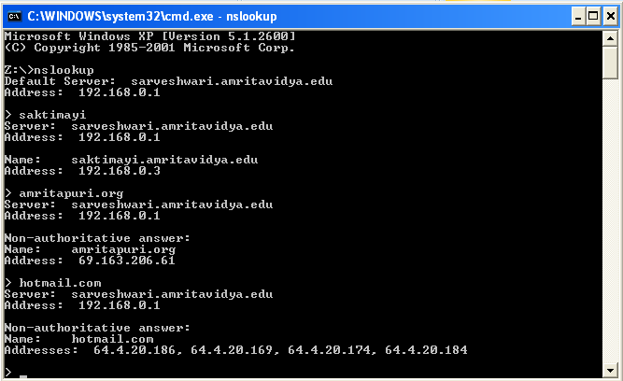

2. ipconfig
ipconfig (for Windows) and ifconfig (for Linux/Unix) are among the most useful little utilities in your host, especially for debugging network issues. Here we’ll only describe ipconfig, although the Linux/Unix ifconfig is very similar. ipconfig can be used to show your current TCP/IP information, including your address, DNS server addresses, adapter type and so on. For example, if you want to see all this information about your host, simply enter:
ipconfig /all into the Command Prompt, as shown in the following screenshot.
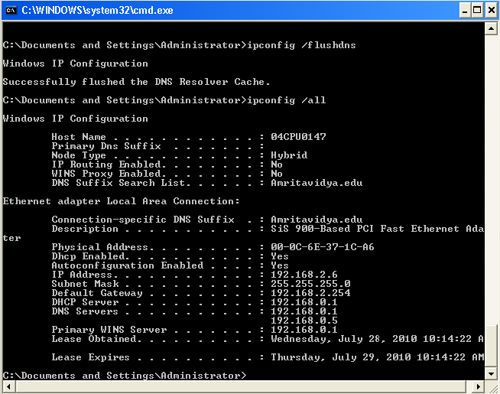

ipconfig is also very useful for managing the DNS information stored in your host. We have learned that a host can cache DNS records it recently obtained. To see these cached records, after the prompt provide the following command: ipconfig /displaydns
Each entry shows the remaining Time to Live (TTL) in seconds.
To clear the cache, enter ipconfig /flushdns
Flushing the DNS cache clears all entries and reloads the entries from the hosts file.
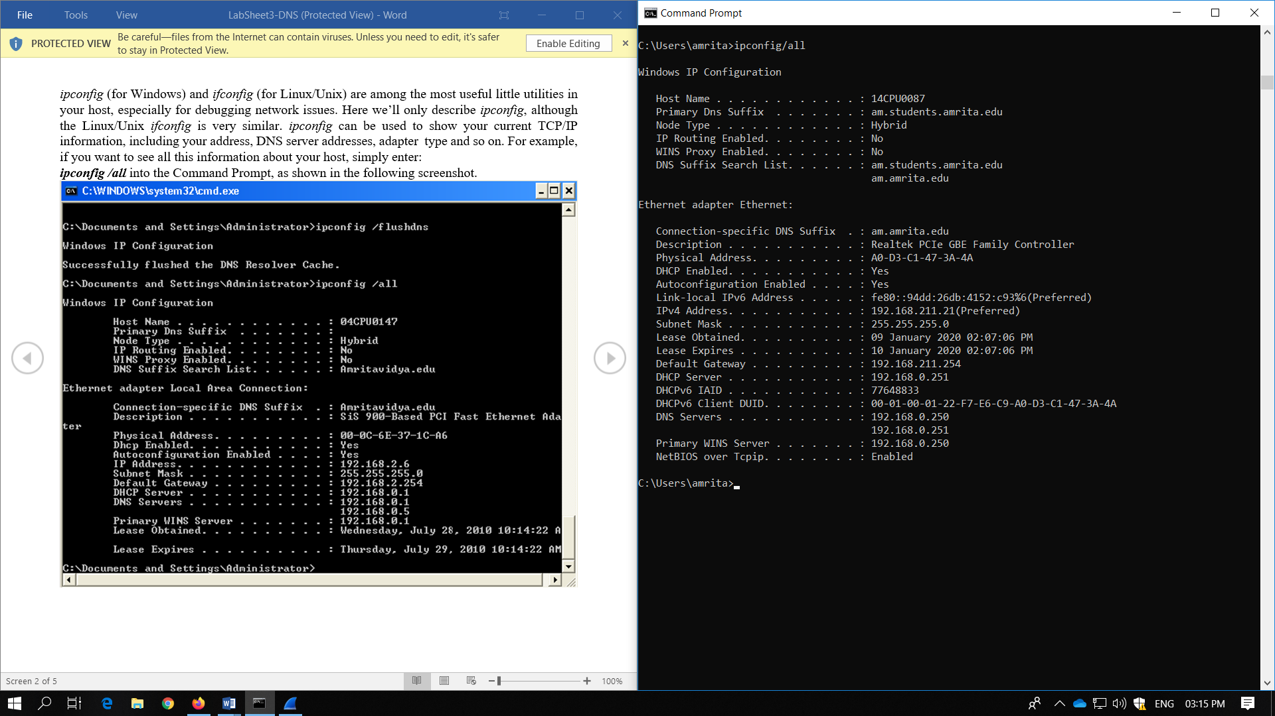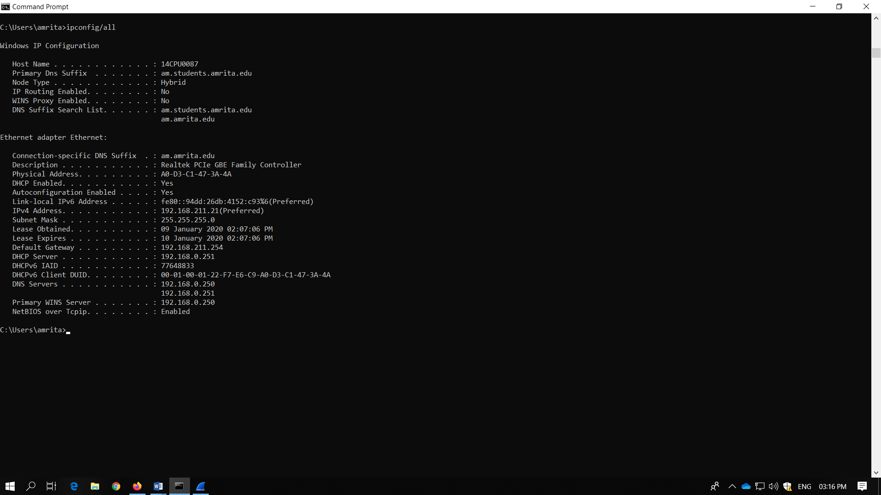

3. Tracing DNS with Wireshark

Now that we are familiar with nslookup and ipconfig, we’re ready to get down to some serious business. Let’s first capture the DNS packets that are generated by ordinary Web surfing activity.
• Use ipconfig to empty the DNS cache in your host.
• Open your browser and empty your browser cache. (With Google Chrome, go to History, then Clear browsing Data, in Time Range=ALL Time, then Apply Clear data)
• Open Wireshark and enter “ip.addr == your_IP_address” into the filter, where you obtain your_IP_address (the IP address for the computer on which you are running Wireshark) with ipconfig. This filter removes all packets that neither originate nor are destined to your host.

• Start packet capture in Wireshark.
• With your browser, visit Web pages belonging to our intranet.
• With your browser, visit Web pages belonging to internet.
• Stop packet capture.
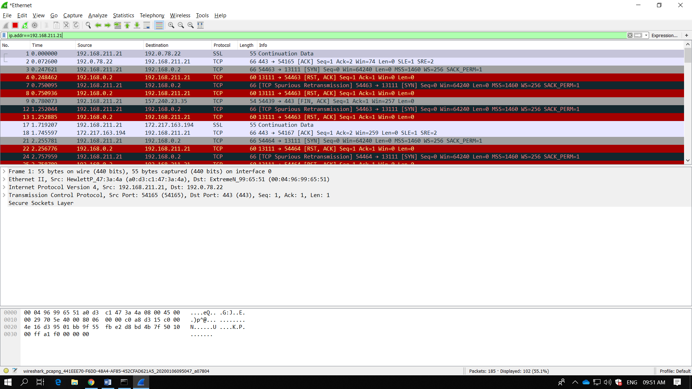
- Explain the working of the DNS protocol[DNS Request Query and DNS Response message] briefly with typed answers and answer highlighted screenshots for the above capture
  - Locate the DNS query and response messages. Are they sent over UDP or TCP?
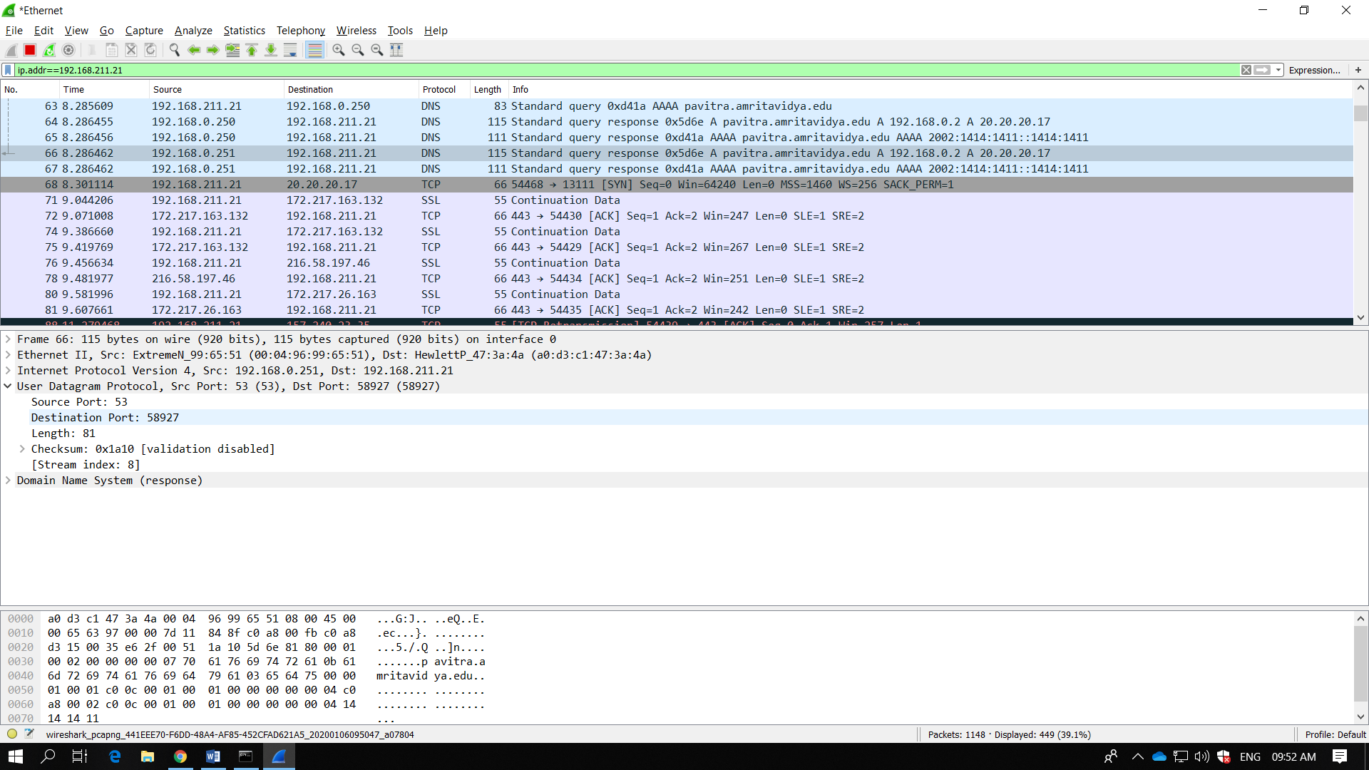
- The DNS query and response messages are sent over UDP.

  - To what IP address is the DNS query message sent? Use ipconfig to determine the IP address of your local DNS server. Are these two IP addresses the same?
The DNS query was sent to IP address 10.40.4.44. Yes it is the same IP address as that of my local DNS server.
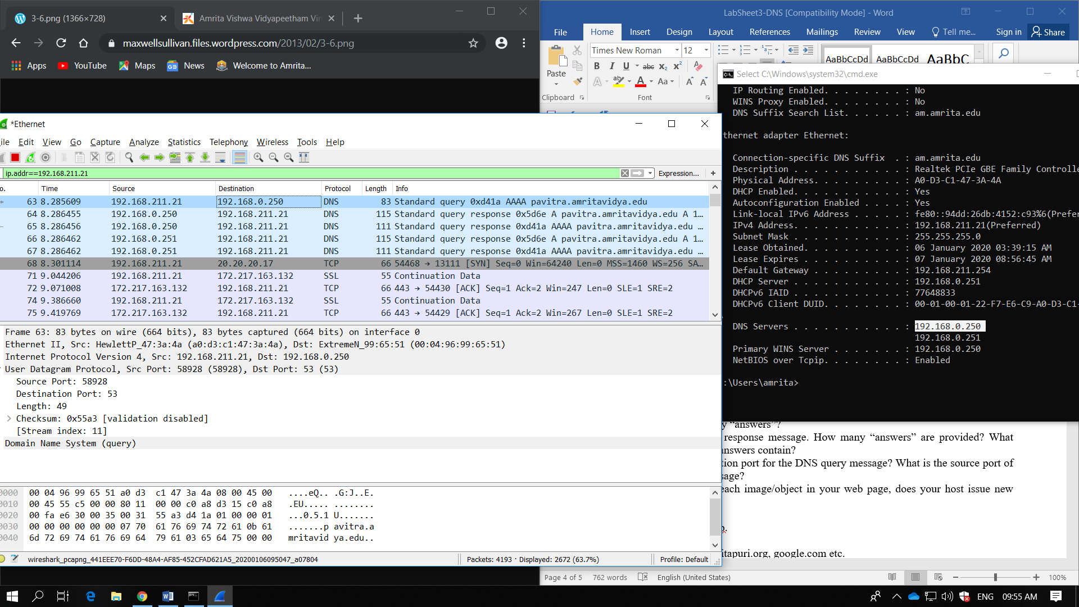
  - Examine the DNS query message. What “Type” of DNS query is it? Does the query message contain any “answers”?
The query message was a type “A” query, but the message did not contain any “answers.”
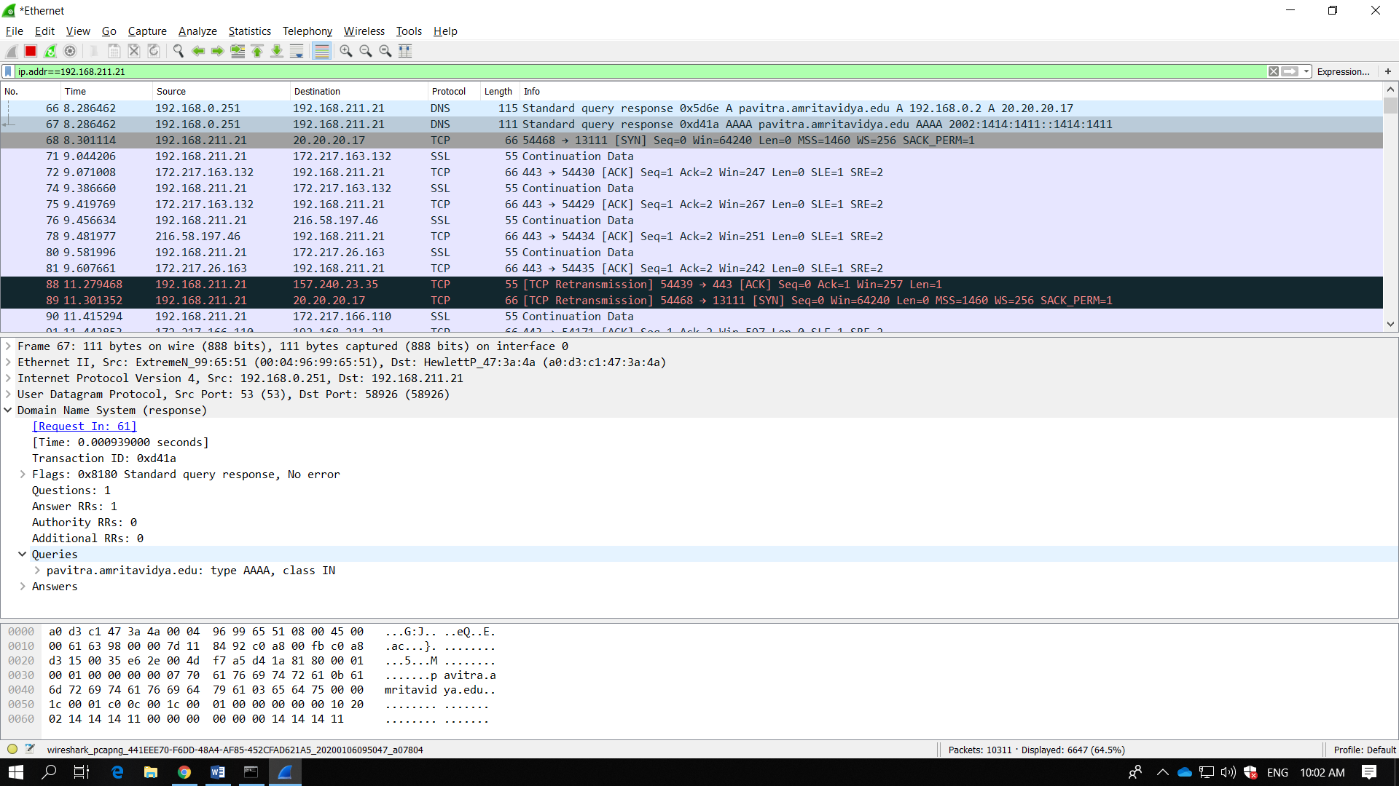
  - Examine the DNS response message. How many “answers” are provided? What does each of these answers contain?
The response message contained one answer to the query which was the sites address [192.168.211.21]. Although it also provided 6 authoritative nameservers, and 11 other responses containing additional information.
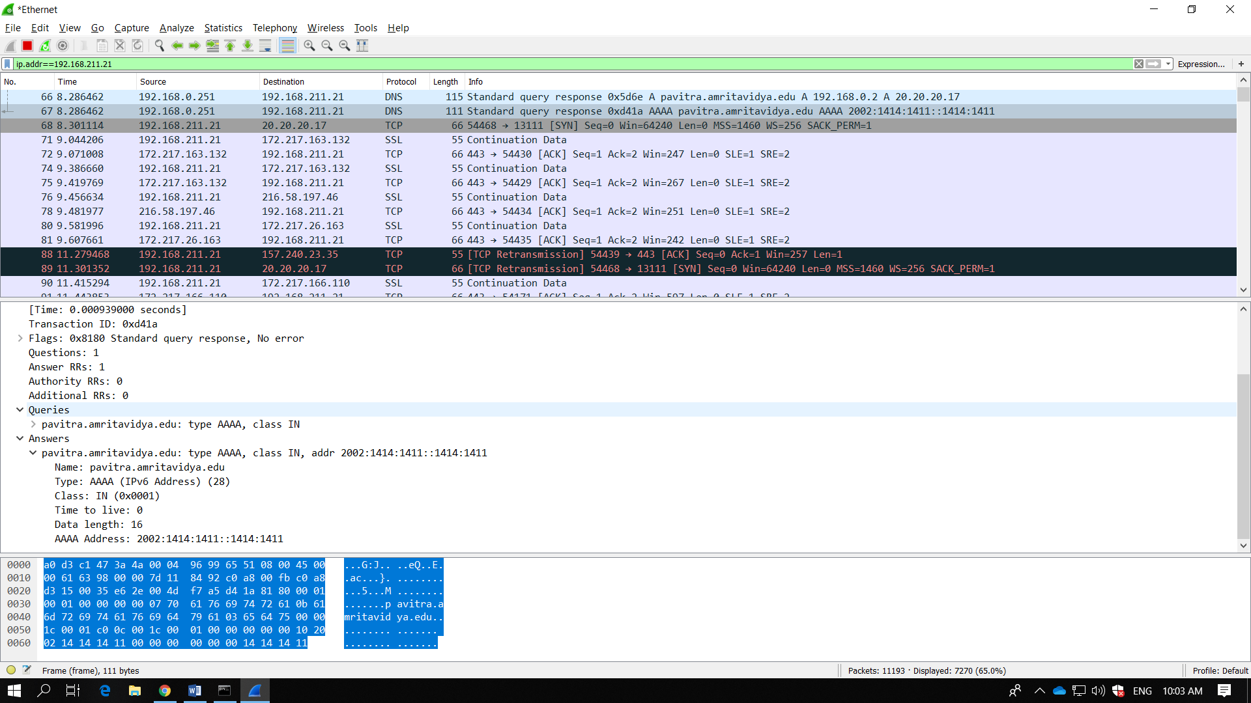
  - What is the destination port for the DNS query message? What is the source port of DNS response message?
Destination Port: 58926
Source Port: 53
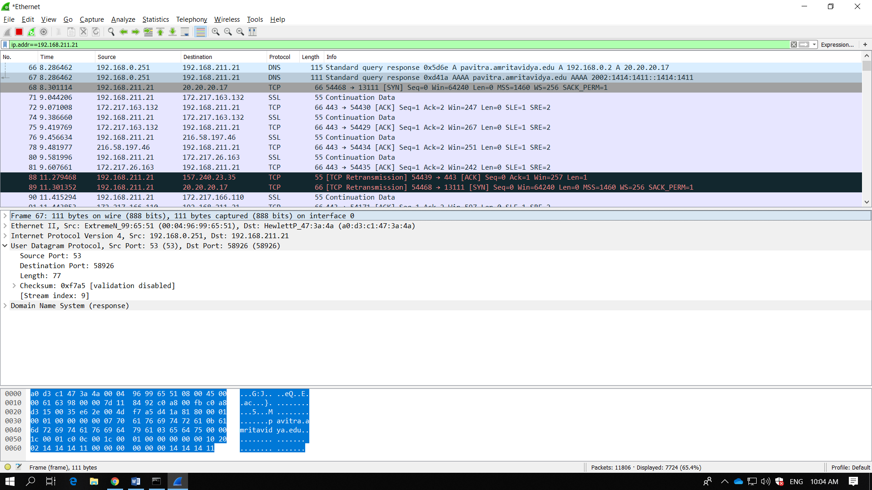
  - Before retrieving each image/object in your web page, does your host issue new DNS queries?
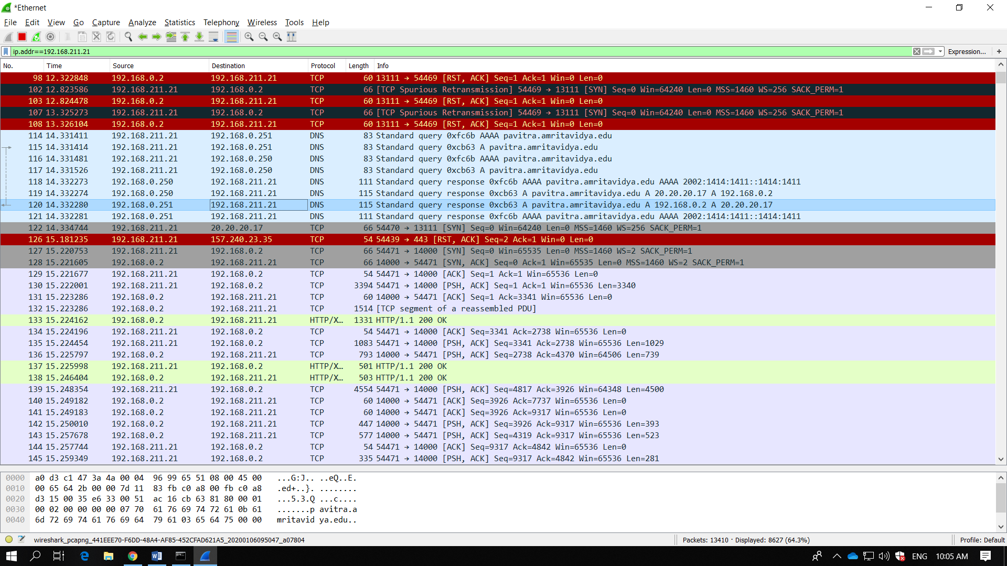

- Now let’s play with nslookup.
• Start packet capture.
• Do an nslookup on amritapuri.org, google.com etc.
• Stop packet capture.
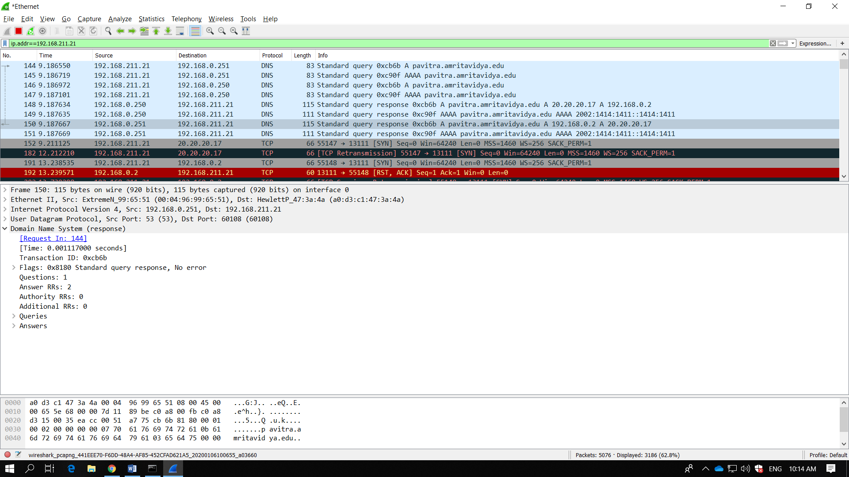
You should get a trace that looks something like the following:
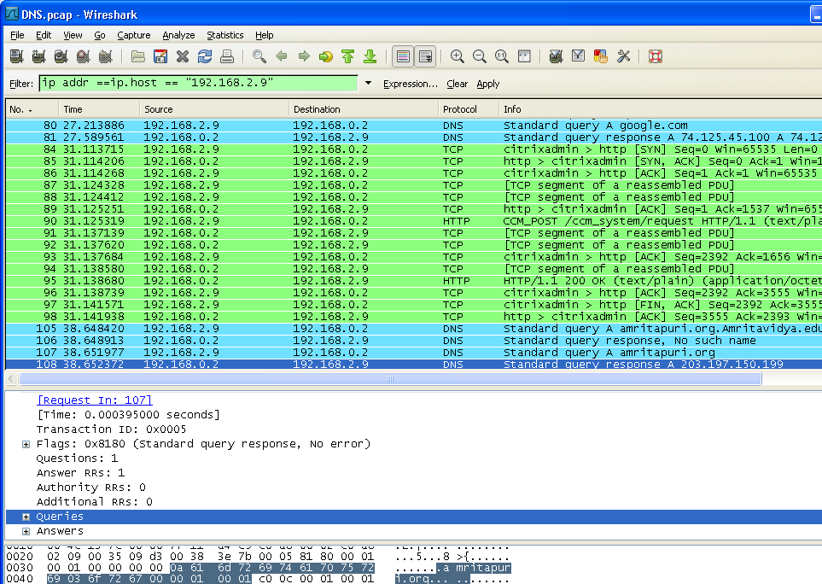

We see from the above screenshot that nslookup actually sent two/three DNS queries and received two/three DNS responses. For the purpose of this assignment, in answering the following questions, ignore the first one/two sets of queries/responses, as they are specific to nslookup and are not normally generated by standard Internet applications. You should instead focus on the last query and response messages. Again, answer the following questions for this capture of frames.
- What is the destination port for the DNS query message? What is the source port of DNS response message?
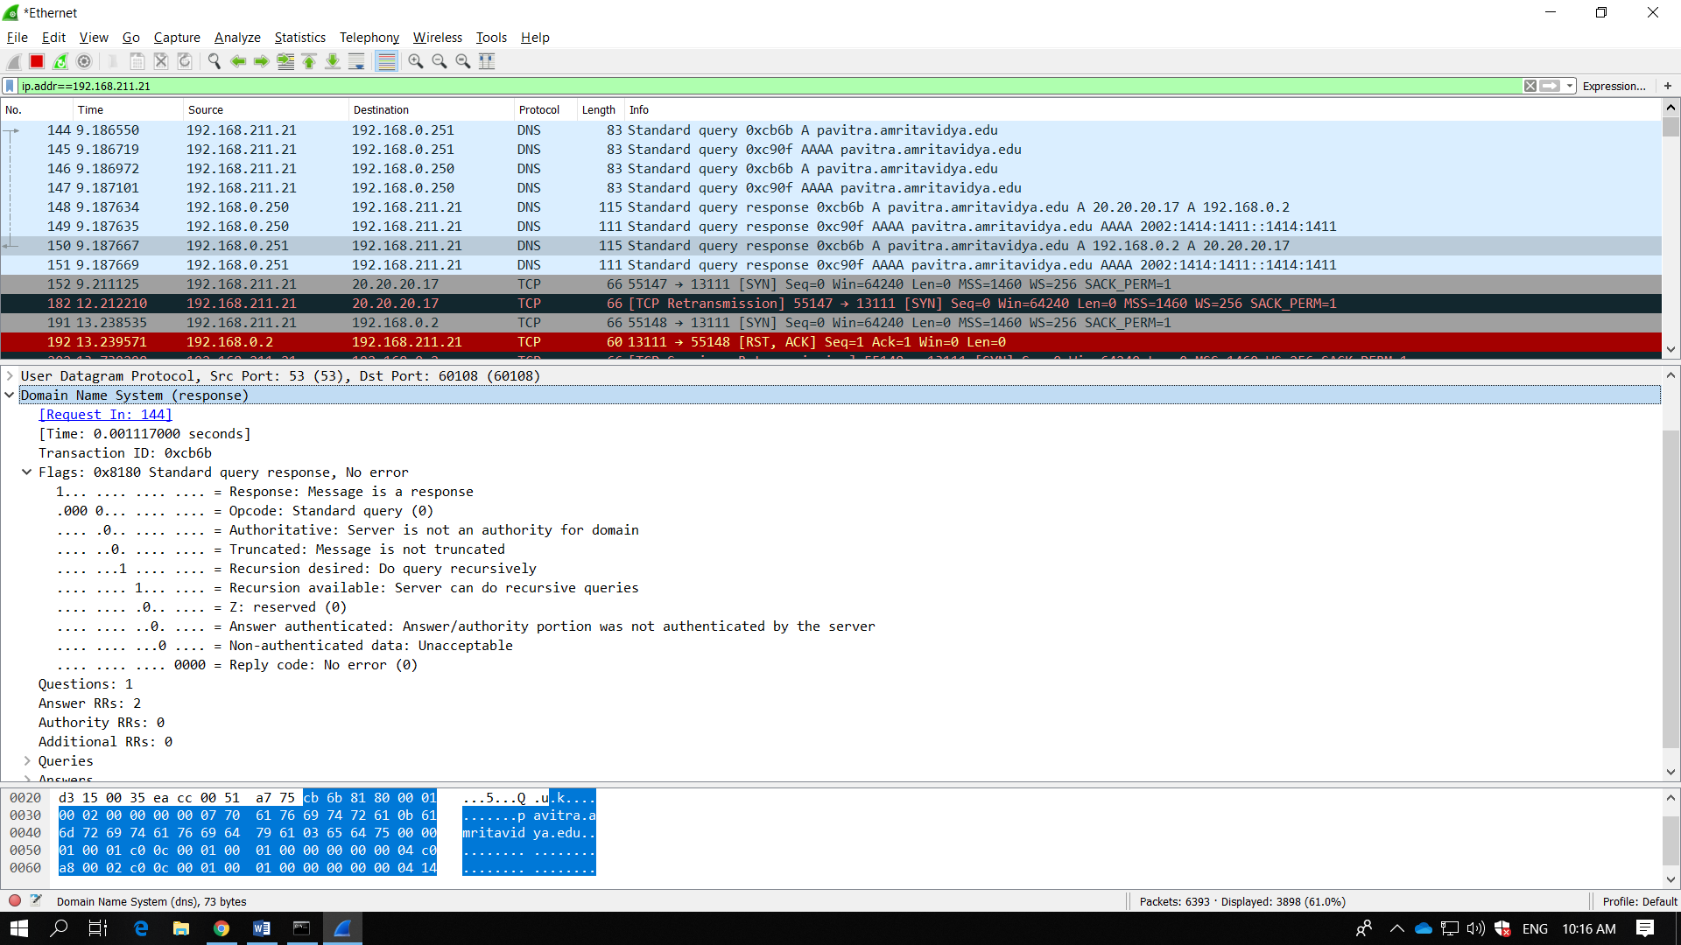
- To what IP address is the DNS query message sent? Is this the IP address of your default local DNS server?
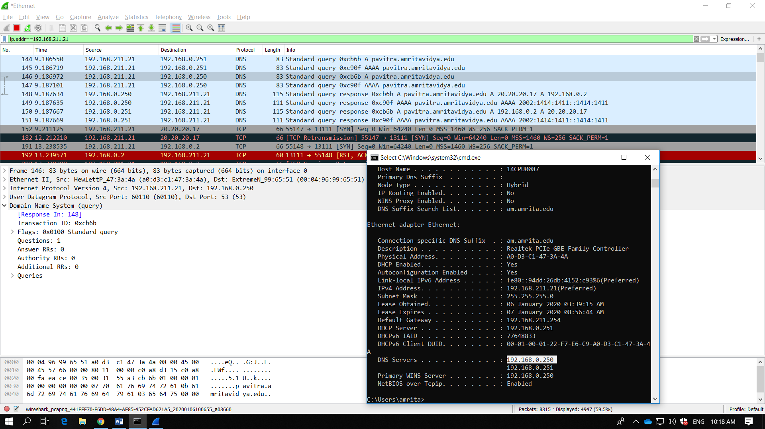
- Examine the DNS query message. What “Type” of DNS query is it? Does the query message contain any “answers”?
This DNS query is a type “A” query. The message does not contain any answers.
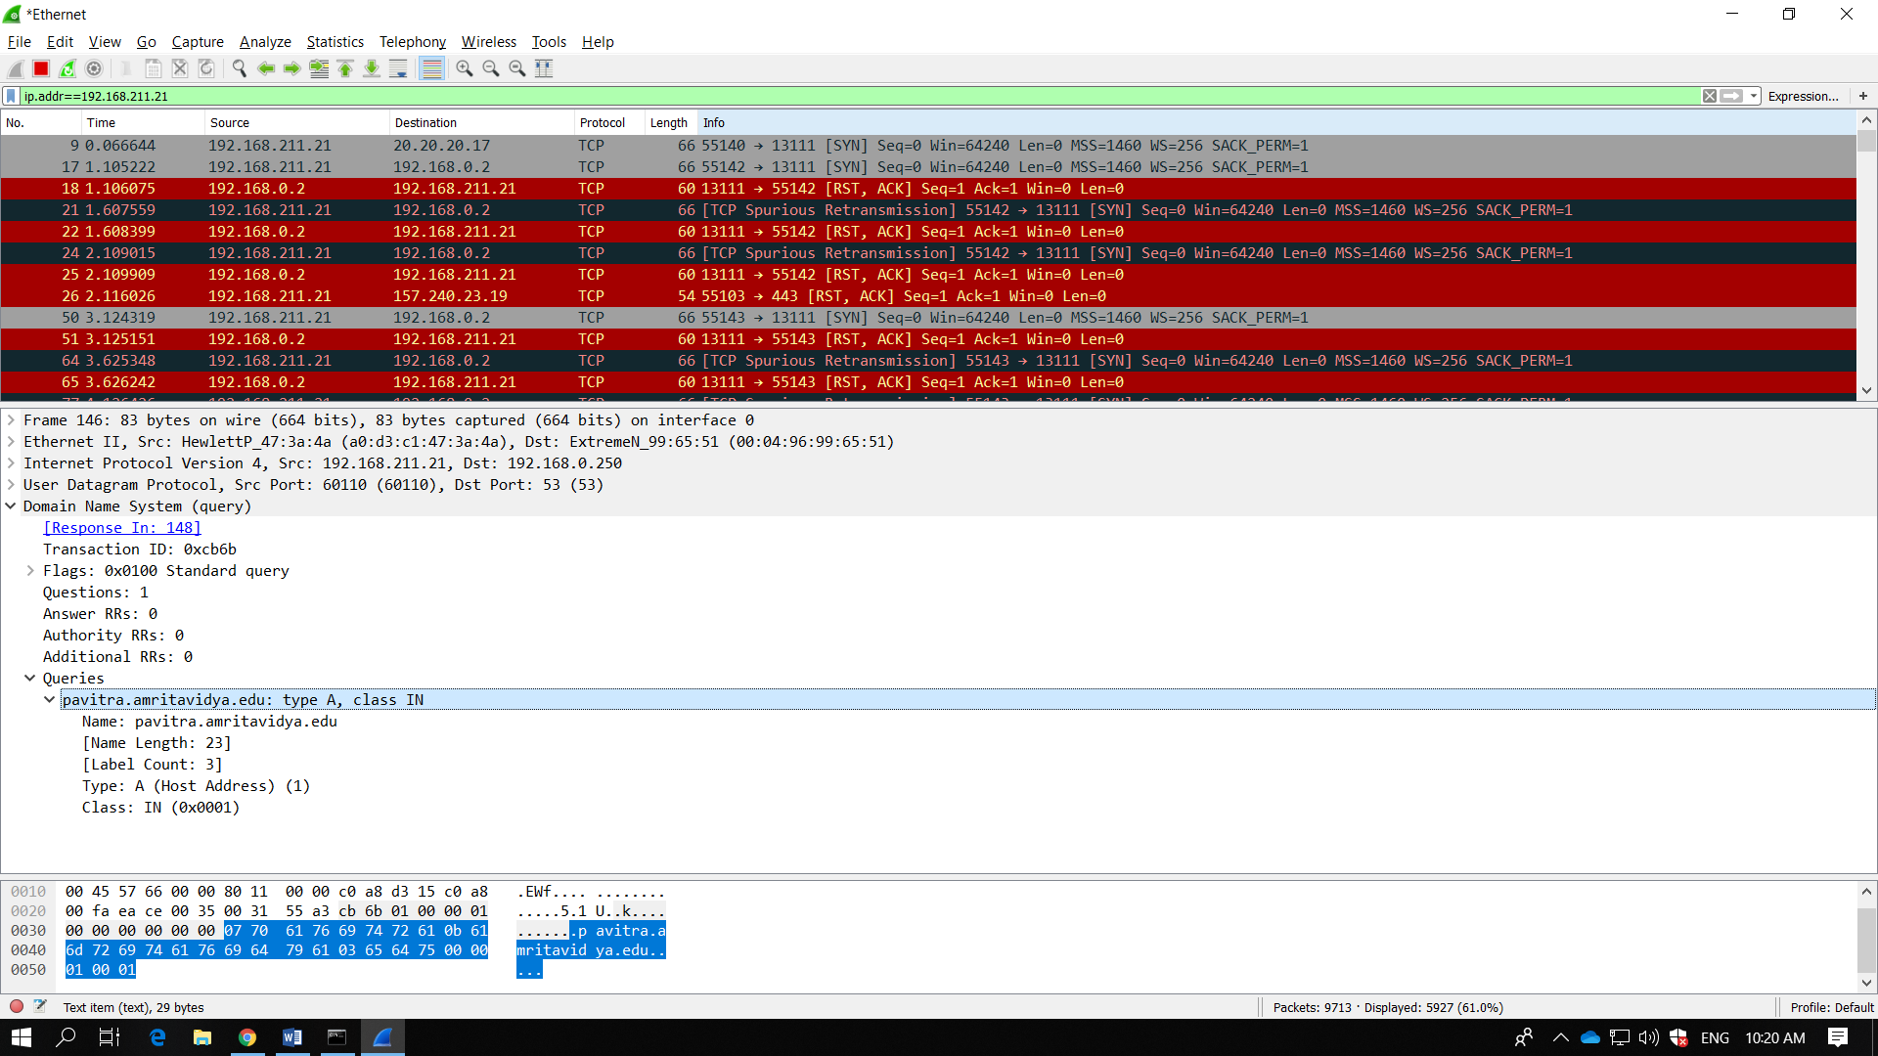
- Examine the DNS response message. How many “answers” are provided? What does each of these answers contain?
the server returned a flag that stated that it could complete a recursive query.
