Subject: Programming with Java
ASSIGNMENT No :2
TITLE :Develop a Java application demonstrating the use of default, parameterized, and copy constructors for object initialization and data management.
Assignment 2: Methods and Static Members

Problem Statement
Develop a Java application demonstrating the use of default, parameterized, and copy constructors for object initialization and data management.

Learning Objectives

To understand and implement default, parameterized, and copy constructors for object initialization.

Theory
Constructors are special member functions that are automatically invoked when an object is created. Java supports default constructors provided by the compiler, parameterized constructors for initializing objects with user-defined values, and copy constructors (implemented manually) for creating duplicate objects. Constructors improve code readability and simplify object initialization while supporting object-oriented programming principles.

Conclusion
Hence, the implementation of various constructor types in Java was successfully demonstrated to handle object initialization and data management effectively. By utilizing default constructors for baseline setup, parameterized constructors for assigning specific user-defined values, and copy constructors for creating accurate duplicate records, the exercises illustrated flexible and efficient object creation. This approach not only improves overall code readability and simplifies the initialization process, but it also strongly reinforces core object-oriented programming principles by ensuring data consistency and reusability across multiple instances.
Exercise
- Create a Student class using default and parameterized constructors to initialize student name and roll number.
Code:

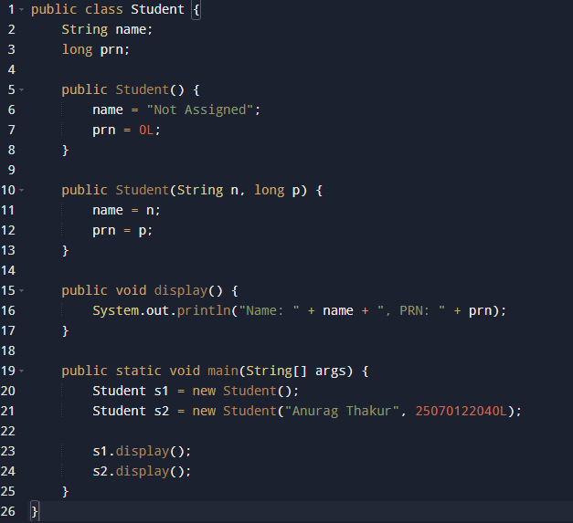

Output:


- Develop a Mobile Phone Inventory System using different constructors to initialize mobile details and create duplicate object records.
Code:
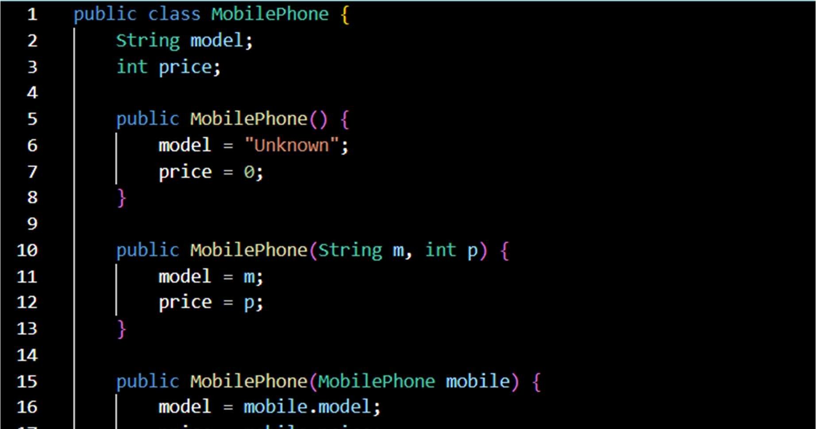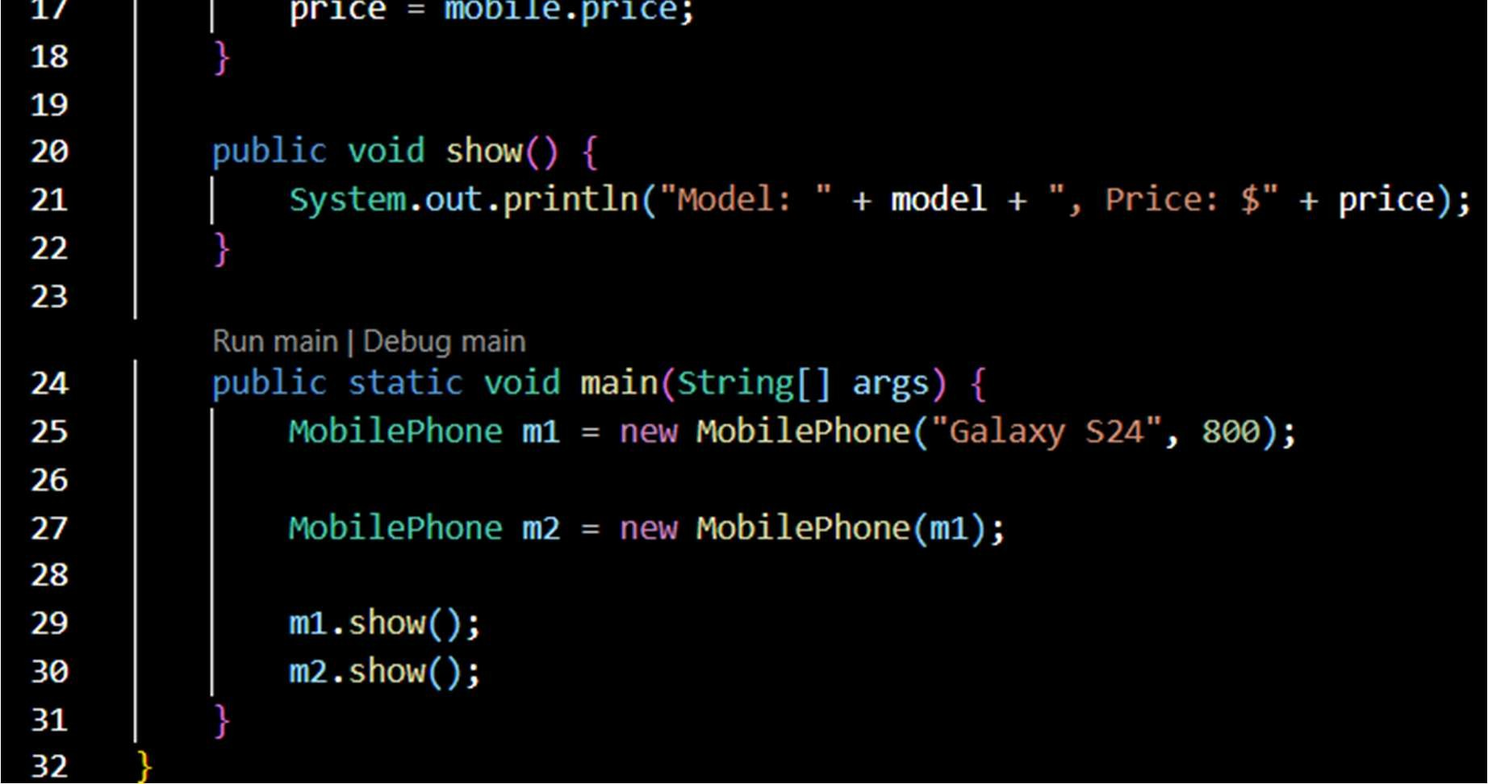

Output:
