# Our Approach

We have tried clustering on the dataset.

1. Hierarchical clustering to understand the number of clusters.

From the clustering output we could see that k=3 is a good number to begin with

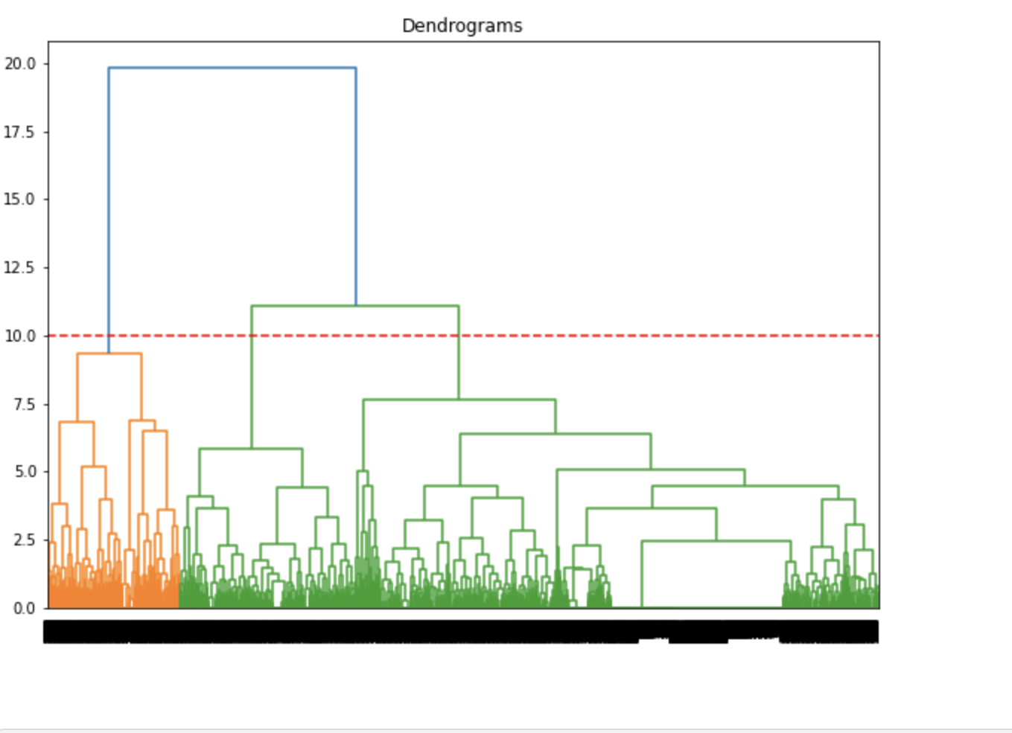

2.) We performed K means clustering with k=3 and below are the results

The segments could be translated as below from the average scores of the 7 variables

cluster 1- burned out

cluster 2-burned out

cluster 3-prone to be burnt out

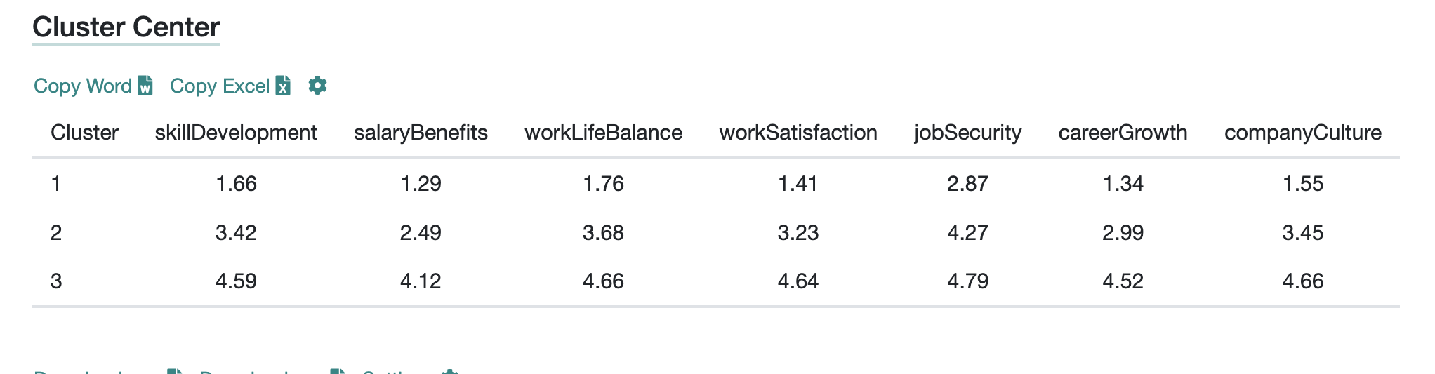

From the elbow plot we are also tempted to use k=4??? (doubt)

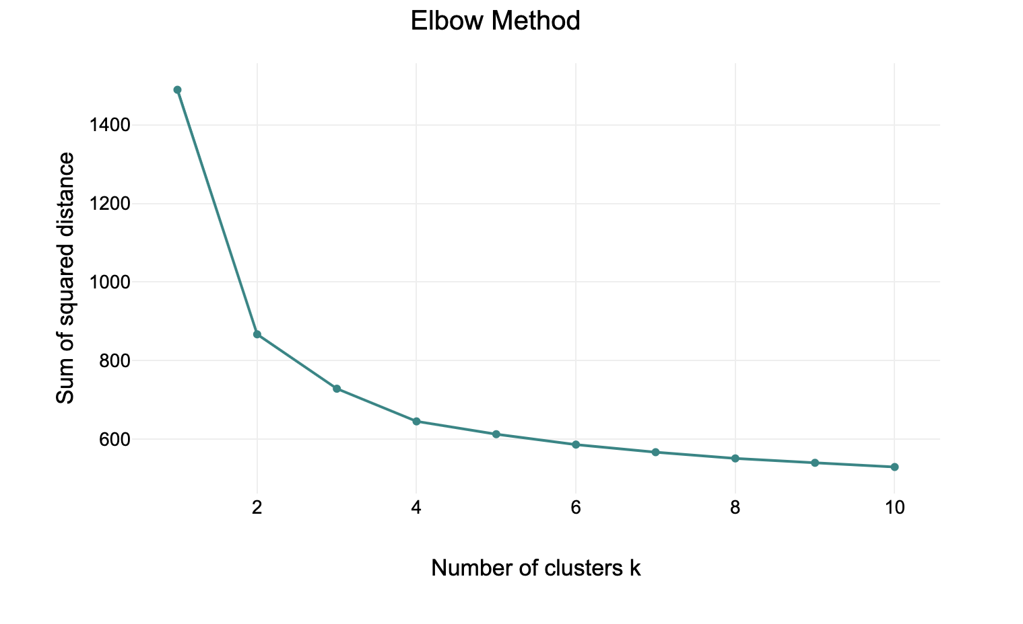

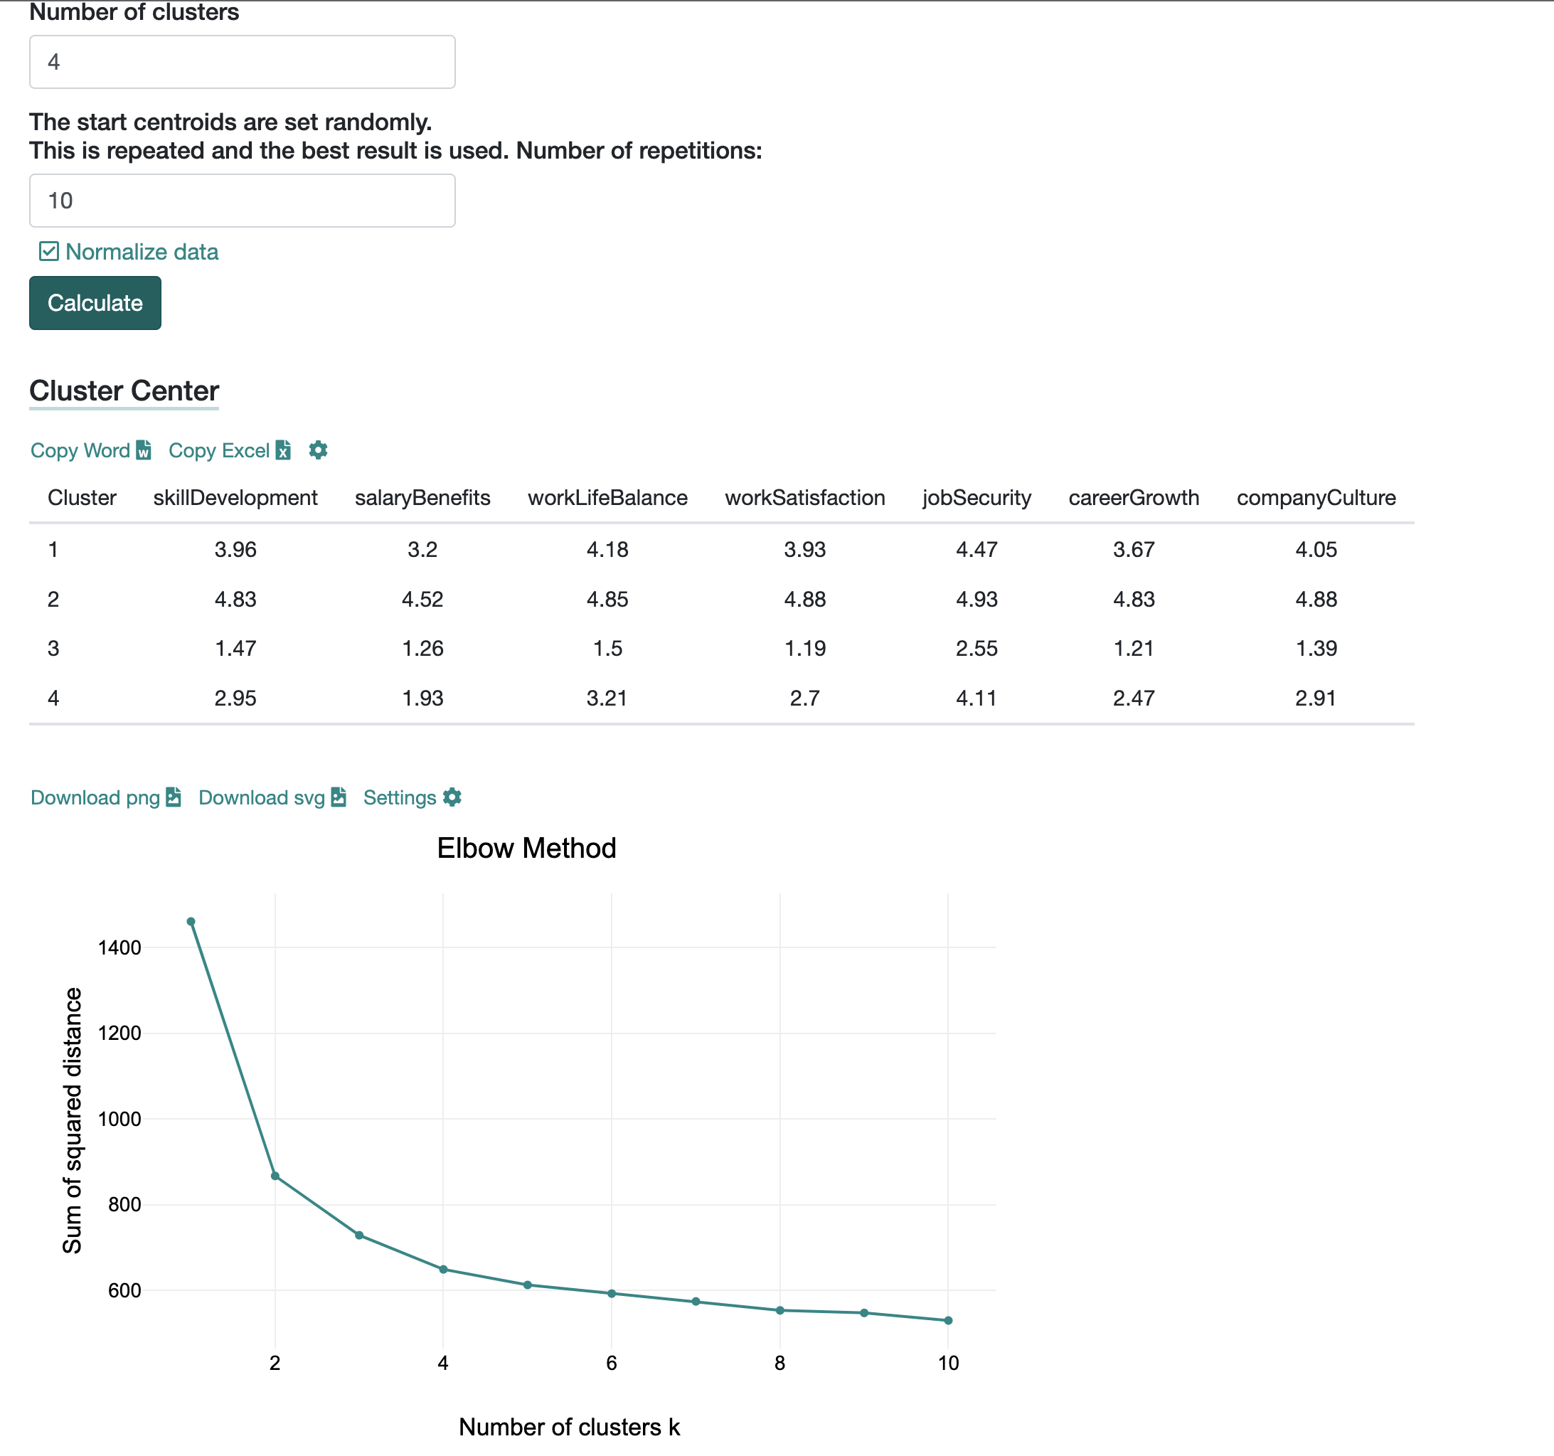

The cluster allocation

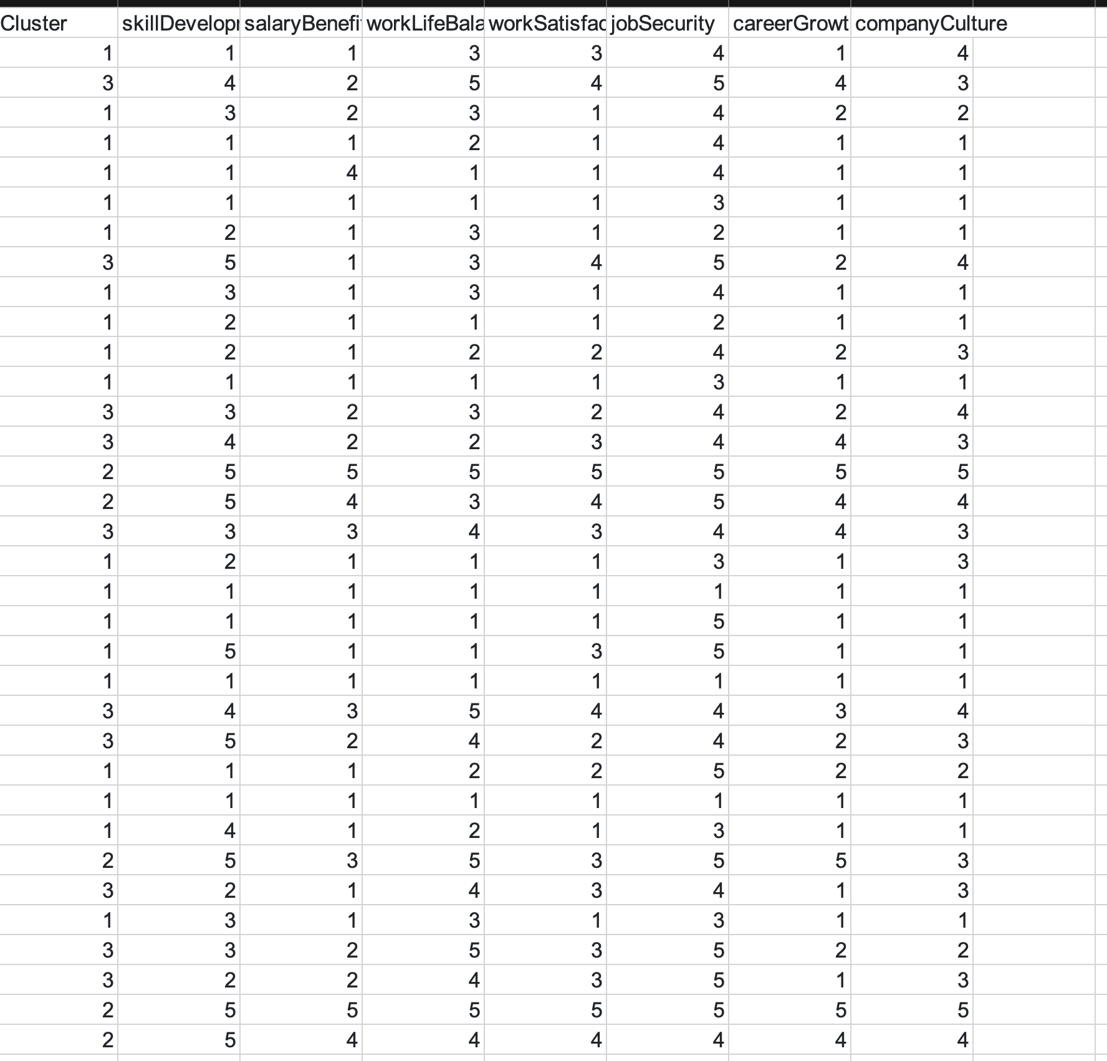

# Factor Analysis Output

## Exploratory Factor Analysis

* With the Job security variable, the below latent constructs

* Without Job security variable below are the latent constructs

## Confirmatory Factor Analysis

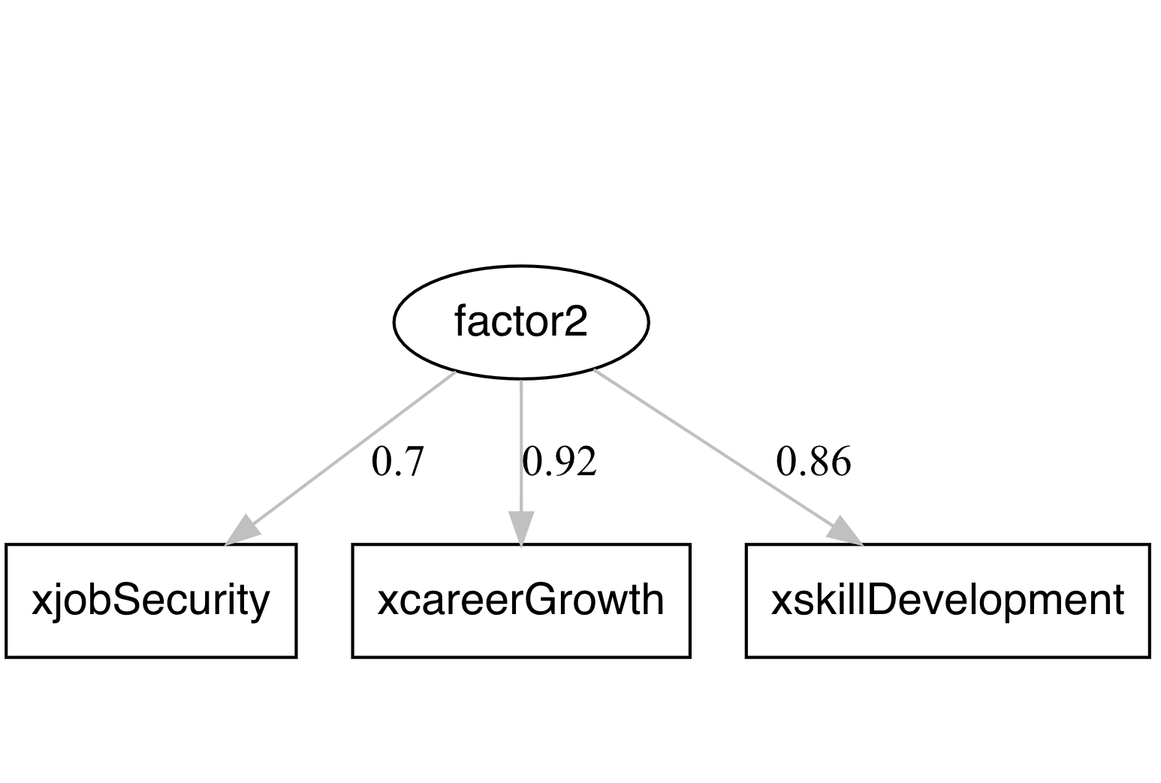

From the above Factor Analysis output we could see that there are three latent constructs (factors) from the 7 variables.

Naming those 3 Factors requires domain expertise.From the research we did from our end we thought these factors could be any of the 3 axis (De personalization,Exhaustion,Lack of achievement).Or should we leave them as is.Is this the right approach to follow???.

# FUTURE STEPS

* Given our approach of clustering into 3 segments and the factor analysis .we would like to proceed using the clustered category text for further analysis.

(Ex.Analysing cluster 1 text and topic modelling of cluster one helps us in understanding the sentiment of the people who have given very less ratings to the company )

* We would like to translate this to a recommendation system or a Multiclass classification approach (As we have data that is labelled into clusters now)
* Converting the text to a sentiment score and validating our approach with text and without text scores