Kubectl outputs:

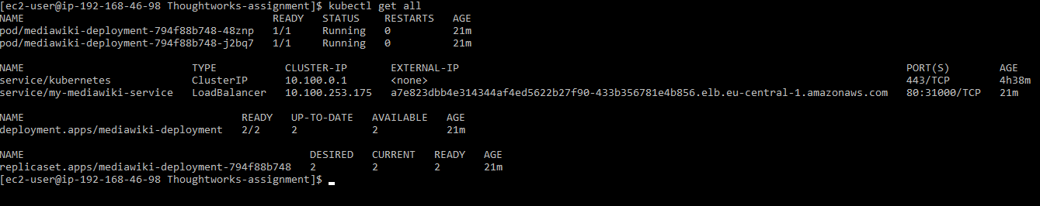

Helm install outputs:



