Azure

**Cloud (Internet or network):** we can say that cloud is something which is present at remote location. Cloud can provide services over public and private networks. WAN, LAN, VPN.

**Cloud Computing:** It refers to manipulating, configuring and accessing the hardware and software resources remotely. it offers online data storage and infrastructure and application. Platform independency.

**Basic Concepts:** When we are talking about cloud computing two concepts 1). Deployment models 2). Services Models

**Deployment Models:** This will define type of cloud i.e we can acces cloud in 4 ways.Public,private,Hybrid and community cloud.

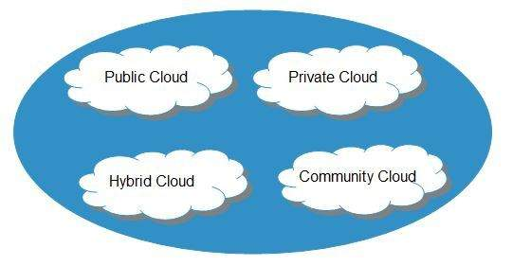

**Public cloud**: It allows systems and services to be easily accessible to the general public. Public cloud may be less secure because of its openness.

**Private cloud**: It allows systems and services to be accessible within an organization. It is more secured because of its private nature.

**Community cloud:** It allows systems and services to be accessible by a group of organizations.

**Hybrid cloud:** It is a mixture of public and private cloud, in which the critical activities are performed using private cloud while the non-critical activities are performed using public cloud.

**Service Models:** These are categorized into three basic service models which are -

* Infrastructure-as–a-Service (IaaS)
* Platform-as-a-Service (PaaS)
* Software-as-a-Service (SaaS)

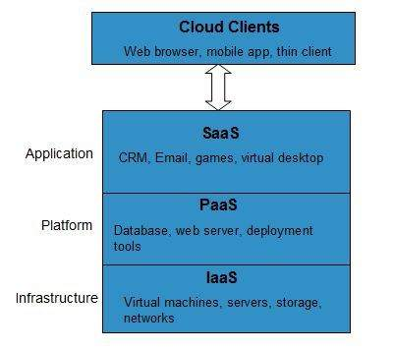

**IaaS** is also known as **Hardware as a Service (HaaS)**. It is a computing infrastructure managed over the internet. The main advantage of using IaaS is that it helps users to avoid the cost and complexity of purchasing and managing the physical servers.EX: DigitalOcean, Linode, Amazon Web Services (AWS), Microsoft Azure, Google Compute Engine (GCE), Rackspace, and Cisco Metacloud.

**PaaS** cloud computing platform is created for the programmer to develop, test, run, and manage the applications.EX: AWS Elastic Beanstalk, Windows Azure, Heroku, Force.com, Google App Engine, Apache Stratos, Magento Commerce Cloud, and OpenShift.

**SaaS** is also known as "**on-demand software**". It is a software in which the applications are hosted by a cloud service provider. Users can access these applications with the help of internet connection and web browser.EX: BigCommerce, Google Apps, Salesforce, Dropbox, ZenDesk, Cisco WebEx, ZenDesk, Slack, and GoToMeeting.

**Virtualization: Virtualization** plays a very important role in the cloud computing technology, normally in the cloud computing, users share the data present in the clouds like application etc, but actually with the help of virtualization users shares the Infrastructure. Mainly Virtualization means, running multiple operating systems on a single machine but sharing all the hardware resources. And it helps us to provide the pool of IT resources so that we can share these IT resources in order get benefits in the business.

**Azure**

Windows Azure, which was later renamed as Microsoft Azure in 2014, is a cloud computing platform, designed by Microsoft to successfully build, deploy, and manage applications and services through a global network of datacenters.

1. Region: It is nothing but called it as India
2. Zone or Datacentres: When India is region Ap, Telangana, Karnataka these are all zone or data centres
3. Server:or vm or vn
4. virtual network(ip address)
5. Migration, on-premises()
6. Monitoring
7. Peering

Azure portal creation